HSS2103 – Experience of Illness, Impairment, Disability and Care
Influence of Developmental or Life Stage: Experiences of Adults and Older Adults with Illness or Disability

Topics to be Covered
- Experiences of adults and older adults living with a disability or chronic illness
- Engagement/participation in daily activities
- Techniques to facilitate personal care, transfers, and mobility when living with a physical disability
- Emphasis on issues related to physical disability
- Work and employment
- Disability and abuse

PART 1:
ADULTS WITH DISABILITY, CHRONIC ILLNESS, OR TERMINAL ILLNESS

Definition of Adult & Older Adult
- In Canada, the age of majority reflects when a person is considered to be an adult under the law (i.e., in Ontario it is 18 years of age).
- Life expectancy at birth: 80.4 years
- - Females: 82.7 years; Males: 78 years
- The working-age population is aged 15 to 64 years AND seniors are those 65 years and older (approximately 4,335,255 persons are aged 65 years and over).
- According to the 2006 Census, the very elderly group – 80 years or older – experienced the largest increase (approximately 1,167,310 aged 80 years and over).
- Creates a significant demand for health care services

Defining Old
- The aging process is a biological reality which has its own dynamic, which is largely beyond human control.
- In the developed world, chronological time may play a paramount role in defining old age (e.g., age of 60 or 65, which reflects retirement age, may be considered to be the beginning of old age).
- Influenced by how society defines old age (i.e., roles assigned to individuals OR loss of roles accompanying physical and/or cognitive decline in function).

What are some differences/similarities between individuals with chronic illness versus terminal illness?

General Adaptation Process to Illness
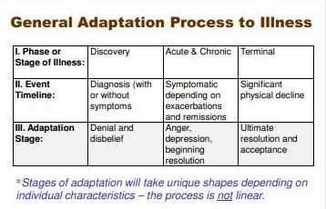

What are some losses associated with chronic and terminal illnesses?
- some obvious ones = loss of function or body part.
- loss of independence
- loss of social role and productive role
- can be loss of social stuff, self concept, and self esteem might be affected. Quality of life/wellness might be affected.

Aspects of Adaptation to Chronic/Terminal Illness
- Engel (1960) poses a model of adaptation for chronic conditions consistent with the grieving process
- highlights notions of shock or disbelief, gaining awareness, restitution, resolution of the loss, and identity change
- The initial diagnosis can trigger one sequence and a series of emotions, but the reappearance of symptoms or the development of new symptoms or problems can trigger additional cycles
- Responses may include anxiety, anger and depression, and recurrent feelings of helplessness, hopelessness, and powerlessness

Responses to Chronic/Terminal Illness

- Denial is a powerful coping response in which certain perceptions are not processed in usual ways (e.g., deny facts, implications, and/or ultimate outcomes; explain facts as insignificant; avoid certain issues)
- Fear, anxiety, and disorganization often result from becoming aware of an illness or injury and the appraisal of its severity (minor versus major)
- Anger and hostility are a reaction to stress and a statement of protest (e.g., “Not me? –TO-- Why me?”), and often depends on the significance of the stressor (e.g., impact on quality of life)
- Depression may be experienced and reported during the course of the illness, coupled with feelings of hopelessness and powerlessness
- Resolution and acceptance tend to occur over time when the ‘crisis’ is no longer viewed in the same manner (whether a chronic or life-threatening illness)

What happens if a person cannot cope with the demands of their illnesses or has difficulty accepting the reality of their decline or limitations?

What about the impact of acquired disability on the ‘self’?
Biographical Disruption (BD)

- Biographical disruption (BD) is the sense of disruption to expectations, life plans and the predictability of daily life that are faced by those who have experienced unexpected life events (e.g., physical disability; terminal illness).
- In the context of a health crisis, BD involves three dimensions:
  - 1) bodily changes,
  - 2) perceptions of self
  - 3) notion of time.
- Inability to perform valued ADLs may lead to loss of certain aspects of the self (e.g., self-worth; perceived competence).
- Personal meaning of an impairment depends on: 1) its consequences(i.e., how it disrupts daily activities/relations, and 2) its significance(i.e., what are the social implications)

- You may change the consequencesof a disability by – attending to the body, re-structuring your thinking around disability/ability, and mobilizing social and material resources.
- You may change the significanceof a disability by – redefining values, broadening the range of things that are valued, and decreasing emphasis on physique as a measure of the self.
- Four dimensions that contribute to the experience of a life worth living following a biographical disruption are:
  - 1) meaning (personal fulfillment),
  - 2) purpose (goal-directed),
  - 3) choice and control
  - 4) self-worth.

Disability-Related Factors that may Influence Daily Living
- 1. Fundamental effects of the physically disabling condition focus on the individual or medical aspects, including:
  - i. primary effects (e.g., mobility, cognition, comfort, communication, energy) andsecondary effects (e.g., indirect effects such as side effects of meds or fatigue)
  - ii. trajectory (e.g., how the condition presents, including predictability, manageability, visibility, stability, severity, permanence)
  - iii. type and timing of the onset (e.g., immediate or gradual; whether diagnosis was prompt and accurate; age)
- 2. Other’s perceptions of the disability and its influence
  - how the disability is perceived and who is perceiving it; viewing the disability as all-encompassing, universally devastating, and as a central defining characteristic
- 3. Need for and use of multiple external resources from various sources
  - availability and usability of resources (appropriate, accessible, adaptable, reliable), and level and type of need
- 4. Contextual conditions
  - environmental factors (e.g., natural and built environment)
- 5. One’s personal views and experiences
  - beliefs, knowledge, values and cultural meanings attached to illness/disability
  - over time one adjusts and adapts to their new body, circumstances and opportunities

PART 2:
ENGAGEMENT IN DAILY ACTIVTIES

Basic Activities of Daily Living (B-ADLs)
- B-ADLs are daily activities that require more basic physical or cognitive skills, including activities for:
  - self-care (e.g., bathing, toileting, dressing, grooming, eating, medication regimen, health maintenance)
  - functional mobility (e.g., bed mobility, propelling wheelchair, ambulating, transfers, turning faucets on/off, opening/closing doors, using keys)
  - communication (e.g., speaking, telephoning, using augmentative communication devices, writing)
  - sexual expression (e.g., self pleasure, sexual activity with a partner)

Instrumental Activities of Daily Living (I-ADLs)
- I-ADLs are daily activities that require more advanced cognitive and problem-solving skills, social skills, and environmental interactions, including activities for:
  - home management (e.g., meal preparation, laundry, managing finances, housekeeping tasks, caregiving)
  - community living (e.g., errands, shopping, socializing, traveling as a pedestrian or by public transportation)
  - using complex environmental hardware (e.g., stove, microwave, vacuum)
  - driving (visual, physical and cognitive skills required)

Occupation
- refers to groups of activities and tasks of everyday life, which are named, organized given value and meaning by individuals and a culture.
- Is everything people do to occupy themselves, including looking after themselves (self or personal care), contributing to the economic and social fabric of their communities (productivity), and enjoying life (leisure).
- Includes activities that one needs, wants or is obligated to do. Provide a source of meaning, choice and control.
- Should meet the intrinsic needs of individuals for self-maintenance, self-expression and self-fulfillment.

Autonomy and ADLs
- Independence: The ability to engage in activities on your own (may include the use of aids or equipment, but not another individual’s assistance or support).
- Dependence: The inability to engage in activities without the full or complete support, physical assistance, and/or supervision of another individual.
- Interdependence: The ability to engage in activities by relying or depending on another individual for some support.

Occupation and Health & Well-being
- Physical Well-being(e.g., mobility; range of motion; endurance; strength; transfers)
- Cognitive Well-being(e.g., action of knowing; processing information; learning; problem solving)
- Psychological Well-being(e.g., mental health; emotions; mood)
- Social Well-being (e.g., social participation and integration; communication; use of transportation)
- Spiritual Well-being (e.g., sense of meaning; will; purpose and connectedness; self-determination)
- Safety(e.g., minimize risk or harm to self/others; prevent injury or accidents)

PART 3:
MOBILITY AND PHYSICAL DISABILITY OR LIMITATIONS

Facilitating Personal Care & Mobility with Persons with Disability or Illness
- Help to facilitate mobility and transfers
- Use equipment or assistive aids
- Make adaptations, including i) changing the task (e.g., objects, procedures) and/or ii) changing the context (e.g., modifying the environment)
- Provision of services and resources at the private and public sectors (e.g., CCAC)
- May involve teaching and re-training the individual to establish new skills, habits and behaviours

Mobility, Transfers & Physical Disability
- Mobility is movement that involves changing the body’s position, including the ability to move parts of the body OR the body as a whole.
- A person with a mobility impairment or a physical disability may have difficulty with walking (or ambulating), standing, lifting, climbing stairs, carrying, balancing, or having the stamina and endurance to do these kinds of activities.
- Transfers involve a person moving between surfaces, including the bed, chair, bathtub/shower, or a vehicle.
- Classification of transfers – individual may require:
  - i. no assistance
  - ii. supervision (no touching but another individual is present)
  - iii. minimal assistance (light hands on person)
  - iv. moderate assistance (hands on person with greater control)
  - v. maximum assistance (assistance of more than one individual or the use of a mechanical lift)
- Individual may also require assistive aids to perform a transfer (e.g., transfer belt, pivot disk, sliding board).

Transfer Aids Pivot Desks
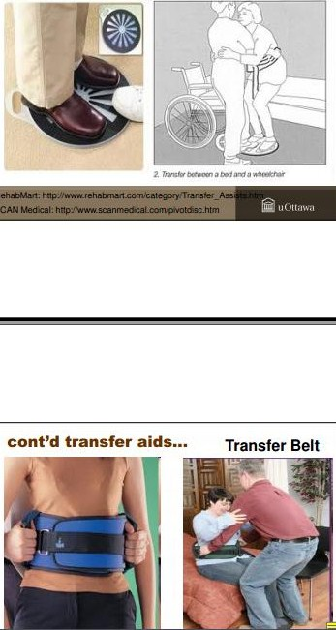

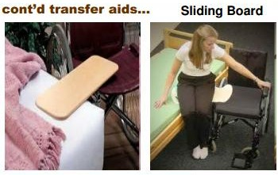

- Effort required to do a manual transfer may vary throughout the day or from day to day (e.g., depending on the energy level or alertness of the patient; fatigue; side-effects of medication) AND depending on the surface (e.g., transferring into a car).
- Example of transfers and transfer techniques:
- 1) Standard manual transfer from bed to wheelchair with use of a belt and minimal/moderate assistance

Characteristics of Safe Transfers
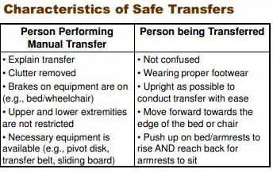

Equipment and Assistive Aids for Personal Care and Mobility
- Bedside commode
- Commode over toilet
- Raised toilet seat
- Tub Transfer bench
- Walk in shower or bath seat
- Reacher
- Sock Aid
- Standard walker
- 4 wheeled walker
- High End specialized wheelchairs

Impact of Lack of Mobility or Immobilization
- Mobility is critical to maintain the physical, psychological and social well-being of individuals.
- Immobilization may result in physical or anatomical problems with the body (e.g., pressure or bed sores or contractures) AND psychological distress from lack of socialization and increased isolation.

Pressure Ulcers: Impact of Immobilization
- pressure ulcer (or pressure/bed sore) is the breakdown of skin that may occur, at a certain location, from a lack of blood flow of more than 2 or 3 hours due to constant pressure. Categorized into 4 stages.
- Most commonly seen at boney regions close to the skin surface that tend to have increased contact with surfaces (e.g., sacral region or coccyx, buttocks, hips, heels, elbows, back of head, ears).
- Main risk factor for pressure ulcers is inability to move or reposition one’s body. Any illness that results in immobility or having to stay in bed for a long time increases the risk of pressure ulcers (e.g., stroke, surgery, cancer, heart failure, pneumonia, sensory or cognitive issues).
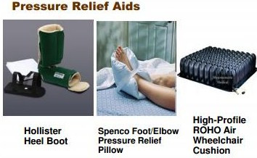

Contractures: Impact of Immobilization
- Contractures are structural changes to muscles, ligaments and tendons that result in loss of joint motion.
- Can occur at any joint in the body due to increased muscle tightness that has gone on for an extended period of time.
- In most cases, once a contracture develops, it is irreversible.
- Strategies to reduce the risk of developing contractures include manual techniques (e.g., massage and stretching to promote mobilization), mechanical techniques, casting or splinting (e.g., to promote normal positioning), and surgery.

Falls and Elderly with Disability
- Falls are a major source of physical dysfunction and mortality among the elderly and physically disabled. Falls often occur during ADLs.
- It is a national health priority to prevent falls.
- Interventions to prevent falls may include:
  - 1) home safety assessments and modifications (e.g., securing rugs and electrical cords, removing clutter, installing hand rails and grab bars),
  - 2) improving intrinsic factors (e.g., balance, stamina, gait, energy conservation techniques)
  - 3) safer use of mobility aids (e.g., proper use of brakes on walker).

Adults with Disability & Chronic Illnesses and Discharge from Acute Care Facilities
- Discharge home with no support (i.e., able to safely function physically and cognitively).
- Discharge home with support (i.e., able to function safely, but require assistance with some ADLs such as bathing from CCAC or meals-on-wheels).
- Discharge to retirement home (i.e., functioning well cognitively, but with some physical limitations in mobility or cooking and may require a more accessible setting).
- Discharge to nursing home (i.e., fairly severe level of cognitive functioning and safety is a concern; may also have limited level of physical functioning)
- The individual (who is medically stable) is discharged from the hospital TO a ‘personal’ environment (e.g., home, retirement residence, etc) for safe or independent living in the community.
- Adults with illness and/or disability-related problems who require further treatment/therapy/care may also be transferred or referred within a health care setting (e.g., to a specialized unit within a hospital, to a complex continuing care facility, to geriatric rehabilitation, etc).

PART 4:
PRODUCTIVITY IN ADULTHOOD – EXPLORING WORK/EMPLOYMENT

Productivity and Employment
- Working aged persons with disabilities experience significantly lower rate of employment than persons without disabilities. If persons with disabilities are employed, they tend to earn less than non-disabled individuals, woman with disabilities generally earn less than men with disabilities.
- Factors that influence the role of persons with disabilities in the labour market include: differences in productive capacity; discrimination and prejudice; inadequate work supports and resources; and disincentives created by disability benefit systems.
- Enforcing antidiscrimination laws is expected to improve access to work opportunities.

Affirmative action commonly refers to policies that aim to restore equality in employment and education for those who suffer from discrimination (e.g., persons with disability). What do you think about the notion of affirmative action?

Analysis of the World Health Survey results for 51 countries gives employment rates of 52.8% for men with disability and 19.6% for women with disability, compared with 64.9% for non-disabled men, and 29.9% for non-disabled women.”

Reasons for Limited Employment Opportunities
- According to labour market theory:
  - persons with disabilities will experience greater cost with working (e.g., more effort to reach workplace and perform work)
  - employment may result in loss of benefits
  - health condition may make a person less productive, especially if workplace is not accommodating
- Persons with mental health problems or intellectual impairments experience the lowest employment rates.
- Other barriers to entering the labour market include: lack of access to education and training; limited financial resources; inaccessible information; nature of workplace and physical environment; negative perceptions of employers; prejudice and misconceptions about disability; low self-expectations; policies in labour laws (e.g., shorter working days).

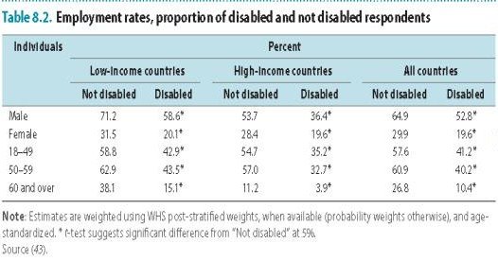

Addressing Barriers to Work / Employment
- Laws and regulations– anti-discrimination laws and affirmative action
- Tailored interventions – may have a quota for the employment of people with disabilities; incentives for employers; supported employment; employment agencies
- Vocational rehabilitation and training – job training, counselling, and placement
- Self-employment and microfinance– to help start small businesses
- Social protection – provides social security; long-term disability benefits can provide disincentives
- Working to change attitudes

Work Hardening
- involves maximizing the person’s ability to return to work, including:
- 1. attaining optimal physical tolerance and abilities
- 2. maximizing cognitive and psychosocial function
- 3. developing appropriate work behaviours
- 4. reducing fear and increasing confidence to work
- 5. identifying problems that may necessitate placement in an alternative job

What are the benefits of people with disabilities participating in the labour force?

PART 5:
ABUSE AND ADULTS WITH DISABILITY

Defining Disability and Elder Abuse
- “The World Health Organization (2002) defines abuse as a single, or repeated act, or lack of appropriate action, occurring within any relationship where there is an expectation of trust that causes harm or distress to an older person. … Statistics on elder abuse indicate that between two and 10 percent of older adults will experience elder abuse

Disability and Elder Abuse
- Elder abuse refers to any (un)intentional act by an individual, within the context of any relationship, which may cause risk or harm to an elderly person.
- Types of abuse may include physical, psychological, verbal, emotional, denial, financial, sexual, neglect, etc
- Given the rise in older people with disabilities, it is important to be aware of some of the signs that may indicate abusive relationships between the elderly and their care providers (e.g., self-reports; fractures; upset or non-responsive; fear; depression; discomfort; low self-esteem; malnutrition; unsanitary living conditions; changes in financial status; bruises around genital area; unexplained genital infections or STDs).

Example of Elder Abuse
- “William, who had a number of physical health problems and a diagnosis of dementia, hired a young man, Elliot, to provide him with assistance with household tasks, medication management, accompaniment to appointments and banking. Elliot used his position to convince William to give him a great deal of additional money to spend on his own interests and also withdrew funds from William’s accounts without consent. Neighbours found William alone in his home in a state of extreme malnourishment and dehydration, and with no access to his medication.
- Elliot’s behaviour represents both financial abuse and neglect
- Physical assault: “Martha regularly dressed and fed her husband in the mornings. Sometimes frustrated with his lack of mobility, Martha would grab his right arm and forcefully pull him from the bedroom to the kitchen.”
- Over-medicating a person (i.e., give medication that is not needed, administering too much medication): “Aparna increased her mother’s medication, without consulting a doctor or her mother. The extra medication has severely limited her mother’s alertness and agility, confining her to bed. She sleeps for longer periods of the day, is often incontinent and no longer has visitors.”
- Withholding medication (i.e., refusing to pay for a prescription, rationing or limiting the dosage of medication): “Peter’s heart medication is expensive. Without consulting a doctor, Peter’s son began rationing the pills, cutting the dosage in half. Peter did not know about or consent to the change in dosage.”
- Unlawful confinement (i.e., locking someone in a vehicle, room or building, using restraints to keep someone in bed or in a chair): “Flora often scratches or picks her skin until it bleeds. Hoping to prevent her from causing more damage to herself, her son and daughter made her wear gloves. When Flora insisted on removing the gloves, her son tied her arms down to a chair.”

What are some barriers that elders may face to disclosing abuse?

Scenario -Elder Abuse
“Mrs. S. has Parkinson’s disease and lives with her son and daughter-in-law. The [home therapist] has noticed that she is frail and unkempt, smells of urine and is unable to recall her medical history. On speaking with the family, they say that she is requiring more help and they would like homemaking but they want to take care of her at home. Mrs. S.’s son calls the therapist on his own and states that he didn’t want to say anything during the visit but his wife has started yelling at his
mother, and discourages her from coming out of her room to eat with the family. She says she’ll “put her in a home,” but when he has talked with his wife she denies being frustrated.
He is worried that his wife is “too stressed” but wants his mother’s income to keep their own household running.”



