HSS2103 – Experience of Illness, Impairment, Disability and Care – Lecture 2
Disability Statistics and Conducting Research on the Experience of Illness, Impairment and Disability

Topics to be covered
- Disability Statistics
  - Canada
  - Globally
- Conducting Research on the Experience of Illness, Impairment and Disability
- Special Issues in Conducting Research
  - Culture, Diversity and Health Research
  - Children and Adolescent Participants

PART 1:
DISABILITY STATISTICS CANADA, 2006

Disability Statistics in Canada, 2006
- Canada’s population in 2006: 31,612,897 people.
- 2006, 4.4 million Canadians living in households reported having an activity limitation due to a physical, psychological or other health condition, which resulted in a disability rate of 14.3% (*an increase from the 2001 disability rate of 12.4% or 3.6 million people).
- What do you think accounts for the increase in disability rate?

Collecting Data on Disability in Canada
- Participation and Activity Limitation Survey (PALS) post-census, national survey used to collect data on adults and children who have a disability (i.e., whose daily activities are limited because of a health condition or problem).
- PALS used the 2006 Census to identify its sample. PALS respondents were selected through the 2006 Census data on age, geography, and the responses to 2 general questions on activities of daily living and activity limitations.
- Total sample was 48,000 respondents (i.e., 39,000 adults and 9,000 children).
- PALS collected info on impact of disability on daily activities and other aspects of life.
- Interview/survey was administered by telephone using a computer assisted method.
- 2 questionnaires were used: 1) for adults 15+, and 2) for children under 15
- The population covered by the survey was persons residing in private and collective households. Persons living in institutions & on First Nations reserves were excluded.
- Overall response rate was 75.0%.

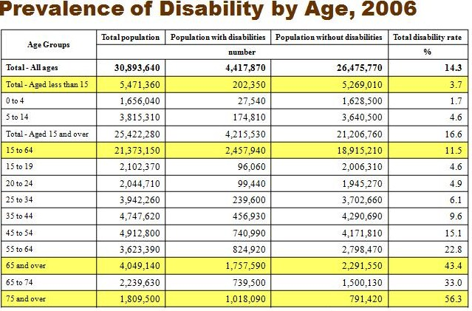
- Disability steadily increases with age.
- People are living longer and reporting more chronic illnesses.
- People see greater impairment with ages Canada only.

Disability Rates by Age and Sex, 2006
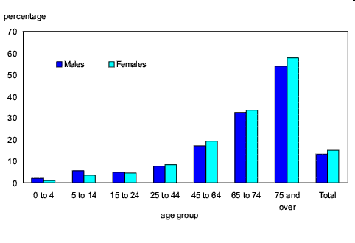
- Women are more likely to develop disabilities or chronic illnesses.
- Men tend to develop more permanent disabilities and die from a result of these things.
- Boys are more likely to be diagnosed early
- Disability is higher in women because they get reported much more than men.

Provinces & Territories: Rates of Disability

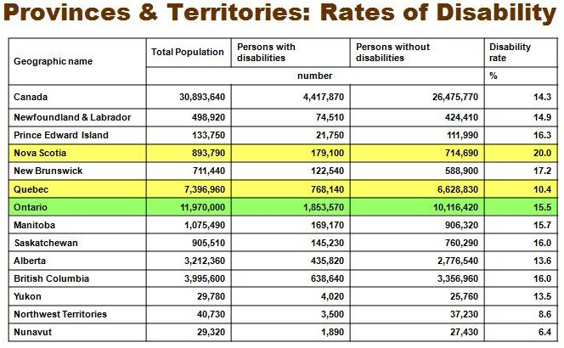
- Varies by province and ontario is 15.5%, higher than average.
- Varies in provinces because of the variation of populations, make up of the province and demographics and how many younger people are living.
- In quebec, people tend to report more mild disabilities.
- Alberta has a younger population and an older population.
- Nova scotia, new brunswick and saskatchewan tend to have a more older population.

Profile of Disability Among Children in Canada
(0-14 years of age)

Disability Profile for Children, 2006
- 2006, 69.8% of children aged 0 to 4 with one or more disabilities had a chronic health condition-related disability (or 1.2% of all Canadian children under the age of 5 years).
- Most common chronic conditions reported were asthma or severe allergies, attention deficit disorder with/without hyperactivity (ADD/ADHD), and autism.
- Transition from home to school is a key time in identifying learning disabilities in children.

Type of disabilities among children with disabilities, by age groups, 2006
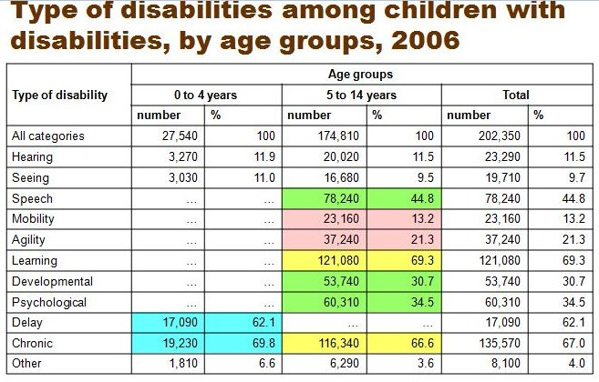
Number of disabilities for children, 2006
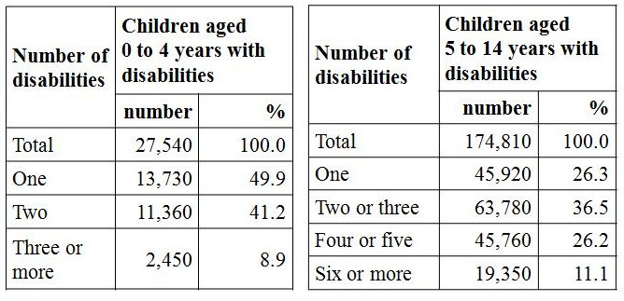
- Most children consider more than one disability is linked to severity to more than one problems.
- May take into consideration of more than one of these categories.

Disabilities in children with disabilities aged 5 to 14 years, by sex, 2006
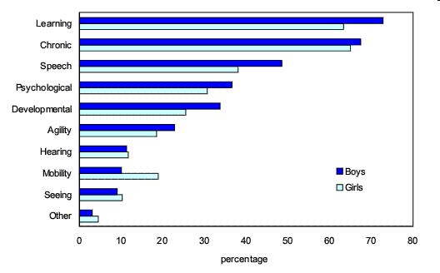
- Types of disabilities among children:
- Hearing - Difficulty hearing.
- Seeing - Difficulty seeing.
- Speech - Difficulty speaking and/or being understood.
- Mobility - Difficulty walking (e.g., on flat firm surface - sidewalk or floor).
- Agility - Difficulty using hands or fingers to grasp small objects - pencil or scissors. Inability to change body's position efficiently or integrate isolated movements (e.g., balance, coordination, speed, reflexes, strength, endurance and stamina).
- Learning - Difficulty learning due to presence of a condition (e.g., attention problems, hyperactivity or dyslexia; whether condition was diagnosed by a teacher, doctor or other health professional).
- Developmental delay - Delay in his/her development (e.g., physical, intellectual or another type of delay).
- Developmental disability or disorder - Cognitive limitations due to the presence of a developmental disability or disorder (e.g., down syndrome, autism or mental impairment caused by a lack of oxygen at birth).
- Psychological - Limited in amount or kind of activities one can do due to presence of an emotional, psychological or behavioural condition.
- Chronic condition - Limited in amount or kind of activities one can do due to presence of one or more chronic health conditions that have lasted or are expected to last six months or more and that have been diagnosed by a health professional (e.g., asthma, severe allergies, heart condition or disease, kidney condition or disease, cancer, epilepsy, cerebral palsy, Spina Bifida, Cystic Fibrosis, Muscular Dystrophy, Fetal Alcohol Syndrome).
- Other - If the respondent answered YES to the general questions on activity limitations, but did not provide any YES to the questions about type of disability that followed.
- Mobility is where girls dominate.

Profile of Disability Among Adults in Canada (15 years of age and older)

Disability Profile for Adults, 2006
- Disabilities related to pain, mobility and agility are most common among adults aged 15 years and over (e.g., problems with walking, climbing stairs, or carrying an object a short distance are often associated with agility problems or pain).
- 3 million adults (11% of the total population aged 15 yrs +) reported one of these limitations.

Prevalence of disabilities in adults aged 15 years and older by type of disability, 2006
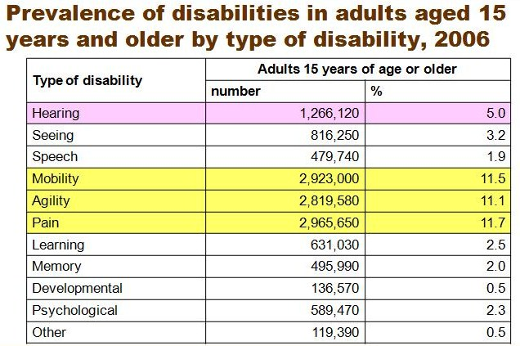
Prevalence of disability in adults aged 15+ years, by type of disability and age, 2006
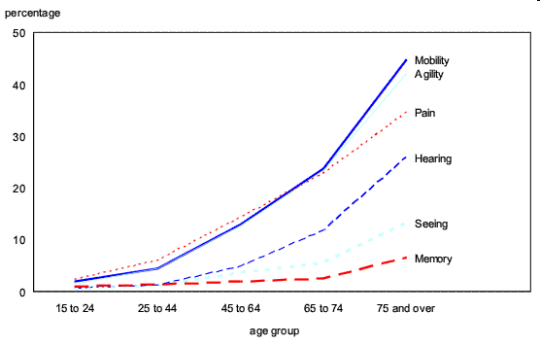

Prevalence of disabilities in adults aged 15+ years, by type of disability and sex, 2006
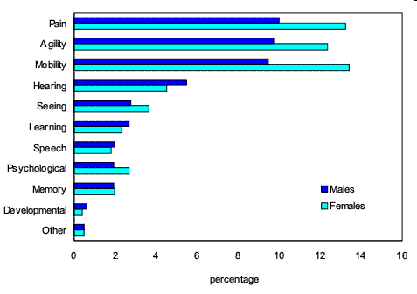

Number of disabilities reported in adults aged 15 years+ with disabilities, 2006
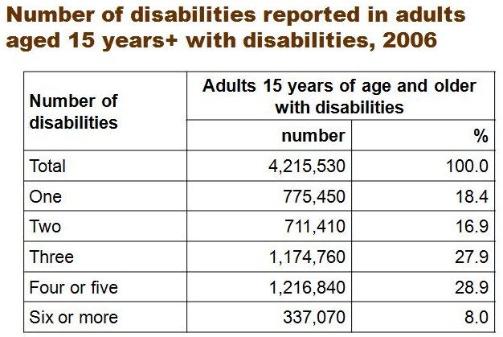
Severity of disability among adults aged 15 years+ with disabilities, by sex, 2006
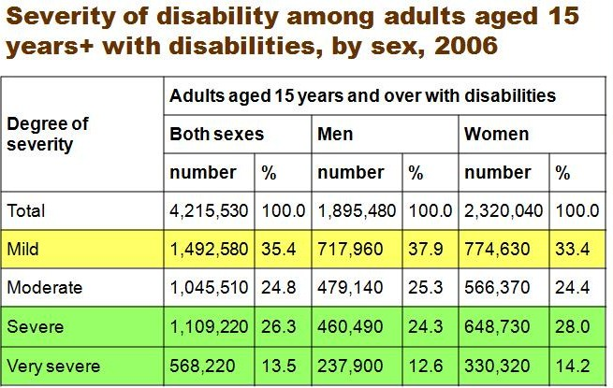
Why Collect Statistics on Disability?
- To collect systematic information on the nature and distribution of disability and chronic illness, and the social position of persons with disabilities.
- To provide information on the living conditions of Canada's disabled population.
- To increase awareness among governments, organizations and researchers of the limitations and strengths of such data.
- To inform and improve services.
- To facilitate the provision of services and reach out to persons with disabilities.

PART 2:
DISABILITY STATISTICS
A GLOBAL PICTURE

Global Prevalence of Disability
- Disability prevalence rates from around the world vary (e.g., disability rate is 1% in Kenya and Bangladesh; 2.13% in India; 20% in New Zealand).
- Many estimates are significantly below WHO’s suggested global prevalence rate of 10%, especially in developing countries.
- What do you think accounts for the extreme variation in disability rate?

Measuring Disability Globally
- Collecting statistical data on disability globally poses many challenges because the approaches to defining & measuring disability vary across countries – some challenges include:
  - different definitions of disability & expectations of functioning
  - varying data collection methods and nature/design of questions
  - untrained field investigators
  - reporting sources
  - cultural variation and differences
  - social stigma and/or social isolation
  - challenges of obtaining data from certain locations

Disability Prevalence Rate in Developed vs. Developing Countries
- 650 million persons with disabilities globally; 80% of whom live in developing countries
- Developing countries report a low disability prevalence rate
  - tend to collect disability data through censuses or use measures focused exclusively on a narrow choice of impairments
- Developed countries report a higher disability prevalence rate
  - tend to collect their data through surveys and apply a measurement approach that records activity limitations and participation restrictions in addition to impairments

Estimates Based on WHO World Health Survey
- Across 59 countries, average prevalence rate of disability in the adult population aged 18 years + was 15.6% (~650 million people of the estimated 4.2 billion adults aged 18 + in 2004).
- Rate of disability ranged from 11.8% in higher income countries to 18.0% in lower income countries (note: figure refers to adults who experienced significant functioning difficulties in their everyday lives).
- Average prevalence rate for adults with very significant difficulties was estimated at 2.2% or about 92 million people in 2004.

Estimates of Young People with Disabilities
- The Global Burden of Disease estimates the number of children aged 0 to14 years experiencing “moderate or severe disability” at 93 million (5.1%).
- Approximately 180 million individuals between 10 to 24 years of age are living with physical, developmental, sensory or mental health disabilities that have a significant impact on their daily life; an estimated 150 million of them live in developing countries
- Adolescents with disabilities in developing countries are one of the most disadvantaged groups in the world because they are often excluded from educational, occupational, social and cultural opportunities

“Including children, over a billion people (or about 15% of the world’s population) were estimated to be living with disability.”

Factors Impacting Rate of Disability Globally
- Environmental, social, political, and economic influences and risks (e.g., poverty, malnutrition, inaccessibility, unmet needs for services and assistance, etc)
- Infectious diseases (e.g., HIV/AIDS, TB, malaria, etc)
- Non-communicable diseases (e.g., diabetes, heart disease, stroke, cancer, mental health disorders, etc)
- Injuries and accidents
- Lifestyle factors (e.g., tobacco, alcohol, diet, exercise)
- Stage of life and the aging population

PART 3:
CONDUCTING RESEARCH

What is research?
- A rigorous, systematic inquiry or investigation.
  - Systematic implies careful preparation, planning, organization and critical evaluation.
- Purpose is to validate and/or refine existing knowledge and to generate new knowledge.
- Conducted according to a set of rules or principles that constitute the research or scientific method.

Systematic
- 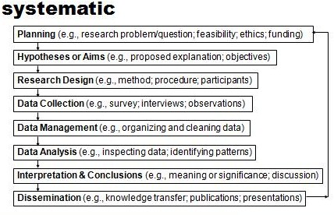

method
A systematic procedure and set of rules which specify:
  - How knowledge should be acquired.
  - The form in which knowledge should be stated, reported or presented.
  - How the truth or falsity of the knowledge should be evaluated.

Health Research Defined
- Aims to gather information in order to investigate and understand health issues, solve health problems or improve the quality of care.
- May inquire into the causes, diagnoses and prevention of diseases; promotion of health; the health care of individuals and groups; and the effects of the environment on health and well-being.
- Directed towards understanding the biological, physiological, psychological, social, behavioural and environmental mechanisms that influence health, wellness, illness and disability.

Research Paradigms
- Assist researchers in determining what is real and essential, how to proceed in daily research activities, and propose a set of assumptions, concepts and values about what can be known.
- Described as a worldview, a way of looking at and interpreting the world and reality.
- Provides a lens through which to develop, initiate, and continue a particular research tradition.

Common Research Paradigms
1) Positivistic or Empirico-Analytical:
  - World is an objective reality that can be studied, measured or understood accurately.
2) Post-Positivistic:
  - There is a reality out there to be studied, but the reality is complex and can only be studied or understood imperfectly.
3) Interpretive or Constructivist:
  - Multiple realities are created and are valid. Refuse to adopt any rigid standards by which the truth can be known universally.
4) Critical:
  - Reality is socially structured, not individually (i.e., reality is shaped by social, cultural, political, economic and gender values that are crystallized overtime), and is governed by power relations.

Deductive and Inductive Thinking
- When conducting research, two broad methods of reasoning are often referred to: deductive and inductive approaches or thinking.
- Inductive reasoning is more exploratory by nature.
- Deductive reasoning is concerned with testing or confirming hypotheses.

Deductive & Inductive Reasoning and Quantitative & Qualitative Research
- Deductive and inductive reasoning are often discussed in relation to quantitative and qualitative research.
- A particular health or social research study often involves both deductive and inductive reasoning processes at some time within the project.

Deductive Reasoning

- General Specific

Inductive Reasoning

Specific General

What is a theory?
- Aim to bind together – in a systematic fashion – knowledge about some particular aspect of the world or experience.
- General statement(s) about logical relationships between variables to explain a class of phenomena.
- Descriptive in nature and promotes understanding.
- Function is to help make predictions.
- Example: Developmental theories, including Piaget’s Theory of Cognitive Development and Erikson’s Theory of Psychosocial Development.

Health Research uses 2 Major Approaches:
- Experimental-type design
- Naturalistic inquiry (non-experimental design)

Experimental-type Design (Quantitative Research)
- Concerned with testing hypotheses that are derived from theories.
- Aims at providing explanations and insight into the causes of behaviour (establishing cause-and-effect relationships).

Naturalistic Inquiry (Qualitative Research)
- Aims to understand people’s experiences, perceptions, actions, and logic of thinking as they are constructed by people (i.e., focus on the emic versus etic perspective).
- Develops theoretical insights or theories.
- Promotes understanding of peoples’ lived experience by interacting with them in their ‘natural’ surroundings.
- Embedded in multiple theoretical frameworks.
- Researcher acknowledges any preconceived notions, and makes an effort to “bracket” his/her own beliefs.

Classifying Research
- THEORETICAL OR APPLIED RESEARCH:
- Theoretical: Aims to expand knowledge about a health phenomena or problem without direct application to practice.
- Applied: Aims to solve a health problem that has direct and immediate implications for practice.
- DESCRIPTIVE OR EXPLANATORY RESEARCH:
- Descriptive: Aims to identify the nature and attributes of phenomena, discover new information, classify information or describe the relationships between phenomena.
- Explanatory: Aims to clarify relationships among phenomena and identify reasons why certain events occur.

Qualitative Research in Health Care
- Hearing important voices.
- Understanding of i) health-related experiences and ii) disease as a social construction.
- Participants’ meanings are often associated with health outcomes.
- Healing processes occur in everyday life and not just in clinical settings.

The Research Question
- ‘‘You can tell whether a man is clever by his answers.
- You can tell whether a man is wise by his questions.’’
- Naguib Mahfouz

Where do research questions originate from?
- Logically deduced from existing theories or the literature.
- Evolve from clinical experiences, observations or insights.
- Raised from gaps, consistencies, inconsistencies or unanswered questions in previous research.
- Address health problems or problems in health settings.
- May concern some aspect of the illness, disease or disability experience OR the effectiveness of current interventions or new interventions and assessments.

Example of a Research Problem
Experimental vs. Naturalistic Inquiry
- You work in an outpatient rehabilitation unit of a hospital in a large urban area. You just had a session with Mr. Brown, a 52 year old man who recently had a stroke. You are approached by Mrs. Brown who is worried about her husband’s ability to communicate. She questions whether he will need long-term care or will be able to return to work. She seems isolated, stressed and wants to share her experiences. She asks if stroke caregivers have experienced similar things, and if support groups could help someone in her situation. You are aware that similar concerns are common among relatives of stroke patients and that local facilities are interested in funding studies in this area.

possible research questions…
- Naturalistic Inquiry:
- What are the experiences of stroke caregivers participating in support groups?
- Experimental-type Design:
- For persons who are caring for a spouse who had a stroke, how effective are stroke caregiver support groups in alleviating perceived caregiver stress?

hypothesis…
- Hypothesis:
- Participating in weekly support groups significantly reduces the level of perceived stress reported by stroke caregivers after 16 weeks (i.e., after 4 months or 16 sessions).

- Stroke caregivers who participate in weekly support groups report a significant reduction in perceived stress on the X survey after 16 weeks.

Two Methods for Collecting Descriptive Data
1. Interview
- Structured, Semi-Structured or Unstructured
- Face-to-Face or Telephone
2. Survey
- Mailed
- Emailed
- Both methods may be helpful for exploring, understanding and describing health-related experiences, the experience of living with a disability or chronic illness, and quality of life.

Interview: Selecting Participants

Purposive sampling:
To select individuals who are most likely to to provide insights into the situation or issues under investigation (“key informants”).

Interview: Types of Questions
- Open-ended questions:
- Encourage the respondent to elaborate on their response. Does not limit the respondent to answering ‘yes or no’ OR to rate their experience or perspective on a scale.
Examples:
“How have you been feeling this past week?”
“Tell me about the day when you received your cancer
diagnosis.”

2) Closed-ended questions:
- Require (or result in) the respondent to answer ‘yes or no’ to a question OR rate their response, perspective or experience on a scale (e.g., multiple choice; rank-order; rating scale).
Examples:
“During this past week, how would you rate your health?
“Did you attend an eating disorder support group?

Structured Interview
- Develop and use a written interview protocol that relies on a set of pre-determined questions.
- Questions are developed from the aim of the research or the central research question or research sub-questions.
- Most questions are closed-ended or fixed.
- Interviewers are instructed to ask each question precisely as it is written in the protocol.
- Maximum researcher control is imposed on the content and order of questions.

Strengths:
- Possible to conduct a large number of interviews in a relatively short time.
- Responses can be compared across individuals and groups.
- Statistical analyses can be conducted.
Limitations:
- Uncertainty about how the question was understood or interpreted by the respondent.
- Issues relevant to the respondent may not be captured.
- Answers may reflect socially desirable responses.

Semi-Structured Interview
- Develop and use a written interview protocol as a guide to facilitate the interview.
- Good questions are sensitive to wording, familiar with use of language, and stimulate responses.
- Interviewer has flexibility to ask additional questions, probe, and ask for clarification.
- Interview itself directs the process and may provide insight into questions to ask other respondents.
Possible problems with interview questions or conducting semi-structured interviews:
- Too many questions.
- Yes/no questions when the interviewer desires more in-depth information.
- Leading questions.
- Inadequate pilot testing of questions.
- Failure to actively listen during the interview.
- Moving into therapy mode.

Strengths:
- More likely to generate rich in-depth data.
- Ability to probe and ask for clarification.
- Issues relevant to participant are more likely to be captured.
Limitations:
- Time-consuming depending on the research topic and interview guide.
- Respondent going off on a tangent.
- Interviewer unable to keep interview on track.

Unstructured Interview
- Used primarily in naturalistic research OR exploratory research using an experimental-type design (to discover important themes and response options for future surveys or questionnaires).
- Interviewer presents the topic area of interest to the respondent (e.g., “Could you please describe how you felt when you first learned that you had cancer?”)
- Interviewer may use probing questions (probes) to obtain desired level of detail and to encourage the respondent to elaborate (e.g., “Tell me more about…”).

Strengths:
- Highly sensitive issues can be explored.
- Able to note and analyze nonverbal behaviours.
- Issues important to the respondent can be identified, explored and clarified.
Limitations:
- Time-consuming.
- Respondents may not want to address sensitive issues directly.
- Responses across groups cannot be readily compared.
- Statistical analysis is difficult.

Probing Questions
- Used in semi-structured or unstructured interviews to encourage respondents to elaborate on their response(s).
Examples:
Original Question: “Could you please describe how you felt when you first learned that you had cancer?”

Probing Questions:
Did you understand your diagnosis?
Did you feel informed about how things would proceed?
Did you share the news with anyone right after you received it? How did it make you feel?

Face-to-Face Interviews
Strengths:
- Flexible.
- Establish rapport with participants.
- High response rates.
- Greater control over the process.
- Less prone to sampling bias.
- Can ask for clarification.
- High likelihood of completion.
- Spontaneous responses.

Limitations:
- Expensive.
- Possibility of interviewer error or data being altered.
- Interviewer or respondent bias.

Telephone Interviews
Strengths:
- Less expensive.
- Fewer staff required.
- Better control over interviewer bias.
- Response rates can be increased.
- Fast.
- Follow-up call backs are possible.
- Retain data from partially completed interviews.
- Probes and clarification possible.
- Questions and answers may be controlled.
- Ethno-cultural sensitivity.

Limitations:
- Sampling bias.
- Perceived as a lead in to a “sales pitch”.
- Limited information.
- Limited data collection options.
- Bias (social reactivity).
- May need follow up.

Recording Interview Information

Audio Recording
Strengths:
- Full transcripts of interview are possible.
- Accessible to independent analysis by multiple research team members.
Limitations:
- Intrusive (but less than video).
- May reduce disclosure.
- Privacy.
- Potentially greater rates of refusal to participate.
- Substantial and costly analysis.

Video Recording
Strengths:
- Full transcripts of interview are possible.
- Nonverbal data are available.
- Accessible to independent analysis.
Limitations:
- Intrusive.
- Less disclosure.
- Confidentiality.
- Potentially greater rates of refusal to participate.
- Substantial and costly analysis.

Unstructured Notes or Fieldnotes
Strengths:
- Cheap and simple.
- Flexible.
Limitations:
- Interviewers may bias data in their recording.
- Some data may be omitted.
- Inaccessible to independent analysis.
- May require post-interview follow-up or analysis.

Surveys & Questionnaires
Mailed Survey
Advantages:
- Inexpensive or cheaper.
- Respondents may be more direct and honest.
- No interviewer bias.
- Easier to reach people.
- Respondents can be more informative.
- Time to discuss questions and answers with others.
- Time to think and not provide spontaneous answers.
Disadvantages:
- Low response rates.
- Lost questionnaires.
- Lack of control.
- Bias (i.e. those who respond vs. those who do not).
- Limited information.
- Problems interpreting questions or responses.
- Telephone follow up may be required.
- Costly if response rate is low.
- Identity of the respondent is unclear.

Email or Online Surveys
Advantages:
- Inexpensive.
- Easy to create and access people.
- Respondents may be more honest.
- May be more informative.
- Response rates may be slightly higher than mailed.

Disadvantages:
- Low response rates.
- Excludes people who do not have email or internet.
- Should be short.
- Cannot clarify how questions were interpreted.

Quality Control in Research

QUANTITATIVE
- - Reliability (consistency)
- - Validity (accuracy)
- - Objectivity
- - Generalizability

QUALITATIVE
- - Dependability
- - Credibility
- - Confirmability
- - Transferability

Quantitative Research
- Reliability – refers to consistency; e.g., how consistent are the measurements.
- Validity – refers to accuracy; e.g., is the instrument or survey measuring what it intends to measure.
- Objectivity – extent to which the study is free from researcher bias.
- Generalizability – extent to which the findings can be generalized to populations outside the study.

Qualitative Research: Trustworthiness and Rigor
- Dependability – concerned with the consistency and stability of the findings (e.g., audit trail; thick description).
- Credibility – extent to which data is an accurate representation of the phenomena studied (e.g., field experience; triangulation; member checking; reflexivity).
- Confirmability – extent to which an external auditor can follow the research process and reach comparable conclusions given the same data and context.
- Transferability – concerned with the applicability of research findings across various settings/populations.

Ethics Scenario
- As part of a qualitative research proposal, a researcher would like to collect data by observing how people using mobility aids and assistive devices (i.e., a wheelchair, walker, cane, communication devices, etc) are treated in a busy public bus terminal in an urban centre.
Is ethics clearance required? Why or why not? Is this study ‘ethical’?

Ethics
- Concerns the protection of human rights, confidentiality and dignity of participants.
- Ensures that the research process is directed at the well-being of participants and avoiding risk or harm.
- Formalized safeguards, including institutions, policies and processes have been established.

Codes Of Ethics For Research
- Potential risk or harm to participants should be minimized.
- Understand inequality between researcher–participant(s).
- Informed consent is obtained.
- Deception should not be practiced.
- Privacy and confidentiality of participants should be respected and meet new privacy standards/legislation.
- Accuracy of research data and findings

PART 4:
SPECIAL ISSUES IN CONDUCTING HEALTH RESEARCH
What special factors might you want to consider when conducing research on disability and illness
- …in Canada, with an increasingly diverse population?
- …cross-culturally in marginalized or underserviced areas?
- …with children and adolescents?

What is culture?
- Culture has been broadly described as: The learned and shared way of life, traditions, values, beliefs, norms, dress, language, artifacts, attitudes, behaviours and knowledge that create a describable pattern in the lives of groups of people or communities.
- Deals with: 1) actions of people (cultural behaviour), 2) knowledge of people (cultural knowledge), and 3) objects or resources people create and use (cultural artifacts).
- Best to view culture as a series of ‘guiding mechanisms’ (e.g., rules, norms and strategies) that direct behaviour and thought, rather than complex and concrete patterns of behaviour (e.g., customs and traditions).

Culture and Health Research
- Culture intimately interweaves every layer of life.
- From a critical perspective, what may seem to be common cultural practices across persons may in fact be a response to their subordinate status.
- In applied social and health research, focus shifts from studying a particular culture TO investigating cultural processes and how particular groups associate and negotiate to respond to human problems (e.g., exclusion of persons with disabilities; lack of health resources).
- Culture has been conceptualized as either a static trait of a group of people or a dynamic process.
  - Static perspective of culture:
    - Culture is considered a representative picture of an ethnic group (e.g., lifestyle, traditions, rituals).
    - People are subjected to cultural traits and become passive recipients of such characteristics.
  - Dynamic perspective of culture:
    - Culture is viewed as learned patterns of behaviour or shared perceptions among people.
    - People become active learners about their culture.

Culture and Health Interventions
- Possible health interventions arising from the static perspective of culture are aimed at correcting collective cultural flaws to improve health.
- Possible health interventions arising from the dynamic perspective of culture assume that the individual is a an active decision maker who is able to choose between behavioural and treatment options within a given context.

Common Problems when considering Culture in Health Research
- Defining culture as a variable (e.g., race, ethnicity or language as being synonymous with culture).
- Excluding culture from the research design (e.g., recruiting only English-speaking participants).
- Using invalid measurements (e.g., an instrument that has not been adequately translated to be used with a cross-cultural group or is not culturally-sensitive).
- Interpreting findings using mainstream perspectives (e.g., complementary and alternative medicine is bogus).

Employing the Concept of Culture in Health Research
- Strengthen the research design.
- Use culturally-sensitive instruments.
- Strive to understand the insider perspective.
- Conducting similar health research studies across diverse and changing populations.

Immigrant Health Research
Some important statistics…
- According to the 2006 Census, immigrant families comprise 19.8% of Canada’s population.
- 70.2% of the foreign-born population reports a mother tongue other than English or French.
- Approximately 2% of the population report that they do not know either of the two official languages.

Individuals facing communication barriers
  - may have a poor understanding of medical treatments
  - are less likely to access services
  - are less likely to ask questions or receive responses
  - are more likely to have costly tests and longer stays in the emergency department
  - may be at higher risk for medical errors
  - may be unable to express their wishes to healthcare providers resulting in poorer health outcomes and disempowerment
- According to the Canadian health literacy survey, Canadians with low health literacy perceive themselves as having fair or poor health.
- Health literacy is described as a person’s ability to understand, access and use health information and resources in order to make informed health decisions.
- Immigrants to Canada are among the groups most at risk for low health literacy due to language and socio-cultural issues.

Why use multiple methods to collect data?
- Cultural practices may hinder people from expressing their views fully or comfortably.
- Consider the influence of the socio-cultural context, age, nature of disability or illness, educational background, and lack of opportunity to express views.
- Can serve to contextualize data to see the larger picture, and to clarify, validate and evaluate findings.
- Distinguish between core or primary data and supplementary or secondary data.

Participatory Development Techniques
- Used to gather information on community and disabled persons’ issues in a visual form.
- Shown to provide great insight into the lives of community members, their difficulties and values.
- Literature concerning the use of these techniques is descriptive in nature and provides limited statistical data on the reliability or validity of these techniques.
- Examples include: Impact Drawing, Force Field Analysis, Daily Schedule, List of Problems, Tree Diagram (group activity), Fishes & Boulders (group activity)

Force Field Analysis
- See what their achieving goals present time, a year and then in the future
- What are the resources and what is preventing them from getting there.

Focus Group

Tree Diagram
- Collective Understanding of disabilities

Fishes & Boulders

Draw-and-Write Techniques
- Reflect the need for innovative and participatory approaches to enhance our understanding of how people see the world, health and illness.
- Non-projective use rather than the projective use of such techniques.
- To be implemented carefully and sensitively if it is to treat young people as participants rather than objects.
- Important to debrief with participants to ensure information is interpreted accurately.

Focus Groups /Group Interviews
- Elicit information that is difficult to obtain from individual interviews or for which you need a collective understanding.
- Provide more multivariate accounts of health, and social, cultural and political influences.
- Suggest inclusion of fun or productive exercises or activity-related questions within focus groups with young people to encourage active participation.
- Data must be analyzed considering the group context.

In-Field Observations
- Provide insight to the researcher that may be denied to the formal or external researcher.
- Help to corroborate or contradict data provided verbally or in a written manner by participants.
- Need to determine observer’s degree of involvement (e.g., passive observer TO actively involved).
- Allows for ‘unobtrusive measures and outcroppings’.
- Checklist or guide to facilitate observations and notes.

Audio-Visual Data: Photography and Videography
- Provide great potential to further study daily activities, health experiences, and multiple contexts.
- Allow for the continuous review of data, greater interpretation of non-verbal behaviour, and further analysis of the physical environment.
- Little information on criteria for quality, how to accurately manage and analyze audio-visual data, and ethical issues.

Romanticizing Disability
What does the notion of romanticizing disability refer to?

Ethical Scenario…Culture and Health Research
You are conducting a qualitative research study on adolescents’ experiences of living with a disability in a small rural community. You have limited knowledge about the community’s culture, but your observations and interactions suggest that people appear to have a conservative or traditional outlook on life. Given the rural context and ‘tight-knit’ nature of the community, many community members have become aware of the adolescents who are participating in your study. There are 16 participants in your study.
Three adolescent women with physical disabilities between 15 to 17 years of age share information with you about their sexual experiences and challenges. Your findings are interesting and may raise important issues concerning the sexual health and safety of young people with disabilities living in this community and similar communities. However, you believe that raising issues around pre-marital sexual activity may be frowned upon in the community.
Do you disseminate and publish these findings?

Special Ethical Considerations
- Clarify use of audio-visual data.
- Explain issues around confidentiality and the right to withdraw on a more regular basis.
- Interviewer judgment and responsibility to ensure that there is no risk or harm to young participants.

