- The _______________________ is a system of lenses that concentrates the light furnished by the illuminator.
- The _______________________ allows one to focus the concentrated light onto the specimen.
- The _______________________ is used to reduce glare from unwanted light by adjusting the _______________________ of the cone of light that comes from the condenser.
- The 0.95 located on the right of the 40x represents the _______________________.
- The 160 / 0.17 below the above represents the _______________________.
- Working distance _______________________ as the magnification increases.
- The depth of field _______________________ when magnification increases.
- Dissecting microscopes can be used with two types of light: _______________________ and _______________________.
- The prokaryotic cell used in this experiment is called _______________________.
- The name of the shrimp larvae observed in this lab is _______________________, and 1-2 drops of _______________________ solution is used to slow down the larvae.
- These types of cells can be kept for a long time for 3-4 days in _______________________ or one week in _______________________.
- Water movements are driven by _______________________ which is the ability for water to move from the compartment with lower solute to higher solute.
- When molecules in a solution cross the membrane against their own concentration gradient, _______________________ occurs.
- A solution of _______________________ was used in this lab to induce pinocytosis.
- The duplicated chromosomes consist of two _______________________ joined together by protein complexes called _______________________.
- Mitosis is more easily seen in _______________________ cells because the chromosomes stand out more clearly.
- The _______________________ is the inactive region where the cells are arrested in the G1 of interphase.
- Is there DNA duplication in meiosis? _______________________.
- Sporophyte’s form haploid _______________________, which divide to produce _______________________, which eventually produce gametes. Those gametes fuse to form diploid _______________________. This type of meiosis is called _______________________.
- _______________________ precedes Meiosis 1 and is composed of G1, S and G2; the result of this stage is two _______________________ sister chromatids attached at the centromere.
- RNA and proteins are synthesized in _______________________ stage.
- The five sub-stages of Prophase 1 are:
  - _______________________
  - _______________________
  - _______________________
  - _______________________
  - _______________________
- At the beginning of _______________________, the nuclear membrane breaks down and the homologues line up on the equator. The two sister chromatids attach their _______________________ via microtubules to the same spindle pole.
- _______________________ have quantitative scales along both axes.
- In Telophase 1, the spindle breaks down and the _______________________ reforms.
- During the interphase like stage called _______________________ between meiosis 1 and meiosis 2, does DNA replication occur? _____________.
- __________ sperm are produced from each pair or meiotic divisions.
- In the female _______________________, the whole cytoplasm and stored food must be retained in the egg for the use of the developing embryo.
- One of the earliest studies of meiosis on egg formation was done in the parasite roundworm _______________________.
- The haploid egg and sperm nuclei remain in the interphase for a while, and they are called the male and female _______________________.
- The oocyte floats in a fluid space called _______________________.
- _______________________ are large cells found in the walls of the seminiferous tubules, and they fed and regulate the spermatids.
- The caption is located _______________________(above/below?) the table body.
- Each oogonium is surrounded by a layer of _______________________ and together they constitute a _______________________.
- _______________________ graphs are used when many data points (n>30) are available at constant intervals, in order to see trends or changes in a variable through time.
- _______________________ are small round structures that contain one oogonium within one layer of follicular cells.
- _______________________ are larger follicles with a few layers of follicular cells. Each follicle contains a primary and secondary oocyte.
- _______________________ are large follicles that are occupied by a clear fluid-filled cavity.
- _______________________ may be used to explain an abbreviation, symbol or term in the caption, heading or body of the table.

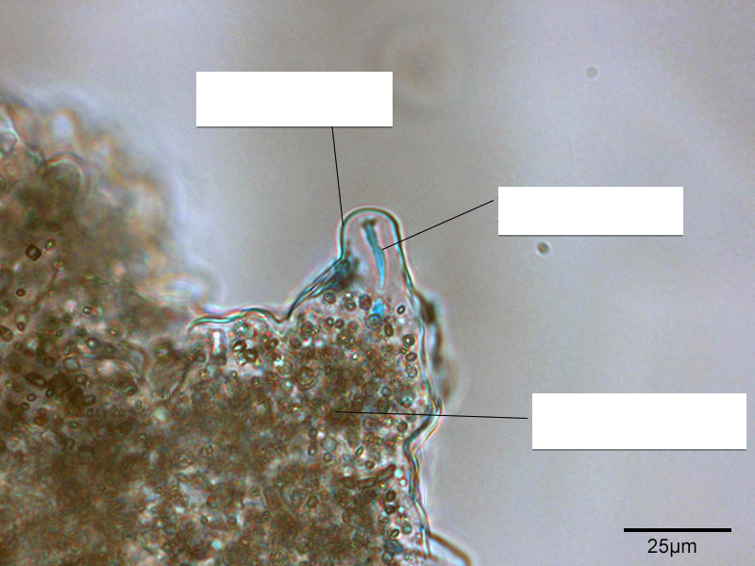
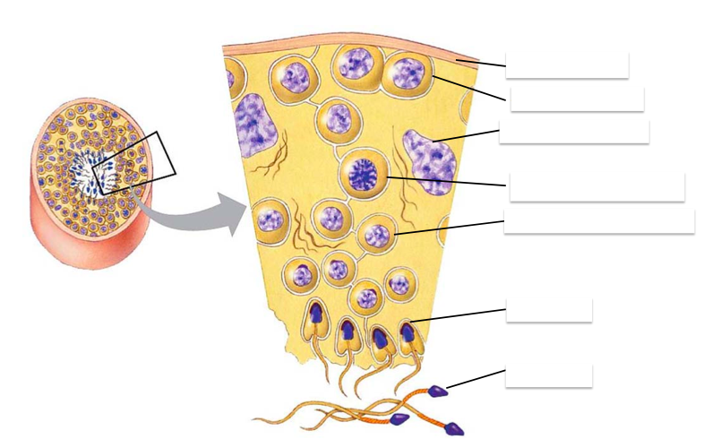
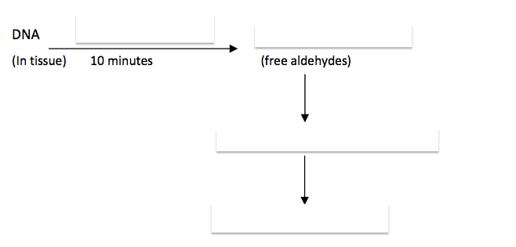
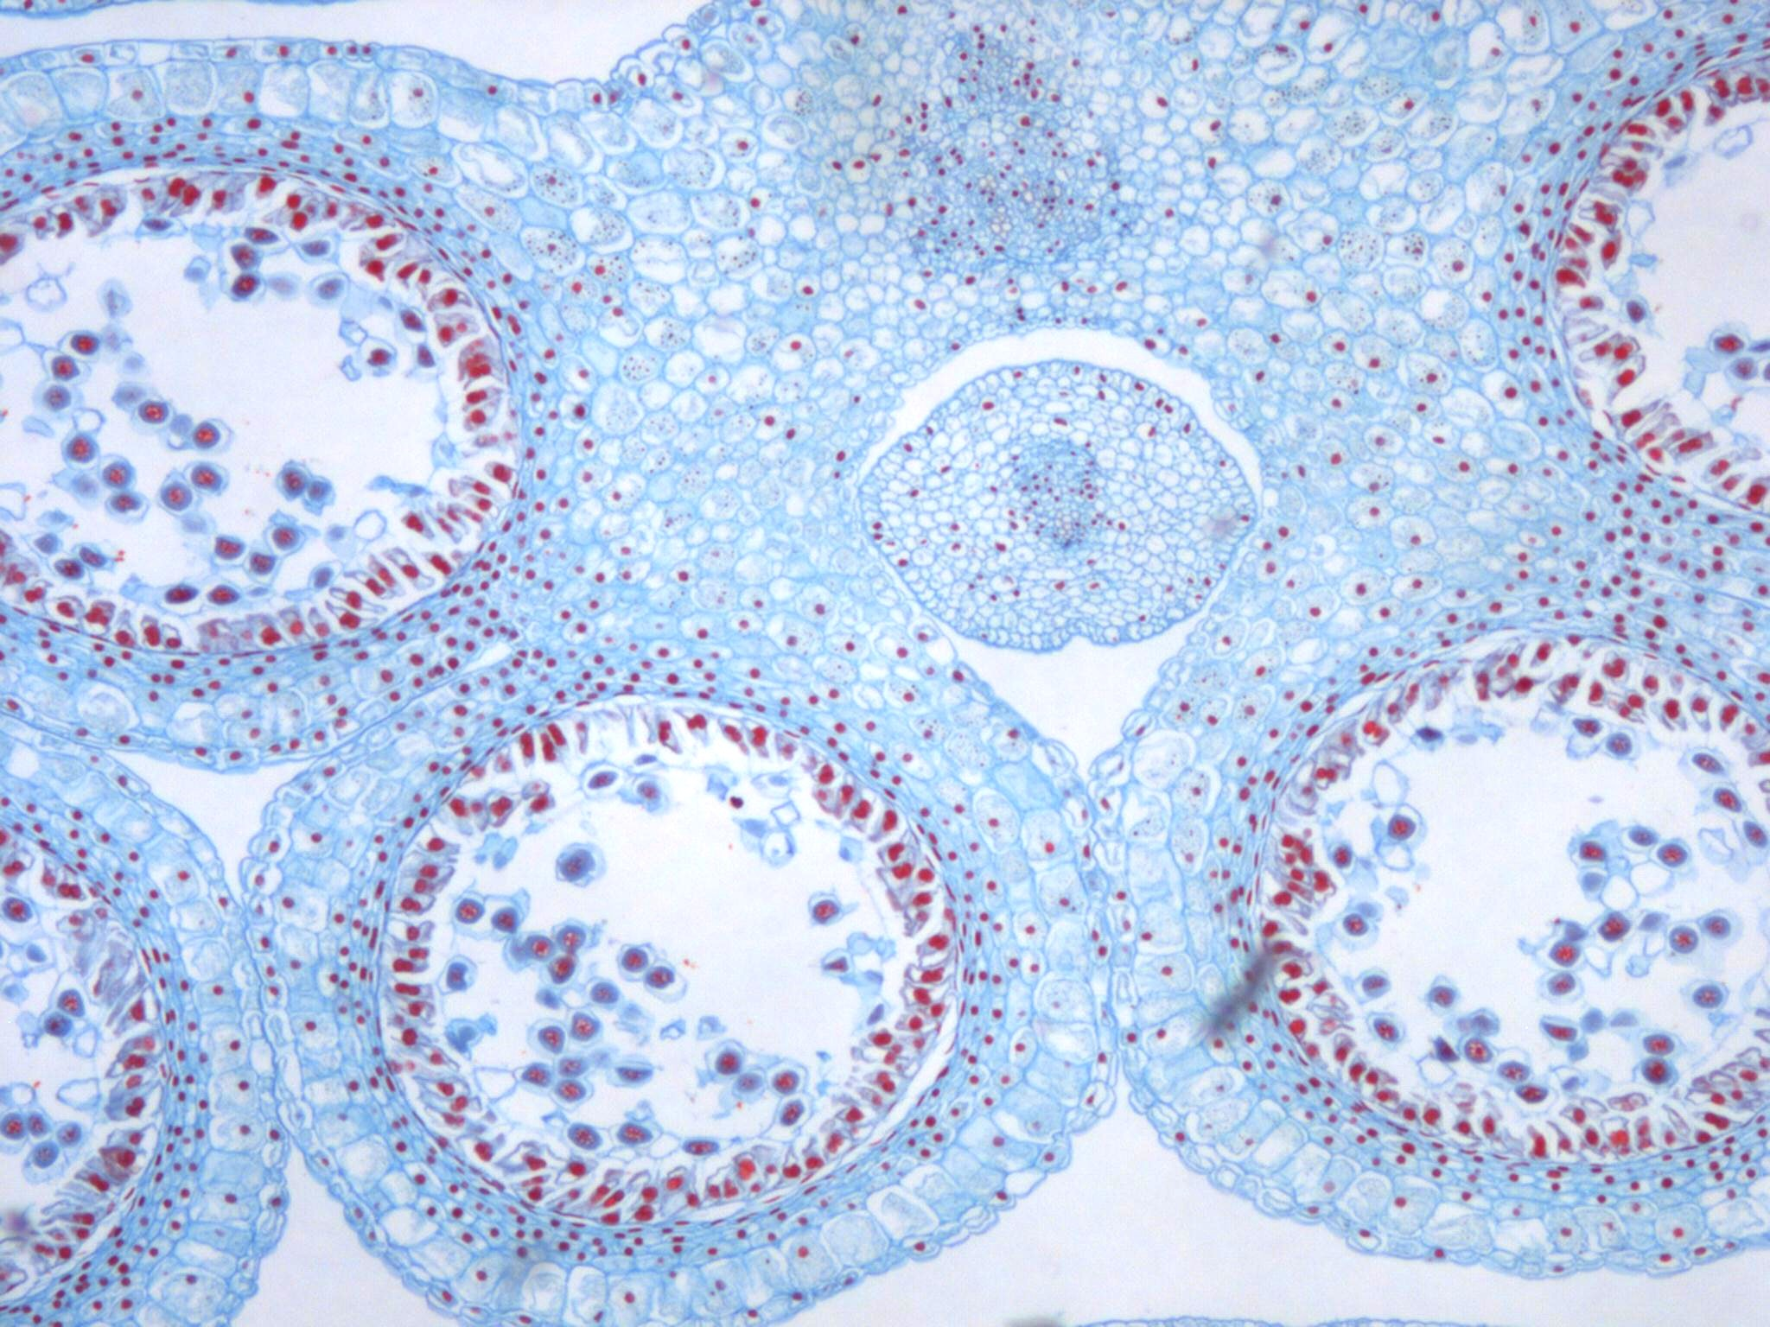
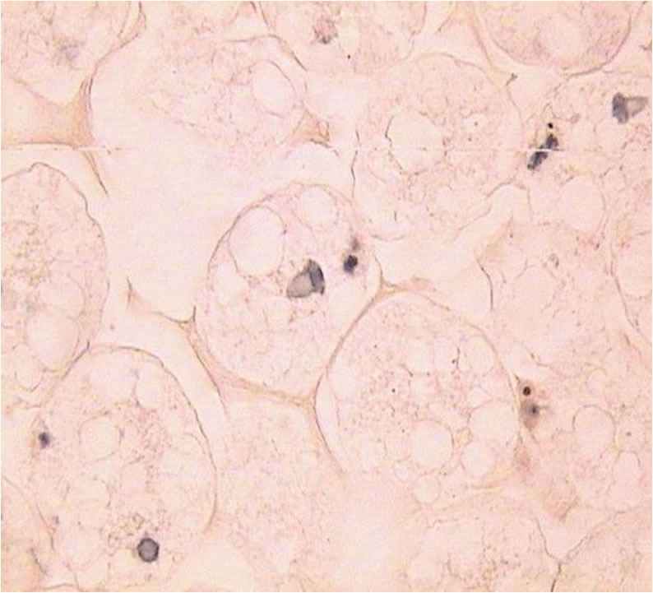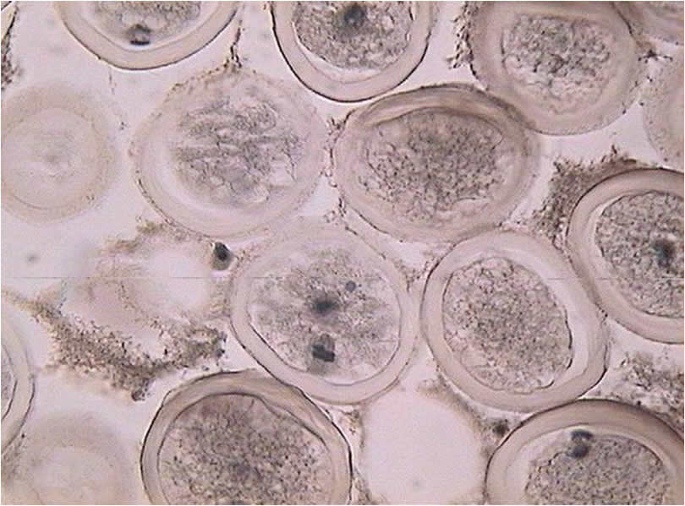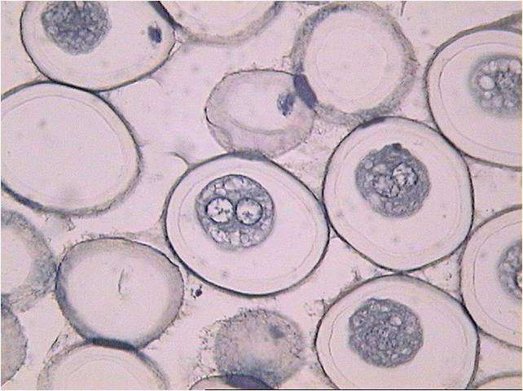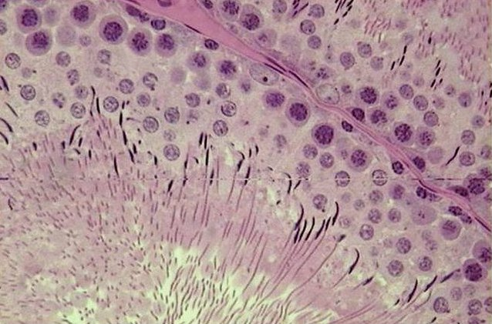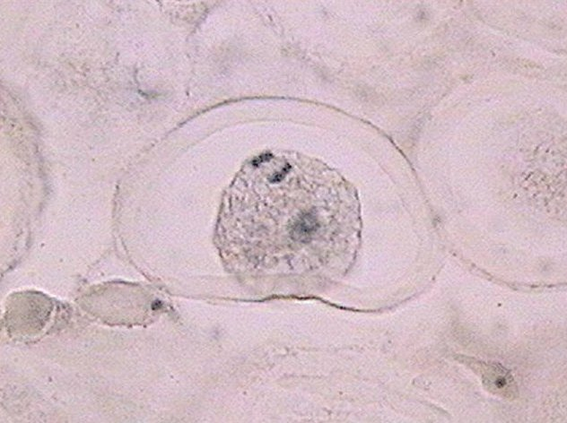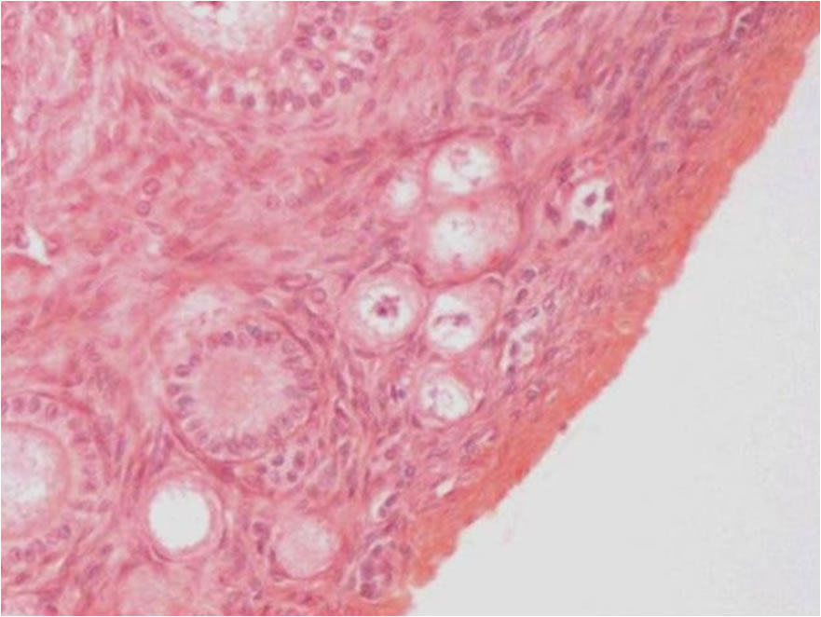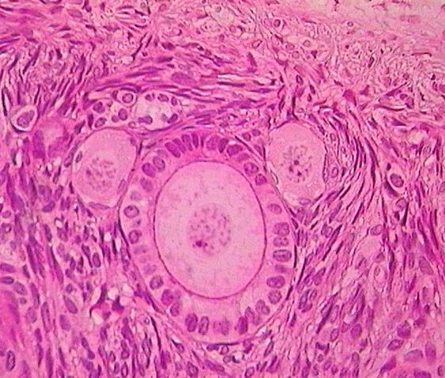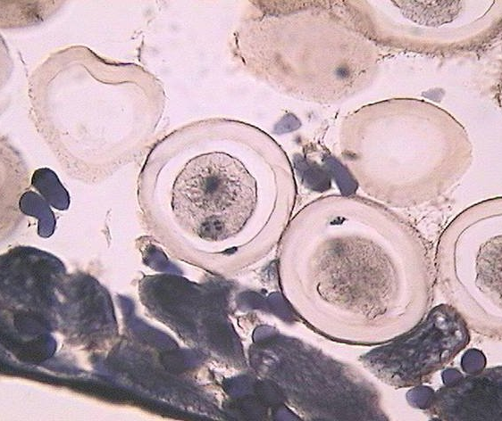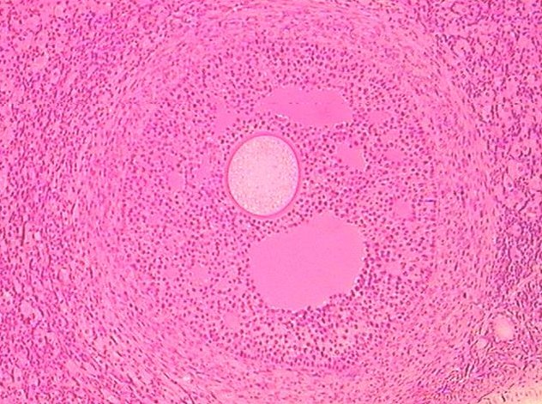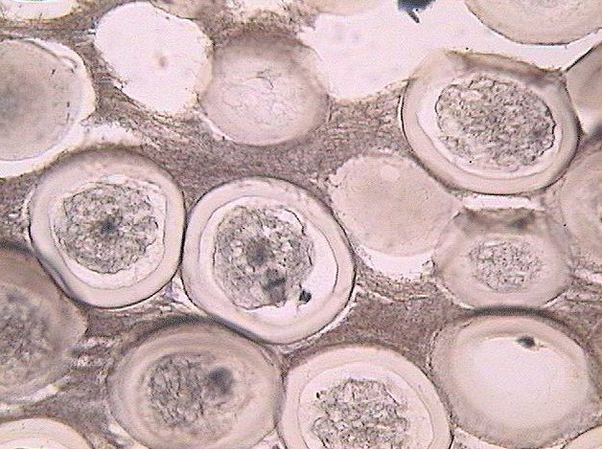

so
fca



