MANA 362: Introduction to Human Resources Management

Chapter 1: The Challenges of Human Resources Management
- What is Human Resources Management (HRM)?
  - An integrated set of processes, programs, and systems in an organization that focus on effective deployment and development of its employees
  - Key HRM activities:
    - Organizational work/work/job design
    - Planning
    - Recruitment & selection
    - Training and development
    - Performance management
    - Rewards and recognition
    - Occupational health and safety
    - Employee relations
  - HRM works to overcome current business challenges
    - Ex. Global economy, evolution of firms, technology quality, sustainability, developing human capital, demographic and employee concerns
- Why Study HRM?
  - Managers need an understanding of HRM practices to effectively manage their employees

- Current Business Issues:
  - Global Economy
    - Impact - trade agreements and global markets
    - Effect on HRM – balancing a complicated set of issues related to different cultures, laws, and business practices
  - Evolution of Firms and Business Sectors
    - Continuing slow economy
    - Consolidation of businesses ( Tim H and Burger king)
    - Increased competition
    - Struggles for tech
    - Downsizing/rightsizing
  - Technology and Quality
    - Technology has allowed companies to improve processes
    - Quality initiatives key to customer retention
  - Sustainability
    - More attention to environmental impact and economic growth
    - Old industries are losing jobs, new businesses are creating new careers
  - Developing Human Capital and Talent Management
    - Individual knowledge and skill have economic value to org’s
    - Managers need to ensure that employees have opportunities to increase their capabilities
    - Core competencies produce sustainable competitive advantage
  - Demographic and Employee Concerns
    - Diverse back grounds
    - Different generations
    - Skills and labour shortage
    - Gender accommodation
    - Rising levels of education
    - Changing nature of job rights, ethics and privacy
    - Changing attitudes toward work including balancing work and family

- Business Strategy and HRM Strategy
  - Corporate Strategies:
    - Answer questions like – What business should we be in?
  - Business Strategies:
    - Focus on how do we do our business better?
      - Being competitive
      - Ensuring people processes provide competitive edge
  - HRM Strategy
    - Identifies and strengthens the key HR people processes and practices that are linked to the overall business strategy.

Chapter 2: The Legal Framework of HRM
The Law’s Impact on Managers
- Laws determine what is expected when managing people
- Laws are written to protect both the employer and the employees
- Treating employees fair is not just a legal requirement but also good business
The Legal Framework I Canada
- 2 Sets of Legislation
  - Federal Government
    - Federal legislation applies to only 10% of the Canadian workforce
    - Federal Employment Laws
      - Canada Labour Code
      - Canadian Human Rights Act
      - PIPEDA (Personal Information Protection and Electronics Document Act)
  - Provincial/Territory Government
    - Provincial Employment Legislation
      - Similar to federal legislation
      - Provides certain rights and guarantees
      - Covers health and safety, human rights, privacy, unionized workplaces
  - Human Rights and Legislation (Federal and Provincial)
    - Discrimination (intentional/non intentional)
      - Race
      - Religion
      - Gender
      - Age ethnicity
    - Bona Fide Occupational Requirement / Qualification (BFOR/BFOQ)
      - Justifiable discrimination
      - Able to set certain qualifications based on essential job requirements that can discriminate
    - Reasonable accommodation
      - Making adjustments to working conditions to prevent discrimination
      - Undue hardship
      - Differences in undue hardship for small and large org’s
    - Harassment
      - Hostile workplace behaviour and actions
      - Concept of the reasonable person
      - Development of policies and procedures to deal with complaints of harassment
Enforcement of Human Rights Legislation
- Complaint driven
- Investigation
- Determination of Reasonable cause
- Resolution/Reconciliation
- Decision
- Acceptance or Appeal
Employment Standards
- Minimum Obligations of Employers
- Covers such rights as:
  - Hours of work
  - Overtime pay
  - Vacation pay
- Administered by the agency of commission
Labour Relations Legislation
- Governs process and procedures between trade unions and employers
- Administered through a labour relations board
Health and Safety Legislation and Workers Compensation
- Governs employer responsibility to provide healthy and safe workplace
- Administered through gov. agency
- Provides monetary payment to injured employees
Employment Equity
- Employment of individuals in a nonbiased manner
- Legislation that focusses on four groups that have been historically at a disadvantage
  - Women
  - Visible minorities
  - Aboriginal people
  - Disabilities
- Systemic Discrimination
    - Hidden employment barriers
    - Result in inequities if individuals are discouraged from certain groups
      - Recruiting only friends
      - Inflated job responsibilities
      - No wheel chair access
Pay Equity
- Federal legislation that applies to federally regulated companies
- Equal pay for work of equal value
- Difficulty determining equal pay for dissimilar jobs
Diversity Management
- Optimizing everyone’s background for business success

Chapter 3: Defining and Designing the Work
Role of Line Manger
- Primary Individual who determines what work is to be performed and in what order
- Takes an active role determining the knowledge, skills, abilities and attitudes (KSA’s)needed to successfully perform the work
Job Analysis
- Process to gather job information
- Is a Cornerstone of HRM
- Identifies duties, tasks, skills, knowledge, attitudes, and abilities to perform at work
- A job description is the written output from job analysis
- The Process of Job Analysis
  - Where you get job information
  - How you obtain job information
  - What job information is collected
  - Where the information goes
  - How information is used
Job Descriptions
- Written document that contains
- Job title
- Summary of job
- Job duties and responsibilities
- Job specifications (KSA’s)
- Performance standards
- Date
Problems with Job Descriptions
- Poorly written, using vague rather than specific terms
- Lack updating
- May violate law by containing specifications not related to the job
- Can limit scope of activities
- May not contain standards of performance
Standards of Performance
- Identifies expected results
- Minimizes misunderstanding
- Establishes foundation for taking corrective action
- Key to progressive discipline and legal dismissal
Job Analysis for Changing Environment
- New job analysis approaches include
  - Future orientation
  - Competency based
  - Living job description
Uses of Job Information from Job Analysis
- Recruitment
- Selection
- Training and Development
- Performance review
- Health and Safety
- Compensation Mngt
Job Characteristics Model
- Skill variety
- Task identity
- Task significance
- Autonomy
- Feedback
Job Enrichment
- Enriching jobs results in increased performance and satisfaction if there is modification to three psychological states
  - Meaningfulness
  - Sense of responsibility
  - Feedback on results
- Employees also need the desire and ability to make this a reality
Line Manager and Job Design
- Line manager needs to understand different forms of employee involvement
- Line manager will be expected to help create opportunities for involvement, as well as support and encourage employee involvement
Employee Empowerment & Engagement
- Pushing down the decision making responsibility to those close to internal and external customers
- Relies upon shared information and power to act
- Must invest in training and development
- Culture of organization must be open and receptive to change and risk
- Shown to increase employee engagement
Employee Teams
- Groups of employees who assume a greater role in the production or service process
- Can be self-managed where they set own work schedules and deal directly with customers
Future Design of Organizational Work
- Non Traditional employment forms such as contract work, telework, e-work
- Use the convergence of social, mobile, and cloud computing technologies
- Dynamic and fluid relationships
- More attention needed in job crafting to ensure organization and context and culture is part of design

Chapter 4: Human Resource Planning, Recruitment, and Selection
Human Recourse Planning
- Ensures people are being used effectively to accomplish organizations goals
- Links to organizations strategic plan
- Important during economic difficulty
  - Right sizing vs recruitment during growth
HR Planning Approaches
- Trend Analysis – quantitative approach
- Management Forecast – based on knowledge/experience
- Staffing Tables – graphic representation of internal jobs
- Markov Analysis – tracks employee movements
- Skills Inventory – HRIS (Human Resource Information System) info on current employees
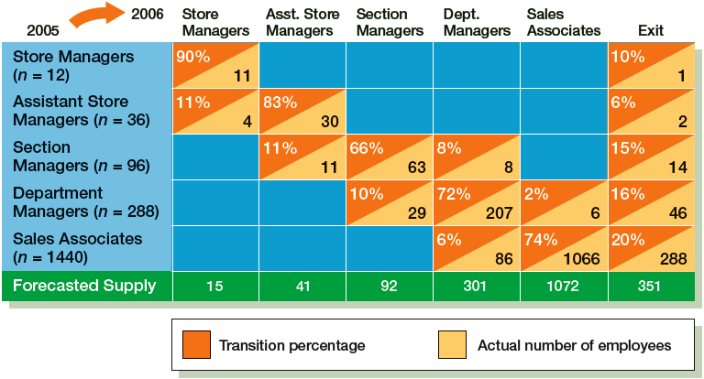

Asdfasd

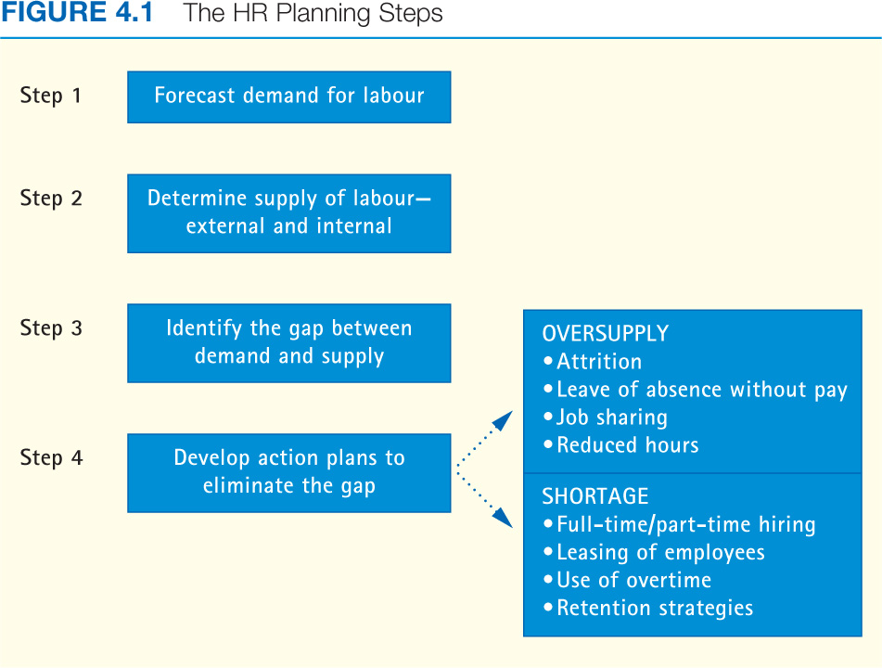
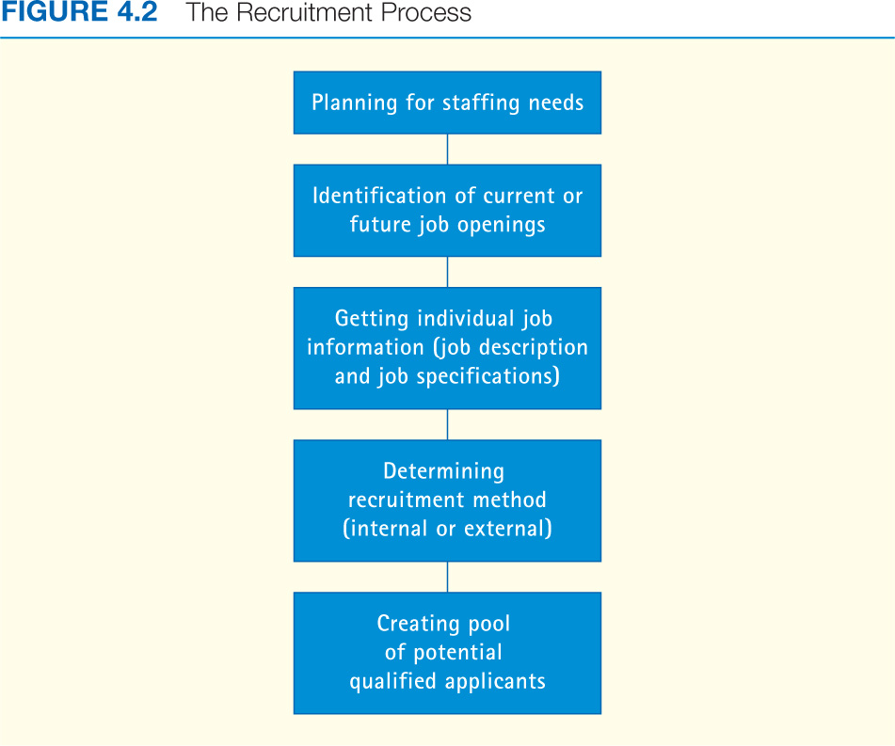
Advantages of Internal Recruitment
- Reward of past performance
- Motivates other employees
- Compatible with values and culture
Ways to Locate Qualified Internal Candidates
- Through the use of HRIS
- Succession planning
- Internal Job posting
Limitations of Internal Recruitment
- Lack of specialized training
- Lack of experience
- Lack of new ideas and perspectives
- Creates internal dissension
Advantages of External Employment
- Person brings different variety of experience
- Person has knowledge or skills that are required now
Disadvantages of External Recruitment
- Person may not know industry
- Lack of attraction due to salary constraints
- Lack of first hand info about job performance
- Might not align with company attitude
- Can cause internal dissension
Recruitment Outside the Organization
- Can include a variety of ways
  - Internet
  - Employee agencies
  - Job fairs
  - Educational institutions
  - Employee referals
Steps in the Selection Process
- Completion of application form or submission or resume
- Initial screening/interviewing by HR
- Employment test
- Supervisory or team interview
- Reference checks
- Hiring decision
Obtaining Reliable and Valid Information
- Reliability – the degree to which selection procedures yield comparable over time
- Validity – how well the selection procedure measures a person’s attributes and abilities to successfully perform the job
Sources of Information about Job Candidates
- Applications/resumes
- Interviews
- Employment test
- Reference checks
Interviewing Methods
- Telephone
- One on one
- Panel or group
- Internet based
Types of Interview Questions
- Structured Questions
  - Behavioural description interview
  - Situational Interview Questions
- Unstructured Questions
  - Open-ended
  - Trying to gain insight into personality / fit with corporate culture
Guidelines for Employment Interviews
- Establish an Interview plan
- Maintain rapport
- Active listener
- Pay attention to non-verbal cues
- Separate facts from inferences
- Control the course of the interview
- Standardize the question asked
Types of Employment Tests
- Cognitivity ability test
- Personality and interest
- Emotional Intelligence EI
- Physical Ability Test
- Job Sample Test
Factors Affecting Selection Decision
- Job Requirements: important o know the qualifications and expectations of the job
- Organizational Culture: is there a fit?
- Organizational Constraints: Policies, Finances, Business conditions
- Hiring for specific job or organization in the long run
Making the Selection Decision
- Summarize the Applicant Information
  - Can do
  - Will do
- Final decision can be made using a variety of techniques
  - Quantitative score
  - Hurdle technique

Session 5: System Model of Training
Training Model Process:
- Training needs and assessment
- Training design
- Training delivery
- Evaluation
Scope and training Development
- Training – perform current work
  - Acquiring skills
  - Behaviours
  - Abilities
- Development – perform future work
  - Acquiring skills
  - Behaviours
  - Abilities
- Learning – an on-going change in behaviour and thinking
Workplace skills and capabilities
- Fundamental skills
  - Read and understand information
  - Write and speak so that others can understand
  - Use relevant skills and knowledge
  - Identify root problem
- Personal Management
  - Be flexible and adaptable
  - Honesty
  - Setting goals
  - Work safely
  - Demonstrate positive attitudes
- Teamwork Skills
  - Understand and contribute organizational or team goals
System Approach to Training
- Conducting a needs assessment

- Designing the program
  - Instructional objectives
  - Trainee readiness and motivation
  - Principles of learning – building bridge between org. and employees
    - Goals achieve an objecive
- Implementation
  - Sample training development methods
    - On the job training
    - Apprenticeship training
    - Internships
    - Classroom training
    - On the job experiences
    - Case studies
- Evaluation
Orientation
- Formal process of familiarizing new employees with the organization, their jobs, their work units and embedding values and beliefs and behaviours
Career Development
- Dynamic process
- Individuals responsible for their own career planning
- Organization responsible for supplying information about mission and support
- Organizational needs linked to individual needs
Favourable Conditions for Career Development
Special Development Needs
- Mentoring
- Specialized career development for diverse workforce
- Consideration for balance of work and personal life

Session 6:
Why a system approach in managing Performance?
- Improves organizations ability to get things done
- Increase employee satisfaction by involving them in teamwork and key decisions affecting their jobs
Strategic importance of performance management
- Alignment of individual goals with organizational goals
- Identify training and development needs
- Assessment of peoples strengths for business growth
Management practices
- Setting clear expectations
- having specific standards of performance
- Provide helpful coaching
- Focussing on accomplishments
- Recognizing and celebrating good performance
- Creating action plans to improve performance
Purposes of Performance Reviews
- Compensation
- Administrative
- Measurement of performance
- Development
Why do performance Management Systems Fail
- Performance management is seen as punishment
- The performance mngt. system is perceived to be managed by HR department
- Performance review is seen as unpleasant
- Continuous feedback and coaching are not given to employee
- forcing out poor performing employees before trying to help them improve
- managers are not trained in the performance management process
- employees don’t know what is expected of them
Steps in an Effective Performance Management System
- clarify work objectives accomplished
- set goals and plan performance
- regular and frequent coaching
- review performance
- recognize and reward performance
Complying with the Law
- Performance standards must be job related
- Employees must be given written copy of performance standards
- Managers be able to observe performance
- Managers and supervisors should be trained in managing performance
- Appeals procedure should be established
Who should provide Perfomance Information?
- Manager/supervisor
- Self
- Subordinate
- Peer
- Team
- Customer
Training Reviewers
- Improve overall performance of management system
- Helps to remove barriers of time constraints and lack of knowledge
- Improve feedback
Performance Review Methods
- Trait Methods
  - Measure the extent to which employees possess certain traits
  - Used to ease developing list of traits
  - Can be biased and subjective
- Behaviour Methods
  - Behavioural checklist method
  - Behaviourally anchored rating scale (BARS)
  - Behaviour observation scales (BOS)
- Results Method
  - Productivity Measures
    - Sales volume
    - Number of units without deficits
  - Management Objectives
    - Philosophy of management
    - Goals established jointly by manager and employee
Conducting Formal Performance Interview
- Ask for a self-assessment
- Invite participation
- Express appreciation
- Minimize criticism
- Change behaviour, not the person
- Focus on solving problems
- Be supportive
- Establishing goals
- Follow up

Session 7: Rewards
What are Rewards?
- Financial
  - Direct (hourly wage, salary, bonuses)
  - Indirect (Benefits)
- Non-Financial
  - Employee Recognition Programs
  - Flexible work hours
  - Programs that provide value to employee in exchange for their efforts
Linking Rewards to Company Objectives
- Structure of reward framework motivates employees and align with business objectives
  - When done successfully performance will increase
- Total Rewards includes career development and work climate/culture
Common Organizational Reward Goals
- Alignment of individual goals with organization
- Identification of training and development needs
- Assessment of peoples strengths for business growth
Management Practices
- Setting clear expectations
- Having specific standards of performance
- Providing supportive and helpful coaching
- Focussing on accomplishments
- Recognizing and celebrating good performance
- Creating action plans to improve performance
Common Organizational Reward Goals
- Pay for performance standard
  - Effort to raise productivity and lower labour costs
  - Relationship of employee effort to reward

- Motivational Factor
  - Quantitative measures of employees relative worth
  - Relates to perceived employee contribution to organize success
Internal Factors Determining Wages
- Employers compensation strategies
- Perceived worth of job
- Employees relative worth
  - Relative to both internal and external competition (market)
- Employers ability to pay
External Factors Determining Wages
- General economy
- Labour market conditions
- Area wage rates
- Cost of living
- Collective bargaining
- Legal requirements
Job Evaluation Systems
- Job ranking system
- Job classification system
- Point system
- Factor comparison
Compensation Structure
- Wage and salary Surveys
- Wage Curve
- Pay grades
- Rate ranges
Other Ways to Determine Wages
- Competency based pay
  - Pay based on how many capabilities employees have or how many jobs they can perform
- Broad banding
  - Looking at the tendencies of an industry
  - Few wide salary bands
Employee Benefits
- Indirect rewards on behalf of employees to improve the quality of their work and personal life
- Can be voluntary or mandatory
Incentive plans
- Individual bonus
- Team or group based incentive
- Merit raises
- Profit sharing
- Employee stock ownership plans
Linking Benefits to Overall Rewards Programs
- Primary objective of benefits are to improve employee satisfaction and maintain a favourable competitive advantage
Benefits Required by the Law
- CPP/CPQ
- Employment Insurance
- Workers compensation insurance
- Provincial hospital and medical services
- Leaves without pay
Voluntary Benefits
- Health and welfare insurance
- Retirement and pension plans
  - Defined contribution plan – company matches employee contribution up to 5%
- Pay for time not worked
- Leaves of absence
- Wellness programs
- Employee Assistance program
- Educational Assistance
- Child and Eldercare

Session 8:
Health and Safety: the Law
- Focus on workplace and working environment
- Regulated through federal and provincial legislation
- Operates on the premise that both employer and employees have a responsibility for a safe and healthy workplace
  - Occupational Injury: any injury resulting from a workplace accident
  - Occupational Illness: any abnormal condition that is the result of exposure to workplace conditions
Duties and Responsibilities of Employers
- Provide a hazard free workplace
- Comply with regulation
- Inform employees
- Keep records
- Compile annual records
- Inform supervisors
Duties and Responsibilities for Employees
- Comply with acts and regulations
- Report hazardous conditions
- Follow safety rules and regulations
Duties and Responsibilities of Supervisors
- Advise employees of potential hazards
- Ensure workers wear safety equipment
- Provide written instructions
- Take every reasonable precaution
D & R Health and Safety Committees
- Create a non-adversarial climate in which labour and management can work together
- May require special training and education of members
Workers and Compensation
- Workers can receive benefits in the form of cash payouts or wage loss payments if absent due to work-related injury or serious illness
- Pays for medical expenses and vocational rehabilitation
Ways to Reduce Workers Compensation Costs
- Perform an audit to assess high risk within a workplace
- Prevent injuries by proper ergonomic design of the job
- Provide quality medical care to employees by experienced physicians
- Manage the care of the injured worker until their return to work
- Provide extensive worker training in all related health and safety areas
Creating a Safe Work Environment
- Promoting safety Awareness
- Safety awareness programs
  - Communication role of supervisor
  - Proactive safety training programs including use of technology
- Enforcement of safety rules
- Accident investigations and records
Creating a Healthy Work Environment
- Health Hazards and Issues
  - WHMIS
  - Indoor air quality
  - Technology
  - Cumulative trauma disorders
  - Communicable disorders
Workplace Violence and Security
- Reducing Workplace Violence
  - Training
  - Risk assessment
- Violence response teams
- Proactive security measures
Stopping Violence in the Workplace
- Establish violence prevention policy and standards
- Control violence hazards through workplace design and workplace practices
- Develop safety plan if any employee reports violence to ensure victim is safe
Stressors in the Workplace
- Any demand on the physical or emotional self that requires a person to cope with that demand
- More legislation is requiring that organizations provide psychologically safe work environments
- Manifestations of mental illness are increasing in the workplace
Building Better Health
- Health services
- Alternative approaches
- Wellness programs
- Disability management
- Employee assistance programs

Session 9: Management Rights
Management Rights
- What does this mean?
  - The rights of the manager
- Why are they Important?
- What are some of these rights?
  - Right to set working hours
  - Right to hire
  - Right to set wages
- Can they be challenged? How?
  - Can be challenged through unions
Employee Rights
- Guarantee fair treatment from employer, particularly employee privacy
- Employers must exercise reasonable care
  - Reasonable care refers to the acts and measures an organization puts in place to look after and protect employee safety, privacy, and health and the procedures that are in place when one of these is threatened
- Employers can be held negligent by outside parties or parties if reasonable care is not exercised
Employment Protection Rights
- Statutory Rights
  - Rights that derive from legislation
- Contractual rights
  - Rights that derive from contracts
- Due process
  - Right to be heard, especially during disciplinary process
  - A process that must be followed
- Employment rights not a guarantee
Jon Expectancy Rights
- Substance abuse and drug testing
- Employee searches and electronic monitoring
- Access to employee files
- Electronic Privacy
- Employee conduct outside the workplace
Tools and Techniques for Monitoring Employees
- Performance
  - Output, use of resources,
  - Communication content: email and web
  - Location
  - Covert
- Behaviours
  - Communication content: email and web
  - Covert: mystery shoppers
  - Psychometric, testing, drug testing, biometrics
- Personal Characteristics
  - Psychometric, testing, drug testing, biometrics
  - Covert
Disciplinary Policies and Procedures
- Effective policies and guidelines to use
- Justifiable reasons
- Key responsibility for discipline rests with employees immediate supervisor
Setting Organizational Rules
- Clearly stated expectation of performance and behaviour is foundation for effective discipline system
- Expectations govern employee behaviour standards
- Important to communicate to everyone in organization
Discipline
- Treatment that punishes
  - Ought to be about modifying behaviour
- Orderly behaviour in an organizational setting
- Training that moulds and strengthens desirable conduct and develop self-control
Common Disciplinary Problems
- Attendance Problems
- Dishonesty and Related Problems
- Work Performance Problems
- On the Job Behaviour Problems
Lack of Discipline
- Failure to act implies that the performance is acceptable
- Delaying discipline makes it more difficult to justify the action if challenged
Disciplinary Model
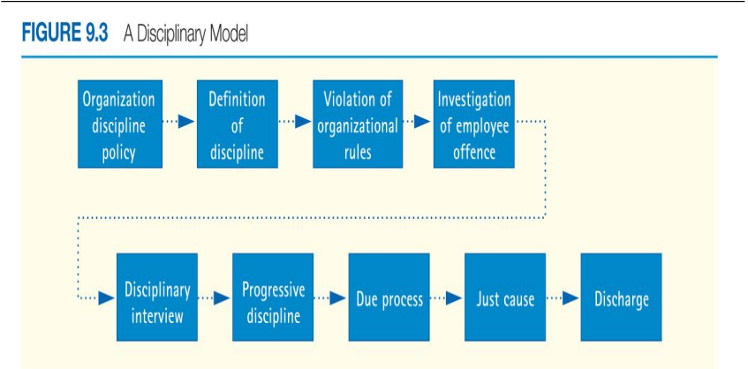
Investigating Disciplinary Problem
- Documentation of Employee Misconduct
  - Accurate and complete information
  - Supervisor needs to record incident immediately after infraction took place
- Investigative Interview
  - Need to check supervisors view with employee’s view
  - Concentrate on how situation violated performance standards
Effective Disciplinary Investigation
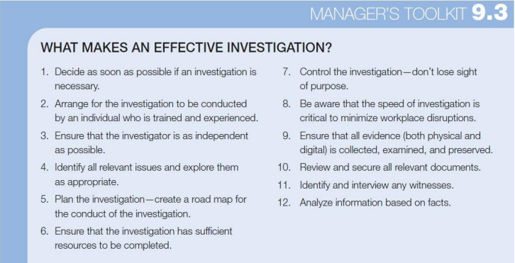
Types of Disciplinary Approaches
- Progressive discipline: increasing corrective measures
  - The means of which the result is achieved
- Positive Discipline: Joint responsibility; educate and involve -> result is the changed behaviour or termination
  - First conference – oral reminder
  - Second conference – written reminder
  - Decision making Leave – obtain employees commitment to meet standards or terminate
Compiling Disciplinary Record
- Complete written record
- Retained in employees official employment file
- Can assist employer in identifying work expectation that are counter-productive to organizational success
Grounds for Dismissal
- Wrongful
  - Terminating an employees employment without just cause
- Constructive
  - Changing an employees working conditions such that compensation, status, or prestige are reduced
- Examples of Just Cause
  - Excessive lateness or Absenteeism
  - Theft from the company
  - Improper or wrong conduct, such as fighting with a co worker
Dismissing Employees
- Undertake after thorough and thoughtful review of facts
- Behave in a fair manner
- Personally inform the employee
- Provide appropriate assistance and follow thorough
Appealing Disciplinary Actions
- Mediation
- Step review
- Hearing officer
- Ombudsperson
- Arbitration
Organizational Ethics in Employee Relations
- Set Standards of acceptable conduct and moral judgement
- Cultural guidelines that help us decide between right and wrong

Session 10: Labour Relations
Laws Governing Labour Relations
- Laws seek to create an environment in which both unions and employers can exercise respective rights
- Laws reflect government policy- federal or provincial
Administration of Legislation
- Canada Industrial Relations Board administers and enforces Canada Labour Code
- Each province has its own labour relations board
- Quebec has a labour court and commission
Duties of Labour Relations Boards
- Develop administrative regulations that describe how people unionize
- Hear complaints to unfair labour practices
  - Employer – can submit complaint if union is intimidating employees to join the union
  - Union – can submit complaint if Employer is intimidating employees not to join the union
- Determine if bargaining is done in good faith
- Remedy violations of legislation
Why Employees Unionize
- Requirement of collective agreement
  - Union shop
  - Closed shop
  - Open shop
- Economic needs
  - Provides economic security
- Dissatisfaction with management
- Social and status concerns
How Employees Unionize
- Employee/Union contact
  - Initial word of mouth among employees
- Initial meeting
- Formation of in house committee
- Application to labour relations board
- Issuance of certificate by labour relations board
- Election of committees and commencement of negotiations
Employer Obligations and Tactics
- Cannot interfere with certification process
- prohibited from dismissing, disciplining, or threatening employees for exercising their rights to form unions
- cannot promise better conditions
- cannot change conditions
- must bargain in good faith
Union Obligations and Tactics
- Cannot Interfere with operation of the employer
- Cannot coerce or intimidate
- Must provide fair representation to all members of bargaining unit
- Cannot engage in illegal activities
Unfair Labour Practices
- Specific employer and union illegal practices that operate to deny employees their rights and benefits under labour law
Certification Procedures
- Voluntary recognition
- Regular certification
- Prehearing votes
- Contract negotiations
  - Union tells management what their problems are and how they want it o be fixed
  - Management takes problems and comes back with a offer which is continually egotiated until both parties are happy
- Decertification
Impact of Unionization on Managers
- Greater involvement in management decisions
- Restrictions to behaviours and actions
- Formalized challenges to decisions
How Unions Operate
- Craft unions
  - Unions related to craft work (metal workers, wood workers etc)
- Industrial unions
- Employee associations
- International Unions
- National unions
- Local unions
  - Role of Shop Steward
    - Employee of the organization
    - Non paid union official
    - Represents the interests of union members in their relations with management
  - Role of business agent
    - A paid union official responsible for negotiating and administering the collective agreement and working to resolve union problems
Labour Relations in Public Sector
- Special legislation
- Political nature of labour management relationship
- Effect of strikes
- Alternative services
- Management authority
The Collective Bargaining Process
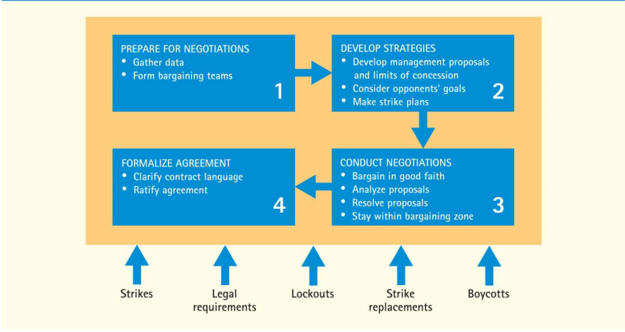
Preparing for Negotiations
- Gathering bargaining data
  - Wage/benefit comparisons
  - Review of grievance
- Bargaining patterns: what has the union negotiated elsewhere
  - Pattern that is established across an industry (Car manufacturers)
- Bargaining Strategies (KEY!)
  - What are your objectives
  - What are the unions objectives
  - Are you prepared to take a strike or lockout
  - What is the nature of the union-management relationship
- Forms of collective bargaining
  - Interest based
Conducting Negotiations
- Bargaining teams
- Analyzing the proposals
- Resolving the proposals
- Style of negotiators
Power in Collective Bargaining
- Union
  - Striking the employer
  - Picketing the employer
  - Boycotting the employer
- Employer
  - Operating during strike
  - Locking out employees
Collective Agreement
- Is the conclusion of negotiations
- A legal, binding, written document
- A living document
  - Examples of Collective Agreement Provisions
    - Wages and benefits
    - Health and safety
    - Hours of work and overtime
    - Seniority
    - Discipline
    - Union checkoff dues
    - Grievance procedures
      - Complaint by employee/employer that some aspect of collective agreement has been violated
      - Grievance procedure:
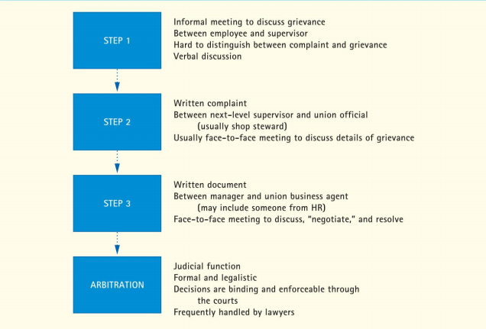
Rights of Arbitration
- Functions both to provide solution to grievance if parties unable to resolve
- Performed by neutral third party
- Both parties obligated to abide by decision
Arbitration Process
- Provides full and fair hearing
- Union and employer are permitted to introduce evidence
- Witness sworn in
- Burden of proof usually rests union
- Arbitrator must decide
Arbitration Award
- Cornerstone decision is the collective agreement
  - Also use testimony and evidence
  - Arbitral standards
- Award is enforceable in civil courts
- 70% of arbitration cases are discipline cases

