Experiment 6: Regioselective Nitration of Aetanilide
April 6, 2016

Observations and Results:

Procedure:

- Add 1.03 g of acetanilide, light brown coloured flakes into a clean 25 mL round bottom flask along with a stir bar and clamped it over a magnetic stir plate.
- Add 5 mL of sulfuric acid into the round bottom flask for one or two minutes to dissolve the acetanilide.
- The solution was cooled using an ice bath. Cooling was completed by stirring for 5 to 10 minutes.
- In a new 50 mL Erlenmeyer flask, combined 0.9 mL of concentrated nitric acid that was transparent, colourless, and clear, and 1.2 mL of concentrated sulfuric acid, which was transparent yellow, clear, and colourless. Slowly added this combined mixture to the round bottom flask.
- A TLC was taken after 10 minutes using EtOAc:hexanes 5:5 to see that the reaction went to completion. The reaction went to completion if the spots were not aligned on the reference and sample lane.

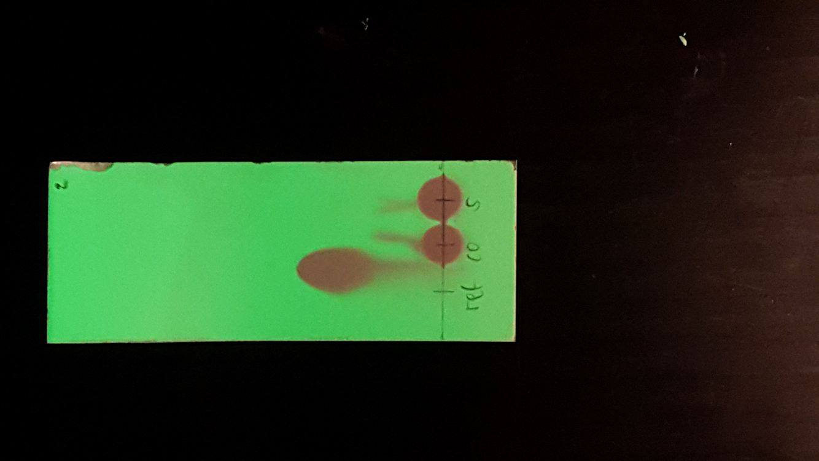

- 3-4 ice small ice cubes were placed into a 125 mL Erlenmeyer flask along with around 20 mL of water. The contents of the reaction flask were transferred into this one along with a stir bar, rinsing with small amount of water. Contents of the flask were stirred until all the ice melted. The mixture was brownish yellow, hay coloured before ice was added. After the ice was added, the mixture turned cream white with film at the top, foamy, and frothy.
- The solid that formed was collected by suction filtration with cold water.
- TLC plates were comparing the crude product to ortho, meta, para, and 2, 4-dinitro product isomers. The beige coloured crude product was dissolved in acetone and spotted on the sample lane. The solvent system was again EtOAc:hexanes 5:5.

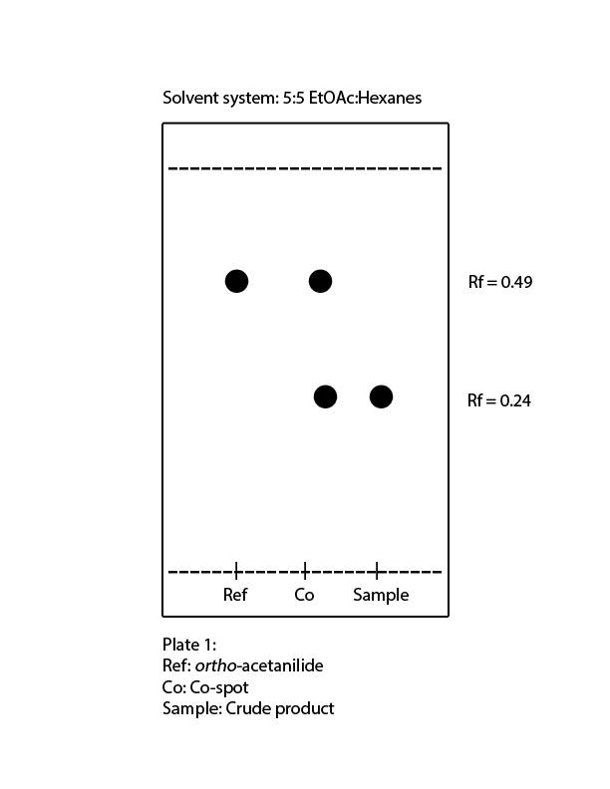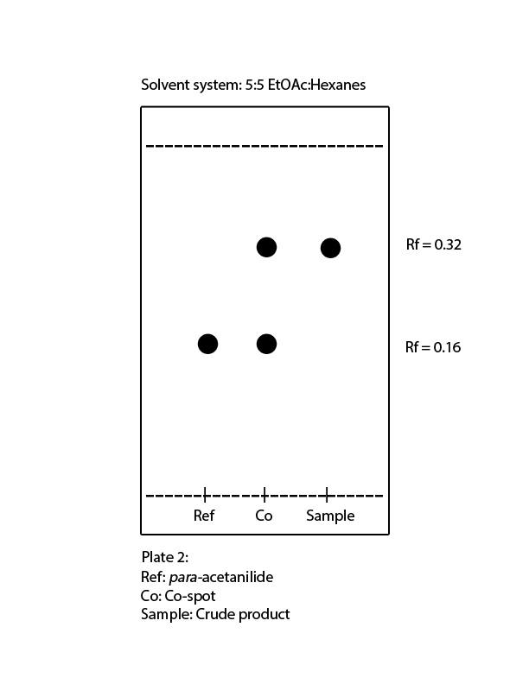

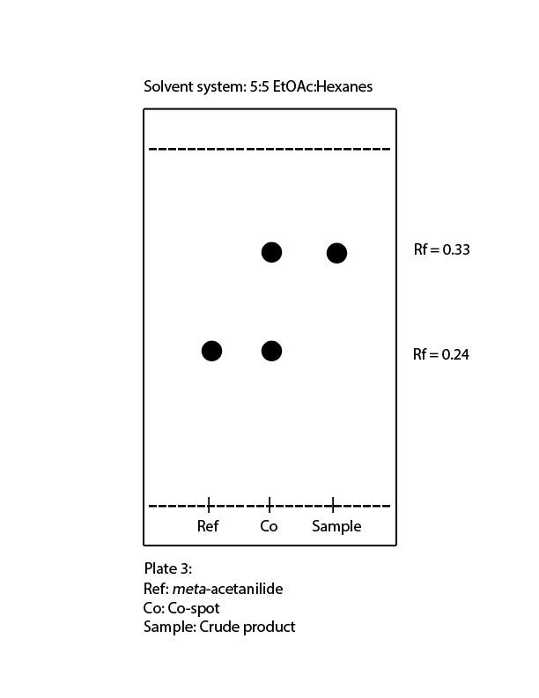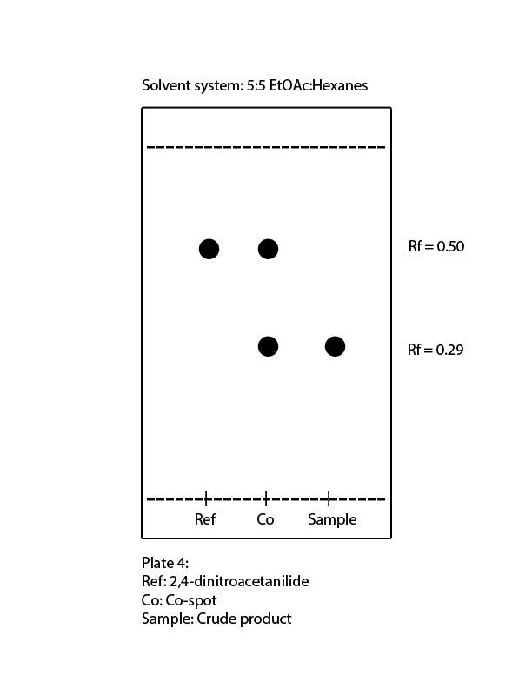

- Dissolve the remaining crude product in 15- 20 mL of boiling ethanol in a 50 mL Erlenmeyer flask with a stir bar.
- When dissolved, the solution was allowed to cool to room temperature undisturbed until crystals formed.
- Once crystallized, the product was isolated using suction filtration again. TLC plate of the crude product vs purified product and another plate comparing the purified product to the mother liquor was made and visualized under UV light. The pure product was orange, clear, and transparent. The mother liquor was greasy in consistency, with light gold splotches.

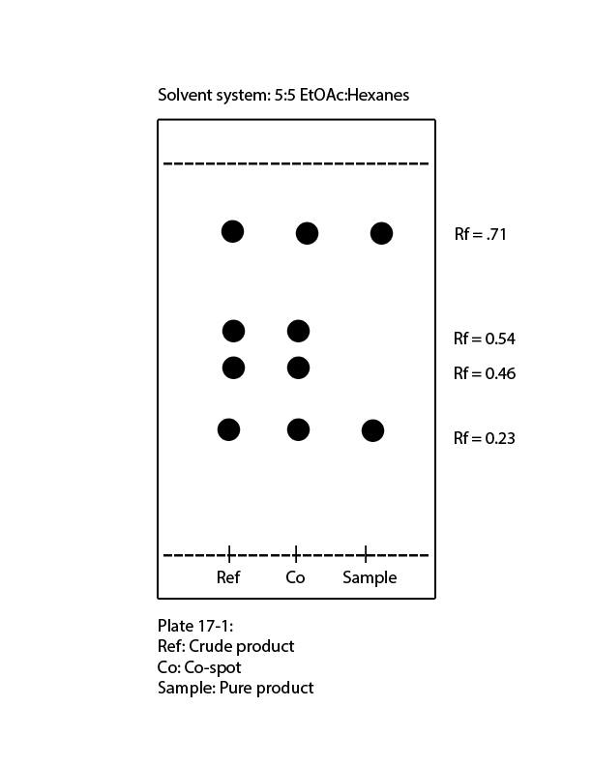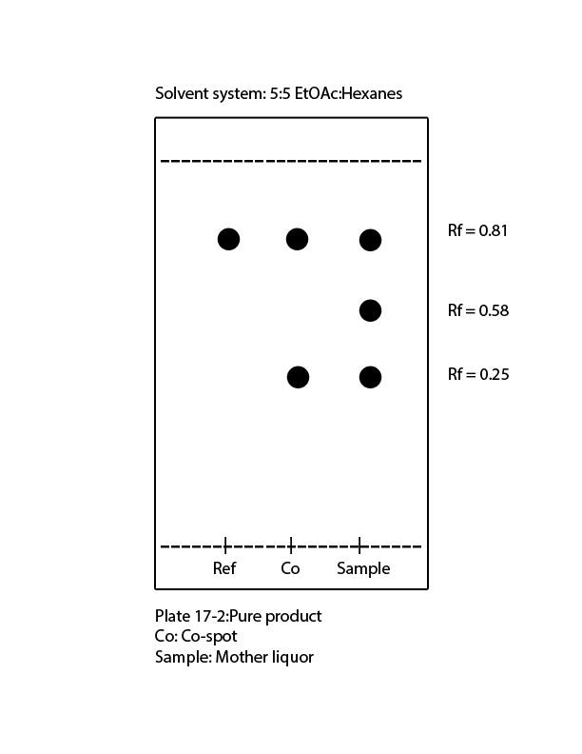

Table of Reagents
Compound | Molecular Weight (g/mol) | Amount | Density (g/cm³) | mmol
Acetanilide  Sulfuric Acid  Nitric Acid | 135.16  98.08  63.01 | 1.03 g  6.2 mL  0.9 mL | 1.13  1.84  1.51 | 7.6  63.2  14.3

Data:

Table 1: Isolated Pruducts
Mass of Crude Product (g) | 0.9703
Mass of Pure Product (g) | 0.98

Calculations:

Reaction: Ph – NHAc _{(aq)} + HNO3_{(aq)+}H₂SO_{4(aq)} —> NO₂-Ph – NHAc _{(aq)+}H₂SO_{4(aq)}

- Actual Yield = mole of NO₂-Ph – NHAc = mass of pure product / molar mass
= 0.98 g / 180.2g/mol
=5.44 X 10 ⁻³ mol

Theoretical Yield = mole of acetanilide = mole of NO₂-Ph – NHAc
=7.62 X 10 ⁻³ mol

Percent yield = actual/theoretical x 100%
= (5.44 X 10 ⁻³ mol / 7.62 X 10 ⁻³ mol) x 100%
= 71.39%

Reaction Mechanism:

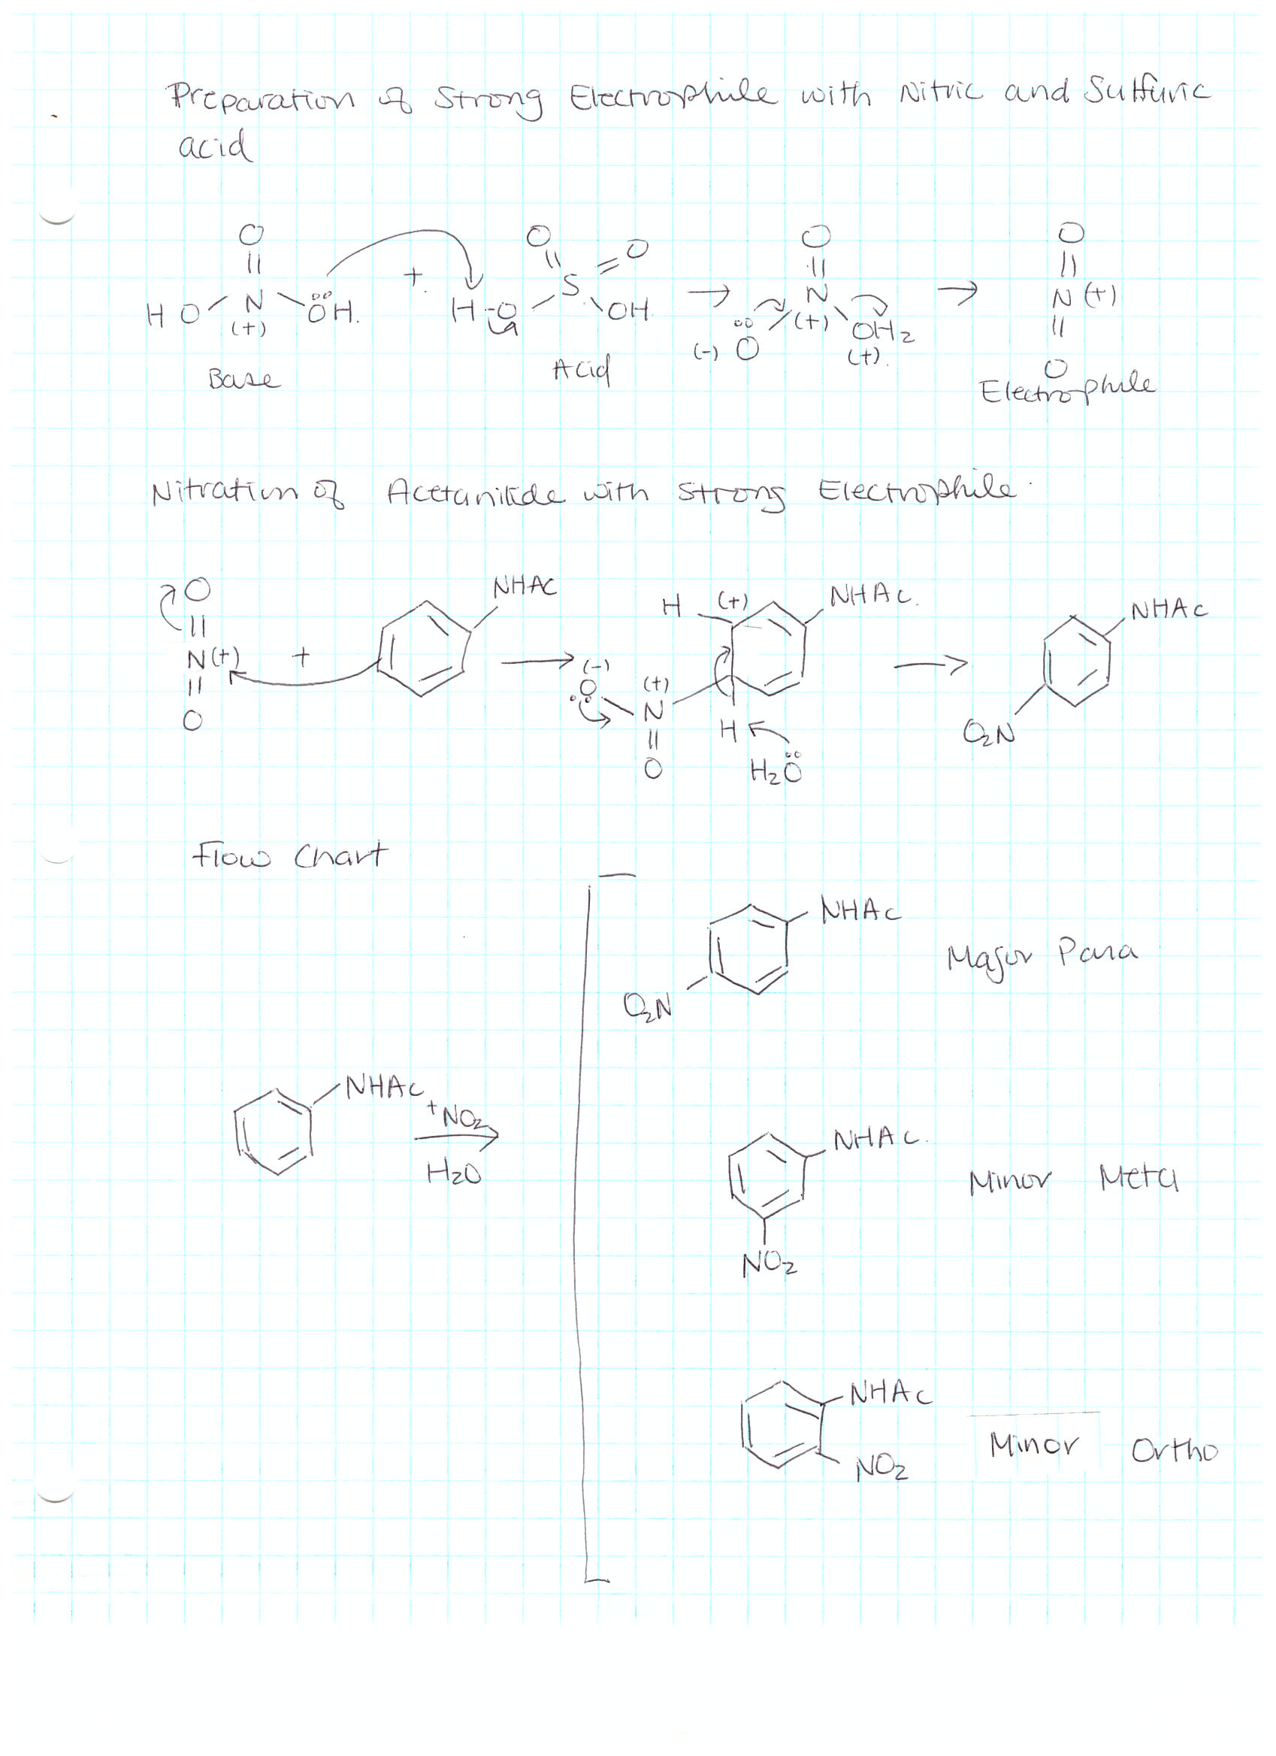
Discussion:

There were definitely sources of error as when trying to recrystallize, and obtain the pure product, none formed. This could be due to human errors as mixing up nitric and sulfuric acid, not measuring the correct amount, or not cooling the solution long enough. Compared to the other groups, the solution was light beige instead of bright orange. Thus, the mass of the pure product was obtained from the neighboring students.

The TLC plates compared with para, meta, ortho, and dinitro isomers were not accurate. According to the plates, the crude product did not contain any of the isomers, which is not possible unless the reaction did not go to completion. In hypothesis, para isomers are suppose to be the major products due to the sterics.

Questions:

- According to the TLC plates, between the para and ortho isomers of nitroacetanilide, the para isomers are more polar with a smaller Rf value. This is explained because the dipoles on the para add up. Therefore, the added dipoles interact more with the silica gel thus preventing it from moving up too much. With ortho isomers the dipoles cancels out.

- Second nitration is slower because the electron donating and electron withdrawing group cancels out. Nucleophilicity decreases, thus, the reaction rate a lot slower. The activation energy comes down to benzene level.

- Para isomers are favoured over ortho isomers because of sterics. Para isomers experience less steric hindrance due to the positions of the substituents. Less steric hindrance means more stability.

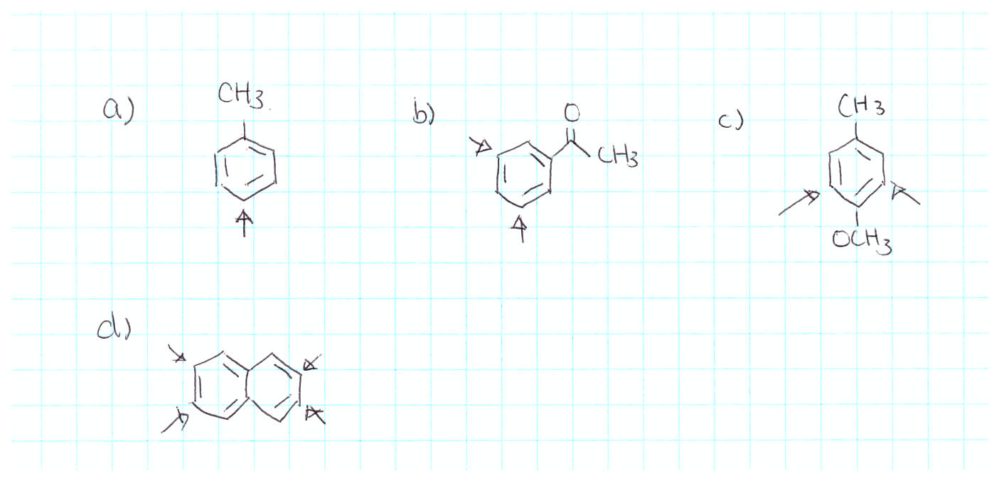

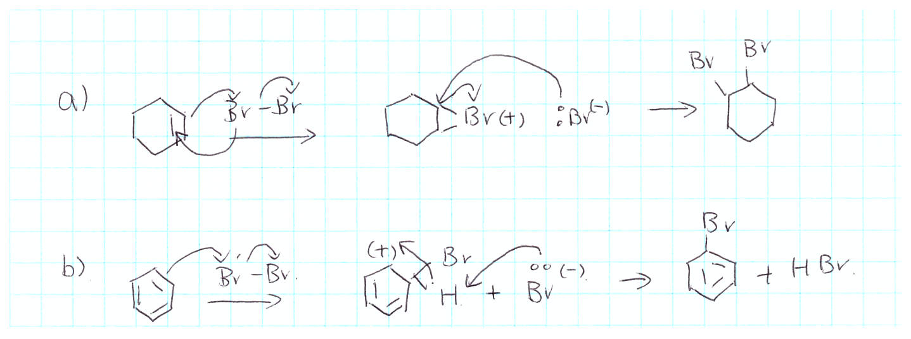

- A) mole of benzene = 780g / 78g/mol = 10 mol
mole of nitric acid = 0.750L x 16mol/L = 12 mol
mole of sulfuric acid = 0.750L x 18mol/L = 13.5 mol

Thus limiting reagent is benzene since the ratios are one to one

B) Theoretical yield of nitrobenzene = mole of benzene x molar mass of nitrobenzene = 10 mol x 123g/mol = 1230 grams
Actual yield = 1000 g

Percent yield = actual/theoretical x 100%

= (1000g / 1230g) x 100%

= 81.30%

C) Sulfuric acid is probably the most probable side product with the high boiling point since it has a boiling point of 337 degrees Celsius.

D) Sulfuric acid in this reaction acts as a catalyst in order to form a positively charged nitronium ion. Reaction mechanism below.

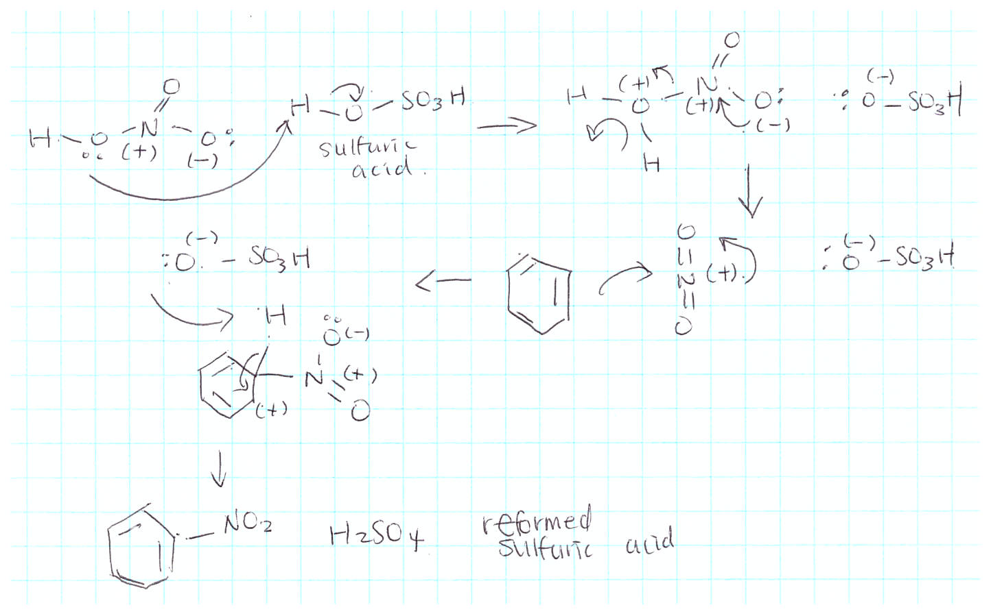

E)
C₆H₆ NO₂⁺ -> C₆H₅NO₂ C₆H₄N₂O₄
Mass (g) | 780 | 310.57 |  | 830.25 | 1134.74
M (g/mol) | 78 | 46.01 |  | 123 | 168.11
N (mol) | 10 | 6.75 |  | 6.75 | 6.75

According to the above table, the limiting reagent is NO₂⁺

Percent yield = actual/theoretical x 100%

= (250g / 1134.73g) x 100%

= 22.03%

- Nitration of furan leads preferably to 1-nitrofuran rather than 2-nitrofuran isomer because of the ability of the molecule to better stabilize its charges when nitronium attacks. Stability is achievable due to the induced dipoles present on the molecule.



