Biology 201
Class 1 - Sep 8th , 2015
Notes:

Office hours.
Wednesday 12:00-13:00
Thursday 10:15-11:15

Midterm – Multiple Choice + Short Answer (15%)
Lab Exam (20%)
Quiz at the beginning of each lab (10%)
Reports (20%)
Final Exam - Multiple Choice + Short Answer (35%)

Get a lab coat.

Lecture notes.

Biology is based on a lot of chemistry.
Element: can’t be broken down to other substances (Oxygen).
Atom: Smallest unit of an element that retains all of the elements properties.
Atoms contain Electrons -1, Protons +1 and Neutrons.
Number of protons in a atom determines the element.
Isotopes: Atoms with the same number of protons (the same element), but different numbers of neutrons.
An electron shell is the orbit around the nucleus where the atoms spin each. Each shell has a limit space of electrons
Valence Shell: the outermost shell that contains one or more electrons.
Atoms with full valence shells tend not react with other elements.
Covalent bond a chemical bond in which two atoms share one pair of valence electrons. Which creates a Molecule, which contains two or more atoms held together by chemical bonding.

A compound is a molecule with two or more elements. The properties of a compound are not simply the combination of the properties of its elements it has emergent properties (new properties). Some molecules have an uneven distribution of electrical charge because some of the atoms have a stronger charge this is called a polar molecule (like water).

Ion is a atom or a molecule with a net electrical charge. Which can create a chemical bond is which is a result of the attraction between oppositely charged ion better known as an Ionic Bond.

Chemical Reactions is the making and breaking of chemical bonds.
2H2+O2-- 2H2O+ Energy
You have to put energy in to the reaction to make it happen and have the atoms rearrange themselves.

Enzymes makes a chemical reaction take place more easily it’s a catalyst. The enzyme is not change by the reaction. In general the enzymes are fairly specific. The enzyme does not affect the energy. Because in the atom world molecules bounce around the enzymes don’t need to really move around

Hydrogen bonds are a weak attraction between polar molecules which attend to attract to each other not considered as a chemical bonds because they are much weaker.

Acidity refers to the concentration of hydrogen ions acids and bases tend to neutralize each other.. An acid is a substance that in water increases the concentration of hydrogen ions, on the other hand there are Bases which is a substance that in water increases the concentration of hydroxide ions.

PH measures acidity. The higher the PH the lower the concentration of H+, which is hydrogen ions. (Acids PH<7, PH Neutral PH=7, Bases PH>7)

Molecules always have Kinetic Energy, they are moving. Temperature is just a measure of the average kinetic energy of molecules.

Diffusion is the net movement of a substance from an area of high concentration to an area of low concentration. Osmosis is the diffusion of water across a semi-permeable membrane (basically theirs a barrier that only allows water in and out but doesn’t allow other molecules)

Covered chapter 2
Covered chapter 3

Class 2
Sep 10th 2015

There are a few classes of Macromolecules that are important for biology
Lipids: Oil, Far, Wax they are none polar molecules they don’t mix well with water so they are hydrophobic. Lipids are relatively high in chemical energy.
Carbohydrates: Sugar Starch, Cellulose they are also high in chemical energy unlike lipids their molecules are polar. The simplest carbohydrates are called Monosaccharide each molecule has single sugar unit. Like Glucose. We can take two Monos and form them together to form a Disaccharide. Polysaccharide are Carbohydrates with more than two monos this is a Polymer of glucose (polymer is a molecule made of many of the same small molecule)
Nucleic acids: DNA, RNA (long chains of nucleotides) they in making your genes and the expression of you genes. Nucleic acids are a polymer of nucleotides.
Proteins: Enzymes, Hormones, structure etc… (Very important molecule) Proteins are polymers of amino acids. Some parts of the protein may be polar, other parts maybe none polar (there are 20 kinds of amino acids).

The primary structure is the sequence of amino acids that make it up (each protein is defined by his primary structure).

Secondary structure is repeated coils and folds

Tertiary structure is an irregular folding.

All three structures are required to make a protein. This basically creates the shape of the protein.

In some cases two or more chains aggregate to form a functional unit so basically its another structure called the quaternary structure.

These are all different levels of structures with in the protein.

Biology is the scientific study of life.
What is Life: chemical process, growth, reproduce, the exchange of materials, respond to their environment.

Life is an emergent property of a particular arrangement of certain molecules.

There are some things that have parts of these
Crystals, Viruses, Cells

Cells:
Prokaryotic cells: no true nucleus like bacteria ( Average size 1-10 UM - Microns)
Eukaryotic Cells: have a true nucleus almost everything other than bacteria (Average size 10-100 UM – Microns)
One or more cells compound some creatures
Unicellular: each cell carries out all life process
Multicellular: Made up of many cells with different cell specialized to perform different functions.

The ratio of Surface to Volume determines the more volume they have the more exchange the have to do but the surface area determines how much of exchange will happen.

Cells are small because they require a high surface to volume ratio to exchange martials with the environment.

Structure of a prokaryotic cell
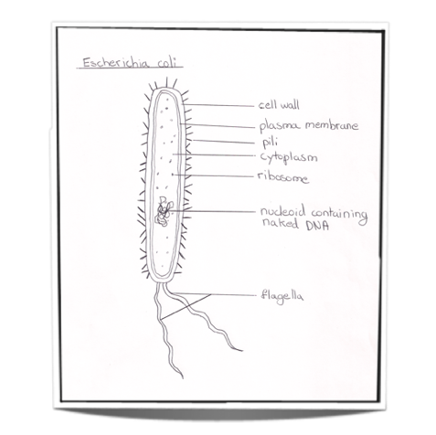

Cytosol is a fluid that fills up must of the cell is a mixture of enzymes and many other molecules in water. – many chemical reactions take place here

The cell is surrounded by the plasma membrane, which is a boundary between the cell and its environment it controls the exchange with the environment. The main part of the membrane is call a phospholipid which has a polar head and none polar tails.

The none polar tails tend to pull together its basically created by a phospholipid bilayer the none polar layer in the middle makes it relatively impermeable to polar to molecules.

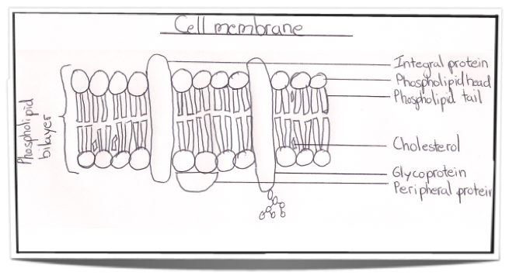

None polar molecules diffuse through the membrane very freely.

Small polar molecules like H2O and Ethanol can diffuse through much more slowly.

Larger polar molecules like glucose and ion barely diffuse through. So basically the bi layer is a semi permeable membrane.

There are proteins that are imbed in the bilayer usually the edges of these proteins are polar the protein is constantly shifting in the place membrane.

Certain proteins are channel proteins, which provide an opening through the membrane the channels are very specific on what can pass through. Each channel protein is specific for certain molecules. Some of the channel proteins are called Aquaporin’s, which allow water molecules to pass through.

The simples channel proteins are constantly opens and there are gated channel proteins, which can open and close

Carrier proteins are embed in the membrane and is mean to catch certain molecules and shift around to insert them in to the cell

All the guys have to work according to diffusion

Active transport proteins are also embedded in the membrane and it requires ADP which is energy (created only in the cell) to do it and it can do it regardless to the levels of concentrations.

Class 3:

Scattered around the cytosol are the ribosomes, which are the site of protein synthesis which create proteins or enzymes

In the middle of the Prokaryotic cell is nucleoid. It doesn’t have a membrane around is and it contains the majority of the genetic information its made of a single loop of double-stranded DNA.

Bacterial Cell specifically which pretty much prokaryotic cell

These are optional for each prokaryotic cell

Outside the plasma membrane is a thick cell wall. It’s a part f the cell. This part is rigid, giving the cell shapes and protects it from bursting.

A few of types of the bacterial cells have a flagellum (sort of a tail) its there to rotate in order to improve the cells mobility in liquids.

Some bacteria have Membrane sacks inside the sell in cytosol is they are called thylakoids and they provide membrane for the photosynthesis. Some bacteria do photosynthesis.

Capsule is a thick layer of slimy stuff that protects the cell from attacks and dehydration.

Some cells have plasmids floating around the cytosol, which is a small string of DNA, which carry’s accessory genetic information

Eukaryotic cells are more complicated and each ones are different (like a human cell or an animal cell)

Like a prokaryotic cell they have a cytosol, it has a plasma membrane, there are ribosomes.

Some times they have a flagellum in a eukaryotic cell it moves like a whip in a prokaryotic cell its more like a proppeler, some cells are surrounded by cilium which are like a million flagellum that are coordinated beating together to provide mobility.

Differences:

In the center of the Prokaryotic there theirs an area full of Chromatin, which has most of the genetic information, found in the cell it is made from several diffused chromosomes basically its not one single chromosome there mixed and each chromosome is one double-stranded DNA molecule with associated proteins.

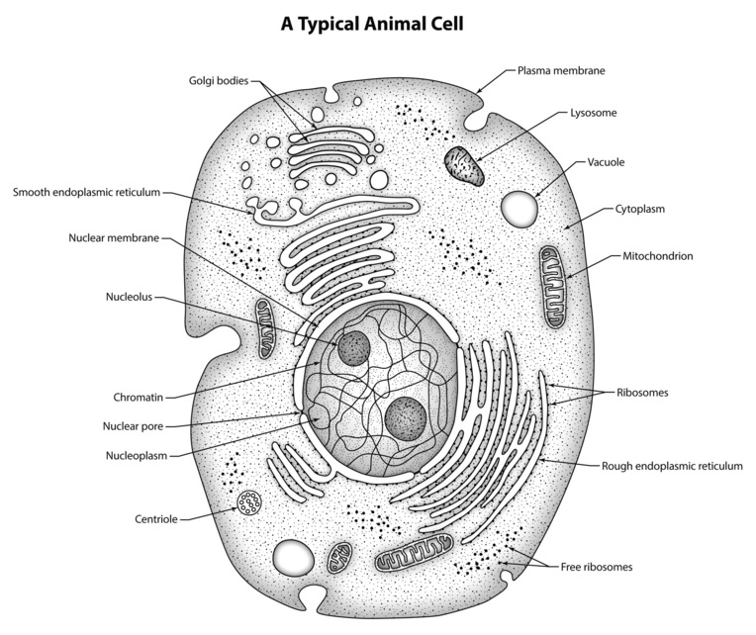
In the chromatin there’s a nucleolus (sometimes more than one) it’s the site of assembly of ribosomes.

The chromatin is contained inside the Nuclear envelope. Is a double phoplipid bilayers separating the chromatin and the cytosol which nuclear pore through out its

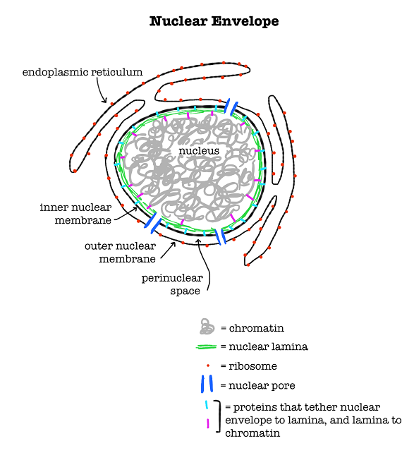

Phospholipid Bilayer Nuclear pore.

Nuclelus everything that is contained in the nuclear envlope is the defining features of the eurkatoyic cell.

Smooth endoplasmic reticulum (continuation of the nuclelus) floats around in the cytosol connecting to the the nuclear envlope. It usually is used for the synthesis of lipids and the destructions of drugs and toxins.

Rough endoplasmic reticulums (continuation of the nuclelus) it has a lot of ribosomes around it. It synthesis proteins to be packaged. Basiclly some proteins are dangerous to the cell like enzymes one the rouge endoplasmatic reticulum is done synothise them its goes to the Golgi apparatus which packages, modifys and sorts proteins coming from the rouge enoplasmic reticulum. (it is not attached to the nuceleus)

Vesicles which is a small membrane sack of matrial (they carry the

Vacuoles are largers vesicles (they are a larger membrane sack of matrial) one type of specfic vacuole is a lysosome which is a vacoule contains digestive enzymes.

Another part floating in the cytosol is the mitochondrion which is where most of the ATP (energy) is genrated for the cell.

Mitochondrion:
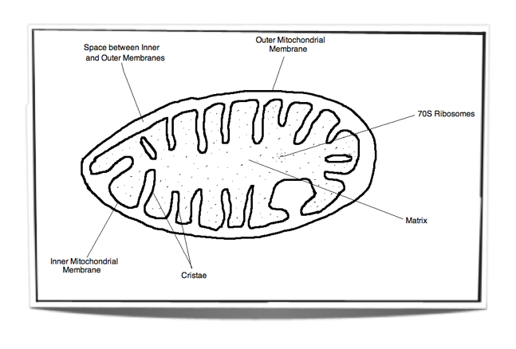
Outer membrane – very similar to the eukaryotic plasma membrane.
Inner Membrane – Very similar to a prokaryotic plasma membrane.
Inside theres a fluid called the Matrix which is similar to the cytosol. And has Ribosomes floating around (they are similar to prokaryotic cell ribosomes). each mitochondrian have a loop of DNA floating around.
A lot of similar bacteria features

Terms:
Organelles = small organs in the cells.
Cytoplasm = cytosol + all the organelles floating around in it.

Cytoskeletons a network of fibers running through the cell, which is gives, the cell shapes movement and intracellular transport. They are attacked to proteins in the plasma membrane.

Inside the cell is the centrosome (Microtubule organizing Centre) all the fibers run through here in order to organize the cytoskeleton.

In the outer side of the animal cells there are extracellular matrix. It strengthens tissues, and helps the cell to react to the environment. Inside the plasma membrane of animals is the cholersterol.

There are also receptor proteins. Which respond to specific chemicals.

There are enzymes in the plasma membrane

There identification markers in the plasma membrane.

There are also tight junction proteins. Which allow cells to be held together very tightly.

Cytosis
Transport via folding of the membrane.
Endocytosis
Entering the cell via cytosis
Exocytosis
Exit the cell via cytosis

Plant cells are Eukaryotic cells.
They are similar to all eukaryotic cell but they

Class 4

Cell plants vs the animal cell
There is a microtubules organizing center on nuclear envelope but no centrosome with centrioles.

Plant Cells have a cell wall its rigid gives the cell shape and helps protect them from bursting cellulose.

Instead of having small little vacuole sacks it has one big one called the central vacuole. Its used for storage and turgor (stiffness caused by water pressure).

Plant cells sometimes have chloroplast (depending what the cell does) sometimes which where the photosynthesis takes place.

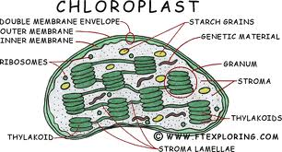

a leaf is green because of thylakoid because their green.
there’s also a loop of DNA floating around

The plasmodesma is a channel running between cells and they allow the passage of cytosol between cells

Summary:
Bacterial cells
No true nucleus
No ER
No Golgi apparatus
No Mitochondria
No chloroplasts
No vesicles or vacuoles
No centrosome.
Animal Cells
No cell wall
No plasmodesmata
No chloroplasts
No central vacuole
Plant cells:
No centrosome
No lysosomes
Cell wall: cellulose
Fungal Cells
Eukaryotic
Cell wall: chitin
Pores between cells
No Plasmamodestmata
No Centrosomes
They don’t have chloroplasts

Metabolism
All the chemical reactions taking place in an organism.
Metabolic pathway : a particular sequence of connected reactions.
Enzyme: a protein that facilitates a specific chemical reaction

ATP: Adenpsome TriPhosphate
This is a high-energy molecule used to provide energy in cells.

ADP: Adenosine Diphosphate
The lower energy form of ATP.

When ATP breaks down to ADP + a P(phosphate) so the energy goes to the active transport molecule

NADH,FADH2, NADPH are high energy molecules high energy electrons.
NAD, FAD, NADP low energy forms of the above molecule without high energy electrons.

Cellular respiriation
The goal of generating energy for the cells.

C6H12O6+6O2---- 6CO2+6H2O + ATP energy

Glucose goes through Glycolysis (splitting glucose) which creates another molecule call pyruvate (has less energy than glocuse) during this reaction there ATP generates aswell as NADH because the splitting releases energy.

The Pyruvate continues on another cycle known as the citric acid cycle during this reaction the pyruvate turn in to CO2 in a reactions which releases energy and generates NADH+ and FADH+.

Theres a reaction now called the oxidative phosphorylation between the Bolded molecules to creat more ATP.

Prokayotic.
Glycoliss and Citric Acid cycle take place in the cytosol.
oxidative phosphorylation takes place in the plasma membrane.

Eukaryotic Cells

Glycolysis takes place in the Cytosol.
Citric Acid cycle and the oxidative phosphorylation take place in the mitochondrion.

Glycolysis: Metabolic pathway the breaks down glucose into two molecule of pyruvate. The energy released is used to change ADP to ATP and NAD+ to NADH.

The citric Acid Cycle
A cyclical metabolic pathway that breaks down Pyruvate in to 3 CO2.
Energy released is used to change adp to ATP, NAD+ to NADH and FAD to FADH

oxidative phosphorylation
A Chain of molecules used energy drom NADH and FADH to generate a H+ gradient

