Engineering economics notes:
Chapter 1:
1.1:
- Early Engineers only had to know technical aspects
- Since Engineering projects use resources (raw material, money, labour, time,) they must be economically aware
- Engineers must be able to choose among several technically feasible alternatives.
- The practical science of Engineering Economics was originally developed to deal with determining which alternative was most economically viable.
- In recent times we add financial, environmental and political concerns
1.2:
- Because of Engineers’ technical and analytical skills, they have increased influence in the decision-making process – and often used in Managerial capacity
- Engineering Economics: The science that deals with techniques of quantitative analysis useful for selecting a preferable alternative from several technically viable ones.
- The evaluation of costs and benefits makes up the bulk of engineering economics, but limitations of such methods must be appreciated.
1.3:
- Decisions are made, in the end, on the basis of belief, but “facts” should be the “foundation” of belief (Fig 1.1)
- Economic Analysis deals with the “facts” - information about costs and benefits of a project.
- Decisions may be made on basis of preferences, politics and people, but Economic Analysis establishes the facts upon which a decision can be based
- These facts should tend to control politics, people, and preferences.
- Facts accumulated over time create intuition, experience that control our “gut feeling” about a decision

Decision Pyramid:
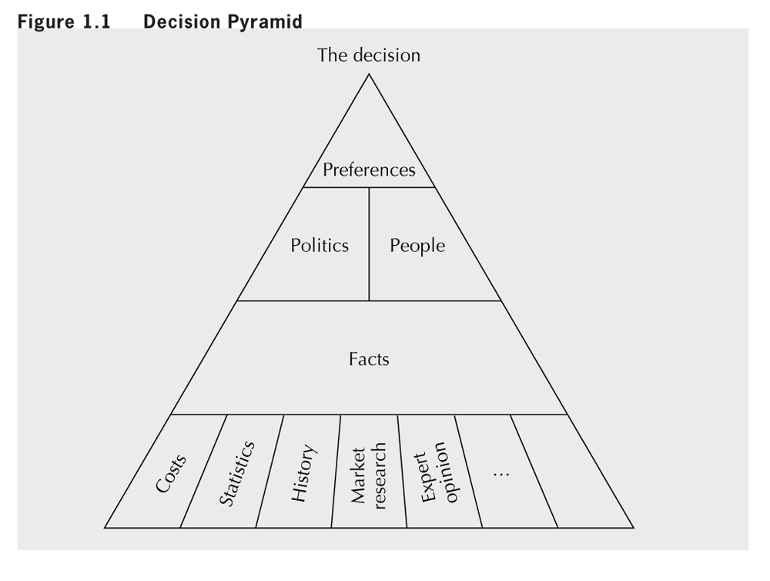

1.4:

- When dealing with the complexities of reality, it is advisable to use a model.
- A model is an simplification of reality that captures information useful and appropriate for a specific purpose.
- Models can be used to analyze a situation and make predictions about the real world.
- Engineering Economic models typically represent a project through estimates of its costs / benefits over time.

The modelling process:
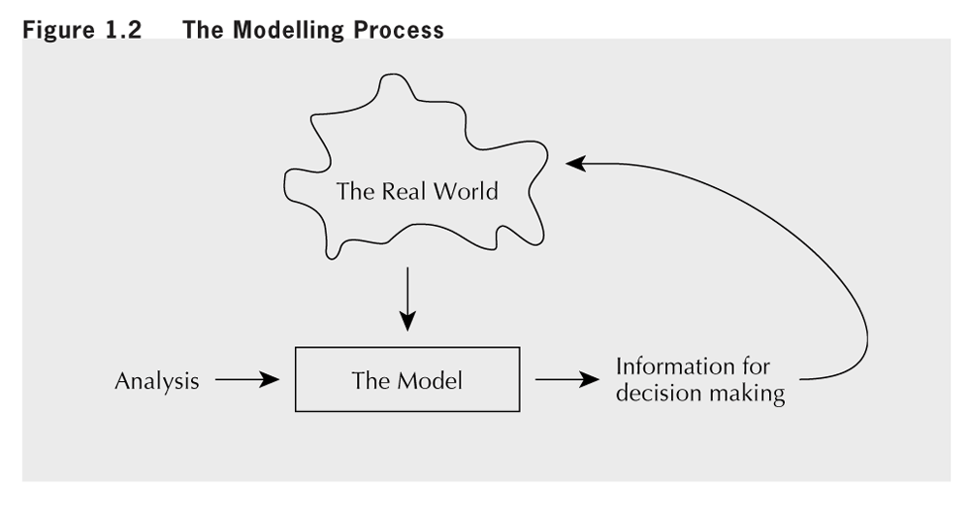
NOTE: The model is a simplification of the reality.

1.5:
- Complex Decisions often have an ethical component
- Recognizing this is important for engineers, since society relies on them to stick to “truth” of analysis
- “As guardians of knowledge, engineers have a vital responsibility to society to behave ethically and responsibly in all ways”
- The three anecdotes of Chapter 1 illustrate this
1.6:

- When constructing economic models, must estimate costs, make predictions – this creates uncertainty
- Sensitivity analysis is means of dealing with uncertainty
- Assesses effect of uncertainty on decision by carrying out an analysis for range of estimated (predicted) values
- Sensitivity analysis can identify robust decisions.

Chapter 2:
2.1:
- Engineering decisions frequently involve tradeoffs among costs and benefits occurring at different times
  - Typically, invest in project today to gain benefits in future
- Chapter 2 discusses economic methods used to compare benefits and costs occurring at different times
- The key to making these comparisons is the use of interest rates.
2.2:
- Interest (I) is compensation for giving up use of money
  - difference between the amount loaned and the amount repaid.
- An amount of money today, P, can be related to a future amount, F, by the interest amount I, or interest rate i:
F = P + I = P + Pi = P(1 + i)
- Right to P at beginning time period exchanges for right to F at end, where F = P(1+i)
- i interest rate, P present worth of F
- F future worth of P, base period interest period
Present and future worth:
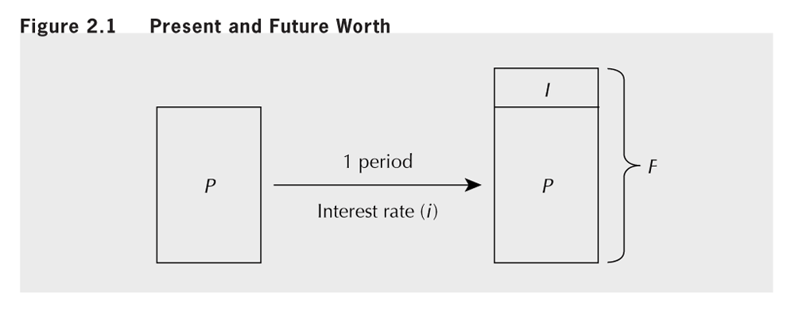
- The dimension of an interest rate is (dollars/dollars)/time.
- i.e. if $1 is lent at a 9% interest rate then $0.09/year would be paid in interest per time period
- period over which interest calculated is interest period.
CLOSE-UP 2.1 Interest Periods:
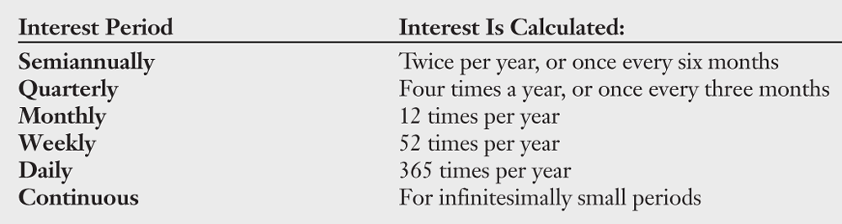

2.3:
- If amount P is lent for one interest period at the interest rate, i, the amount that must be repaid at the end of the period is F = P(1 + i).
- If number of periods is greater than one, interest usually compounded (at the end of each period, interest is added to principal that there was at the beginning of that period).
F = P(1 + i)^{N}
- The interest accumulated is:
I_{C} = F – P = P(1+i)^{N} – P
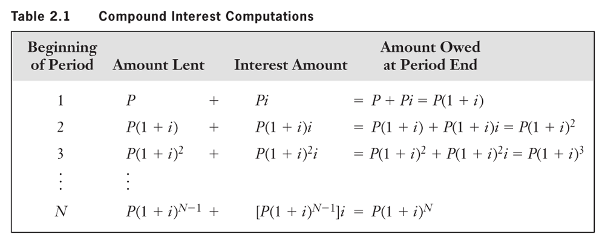
2.3:
Simple Interest – interest without compounding (interest is not added to principal at end of each period)
I_{S} = P I N
- Compound and simple interest amounts equal if N = 1.
- As N increases, difference between accumulated interest amounts for the two methods increases exponentially.
- The conventional approach for computing interest is the compound interest method. Simple interest rarely used.
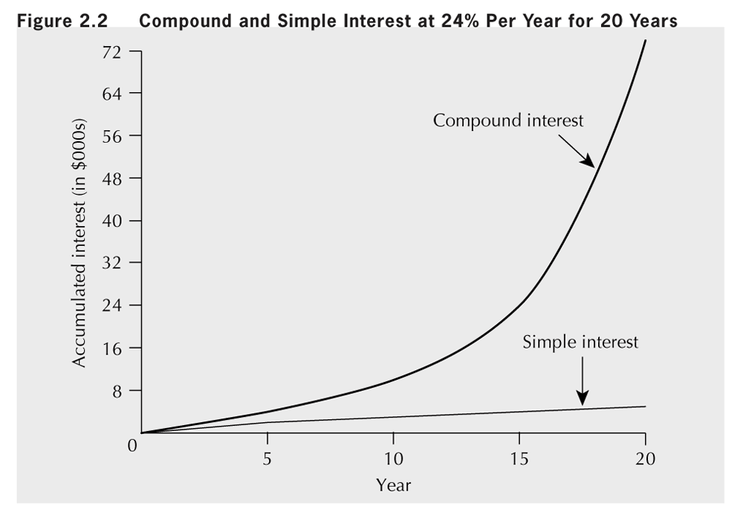
2.4:
- Interest rates stated for some period, like a year.
- Computation based on shorter compounding subperiods
- In this section we consider the relation between:
  - The nominal interest rate stated for the full period.
  - The effective interest rate that results from the compounding based on the subperiods.
- Unless otherwise noted, rates are nominal annual rates
- Suppose: r is nominal rate stated for a period (1 year) consisting of m equal compounding periods (sub-periods)
- By convention, nominal rate for each sub-period is calculated as i_{s} = r/m
- … then F = P(1 + i_{S})^{m} = P(1 + i_{e}), where i_{e} is the annual effective rate
Effective interest rate, i_{e}, gives same future amount, F, over the full period as when subperiod interest rate, i_{S}, is compounded over m subperiods. F = P(1 + i_{s})^{m} = P(1 + i_{e})
- EXAMPLE 2.6 (p27) Cardex Credit Card Co. charges a nominal 24 percent interest on overdue accounts, compounded daily. What is the effective interest rate?
Since F = P(1 + i_{S})^{m} = P(1 + i_{e}), i_{e} = (1 + i_{S})^{m} − 1
where i_{s} = r/m = 0.24/365 = 0.0006575
then i_{e} = (1 + i_{S})^{m} − 1 = (1 + 0.0006575)³⁶⁵ - 1 = 0.271
- The effective interest rate is 27.1%

2.5:
- Suppose that the nominal interest rate is 12% and interest is compounded semi-annually.
- We compute the effective interest rate as follows: where r = 0.12, m = 2
i_{s} = r/m = 0.12/2 = 0.06
i_{e} = (1 + i_{S})^{m} − 1 = (1 + 0.06)² - 1 = .1236 (12.36%)
What if interest were compounded monthly?
i_{e} = (1 + i_{S})^{m} − 1 = (1 + 0.01)¹² − 1 = 0.1268 (12.68%)
- Daily? i_{e} = 0.127475 or about 12.75%
- More than daily? …Continuous Compounding

- The effective interest rate under continuous compounding is:
i_{e} = lim(m->infinity)(1 + (r/m))^{m} – 1 = e^{r} – 1
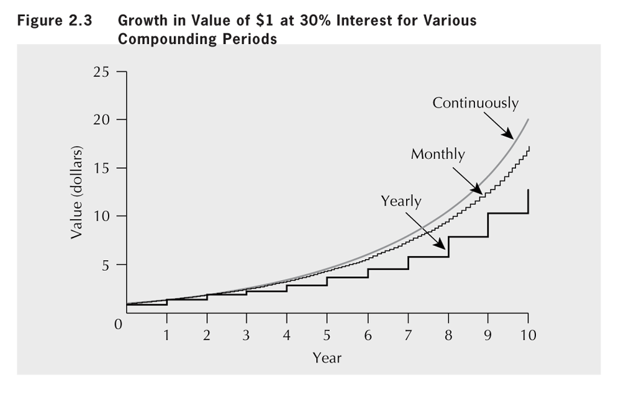

- Now, we may compute the effective interest rate for a nominal interest rate of 12% under continuous compounding:
i_{e} = e^{r} − 1 = e^{0.12} − 1 = 0.12750 = 12.75%
- Although continuous compounding makes sense in some circumstances (i.e large cash flows), it is not often used
- Discrete compounding is the norm.

2.6:
- Cash flow diagram is a graphical summary of the timing and magnitude of a set of cash flows
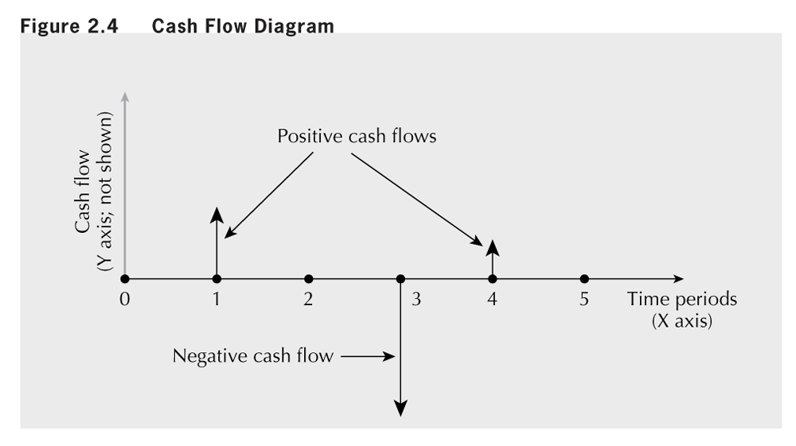

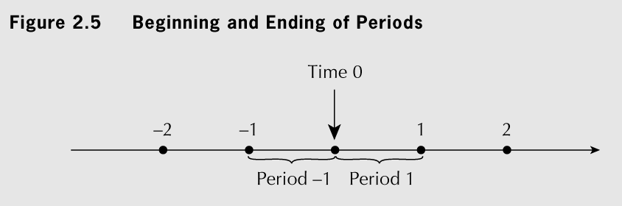
Assumptions:
Cash flows occur at the ends of periods.
End of time period 1 = beginning of time period 2, etc.
Time 0 = “now”

2.7:
- Engineering Economics utilises “time value of money” to compare certain values at different points in time.
- Three concepts of equivalence are distinguished underlying comparisons of costs/benefits at different times:
  - Mathematical Equivalence
  - Decisional Equivalence
  - Market Equivalence
- Mathematical Equivalence: Decision-makers exchange P dollars now for F dollars N periods from now at the rate, i, and the mathematical relationship: F = P(1 + i)^{N}
- Decisional Equivalence: Decision-maker is indifferent as to P dollars now or F dollars N periods from now.
  - We infer decision-maker’s implied interest rate
- Market Equivalence: Decision-makers exchange different cash flows in a market at zero cost.
  - In a financial market, individuals/companies are lending and borrowing money.

- For the remainder of this text, we assume:
  - market equivalence holds
  - decisional equivalence can be expressed in monetary terms
- If these two assumptions are reasonably valid, then mathematical equivalence can be used as an accurate model of how costs and benefits relate to one another over time.

Chapter 2 summary:
- Notion of Interest and Interest Rates
- Compound and Simple Interest
- Effective and Nominal Interest
- Continuous Compounding
- Cash Flow Diagrams
- Equivalence

