Molecular Biology Lecture 2 & 3: Bacterial Genetic Material
Bacterial Genetic Material:
- Prokaryotic genomes generally contain one large circular piece of DNA known as the bacterial "chromosome" (not a true chromosome in the eukaryotic sense).
- Some bacteria have linear "chromosomes".
- Bacterial chromosome sizes vary between 0.6 and 10 Mbp.
- DNA must be compacted: chromosome has a ~ 1.6 µm circumference and E. coli dimensions are: ~1.0 x 2.0 µm.
- Many bacteria have small circular DNA structures called “plasmids” which can be exchanged across bacterial species.
- Plasmids are separate from, and can replicate independently of, the chromosomal DNA.
- Plasmid sizes vary between 1 to over 1,000 (Kbp).
- Plasmids are not considered as being part of the bacterial genome.
- In prokaryotes, there is one circular chromosome, but eukaryotes have numerous linear chromosomes.
- More than one plasmid can be found in bacteria.
- Genetic material in plasmids is not included in bacterial genetic material. The plasmids originate from infectious particles and other bacteria.
- The source of antibacterial resistance is due to transfer of plasmids in bacteria.
- They are replicated independently of chromosomal DNA, they vary in size, and again, they aren’t genomic DNA material.

Bacterial Genome Sequence:
- Coding DNA: ~90% of the total genome.
- Bacterial genes have no introns, however there are a few exceptions to this rule.
- Prokaryotic genes are smaller than their eukaryotic counterparts: the average length of a bacterial gene is ~ 2/3 that of a eukaryotic gene.
- The space between prokaryotic genes is very small and varies between 0 and a few nucleotides.
- Prokaryotic genes are often organized in operon structures and encoded proteins are involved in the same biochemical pathway. These operon structures are not found in eukaryotes.
- Repetitive sequences are not frequent in prokaryotes;
- In eukaryotes, most of the material is intergenic and a small percentage codes for protein. So in eukaryotes, there are a lot of repetitive sequences.
- Phylogenic trees were used to classify bacteria according to certain traits such as the biochemical pathways available in the bacteria. For example, there are aerobic and anaerobic bacteria and each would have a branch in the tree.
- When sequencing the genome of the bacteria was done, the tree became even more branched.
- For example, E.coli K12 is not pathogenic and E.coli 0157 is pathogenic, and has 1347 genes not found in K12. There are only 4000 genes in E.coli, therefore 1347 is a significant difference. E.coli K12 and 0157 are now being debated whether they are different species or not.
- The sequencing increased branching.
- The concept of species as we apply it to eukaryotes does not apply to prokaryotes. The sizes of the genomes are on a different scale. The most important criteria used to classify bacteria is sequencing of the genome and not only biochemical pathways. The tree did not get changed but rather was even more branched at the ends because of new knowledge obtained from sequencing.
- Conclusion: there is substantial variation in genome content in between two different prokaryotic strains, and the species concept that is used to classify them into a phylogenic tree can’t be applied to prokaryotes as for higher organisms.

Genome Structure of Prokaryotes: Mobile Genetic Elements
- Prokaryotic genomes are highly mosaic; composed of DNA segments acquired both by vertical descent (i.e., descent of genetic material from bacteria to progeny) and by lateral transfer (acquiring genetic material from bacteria as is shown in diagram below).
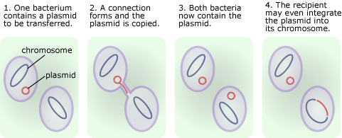
- Mobile genetic elements: “a nucleotide region of varying length with either intragenome, intergenome or intercellular mobility, and which often carries the information necessary for transfer and for recombination with the host genome.”
- Possible role: the emergence of antibiotic resistance in bacterial populations.
- Three major biological processes ensure lateral gene transfer: transformation, conjugative transfer, and viral infection and the release of viral particles.
- The plasmid gets exchanged between two bacteria and then the plasmid can be found in both bacteria.
- The transferred plasmid can be integrated into the sequence of the genome. If the bacterial genome is sequenced, you will find new genetic material.

Prokaryotes: Gene Flow
- The genomes of some bacteria do not allow the integration of plasmids into their DNA. However, other bacteria, allow the integration of plasmids into their DNA.
- 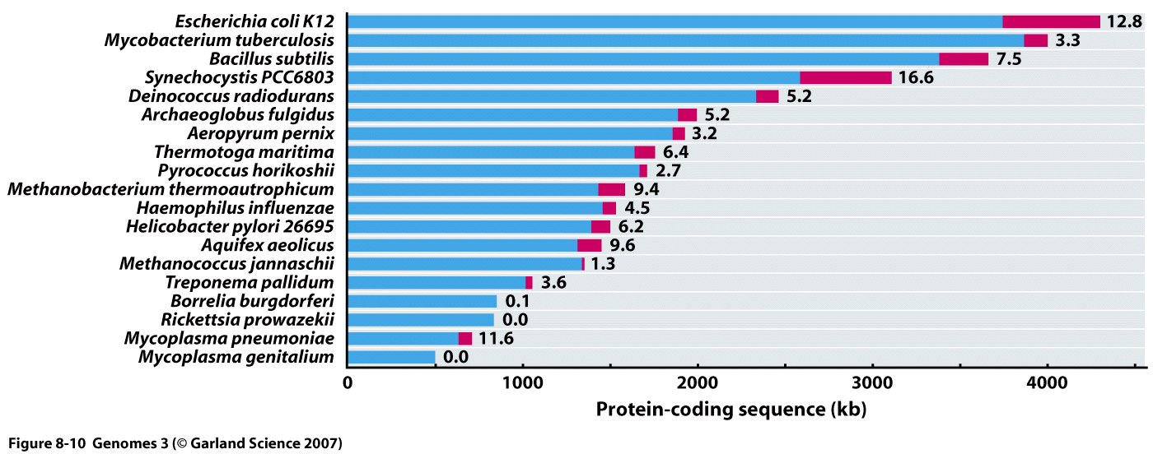
- Blue: DNA unique to a species; Red: DNA acquired by lateral gene transfer. As we see in the figure, some bacteria have allowed plasmid DNA in red to be incorporated into their total genomic DNA, which was sequenced and illustrated above. However, some bacteria did not allow for the plasmid DNA to be incorporated at all as in the last one. They also have similar sequences due to lateral transfer of plasmids and they are of varying size because the genome can have some part of it included in the new plasmid, or it could be half of the original plasmid included into it.

Eukaryote Genetic Material: Human (nucleus)
- Eukaryotic genomes generally contain many large linear pieces of DNA referred to as "chromosomes" (humans have 46 chromosomes).
- There is a lot of variation in the sizes of eukaryotic chromosomes: 2.9 to 4000 Mbp.
- Human chromosomes are not of equal sizes; the smallest chromosome is 21, and the largest is chromosome 1.
- Each chromosome consists of a piece of linear DNA associated with proteins involved in folding and compacting it to form chromatin.
- Genetic material is also stored in mitochondria: ~16.6 Kbp.
- There are a lot of proteins associated with the DNA and the DNA is large therefore it must be well compacted in the nucleus.

Eukaryote Genetic Material: Human (mitochondria)
- The mitochondrial DNA is a single double stranded circular molecule.
- There are several copies in each mitochondrion and there are many mitochondria in each human eukaryotic cell.
- It is similar to prokaryotic DNA; there are no histones or any other proteins associated with mtDNA.
- The genes contain no introns and the mode of inheritance of mitochondrial DNA is maternal.
- Because it is in a highly oxidizing environment it has a much higher rate of mutations than nuclear DNA.
- Genes in mtDNA code for mitochondrial ribosomes and transfer RNAs.
- Some genes code for polypeptide subunits of the electron transport chain.

Eukaryote Genetic Material: Packaging
- The wrapping of DNA around nucleosomes introduces tension, which is relieved by supercoiling structures that spontaneously form. The supercoiling goes in the negative direction. Is the supercoiling shown in the 300nm structure? No, the supercoiling is the 700nm structure and it is not spontaneous there is an enzymatic component that controls this supercoiling to introduce further compaction.
- The histones come together to make a 30nm chromatin fibre.
- The chromatin fibre will be looped and the loops will be further coiled to form the chromosome.

Sequencing the Human Genome (do we need to know this?) Not really
- Map and sequence the human genome: build genetic and physical maps spanning the human genome; determine the sequence of the estimated 3 billion letters; chart variations in DNA spelling among human beings; map all the genome genes; begin to label the functions of genes and other parts of the genome.
- Map and sequence the genomes of important model organisms: Escherichia coli, Saccharomyces cerevisiae, Caenorhabditis elegans, Drosophila melanogaster, and Mus musculus.
- Collect and distribute data
- Develop new technologies and transfer them to the private sector
- One of the goals was to map the genomes that are important to model diseases, evolution, exposure to environment, etc… to study and understand what is going on.
Information about the human genome:
- The length of human DNA is approximately 3.2 x 10⁹ nucleotide pairs.
- The number of genes that humans have is about 22,000.
- 1.5% of human DNA exists in exons.
- Percentage of DNA in high copy (repetitive elements) is around 50%.
- The nucleotide sequence of ~95% of nucleotides is known; the rest of a chromosome consists primarily of very short repeated sequences that do not code for proteins or RNA.
- A pseudogene is a nucleotide sequence of DNA closely resembling that of a functional gene, but containing numerous deletion mutations that prevent its proper expression. Most pseudogenes arise from the duplication of a functional gene followed by the accumulation of damaging mutations in one copy.
- Not all of the human genome is yet known.
- The majority of the genome is intergenic DNA, and most of integenic DNA consists of genome wide repeats (Lines, Sines, LTR elements, and DNA transposons).
- The human genome is graphically represented with the circos plot. On the outside of the circle there are the chromosome numbers, and the lines link sequences that share some homology. Further outside, there are histograms that depict the level of expression of each chromosome number.
- Human chromosomes are stained with Giemsa staining which binds to A-T rich regions of denatured chromosomes, therefore the white bands in the chromosomes are not A-T rich

Important Structural Elements of Eukaryotic Chromosomes
- Unique sequences: genes, dispersed repeats, regulatory regions, multiple replication origins.
- Centromere: attachment point for proteins that link the chromosomes to the mitotic spindle.
- Telomere: located at the end of chromosomes and involved in chromosome stability. It ends with multiple repeats of the sequence: TTAGGG (human).
- Euchromatin is relaxed DNA where there is genetic expression.
- Telomere and centromere are heterochromatin, which isn’t expressed.

Organization of Genes in the Human Chromosomes:
- Only 1.5% of the human genome codes for proteins. Much of the remaining chromosomal DNA is made up of short mobile pieces of DNA that gradually inserted themselves in the chromosomes over time. They are called transposable elements.
- The average gene size is 27,000 nucleotide pairs. However, only 1300 are required to encode an average sized protein. Most of the remaining DNA in the gene consists of long stretches of non-coding DNA called introns. In contrast, the majority of genes from organisms with concise genomes lack introns.
- In addition to introns and exons, each gene is associated with regulatory DNA sequences which are responsible for turning the gene on or off at the right time, having it expressed in the right type of cell and in the right amounts.
- Left arm of chromosome 22 (smallest autosome) consists of short repeat sequences of DNA that are packaged in a particularly compact form of chromatin (heterochromatin).
- Published human genome is a composite of many individual sequences.
Sequence Content of the Human Genome:
- 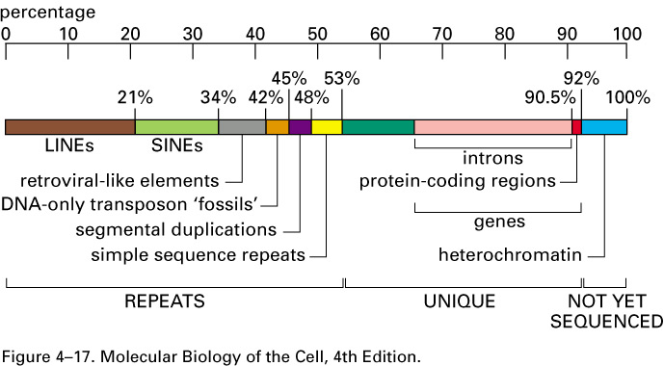
- Half of the human genome consists of repeated sequences that don’t code for protein and the other half consists of unique sequences that contain introns and exons and non-repetitive DNA that is neither in intron nor exon. This is accurate.
- From the half of the gnome that consists of repeated sequences, around 45% is transposon based repeats (lines, sines, and retroviral-like elements, etc…) that are moderately repeated. And the rest is highly repeated DNA which is constitutive heterochromatin and microsatellites.
- Where are the microsatellites, in segmental duplications or simple sequence repeats? How about the constitutive heterochromatin? The satellites are not shown in the figure but they are in the “repeats” section. The constitutive heterochromatin is in both the repeats section and the not yet sequenced section.
- LINEs, SINEs, retroviral-like elements, and DNA-only transposons are all mobile genetic elements that have multiplied in our genome by replicating themselves and inserting the new copies in different positions.
- Simple sequence repeats are less than 14 nts pairs that are repeated for long stretches.
- Segmental duplications are large blocks of the genome (1k to 200K nts pairs) that are present at two or more locations in the genome.
- LINE: long interspersed nuclear element = L1 element (~6 kb) = mutated and truncated version of a retrotransposon, most of them are immobile but few retain their ability to move (require an endonuclease and a reverse transcriptase). L1 insertion into factor VIII gene (blood clotting factor) results in hemophilia.
- SINE: short interspersed nucleotide elements (transposable elements of about 300 bp), e.g. Alu element; thought to be able to move using endonuclease and reverse transcriptase present in the cell.
Highly Repeated Sequences
- The highly repeated sequences are short sequences in long tandem arrays, mostly near centromeres or on the short arms of acrocentric chromosomes.
- Are the highly repeated sequences the same as the segmental duplications or simple sequence repeats? No, they are their own thing and are in the repeats part of the genome.
- Some are also on other chromosome arms, appearing as “secondary constrictions” in metaphase chromosomes under the microscope (centromere is the primary constriction).
- Constitutive heterochromatin is composed of highly repeated DNA. As seen in the microscope, it is densely staining and late replicating chromosomal material. It contains very few genes.
- These sequences are not normally transcribed.
- Subclasses of highly repeated sequences: satellite, minisatellites, microsatellites.

Satellite DNA
- Satellite DNA: it is named so based on its behavior during density gradient established by centrifugation.
- During centrifugation at 50,000 xg, a CsCl solution settles into a gradient of density: denser near the bottom of the tube. Objects in the solution float to their neutral buoyancy point.
- The bulk of human DNA forms a band at a density of 1.55.
- However, short tandem repeats have a slightly different density because they don't have the same base composition as bulk DNA--they form density "satellites" in the centrifuge tube, bands of slightly different density above or below the main DNA band.
Is the main DNA band the one of medium density in the diagram? The main medium band is the majority of DNA.
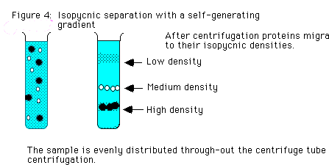
- Three density satellites for human DNA: I, II, and III. Found in centromere regions on all chromosomes.
- An example: "alpha" (or “alphoid”) sequence is 171 bp repeat found at all centromeres in many copies. It apparently binds the kinetochore proteins (which anchor the spindle fibers). Lots of variation between chromosomes, and the variants seem to evolve rapidly.
- Minisatellites are other short repeats, mostly 10-30 bp long, mostly found in and near the telomeres. Some of them are “hypervariable”, meaning that the number of copies of the repeat varies greatly among people. This property makes them useful for DNA fingerprinting: getting a unique DNA profile for individuals using a single probe. These hypervariable minisatellites are also called “variable number tandem repeats” (VNTRs).
- Microsatellites (SSRs) are much shorter, 2-5 bp repeats, and microsatellite arrays are found all over the genome. A source of good genetic maps.

Moderately Repeated Sequences –Transposable Elements in the Human Genome

- All four types of transposable elements (LINES, SINES, LTR retrotransposons, and DNA transposon) are inserted more or less randomly throughout the genome.
- However at the four homeobox gene clusters (HoxA, HoxB, HoxC, and HoxD) these elements are rare. Each Hox cluster is about 100 kb (~9 to 11 genes).
- Differential expression of Hox genes along the anteroposterior axis of the embryo establishes the basic body plan.

Chromosome Differences: Prokaryotes vs Eukaryotes
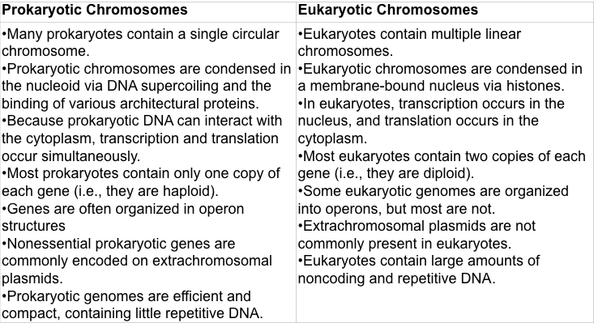

The Number of Open Reading Frames in Each Genome vs. Genome Size
- 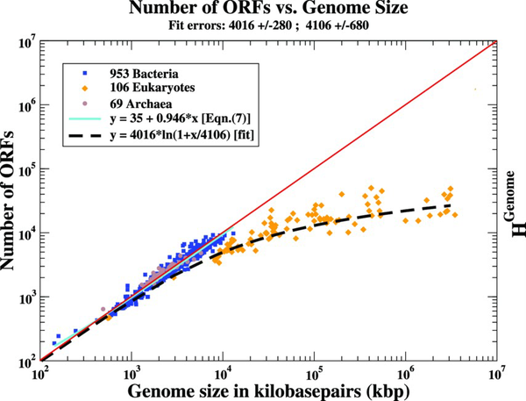
- The more open reading frames, and the bigger the genome, means it is dense. However, in eukaryotes, the genome increases in size but the open reading frames plateau, which means that the genes are remaining the same in number but the genome is increasing in size.The gene density is inversely proportional to organism complexity.

Comparative Genomics: Synteny
- Sequences that have a function are relatively conserved during evolution, whereas those without a function are free to mutate randomly.
- When comparing the human gene sequence with that of a corresponding region in a related genome (such as that of mice), we find some conserved regions. These regions are those that if mutated would impair function and result in the elimination of the organism from the population through natural selection.
- The conserved regions include both functionally important exons and regulatory DNA sequences. Nonconserved regions are those where the sequence is unlikely to be critical for function.
- Roughly 5% of the human genome consists of “multi species conserved sequences.” One third of these sequences code for protein, some of those sequences are clusters that correspond to protein binding sites that are involved in gene regulation, while others produce RNA molecules that are not translated into protein.
- Not only do humans and other mammals share these conserved regions, but also that large blocks of the genome contain these genes in the same order, and that is called conserved Synteny. Large blocks of human chromosomes are recognized in other species.
- Figure: The 21 Tetraodon chromosomes are represented in a circle (Circos plot) in numerical order and each line joins duplicated genes at their respective position on a given pair of chromosomes. Is my idea of conserved synteny right? Yes. Also, how does this figure work, does it mean that the connected chromosome 1 and 18 have chunks that are identical? There is a block of genes in the same order between 1 and 18 for example, and the synteny can be found within the same species or within different ones.
Chromosomes Exist in Different States Throughout the Cell Cycle
- Interphase: the cell is actively expressing its genes and is therefore synthesizing proteins. Also, during interphase, the DNA is replicated and the chromosomes are duplicated. The chromosomes are extended and are referred as interphase chromosomes.
- Once the DNA replication is complete, the cell can inter the M phase. Mitosis occurs and the nucleus is divided into two daughter nuclei. During mitosis chromosomes become highly condensed and are referred as mitotic chromosomes.
- So just know that in interphase they aren’t as compact and in mitosis, they are very compact? Yes, know that there is a significant difference in compaction of the chromosomes.
DNA Sequences on Chromosomes are Linked to Different Activities
- There are three types of specialized nucleotide sequences in DNA that bind specific proteins that guide the machinery that replicates and segregates chromosomes.
- One of these is the DNA replication origin, which acts as a location at which duplication of the DNA begins. There are multiple sites for the DNA replication origins in eukaryotic chromosomes.
- The second is the centromere, which allows one copy of each duplicated and condensed chromosome to be pulled into each daughter cell when a cell divides. It does so by having a protein complex called the kinetochore form around it.
- The last one is the telomere, which is a repeated sequence at the very ends of chromosomes (2 of them for each chromosome) that allows efficient replication of the ends and stops the cell from mistaking the chromosome for being a piece of broken DNA.
- DNA replicates in interphase beginning at the origins of replication and proceeding bidirectionally.
- M phase: centromere attaches the duplicated chromosomes to the mitotic spindle so that one copy is distributed to each daughter cell during mitosis.

Lampbrush Chromosomes
- As a 30 nm fibre, the human chromosome would be still large enough to span the nucleus more than 100 times. Therefore, it is further folded into a series of loops and coils. This chromatin packing is fluid, frequently changing in response to the needs of the cell.
- Most chromosomes in interphase cells are too fine and too tangled to be visualized clearly. In a few exceptional cases, however, interphase chromosomes can be seen to have a precisely defined higher-order structure (immature eggs of amphibian oocytes).
- The regions of the chromosome that are being actively expressed are stained green by using antibodies that go against proteins that process RNA during gene expression.
- Round granules: RNA-splicing machinery.
- 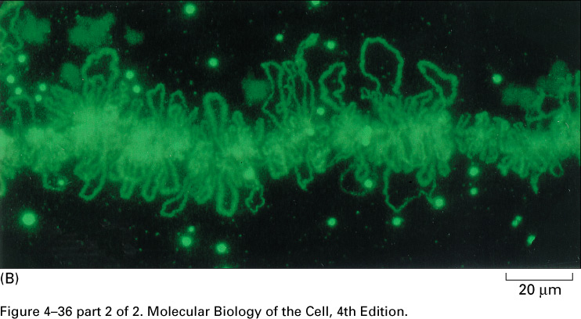
- Lampbrush chromosomes (the largest chromosome known): they are the meiotically paired chromosomes in growing amphibian oocytes that are organized into a series of large decondensed chromatin loops emanating from a linear chromosomal axis.
- A given loop always contains the same DNA sequence, and it remains extended in the same manner as the oocyte grows. These chromosomes are producing large amounts of RNA for the oocyte, and most of the genes present in the DNA loops are actively expressed. The majority of the DNA is not in the loops but is highly condensed in the chromomeres on the axis where the genes are generally not expressed.
- DNA in human chromosomes is organized in loops of different lengths.
- The set of lampbrush chromosomes contains a total of about 10,000 chromatin loops, although most of the DNA in each chromosome remains highly condensed in the chromomeres (which are generally not expressed).
- A given loop always contains the same DNA sequence and it remains extended in the same manner.
- Most of the genes present in the DNA loops are actively expressed.
- Four copies of each loop are present in each cell. How?
Two chromosomes are found in each cell and each one is duplicated making a total of four chromosomes, each of which has the same loop.
Model for Chromosome Structure Axis of the Chromosome
- Multi-protein complexes, including the proteins called condensins, mediate chromosome condensation.
- Condensins are part of the SMC (Structural Maintenance of Chromosome).
- Condensins have an elongated shape and form dimers. Many dimers will associate to bring closer in proximity DNA loops and condense the genetic material and will form the axis of the chromosomes.
- 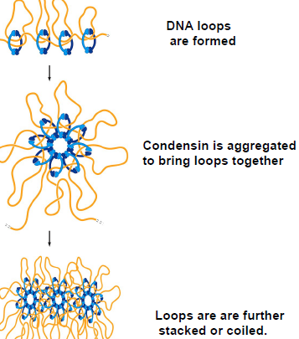

Model for the Structure of an Interphase Chromosome
- A section of the interphase chromosome is shown folded into a series of looped domains, each containing 20K to 100K nucleotide pairs of double-helical DNA condensed into a 30-nm fiber.
- Individual loops can decondense, perhaps in part though an accordion-like expansion of the 30-nm fiber.
- Enzymes that directly modify the chromatin structure bring about the decondensation.
- How is the folded 30-nm fiber anchored to the chromosome axis? DNA topoisomerases (hypothesis) I don’t understand why it is thought to be DNA topoisomerases that anchor the 30-nm fiber to the chromosome axis? Don’t the condensins form the chromosome axis and have loops through them? Topoisomerases are managing the tension by compacting and decompacting the DNA according to the needs of the cell, while the condensins anchor the chromosome onto the axis that is made of many proteins.
- 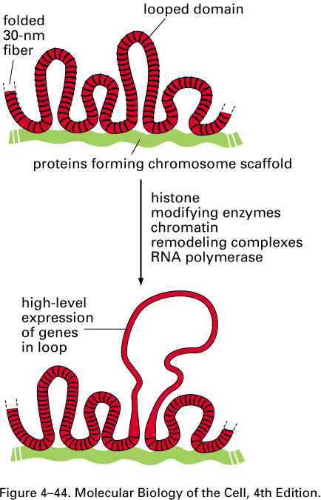

Two Types of Chromatin
- Two types of proteins bind to the DNA to form the eukaryotic chromosome: the histones and the nonhistone chromosomal proteins. The complex of both classes of protein with nuclear DNA is known as chromatin.
- Two types of chromatin in the interphase nuclei of many eukaryotic cells: a highly condensed form, heterochromatin, and all the rest, which is less condensed, euchromatin.
- Euchromatin is composed of the type of chromosomal structure we have discussed so far (30-nm fiber and loop domain).
- Heterochromatin includes additional proteins and probably represents more compact levels of organization.
- In a typical mammalian cell, ~10% of the genome is packed into heterochromatin.
- Heterochromatin is concentrated in specific regions, including centromeres and telomeres.
- Most DNA folded into heterochromatin does not contain genes (genes that become packaged into heterochromatin are usually resistant to being expressed).
- This type of packaging turns off Euchromatic genes packaged into heterochromatin.

Position Effect on Gene Expression in Drosophila
- When a gene that is normally expressed in euchromatin is experimentally relocated into a region of heterochromatin, it ceases to be expressed and the gene is said to be silenced.
- These differences in gene expression are examples of position effects in which the activity of a gene depends on its position relative to a nearby region of heterochromatin on a chromosome.
- In Drosophila, chromosome breakage events that directly connect a region of heterochromatin to a region of euchromatin tend to inactivate the nearby euchromatic genes.
- The zone of inactivation spreads a different distance in different early cells in the fly embryo, but once the heterochromatic condition is established on a gene, it tends to be stably inherited by all the cell’s progeny.
- Wild-type flies with normal white gene have normal pigment production, which gives them red eyes.
- If the white gene is moved near a region of heterochromatin, eyes are mottled (red and white patches). Because some of the cells had heterochromatin spread over their genes (genes were turned to heterochromatin), the genes got silenced. And some didn’t have the heterochromatin spread to them, they were kept active and in euchromatic form. This is position effect variegation that is only possible because of a chromosomal rearrangement that moves the DNA barrier away from the heterochromatic regions. Heterochromatin is normally prevented from spreading into adjacent regions of euchromatin by special boundary DNA sequences. In flies that inherit certain rearrangements, this barrier is no longer present.
- White patches: white gene is silenced.
- Red patches: white gene is expressed; the heterochromatin did not spread across this gene.
- Many position effects exhibit an additional feature called position effect variegation. These patterns can result from patches of cells in which a silenced gene has become reactivated (or the opposite). There can be a retraction from a gene in some clone that used to be silenced in the original cell but gets activated in the clone cell.
- 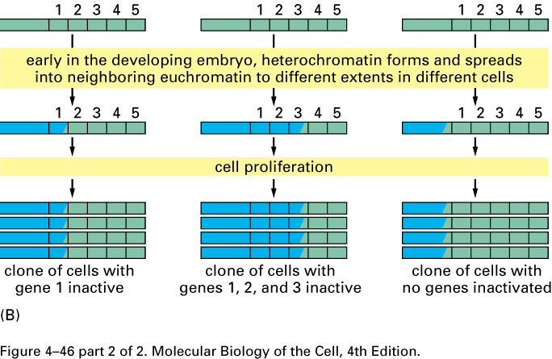
- The study of position effect variegation has revealed two important characteristics of heterochromatin:
- Heterochromatin is dynamic: it can spread into a region and later retract from it.
- The state of chromatin tends to be inherited from a cell to its progeny. (heterochromatin is compact due to non-histonic proteins). Proteins are going to also be therefore transmitted to progeny to keep the heterochomatic structure. Central dogma not exact. The information is not all embedded in the sequence, proteins are governing the final gene expression. It is not only the sequence that controls gene expression as Watson and crick suggested.

Models for the Heritability of Heterochromatin: how the packaging of DNA in chromatin can be inherited during chromosome replication.
- New heterochromatin components bind cooperatively to the inherited components, thereby beginning the process of new heterochromatin formation. The process is completed with the assembly of additional proteins and eventual covalent modification of the histones.
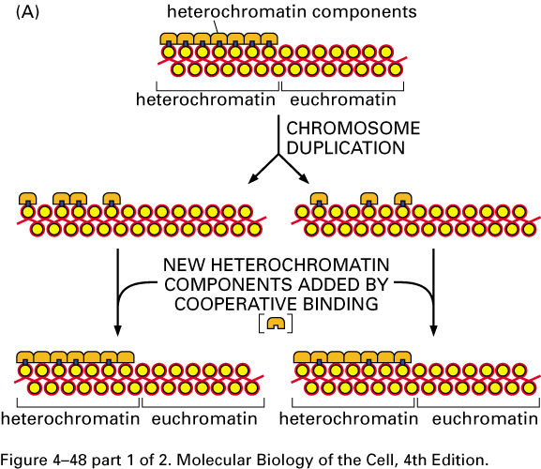
- In this model, some of the specialized heterochromatin components are distributed to each daughter chromosome after DNA duplication, along with specially marked nucleosomes that they bind. After DNA replication, the inherited nucleosomes that are specially modified, acting in concert with the inherited heterochromatin components, change the pattern of histone modification on the newly formed daughter nucleosomes nearby. This creates new binding sites for the same heterochromatin components, which then assemble to complete the structure and make it the same as the parent chromosome’s structure.
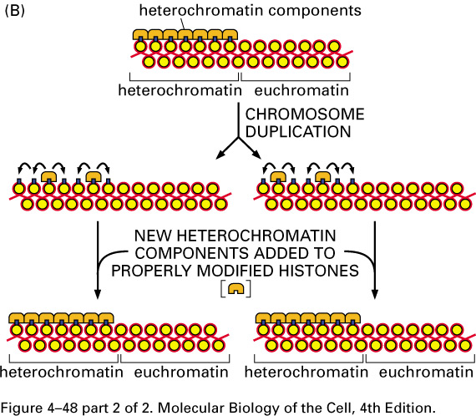
- In both models, covalent modifications of the nucleosome core histones have a critical role in the heritability of heterochromatin. In the first model, the covalent modifications occur right after the cooperative bonding of the new heterochromatin components to assemble additional proteins and complete the structure. In the second model, covalent modifications occur right after duplication and they are done by the inherited heterochromatin components to create binding sites for more heterochromatin components to bind. Proteins are passed on and not just DNA. More evidence that central dogma is not exact.

Heterochromatin at the Ends of Yeast Chromosomes: Sir Proteins
- Unlike the nucleosome and the 30-nm fiber, heterochromatin is not well understood structurally: it certainly involves many proteins in addition to the histones (non-histonic proteins).
- In yeast: the chromatin extending inward ~5000 nucleotide pairs from each chromosome end is resistant to gene expression – structure probably similar to heterochromatin of more complex organisms.
- Extensive genetic analyses have revealed proteins required for this type of gene silencing: Sir (silent information regulator proteins).
- Heterochromatin is usually underacetylated.
- Underacetylated tails of histone H4 are proposed to interact with a complex of Sir proteins to stabilize the association of these proteins with nucleosomes.
- Exact pattern of histone H4 tail modification required to bind to the Sir complex is less known.
- 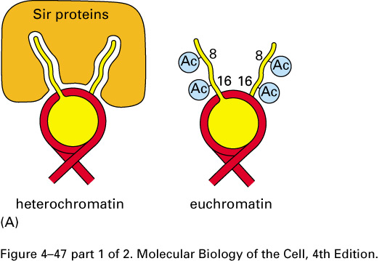
- Specialized DNA binding proteins (blue triangles) recognize DNA sequences near the ends of chromosomes and attract the Sir proteins.
- Sir2 is an NAD⁺-dependent histone deacetylase.
- Cooperative spreading of the Sir protein complex down the chromosome.
- As the complex spreads, the deacetylation catalyzed by Sir2 helps create new binding sites on nucleosomes for more Sir protein complexes.
- Formation of a “fold back” structure.
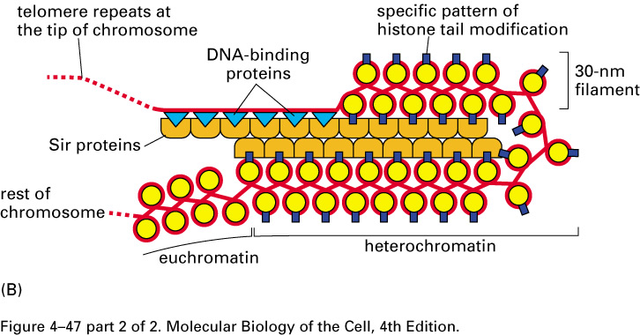
- The blue triangle proteins will bind the DNA sequences at the end (telomere) and also bind to sir proteins. Know that the tip is folded and this is shown in the left as the dotted line. The dotted line is the end of the DNA sequence.

Structure of Human Centromere
- The centromeres in more complex organisms are considerably larger than those in the budding yeast. For example human centromeres extend over hundreds of thousands of nucleotide pairs.
- Human centromeres consist largely of short repeated DNA sequences known as alpha satellite DNA.
- Alpha satellite DNA are AT-rich and consist of a large number of repeats.
- The kinetochore on the centromere consists of two regions: an inner kinetochore plate, formed by kinetochore proteins bound to alpha satellite DNA; and an outer kinetochore plate, formed from special protein that interact with microtubules. Even the simplest kinetochores consist of more than 45 different proteins.
- 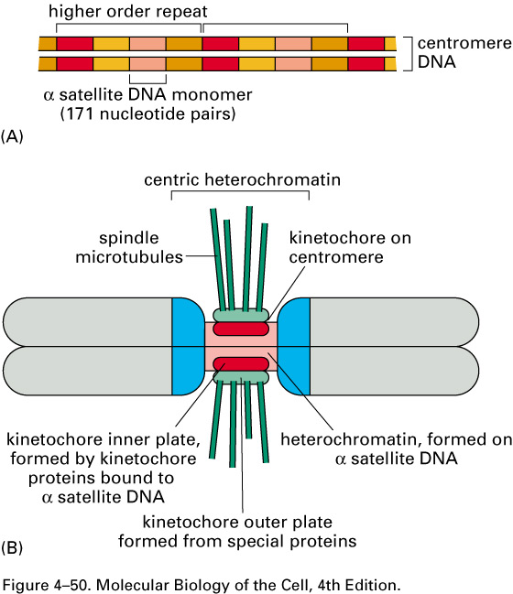

Nucleosomes Observed by Electron Microscopy
- When interphase nuclei are broken open very gently and their content examined under the electron microscope, most of the chromatin is in the form a fiber with a diameter of about 30 nm (panel A).
- If the chromatin is subjected to treatment that causes it to unfold partially, it can been seen as a series of “beads on a string” (panel B).
- 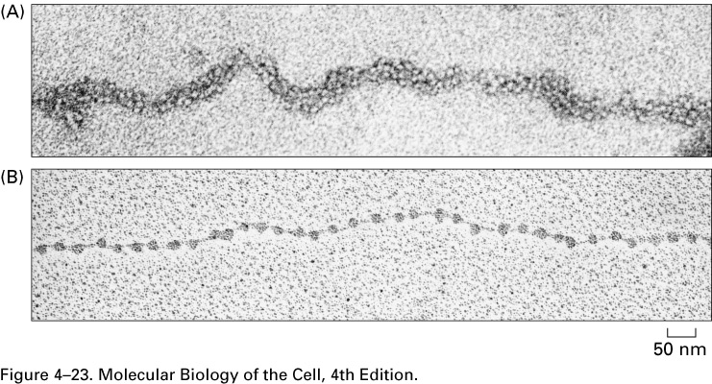

Structural Organization of the Nucleosome
- Each nucleosome core particle is separated from the next by a region of linker DNA (few bp to 80 bp).
- On average, nucleosomes repeat at intervals of about 200 nucleotide pairs.
- Core protein made of 8 histone molecules.
- 146 bp to wrap 1.65 times around the histone core.
- Histones are relatively small proteins (102-135 aa), and they share a structural motif, known as the histone fold.
- The enzymes added only digest the DNA in between the nucleosomes (linker DNA) and not the DNA wrapped around.
- The individual nucleosomes with DNA wrapped around are obtained.
- These are exposed to high salt concentration and then we get proteins, the octomer, and the DNA. The DNA around the histones produces the same band on the gel of the size 146 bp every time.
- The histones are then further decomposed only to find that there are 4 types of proteins.
- The length of the DNA around histones is always 146bp, but the one of the linker DNA can vary in length from a few bp to 80 bp.
- 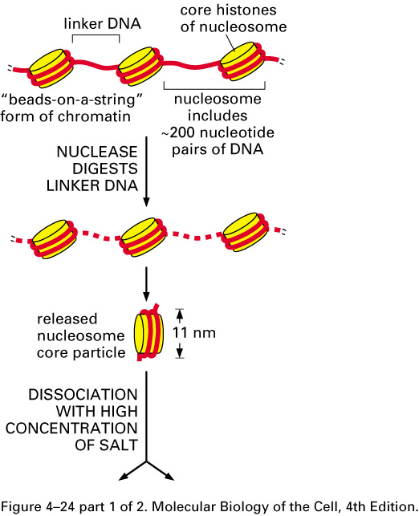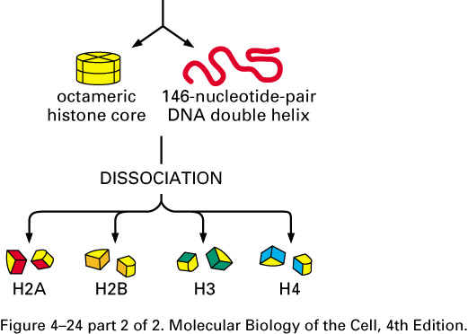

Models for the 30-nm Chromatin: Zigzag and Solenoid
- Although long strings of nucleosomes form on most chromosomal DNA, chromatin in a living cell probably rarely adopts the extended “beads on a string” form, it adapts the 30 nm diameter form. 2 models are proposed to explain how nucleosomes are packed into a 30 nm fiber:

- The zigzag model: interactions between alternative nucleosomes (N1 to N8). N1 interacts with N3 etc. Fluid model: the structure of the fiber changes, which allows the accommodation of the variability of the linker DNA sizes. Know that it is necessary to change the direction of the of the 30nm fiber.

- Solenoid: interactions between consecutive nucleosomes; N1 interacts with N2 etc. Intercalation of a dimer of nucleosomes into a formed helical structure. Know that it forms duos.
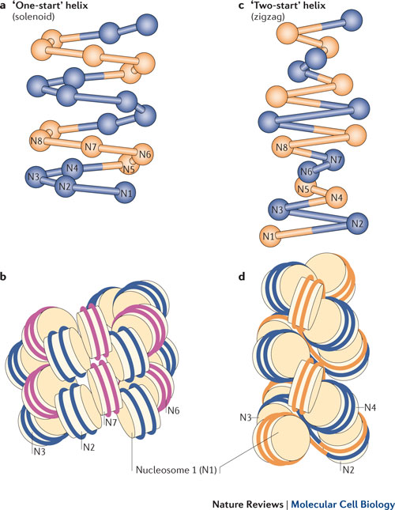
- The nucleosomes stack so tightly on each other in a 30 nm fiber because the nucleosome-to-nucleosome linkages are supported by histone tails, most notably the H4 tail and the whole histone H1 (it is the linker histone).
- Histone H1 is larger than the individual core histones and it has been less conserved during evolution. A single histone H1 molecule binds to each nucleosome contacting both DNA and protein and changing the path of the DNA as it exits from the nucleosome. Although, it is not understood how H1 pulls nucleosomes together into the 30 nm fiber, a change in the exit path in DNA is crucial for compacting nulceosomal DNA so that it interlocks to form the 30nm fiber. There are several different types of H1 proteins of related but distinct amino acid sequences.

Irregularities in the 30-nm Fiber
- The 30 nm structure found in chromosomes is probably a fluid mosaic of the different zigzags variations
- The linker DNA that connects adjacent nucleosomes can vary in length: these differences in linker length probably introduce further local perturbations into the zigzag structure.
- The presence of other DNA-binding proteins and DNA sequence that are difficult to fold into nucleosomes punctuate the 30-nm fiber with irregular features.
- Several mechanisms act together to form the 30-nm fiber from a linear string of nucleosomes. An additional histone, called histone H1, is involved in this process.
- 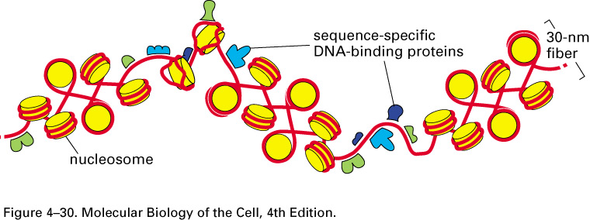
- Histone H1 consists of a globular core and two extended tails
- The zig-zag structure allows a change in directionality.
- A single histone H1 molecule binds to each nucleosome, contacting both DNA and protein, and changing the path of the DNA as it exits from the nucleosome. This change in the exit path seems to be crucial for compacting nucleosomal DNA so that it interlocks to form the 30-nm fiber.
- Part of the effect of H1 on the compaction of the nucleosome organization may result from charge neutralization: H1 is positively charged (C-terminus) and this helps to compact the negatively charged DNA.
- H1 is not essential for cell viability.

Structure of Core Histones
- Each core histones has a long N-terminal amino acid “tail”, which is subjected to several different covalent modifications. These modifications control many aspects of chromatin structure.
- The histone fold is shared by all 4 core histones and is formed from 3 α helices connected by 2 loops. 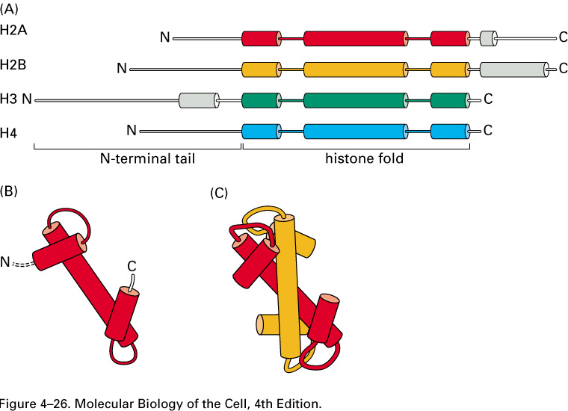
- In assembling a nucleosome, the histone folds first, then bind to each other to from H3-H4 and H2A-H2B dimers through an interaction known as the “handshake”. Finally the 2 dimers assemble to form the compact octamer core.

Chromatin Remodeling Complexes
- Eukaryotic cells contain chromatin-remodeling complexes (protein machines that use the energy of ATP hydrolysis to change the structure of nucleosomes temporarily).
- Different chromatin remodeling complexes are used to disrupt and re-form nucleosomes.
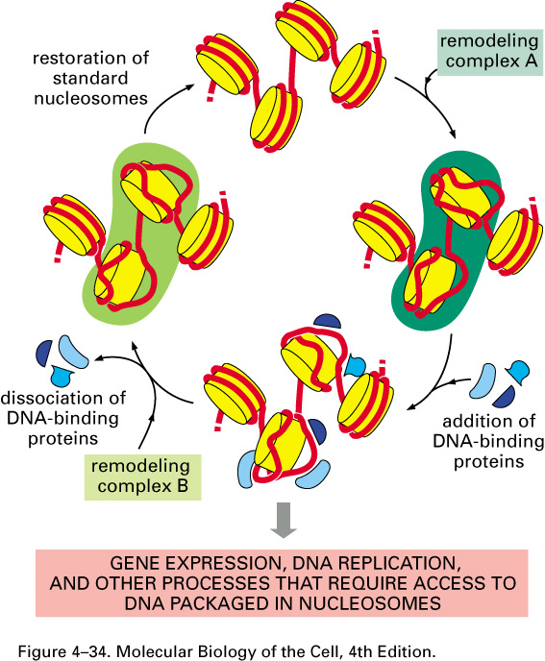
- The remodeling of nucleosome structure has 2 important consequences:
- It permits ready access to nucleosomal DNA by other proteins in the cell (gene expression, DNA replication, and DNA repair).
- It can catalyze changes in the positions of nucleosomes along DNA.

Modification of the Histone Tails: Histone Code:
- The N-terminal tail of each of the 4 core histones are highly conserved in their sequence, and perform crucial functions in regulating chromatin structure.
- Each tail is subjected to several types of covalent modifications (methylation, acetylation, phosphorylation, ubiquitination).
- These modifications have no effect on the stability of the nucleosome, but they seem to affect the stability of the 30-nm chromatin fiber. But, the most profound effect of modified histone tails is their ability to attract specific proteins, which can either compact the chromatin further or facilitate access to the DNA.
- Each modification can convey a specific meaning to the stretch of chromatin on which it occurs.
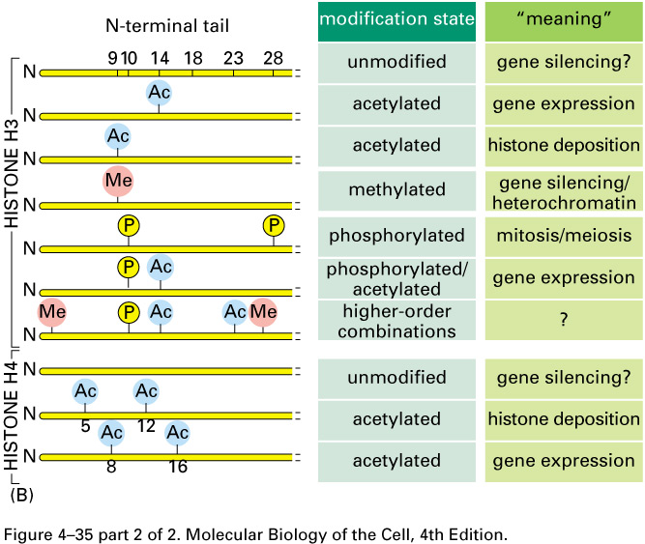

Learning Objectives:
1. List the important features of the genomes of bacteria and of human. How did the results from genome sequencing experiments influence the biological concept of species for bacteria?

Characteristic | Prokaryote | Eukaryote (Human)
Features | A single chromosome (0.6-10 Mbp) that is compacted by a factor of x1000 | 46 chromosomes (3.3 x 10⁹ Mbp). For eukaryotes in general (2.9-4000 bp). Compacted by a factor of x10,000
Sequences | ≈ 90% coding for proteins  ≈10% non-coding | ≈ 1.5% coding for proteins  > 98% non-coding for proteins
Genes | Smaller (≈2/3 of eukaryotic genes)  No introns  Operon structures | Larger  Have introns  No operon structures
Repetitive sequences | Low amounts | Abundant
The original phylogeny of bacteria was based on biochemistry experiments and for example bacteria was classified based on the criteria of aerobic or anaerobic. After sequencing, it became clear that the difference between bacteria, although from the same species as defined by biochemical results, was greater.

Example, E.coli K12 is not pathogenic and E.coli 0157 (pathogenic, and has 1347 genes not found in K12) there are only 4000 genes in E.coli therefore 1347 is a significant difference. E.coli K12 and 0157 are now being debated whether they are different species or not.

The sequencing made the same phylogenic tree even more branched due to increased knowledge about members of the same species.

2. Compare the transposable elements in the genomes of the bacteria and human.

Transposable element: a nucleotide sequence of varying length, with either intragenome or intergenome mobility and it could have intercellular mobility.

In Prokaryotes: they are identical sequences that were found when comparing the genomes of various prokaryotes. Sequences in the transposable element include the necessary information for insertion into the host genome and transfer in between genomes or between cells. Within the transposon (same thing as transposable element) itself, the information necessary for transposable mobility is included.
4 types:
- IS: insertion sequence
- Composite
- TN3 type
- Transposable Phage

In Eukaryotes: the transposable elements are found in repetitive regions, which are very abundant in the human genome. They are classified into two groups:
- Transposable Elements Related to Protein Sequences (i.e., encode proteins): they have intergenome movement.
- Retroviruses.
Mechanism for transposition for eukaryotes is different from prokaryotes. The information for the mobility of transposable element is not included in the transposable element itself. Mobility occurs via a mechanism called non-homologous recombination. For example, the retrotransposon inserts into the human genome through non-homologous recombination. There are 4 types of transposable elements:
- Lines
- Sines
- LTR Retrotransposon
- DNA Retrotransposon
- Lines and Sines are about 50% of the human genome. The DNA transposon would be about a few percent and the viral like element and the LTR retrotransposon are about 10% or less.

3. Explain the concept of conserved senteny.
Synteny: a physical co-localization of genetic loci on the same chromosome within an individual or species.
Conserved Synteny: preserved co-localization of genes on chromosomes of different species or individuals. Blocks of genes are organized in a conserved order.
Tetraodron fish has 21 chromosomes and the genome of this fish was sequenced. Each chromosome is illustrated on the outside of the circle (circos plot). The purpose of the circos plot is to compare sequences on each chromosome and to identify other chromosomes with similar sequences. In the case of this fish the synteny is high, because for example between chromosome 10 and 14, there is a lot of duplication, the blocks of genes found in chromosome 10 were found in chromosome 14. The overall conclusion from this sequencing was to show that in this particular species the genome is duplicated. Conserved synteny in this case is within the same species.

4. How is the folded 30-nm fiber anchored to the chromosome axis?

Anchoring takes place via a scaffold of proteins. To this scaffold of proteins the fiber is attached at different points and will form loops of different lengths (from 20,000 -100,000 bp). The structure of the fiber is very dynamic and changes occur with respect to the condensation and compaction of the DNA. For example, during mitosis, condensation occurs where special proteins called condensins are able to both bind DNA (has 2 DNA binding domains) and an ATP to form an intramolecular cross-linker between the different loops of DNA. So, they will bind single stranded DNA at two sites and that would bring them in close proximity.

Topoisomerase cuts the two strands of DNA to form the loops. The concerted action of condensins and topoisomerase will introduce supercoiling into the DNA (requires ATP). The DNA will twist and coil and as the cell cycle progresses, the condensins and topoisomerase activity will slow down and DNA becomes less compacted. This is the case where dynamic changes occur for gene expression, where proteins of the transcriptional machinery must access the DNA so compaction is reduced.

Therefore, the axis of the chromosome is made of proteins and those proteins will bind to the 30 nm fiber at various sites forming loops of various length.
The condensins that attach to each other form the axis along with other proteins.

5. Compare heterochromatin and euchromatin structures and sequence content.
Characteristic | Heterochromatin | Euchromatin
Condensation | Highly condensed | Less Condensed
Location in chromosome | Mainly centromere and telomere | Everywhere else on the chromosome
Gene amount | Almost devoid of genes | Gene Rich
Expression of Genes | Not expressed (with some exceptions) | Expressed
Percentage in Genome | ≈ 10% | ≈ 90%

6. Explain the experiment conducted in the drosophila demonstrating the control of chromatin structure on gene expression.
Those experiments discovered the positional effect: the level of expression of a gene will vary according to its position along a chromosome. Genes in euchromatin are likely to be expressed, and what was observed was that the white gene, when expressed, produces a phenotype of red eye colour. It is expressed when it is far away from heterochromatin. If an inversion occurs in this segment of DNA where the white gene becomes closer to the heterochromatin region, this would prevent the expression of the white gene and silencing the white gene produces a white eye. In this case the white patches are a result of the lack of expression of the white gene as opposed to the red patched where there is expression of the white gene.
The location of the white gene determines the rate of expression of the gene.

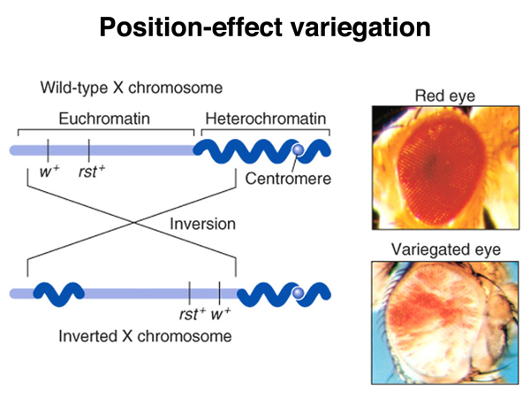
7. Compare the 2 models for heritability of heterochromatin.

Heterochromatin is the most compact form of DNA and usually there is no or very rare gene expression occurring in regions of heterochromatin. The compaction of DNA into heterochromatin is mediated by both histone and non-histone proteins. These proteins make the DNA so compact that it becomes inaccessible to replication and transcription machinery. Heterochromatin is approximately 10% of all chromatin in a cell. The two models explaining how it is transmitted from parent to progeny are:
- During cell division, the chromosomes are replicated and each daughter will receive one copy of the DNA. The replication is semi-conservative. In the heterochromatin region there will be some of the heterochromatin components from the parent distributed to each daughter chromosome. In each daughter chromosome, in order to fill the missing heterochromatin components, there will be cooperative binding of additional heterochromatin components to the daughter cells. The cooperative binding is mediated by existing heterochromatin components along the chromosome.
- The heterochromatin components are inherited in different amounts to each daughter chromosome. These components will induce histone modifications in the neighboring histone complexes which makes these neighboring histone complexes have binding sites for additional heterochromatin components and at the end the progeny will have heterochromatin regions identical to that of the parent.

8. Illustrate and explain the structural organization of the nucleosome.

- It is the first level of organization for the chromosome.
- It requires histones; the structure formed between histones and DNA is called beads on a string where the string is DNA and the beads are histone complexes.
- The length of DNA separating two nucleosomes is approximately 20-80 bp.
- The amount of DNA circling around histone cores is approximately 147 bp.
- The histones are composed of 8 proteins (octamers). These proteins are H2A, H2B, H3, and H4.
- N-terminal of proteins of histones (histone tail) is flexible and it can make contact with adjacent nucleosomes. It is also the site of covalent modifications that occur mainly on lysine, arginine, and polar amino acid residues (serine or threonine).
- There are 4 modifications: acetylation, phosphorylation, methylation, or ubiquitination. These modifications impact how dynamic the structure of the nucleosome is.

9. Explain the role of histone H1 protein.
- It is a globular protein and there is one H1 per nucleosome.
- The two tails, the N-terminus and the C-terminus of the H1 protein are unstructured and very flexible. The H1 protein binds along the nucleosome and the DNA enrolled around the nucleosome and the two tails of the H1 protein are subject to modifications.
- The two roles of H1 protein:
- Change the path of the DNA enrolled around the nucleosome. Changing the path of the DNA around the bead so that it is not a strait line of DNA wrapped around the nucleosomes but more like a zig-zag transition from each nucleosome to the next. This possible due to the chemical modifications incurred on both the N and C terminus.
- Attach the nucleosomes to one another so that DNA becomes more compacted. DNA is dynamic and is always changing its compaction level (and thus accessibility to transcription and replication machinery) according to the demands of the cell in terms of replication and transcription. Histone H1 is one of the main players that mediate this change in compaction level.

10. Explain the cycle of chromatin remodeling.
- It is constantly occurring and it is necessary to give some protein access to DNA that is found wrapped around the nucleosomes.
- Take the example of a gene that needs to be accessed for the purpose of expression, however it is in a portion of DNA that is wrapped around a nucleosome. The nucleosome structure is altered by numerous proteins that form a complex called remodelling complex A. Remodelling complex A binds to more than one nucleosome and alters the interaction between DNA and the nucleosome (mainly H-bonds). As a result, the DNA, which was not available to DNA binding proteins (such as the transcriptional or replication machinery), would be accessible.
- The alteration in the structure of the nucleosome is temporary, and with the assistance of remodelling complex B, the original structure of the two nucleosomes is restored so that the DNA is not accessible to transcriptional or replication machinery.
- In conclusion, chromatin-remodelling complexes are made of proteins, and use ATP hydrolysis to change the structure of the nucleosome. The changes induced by the remodelling complexes are temporary and the result of the action of complex A would be to change the position of the nucleosome on the DNA and to give access to DNA for replication machinery or transcription machinery, and other large complexes.
- The protein complex B forms and restores the original structure of the chromatin.

