Molecular Biology Lecture 1: DNA Structure and the Central Dogma
The Two Experiments Suggesting that Genes are Made of DNA:
- Griffith-Avery:
- There is a chemical responsible for passing on hereditary material. They called this chemical the transforming principle. They used the streptococcus pneumoniae bacterium in their experiments.
- There are two strains of streptococcus, the R strain and the S strain. The R strain appears rough in a colony because it has no protective capsule, it is not virulent, the immune system is able to attack and destroy it. The S strain appears smooth in a colony because it has a capsule around it that protects it from the immune system; this makes it virulent.
- They took the R strain and injected it in a mouse, and the mouse lived. They concluded that the R strain is benign. They then took the S strain and injected it into a moue and it died, therefore, they concluded, that the S strain is virulent.
- They then heated up the S strain, which killed it, and they injected it into the mouse. The mouse lived. Therefore, killed S strain cells are benign.
- However, they mixed the heat killed S strain and the R strain and injected that mixture into the mouse and the mouse died. They then took a blood sample from the dead mouse and found living S strain cells. The conclusion was that the dead S strain cells transformed the living R strain cells by the movement of the transforming principle.
- Based on his observations, Griffith concluded that there is a transforming principle that is the genetic material which can pass on from dead S bacteria to living R bacteria and transform them so that future generations of R bacteria are S bacteria.
- Now was this transforming principle protein or DNA?
- Hershey-Chase:
- They used a bacterium that gets infected by the bacterial phage virus.
- The phage infects it by binding to its surface and injecting the genetic material (protein or DNA).
- They grew some of those viruses into a radioactive rock containing ³²P and ³⁵S and as the viruses grew, they incorporated ³²P into DNA and ³⁵S into their proteins.
- The phage is now radioactive and it was then mixed with the bacteria.
- It injected DNA into the bacteria and they looked at the bacteria to see what type of radioactive particle is there.
- They centrifuged the bacteria and then saw that the pellet of bacteria has mostly ³²P and concluded that the transforming principle is DNA.
- But there was some ³⁵S in the bacteria from the DNA binding proteins and the little bit of un-separated proteins of the phage capsule that were present in the pellet of bacteria.
Chemistry of DNA: Sugar, Base, and Phosphate
- The sugars:
- Ribose, which is found in RNA or Deoxyribose, which is found in DNA.
- There are 5 carbons in a ribose sugar. The way they are numbered is by starting with the anomeric carbon as 1’ (attached to the base) and going through to the 5’ being the one attached to the phosphate.
- The 3’ and 5’ carbons are most important in DNA and RNA directionality.
- 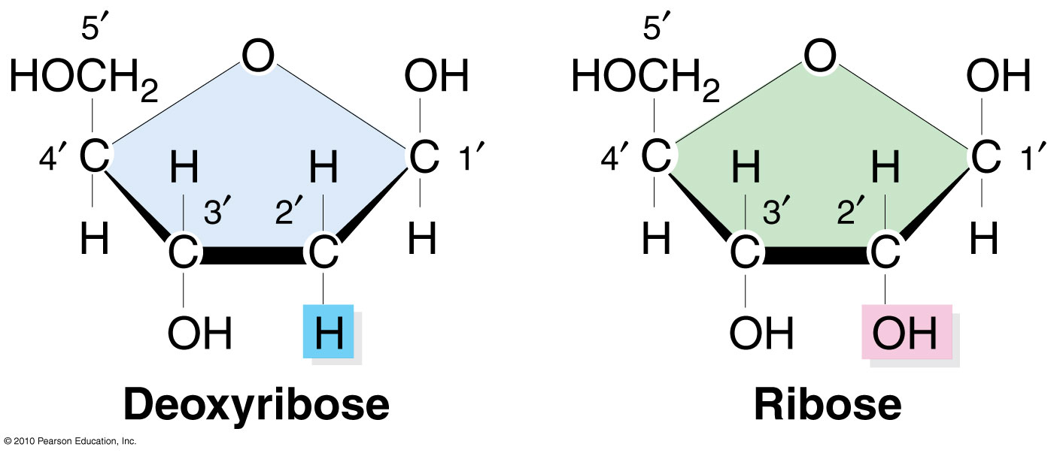
- 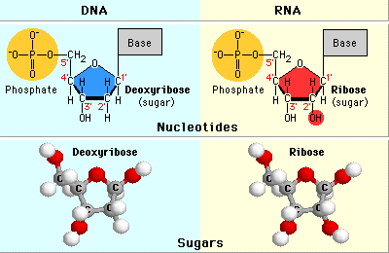
- The Bases:
- Purines: they are aromatic rings, where a 5-membered ring is fused to a 6-membered ring. All of the atoms in a purine are sp2 hybridized, and the rings are flat. Purines have 4 nitrogens, and differ based on substituents attached to the 6 membered ring and all of these purines attach to the sugar through the nitrogen that is usually labeled number 9.
- 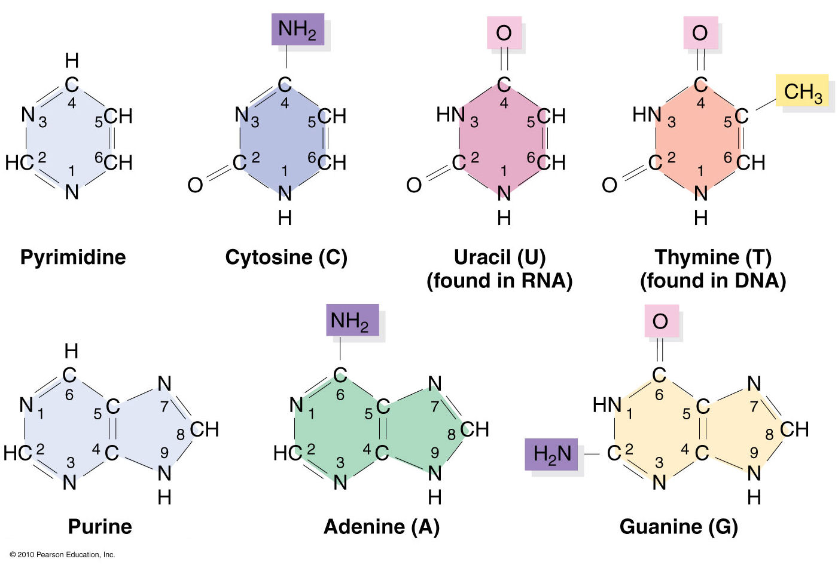
- The other group of bases is the 6 membered bases with 2 nitrogens in the ring and they are called the pyrimidines. We have 3 of them, cytosine, uracil, and thymine. The C and T bases are in DNA and the U base is exclusive to RNA. The U and T are similar and they only differ in the presence or absence of a methyl group, which serves a role in stability.
- All of the bases are aromatic and that causes them to become flat. They are able to generate the polymers they can generate because of their flatness. They can tautomerize (tautomers are structures that differ only in the position of a hydrogen atom) and in general, they are more stable in their keto form than in their enol form. This is important because they hydrogen bond in their keto form.
Link the sugar to the base; formation of water. Draw a phosphodiester link:
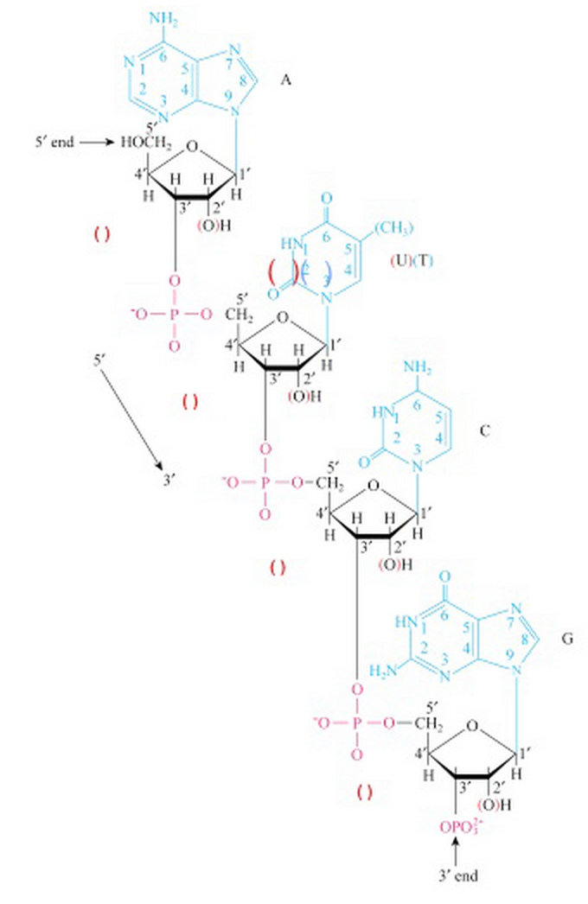

Draw base pairing: A-T, C-G, A-U:
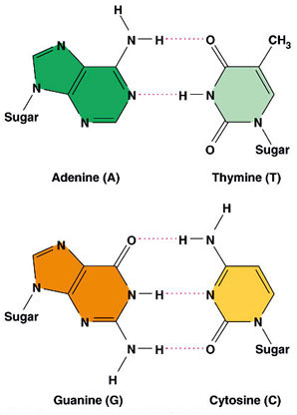
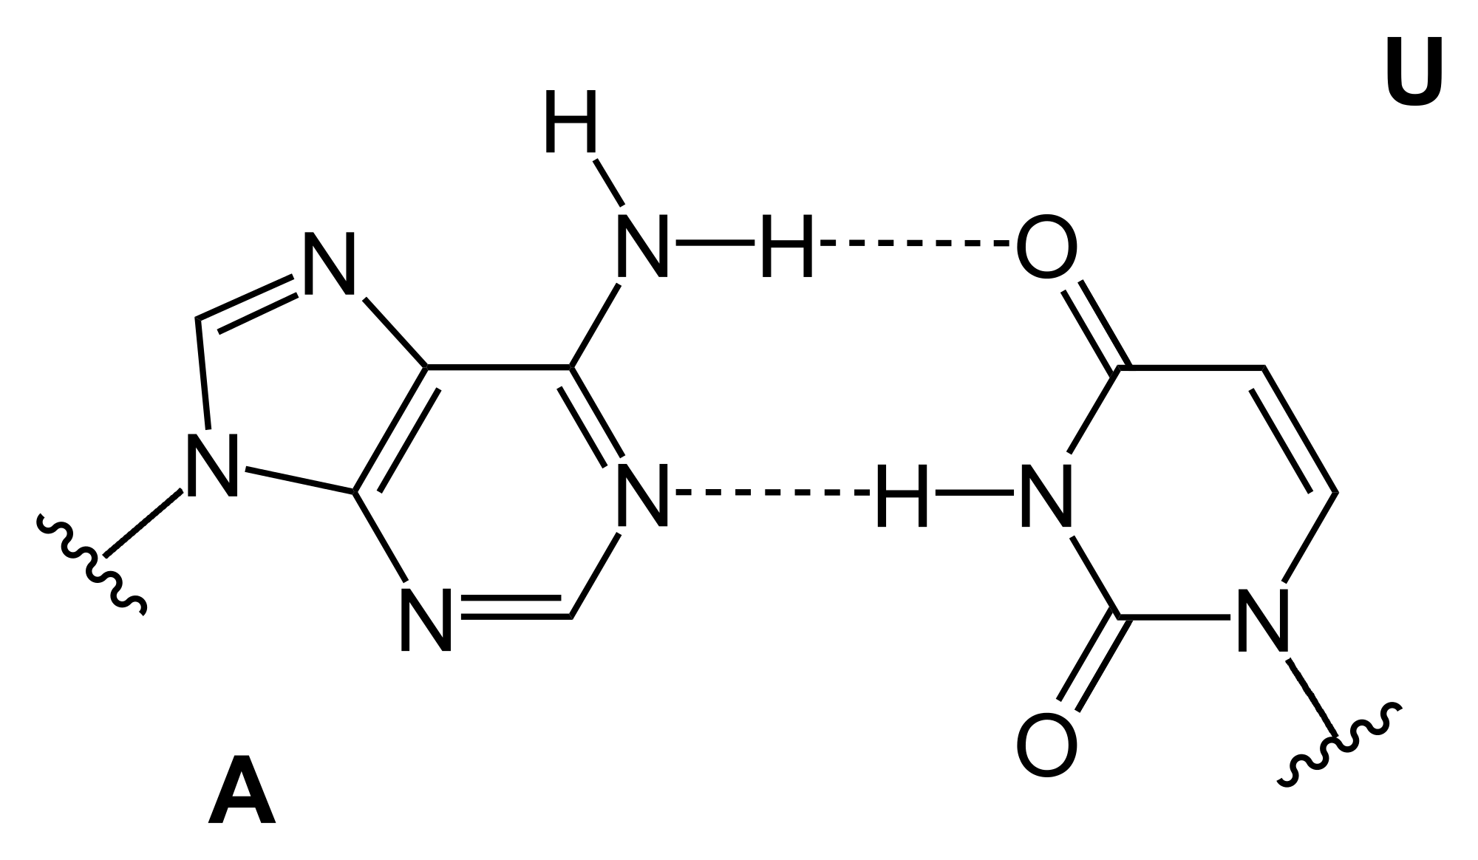

Characteristics of the B Form of the DNA Double Helix
- The B form of the DNA helix is made of 2 chains of complementary polynucleotides turning around the same axis in the right-handed orientation.
- The 2 chains run in opposite directions: one is oriented 5’ to 3’ and the other 3’ to 5’.
- The bases are located inside the helix while sugars are located outside of the helix and the net charge of the helix is negative from the phosphates.
- The planes formed by the bases are perpendicular to the axis of the helix.
- The 2 chains are maintained by hydrogen bonds formed between 2 bases located in the same plane. The forces of the H-bonds are additive and thus contribute to the stability of the double helix.
- Hydrophobic interactions and Van der Waals forces stabilize the helical structure.
- The distance between the phosphorous atom located at the exterior of the helix and the axis of the helix is 1 nm. The width of the double helix is therefore equal to 2 nm.
- A pyrimidine from one chain is always paired with a purine from the other chain, which begets the uniformity of the helix.
- The helix makes one complete turn every 10 nucleotides. The distance between 2 adjacent bases on the same chain is equal to 0.34 nm. A complete turn of the helix therefore measures 3.4 nm.
- The nitrogen atoms linked to the C₄ of the cytosine and to the C₆ of the adenine are taking the amino (NH₂) form instead of the imino (NH) form. Similarly, the oxygen atoms linked to the C₆ of the guanine and to the C₄ of the thymine are taking a keto (C=O) form instead of the enol (C-OH) form. Those configurations impose restrictions to the base pairing: A-T and C-G (rule established by Chargaaf).
- Since Adenine from one chain only pairs with Thymine and Cytosine only pairs with Guanine, the sequence of the nucleotides is fixed and knowing the sequence of a chain, one can deduce the sequence of the other chain.
Describe the forces dictating the structure of the double helix. Why are the bases found in the center of the helix while the sugars are in the periphery of the helix?
- DNA is usually in water, and in order to explain why the bases are found in the centre of the helix, one must look at the structure of water molecules.
- In a pure solution of water, individual molecules will organize in such a way that the number of hydrogen bonds in between individual water molecules would be maximized.
- If this pure water solution has DNA, what will happen is that the water molecules will continue to maximize the number of hydrogen bonds they can form.
- They are more likely to form hydrogen bonds with other water molecules, sugars, and phosphates as opposed to bases.
- The number of hydrogen bonds will be maximized through the formation of those bonds with atoms of the sugar and phosphate rather than with the base, which forces the bases inside and leads to the exposure of the sugars in the periphery.
- Therefore, the water molecules dictate the DNA double helix structure.
Structure Stability of the DNA Double Helix
- H-bonds between complementary bases on opposite strands:
  - 2 H-bonds in A-T pair
  - 3 H-bonds in G-C pair (stronger than AT)
  - Hydrogen bonds in the core of the structure.
  - In there, there is no water.
  - Water could destabilize hydrogen-bonding interactions; therefore, its lack makes those hydrogen bonds very strong and linear.
  - However, in general, hydrogen bonds contribute little to the stability of the double helix.
- Hydrophobic interactions:
- Water molecules tend to hydrogen bond with other water molecules, which excludes the hydrophobic aromatic bases from the water solution. The aromatic bases will tend to stack on top of each other in avoidance of the great force of the water molecules attempting to maximize hydrogen bonding with each other, the sugars, and the phosphates.
- Van der Waals forces “stacked bases”
- Aromatic bases have π-electrons that interact via attractive Van der Waals forces.
- π,π stacking: van der Waals forces are stronger in between the aromatic bases. The dipoles are induced due to asymmetry in an aromatic molecule and therefore there is an induced positive and negative charge, which causes another base to have an induced positive and negative charge to interact with it. Therefore, the easier it is to push the electrons around, the stronger the induced positive and negative charges are. In aromatic rings, there is a delocalized ring of π electrons above and below the plane of the ring, and these electrons are easy to push around and thus the rings become well polarized. There is a strong induced dipole and van der Waals interaction between the aromatic rings.
DNA Double Helix is a Dynamic Structure
- The conformation of a nucleotide unit is determined by the seven indicated torsion angles: six main chain torsion angles (α, β, γ, δ, ε, and ζ) of the sugar-phosphate backbone (covalent bonds), and χ about the glycosidic bond. Torsion angles are subject to a variety of internal constraints that restrict their conformational freedom.

Structural Characteristics of the Double Helix: A, B, and Z Forms :
A short DNA composed of the repeated sequence CG on one strand and GC on the other strand will adapt a Z form when salt concentrations are high. What are the characteristics of the DNA Z form and explain its physiological importance.

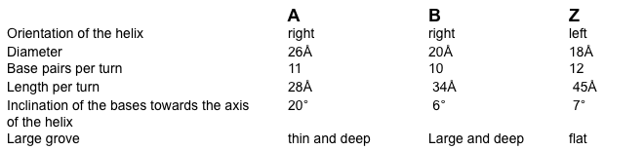
- The characteristics of the Z form of DNA are outlined in the table above in the Z column. It is compared with the A and B forms of DNA.
- A and B forms of DNA are more common in-vivo.
- The Z form is found in regions of DNA rich in C and G and particularly where C residues are methylated. These regions, where C is methylated, are found where promoters are located, which are sequences that regulate the expression of genes.

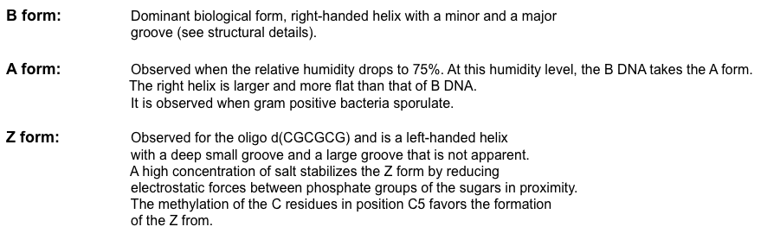

Other Non B Structures of DNA
- The convergence of biochemical, genetic, and genomic studies has demonstrated a new paradigm implicating the non-B DNA conformations as the mutagenesis specificity determinants, not the DNA sequences as such.
- Recent discoveries have revealed that simple repeating DNA sequences, which are known to adopt non-B DNA conformations (such as triplexes, cruciforms, slipped structures, left-handed Z-DNA and tetraplexes), are mutagenic. The mutagenesis is due to the non-B DNA conformation rather than to the DNA sequence per se in the orthodox right-handed Watson-Crick B-form.
- The human genetic consequences of these non-B structures are ∼20 neurological diseases, ∼50 genomic disorders (caused by gross deletions, inversions, duplications and translocations), and several psychiatric diseases involving polymorphisms in simple repeating sequences.

The Effects of Tautomerism on Base Pairing
- The nitrogen atoms linked to the C₄ of the cytosine and to the C₆ of the adenine are taking the amino (NH₂) form instead of the imino (NH) form.
- Similarly, the oxygen atoms linked to the C₆ of the guanine and to the C₄ of the thymine are taking keto (C=O) form instead of the enol (C-OH) form.
- In the keto and amino forms of the bases, the base pairing rules followed are those of chargaaf where A base pairs with T and G base pairs with C.
- In the minor enol and imino forms of the bases, the base pairing rules change. Thymine base pairs with Guanine and Adenine base pairs with Cytosine.
- Important for base pairing. Frequent source of error during DNA synthesis.
- Each of the bases in DNA can appear in one of several forms, called tautomers, which are isomers that differ in the positions of their atoms and in the bonds between the atoms.
- The forms are in equilibrium. The keto form of each base is normally present in DNA, whereas the imino and enol forms of the bases are rare. The ability of the wrong tautomer of one of the standard bases to mispair and cause a mutation in the course of DNA replication is possible.
- Mispairing resulting from the change of one tautomer into another is termed a tautomeric shift.
- All the mispairs possible through tautomeric shifts lead to transition mutations, in which a purine substitutes for a purine or a pyrimidine for a pyrimidine

Genome Packaging in Prokaryotes
How do bacteria, lacking a nucleus, organize and pack their genome into the cell?
- Prokaryotes have a large single chromosome that is circular.
- Packaging this chromosome achieved through supercoiling. The supercoiling is negative, which means that DNA is twisted in a direction opposite to that of the double helix.
- Multiple proteins work together to fold and condense prokaryotic DNA; In particular, the HU protein, the most abundant protein in the process, which works with the enzyme topoisomerase I to bind DNA and to introduce sharp bends in the chromosome generating the tension necessary for negative supercoiling.
- Topoisomerase I and other proteins help maintain supercoiling.
- E.coli: ~4 x 10⁶ bp genomic DNA and bacteria volume: ~1 µm³
- Human cell: ~3.3 x 10⁹ bp genomic DNA and cell volume: ~2000 µm³

Genome Packaging in Eukaryotes: Mitotic Chromosomes
Solenoidal coiling of DNA provides packaging efficiency.
Compare DNA packing of prokaryote and eukaryote genomes.
Characteristic | Prokaryotes | Eukaryotes (Human)
Size | ≈ 4 x 10⁶ bp | ≈ 3.3 x 10⁹ bp
Cell Volume | ≈ 1 µm³ | ≈ 3000 µm³
Nucleus | No | Yes
Chromosome # | 1 | 46
Length of DNA (Not compacted/Compacted) | 1300 µm/1.2 µm | 12000µm/1.4µm  (more efficient at compacting)
Packaging strategy | Supercoiling (-)  Proteins (HU) | Supercoiling (-)  Proteins (Histones)
Condensation Factor | x1000 | x10,000
At the core of the prokaryote genome, there is a protein nucleus around which the loops of DNA are attached.
Eukaryotes package their DNA around histones (protein complex around which the DNA wraps up) the histones cluster together and form a condensed chromosome.
DNA Structural Changes: Supercoiling
- DNA supercoiling is a confirmation that DNA adopts in response to superhelical tension.
- There are some topological constraints that can cause supercoiling.
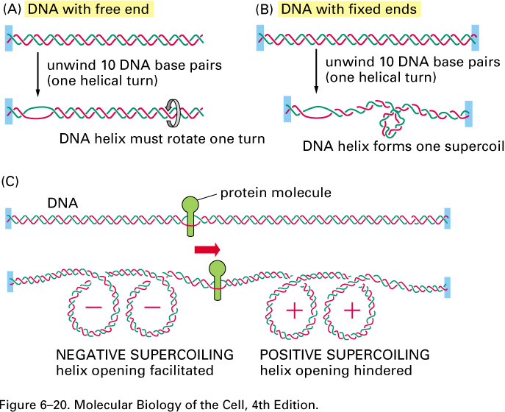
- The first topological constraint to consider is that of DNA with one free end (as is the case if the strand has a nick in its structure). The DNA helix would rotate for one turn for every 10-nucleotide pairs opened. This is shown in case A in the diagram above.
- The second topological constraint to consider is that of DNA with no free end, rotation is blocked, a tension is created in DNA and supercoiling occurs. An example of DNA with no free end is the circular DNA of bacteria. The helix opening only creates tension because rotation is prevented. This tension is accommodated for by the resistance of this deformation in a spring-like fashion preferring to relieve the superhelical tension by bending into supercoiled loops. A supercoil forms for every 10 nucleotides opened.
- Proteins tracking through DNA double helix induce Supercoiling; they create positive supercoils in front and negative supercoils behind.
- Positive supercoiling of DNA occurs when the right-handed, double-helical conformation of DNA is twisted even tighter (twisted in a right-handed fashion) until the helix begins to distort and "knot." Negative supercoiling, on the other hand, involves twisting against the helical conformation (twisting in a left-handed fashion), which preferentially underwinds and "straightens" the helix at low twisting stress, and knots the DNA into negative supercoils at high twisting stress.
The Central Dogma
- Define the Central Dogma:
- Transcription: a section of DNA is copied as mRNA.
- Translation: copies of mRNA are used as templates for the synthesis of proteins.
- Flux of genetic information: DNA → RNA → protein (universal)
- 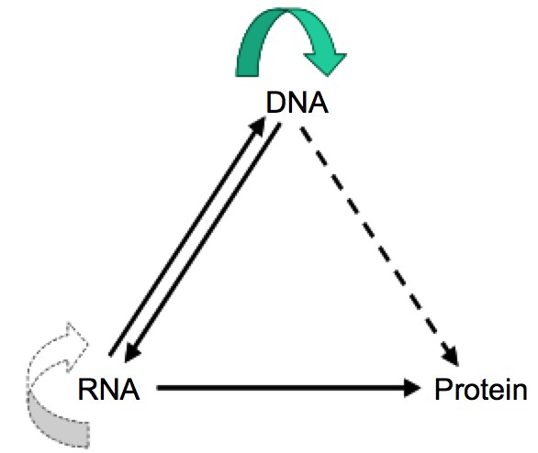
- Information is stored in a sequence of nucleic acids forming DNA. DNA is then transcribed to mRNA, and mRNA is translated to proteins. Crick said that the molecular agent of inheritance is DNA.
- Segments of DNA comprise the genes that, through a series of molecular processes, give rise to each of our inherited traits. Once information has passed into protein it cannot get out again. The protein is the end point of the central dogma.

Interpretation of The Central Dogma
- A series of molecular events leading to the presentation of the genetic traits from the genes. This is a rigid process: the genes control in a unique, universal and absolute fashion the traits that characterize all forms of life.
- The genes govern protein synthesis and proteins, form internal structures of the cell, catalyze chemical events all defining genetic traits. The capacity of DNA to govern protein synthesis is facilitated by similar structures of DNA and proteins; both are composed of specific sequences.

- A gene is distinct from another gene; the order of the 4 different nucleotides forming DNA differs. The same applies for proteins; the sequence of 20 amino acids is different for each protein. The DNA sequence is linked to the protein sequence and the genetic code is universal.
- For each living creature, there has to be a 1 to 1 match between the number of genes and the total number of proteins. The human genome must include the entire genetic heritage and at the same time must confer the distinctions we observe between the different organisms.

- How did the Human Genome Project change the Central Dogma?
- In 2001, the human genome was entirely sequenced. It was expected from the sequencing result, that there would be a 100,000 genes, because there are a 100,000 proteins. The number of genes discovered was 22,000.
- 22,000 genes generate 100,000 proteins by splicing which is the removal of introns from transcribed mRNA.
- Approximately 40% of the genes are alternatively spiced. The RNA sequence originally transcribed is cut in fragments, which are then recombined to generate the multiplicity of proteins. Each protein has a sequence of amino acids that is different from the other protein and which is also different from the unspliced mRNA.
- Through rearrangement of the nucleotide sequences in a multiplicity of new mRNAs, each being different from the unspliced sequence, alternative splicing generates genetic information.
Why is the Dogma not Exact?
- The genetic code is not universal: one codon will form one amino acid. However, mitochondrial mRNA has UGA code for tryptophan rather than stop as it is in the nucleus.

- Error during replication: the error rate is 1/100 with no enzymes added to solution in vitro. With enzymes added to solution in vitro, the error rate is 1/10⁷. With enzymes added to solution and the repair system in vitro, the error rate is 1/10¹⁰. Enzymes are involved in the transmission of information from DNA to proteins.

Enzymes catalyzing DNA synthesis influence the nucleic acid sequence. Therefore the genetic information derives not only from DNA but also from the collaboration of essential enzymes (i.e., proteins).

- Splicing: the splicing machinery is composed of around 60 different proteins and those proteins are responsible for selecting exons from mRNA, which then get translated. The splicing machinery itself is a complex of proteins and those proteins confer a change in the transmission of genetic information.

The splicing unit formed from proteins has different affinities for the various splicing sites on the RNA. Splicing proteins catalyze actively the cuts and ligations of the fragments resulting from splicing. Therefore proteins forming the splicing unit (50-60) contribute to add genetic information generated by alternative splicing.

Proteins can transmit genetic information to nucleic acids.

- Protein folding: once it is translated from mRNA, it has to be folded to be active. Folding is catalyzed by a group of proteins called chaperones, when folding goes wrong the protein is not active or it has different activity, therefore, the chaperones (proteins themselves) influence the transmission of genetic information from DNA to protein.

Chaperons are proteins facilitating the folding of newly synthesized proteins and play an essential role in the cascade of gene expression from gene to protein.

Define the elements conferring structural flexibility to DNA:
- Confirmation of deoxyribose.
- The rotation of all bonds forming the phosphodiester backbone will confer flexibility.
- The free rotation of the glycosyl bond will account for flexibility. It is the one linking the sugar to the base.

