MAT8201 Handout 12
Application of Integrals. Centroids
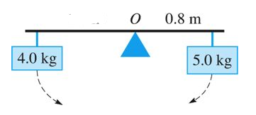

Centre of mass by Integration
Centroid
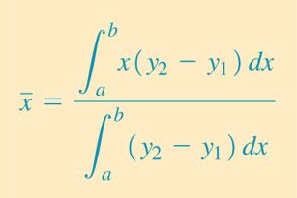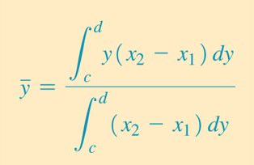
Find the coordinates of the centroid of a thin plate covering the region bounded by the parabola y = x², and the line y = 4

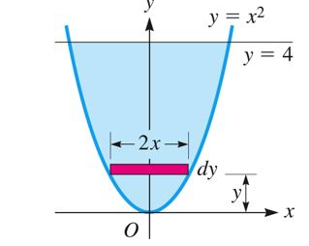

Centroid of a triangular plate with side a:


