MAT8201 Handout 9
Maximum - minimum problems
Example: A rectangular corral is to be enclosed with 1600 m of fencing. Find the maximum possible area of the corral.
There are limitless possibilities for rectangles of a perimeter of 1600 m and differing areas. See Fig. 24.45. For example, if the sides are 700 m and 100 m, the area is 70 000 m², or if the sides are 600 m and 200 m, the area is 120 000 m2.

Example:
The strength S of a beam with a rectangular cross section is directly proportional to the product of the width w and the square of the depth d. Find the dimensions of the strongest beam that can be cut from a log with a circular cross section that is 16.0 cm in diameter.

Example:
A company determines that it can sell 1000 units of a product per month if the price is $5 for each unit. It also estimates that for each 1 cent reduction in the unit price, 10 more units can be sold. Under these conditions, what is the maximum possible income and what price per unit gives this income?

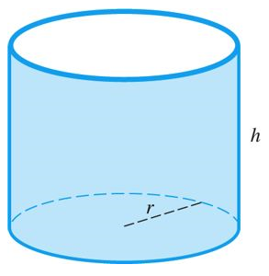
Find the dimensions of a 700-kL cylindrical oil-storage tank that can be made with the least cost of sheet metal, assuming there is no wasted sheet metal.

Derivatives of trigonometric functions

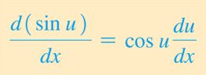

Find the derivative of y = sin 2x

Find the derivative of y = 3 sin(4x +1)

Find the derivative of y = sin² x

Find the derivative of y = $\sqrt{sin⁡(x\text{2 }}$)

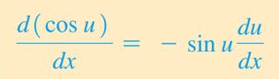

P = 25 cos² 120πt

Find the derivative of y = 5(1 + cos x² )²

Find the derivative of y = $\sqrt{1+cos2x}$

Find the derivative of y = $sin2x\cos{x}$²

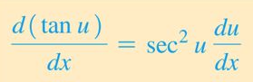

Find the derivative of y = $3\tan{8x}$

Find the derivative of y = tan² (x²)

