MAT8201 Handout 5
Product of functions: (section 23.6, p. 686)
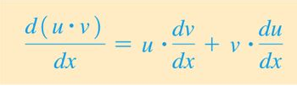
Find the derivative of

Find the derivative of

Find the derivative of

Derivative of a quotient:
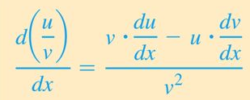
Find the derivative of
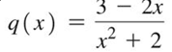

Find the derivative of
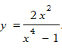

Evaluate the derivative of:
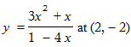

Practice:
Find the derivatives:



