MAT8201 Handout 2
Function continuity:
F(x) = 3x² :
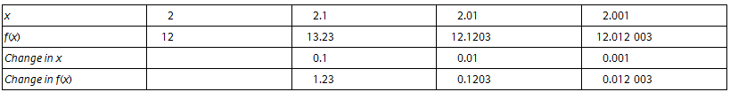
Function: f(x) = $\frac{1}{x -2}$ discontinuous at x = 2
Limit of a function
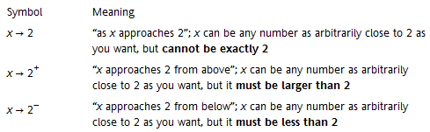
Example limit of f(x) = 2x + 1 as $x→2$

Function is continuous at x = a if:
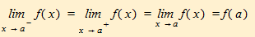
Finding a limit using a table:
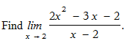

Practice:
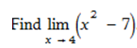
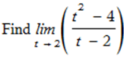
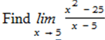
Limit as x approaches infinity
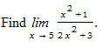

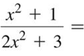

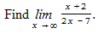
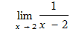
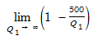
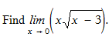
Determine the values of x for which the function is continuous:
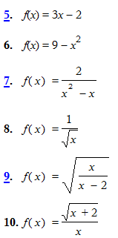
Graph the functions and determine the values of x for which the function is continuous:
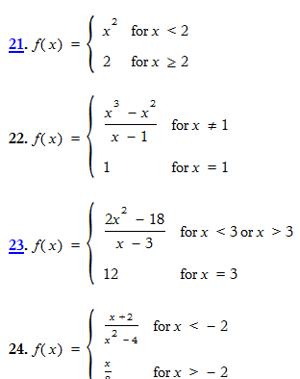

Find limits:


