MAT8201 Handout 1
Order of operations:
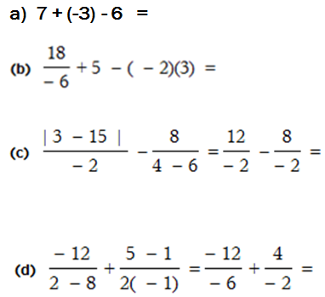
Exponents: Simplify:
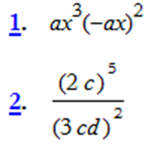
Simplifying – nested grouping symbols:
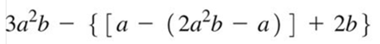
Factoring:
3cx³ − 9cx
9cx³ − 3cx
6a⁵x² − 9a³x³ + 3a³x²
9c² − 64
18c² − 128
x² − x − 2
x² − 4x + 4
4x² + x − 5
Fractions
Simplify:
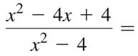
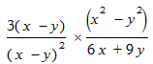

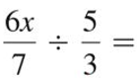
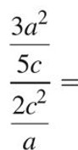
$\frac{\frac{2}{3}}{\frac{5}{7}}$ =
$\frac{\frac{2}{3}(a+b)}{5 (c+d)}$ =
$\frac{2(a+b)}{\frac{5}{7}(c+d)}$=

Addition / Subtraction
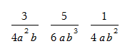
Find the LCD:
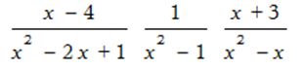

Practice evaluation:


