“Basic cellular physiology and the anatomy and Physiology of the cardiovascular Lymphatic and Respiratory Systems”

Chemical | Atoms, molecules; & organelles
Cellular | Cells
Tissue | Groups of similar cells
Organ | Contains two or more types of tissue
Organ System | Organs that work together
Organismal | All organs

Atom: Smallest particle of an element with all of the properties of that element
-What are the different parts of an Atom? Atoms are tiny building blocks of matter, which combine to form molecules such as water and protein.

Molecule: Smallest amount of a substance that can exist alone; which contains a combination of atoms

Organelle: Molecules associate in specific ways to form organelles; basic components of living cells
-Give 5 examples of organelles: Nucleus, mitochondria, ribosomes, chloroplast and lysosomes

Cells: Fundamental structural and functional unit of a living thing; cells vary widely in size and shape, which reflects unique functions in the body

Tissue: Groups of similar cells that have common function
Ex: & indicate main functions of these tissues
- Epithelium: covers the body surface & lines its cavities
- Muscle: provides movement
- Connective tissue: supports and protects body organ
- Nervous tissue: provides a means of rapid internal communication by transmitting electrical impulses.

Organ: Structure composed of 2 (but 4 is more common) tissues types that perform a specific function of the body.
-Give an example of an organ, and describe how each of its tissue types contribute overall role of function in the body? The stomach’s lining is an epithelium that produces digestive juices. The bulk of its wall is a muscle, which churns and mixes stomach contents (food). The connective tissue reinforces the soft muscular walls. Its nerve fibers increase digestive activity by stimulating the muscle to contract more vigorously and the glands to secret more digestive tissues

Organ system: Organs that work closely with one another to accomplish a common purpose
-Name some organs associated with each of these systems? The heart and the blood vessels of the cardiovascular system circulate blood continuously to carry oxygen and nutrients to all the body cells.

Plasma Membrane:
- Plasma membrane is considered a fluid because the phospholipids and many other molecules in the membrane can move about laterally and sometimes from one side of the bilayer to the other (they are not linked together by chemical bonds)
- Function
Transport
Enzymatic Activity
Receptors for signal transduction
Intercellular joining
Cell-cell recognition
Attachment to the cytoskeleton and extracellular matrix
Extra Information
- The phospholipid bilayer forms a barrier to large polar molecules
- Phospholipids
- A glycerol backbone with two fatty
- Acids + phosphate containing group
- Majority contain polyunsaturated fatty acids (PUFA) increase membrane fluidity
- Mosaic structure of plasma membrane – proteins dispersed in the lipid bilayer those that are not anchored, constantly change their position
- Two classes of membrane proteins
- Integral membrane proteins embedded within the lipid bilayer; some of them Transmembrane proteins
- Peripheral membrane proteins – loosely attached to integral proteins or membrane lipids
- Saturated fatty acids (SFA) in phospholipids lipid rafts more stable, less fluid, involved in cell signalling

Mitochondria:
- Rod-shaped; double membrane, smooth outer and folded inner membrane (cristae), matrix
- Granules (calcium phosphate)
- Function
Powerhouse of the cell aerobic metabolism of glucose and fatty acids ATP production
Self-replicating (own DNA, RNA& ribosomes)

Ribosomes:
- Small, dark-staining granules of protein + rRNA;
Large + small subunits
- Function
Site of protein synthesis
Extra Info
- Two flexible distributions of ribosomes:
Free ribosomes produce soluble proteins
Membrane-bound ribosomes (ER)
Produce proteins primarily for membrane or export

Rough Endoplasmic Reticulum:
- Flattened sacks with ribosomes containing complexes of RNA and proteins
- Continuous with outer membrane of the nuclear envelope
- Abundant presence in secretory cells, antibody-producing cells, liver cells

Smooth endoplasmic Reticulum:
- Smooth tubules, no ribosomes
- Synthesis of cholesterol, steroids, lipid components of lipoproteins absorption, synthesis and transport of lipids in the intestine detoxification of drugs, certain pesticides and carcinogens breakdown of glycogen to glucose
- SER of muscle cells is specialized in storing calcium

Golgi Apparatus:
- The Golgi apparatus consists of stacks of flattened sacks called cisternae; Cis side of Golgi apparatus faces the endoplasmic reticulum, trans side plasma membrane
- Packages, modifies and concentrates proteins for secretion from the cell, inclusion in lysosomes and incorporation into the plasma membrane
- 3 destinations for Golgi Derived Vesicles: Phagosome, Vesicle incorporated into plasma membrane and secretion by exocytosis

Lysosomes:
- Spherical structures surrounded by a single membrane (bud off the Golgi apparatus); contain digestive enzymes
- Function
Safe environment for cellular digestion (contains 30 hydrolytic enzymes)
1. Following endocytosis – digestion of bacteria,
Viruses, toxins
2. Breakdown of non-useful tissue: fatal development menstruation, bone recycling
3. Metabolism: e.g.: of glycogen, thyroid Hormone release,
4. Organelle replacement

Peroxisomes:
- Most abundant in the liver and kidney cells
- Are formed by budding off the endoplasmic reticulum
- Spherical sacs, similar to lysosomes (smaller)
- Single membrane
- Contain enzyme
- self-replicate
Function
The degradation of molecules (fatty acids, amino acids, toxic foreign matter)
Most important Inactivation of free radicals (highly reactive chemicals with unpaired electrons - eg: O₂⁻, OH⁻)
- oxidase enzymes convert free radicals to H₂O₂
- catalase enzyme then converts H₂O₂ to H₂O
Catalase
2H₂O₂ 2H₂O + O₂

Microtubules:
- Provide strength to the cytoskeleton
- Form spindle fibres during cell division
- Assist with directional movement of vesicles with large biomolecules within the cytosol
- Are components of cilia and flagella
- Cilia: Ex respiratory tract - propel mucus laden with dust & bacteria up & away from lungs
- Cilia propel substances across cell surface while flagellum propels the cell

Microfilaments
- Main organelle for Microfilaments: Cytoskeleton
- Thin strands of contractile protein: actin – dynamic protein; cell shape & cell motility, separation of cytoplasm during cell division, structural support (microvilli)

Intermediate Filaments:
- Tough, rope-like protein fibbers, more stable than microfilaments
- Example: keratin (skin, hair), myosin (muscle)

Centriole:
- Organize mitotic spindle, role in cytokinesis; form basis for cilia and flagella basal bodies; 9 triplets of microtubules - source of microtubules; formation of mitotic spindle, base of cilia, flagella

Flagella:
- Exists ONLY in sperm - Microtubules organelle which moves sperm

Cilia:
- Move things along
- For example respiratory track

Microvilli:
- Are minute, fingerlike extensions of the plasma membrane that project from an exposed cell surface
- They increase the plasma membrane surface area and are usually found on the surface of absorptive cells ( ex intestinal and kidney tubule cells)

Nucleus:
- The nucleus – cell’s largest organelle;
- Control center (“headquarters”) contains the genetic material responsible for transmitting genetic information and providing the instructions for protein synthesis
Extra Information
- Most human cells have one nucleus
- Some cells are multinucleate (e.g., skeletal muscle)
- Mature red blood cells anucleate (no nucleus; cannot reproduce)

Nuclear Membrane/Nuclear Envelope:
- Selectively permeable double membrane with large pores
- Separates the nucleoplasm from the cytoplasm; regulates passage of the substances to and from the nucleus

Nucleoli/Nucleolus:
- Spherical structures composed of RNA and protein; nucleolar organizer regions DNA with instruction for ribosomal RNA synthesis site(s) of ribosome assembly

Chromatin:
- Threads of 30% DNA combined with 60% histone proteins and 10% RNA; the fundamental units- nucleosomes
- DNA site of genetic information

Tissue:
Group of structurally similar cells that perform common/related function

4 Primary Tissue Types are:
- Nervous: control (regulation)
- Muscle: movement
- Epithelial: covering
- Connective: support

Define the epithelial tissue; list 6 functions associated with Epithelia

Epithelial Tissue:
- Sheet of cells that covers a body surface or lines a body cavity (creates boundaries) covering and lining Epithelium (ex Digestive Tract), and Glandular Epithelium
It also lines other Hollow organ
Functions
Protection: (mechanical, chemical, infectious) skin
Absorption: GI Tract
Filtration: Kidney
Excretion-Kidney
Secretion- Glands
Sensory Reception- Taste buds, olfactory membranes

7 special structural characteristics of epithelial tissue

Specialized contacts: tight junctions and desmosomes (why?)
They bind adjacent cells together at many points, the tight junctions help keep proteins in apical region of the plasma membrane from diffusing into the basal region to maintain the epithelial polarity

Polarity: apical and basal surfaces; apical surface often specialized such as having…
All epithelia have an apical surface, which is an upper free surface exposed to the body exterior or the cavity of an internal organ, and a lower attached to the basal surface (both functions are different)

Basal Lamina: noncellular, underlying supportive sheet of primarily glycoproteins
What are two functions of a basal Lamina?
The basal lamina acts as a selective filter that determines which molecules diffusing from the underlying connective tissue are allowed to enter the epithelium; it also acts as scaffolding along which epithelial cells can migrate to repair a wound.

Supported by a connective tissue: basement membrane= basal lamina + underlying reticular CT
Extra Info
All epithelial sheets are supported by the connective tissue; deep to the basal lamina there is the reticular lamina (layer of extracellular material including collagen protein fibbers that are under the connective tissue.) The two laminae form a basement membrane, reinforces the epithelial sheet, & helps resist stretching and tearing.
An important feature of cancerous epithelial cells is failure to respect the boundary imposed by the basement membrane

Innervated but avascular: How nourished?
Although the epithelium is avascular (no blood vessels), it is also innervated (supplied by nerve fibber’s). The epithelial cells are nourished by substances diffusing from the blood vessels in the underlying connective tissue.

Regeneration: high regenerative capacity-why?
Some epithelium are exposed to friction and the surface cells rub off, where others are damaged by hostile substances (bacteria, acids, smoke); when the apical basal polarity and lateral contact are destroyed, the epithelial cells start to reproduce rapidly (as long as epithelial cells receive there nutrition, they can replace lost cells by cell division)

All epithelial tissues have two names
- One indicates shape of the cells (simple epithelia)
- One indicates number of cell layers (stratified epithelia)
Cell shape
- Squamous cells: flattened and scale like
- Cuboidal cells: boxlike, they are as tall as they are wide
- Columnar cells: tall and column shaped
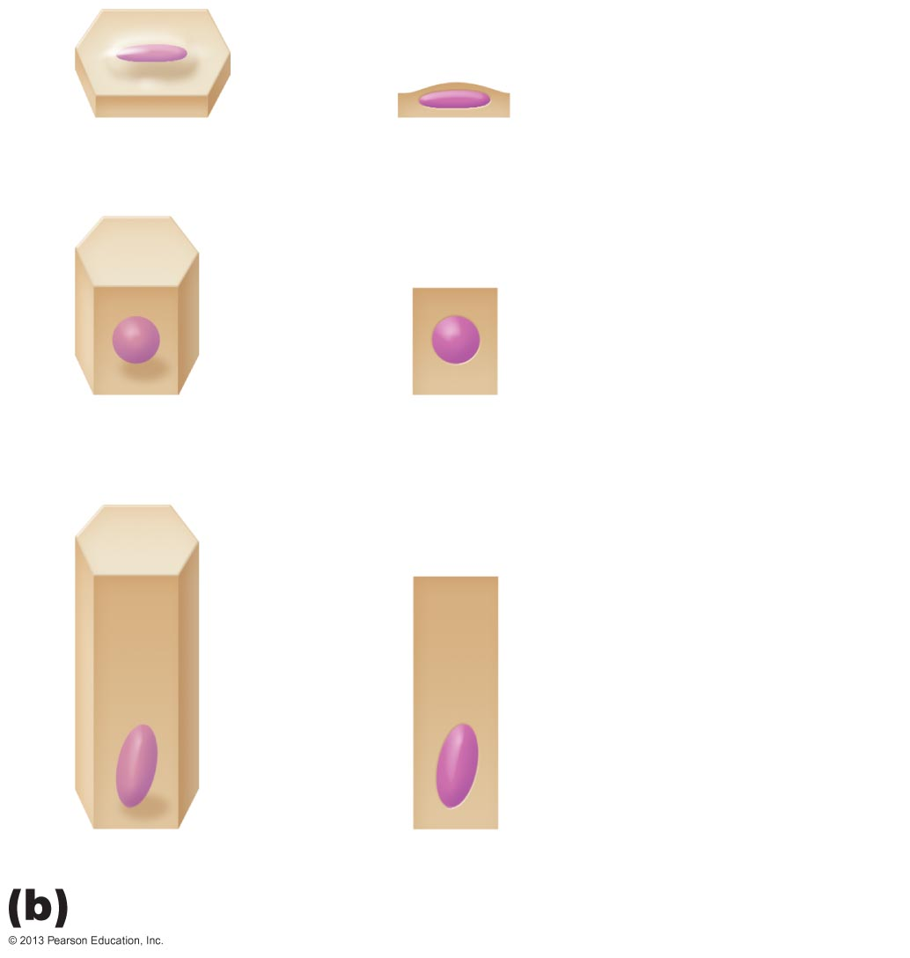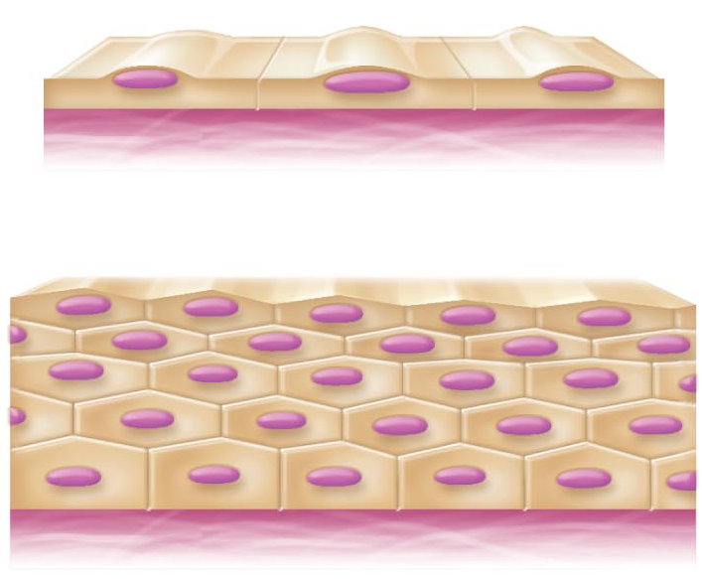

Examples of Simple Epithelia: (absorption, secretion, filtration)
1.Simple Squamous Epithelium: thin & permeable - filtration, diffusion
eg: endothelium & in kidney, lungs
2.Simple Cuboidal epithelium: secretion & absorption –
eg: kidney tubules, small glands
3.Simple Columnar epithelium: also digestion & secretion
eg. digestive tract
4.Pseudostratified columnar Epithelium: a single layer - eg: respiratory tract where cilia and mucus secretion are local specializations
- Transitional epithelium (not simple!): is stratified in which the shape of the surface cells changes (undergoes transitions) depending on the degree of stretch
- Lines the bladder, an organ that has to fill – the basal layers are columnar to cuboidal and the apical layers become increasingly flattened & squamous-like as filling occurs

Describe the structure of stratified squamous epithelium and give a sample body location
- Two or more cell layers
- Regenerate from below
- Basal (cuboidal) cells divide, cells migrate to surface
- More durable than simple epithelia
- Protection is major role
- Sample body location: esophagus

Gland: one or more cells that make and secrete a particular product
Glands are
1) Endocrine: ductless, products are called hormones
2) Exocrine: mucous, sweat, oil/salivary glands, liver, pancreas, etc.

Unicellular exocrine glands:
- No ducts because only one cell!
- Really just the goblet cells (digestive & respiratory tracts)

Multicellular exocrine glands:
Classified by structure and type of secretion
Epithelium-derived duct & secretory cells; surrounded by supportive CT which brings blood vessels & nerves

Multicellular exocrine glands:

Secretory method
Merocrine/eccrine: Exocytosis: most common type. Ex pancreas, salivary glands most sweat glands
- Holocrine: cell rupture; only sebaceous glands
- Apocrine: cell apex pinches off with secretory product

4 major types: CT proper, cartilage, bone, blood

Major functions of Connective Tissue:
- Binding or support
- Protection
- Insulation
- Transportation

Three structural elements:
  - Ground substance
  - Fibers
  - Cells

Composition and arrangement varies in different connective tissues

Ground Substance
Interstitial fluid + cell adhesion proteins & proteoglycans: molecular sieve
• fibronectin, laminin - help cells attach to CT elements
• Proteoglycans -consist of a protein core where glycosaminoglycans(GAGs) are attached.

Fibers:
(3 types to provide support)
- Collagen fibers: high tensile strength
- Elastic fibers: elastin has coiled structure to allow stretch + recoil
- Reticular fibers: thin collagen protein; fine network to support blood vessels, soft tissues

Cells
Immature (“blast”) forms vs mature (“cyte”) forms
• “blasts” are actively dividing/synthesizing cells during growth & repair
• “cytes” primarily provide a level of maintenance

TYPES OF CT:
CT Proper: 2 subclasses
- All connective tissues except bone, cartilage and blood
- Two subclasses
  - Loose connective tissues
    - Areolar; Adipose; Reticular
  - Dense connective tissues (also called fibrous connective tissues)
    - Dense regular; Dense irregular; Elastic

Loose connective Tissues

AREOLAR CT
Gel-like matrix with all 3 fiber types; cells = fibroblasts, macrophages, mast cells, & some WBCs
Description: loose arrangement of fibers; reservoir of water & salts but is also a prime site of edema during inflammatory reaction
Location: widely distributed under epithelia of body
Function: cushioning of organs, immunity (macrophages) & inflammation; fluid reservoir

ADIPOSE TISSUE:
Areolar CT modified to store nutrients; adipocytes
Description: fat-filled adipocytes with displaced nuclei; do not reproduce; scanty matrix
Location: under skin, around kidneys & eyeballs, in bones & within abdomen, in breasts; 18% of average wt (15% ♂ & 22% ♀)
Function: fuel reservoir, insulation, supports & protects organs
RETICULAR CT:
like areolar CT, but only reticular fibers
Loc: lymphoid organs (lymph nodes, bone marrow, spleen)
Fcn: fibers form soft internal skeleton that supports free blood cells

DENSE REGULAR CT:
bundles of collagen fibers running parallel to direction of pull white, flexible tissue with great resistance to tension
Loc: tendons (??? to ??), ligaments (?? to ?? at joints), also aponeuroses
Function: attachment with strength

DENSE IRREGULAR CT:
same as regular, but collagen bundles thicker & arranged irregularly
Location: dermis, submucosa of digestive tract, fibrous capsules of organs & joints
Function: withstand tension exerted in many directions; strength
ELASTIC CT:
like dense regular CT, but a very high content of elastic fibers; found in some very elastic ligaments; walls of large arteries

CARTILAGE
Features between dense CT & bone tough, but flexible
- Avascular, devoid of nerve fibers
- Ground substance contains lots of the GAGs chondroitin sulfate & hyaluronic acid - also chondronectin, (adhesive protein)
- Collagen fibers (can have some elastic fibers)
- up to 80% H₂O

BONE
calcium salts give hardness & strength for support/protection of softer tissues; cavities for fat storage & synthesis of blood cells
Osteoblasts: bone-forming cells that secrete from the bone matrix
Osteocytes: mature bone cells that occupy spaces that conform to their shape, they monitor and maintain the bone matrix
Osteoclasts: giant multinucleate cells located at sites of bone resorption

BLOOD
classified as a CT because it consists of cells (RBCs, WBCs) surrounded by a nonliving fluid matrix, blood plasma
“fiber” components are soluble protein molecules - only visible during clotting

