Module 3 Notes
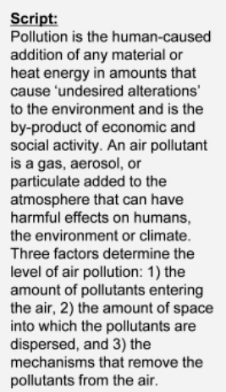
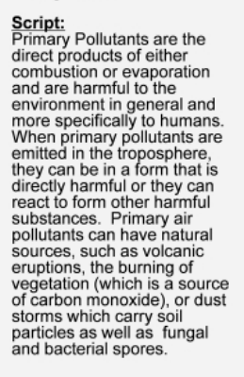
Secondary pollutants are products of the interaction of primary pollutants with constituents of atmosphere and light from sun. 2NDARY pollutants can have harmful effects to environment and humans
Include chems like
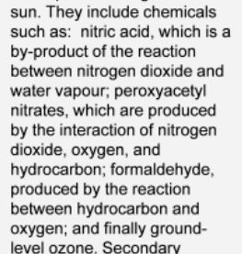

Sources of air pollution:
POINT SOURCE= Fixed locations=
Fugitive sources: open areas exposed to wind action e.g.result of land clearing
Area sources: well defined areas within which there are several air pollutants e.g. small urban communities
Mobile sources: mobile sources that move from place to place while emitting pollutants

Ozone tri-atomic form of oxygen essential to life on earth majority of atmospheric 97% found in stratosphere 14-50 km above earth’s surface where it forms natural combines with oxygen, concentration here is less than 0.002 and this small quantity shields plans, animals and humans from UV radiation. UV is absorbed by O3 turning it into 02 and 0. Then they reform into 03

Review Q: Single Factory spewing shit on a hill is a point, area, fugitive or mobile source?
A: Point source

Major atmospheric pollutants
Sulfur dioxide
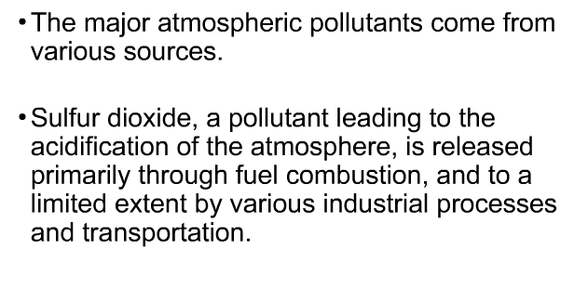
Nitrogen oxide
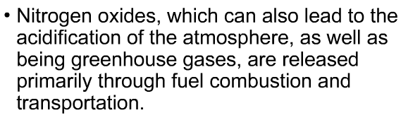

Sources of volatile organic compounds (VOCs)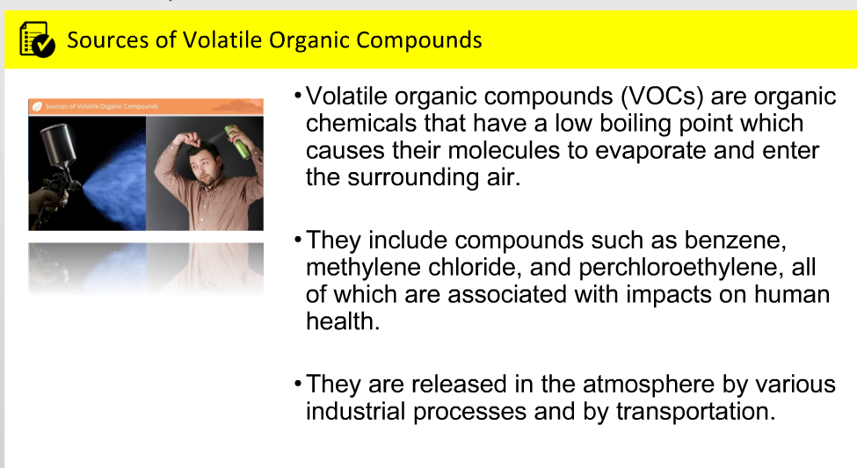

Chroloflurocarbons (CFCs) used to be wudeky used in spray cans and shit. They migrate to the upper atmosphere and destroy the ozone layer since UV rays break down CFCs into chlorine that breaks O3 or ozone apart. Cl attacks O3>creates ClO and O2>ClO binds with 02>Cl is formed again and attacks more ozone (o3)

Thus a single atom of chlorine (cl) can elminate many O3 (ozone) molecules

Ozone concentrations have been decreasing specifically around the poles, with the lowest being around there due to high Chlorine monoxide (ClO) concs.
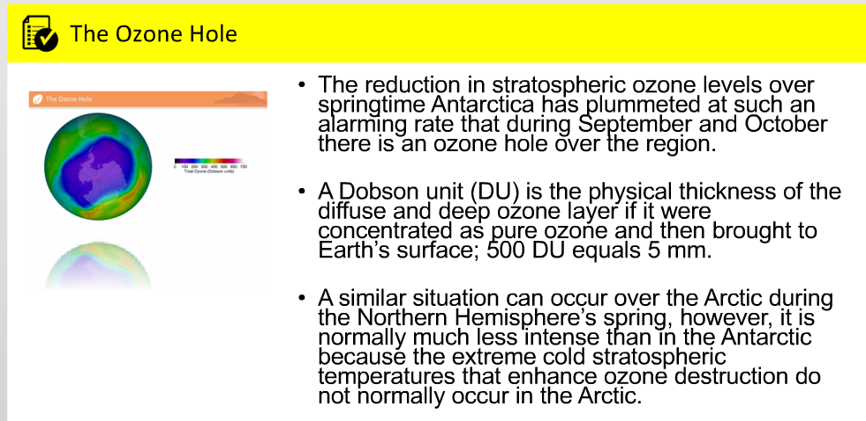

Ozone destruction peaks over the southern hemisphere and persists throughout spring. CFCs were phased out around the 1980s and hydroCFCs are used instead

Week 2 Readings and notes:
Ross Chapters 1-3
Meteorology is the study of weather and climatology which is the study of climate
Climate is decades worth of data, weather is conditions at a certain moment in time
Net result of human caused changes to climate=global warming
Earth-atmosphere system has 4 major parts:
Lithosphere: rocks
Biosphere:all life
Hydrosphere: all water, ice is cryosphere
atmosphere.

Pressure decreases with heigt in the atmosphere cuz pressure results from weight of the overlying atmosphere i.e. highest pressure at the surface
Density decreases with height in the atmosphere because air is compressible

Layers of atmosphere: starting with the lowest
Troposphere: extends from the surface to the tropopause
Stratosphere
Mesosphere: temp decreases with height
Thermosphere: top layer,
Water vapour is the most variable gas in the atmosphere

Ch.3
When Temp is constant volume and pressure of a gas are inversely proportional this is Charles law

