- Know what understands which aspects of DNA? Structure? Base sequences?

- Which of these “signals” in DNA is understood as DNA?
  - Promoter
  - SD Box
  - Start Codon
  - End Codon
  - Terminator
- Answer: Promoter (it is used in the DNA form)
- SD Box and Start and End codon are used in the RNA form.

- Lactose and Lies

- Lactose metabolism is regulated by the lac Operon in E.coli

- E.coli is able to grow on lactose and degrade lactose and gain energy from it because of galactosidease which breaks down lactose into galactose and glucose.
- Galactosidease has a side reaction, that creates just an isomer of lactose called Allolactose.

- 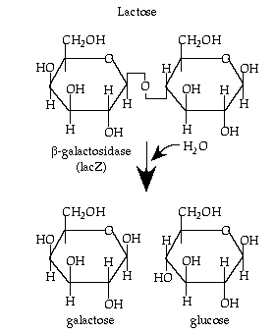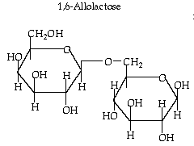

- Wild type phenotype is “inducible”

- galactosidease
- expression

^ Time

Lactose Added

- Normally there is always some activity of galactosidease, but when we add some lactose, the galactosidease expression began to increase.
- This is normal, and we call this type of phenotype ‘inducible’
- The lac Operon is considered to be inducible by lactose.

Mutant Phenotypes Lack Inducibility

lacl^-

Lac operon

Expression

lacZ^-

Time
- Two different kinds of mutants
  - lacl- was not inducible (it was constitutive expression) (always expresses lots of galactosidease)
  - lacZ- was not inducible (it was constitutive expression) (doesn’t express any galactosidease)

- Gene Machine – The Lac Operon

- Lactose transport genes
- lacZ gene – galactosidease
- lacY gene – permease gene (transporter for lactose into and out of cells)
- lacI gene – a protein called the repressor

- The lacZ gene and the lacY gene both share the same promoter.
- This is one of the fundamental components of an operon. Several genes all under the control of one promoter. If you need galactosidease, then you need the permease, so why not put them under the same promoter.

- The lacI gene is a separate gene with its own promoter, and its product is the repressor. The repressor is a DNA binding protein, that binds to what is know as the operator, which is the region to where the repressor binds. This prevents the genes following the operator to not be translated.
- The repressor can naturally detach from the operator based on the equilibrium of the reaction.

- When we introduce the E.coli to a lactose environment, will all genes active, there will be a little bit of each protein produced. When lactose is converted to allolactose, it binds to the repressor, inhibiting the repressor from binding with the operator.

- If the lacZ is mutated, then there is no enzyme to break down lactose, but there is still permease proteins so, the concentrations of lactose rise in the cell but the lactose won’t be broken down.

- *Haffie expects us to be able to tell the phenotype based off of knowing which genes are mutants, and also predict which genes are most likely mutated based off of know the phenotype.

- lacI {Promoter, Operator, lacZ lacY lacA} operon
- 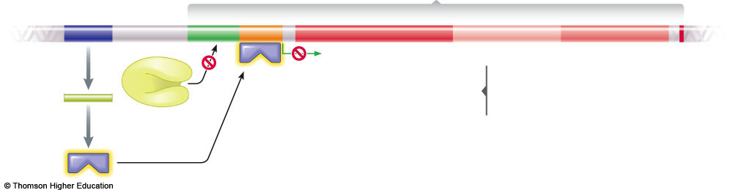
- Lac repressor (active)

- 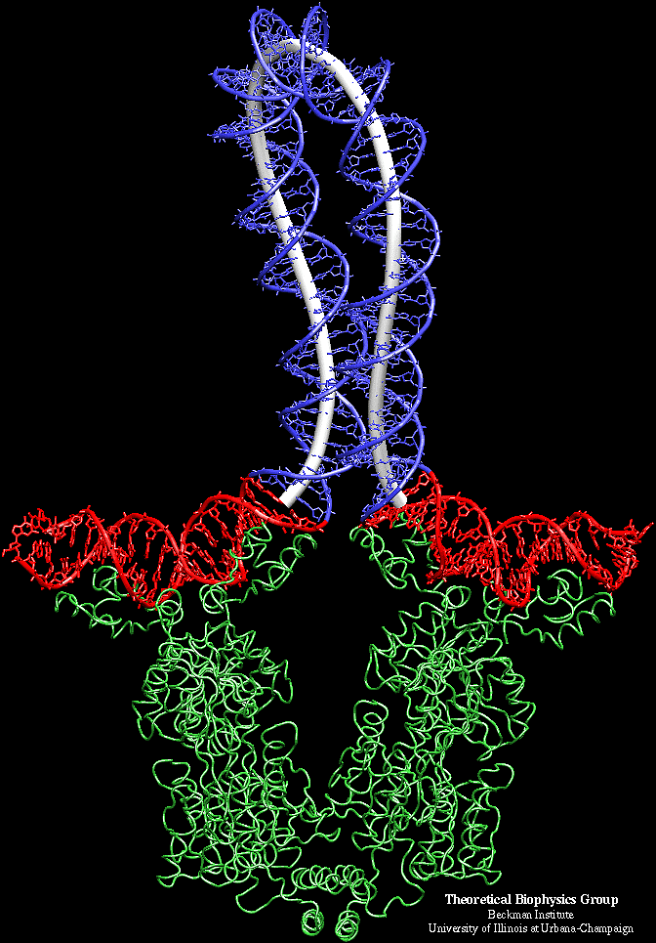
- Red=operator of the operon
- Blue = part of the operator
- Green = two molecule of repressor protein work together to bind onto the operator. It works as a dimer, one molecule of repressor binds with another and they work together to bind to the operator to stabilize the blue strand. The blue loop is not a hairpin loop. A hair pin loop is single stranded, this is double stranded.
- This is considered negative control. When repressor binds to the DNA, and transcription goes down. That is negative control.
  - As [lactose] increase, the repressor comes off of the operator, transcription speeds up and the cell can grow on the sugar.

- Lac expression is also under positive control by CAP/cAMP
- Cells prefer to use glucose rather than lactose if it is available.
- The Lac operon needs a way to know that glucose is available.
- Another binding site does this.
- CAP/cAMP binding (Catabolite activator protein) is a DNA binding site. Proteins bind on there to regulate transcription. It is upstream of the lac promoter.
- That is the site the cell uses to detect the presence of glucose.
- DNA often sense the environment through the binding of proteins.
  - CAP binding is a positive control. When CAP binds onto the DNA, transcription goes up.
  - CAP can only bind to the DNA only if that protein is already bound to cAMP (cyclic AMP) is required in order for CAP to bind onto the DNA
  - Glucose coming into the cell, the availability of glucose into the cell, consumes the cAMP. High levels of glucose result in low levels of cAMP, therefore less cAMP is available to bind with CAP, therefore CAP is less likely to bind the DNA, therefore expression of the lac operon goes down in the presence of glucose.

- CAP binding requires cAMP (only available at low [glucose])

- Both negative and positive control are going on at the same time, depending on which sugar is available.
- Two molecules of CAP (working as a dimer) bind that CAP/cAMP binding site, and it just distorts/bends it a little bit. That bending of the helix makes the lac promoter more attractive to polymerase and transcription levels increase.
- 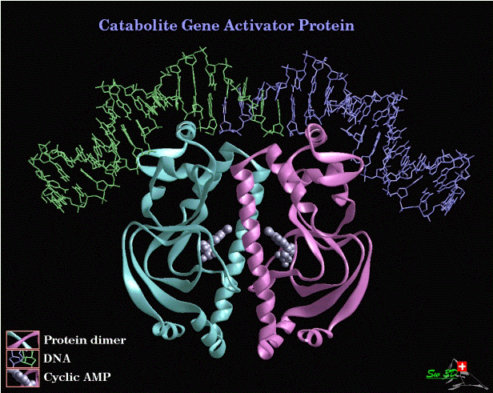

- Lac Operon goes full blast when:
  - We have lactose (repressor is inactive)
  - No glucose so we have lots of CAP bound.

- In the trp operon of E.coli, the presence of tryptophan promotes binding of the trp repressor resulting in decreased expression. Is this an example of positive or negative control?

- Negative control.

- Lac Operon: what would be the phenotype of various mutations?
  - lacI gene to make repressor insensitive to allolactose
  - promoter of CAP that stop expression
  - in CAP gene to decrease cAMP binding
  - lacY gene to decrease activity
  - lac promoter to increase affinity of RNA polymerase

