Biology 1002 B Lecture 18-26 and Independent Study Outcomes

LECTURE 18: CANCER
- Nixon declared war on cancer in 1971; 45 years later, it still exists today
  - US was most technologically advanced society at the time
- Death rates due to cancer have remained stable since then
  - We have had some local success (ie. a decrease in the rate of children developing leukemia)
Lecture Outcomes:
four most common types of cancer in Canada:
- Lung cancer
- Prostate cancer (M)
- Colorectal (colon) cancer
- Breast cancer (F)

likely factors contributing to cancer incidence in Canada:
- Leading cause of premature death in Canada
- Cancer is progressive (happens/develops in stages) and so is more common in aging populations
  - In western culture, people are much older
- Men are at a higher risk of dying from cancer than women
  - 20% chance for women (40% will develop it)
  - 25% for men (45% will develop it)
- 25% of Canadians can expect to die from cancer
  - Youth rates are rising
- Heritability of overall cancer types from twin studies is low (0.27-0.42)
  - Heritability of Cancer: how much of the variability in cancer incidence can be attributed to the variability in genetics?
  - Indicating a high environmental component (colon and lungs directly in contact with outside world) and hormonal influences

role of cyclin/CDK complexes in cell cycle regulation:
- Embryology requires rapid cell division (zygote divides by mitotis into millions of cells that form an embryo)
  - Most cells in our body right now are NOT actively cycling
- Checkpoints are mediated by protein complexes (CDK- cyclin dependent kinase)
  - Kinases phosphorylate targets; they add phosphate groups to proteins (post-translational modification)
    - CDK is only active when bound to cyclins (post-translational modification)
    - CDK cyclin complex phosphorylates target proteins that allow cells to get through their checkpoints; CDK encourages the cell to cycle
      - Regulates G1/S checkpoint
      - Other CDKs and cyclins control other cell check points
    - Cyclin is degraded and made again at next check point
    - Repeat for each checkpoint; different CDKs
    - Tumors: cells constantly going through the cell cycle and can’t stop cycling

role of proto-oncogenes, tumor suppressor genes and oncomirs in cancer:
- Expression of proto-oncogenes promotes cell cycling: e.g. EGFR
- Onco and proto onco genes are associated with tumor growth; they DO NOT cause tumor growth
  - These genes DID NOT evolve to cause cancer; these are NOT cancer genes
  - They are just normal genes; “embryo genes”; genes needed to regulate the cell cycle during normal embryonic development
    - If they’re regulation goes badly, then they can contribute to abnormal cell cycle and tumor growth; but that is not their purpose
- EGFR: Epidermal growth factor receptor (membrane bound receptor; receptor domain outside, signaling domain inside)
  - Receptor functions to tell cell metabolism whether or not Epidermal growth factor (EGF) present in extracellular fluid
    - If EGF is present, the cell MUST DIVIDE
    - If receptor was mutated and sends a false signal, the cell would want to divide and divide and divide
      - EGFR (a proto-onco gene) only contributes to abnormal/uncontrolled cell division and cancer development if it becomes mutated or deregulated
    - Presence of EGF, through many pathways and connections within the cell activates the nucleus to make different proteins required for cell division
- Proto-Oncogenes: When EGFR functioning normally called “proto-oncogene”; codes for a protein that encourages cell cycling
  - There are many proto-onco genes that do various jobs contributing to active cell cycling
- Oncogenes: Once proteins de-regulated (not regulated properly) they are considered “oncogenes”
  - any of the proteins in the signaling pathway (cascade) can become “oncogenes”
- Tumor Suppressor Genes:
  - Repress the cell cycle, shut off rapid cell division once a certain developmental stage is met
  - Evolved as normal development to regulate cell cycle, not to stop tumors
    - If mutated, can lead to the development of tumors
- Oncomirs:
  - are miRNAs that are inappropriately expressed; did not evolve to cause cancer
    - But if mutated, can cause cancer
    - miRNA is very involved in regulation and deregulation (giving rise to cancer) of DNA in euks
    - miRNAs are diagnostic for particular types of cancer
      - Particular types of cancer have particular arrays of miRNA (we must keep our eye on these)
        - Each cancer has its own kind of “finger-print” but for miRNA expression
      - The oncogenes and tumor suppressor genes are not as diagnostic
        - If we look at which specific genes have a mutation, we can’t tell what cancer it is
    - Upsetting the balance between promotion and inhibition of the cell cycle results in uncontrolled cell growth

role of p53 gene:
- p53: detects DNA damage and stimulates a response to repair that damage; prevents cell from getting through G1 checkpoint with damaged DNA
    - p53 can also bind to reaper and initiate programmed cell death/apoptosis if its DNA is too mutated
    - Master tumor suppressor gene, it codes a transcription factor whose activity can result in
      - In summary, p53 is responsible for:
        - Increased DNA repair
        - Cell cycle arrest by blocking cyclin/CDK
        - Apoptosis by activating reaper (binds to reaper DNA)

explanation for why increased cancer risk can be inherited:
- Cancer requires a mutation in both alleles of a tumor suppressor gene (ie. BRACA1, in breast tissue)
- People who are born with 2 normal alleles need to collect 2 mutations to that specific gene and that is rare in any one cell over the course of your lifetime
- People are more likely to inherit one bad allele and therefore only need to collect one mutation and lose ability of tumor suppressor genes; much more likely
- Therefore people do not inherit cancer, they just inherit a higher risk of developing cancer

explanation for why cancer incidence tends to increase with age:
- Cancer is deregulation
  - Uncontrolled growth can arise from upsetting the balance between the activity of gene products that promote cell cycling vs. those products that suppress cell cycling
- It is very rare for a single mutation to give rise to a tumor
- Single mutations predispose cells to suffer another mutation
- Mutations accumulate over your lifetime and put you at a high risk when you are older
- Being older means you’re exposed longer to the environment and more likely to build up more mutations

- Cancer is progressive (happens gradually/in stages)
  - Cancer is an accumulation of the deregulation of the genes above
  - Several mutations are needed to cause cancer
  - Possible pathway:
    - Lose a tumor suppressor
    - Activate an oncogene
    - Mess up miRNA
    - These all accumulate over time, causing DEREGULATION over time
- Living longer means that there is more time for exposure to carcinogens and more accumulated mutations

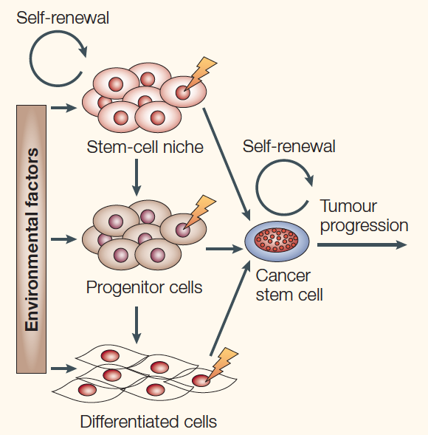
role of stem cells in tumor growth:
- Cancer may begin as alterations to gene expression in stem cells
- Many of your adult tissues have stem cells (undifferentiated cells) that replenish your tissues
- Stem cells divide asymmetrically, one daughter cell becomes a progenitor cell (cell with a fate, will go on to become something else a particular kind of tissue) and one remains as a stem cell
- Progenitor cells: differentiate into a particular tissue
- All three kinds of cells (stem cells, progenitor cells, and differentiated cells) can all be converted back into a cancer stem cell
  - We used to think that all the cells of a tumor are the same; but now we think that stem cells are responsible for the tumor and we need to get these cells out to get rid of the tumor
    - Difficult to locate and remove these stem cells since they don’t have any defining features/they are undifferentiated, all they do is divide over and over
    - Probably would need to find that original stem cell that keeps dividing, started it all and kill it

evidence that epigenetic regulation may be relevant in cancer:
- Study done on mouse family
  - Took an unfertilized mouse egg cell and replaced it with the tumor nucleus (bad nucleus and put it in a good cell; nucleus no longer acted bad)
    - Electric shock stimulated fertilization and allowed the egg to begin dividing
      - The tumor nucleus successfully developed into a mouse
      - Cytoplasm in the egg (packed by mom) gets control of the nucleus and drives normal development of a mouse
        - NUCLEUS IS REPROGRAMMED; maybe egg cell is epigenetically reprogramming the nucleus
- Maybe cancer starts with an epigenetic change that can be reversed easily, but then mutations occur that are not reversible
- Initial stages of cancer are epigenetic
  - Maybe anything that affects methylation (epigenetic changes) increase/decrease risk for cancer
  - Maybe epigenetic change is first step before mutation
- The epigenetic changes are what “reprograms the cell”
  - DNA in messed nucleus is right, (gene is right), so when put in cell with proper regulation, the gene will develop normally

LECTURE 19: MOLECULAR HOMOLOGY
Lecture Outcomes:
- Maxwell’s Point on Evolution
  - A lot of evolutionary change is caused by tinkering (changing genes you already have, ie. putting a different promoter on)
    - Not evolving new genes, just changing the ones you already have
  - Current phenotypes are constrained by the past
    - Humans are the way we are because we’re constrained by evolutionary history; the path we took on the phylogenic tree
    - The path we took constrained our possibilities for the future
    - Ie. Want a Ferrari but get an 85 Honda Accord; as hard as you try to turn the accord into a Ferrari (paint it head, add new wheels), will always just have an accord because you are constrained by what was given to you
  - Both random and non-random processes are important
    - Ie. Natural selection is not random, alleles change over time so we can be better suited to our environment
    - Genetic drift is random
  - Similarity can reflect common ancestry but also common solutions
    - Ie. Common ancestry = homology; things look similar because in the past they were one thing, share a common ancestor
      - Ie. human eye and gorilla eye are similar, because it was developed in our common ancestry, not phylogenically similar
      - Ie. human eye also looks like octopus eye, but not due to common ancestor; Only so many ways to develop an eye (common solutions)
  - Evolution involves many types of genetic change
    - Molecular Evolution: also called gene and protein evolution evolutionary change at the level of genes
- MUTATION
  - Random mutations
- DUPLICATION
  - Of genes, whole genomes or sections
- REARRANGEMENT
- LOSS
  - Not as important
- It is not important to evolution if it does not affect the phenotype (observable characteristics of an organism)
  - Mutation, duplication, rearrangement and loss all have potential to affect phenotype
  - But some mutations will not affect phenotype at all
- Natural selection only acts on the phenotype not the genotype of an organism

How does one prove HOMOLOGY?
- Homology: similarity due to common ancestry
- Use Comparative Genomics:
  - Sequence DNAGenome assembly Genome annotation Align sequences Determine Homology
  - Two types of Genomics:
    - Functional Genomics: understanding and comparing the function of different genes
    - Comparative Genomics: how many genes does one genome have, how many genes does it have for transport; more so looking at the big picture
- Genome Annotation:
  - Attributing function to the sequences found; attaching biological meaning to sequence data
  - Annotation features: promoters, introns, PCG, ascribing function
  - All in silico: performed on computer or via computer simulation
    - Ie. if you wanted to determine the # protein coding genes in chlammy: use computer algorithms

Methodology and importance of determining/detecting open reading frame (ORF):
- To determine what protein a protein coding gene actually codes for, we must look at the ORF
- ORF: from the start codon to the stop codon of the DNA
  - ORF does NOT include introns
  - Coding sequence only refers to DNA that actually gets translated (ie. without introns)
- There are 6 potential ORF in a DNA molecule (since it is double stranded; 3 on each strand)
- The actual protein that a protein coding gene will make is the longest ORF (most amino acids from start to stop), so this is one we care about

Sequences detected by annotation programs to detect open reading frames (ORF):
- Using a computer, you can also translate a DNA sequence of a protein coding gene (with all intron regions removed), you can translate it and figure out what protein it is
  - Detect: promoter elements, intron/exon boundaries, other conserved DNA motifs
    - Splice out introns to get predicted sequence
    - Use to find which of 6 reading frames is most possible open reading frame

Usefulness of BLAST analysis of sequences in Genbank at NCBI:
- NCBI: National Centre for Biotechnology Information
- Repository of molecular information (where EVERYTHING goes; DNA, a single gene, proteins and genomes)
- Deposit and search databases (in the GenBank)
- 100 M sequences of DNA have been deposited here (some protein, some genes)
  - Now we are more likely to sequence and deposit the whole genome rather than just a single genome because it is much cheaper now
- Can compare your DNA or protein sequences with one or more other organisms
  - To do this we arrange sequences to show regions of similarity
  - From sequence to similarity one can infer
    - 1. FUNCTION (similar gene out there that has already been researched and you know what it does)
      - Figure out the possible function of your unknown gene by looking at the function of similar sequences
    - 2. HOMOLGY (infer/estimate common ancestry)
      - higher the similarity between 2 sequences, the lower the probability that they’re NOT ancestrally/phylogenically related

Differences between global and local protein alignment:
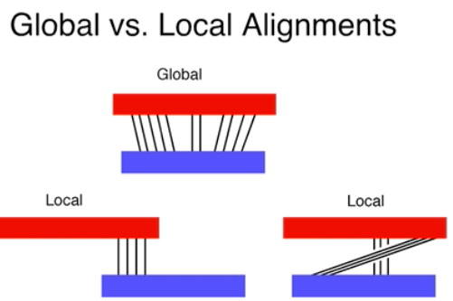
- Two ways to make an alignment (matching up amino acids or nucleotides)
  - LOCAL PROTEIN ALIGNMENT:
    - BLAST: basic local alignment search tool; algorithm only looking for small regions of high similarity
  - GLOBAL PROTEIN ALIGNMENT:
    - CLUSTAL: algorithm trying to match up two sequences/proteins perfectly from beginning to end (may need to put in gaps)

Reasons why amino acid sequence comparisons are more informative than nucleotide sequence comparisons:
- Query: what you actually send
  - Can do nucleotide blast or protein blast depending on the sequence you have
- Subject: what’s coming back, what algorithm is matching/aligning the query with
- Protein data is better than nucleic data when looking for homology
  - Better to get ORF and translate DNA sequence to protein sequence
- Compared to nucleic acids of the same length, proteins carry more information
  - More info in 8 amino acids than 8 nucleotides (in comp. science language)
  - Amino acids have alphabet of 20, while DNA has an alphabet of only 4
  - Amino acid sequence of same length packs a bigger punch
- DNA databases are too big and full of junk (stuff that doesn’t do anything and isn’t important) too big, therefore harder to search
- The genetic code is redundant; a different codon in DNA can code for the same amino acid
  - Natural selection works on phenotype, don’t care if there is a difference in the genotype, only care if there is a difference in the phenotype
  - The fact that two codons aren’t identical doesn’t really matter, but would show less similarity on BLAST, we only care that they are similar in that they have the same amino acid

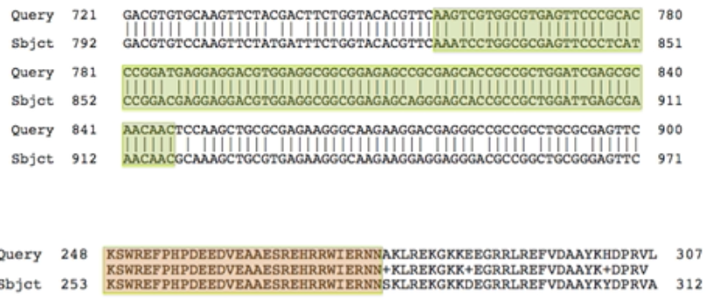
- Nucleotide alignment on top, protein alignment on bottom
- High levels of sequence conservation: sequences are the same
  - High in nucleotide, absolute in amino acid

Relationship between E-value and likelihood of homology:
- Establishing homology is based on probability and statistics
- Decisions on homology are made based on similarity numerical and correlated with probability
  - The higher the similarity between two sequences (especially proteins), the lower the probability that they originated independently of each other and became similar just by chance
    - Therefore the higher the similarity between two sequences, the higher the probability that they are derived from a common ancestor/homologous
- E-Value: the probability that you arrive at the same sequence simply by chance; representation of the probability statistic that the BLAST algorithm uses
  - Factors the E-Value takes into account
    - How big the data base is (how many sequences are you really comparing)
    - How long your query sequence is
  - E - value < 0.00001 = then 2 sequences are said to be HOMOLOGOUS (or 1 in 100, 000) and shared a common ancestor
    - Ie. E value between chlammy and volvox glsA gene is 0.0

Underlying reasons to explain why two proteins have weak global alignment (CLUSTAL) but strong local alignment (BLAST):
- Transposons: the mobile elements of DNA
- Copy Number Variation: different organisms have different copies of the same genes

LECTURE 20: MOLECULAR CONVERGENCE
Lecture Outcomes:
synonymous vs nonsynonymous mutations/substitutions:
- Synonymous: change in nucleotide sequence does not change the amino acid (due to redundancy in genetic code)
  - Do not affect selection because they do not affect phenotype (a.a. remains the same)
  - Neutral with regard to selection (not harmful or advantageous)
  - Stable over time, in every individual of volvox
  - Tend to accumulate more over time because not as many consequences from these mutations since don’t change the phenotype
- Nonsynonymous: a change in the nucleotide sequence that does change the amino acid
  - If selection acts on a phenotype, then the amino acid sequence must be affected
  - Does not accumulate as much, since natural selection actually acts on it (changes the phenotype) there are more consequences to these mutations
- Underlying molecular biology of how these changes arise is the same, some just affect amino acids differently than others

characteristics of the neutral theory of molecular evolution:
- Selection Theory: mutations are mainly deleterious, chances are your change will be harmful (protein wont fold properly etc.); but a small number of mutations are advantageous
  - ALL MUTATIONS AFFECT FITNESS
- Neutral Theory: came about from genome sequencing in the 60s; some changes are deleterious and a very small number are advantageous, but most mutations have no affect on the phenotype or selection; they accumulate over time, not selected for or against but these mutations are just neutral
  - Why when you compare two sequences and see lots of differences; you cannot say that these differences are due to natural selection
    - Lots of these changes may simply be neutral (therefore do not affect selection)
    - If neutral theory is correct the more divergent two species are (more distantly related they are), the more neutral mutations/substitutions that would exist (since neutral mutations arise as a function of time)

deduce time of divergence given number of amino acid changes in particular protein:
      - Time since MRCA should be proportional to number of neutral mutations
    - Means the NEUTRAL THEORY IS CORRECT
      - Important because you can compare DNA between two organisms and look at number of substitutions and then can see how long ago they diverged by finding the y value on the line of best fit (very strong)

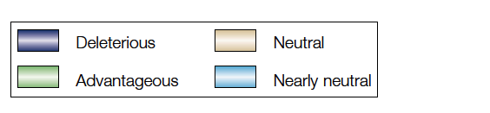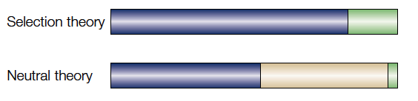

relationship between frequency of amino acid substitutions in given proteins vs. time since common ancestor:
- Graph and line of best fit allows you to use sequence differences to tell time
  - Can tell time of divergence by looking at rate of substitutions in a given gene
- The number of differences between protein sequences of different species are proportional to the time since those species diverged
- Proportional: if they diverged a long time ago expect more differences than if they have diverged more recently.
  - i.e. humans vs. yeast, and humans vs. chimps (more recent, therefore fewer differences)

characteristics of the "molecular" clock:
- The rate of mutation needs to be constant (this is the only way that we can deduce the time of divergence)

relative rates of accumulation of synonymous vs. non-synonymous mutations:
- Synonymous mutation (silent substitution) rate is higher than the rate of the nonsynonymous mutations (replacement substitutions)
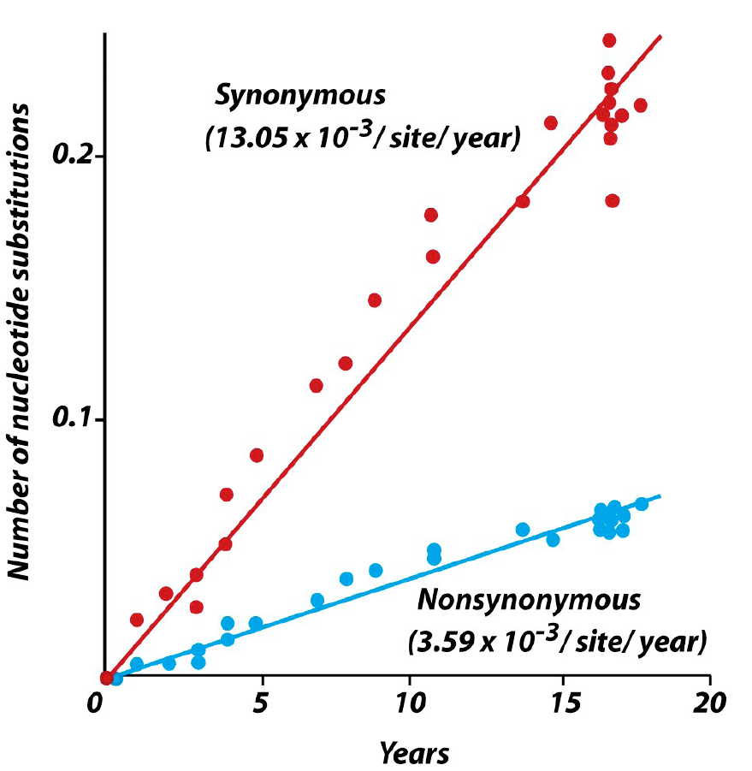
- Steeper slope shows a larger increase in the number of mutations over time
- Why the difference?
  - There is a much higher chance that the nonsynonomous mutation will be deleterious rather than avantageous, so the rate is kept low; must be more careful
  - The synomous rate can be high and it won’t matter because you are not affecting the amino acid and therefore not affecting the protein or phenotype
    - Synomous sites include introns, pseudo genes, junk that doesn’t code for anything; rates of mutations are higher here

variables that affect the rate of evolution of a particular protein:
- Proteins differ in how fast their sequences change over time (rate at which they evolve through selection or neutral chances is NOT CONSTANT)
  - Ie. Fibrinopeptides have a higher rate of change than hemoglobin which has higher rate of change than cytochrome c
    - Firbrinopeptides are proteins used to clot blood; you can have lots of mutations in the protein and it will not change its function that much
    - Hemoglobin are proteins used to carry oxygen; can still fold different and carry oxygen just as well
    - Cytochrome c is an enzyme; has to have binding sites for cofactors and oxygen
      - It is constrained, it can’t evolve very much, otherwise it cannot function properly; gene cannot be changed as much as fibrinopeptide gene can

    - Cytochrome c may be more constrained by its past and so its sequence changes slower over time
  - Why else may some proteins evolve less than others over time?
    - Some proteins may have a stronger effect on the phenotype
    - Some proteins are more sensitive to changes because of their sequence (aren’t a lot of places that can be changed without changing the function of the protein)
      - Mutations in essential proteins may be constrained

regions of two unrelated proteins that would be expected to be similar if they were the products of convergence:
- Convergent Evolution: the independent evolution of similar species in different lineages
- Phenotype can be similar because of homology or because of convergence
- There is no reasons for two proteins to share high identity across their entire sequences
  - At the nucleotide sequence, you wouldn’t expect to see very close similarity
- Regions that you WOULD expect to see similarity
  - Location of cycteins (disulfide S-S bonding)
  - Amino acids necessary for catalysis
  - Receptor binding sites
  - Local area of high similarity
  - Binding sites/domains (ie. For ATP, or DNA)
  - Active site
- The functionality is not represented by the entire sequence – but by the local sequences
- If you see sequences that are highly conserved over MANY different organisms, it is the result of homology

difference between Contingency and Convergence in understanding evolutionary change:
Predictability of Evolution:
- Gould believes in CONTINGENCY: the idea that each step in evolution is dependent on all the steps before it
  - Ie. if we went back in time and made a few changes, we would not end up where we are today
    - One random mutation will send you in the wrong direction, you’ll never get to where we are today again
    - Too many steps have to take place to get to where we are as humans today and it would never happen again
- Conway Morris believes in CONVERGENCE: the idea that the evolutionary routes are many but the destinations are limited
  - Lots of places to get an intelligent being (may not look exactly the same, ie. no hair) but general pull will always be in this direction
  - A few mutations will not take you completely off course of developing into a human; just may take a different path to get to this inevitable destination
- So is evolution contingent on stuff that happened millions of years ago or is it inevitable?

- Why do we know for sure that two proteins with similar sequences are homologus and do not just have similar sequences due to random mutations that have occurred over time?
  - Proteins do not need to have perfectly identical sequences across their entire length or across major regions of the sequence to be functionally similar
    - Ie. Enzymes need to have similar amino acid sequences around their active sites (highly conserved, high similarity) if they both want to bind to glucose; but the rest of the enzymes can differ ALOT and still accomplish the same function

Evolution of channelrhodopsin vs rhodopsin:
- Channelrhodopsin and rhodopsin are NOT HOMOLGOUS, they evolved independently (are CONVERGENT) but are remarkably similar in function
  - Both bind retinal, both have 7 trans-membrane spanning domains, both involved in phototransduction
  - Sequences in the amino acids that make up these proteins show NO HOMOLOGY
- Convergence: two different branches leading to proteins that look and behave very similar
  - Conway Morris would argue that the need to have a protein that sits in a membrane and absorbs light is so fundamental to life, that it can be evolved may different ways
- Differences between Channel Rhodopsin and Rhodopsin:
  - 1. Native confirmation of these proteins as they sit on the membrane is different; folding of proteins is not the same
  - 2. Photoisomerization is different (both bind retinal but change its confirmation differently)
  - 3. In eye, rhodopsin is GPCR: G protein coupled receptor
    - In chamly, channel rhodopsin is a channel that ions pas through

Seven-transmembrane proteins:
- Evolved very early on
  - Not monophyletic, evolved multiple times over the course of evolution
- Proteins that need to bind a ligand and interact with their internal and external environment have these 7 transmembrane spanning domains
  - GPCRs (signaling, sense perception, bind ligands) only evolved in branch leading to rhodopsin in your eye not in chlamy
- Seven transmembrane proteins used for many things such as a place for hormones to bind, involved with olfaction (smelling)

function of lysozyme:
- Enzyme, kills bacteria by attacking their cell wall
  - found in tears, blood, mucus, egg whites

characteristics of ruminant organisms that enable them to extract energy from cellulose:
- Cows (ruminant) have a different type of enzyme called digestive lysozyme found in their stomach
- Cows eat grass and bring in bacteria into a foregut that can break down the cellulose the cow needs
  - Needs cellulose so it can be broken down into sugar
- When cud (mixture of cellulose and bacteria) enters stomach, digestive lysozyme found in stomach to kill the bacteria
- How is the digestive lysozyme different from normal lysozyme?
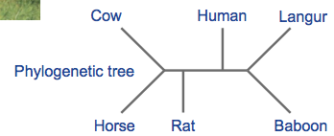
  - Stomach contains:
    - Low pH, so digestive lysozyme must be able to withstand low pH
    - Proteases, which normally break down proteins, but this must be “protease resistant lysosome”
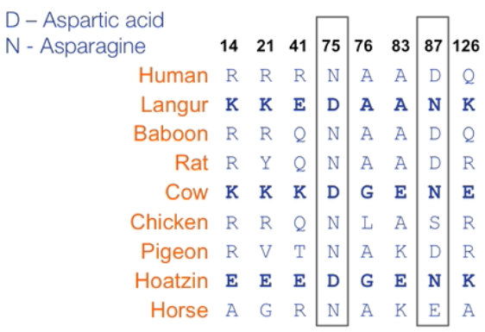
- Hoatzin and Langur monkey also able to bring in bacteria and digest cellulose and so contain a digestive lysozyme
  - Digestive lysozyme evolved independently
  - Not phylogenically related at all but all have the need for this enzyme and so have developed it, all converged to the same amino acids in certain positions (ie. Asp 75)
  - Not over entire length of sequence, but over positions/regions important to function of the enzyme they have converged to having the same amino acid
    - These specific changes/substitutions in amino acids provide protease protection and resistance to low pH
      - Position 75, changed to an aspartic acid
      - Position 87, changed to an Asparagine

LECTURE 21: EXPERIMENTAL EVOLUTION
Independent Study Outcomes:
what is meant by Potentiation, Actualization and Refinement:
- Potentiating Mutations: a change (mutation) of unclear nature that occurs around 20, 000 generations; must occur in order for actualization mutation to occur at 30, 000 generations
- Actualizing Mutations: rearrangement of genes that allowed for some growth (although poor) on citrate in presence of oxygen
  - the actual mutation that allows the ecoli to use cit+
- Refining Mutations: further refining mutations involve duplication of the rearranged DNA sequence (DUPLICATION OF ACTUALIZATION MUTATIONS), needed for healthy growth under such conditions

Where does glucose and citrate come in to cellular respiration:
- Acetyl-coA is transferred to oxaloacetate(4C) to form citrate (6C) in the first stage of the citric acid cycle
- Glucose is broken down into two pyruvate molecules in glycolysis

Lecture Outcomes:
characteristics of model systems that can be used for experimental evolution:
- Experimental Evolution: testing hypothesis about evolution using controlled experiments
- Most studies of evolution are constrained by two facts:
  - 1. Generation time; most organisms evolve very slowly
  - 2. Can’t go back in time and study the ancestral form
- Model Systems for Experimental Evolution:
  - Viruses
  - Bacteria
  - Chlamy
  - Drosiphilia
  - Yeast
    - All have very short life cycles, and therefore short generation times
      - Hours, or days not 25 years like human
      - Important because to study molecular evolution you need to use a model with short generation time so you can effectively look at evolutionary change

Measuring relative fitness in E. coli:
- Have one population and split it into two groups: an ancestral and an evolved strain
  - Both descendent from same population and so start with the same genotype
- In the evolved strain, place a neutral gene in the one strain that turns its cells red so you can track it
  - Place red cells in low pH conditions for a few thousand generations
  - Then at time zero, mix the two strains together at low pH
  - Count number of red and white cells at time zero compared to at the end of the day
    - You can calculate relative fitness (w) of evolved vs. ancestral population
      - Growth rate of evolved strain/growth rate of ancestral strain
      - # cells at time 0 / # cells at end for each strain
      - Relative fitness = 1; no adaptation (no evidence the evolved population can grow any better than ancestral at low pH)
      - Relative fitness > 1 = adaptation, growth rate of evolved population is greater than ancestral
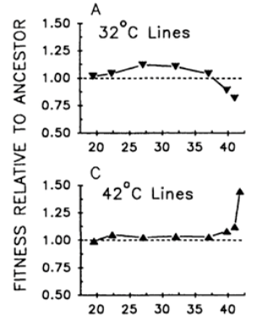
      - Relative fitness <1 = maladaptation, evolved strain doesn’t compete that well with ancestral after being subjected to low pH for many generations
        - Ancestor performs better than the evolved
    - Very helpful experiments with bacteria because can be done in only a few months
- Ecoli after 2000 generations of ecoli grown at 32 and 42 degrees (evolved strain)
  - Compare it to ancestral strain grown at 37 degrees
  - All 3 populations have identical original genotype (all originated from the same population)
    - For 32 degree line at low temperatures (w>1) but after 35, ancestor being maintained at 37 does better than evolved at 32 (w<1)
    - At high temperatures (42 degrees), fitness is above 1 (adaptation, lines are better able to grow to high temperature compared to ancestral strain) so evolved grows better than ancestor
      - Only possible to detect this because generation time of these ecoli is so fast

design of Lenski's long term evolutionary experiment (LEE) with E. coli at MSU:
- Actually able to identify the genetic changes that caused the change in phenotype resulting in an adaptation
- Ecoli cells via asexual reproduction (no recombination)
  - If mutations arise they are spontaneous
- Advantage of using ecoli is that the population size can be gigantic (short generation time)
- Lenski wanted to know if evolution can produce adaptation if it depends on random mutations (most of which are harmful)
- Started project in 1988,
- Separated a single bacteria into 12 independent identical lines/populations
- Have to sub-culture cells once per day:
  - Have a 10.0 mL culture (5x10⁸ cells), move 0.1 mL (5M cells per day)
    - Genetic drift could play a role here; rare allele may not be represented in this new population
- Bacteria call also be frozen before they are sub-cultured so that they always keep the ancestors for every line
  - Allows you to revive ancestral populations and compare them to the evolved
  - Almost like going back in time
- In 2010, now at 50, 000 mark
  - 6.6 generations per day, generation time of 3.63 hrs (ie. 1 cell goes to 2 cells in 3.63 hrs)
  - In terms of human evolution, 50, 000 generations is reflected in 1.25 M years (as opposed to only 22 yrs for ecoli)
  - Humans and Neanderthals shared MRCA only 700, 000 yrs ago (half this time)
- Lenski’s experiment had a growth media containing citrate (citrate NOT used as a carbon source for food)
  - Citrate used to keep Fe in suspension so it doesn’t precipitate so that the Fe can be taken up by cells (Citrate binds with iron Fe-citrate)
- Usually e coli is unable to use citrate as a carbon source (when under aerobic conditions as in this experiment)
  - ONLY UNER ANEROBIC CONDITIONS (this experiment is NOT anerobic)

value of cryopreservation to LEE:
- Cyropreservation: freeze the culture
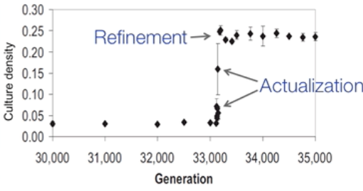
- Lenski can go back in time and revive an ancestor that has been frozen
- Found this ability to use citrate 30-33 000 generations in
- Actualization: Ara-3 line acquired ability to use citrate, culture density goes up
  - Since experiment is under aerobic conditions, can now use citrate to undergo ETC and make even more ATP therefore grow faster
- Refinement: the ability to grow using citrate is even better, Ara-3 population evolves ability to grow on citrate even better
  - Each dot represents a population; can be removed from freezer and are able to see the culture density and exactly what generation it is

where citrate enters metabolism:
- At 30, 000 generations in his experiment, one of the flasks/populations (Ara-3) got cloudy (culture turbidity was higher: had more cells)
  - Over the course of a day, this line grew faster than all the other ones
  - HOW? This line acquired ability to use citrate as a carbon source
- How many mutations have occurred over 30, 000 generations?
  - Billions of mutations (due to large population size and mutation rate)
  - Genome is only 5000 bp
  - Every possible mutation has occurred (every based has been changed multiple time)
    - Every mutation was “tried” many times
  - Suggests that citrate positive phenotype is very rare (not from a single base pair change)

role of glucose limitation in LEE experiment:
- All flasks contain only a small amount of glucose (25 microg/mL)
  - Cells run out of glucose after 8 hours of being sub-cultured
  - Ecoli uses up glucose in its environment quickly
  - Rapid growth for 8 hrs then cells stop dividing until they get sub cultured the next day
  - For 16 hours, no usable substrate in their environment, keeps cell concentration from getting too high
  - Selective advantage if you can use citrate, can outcompete all those organisms that can only use glucose PROVIDES AND ECOLOGICAL OPPORTUNITY

how to determine if Cit+ phenotype arose from one single mutation or was dependent on previous mutations?:
- Thaw out frozen Ara-3 cells from past generations
- Between 30-33 000 generations, you will see a drastic increase in the number of Ara-3 cells (when graph culture density vs. generation)
- Take cells from (30,000 and 31,000) and (32,000 and 33,000) generations and grow on citrate auger
  - Earliest (30,000) don’t show phenotype
  - 32,000 generations show slight cit+ phenotype
  - this suggests that there wasn’t one single rare mutation; but age of generation is important
  - actualization of cit+ phenotype is contingent on previous mutations; not rare single event
- NO Cit+ at all before 20, 000 generations
  - Age of culture is important
  - Demonstrates that ability to use citrate was an accumulation of other mutations; NOT A RARE EVENT/MUTATION

genetic changes giving rise to potentiation, actualization and refinement of Cit+ phenotype:
Actualization of Cit+
- Start with a segment of Ecoli DNA (we know every gene in ecoli, is cheap to sequence its entire genome)
- citT gene: codes for a citrate transporter that sits on the plasma membrane of the cell and transports citrate inside
- Oxygen acts as a repressor that inhibits expression of citT gene under aerobic conditions
  - Normally, citT is only expressed in the absence of oxygen
  - Usually makes citrate transport only active during anaerobic conditions
- Portion of Ecoli genome that include citT gets duplicated
- Then a rearrangement occurs; duplicated portion inserts itself into rnk gene (rnk gene gets destroyed during this process)
  - Rnk is constitutively/always expressed
  - Rnk promoter is always on/active
- Purple part of rnk at beginning of insertion includes the rnk promoter (STILL FUNCTIONAL)
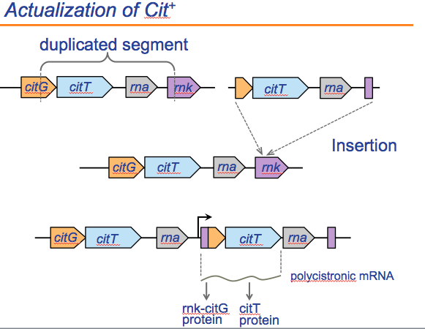
  - cit T is now driven by promoter of the upstream rnk fragment (signified by black arrow)
  - Results in a polycistronic mRNA a single gene that can code for multiple proteins
    - End up with an rnk-citG fusion protein and more importantly, a cit T protein that is NOW EXPRESSED ALL THE TIME (driven by rnk constitutive promoter)
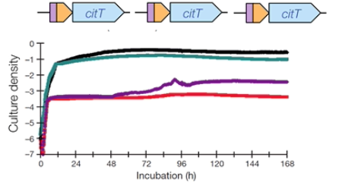
- This is what happened in the Ara-3 line of the ecoli: duplication, insertion and rearrangement ALL OF THESE ARE JUST TINKERING, we didn’t actually create anything new!
  - Now transporter works under aerobic conditions

Refinement of Cit+:
- We can thaw out lines that had actualization and cells that had refinement and tell the difference between them
  - In refined strain, found an increase in copy number of rnk-citT modules
  - What’s limiting is how much citrate you can take up
  - By having more citT genes being expressed, can take even more citrate transporters bring even more citrate into the cell can grow even more under refinement
- Red and purple lines are actualized strains
- Blue and green lines are refined and so even higher growth
  - Actualized samples have lower growth (lower culture density) than the refined strains
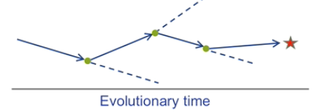
- Proves Steven J. Gould’s idea contingency
  - To get to that star is contingent on things that have occurred in the past
  - To get to the star (cit +) requires a # of steps
    - Getting there is contingent upon 1 or multiple mutations that occurred in the past
  - If you don’t get that mutation, you go off in space and never get to the star (cit + phenotype)

result of "replaying" evolution of Cit+ phenotype:
- Was the Cit+ phenotype the result of an unusually rare mutation or was it contingent on prior mutations?
  - Ie. to get from ancestor to actualized, what were the steps?
- If it was a rare mutation, you would expect that the probability of that single rare mutation would be constant and low throughout ALL GENERATIONS
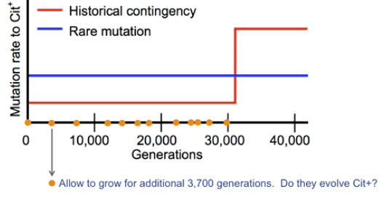
- If it was due to historical contingency you would expect that the big jump to cit+ phenotype mutation required/was contingent upon previous mutations to occur (maybe 20, 000 generations)

- Did this experiment took 12 ancestral strains from the freezer, thawed them out and grew them individually for an additional 3, 700 generations
- RESULTS: Gould was CORRECT
  - Before 20, 000 generations, anything they thawed out and let grow for another 3, 700 generations NEVER GOT THE CIT+ PHENOTYPE
  - Significant percentage of those frozen samples taken after 20, 000 generations DEVELOPPED THE CIT+ PHENOTYPE
    - No capacity to generate cit+ before 20, 000 generations
    - Tells us that some other mutation (yet to be identified) occurred around 20, 000 generations that enabled actualization to occur at 30, 000 generations
- Replaying experiments are VERY IMPORTANT in proving contingency because it’s almost like going back in time and allowing evolution to play out again and see if you get to the same point as the original Ara-3 line

- In original and replay experiment, the strains acquired the cit+ phenotype mutation the same way
  - Always attacked citrate transporter, caused rearrangement in same part of ecoli genome and caused expression of citT gene
  - Many independent lines all produced cit+ phenotype and did it in fundamentally the same way by attacking the same part of the ecoli genome
- red box boundary of amplication of orginial Cit+ line
- blue boxes boundary of amplification of 14 replay expressions
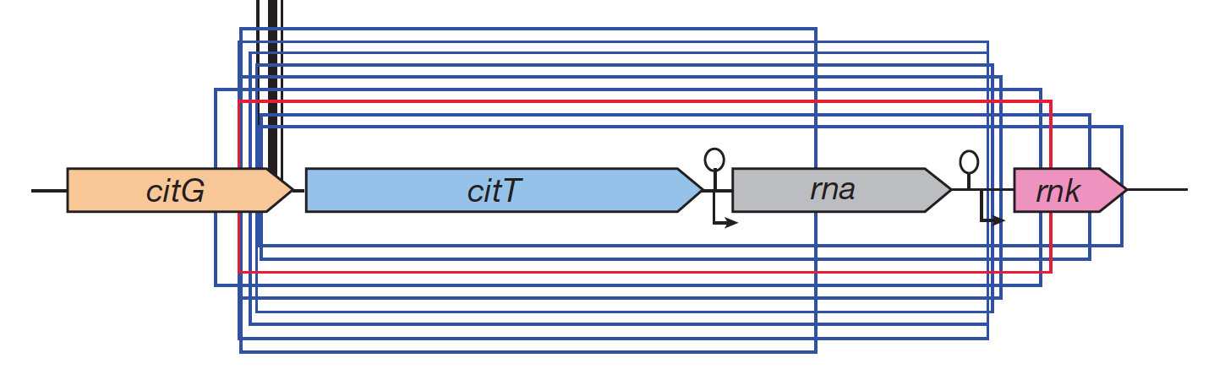

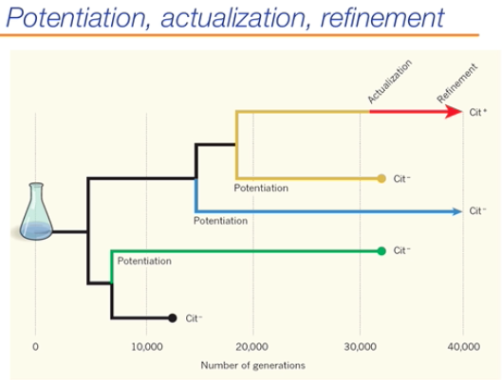

- At 20, 000 generations, potentiation mutation occurred: allowed the actualization to occur around 30, 000 generations (refinement occurs later)
  - Cannot be identified, probably subtle because it DID NOT change the phenotype with regard to citrate
- Actualization and refinement only occur in Ara-3 line (top line)

why Cit+ lines do not drive Cit- lines to extinction:
- Some researchers argue that Lenski has evolved a new species (Ara-3 line is NOT ecoli anymore)
  - Defining characteristic of ecoli is the INABILITY to use citrate under aerobic conditions
  - YES IS A NEW SPECIES!
- The evolution of the Cit+ phenotype did not drive Cit- into extinction
  - Cit- cells continue to exist in population (even though a small proportion)
- Cit- more efficient at glucose utilization; so niche for both phenotypes
  - Soon after transport to new media/after subculturing the glucose levels are HIGH and cit- cells have an advantage; they can suck up the glucose faster and grow better than the cit+ cells
    - Cit+ advantage really only exists after 8 hrs when glucose has been depleted
    - By then, have lots of Cit- cells present and they get carried over when you subculture
    - Allows both to exist in the population of the Ara-3 line

LECTURE 22: THE ELYSIA/VAUCHERIA SYSTEM
Lecture Outcomes:
- Recall that elysia (animal) actually has genes in its genome that code for photosynthetic proteins
- Elysia has ability to retain functional chloroplasts for longer (80 days after kleptoplasty and still doing photosynthesis)
  - When chloroplasts are isolated from spinach in a lab, photosynthesis declines very fast
  - Once elysia eats chloroplasts, it never needs to eat Vaucheria again; the chloroplasts will last for its entire life of 80 days
- But why does photosynthesis decline/decay at all?
- Elysia does not make all the essential proteins

location of PsbO gene in photoautotrophic organisms:
- Reasons why Elysia is able to keep these chloroplasts functional for so long?
- PsbO gene is located in Vaucheria nucleus and encodes a single protein
  - Matches the sequence of PsbO in Elysia nucleus
  - Transcription and translation of these PsbO gene is what allows Elysia to do photosynthesis for such a long time

location and role of PsbO gene product in photosynthetic electron transport:
- PsbO gene is located in the nucleus
  - Encodes a component of PS II
  - Manganese-stabilizing protein; part of the oxygen evolving complex
  - PsbO is soluble protein that sits on luminal surface (underside of thylakoid membrane)
    - Interacts with base of PSII, plays a role in oxygen evolution

purpose of molecular size markers in electrophoresis:
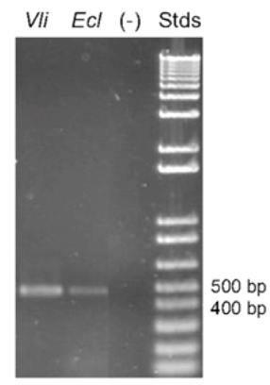
- Provide a reference for fragment size of the mRNA transcript
  - ie. smaller travel farther

interpretation of agarose gel electrophoresis data:
- Photo is evidence that the transcript of PsbO is actually produced in Elysia
  - PsbO gene is functional in Elysia, it is making a transcript (= an mRNA transcribed from DNA)
  - Must amplify (using PCR) the portion of PsbO transcript in order to see it (fragment is 452 bp in size)
- Done 5 months after Elysia stopped eating vaucheria
  - If did this electrophoresis right after Elysia stopped eating vaucheria, could argue that Elysia only had mRNA present because it had eaten gut of vaucheria
  - By waiting 5 months, mRNA would not stick around in Elysia and be detectable therefore can conclude that Elysia has PsbO gene in its own nucleus and had made its own mRNA transcript

mechanism of polymerase chain reaction:
- Most powerful molecular tool invented
  - Invented by Kary Mullis (93)
  - Won Nobel Prize in Chemistry in
- Has ability to amplify tiny segments of DNA
- Each tub holds about 0.5 mL and includes:
  - Taq DNA polymerase (enzyme needed to catalyze the rxn)
    - Specific DNA polymerase from a thermophile (organisms adapted to living at high temperatures)
    - Means the enzyme can catalyze this rxn even when exposed to high temperatures
    - Taq won’t degrade as fast as human polymerases at high temp.
  - Two primers (16-30 bp long)
    - Have high sequence similarity to a region of the DNA that you want to amplify
  - dATP, dGTP, dCTP, dTTP
    - Nucleotides, individual monomers required to synthesize DNAs
  - Template of DNA to amplify/make more copies of
    - Can take a vanishingly small amount of DNA and amplify it into something you can actually work with
- Used in many real world applications like forensics (ie. rape and murder) and gene studies

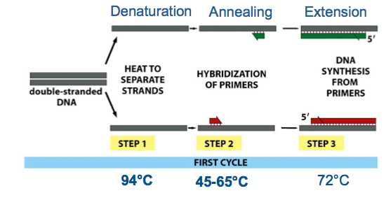
role of thermal cycling in polymerase chain reaction:
- Machine needed to cycle the temperature
- 3 major parts to one cycle of PCR
- First step is denaturation: REQUIRES HEAT TO SEPARATE STRANDS
  - Need high temperatures (94 degrees) for 30 seconds to break the hydrogen bonds of DNA and split dsDNA ssDNA
- Second step is annealing: HYBRIDIZATION OF PRIMERS
  - Lower the temperature to 45-65 degrees C to allow ss primers to anneal (complementary base pair to similar ssDNA strand)
  - One primer is similar to sequence on one ssDNA
  - Other primer is similar to sequence on other ssDNA
    - Anneal faster before the two ssDNA strands have the chance to complementary base pair back together
- Third step is extension Taq Polymerase is active now at 72 degrees,

role of primers in polymerase chain reaction:
- Primers are gene specific
- Primers are complementary ssDNA sequnces that anneal and complementary base pair to either end of their target sequence

role of Taq polymerase in polymerase chain reaction:
- Adds 10 nucleotides /second to primer and extends in 5’ 3’ direction
  - Polymerase only adds onto 3’ end of primer
- Usually PCR runs for 30 cycles so that you get 1 BILLION times amplification of your original DNA sequence
  - So what?
  - Now have enough DNA that you can actually work with/manipulate
    - ie. can run it on a gel, use restriction enzymes to cut certain segment

how to make primers to amplify an unknown gene sequence:
- PCR is based on specificity of primer bonding
  - Must design specific primers that anneal to specific sequences of DNA
- Primers must be at least 16 bases in length because PCR is incredibly specific and is based on extreme specificity of the primers
- PCR allows huge amplification of a piece of DNA
- now can see DNA on gel, can manipulate it , can clone it, do downstream alterations, run profile of human DNA etc…
- In any sequence of DNA
  - ¼ chance of finding an A, G, C or T in any given spot
  - 1/16 chance of finding any dinucleotide sequence (ie. CC)
  - 1/256 chance of finding a given 4-base sequence (ie. GCAT)
  - 1/4¹⁶ (1 in 4B) chance of finding a given unique 16-base sequence (usually that 16 base sequence is unique)
  - primer that is 16 bases long will find its complementary target

- Problem: How do you get psbO sequence for vaucheria to design complementary primers when the PsbO sequence in vaucheria is not known?
  - Vaucheria’s genome has not been sequenced since it is NOT a model system
  - Even though you don’t have the Vaucheria sequence, you can gain information from other sequences at NCBI
  - Go to Genbank and get psbO sequences from other organisms
  - Align them and look for two areas of high similarity
    - One for one end of sequence, the other for the other end (in between is 452 bases)
    - Chances are that Vaucheria psbO will also have these regions of high similarity in its psbO gene
      - Hedging your bets
      - Because this region is so highly conserved in these species, chances are Vaucheria will also have a similar sequence in these positions in its psbO gene
        - Therefore design your primer against this highly conserved region of DNA

why it is necessary to make degenerate primers for PCR:
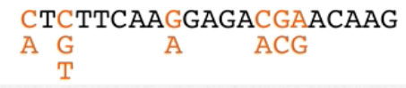
- Degenerate Primers: all possible combinations of primers which accounts for all the variation between the sequences in the box
  - Gives a high chance that one of the primers will work
  - All different potential nucleotides substituted into gaps between highly conserved regions creates the “degenerate primers”

how to use RTPCR to amplify particular mRNA:
- RTPCR: Reverse transcription PCR
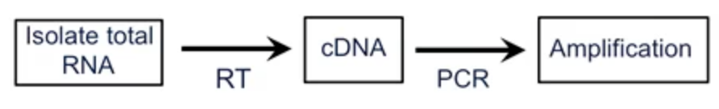
- Isolate total RNA
- Reverse transcribe it to make cDNA (complementary)
- Now you can use PCR to amplify this DNA

- Make DNA poly T primer that anneals through hydrogen bonding to polyA tail to reverse transcribe off of mRNA only (no other types of RNA have this tail)
- Reverse transcriptase extends off of primer- to give complementary DNA
  - Nothing specific about this because can attach to all mRNA
  - You reverse transcribe ALL OF THE TRANSCRIPTS/every mRNA
  - DNA derived from RNA- cDNA
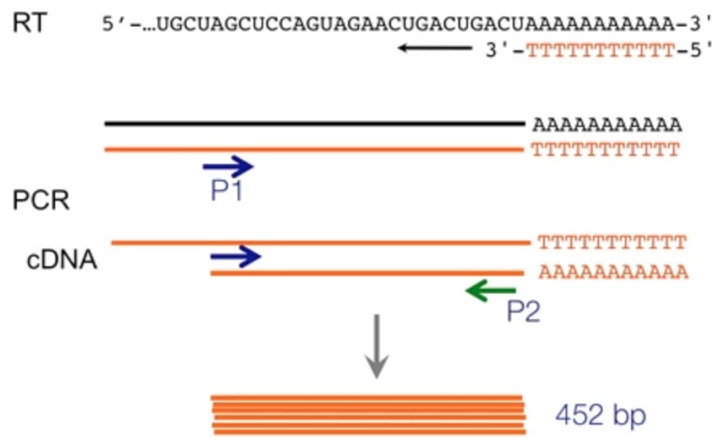
- Template for PCR is total cDNA pool
- BUT primers are specific to specific DNA sequences and only the part between the 2 primers / the actual psbO gene will get amplified by PCR
  - Band on the gel is the 452 base pair fragment
  - No stop sequence for taq polymerase will replicate until the end of the strand

usefulness of Northern blots in addition to standard RT-PCR:
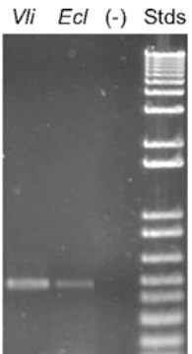
- The PCR amplifies a portion of psbO so that we can see the bands on the Northern blot analysis (for DNA)
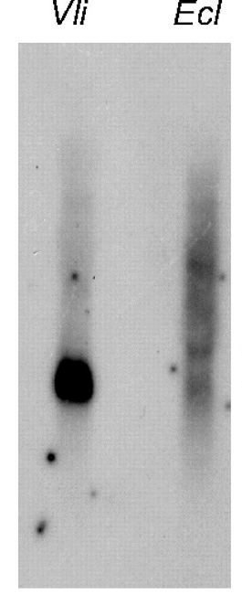
- Excise PCR band from gel
- Sequence it
- BLAST sequence
- Send it through GenBank
- Top hits should be psbO
  - Proves that the band from Elysia is base for base identical to the Vaucheria psbO gene
  - Provides evidence that the transcript for psbO is being produced in Elysia
    - Northern Blot shows us transcript abundance, how much psbo transcript (mRNA) is elysia actually making compared to vaucheria

- Can then label this 452 base fragment with a dye and use it as a probe Northern blot (2nd pic)
  - Probed with Elysia transcript that you amplified, probe hybridizes to DNA in organism
  - Vaucheria shows high abundance of psbO transcript
    - More of transcript in vaucheria than in elysia
  - Elysia lane is weak, but there is some hybridization which shows that the transcript IS THERE
- What would be helpful here would be to have a negative control
  - Would hope for NO HYBRIDIZATION in humans because you know that we don’t have the psbO gene, we are NOT photosynthetic

Obatin full-length protein-coding sequence:
- 452 is only part of the gene/protein coding transcript; whole transcript is 960 bases in length
  - We use 960 bp so we can design new primers for the entire sequence of the gene
- Vaucheria has genomic copy of psbO
- Elysia egg (before any feeding took place) and adult stages also have genomic copy of psbO
- What is the difference is the starting nucleotide sequence of PCR vs RT-PCR?
  - RT-PCR starts as m-RNA hence the need to reverse transcribe. PCR starts with DNA as TAQ polymerase can easily anneal
  - Although they both end up as c-DNA, have different starting pathways
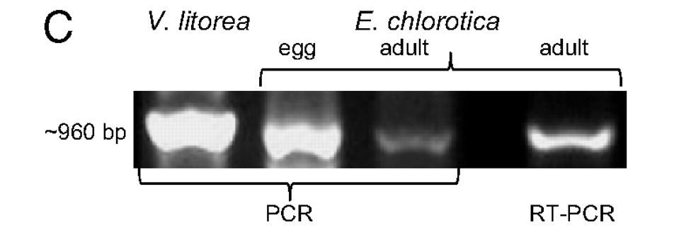
- picking up in entire gene in egg of elysia and adult
- differences in abundance we don’t care about
- egg elysia hasn’t started to feed on chloroplast but it still has the psbO gene
- this confirms the work done with the 452 bp
  - elysia has gene for psbO stabily inserted into its genome and its expressing it

mechanism and result of secondary endosymbiosis:
- Nuclear genes are translated in the cytosol by cytoplasmic ribosomes and have target sequences which are peptides
  - As protein is synthesized off of ribosome, it gets targeted to a specific location
  - Targeting sequence can go to chloroplast, or mitochondria or ER
- For psbO to be functional, must have a targeting sequence that sends it to lumen of the chloroplast

- Vaucheria is a product of secondary endosymbiosis
- 1 euk photosynthetic organisms got engulfed by another eukaryote
- Can tell level of endosymbiot by looking at the number of membranes surrounding the chloroplast
- Primary endosymbiosis 2 (ie. chlammy and plants)
- Secondary endosymbiosis 4 (ie. vaucheria)
  - Two outer membranes of chloroplast in vaucheria are called chloroplast endoplasmic reticulum
  - In elysia, doesn’t have these two extra membranes, were removed during digestion
- Mitochondria and nucleus of what is engulfed is degraded, only the chloroplast survives

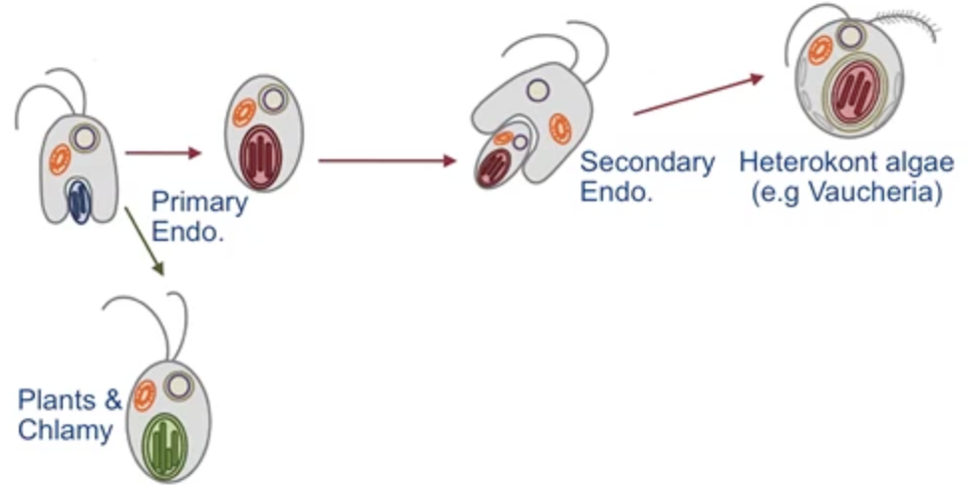
role of tripartite target sequences in localizing proteins to sub-organellar compartments (ie. thylakoid lumen):
- Tripartite Targeting Sequence: part of gene sequence, sends protein to right compartment of the cell
  - Red sequence (1st signal) recognized by transport proteins on the chloroplast endoplasmic reticulum (2 outer membranes of chloroplast of vaucheria)
    - Once imported, red target sequence gets chopped off
  - Exposes blue sequence (2nd signal) which is recognized by transport proteins on two chloroplast membranes
    - Gets into second inner/outer chloroplast membranes; blue part gets cleaved
  - Exposes green sequence (3rd signal) which is recognized by transport proteins on two chloroplast membranes
    - Gets through thylakoid membrane and into the lumen of the chloroplast
    - Once in lumen, the protein folds correctly and inserts under PS II
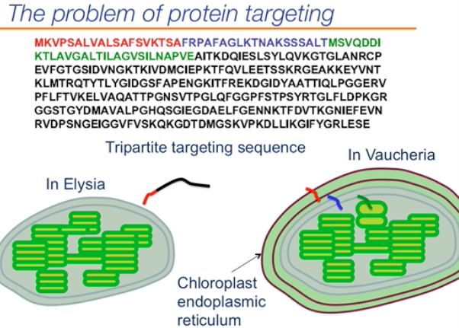
  - If this was actually the mature protein sequence that Elysia makes, it could NEVER GET IMPORTED
    - To enter elysia chloroplast requires the blue sequence, but the transport proteins would only see the red sequence (wouldn’t recognize red and wouldn’t import the protein)
    - We know that if this was the protein actually made in Elysia, it could never be imported into the chloroplast (it needs the red part cleaved off)
- PROBLEM: from RT PCR, we see all three sequences in psbo transcript in Elysia
  - But this could not possibly be the actual protein that gets made because protein would never get into “elysia chloroplast membranes” (blue tag) or into thylakoid membrane (green tag) since red tag won’t have been chopped off since no chloroplast endoplasmic reticulum membranes to go through

LECTURE 23: EVOLUTION OF EYE AND COLOUR VISION I

- Eyes have developed multiple times
  - Ability to evolve eyes overtime is very important; gives you a selective advantage, allows you to see your food and predators
- Irreducible Complexity: Idea that the eye is an example of something that is very complex and that it DID NOT evolve from simpler systems
  - Represents something that you CANNOT break down into smaller parts/something that’s simpler it’s IRREDUCABLE
  - Creationists believe in this, do not believe that eye evolved overtime through natural selection and random mutations
  - Not true, chlamy eyespot is perfect example of a simpler system that shares retinal and 7 membrane spanning domain, lots of simpler light gathering info exists
    - Lots of evidence that you CAN reduce the eye into simpler systems

Homology vs. Convergence:
- Deducing an answer is easy when you have a single protein or gene
  - But a structure like the eye that brings together many genes, proteins and tissues is more difficult to deduce homology from
- EVIDENCE FOR CONVERGENCE:
- 1. Eye Ontogeny suggests convergence; ie. the developmental process that gets you the eye
  - What tissues must be recruited, genes must be expressed, pathways; how the eye is actually made
  - If you look at ontogeny, the eyes are very different
    - ie. insect eye nothing like human eye
  - From a developmental point of view, not a lot of support for homology
- 2. Photoreceptor cells: 2 types rod cells (see black and white and shapes) and cone cells (see colour)
  - Have 3 types of cone cells, each contain LOTS OF COPIES OF THE SAME OPSIN
- 3. Many different organisms have all developed the need to see developed eyes
  - But evolved these eyeball differently

- EVIDENCE FOR HOMOLGY:
- 1. All eyes follow a similar genetic pathway
- Homologous genes play crucial role in development of very different eyes
  - Ie. pax 6 global regular of eye development, transcription factor fundamental for leading to expression of other genes that are required for eye to develop
  - Pax 6 found in very different eyes (from vertebrate to insect)
  - Pax 6 was recruited into playing fundamental role in development of eye
  - Pax 6 even found in organisms that DO NOT HAVE EYES
    - Leads us to believe that it used to do something, else and through tinkering it became important to development of modern eye
  - Pax 6 proteins (transcription factors) have highly conserved domains; suggests these domains are important for pax 6 to function
- Opsins are also highly conserved and G protein coupled receptors
- ALL EYES HAVE PAX 6
  - Fact that organisms have all drawn on pax 6 represents homology; developed eyes differently but ALL EYES DEPEND ON THIS PAX 6 GENE for proper function
- In summary: it’s likely that the development of the eye was due to a little of both convergence and homology

Tinkering with Heat Shock Proteins:
- In vertebrate eye, you have a clear lens that refracts light onto the retina allowing you to see
  - Crystallin proteins that make you this lens, share a common ancestor with HSPs, heat shock proteins found in your cytosol to help proteins fold
  - Crystallins are required in every eye, required to keep lens clear and for vision; BUT the way you get to crystallins is different between different species
  - Aligning both sequences, you will find lots of similarities
- Due to ancestral duplication event we believe ancestral HSP duplicated and gave rise to HSPs and crystalline protein
  - HSPs become crystallin clear protein part of lens
  - Crystallins also keep proteins from clumping together, keep lens clear
  - All eyes have crystallins, but crystallins don’t have to be from HSPs (but they are in vertebrates)
    - NOT HOMOLOGOUS
  - Other eyes have tinkered with a different protein (ie. octopus)

Eye Structure:
- Light gets absorbed in these photoreceptor cells, rods and cones are the two types in our eyes
- Colour vision is perceived by the cone cells; retina has billions of cone cells
  - Photoreceptor cells 2 types (cone cells and rod cells)
- In any one cone cell are thousands of individual photoreceptors (the rhodopsins)
- Photon of light hits retinal retina goes from cis to trans photoisomerization triggers a PHYSICAL change in opsin (since retinal is bound to opsin) G protein now able to bind to G protein coupled receptor on membrane vision occurs
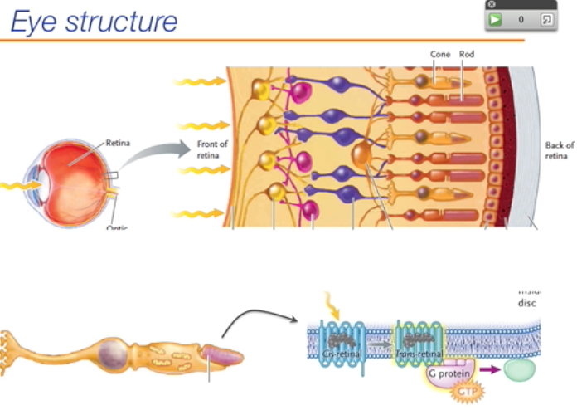

Biophysical Basis of Colour Vision:
- Cone cells come in 3 different types, differing in the type of rhodopsin (3 DIFFERENT opsins bound to the SAME retinal)
  - Every cone cell has thousands of rhodopsin that are all the same within the cell
    - 1 cell only absorbs 1 type of wavelength (only has 1 type of rhodopsin, therefore 1 type of opsin)
      - Technically has the genes for all 3 opsins, but only 1 gets expressed
  - Retinal absorbs different wavelengths depending on what opsin it is attached to in the cell
    - IT IS THE OPSIN THAT DETERMINES/CONTROLS WHAT WAVELENGHT OF LIGHT THE RETINAL WILL ABSORB
  - Gives rise to trichromatic vision: three types of cones reflecting three different types of photoreceptor molecules (rhodopsins)
- Some cone cells have rhodopsins that absorb at small, medium and long wave lengths

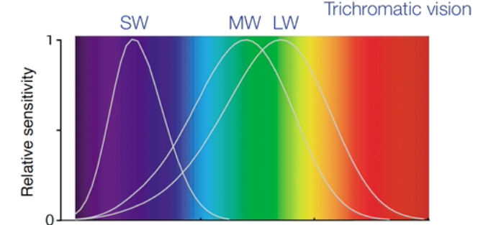

- Gives rise to ability to perceive pink; since pink excites both SW and LW cone cells
- We are most sensitive to green wavelengths of light (more likely cone cells can register their wavelenths)
- Not all organisms have trichromatic vision, some organisms have five different types of cone cells (can absorb light in UV ranges) some have fewer (dichromatic)

What accounts for this difference the wavelength of light the rhodopsin is able to absorb?
- What about this molecule is different in the short wavelength vs. the long wavelength rhodopsin?
  - The retinal is different; the retinal is the pigment that absorbs the light
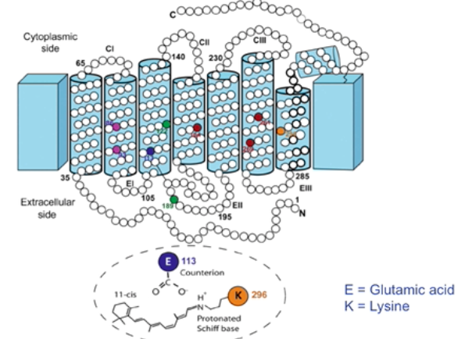
    - The differences in the pigment allow for it to absorb different wavelengths of light
- WRONG
- Retinal is EXACTLY the same, retinal has same number of conjugated bonds in SW absorbing vs. LW absorbing
- The change is in the protein (gigantic), influences retinal molecule (small) to absorb different wavelengths of light

Importance of lysine at position 296 and Glutamic acid at position 113:
Amino Acids Influence Light Absorption:
- Every opsin binds retinal at a specific lysine (K), 296
  - Amino acid 296 is highly conserved
  - Called a schiff base: N-C double bond with nitrogen in a protonated form
  - Stabilized there by a counter ion: an amino acid at a different part in the opsin
  - Glutamic acid (E), 113 in vertebrates also highly conserved; contains a –v charge side group
    - Allows for H-bonding between protonated schiff base and counter ion
    - In order to properly fold opsin, this interaction must occur

Major similarity and differences as revealed in protein alignment of SW, MW and LW opsins
What accounts for differences in absorption spectra of opsins:
Role of opsin and retina in different cone types:
- Opsin: determines what wavelength the retinal pigment is able to absorb at
  - Holds the retinal differently and affects what wavelengths it can absorb
- Retina: tissue layer at back of your eye, contains of rod and cone cells that absorb light and result in vision

SW, MW and LW Opsin Alignment:
- Red: shows absolute conservation, sequence in all three proteins is exactly the same
- MW and LW much more similar than they are to the SW
- All have conserved retinal binding site: lysine and counter ion spot (glutamic acid)
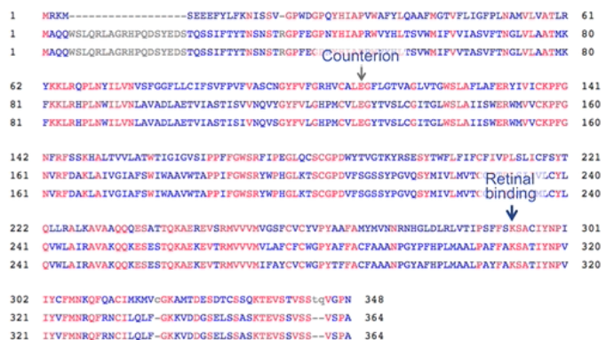
- Subtle change in retinal absorption; how the opsin interacts with retinal is never exactly the same
- Opsin is large and can distort the retinal slightly in all different types of rhodopsins
  - Accounts for a shift in the absorption spectra of retinal
  - Opsin is influencing the wavelengths that retinal is absorbing at
    - Opsin can influence the electronic states of retinal and put strain on the pigments which accounts for the shifts in its absorption spectra
- Why don’t we alternate retinal itself? What is the advantage to changing the opsin?
  - Made by a complicated biosynthetic pathway, to change you would have to change several different enzymes
    - Must change sequence of multiple enzymes DIFFICULT
  - Retinal not coded for by a gene so more difficult to change
  - Easier to change the opsin because can change the sequences directly through mutation

  - Maybe it allows for more subtle changes in wavelength absorption when opsin is manipulated but adding another conjugated bond to retinal is a very large change

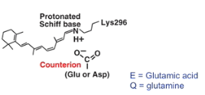
UV Absorbing vs. SW Opsins:
- Some insects have rhodopsin that can absorb in the UV, humans absorb in the blue (SW)
- We think that our ability to perceive short wavelengths evolved from an ancestor that had a UV absorbing opsin
  - UV absorbing opsin changes into a SW absorbing opsin over time

Effect of unprotonated form of Schiff base on light absorption:
- What accounts for this difference between a UV absorbing rhodopsin and a blue absorbing rhodopsin?
  - All you need is a change in the counter ion
  - If counter ion is not a negatively charged amino acid, (ie. if not charged at all), then Schiff base DOES NOT remain in protonated form
    - Schiff base will be unprotonated if the counter ion isn’t negatively charged
      - Protonated form will not be stabilized
    - Causes a shift to the absorbance of much shorter wavelengths
    - Almost every UV absorbing rhodopsin is in the unprotonated form
    - Means that in the unprotonated form it takes more energy to drive the photoisomerization of retinal
      - Blue light can’t do it anymore, need UV light with shorter wavelengths and more energy

Vertebrates have Lost and Regained Cone Pigments Over Time:
- Over 600 M years ago, cells had opsins and were able to detect light
- Opsins have been used over time to make light detecting eyes that later led to actual vision
- We believe the MRCA of all vertebrates had at least 4 opsins
  - Modern day birds have 4 different opsins (birds and fish have better colour vision than humans)
  - Over time of divergence of mammals, we have lost some of our opsin genes
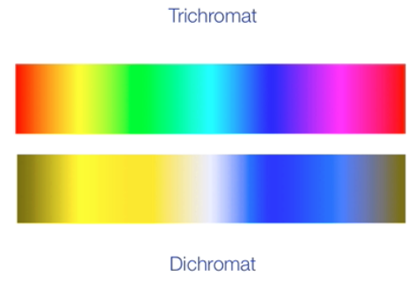
- What could have caused us to lose some of our opsin genes over time? Why would evolution favour a less complex organism over time? Why might you have not been at a disadvantage if you couldn’t see colour as well?
- Most mammals are dichromats (have 2 different kinds of opsins)

Assocatiation between Trichromacy, dichromacy, old world monkeys and new world monkeys:
- Old world monkeys (Africa and Asia) and humans (which are old world monkeys) are trichromats 3 cones to work with, can distinguish more colours) (more closely related than)
- New world monkeys (South America, dichromats – 2 cones to work with)

The Ecology of Colour Vision in Monkeys
- Being a trichromat is not necessarily better than being a dichromat
- Dichromats have difficulty seeing red and green and so find it harder to distinguish leaves that have black fungus on them
  - Trichromatic vision allows you to distinguish food on basis of colour
    - Trichromatic vision gives you an advantage to seeing food at a distance and selecting ripe food that’s close by
  - Why is it useful to distinguish colour when food is in the red range

Food Selection – The Research Part I:
- Offered red and green fruit to monkeys and found that
  - Trichromats could pick out the red fruit better than dichromats (53 vs 37% of time

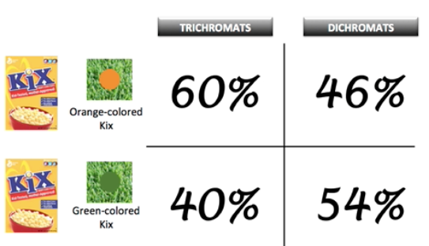
Part II:
- Put orange cereal in green grass and let the monkeys go and get the fruit
  - Orange on green, trichromats win
  - Green on green, dichromats are better at finding the cereal
    - Being dichromatic gives you an advantage when food is camouflaged
- Human vision is not better if trichromatic vs. dichromatic; trichromatic vision is not better than dichromatic in every circumstance
- Being more complex is not always better in evolution

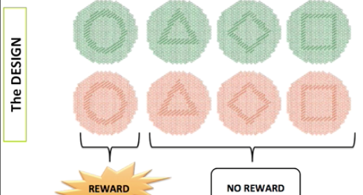
LECTURE 24: EVOLUTION OF EYE AND COLOUR VISION II
Lecture Outcomes:

Part III: Choose the circle and get a reward
- No reward for choosing other shapes
- Dichromats are much more successful in this experiment
  - 85% success rate vs. 51% for trichromats
- Dichromats are much better at breaking camouflage
  - Better at seeing/distinguishing on basis of shape and shade than on the basis of colour
  - Trichromats had a much more difficult time with this experiment because so much colour they were seeing was camouflaging the shape
- Therefore, dichromats actually have a selective advantage under certain conditions
- When is it important in nature to break camouflage?
  - Dichromats are able to break camouflage of predators and prey
  - Dichromats are not fooled by all the colour and can see the bug on the log
- Shows again that evolution DOES NOT always favour the more complex system
  - Being able to see in more colours isn’t always better/isn’t always favoured

Link dichromacy and trichromacy with ecology...ability to discern differences in colour and shape:
Food Selection Summary:
- Dichromatic vision is more likely to be selected for when food is distinguished from non-food by shape
- Trichromatic vision more likely to be selected for when food is distinguished from non-food by colour
  - Doesn’t matter what genotype or phenotype we’re talking about; it’s fitness depends on the conditions!

Relationship between retina, cone, rod, rhodopsin, and colour vision:
- Retina:
- Cone:
- Rod:
- Rhodopsin:
- Colour Vision:

Trichromatic vision means what?
- Trichromatic Vision: 3 opsins coded for by 3 different genes; organisms with these three opsins are said to be “trichromats”
- Means they can distinguish colour better than organisms with only two functional opsins (“dichromats”)

Location of Opsin Genes:
- Everyone has the SW gene (absorbs more in blue range) which is autosomal and often located on chromosome 7
- Trichromat primates have an extra opsin gene on their X chromosomes:
  - MW and LW are located on the X chromosome (are X-linked)
    - LW gene arose through gene duplication and mutation of the MW gene
      - Duplication and divergence of these sequences gave rise to opsins that make the retinal sensitive to different wavelengths of light
      - One way genes can be duplicated unequal crossing over of chromosomes/genes during meiosis (could be original origin of duplicated opsin)

mechanism by which some new world monkey females have better color discrimination than any males:
The Case of Trichromatic Females:
- Some monkey females in (NEW WORLD) South America have better colour discrimination than any of the males
  - Just one gene (opsin) has multiple variations (ALLELES)
    - In each female, they inherited one allele that is slightly different than the allele they inherited from mom
    - Different alleles (results in) slightly different opsins slightly different absorption of retinal
  - Males have only 1 opsin gene to work with; while females have better colour discrimination due to all these slightly different alleles **** why is the answer that females have 2 x chromosomes, would make sense

Biogeography of Global Monkeys:
- Clear geographic separation Asia and Africa monkeys (OW) where humans evolved you have trichromatic vision
- In South America, you have dichromatic vision
- This is due to CONTINENTAL DRIFT
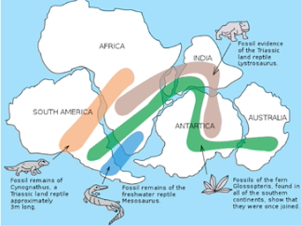
  - Timing of continental drift coincides with evolution of colour vision (evolution of opsins)
  - 225 and 135 ???
  - Plates move and separate because they are floating on the liquid mantle of the earth (2 in. per year)
  - Between 65 mya and today, total separation between North (old world) and South America (new world)
  - Timing matches what we know about when primates evolved
  - Strongest support of continental drift comes from fossils across continents
    - Similar fossils from similar groups found across many continents
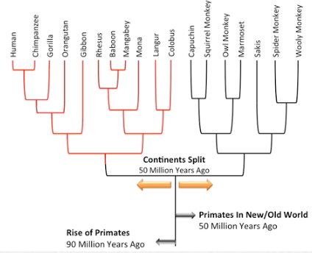
  - We think primates evolved around 90 mya,
    - Before old and new world were isolated
      - 7-9 mya humans and chimps shared a MRCA
      - Using a mixture of morphology, fossil record and the molecular clock to figure out this timing
  - 40-50 mya ago split into OW monkeys (humans and chimps) and NW monkeys
    - After the continents split apart
      - Very left: apes
      - Middle left: OW monkeys
      - Right: NW monkeys

LECTURE 25: THE DRAKE EQUATION
Lecture Outcomes:
- Andromeda; similar in size to Milky Way, both spiral galaxies
  - 100, 000 light years (ly) across
    - Takes light 100, 000 years to go from 1 side to the other
    - Speed of light is 1.1 B km/h
    - Therefore a light year = 9 x 10¹² km
    - Current technology prevents us from getting from one side of galaxy to other
- Nearest star to our sun/solar system is Proxima Centauri
  - 4.22 ly away or 39 x 10¹² km
    - BUT our space shuttle can only travel 31, 000 km/hr
    - But would take 150, 000 yrs just to get to our closest star Proxima Centauri
      - With our technology, we are NOT going to get anywhere with regards to looking for extraterrestrial life
      - May have the capacity to go to Mars, but have no capacity to leave our solar system (or go elsewhere in our galaxy)

Radio Astronomy:
- Advantage: while space shuttle DOES NOT travel speed of light, radio waves do
- Rather than trying to go someplace, we just have to send out/listen for radio waves and try and communicate with other places
- SETI: search for extraterrestrial intelligence (40 yrs)
- Have had the capacity to generate radio waves for 100 yrs
  - Radio waves are picked up from stars and other noise but we have not heard a signal that sounds like the product of intelligence
  - Chances are other life forms have had these radio waves for thousands of years

all of the terms (and the rationale underlying their suggested values) of the Drake Equation:
- N = N_{s} × f_{p} × n_{e} × f_{l} × f _{i} × f_{c} × L
- N = Number of advanced civilizations in our galaxy (Milky Way)
  - what we are actually trying to figure out
  - currently only know of 1
- N_{s} = Number of stars
- f_{p} = the fraction of those stars that have planets
- n_{e} = number of planets that can potentially support life
- f_{l} = the fraction of those planets that develop life
- f_{i} = the fraction of planets that develop intelligent life
- f_{c} = the fraction of planets willing and able to communicate
- L = average lifetime of a civilization
  - Parameter
  - The longer a civilization is around, the greater the chance we can detect and communicate with them

Number of Stars (N_{s})
- 100 billion (10¹¹) stars in the galaxy

Fraction of stars that have planets (f_{p})
- planet formation is a natural consequences of star formation
  - planets DO NOT FORM INDEPENDENTLY of stars; planet formation is not spectacularly rare
- sun forms and planets form at the same time; planets are result of star formation
- set f_{p}=0.5 (half stars have planetary systems around them)
  - 50 B stars in our galaxy have planets!
- Can we detect extrasolar planets?
  - The ability to detect planets that orbit around stars other than our sun
  - Yes we can Kepler Mission
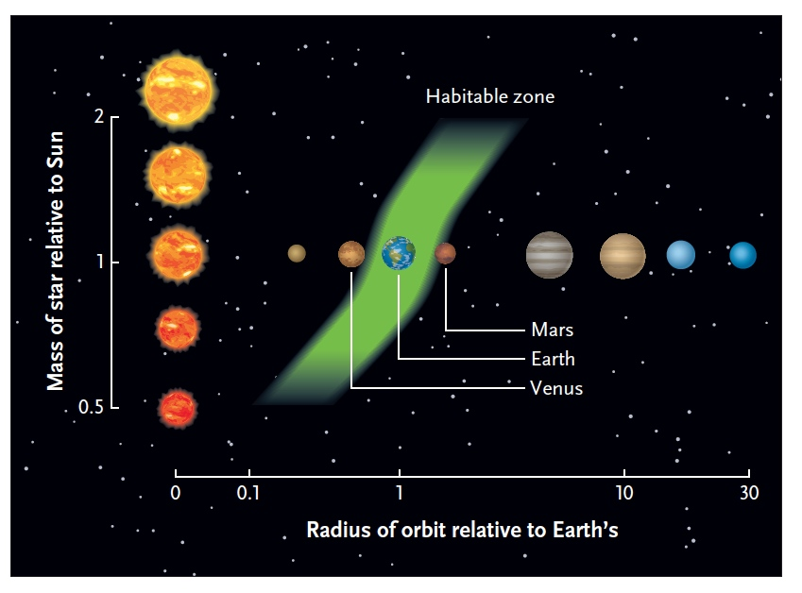
n_{e}
Number of planets that can potentially support life:
- Has to do with distance from planet star
- Habitable zone: planet in right temperature (too close to star = too hot; too far away = too cold); water is in liquid state
- Set n_{e}=2 (two habitable planets per solar system)
- 100 B planets could potentially support life
    - 10¹¹ x 0.5 x 2

- Maybe Venus and Mars at one point did have primitive life; but no evidence of them having life right now
- Both on fringes of that habitable zone; Venus is a little too hot, Mars a little too cold

f_{I}
- What fraction of planetary systems actually develop life?
- We only know about Life on Earth
  - Life evolved fast (600 M years for life to form)
  - All planets capable of developing life do develop life
    - Moris believes the development of life is inevitable
      - Development of life is rare but given enough time, even rare things will occur
- Set this as 1
- N= 100 billion planets with life
  - JUST OUR GALAXY; not the universe as a hole

f_{i} f_{c}
- Proportion of planets with intelligent, communicating life
- Not easy to estimate
- Dolphins don’t count- like really smart (build car or electronics)
- 10% for each become intelligent and 10% of those develop the ability to communicate

N = N_{s} x f_{p} x n_{e} x f_{l} x f_{i} x f_{c}
= 10¹¹ x 0.5 x 2 x 1 x 0.1 x 0.1
=1 billion planets with intelligent, communicating life

***Therefore 1 B advanced civilizations in our galaxy alone***

mechanism by which the “transit method” detects extrasolar planets:
- Kepler Mission (Kepler is an observatory, broken now)
- Instrument is able to detect presence of planets orbiting distant stars
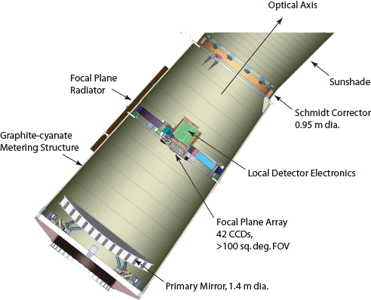
  - Light enters, bounces off parabolic mirror and hits photometer (made up of 42 charged coupled devices CCDS)
    - Photometer converts takes the photons of light and converts them into electrical current
    - Can detect huge amounts of light coming from very far away; CCDs very sensitive
      - Detect very small fluctuations in apparent brightness/light coming from a star
      - From 5 km away, could detect a mosquito walking across a headlight
    - Kepler stays fixed in orbit, only looks at 1 part of sky (0.25% of the sky)
      - Only looks at 100, 000 stars
    - Kepler measures the change in brightness of a star (looks at all 100, 000 simultaneous)
      - Looks for regular fluctuations in the brightness
        - These suggest an orbiting/transiting planet
        - Picks up the drop in brightness as the planet moves between the sun/star and photometer on instrument
        - Has to measure at least 3 transits for each star to make sure it will occur again
      - Kepler can detect changes in the spectral composition of a star
      - Can calculate orbital time and use it to detect distance from planet to star
        - Planets closer to stars have shorter orbital times
        - Planets farther from stars have longer orbital times
    - Can also calculate radius of planet and star (can see how much sunlight drops as planet moves in front)
    - Atmospheric Composition
      - Does the planet even have an atmosphere
        - Can detect differences in starlight alone vs. starlight passing through an atmosphere
      - Starlight can pass through thin layer of atmosphere on way to Kepler photometer
        - Allows you to infer what molecules/elements are found in the
    - Detection of other planets in orbit: planets exert forces on one another so you can see how one planet may alter the orbiting time of another transiting planet

Characteristics of planets that are thought to be conducive to the development of life:
- Kepler has detected about 2, 740 extrasolar planets so far
  - Not even surveying the entire sky, only looking at about 0.25% of the sky
  - Kepler better able to detect giant planets that orbit very closely to the star
    - May be some bias on the part of the machine

- We are mainly looking for planets the same size as Earth
  - If planet is too small, does not have enough of a gravitational pull to hold an atmosphere (ie. Mercury)
  - If too large, too many gas molecules get retained like hydrogen and helium too much atmosphere to support life (ie. Jupiter)
    - Goldilocks Phenomenon
- Water in liquid state on planet surface
- Planet at right temperature

Structure of water that explains its properties:
- Water is fundamental to life on every planet; has such unique properties
- Has a dipole moment (oxygen much more EN than H) water is polar
  - Water does not seem to exists in a liquid state on Mars, too dry thus we don’t believe there is any life present there
- Based on it’s molecular weight, water should be a gas at room temperature
  - This is due to the hydrogen bonding
  - Takes a lot more energy to break these bonds than it does H₂S
- Water molecules surround proteins, nucleic acids and ions and form hydration shells
  - Hydration shells are very important to life
  - Minimize electrostatic interactions/minimize charges
    - Proteins and nucleic acids are full of charged groups; without these hydration shells these molecules would just clump together and interact based on their charge
    - Allow proteins to interact in much more subtle/complex ways that wouldn’t be possible without hydration shells

Evidence of Life Elsewhere in the Solar System:
- We have strong evidence of water elsewhere in our Solar system other than just on Earth
- We think there’s evidence that water used to flow on water
  - Only possible explanation for creation of channels on Mars (rivers that have dried up)
- Enceladus is a Moon of Saturn, covered in ice, but people believe there is a liquid exterior under this icey surface

the Fermi paradox:
- Number of advanced civilizations seem to be so abundant and yet we can’t detect any of them
- If there are so many advanced civilizations out there, where is everybody?
- If the galaxy is so rich with life, why can’t we communicate with anyone?
- We’ve had radio telescopes out in night sky for 40 years BUT we just hear static/noise
  - See no ordered messages from anyone

- Can’t detect them
- Distances are too great
- If N is the number of civilizations and we spread them equally across the entire Milky Way
  - If you had only 100 advanced civilizations (N=100); each would be
10, 000 ly apart
Radio waves would take 10, 000 yrs to get there
  - If you had only 1,000 advanced civilizations (N= 1, 000); each would be 1,000 ly apart
  - If you had only 1 M advanced civilizations (N= 1, 000, 000); each would be 100 ly apart
  - If you had only 100 M advanced civilizations (N= 100, 000, 000); each would be 10 ly apart
- Chances are other civilizations have had communication technologies longer than us
- Maybe there is a technological incompatibility; we believe radio waves are fundamental, maybe not to other civilizations though
  - Maybe they talk at a frequency we don’t understand
- We are alone
- We are the only advanced civilization out there!
- For intelligent, communicating life to occur too many rare mutations must occur!
  - Gould
  - Contingency

