Final Exam Review
What is a Profession?
Lesson 1
Professions in the past
Ancient World
- Professions did not yet exist; lawyers and doctors were not organized professions
- A Professional was someone who “professed” his/her faith (religious background to the word)
Medieval Europe
- Two types of associations present: Religious Order and Secular Guilds
- Guilds are exclusive organizations (authorized by the king, clergy or city hall) to preserve the rights and privileges of members
- Two types of guilds present: Merchant Guilds protect traders and Craft Guilds to protect craftsman (i.e. bakers, cobblers, carpenters etc.)
- Guilds operated in a feudal society thus being in a guild provided an upward movement in status and wealth
- Feudalism: the nobility held lands from the Crown in exchange for military service while the peasants were obliged to live on their lord's land and give him homage, labor, and a share of the produce, notionally in exchange for military protection
- Organizational Level of Guilds:
1. Guilds
2. Craftsman (Business Owner)
3. Apprentice (Works for Craftsman to Learn the Craft Unpaid)
4. Journeyman (Paid Helper for the Craftsman)
Responsibilities Services
- Restrict Poor Workmanship - Health insurance
- Forbade Advertising -Supported Families After Death of a Worker
- Regulated Prices -Made Donations To The City
- Exerted Monopoly Control -Served As Councillors
- Limited The Number Of Members -Constructed Public Buildings
Post-Industrial Society
- Shifts from manufacturing-based massed production service oriented economy (finance, real estate, supply chain management)
- 3 types of workers: Business Entrepreneur, White Collar, Blue collar
- Business Entrepreneur: Someone who owns a business that generates revenue through human, financial or physical capital
- White Collar Worker: Highly paid workers that do administrative or technical work.
- Blue Collar Worker: Low skilled workers that in general do manual labor that does not require high skill training (Paid hourly)
- Being a professional brings high social status because society values their skill and expertise in the betterment of society
Attributes of a Modern Professional
- Skill: Individuals are required to undergo an extensive and formal education usually at the university level which teaches varied and intellectually demanding techniques and practices. Many of the techniques require science, technology or mathematics; it is therefore not enough to have an individual serve as an apprentice for practical training.
- Judgement: Since the work is varied and not routine work, it cannot be mechanized. The variation in the requirements of work means that individuals as part of their work have to make choices. These choices while based on the training they receive, have to be made by the understanding of the individual.
- Membership in a Self-Governing Society: Modern professionals need to be members of self-governing professional associations. These associations are usually established by the government to govern the actions of professionals to ensure that they practice their profession to further public welfare.
- Advancing Public Welfare: If they practice their profession in an ethical fashion, professionals make a significant contribution to improving the welfare of citizens. Conversely, malpractice or the unethical practice of the profession can have a significantly adverse effect on citizens and society. For example, consider the effect that bad construction in a bridge could have on the general population that relies on the bridge to meet their transportation needs.
There are two kinds of professionals: independent professionals and employed professionals.
- Independent professionals as the name indicates work independently and are paid directly by the client for the service provided by the professional. As a result of their independence in employment these professionals have much greater autonomy in their actions.
- Employed professionals: usually hired by a company or organization. In return for a monthly salary, the professional provides their services to their employer. It is the employer that usually sets the terms of their work and so the professional has much less autonomy in their actions.

Professional System
A formalized organization that links professionals with society they operate within. The key objective of the professional system is to ensure that professions are organized to be accountable to society. Professional associations composed of professionals practicing the same profession are a key aspect of the linkage between professionals and society.
- Most professional systems have formal rules (sometime laws) that govern the actions of individual professionals.
- Professionals become members of a profession when they receive a license to practice the profession. The professional license, just like a driver’s license, allows the individual to practice that profession.
- Breaking formal rules can result in penalties and depending on the nature of violation even loss of license. It is through the licensing system that the actions of professionals are governed by the government.
Professional values are those that guide the nature of professional relations with clients, employers, and fellow professionals. This includes aspects such as values of honesty, integrity, loyalty and responsibility.
Professional values relate to societal leadership that relate to how the professional should relate to the values that underpin a particular society or nation they work within. These relate to such aspects as law, prejudice, and safety.
According to the OIQ four values derived from its social mission Competence, Ethical Conduct, Responsibility, Social Commitment
Mixing personal and professional values is considered a “conflict of interest” and should be avoided. For example, wearing a religious symbol is not usually considered in appropriate display of personal values, but giving jobs to people of the same faith could be considered conflict of interest or discrimination, depending on the professional system.
Possible Questions
The four attributes of a profession are skill, judgement, membership in a publicly governed society, welfare to the public. T or F
A waiter is a blue collar worker.
T or F
The historical origin of the word profession is from the faithful who were said to profess their faith T or F

A professional system is organized to ensure that the professionals pursure their professional career interests. T or F
What is not a main form of work in the modern world?
- An Entrepreneur
- An Ascetic
- White Collar Worker
- A Labourer
Guilds were exclusive organizations created to preserve rights and priviledges associated with the practice of a skilled occupation in medieval Europe.
T or F
Skill is an attribute of a professional that can be learned only through extensive and formal education. T or F
What was a secular professional in medieval Europe?
- A monastic order
- A feudal leader
- A royal court
- A guild
Lesson 2
Professional Systems in Quebec
The professional system in Canada is quite unique in the world. One of the factors that make it very unique is the formal nature of control over individual professionals. This formal control is created by making professional associations statutory bodies (requiring a permit). Each professional association derives its power to control individual professionals from this statutory standing. Another aspect of the professional system in Canada is the closed nature of the profession. In order to practice most professions in Canada, an individual has to become a member of the corresponding professional association. A person, who practices the profession without an explicit license, is considered to be practicing the profession illegally and could face legal action.
Social Contract Model: Such a model places more emphasis on member responsibilities rather than rights. (Professional associations) goal protect the public
Collective Bargaining Model: associations are groups that try to further private interest rather than public good. So such associations have more rights and demands and fewer responsibilities. (Labour Unions) goal further personal benefit
Labour Code (Canada) for Professional Employees: is, in the course of their employment, engaged in the application of specialized knowledge ordinarily acquired by a course of instruction and study resulting in graduation from a university or similar institution, and is, or is eligible to be, a member of a professional organization that is authorized by statute to establish the qualifications for membership in the organization.
Five primary groups that administer the system
- The Government of Quebec (Minister of Justice)
- Reports to the national assembly of Quebec on the operations of the professional system.
- The minister present legislation and resolutions regarding the professional system in the national assembly.
- Professional Tribunal
- Groups of judges who are appointed by the court of Quebec who listen to appeals on decisions made by disciplinary councils of different orders.
- Quebec’s Professional Office
- Ensures that different orders respect their mission and give advice to the government.
- Quebec’s Interprofessional Council
- Composed of representatives from all 46 orders and is put in place as a consulting body on professional matters.
- 46 Professional Orders
- Mission of the professional orders is to ensure the protection of the public.
- There are two types in the professional order: Reserved titles and Exclusive rights which means to practice one must be a member of the association and second is reserved title which means users don’t have to be a part of the association to practice.
Professional System
- The formalized system that links professions with society.
- System ensures that professions are organized to be accountable to public and society.
- Professional associations are key aspect of this linkage
- In Europe with a longer history of professionals, there are detailed legal requirements
- In USA there are fewer legal requirements of professionals
- Canada and Quebec are intermediate
Reasons for Professional Systems
Independence: Considerable decision making autonomy for the professional associations
Accountability: Professional system is ultimately answerable to the government and people of Quebec. Monitoring systems allow the government of Quebec to exert control.
Transparency: Regulation of professions is open to public scrutiny
Monitoring: system allows the government of Quebec to exert control
Operation of the Professional Association
- Creates a structure of self-management the members govern the order by financing, creating professional regulations and creating functional roles.
- Control of practice The way they control the practice of the profession is by controlling the title and right to practice, verifying competence and integrity of admissions, maintenance of professional competence and supervision of professional practice.
Role of Professional Associations
- Leadership & supervision
- Training & maintaining competence
- Verifies individual competence
- Investigates malpractice
- Decides on penalties to be awarded
Management of Professional Orders
Executive Committee Leadership and Supervision
Training Committee Training and Maintaining Competence
Inspection Committee Verifies individual Competence
Syndic Investigates mal practice
Disciplinary Council Decides on penalties to be awarded
All engineers must be a part of the OIQ to practice in Quebec. The rules the organization follows are: The professional code, The engineering act, Bill 101, The code of eithics and other regulations for engineers
Professional Code: A Law of public order that reflects the National Assembly’s desire to protect the public in matters concerning professional services. Applies to all professional orders including the OIQ. Creates the Office of Professions and the Interprofessional Council. Creates the different professional orders. Describes the activities of the professional orders.

Engineers Act
- Defines a member as a person on the roll of the OIQ
- Defines an engineer as a member of the OIQ
- Defines the field of practice of an engineer, the kinds of work that requires an engineer,
- Defines the kinds of acts that count as engineering practice (consultation, measurements, design, drawing and inspection)
- Reserves professional titles.
Steps to become a part of the OIQ
- Have a recognized engineering diploma valid in Quebec
- Complete the application form for a permit with the OIQ
- The OIQ declares the candidate admissible
- Entry on the membership role of Junior Engineer
- Professional examination
- Sponsorship
- Engineering experience
- Recognition of engineering experience
- Granting the engineer’s permit and entry on the membership roll of the OIQ
History of Professions in Quebec
- Initially inspired by European models of regulation
Before 1970
- Professional associations had weak social contracts and were non-standardized.
- Liberal Professional – independent and unregulated by governments.

Between 1960-70
- there was a surge in many new & different professions.
Prior to 1973
- Trust in the ability of professional associations to govern themselves
- Professional associations were arbitrary
- Code of ethics not obligatory
Reason for change
- Necessity of ensuring public safety
- Development of many specialized professions
- Formalizing practice rights
In 1973 National Assembly of Quebec initiated a new control of professional orders
- Adopted the Professional Code
- Instituted a Professional System
Possible Questions
The professional code is a law passed by the national assembly of Quebec, that seeks to protect the public in matter of professional services. T or F
In some provinces in Canada, it is possible for engineers to practice their profession without registering with a professional association. T or F
If you are registered with Professional Engineers Ontario, you can work as an engineer in Quebec. T or F
Professional associations such as OIQ, follow a collective bargaining model. T or F
The professional Tribunal is composed of representative of all the orders, and it acts as a disciplinary body. T or F
Labor unions are organized according to the social contract model. T or F
Within which jurisdictional level are professional associations in Canada organized?
- Federal
- Provincial
- Global
- Federal and Provincial
The Interprofessional council is an advisory body composed of representatives of all the ____ professional orders in Quebec. A: 46
A _________ model is an organization model that allows interest groups to further their private interests. A: Collective Bargaining Model
Labor unions are organized according to the social contract model. T or F
The bill 101 in Quebec makes French the official language of the government of Quebec.
T or F
The office of professional conduct is a judicial body that hears appeals on decisions made by disciplinary councils of different professional orders. T or F
Lesson 3
Engineering Ethics
Engineering Ethics: the analysis of decisions, choices and policies that are morally desirable in engineering practice and research. It is a body of philosophy that indicates how engineers should conduct themselves in their professional capacity.
Ethics: Ethics is a branch of philosophy. Ethics is the systematic analysis of behavioural choices that individuals or societies face. Ethics is the study of right or wrong, of obligations and rights, so that social and political goals are met.
Values: Values are beliefs that define individuals. They are the basis of worldviews and guide behaviour. They govern the choices we make
Morals: a person's standards of behavior or beliefs concerning what is and is not acceptable for them to do.
Need for Ethics
Humans face choices in daily life. Choices provide alternative courses of actions that lead to different consequences and to different personalities. Ethics are a way to rationally reason our choices.
Ethics vs Morals
Ethics
- Ethics is systematic analysis of human behaviour.
- Frameworks are not specific to cultural or geographic context.
- Ethics are impersonal
- Ethics require rational examination.

Morals
- Morals are customary norms of behaviour
- Vary with time and geography.
- Morals are personal
- Morals transmitted through socialization.
Need for Ethical Reasoning
Avoids Moral Absolutism: morals are absolute, unchangeable and always true. They NEVER change according to circumstances.
Avoids Moral Relativism: Morals are relative to individuals and so completely subjective. Therefore no one guideline is adequate for everyone
Creating Professional Morality
Internal Influences
- Ethics – provides an objective system of making choices qualified by circumstance. Is ok to kill ? no / if its self defence yes (NOT A PERSONAL OPINION)
- Values – beliefs that define individuals, basis of worldviews and guide behaviour
External Influences
- Justice - It is “fairness” or “rightness” in action and conduct. It is, process and goal, means and end. Concept of “Justice as Fairness” (John Rawls). It implies basic liberty rights that are inalienable. It implies equity and equality of opportunity. It allows inequalities that work to benefit the worst
- Law – established by competent authorities in society. Laws govern what is allowed and forbidden. Laws are based on customs and morals
- Morals – is a classification of right and wrong acts which are based on religious, cultural or customary mores. They can differ from place to place (IT IS A PERSONAL OPINION)
Both Internal and External
- Engineering Ethics – the analysis of choices, decisions and policies that are morally desirable in engineering practice and research. The 4 goals of engineering ethics are as follows:
- Moral Awareness: awareness of value conflicts that underlie choices
- Moral Autonomy: ability to think critically and independently about a moral issue
- Moral Imagination: ability to create solutions to moral dilemmas
- Moral Communication: ability to communicate moral issues
- Code of Ethics – engineers must adopt the code. It states that engineers have duties towards the public, clients (including employees) and profession
Types of Justice
- Procedural Justice – Justice needs to be seen to be done.
- Corrective Justice – Fairness in rectifying wrongs
- Distributive Justice – redistributing for equality in society.
- Political Justice – Fairness in political rights
Lesson 4
Ethical Reasoning
Ethical theories focus on different aspects of human behavior
- Agent – the individual involved
- Action – doing something
- Result – consequences for the action
Ethical Theories
Aristotle’s Virtue Theory (focuses on agent)
- Happiness is achieved by developing virtues, or qualities of character, through deduction and reason. An act is good if it is in accordance with reason. This usually means a course of action that is the golden mean between extremes of excess and deficiency
- Theory suggests that a better guide to ethical action is the character of the person performing it.
- Character and virtue are more immediate guides
- People seek to lead virtuous and balanced lives
- What kind of person will I become if I do this action?
- Does it match a model of a virtuous person you know
- Moderation is key, try not to make drastic decisions
Deontological theory (focuses on action)
- Actions are only as ethical as the nature of the action chosen
- The ends do not justify the means chosen to accomplish them
- However good consequences may be, if the actions are wrong, they do not justify the action.
- Morality is created by following rules.

Immanuel Kant’s Duty Ethics
- Each person has a duty to follow those courses of action that would be acceptable as universal principles for everyone to follow
- Human life should be respected
- People should not be used as a means to achieve some other goal
- Doing your duty: Ethical action arises from following rules generated by ones conscience.
- Problem: An individual’s conscience may conflict with group interests
- No notion of good of society.
- Conflicts arise when following a universal principle may cause harm. For example, telling a "white lie is not acceptable”, even if telling the truth causes harm.
Consequentialism (Results oriented)
- The ethical content of an action depends on the consequences produced.
- “If you want result B, then do A” – hypothetical obligation
- Problems: Good/bad consequences may not be immediately knowable
- Difficulty in characterizing the good and bad
Mill’s Utilitarianism
- Right actions are those that produce the maximum benefit for the greatest number.
- Maximum benefit understood as:
- Number of people affected
- Intensity of benefit – nature of benefit (trivial vs serious)
- Duration of benefit – time period to see benefit
- Conflict: A conflict of interest may arise when evaluating the benefits, or when distributing them equally. Benefits must not favour special groups or personal gain.
Other Relevant Ethical Theories
- Locke’s Rights Ethics: All individuals are free and equal, and each has a right to life, health, liberty, possessions, dignity, and the products of his or her labour
- Natural Ethics: Principles derived from nature.
- Religious Ethics: Christian, Islamic, Jewish, Hindu, and Buddhist ethics.

Steps of Ethical Analysis
Moral Clarity (Identify Relevant Moral Values)
- What are the relevant moral values connected with the situation?
- Remember OIQ’s professional values – Competence, Ethical Conduct, Responsibility & Social Commitment.
- Competence – to be objective and truthful
- Responsibility to the organization – act as loyal agents
- Social Commitment – commitment to society’s welfare
Conceptual Clarity (Clarify Values for the Circumstance)
- Responsibility to company
  - Does that mean obeying everything your supervisor tells you
  - Should you think of the long-term benefits or short-term benefits to the company
- Social Commitment
  - Does it mean to all threats that society faces
  - What level of threat is considered serious enough to warrant disclosure
  - Should you reveal all facts or only what you think is important
Obtain Relevant Information
- Is there uncertainty about the facts?
  - Have the findings been re-evaluated by someone else?
  - Is there any margin of error?
  - What is the possibility of harm coming about to inhabitants?
  - Have there been instances in the literature that suggest anything?
  - Be thorough in research and documentation
Consider All Options
- What are the options for actions that you can take?
  - Is more research required?
  - Can the supervisor be convinced?
  - Are the regulations too strict?
  - Do nothing and have faith in the company or expose the whole company (whistleblowing). It is the spectrum, two extremes and an uncountable amount of actions in between
Reach a Reasonable Decision
- Decision should be based on previous steps.
- Look for a ‘golden mean’
- May not be optimal decision or the decision you want but under the these conditions it is what is most reasonable and defendable.
Possible Questions
Which theory is Kant’s duty ethics most closely related to?
- Deontological Theory
- Natural Law
- Consequentialism Theory
- Virtue Theory
Virtue theory suggests that the character of a person performing an action is a poor judgement of the ethical content of an action T or F
Which of the following best describes a utilitarian decision?
- An action that is considered a good action
- An action that produces the best outcomes for an average number of people
- An action that produces the best outcome for the minimum amount of people
- An action that produces the best possible outcomes for the maximum number of people
Deontological theory suggests that the ethical merit of an action is based on the character of the person performing the action T or F
_______ suggests that every individual has certain non-alionable rights – life, liberty and dignity
A: Rights Ethics
Religious ethics are moral principles that are based on religious standards of behaviour. T or F
Duty theory considers the agent in order to evaluate the ethical content of an action T or F
Actions are only as ethical as the person doing it is a good description of Aristotle’s virtue theory
T or F
Which of the following aspects of human behaviour do not correspond to an ethical theory
- Laws
- Agent
- Result
- Action
Lesson 5
Types of Professional Relationships
Professional Relationship
  - It refers to services a professional provides to a client or an employer.
  - Code of ethics understands “client” as a person to whom an engineer provides professional services, including an employer.
Interpersonal
- Involves creating a relationship between two distinct individuals
- There is a subjective dimension in the relationship
- Engineer in public service who manages individual citizen’s cases
Technical
- Problem solving concerning actual design, and production processes
- There is a stronger technical dimension
- Engineer who designs electronic circuit boards for consumer products
- A quality control engineer
Ideal Model
- It is a direct relationship where the client meets face to face with the professional.
- This usually involves the professional having his or her own practice.
- The professional provides the client with their skill, opinion and judgment directly.
- Quality control is governed only by the professional associations.
- Professional ethics are essential.
- The professional is highly autonomous.

Invisible Client Model
- Professionals are employed by a group or company (organizational setting)
- Professional does not get to see the client face to face.
- The employer dictates the pay, standards, ethics and work.
- The worker is far less autonomous.
- Less autonomy increased pressure to fit in with the organization and thus abandon certain principles and professional values.

Organizational Culture: is a set of values and assumptions shared within an organization.

Organizational Behavior
It is the study of how people think, feel and do in and around organizations. It looks at team and interpersonal factors that influence behavior. In organizational behavior there are three types of influences: individual, group and organizational.
The factors that affect individual behavior are: motivation, ability, role perception, and situational factors. We can easily remember these factors via the acronym MARS
Motivation
- Motivation is the force within a person that drives behavior.
- Motivation affects direction, intensity, persistence and voluntary behavior.
- It is possible to have two people working similar conditions with completely different motivation levels. One says that the evaluation is motivating; the other thinks the boss is not fair.
Ability
- It is recognized as the natural aptitude and learned capabilities that individuals have.
- High amounts of natural ability tend to show a comfort level in the workplace but usually affect how these workers interact with others.
Role Perception
- Defined as the position in which people occupy.
- These positions come with specific tasks and consequences.
- Our roles in an organization help define our personal behaviors.
- Roles help us communicate responsibilities and set expectations.
Situational Factors
- There are 2 types of situational factors that affect behavior.
- Internal: time, budget, work facilities.
- External: economic situation and/or consumer preferences.

Factors That Affect Group/ Team Behaviour
- Leadership
  - Leadership is the process of guiding and directing the behavior of people in the work environment.
  - Formal – organization bestows the authority to guide and direct
  - Informal – Unofficially accorded power by others.
  - The nature of leadership
- Power and Influence
  - Role of power and influence on behaviour
- Working in Teams:
  - The role of groups on productivity
Competencies: skills, knowledge, aptitudes and other personal characteristics that lead to superior performance. The goal of an employer is to match the proper employee’s competencies to the required job.
Skill Will Model performance = ability x motivation
Organizational Structure: Division of labor, patterns of coordination, communication, workflow and formal power that directs organizational activities.
Division of Labor
- Subdivide work job specialization
- Increases work efficiency
- Decrease work time less wasted employee time (save money)
- Lowers training costs
- Diversify the jobs each team does by employee specialization increases workplace efficiency

Informal Coordination
- Sharing information on mutual tasks as well as forming common mental models so that employees synchronize work activities using the same mental road map.

Coordination through Formal Hierarchy
- Assigns power to individuals and uses that power to direct work and allocate resources.

Coordination through Standardization
- Creating routine patterns of behavior or output.

Standardized Processes
- Helps quality and consistency of a particular product or service through job descriptions and procedures.
- This works when jobs are routine

Standardized Outputs
- Ensures workers have clearly defined goals and output measures (customer satisfaction / product efficiency sales targets)

Standardized Skills
- Makes sure that employees are exclusively and vigorously trained or ensure that all newly hired employees have educational certificates to the pertaining job.

Span Control
- It is the number of people directly reporting to the next level in the hierarchy
- Best method is self-directed (direct supervision) however that is decided on whether employees have routine tasks. (factory worker yes, sales reps no)
- Wide span control routine jobs that need less supervision and less direction
- Narrow span control complex tasks that need supervision
- Depends on how independent a job is

Tall Hierarchy
- Less information is relayed to upper management
- It is more costly to have a tall hierarchy due to the fact that there are more high ranking employees to pay
- Information from the bottom gets diluted on the way to upper management because it has be explained and re-explained countless amounts of time

Centralization
- Degree to which formal decisions are made are decided by a small group of people at the top of the organizational hierarchy
Formalization
- Degree in which organizations standardize behavior through given rules, procedure, formal training and related mechanisms

Mechanistic Structure
- Organizational structure with a narrow span of control and high degree of formalization and centralization
- Better for unstable environments which rely on efficiency and routine

Organic Structure
- Organizational structure with a wide span of control
- Little formalization and centralization
- Rapidly changing environments more flexible and responsive to change

Departmentalization
- To organize into departments
- How employees and their activities are grouped together
- Establishes chain of command
- Common supervision
- Determines positions
- Units must share resources
- Establishes interdependencies among employees and subunits
- Focuses people on mental models or ways of thinking such as serving clients, developing products or support a particular subset.
- Focus on budget and performance

Functional Structure
- A type of departmentalization that organizes employees around a specific knowledge or other resources
- The organization groups employees according to a specialized or similar set of roles or tasks.
- Functional structures operate well in stable environments where business strategies are less inclined to changes or dynamism
- he level of bureaucracy makes it difficult for organizations to respond to changes in the market quickly.
- Creates specialized pools of talent that typically serve everywhere in the organization

Divisional Structure
- A type of departmentalization that groups employees around a geographic area, outputs (products/services) or clients
- Promotes growth and focuses employees attention on products or customers rather than tasks

Team Based Structure
- A type of departmentalization built around self-directed teams that complete entire pieces of work
- No formal leader
- Minimal supervision (low formal hierarchy)
- Few rules
- Self-directed team that completes a target task
- Responsive and flexible
- Low cost
- Increased communication quicker decisions

Matrix Structure
- Overlays 2 organizational forms in order to leverage the benefits of both
- Efficiency in communication, project and innovation
- Focuses on serving clients, creating new product yet keeps expertise organized around their specialization
- Employees have dual reporting relationships - generally to both a functional manager and a product manager.
- Existence of 2 bosses can dilute accountability

Organic Culture
- Shared values and assumptions shared within an organization

Types of values
- Innovation – experimenting/risk taking/few rules/low cautiousness
- Stability – predictability and security
- Respect for people – fairness and tolerance
- Outcome orientation – action oriented/high expectations
- Attention to detail – precise and analytic
- Team orientation – collaboration/people oriented
- Aggressiveness – competitive/low emphasis on social responsibility

Power: the capacity or ability to direct or influence the behavior of others or the course of events. (Politics is the use of power and influence to further personal interests)

Leadership: the process of guiding and directing the behavior of people in the work environment.
- Formal leadership – officially sanctioned leadership based on the authority of a formal position
- Informal leadership – unofficial leadership accorded to a person by other members of the organization
- Followership – the process of being guided and directed by a leader in the work place

Leadership vs Management
- Leaders produce useful change in organizations by setting a direction for the organization, aligning people with direction through communication and motivating people to act through empowerment and basic need gratification
- Managers control complexity in the organization and its environment through planning and budgeting, organizing and staffing and controlling and problem solving

Trait Theory: This theory says that leaders tend to look and act a certain way however it was deemed not accurate.
Behavioral Theory for Leaders
Autocratic – uses rules and regulations to run the work environment. This style is particularly effective for tasks that need to be finished urgently. However, long-term reliance on this style can affect the judgment and autonomy of professionals.
Democratic – leaders take collaborative, responsive, and interactive actions with followers. This democratic style allows for the evolution of mutual respect between professionals and co-workers. There is far less pressure to be influenced by organizational priorities.
Laissez-Faire - leader who fails to take responsibility of position. As a result, subordinates may have greater freedom, but there is little evolution of a coherent mission in the organization. In the short-term, professionals may face less pressures, but in the long-run will feel under-valued and frustrated.

Leadership Style
Initiating Structure – leader behavior aimed at defining and organizing work relationships and roles, as well as establishing clear patterns of organization, communication and ways of getting things done.
Consideration Structure – leader behavior aimed at nurturing friendly, warm working relationships as well as encouraging mutual trust and interpersonal respect within the work unit.
Possible Questions
_____________ is the study of individual, team and organizational level characteristics that influence behaviour within work settings. A: organizational behaviour
Power is the ability to influence someone’s behaviour. T or F
____________ is the force within the person that affects their direction, intensity or persistence of voluntary behaviour. A: Motivation
A functional organizational structure is the most hierachal structure of an organization. T or F
Both managers and leaders in organizations are advocates of stability and the status quo. T or F
___________ shows the division of labour and patterns of coordination, communication, workflow and formal power that directs organizational activities. A: Organization Structure
In a matrix organizational structure, information flows from many individuals to many individuals. T or F
An ____________ model is a model of professional relationship where the professional is employed to provide services within the organization. A: Invisible Client
Politics is the use of power and influence to further personal interests. T or F
____________ is the process of guiding and directing the behaviour of people in the work environment. A: Leadership
Lesson 6
Professional Loyalty and Trust
4 Key Values in Professional Relationships
Trust
The ability to rely confidently on people, objects or circumstances. Reliance on any one of these factors introduces risk.
Loyalty
Attitude or character that is demonstrated by a person through their actions. When a person puts someone else’s interests before their even when such an action exposes the person to risk.
Agency Loyalty: arises from fulfilling contractual duties. For example, if you are hired to perform a task in an organization, you are required to be a loyal agent as long as you work for the organization. Agency loyalty is a mandatory obligation that is fulfilled by obeying legitimate authority of colleagues and superiors and by following all policies and norms of the organization you work for.
Attitude Loyalty: an attitude or sentiment of a person. It is an emotional or identity response that arises from group affiliation. A display of attitude loyalty is considered a desirable quality (but usually not an obligation) for members.
Dignity
A feeling of respect or esteem that an individual holds themselves in. The state or quality of being worthy of honor or respect.
Honesty
The quality of being honest.
Trust Building Obligations
Disclosure of Limits
- Disclosing the limits of the ability to the client is the basis of building trust
- Gather intellectual & material resources
- Gather the consent of client to experiment
Integrity and Transparency
- Act in a fashion that demonstrates Integrity & Transparency
- At outset, inform client of terms of agreement in writing
- Avoid providing contradictory advise
- Furnish client with any explanations requested
- If advise is ignored, provide consequences in writing to client
- Documentation & paper trail of all client interactions
Availability and Diligence
- Engineer must show reasonable availability & diligence in professional practice
- The engineer can cease to act for the client under just and reasonable grounds.
- If there is a conflict of interest
- If it involves illegal or fraudulent acts
- If the client ignores the engineer’s advice
- The engineer must give advance notice of withdrawal to the client.
Independence and Impartiality
- Subordinate personal interest to that of the client
- Avoid situations of conflict of interest
- Accept fees only from client or client’s representative.
Confidentiality
- Must respect secrecy of all information obtained in the practice of the profession
- Released from secrecy only by the client or when required by law.
- Shall not use information that will prejudice a client
- Shall not accept a mandate from a client that involves disclosing another client’s information
Fee
- Must charge and accept fair and reasonable fees.
- Fees are considered fair when they correspond to services rendered
- Must give client necessary explanation for fees charged
Conflict of Interest
- Situations where professionals have an interest that, if pursued, might keep them from meeting their obligations to their employers or clients.
- Conflicts of interest have the potential to distort good judgment in faithfully serving an employer or client.
- Kinds of Conflict of Interest
- Gifts, bribes and kickbacks
- Interests in other companies
- Insider information for friends or relatives
- In conflict of interest perception is everything.
- You may not be involved but you are still in Conflict of Interest
- A “conflict of interest” is not the same as having “conflicting interests”
- Conflicting interest: a person has two or more desires that cannot all be satisfied given the circumstances. But there is no suggestion that it is morally wrong or problematic to try pursuing them all.
Potential questions
_________ are defined as disclosing the limits (intellectual, material or human resources) in the ability of the professional to serve the client. A: Disclosure of Limits
________ is the ability to rely confidently on people, objects, or circumstances. A: Trust
An engineer needs not give advance notice of withdrawal, if a client is involved in illegal acts
T or F
Clearly informing your client of the resources at your disposal is an example of confidentiality.
T or F
___________ is the presence of an additional or side interest that could threaten the exercise of good judgement of the typical professional. A: Conflict of Interest
Keeping documentation of all professional relations is the basis for integrity and transparency in professional actions. T or F
Fidelity relationship is a relationship where one person has the obligation to act for the benefit of another. T or F
If a client ignores your advice, you should give consequences of the action in writing. T or F
Absolute loyalty is a desirable characteristic for a professional working in an organization. T or F
___________ is an attitude or character of a person that arises from group affiliation.
A: Attitude Loyalty
_________ is defined by fulfilling contractual duties, according to organization norms.
A: Agency Loyalty
It does not violate confidentiality, if you accept a project from one client and then have to disclose information about another client to complete the project. T or F
A professional needs not charge fees that correspond to the services provided, but they should always provide an explanation for the fees they charge. T or F

Lesson 7
Duties to the Profession
Professional Dignity
- Dignity is a feeling of respect or esteem that an individual holds themselves in.
- Causing damage to the positive feeling of esteem of a person could cause grievous psychological harm to the individual.
- In a similar fashion, professional dignity is considered a positive sense of esteem that the profession has collectively acquired as result of the positive contributions the profession makes to society.
- This dignity or honorable reputation of the profession is fragile and can easily be compromised.
- Any member of the profession, through their irresponsible actions can cause damage to the dignity of the profession.
- In Québec, it is a mandatory duty of each individual engineer to safeguard the dignity of the profession.
- This duty is prescribed in the province’s Professional Code and in the Code of Ethics for Engineers.

3 Aspects of duty to the professions – derogatory acts, relations with the order and relations with colleagues
Relations with the Order of Engineers (Ordre des Ingenieurs)
Maintaining professional dignity requires the individual professional to demonstrate adequate respect for the Order, and for the role the Order plays in ensuring engineers are accountable to society.
- One important requirement is for an engineer to comply with any request from the Order to participate in the self-governance of the profession.
- The engineer does not have a choice and must agree to contribute voluntarily to the Order.
- Similarly, the engineer must reply to any correspondence or letter from the Order as soon as possible.
- Delayed replies could form the basis for a disciplinary investigation.
- Another vital point is that individuals are forbidden to interfere, or otherwise, obstruct a professional inspection or investigation conducted by the Order.
- During such an inspection or investigation, an engineer is required to submit all their professional records (including their computers) for scrutiny.
- Not complying with such an order can result in a disciplinary investigation.

Derogatory Acts
- Derogatory Acts are violations of how professionals should behave in society.
- The Professional Code mentions three points that are Derogatory Acts to all Professions:
- Discrimination to provide services on the basis of race, colour, sex, age, religion, nationality or ethnicity.
- Claiming to be a specialist when you are not
- Sexual misconduct
- Participating in the illegal practice of the profession
- For example: if you place a seal on a plan not prepared by an engineer
- Seeking legal action against a colleague on a professional matter before applying to the Order
- Refusing to comply with the directions of the Order.
- Refusing to present yourself to the Order when requested to do so.
Relations with Colleagues
- The duties to colleagues are important but secondary to duties to public and clients
- Engineer shall not abuse colleague’s good faith by wilfully damaging his/her reputation.
- Forbidden to take advantage of one’s position as employer to limit the professional independence of another
- Proper notice must be given when replacing a colleague.
- No engineer shall refuse to collaborate with a colleague on the basis of race, colour, sex, religion, ethnic or national origin

OIQ Controls Over its Members
Membership
- In Quebec a person can be designated an engineer in the workplace only if they are a registered member of OIQ.
- A member of OIQ is required to hold a permit issued by OIQ and their name be entered on OIQ’s roll.
- If for some reason they lose their membership, it is not possible for the person to continue practicing the engineering profession legally.
- Important membership conditions are as follows:
- 1. Ensure registration on the roll every year on April 1st.
- 2. Not be temporarily or permanently stricken off the roll of OIQ.
- 3. Ensure that your permit is not revoked by the disciplinary council.
- 4. Meet important membership conditions for member renewal. These conditions include not having a criminal record outside the profession in Canada or in another country.
- 5. Another condition is to have completely paid any disciplinary penalties or assessment during the year.
- 6. It may also be required to meet physical/mental competencies to continue active professional life.

Nature of Practice
- OIQ employs different methods to monitor the professional practice.
- A vital and ongoing responsibility is exercised through the process of professional inspection. Professional inspection is conducted at OIQ by the Professional Inspection Committee.
- The primary mission of the inspection committee is to ensure that their membership meets minimum required standards for proper professional practice.
- In order to evaluate standards of professional practice, inspectors can examine any material aspect of practice, including records, books, registers, chemicals, products, substances, apparatus, and equipment entrusted to the professional by a client or employer.
- The Committee conducts general inspection according to a program published in the PLAN (the professional magazine published by the OIQ).
- In addition to the general inspection, the committee also conducts specialized inspection of a member, if it is explicitly asked to do so as part of an investigation.
- If during the inspection, the committee believes that the member is engaging in unethical practice, it cannot take disciplinary action but it can inform the Syndic if there are reasonable grounds that an offence has been committed.
- Another major aspect of professional practice that is controlled by OIQ is discipline and penalty.
- All members of OIQ (including retired members or junior engineers) can have their professional practice investigated.
- Investigation is an internal process that aims to examine if unethical or offending practice was undertaken by a member.
- Once the process of investigation concludes that unethical practice was indeed conducted, the member is liable for disciplinary actions or penalties.
- In Québec, the OIQ has exclusive jurisdiction over any such investigations or disciplinary processes.
- In other words, these investigations or disciplinary processes cannot be challenged in a regular civil or criminal court.
- Investigations of malpractice are investigated by the Syndic. After concluding the investigation, the Syndic makes their recommendation to the OIQ’s disciplinary council. It is the disciplinary council that judges the complaint, hears the member and makes a decision to award penalties.
- According to the gravity of the offense committed by the engineer, the disciplinary council can recommend the following penalties – an oral reprimand; removing the member temporarily or permanently from the roll; a fine of $1,000-$12,500 with fines doubled for repeat offences; an obligation to remit a sum of money to the entitled person; or restriction or suspension to engage in professional activities.
Social Accountability
- A key means of ensuring that members remain accountable to society is through the conciliation or arbitration process.
- Any resident of Québec, who is unhappy over the fees they provided to an engineer and feels they were over-charged, can utilize OIQ’s arbitration process to determine if they were actually over-charged.
- This procedure applies only when the member is engaged in private practice and not employed by a company.
- As part of the arbitration process, the OIQ can examine the quality of service provided by the engineer to verify if the client was overcharged or not. If the investigation reveals that the engineer did over-charge the client for their services, OIQ’s council of arbitration will determine the amount of reimbursement the engineer has to pay to the client.

Lesson 8
Duties Towards the Public
The Code of Ethics specifies that fundamentally in all aspects of their work engineers must respect their obligations towards humanity.
Professional Code specifies that the principal function of each order shall be to ensure the protection of the public.
When we use the term public, we usually mean citizens. The meaning of public refers to the duty of engineers to the citizens of Québec/Canada. But it also uses public in another sense to mean the opposite of private.
Public Citizens
Public Opposite of Private
Engineers have a duty to safeguard the common public good in Québec. This duty to safeguard the common public good is enforced through two duties
- To humanity
- To protect life and environment.

Duty to Humanity
The Code of Ethics for engineers specifies that fundamentally “In all aspects of their work an engineer must respect their obligations towards humanity.” This duty specifies that, first and foremost, engineers exist to protect and respect humans. While this obligation towards humans arises from many civil and criminal laws, fundamentally it is governed by key legal frameworks in Canadian and Québec law – the Canadian Charter of Rights and Freedoms and the Québec Charter of Human Rights and Freedoms.

The Canadian charter guarantees certain fundamental freedoms to humans living in the country. These freedoms include fundamental freedoms, such as freedom of conscience, religion, belief, expression, and association. In addition, the charter gives rights, such as democratic rights, mobility right, legal rights, equality rights, and language rights. In other words, in their work, professionals have a duty to not violate the provisions of the Canadian charter and the Québec charter. One major implication of this duty is to ensure that engineers do not engage in discrimination of any form. Discrimination is a violation of the Canadian charter, especially the equality rights specified in it. In turn, this means that no professional may refuse to provide services to a person because of their race, colour, age, sex, religion, national origin or ethnicity of such person.
Duties towards the Life and the Environment
The Code of Ethics also specifies that “In all aspects of their work, the engineer must take into account the consequences of the performance of his work on the environment and on the life, health and property of every person.” There are two aspects to this duty. The first is to act in a manner to safeguard the environment, and the second is to be mindful of the life, health, and property of every human. Safeguarding the environment requires the engineer to be mindful of technological choices that do not promote the pollution and eventual destruction of the environment and will further sustainable development. The respect for life, health and property relates closely to the rights mentioned in the Canadian charter.
Ethical Constructs
Discrimination- Treating someone differently due to a social attribute (gender, race, religion etc). Discrimination of any form is prohibited based on Equality Rights of the Canadian Charter of Rights & Freedom, Quebec Charter of Human Rights & Freedoms, Professional Code, Code of Ethics for Engineers. No professional may refuse to provide services to a person because of their race, colour, age, sex, religion, national origin or ethnicity of such person. There are 3 types of discrimination: adverse effect, systemic and direct.
Direct Discrimination – discrimination that is directed against a person on the basis of prejudice.
Adverse Effect or Constructive Discrimination – happens as a result of applying a rule or policy uniformly (A form of unintentional discrimination). For example, an employer has a rule that male employees must be clean-shaven. Using this rule, the employer refuses to hire a Sikh man who, according to his religion, is not allowed to shave.
Systemic discrimination - can be described as patterns of behavior, policies or practices that are part of the structures of an organization, and which create or perpetuate disadvantage for racialized persons. It may also be defined by its impact, where the level of discrimination has a profound effect on the ability of the organization to perform its role or to meet the demands of relevant legislation.
- Glass ceiling is the act of disadvantaging women over men in the workplace. Systemic discrimination in the recruitment process could, for example, involve consistently offering lower wages to women than to men.
- Cultural imperialism is referring to the creation and maintenance of unequal relationships between civilizations favoring the more powerful civilization.
- Physical/Attitudinal barriers prevent differently abled from achieving their full potential because fully able cannot perceive the barriers that the differently abled face..

Prejudice – An opinion formed without taking time and care to judge fairly, often based on incomplete and stereotyped information. racism
Harassment - Is a particular form of discrimination. It occurs when a person is subjected to unwanted discriminatory behavior that offends, demeans or humiliates. (Sexual, Racial and Ridicule)
Diversity is the variety in different social categories, such as gender, race, ethnicity, age, religion, national origin or sexual orientation.
Multiculturalism is an equal acceptance for social differences in terms of gender, age, sexual orientation, ethnicity, race or national origin.
While diversity is the presence of cultural differences in society, multiculturalism is a positive accepting attitude towards these differences. Such a multicultural orientation that fosters diversity has several advantages. It fosters a spirit of mutual understanding in the workplace, and more importantly, it allows everyone to develop their abilities to its full potential. In Canada, multiculturalism is an official policy that reflects an equal acceptance of races, religions, languages and cultures. This policy is furthered through Canadian legislation. The preservation and enhancement of multicultural heritage in Canada is the aim of the Canadian Charter of Rights and Freedoms. In addition, Canada’s Multiculturalism Act of 1988 protects aboriginal rights, and the rights of people to enjoy their cultures and use of languages other than English and French. This legal background has allowed a mix of ethnic groups, languages, and cultures to co-exist in Canada. It is for these reasons that Canada is considered a cultural mosaic unlike U.S., which has adopted a melting pot approach. Canada, unlike U.S., seeks to foster diversity without assimilating different cultural groups.
Honesty is a moral virtue that is widely accepted but not very well understood, primarily because it is a practice relevant to many different facets of our existence in society.
- In the personal sphere, honesty can be interpreted as truth-telling. So an honest person is one who can be relied on to tell the truth irrespective of circumstances.
- In the professional context, honesty is not limited to just speaking the truth. It also implies representing oneself, our actions, and our views openly and truthfully, it also means that to be honest in the workplace implies the act of following scientific facts, the act of avoiding inappropriate means, and the act of showing respect to colleagues in a professional relationship.
- The difference between honesty as truth-telling and honesty as correct representation of actions can be distinguished by the difference between an act of commission and an act of omission. While telling a deliberate lie would be an act of commission on the part of the person speaking a lie; on the other hand, we lie by omission when we neglect to mention a relevant event, information, or circumstance to a person. Thus, honest representation requires us to avoid both acts of commission and omission.

Duty to be Honest
- The engineer shall express their opinion on matters dealing with engineering, only if such opinion is based on sufficient knowledge and honest convictions.
- An engineer must be impartial in their relations between the client and the contractors, suppliers, etc.
- An engineer must safeguard their independence at all times to avoid situations of conflict of interest.

Whistleblowing is an act that follows directly from the requirement of engineers to be honest and transparent in their actions and views. It has been defined as an act by an employee of informing the public or higher management of unethical or illegal behavior by an employer or supervisor. As an engineer, if you come to know of the commission of unethical or illegal actions in the workplace, your duty to be honest as an engineer demands that you approach either the supervisor or the public to reveal the existence of such actions. Not doing so would mean you have engaged in an act of omission. Whistleblowing can be categorized into two types – internal or external, depending upon whether the whistle is blown inside or outside the organization.
- Internal whistleblowing would mean going over the head of an immediate supervisor (who maybe engaged in unethical action) to a higher level of management.
- External whistleblowing would mean going outside the company and report unethical or illegal actions to the media or to law-enforcement agencies directly.
- In the context of professional engineering in Québec, there are well instituted procedures for whistleblowing. At a first level, when you encounter an illegal or unethical action in your workplace, your action should bring it to the attention of the company, first verbally, and then failing which clearly indicate in writing to the company, the consequences that may result from ignoring your advice. If after this, there is no satisfactory resolution, as an engineer, your option, especially when certain works are a danger to public safety, must be to notify the Order.

Possible Questions
__________ is an opinion formed without taking the proper time and care to judge fairly, often based on incomplete and stereotyped information. A: Prejudice
A glass ceiling is a form of systemic discrimination faced by the physically disabled. T or F
Systemic discrimination is a discrimination that is directed against a person on the basis of prejudice. T or F
The Canadian Charter of Rules and Regulations is a law that safeguards human rights of Canadians. T or F
Canada is considered a cultural mosaic, because different languages, cultures and ethnicities are expected to assimilate. T or F
Speaking of an engineer’s duty towards humanity, engineers must respect obligations towards humanity in all aspects of their work. T or F
Adverse effect discrimination is when discrimination is directed towards at individuals based on prejudice. T or F
________ is the process of treating people differently because of some particular social attribute, such as race, gender, religion. A: Discrimination
Multiculturalism is an official policy in Canada that reflects an equal acceptance of races, religions, languages and cultures. T or F
____________ is an act by an employee informing the public or higher management about unethical or illegal behaviour by management or an employee. A: Whistle Blowing
A professional may not refuse to provide service to someone because of their race, gender, age and religion. The only exception is their nation origin. T or F

Lesson 9
Legal Issues
Law, as we have described earlier, is a rule that regulates what is accepted or forbidden in a society.
- Laws are created by a competent authority, such as a parliament or a legislative assembly.
- Laws are enforced through a system composed of enforcement agencies (example: the police) and the judiciary.
- The body of law that governs a society can be subdivided, according to its focus, into two broad domains – public law and private law.
- Public laws are those laws that govern the actions of the state (or government) or the relations of the state and individuals. Examples of public law are international law, constitutional law, administrative law, or criminal law.
- Private law, on the other hand, is solely concerned with regulating the relations and disputes between private individuals. Examples of private law include commercial law, family law, property law, etc.

Québec’s legal system is unique in Canada, because it has a mixed legal system. While other provinces in Canada follow the English common law system, Québec, given its French history, follows a mixed legal system that has elements of English common law and French civil law. In Québec, all criminal matters are decided through English common law, while property and civil matters for disputes between private citizens are based on the Québec Civil Code. Québec Civil Code is derived from French civil law, and therefore, legislation is the primary source of law and courts are not dependent on taking into account the precedence value of previous judgments.
Civil Law – Laws are written in systematic collections (codes). Laws are created by legislature.
Common Law – Laws are the results of previous cases and legislation. Laws are created by legislature and judges.
Muslim Law – Laws are derived from religious texts of Islam.
Customary Law – Laws are related to customary norms which are related to particular communities
Mixed System – Mix of civil law, English common law or other laws.
Patent
- Patent is a government grant that gives inventors exclusive rights to their inventions.
- In Canada the inventors have rights for 20 years from date of filing.
- Criteria for patent
- Invention must be novel
- Must show utility (functional and operative)
- Show inventive ingenuity not obvious to someone with skills.
- Invention can be product, chemical composition, process
- Cannot be principle, theorem, idea, computer program.
Copyright
- Copyright is the exclusive right to allow someone to copy a creative work
- Copyright applies to artistic, literary, musical works, computer programs, and sound recordings (CD, tapes).
- Not copyright: Facts, themes, ideas, most titles, names, catch-phrases and other short-word combinations.
- Copyright is owned by creator, employer or one who commissions it. Does not require registration.
- Duration of copyright in Canada exists for the life of the creator plus 50 years following death.
The following are NOT eligible for copyright protection ‒ facts, themes, ideas, most titles, names, catch-phrases, and other short-word combinations. Copyright is owned by the creator, employer, or one who commissioned it. One aspect that makes copyright unique is that it does not require registration. All it requires that the author place the copyright symbol © followed by the author’s name and year in the work to gain copyright protection. In Canada, the duration of copyright protection exists for the life of the creator plus 50 years following death.
Trademark
- A trade-mark is a word, symbol or design, or a combination of these, used to distinguish the goods or services of one organization from those of others.
- Applies for 15 years (renewable indefinitely).
3 kinds of trademarks
- Ordinary marks are words and/or symbols that distinguish the goods or services of a specific firm. (eg. Dell)
- Certification marks identify goods or services that meet a standard set by a governing organization. (eg. Energy Star)
- Distinguishing guise identifies the shaping of wares or their containers, or a mode of wrapping or packaging wares. (iPad)
Industrial design protection
- An industrial design is the features of shape, configuration, pattern or ornament (or any combination of these) applied to a finished article.
- It may be, for example, the shape of a table or the ornamentation on the handle of a spoon.
- What cannot be protected
- the functional features of an article;
- a principle of construction, or how an article is built;
- the materials used in the construction of an article;
- colour per se; or ideas.
- Protection is provided for a period of 10 years.
Integrated circuit topography
- An ICT refers to the three-dimensional configuration of the electronic circuits used in microchips and semiconductor chips.
- ICT protection will give you exclusive rights over the copying of the topography and the commercialization of circuits that contain the topography.
- Registration grants you exclusive rights for 10 years on your original circuit design.
Occupational Health and Safety (OHS)
- In Canada, jurisdiction to ensure OHS is shared between federal, provincial and territories.
- In general, authority on OHS issues rests with provinces for 90% of Canadian workers.
- Canadian Centre for Occupational Health & Safety advances safe and healthy workplaces in Canada.
Supervisor’s Responsibility
- to ensure that workers use prescribed protective equipment devices
- to advise workers of potential and actual hazards
- to take every reasonable precaution in the circumstance for the protection of workers
Employee’s Responsibility
- to work in compliance with OH&S acts and regulations
- to use personal protective equipment and clothing as directed
- to report hazards and dangers
- to work in a manner as required by the employer and use the prescribed safety equipment
- The ability to refuse to do unsafe work. In other words, workers can refuse to do work that they think is unsafe or dangerous.
- Workers also have the right to be informed about actual and potential dangers.
- Another right is to participate in workplace health and safety activities through Joint Health and Safety Committee (JHSC) as a worker health and safety representative.

Despite, their best efforts, if there is an accident in the workplace, supervisors can use due diligence as a defense, if they are charged with violating OHS guidelines. Due diligence is a legal defense that suggests that all reasonable precautions, under the particular circumstances, were taken. If charged under OHS laws, a defendant may be found not guilty, if he or she can prove that due diligence was exercised in protecting the workplace.

Québec OHS legislation called the Act Respecting Occupational Health and Safety (Québec) was introduced in 1979. It provides workers with the right to refuse unsafe work and participate in Health and Safety Committees. In addition, it places the burden of responsibility on employers or supervisors to ensure safe workplaces. Another feature of Québec’s OHS legislation is that it distinguishes workplaces into “ordinary” workplaces, where workers are not exposed to very dangerous environments, and to “special” workplaces, that have elevated risks of injury. Depending on the nature of the workplace, different measures are needed.
Lesson 10
Responsibility and Liability
Responsibility can be defined as responding to or answering for an action performed. All actions that we take have consequences either for ourselves or for other people who surround us. Answering or accounting for the consequences of ones actions is what is implied by responsibility.
In order for a person to be held morally responsible for an action, we should be able to determine two aspects.
- First, we need to verify agency of the action(who did the action).
- Second, we need to know the degree of willful intent or in other words, the nature of circumstances that guided the action. In some situations, the responsibility for the action might be less because of the nature of circumstances.

A key aspect associated with thinking about responsibility is the concept of role. A role (especially a social role) is a position that an individual holds. A few such common roles are parent, student, professor, engineer, doctor, etc. The idea of role is crucial to understand responsibility. Because if a person fills a role in society, then society has expectations about how that person should act in that role. Individuals are held responsible when they do not meet the expectations of the role they fill in society. So if you are an engineer, there is an expectation that you will act responsibly when producing products for society. If you do not meet that expectation, you will be held responsible for it.
Evolution of Liability
Liability can be defined as the responsibility that is backed by the power of the law. In other words, if you do not meet the expected responsibility in your professional work, you could be held liable or legally responsible by the consumer or client for your actions, especially if it causes damage to them. Liability can be of two types ‒ contractual or extra-contractual.
- Extra-contractual : responsibility that is owed by tort or regulatory damages
- Contractual: responsibility that is owed within the bounds of an explicit contract.

We are mostly concerned with extra-contractual liability. Till about two hundred years ago, there was no such thing as product liability. If a buyer bought a product in the market, it was the buyer who took the risk of buying, and therefore had to bear the price of any damage done while using it. There was no compensation that a buyer could expect for damages, caused by a product that they bought. This legal approach is referred to as “caveat emptor” – let the buyer beware.
Compensation is given if three things are established
- An act of omission
- A consequence
- A cause-effect relation between act and consequence
In the last hundred and fifty years, legal systems around the world have moved away from a caveat emptor approach towards an approach that is commonly called “caveat vendidor” – let the seller beware. The producer is thus expected to compensate for damages done in the presence of negligent designs or construction.
In the general public interest, product liability in many countries have moved in the direction of strict liability. Strict liability is the legal responsibility assigned in the public interest, even in the absence of negligence on the part of the manufacturer. This has created the responsibility for engineers to not just make safe products for the intended user, but also consider its effect on all likely uses and users of products. A good example of strict liability is the message that manufacturers put on plastic bags that the bags could be a choking hazard for children. This message is an effort to reduce the strict liability that courts assign to a product. While strict liability is quite common in U.S., in Canadian courts, strict liability is not widely enforced.
Liability Insurance
- It is purchased to address business liability risks that are not covered by their commercial general liability insurance “Errors and omissions” insurance “Malpractice” insurance
- A professional liability insurance policy pays other parties for damages for which the policy holder is legally liable to pay as a result of negligent acts, errors or omissions in the performance of his professional service.
- Addresses compensatory function of negligence torts
- Weakens deterrence functions of tort cases
Reasons for Liability Insurance
Professional liability insurance should be purchased for one or more of the following reasons :
- To protect the firm, its associates and employees from serious financial disruption;
- To provide the clients with financial security for the professional services;
- To have a "damage control" team and legal support available should a problem arise.
Professional Liability Insurance in Quebec
- The Professional Code requires every order to determine the categories of its members that should secure liability insurance coverage
- The Order accordingly adopted a regulation requiring professional liability insurance for the members of the OIQ
- Every member of the OIQ shall join the group plan insurance contract for professional liability entered into by the Order.
- The group plan contract entered into by the Order shall contain some minimum requirements
Contracts
A contract is a voluntary agreement made between at least two persons with the mutual intention of creating a legal obligation.
Elements of a contract in Canada (in common law):
- A mutual intent to enter into a contract.
- An offer made and accepted.
- A consideration of benefit or motive behind the contract.
- Legality of the contract
- All parties should have requisite capacity – legal persons

Other important facts about contracts
- An enforceable contract is one that a court upholds.
- Contracts take many forms: they may be written, oral, or partly written and partly oral.
- Contracts consist of express terms and implied terms.
- Express terms are words, phrases, or conditions that have been discussed and agreed to by the parties.
- Implied terms are those terms that have never been discussed or agreed to between the parties but which are taken for granted.
- While the law requires certain contracts to be in writing in order to be upheld by the courts, such as contracts relating to purchase and sale of land, contracts for construction projects, software development, or consulting services need not be written.
- From a theoretical perspective, the purpose of a contract is to set out the rights, responsibilities, and liabilities of the parties involved.
- A party to the contract is said to be privy to the contract; the parties to the contract are in privity.
- Enforceability refers to the likelihood that a court would uphold a contract or a portion of it in the event of a dispute. Some agreements are unenforceable due to a flaw in the contract or in its formation; and some become unenforceable due to events that occur subsequent to the creation of the contract.
- Two key principles determine whether an enforceable contract exists: contract formation consisting of an offer and an acceptance; and consideration.
- In addition, the parties must have legal capacity to contract and an intention to create legal obligations, and the contract must have a lawful purpose.
- Contracts may become voidable due to events such as duress, frustration, impossibility, mistakes, misrepresentation, and unconscionability.
- A voidable contract can be terminated or ended by a party that is not in breach of the contract; but that party may also choose to continue with the contract. Parties sometimes raise these events as defenses to claims that arise during or following the performance of a contract.

As professionals, a class of contracts they encounter in the workplace is contracts associated with employment. Depending on their status in an organization, an employee would sign one of the following contracts:
- Regular employees: an individual who works for an employer and is entitled to wages under an employment contract that controls the details of work performance
- Contract employees: an individual who has an employment contract for a fixed term
- Independent contractors: an individual who has a contract for services with the client or customer to undertake a specific project but who is left free to do the assigned work

Void Contracts
Duress
- If either party was forced or intimidated to enter the contract
Frustration
- Unforeseen circumstances (usually in a force majeure clause)
Mistakes
- A mistake made by either or both parties
Misrepresentation
- Intentional act to mislead or misrepresent facts
Postal Acceptance Rule - An acceptance is binding and the contract is said to be perfected when the acceptor places this acceptance in the mail box for return mail even if, in fact, it never reaches the offeror.
Procurement is the purchase of goods and/or services. Large-scale procurement often occurs through a bid process. A bid or tender is an offer made in compliance with a fixed set of contract terms in a competitive process. Parties soliciting bids need time to evaluate them and may insist that they remain irrevocable until the end of the evaluation period, usually 30 to 60 days. Similarly, bidders relying on suppliers and subcontractors in order to put a bid together require that the supplier and subcontractor prices be irrevocable for the same period.
Consideration is an old legal concept meaning that something of value, however small, has been given or promised by each party to the contract.' In order for a contract to be enforceable, each party to the contract must receive consideration. The primary consideration given by the client in a consulting contract is the promise to pay the consultant's fees and expenses. The primary consideration given by the consultant is the promise to perform the design work.
- Courts place a great deal of emphasis on consideration. In one case, a contractor was contracted by a builder to deliver and install windows by a certain date. As the date approached, the contractor refused to install the windows on time unless the owner agreed to increase the contract price. The owner reluctantly agreed in order to avoid a delay to the final completion date. Once the work was completed, the owner refused to pay the additional money, arguing that there had been no consideration. The Court agreed that the window contractor had already been under an obligation to perform the work by the given date, and thus did not offer anything new or relinquish any rights in exchange for the promise by the owner for more money. The contractor's duty to perform was found to be past consideration, not new consideration. Had the contractor promised to accelerate the schedule by one week in exchange for the price increase, the amendment to the contract would not have failed for lack of consideration.

Tort
- Breach of a private obligation or a ‘standard of care’
- Standard of care: the level of skill and care required of a competent member of a profession.
Types of torts:
Intentional torts: When a person acted with the intention of causing harm to another
- Fraud
- Trespass
- Defamation and intimidation
- Assault & battery
Unintentional torts: when a person acted carelessly to cause harm
- Professional Negligence
- Nuisance
- Product liability
- Strict Liability torts: when harm is caused even without a careless or negligent action

- Intentional torts - as the name suggests occur, when a person acts with the intent of causing harm to another person. Such torts include fraud, trespass, defamation and intimidation, and assault and battery.
- Negligence torts - as the name suggests, is caused when a person acted negligently to cause harm to another person. Such torts include nuisance, professional negligence, and product liability.
- Strict liability torts – (do not usually apply in Canada) Here a person can be held responsible for damages caused to another person without any negligence or intention.
- In trying to determine whether a professional was negligent in their actions, courts use a standard known as “duty of care” to evaluate the actions of professionals. The duty of care can be defined as the professional expectation to exercise reasonable care to avoid injuring the plaintiff.

Duty of Care
Duty of care is an element of negligence based upon reasonable foreseeability. If at the time he or she committed the negligent act, the defendant could have reasonably foreseen that the plaintiff might suffer loss or damage, then a duty of care is owed to the plaintiff. For example, an engineer designing a building should reasonably foresee that if the design is performed negligently, a tenant may be injured in the event of a collapse. Therefore, a tenant injured in such a collapse would be owed a duty of care by the engineer. Because the courts have feared that too much litigation might occur as a result of the tort concept, they have tried to limit the categories where a duty of care is owed. Courts have limited the scope of duty of care in this way with respect to the following issues:
- Does an auditor preparing financial statements owe a duty to public investors?
- Does an architect owe a duty to a contractor to point out construction errors?
- Does a design professional owe a duty to a contractor for errors in the plans and specifications?
- Does a designer owe a duty of care to construction workers with respect to safety issues?
- Does a contractor owe a duty to subsequent purchasers for construction defects?
- Does a non-contracting party owe a duty for pure economic loss, where no physical damage or injury has occurred?

The duty of care in the situations described above has not been decided consistently from one jurisdiction to another. Duty of care is more easily established if there is a pre-existing relationship between the plaintiff and defendant. For example, if the parties have a contract, duty of care can be more easily established, absent any contractual language to the contrary.
Potential Questions
Absolute liability is assigned in the public interest, even in the absence of negligence on the part of the manufacturer. T or F
Employment contract is a contract that is entered between a _______ and an employer that controls the details of work performance in return for wages. A: Regular Employee
________ is a voluntary agreement made between at least two persons with mutual intention of creating legal obligation. A: Contract
Caveat emptor is a legal doctrine, which specifies that it is the buyer who bears all the risk for any product purchased. T or F
_____________ is a contract that is entered between a person and a client for to undertaking a specific project. A:
What is meant by civil liability?
- Responsibility to pay for damages caused
- Responsibility to compensate according to what is in the fine print
- Responsibility to compensate only under the terms of the contract
- Responsibility to compensate in the absence of negligence
Extra-contractual liability is liability that owed by a tort or regulatory damages. T or F
An employment contract governs the terms of employment for both employees and contract employees. T or F
Lesson 11
Issues in Professional Practice
Compromise
Positive connotation
- Involves finding agreement
- Spirit of mutual agreement between parties
- Flexibility to vary from stated goals
Negative connotation
- Sign of weakness in conviction
- Surrender of one’s objectives and principles
When Does Compromise not Involve Ethics
- Individual agree on fundamental values but disagree on application
- Individuals disagree on the relative importance of two different values
When does Compromise Involve Ethics
- When individuals disagree on the same fundamental value
- Making such a compromise betrays ones ethical principles and personal integrity.
When Is It Ok To Disagree On Fundamental Values
- If there is a great degree of factual or conceptual uncertainty
- The moral issue has great complexity – there is no black/white answer.
- When there is a danger of breaking cooperative relationships – team, friends, or family.
Conflict Resolution
- Individuals deal with conflict & disagreement very differently
Depends on
- Degree of concern about self - Assertiveness
- Degree to satisfy other’s concerns - Cooperativeness
- Awareness about personal mode provides a pathway to resolve conflicts.
5 Modes Of Conflict Handling
Competing
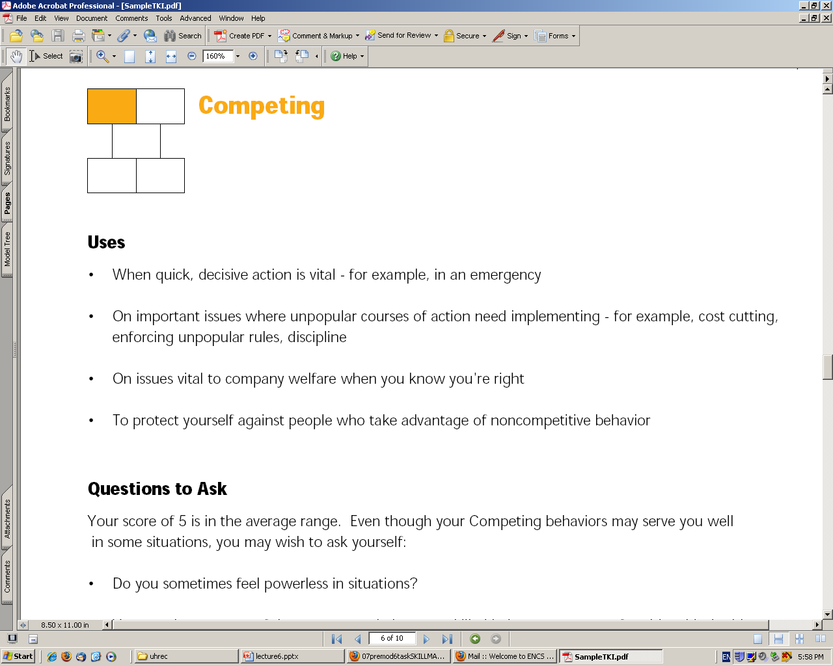
- Individual pursues self-interest at other person’s expense

Accommodating
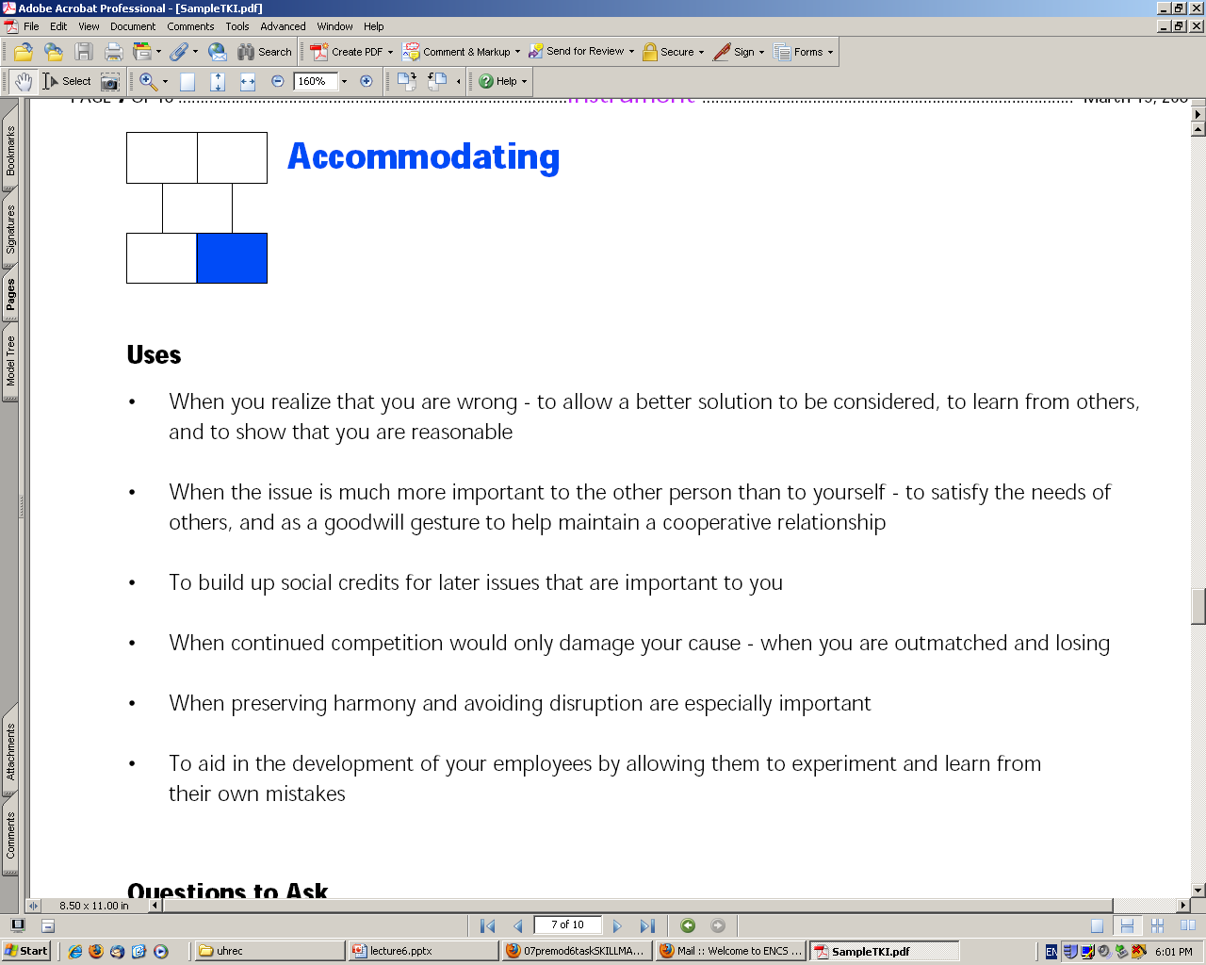
- Neglects self-interest to consider other person’s needs

Avoiding
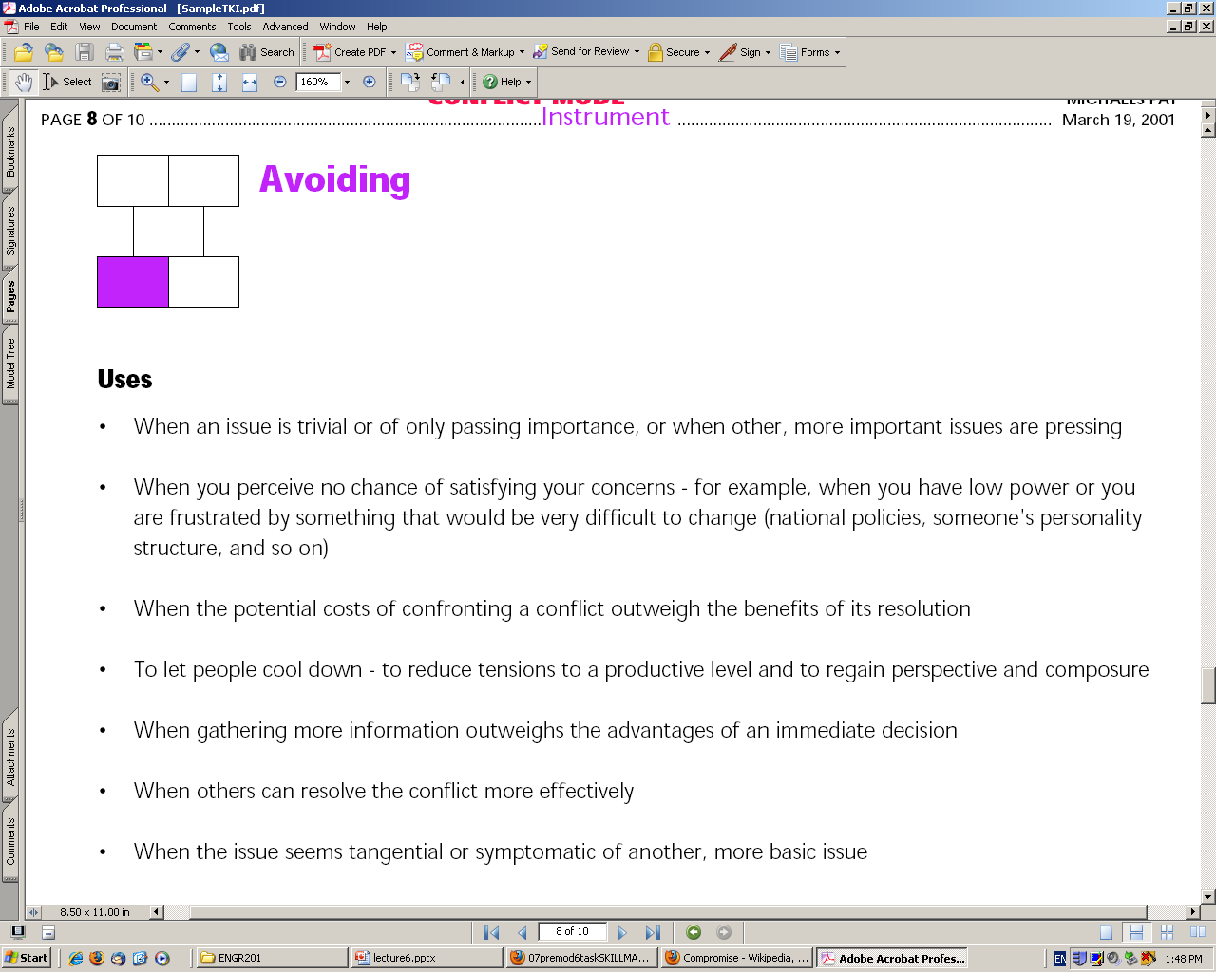
  - Person avoids conflict situation and does not address it.
Collaborating
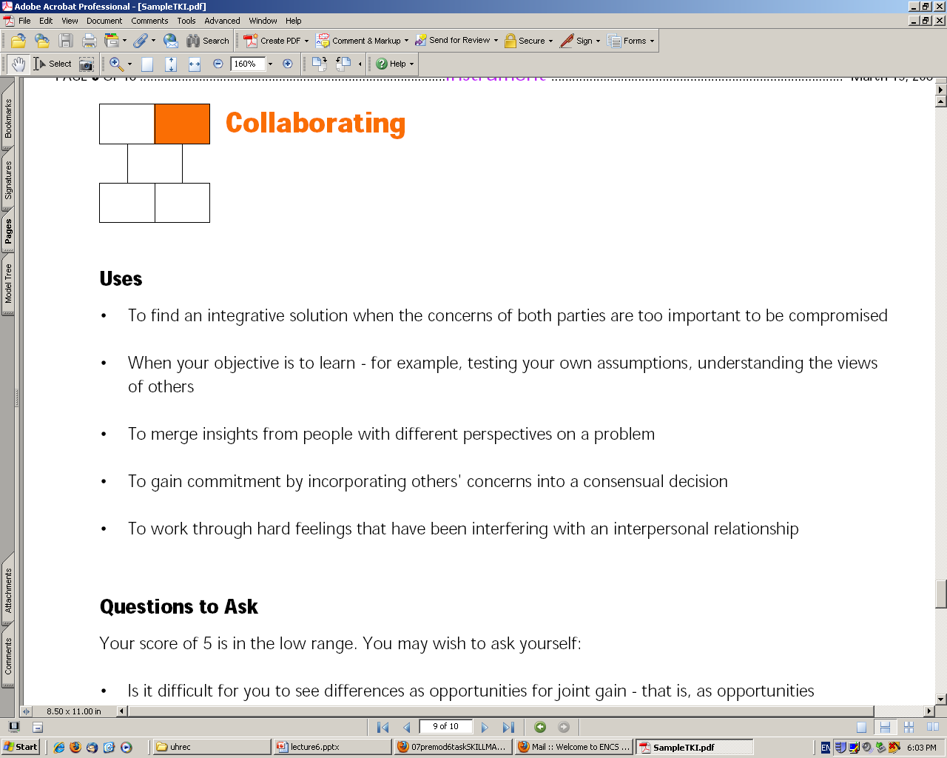
  - Works with other person to find a solution to both persons
Compromising
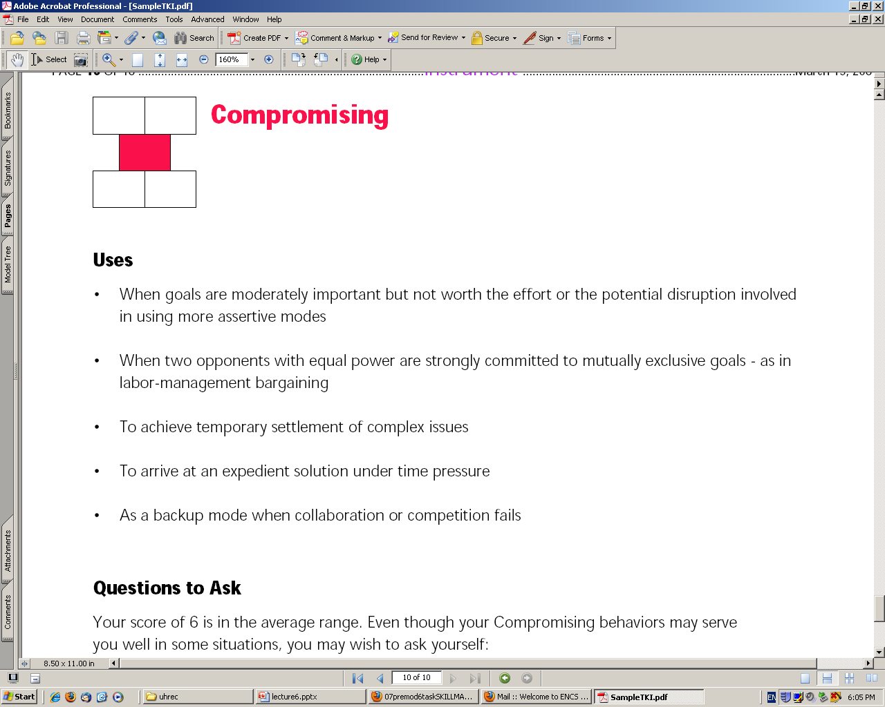
  - Partially satisfies both parties
Safety, Risk & the Public
  - Safety is the responsibility of Engineers
  - Ensuring process and product safety
  - Analyze risk associated with product or process
  - Communicate risk transparently to clients or public
  - Acquire informed consent of participants.
Type of Accidents
- Procedural: attributed to operator error, failure to follow regulations or standard operating procedure. Solution: better training, supervision, regulation
- Engineered: flaws in engineering design result in sub-optimal performance. Solution: better research and testing of materials
- Systemic: complexity and coupling between sub-systems results in unforeseen accident pathways. Solution: multiple redundancies to prevent cascading failures
Ensuring Safe Design
- Safety of the public is an engineers responsibility.
Design criteria for safety:
- Design must comply with applicable legal standards – keep up with laws.
- Design must comply with accepted engineering practice – keep up with state of the art in the field.
- Explore all possible alternative designs – discuss design strategies with other designers.
- Foresee possible uses and misuses especially in system design – create redundancies or backups
Risk: the probability of an event occurring and of the consequences of that event.
Risk Assessment: It is the determination of quantitative value of risk related to a recognized threat
Risk neutralization: The danger potential of a product or process may be reduced by safety measures
- ‘Zero risk’ does not exist
Risk Communication is the communication of risk associated with a technical product or process to the public. It is the basis for getting consent from society for any product or process you want to introduce.

Risk Perception
- It is the degree of sentiment of danger among individuals who are exposed to the source of risk. It varies depending on
- Is risk well known? Delayed or immediate?
- Are consequences short-term or long-term?
- Is it fair or evenly distributed?
- Is exposure voluntary or involuntary?
- Is there real possibility of catastrophe?
How to Communicate Risk
- Goal of risk communication is to inform others and to warn others of potential risks.
- Foster trust in the analysis/assessment of risk
- Communication must be made by persons in charge and having information
- All stakeholders affected must be identified and their concerns addressed
- Delicate balanced operation – informed decision or hysteria
Informed Consent
- Voluntary consent is basis of liberal democracy in a “risk society”
- Informed Consent – based on two aspects
- Providing or disclosing Information
- Obtaining voluntary agreement
Potential Questions
Risk Perception is the determination of the quatitative value of risk related to a recognized threat.
T or F
Cooperativeness is the degree of concern for _______. A: Others
In dealing with conflict, the degree of concern about the self is called assertiveness. T or F
Assertiveness is the degree of concern about ____________. A: Self
Risk communication is the communication of risk associated with a technical product or process to the public. T or F
_____________ is an accident that is attributed to an operator error, failure to follow regulations, or standards of operating procedure. A: Procedural Accident
_______________ is a result of engineering design flaws. A: Engineered Accident
Risk Perception is the degree of sentiment of danger among individuals who are exposed to the source of risk. T or F
_____________ is an accident that is caused when complexity and coupling between sub-systems create unforeseen accident pathways. A: Systemic Accident

