Arth 298M

Amanda Manocchio

Research paper- Summer 2016

Word Count:

Place Ville Marie was given its name by Jean -Drapeau because of the colony founded in 1642. Place Ville Marie is also referred to as PVM or the Royal Bank Building and is one of the most famous landmarks in the city of Montreal. (See fig1) It is known to be a gem to the city because of its unique shape and elegant interior. It is the third highest point in the city of Montreal and it was built above the CN railroad tunnel.
The owner of Place Ville Marie is Ivanhoe Cambridge. This skyscraper was developed by Mr. William Zeckendorf and the architects behind this project was Pei Cobb Freed and Partners Dimitri Dimakopoulos. Its features include a skyscraper of 28000 square meters in the downtown of Montreal, with an open cut of 15m exposing itself to the tracks of the Canadian National Railway and Central Station. This complex is 188.06 metres high and has 2,700,000 square feet of space. It is only 8 meters shorter in height than Mount Royal.
When looking at this building, it was designed to be in the shape of a cross because it symbolizes Montreal’s history as the centre of Catholic culture. In other words, the developers wanted to include the culture of the city to the building. In addition, the tower being built in a shape of a cross was to ensure its stability and allows
for natural sunlight for better light distribution in Place Ville Marie. Place Ville Marie used to be known as a cruciform building, but also applies to the urban plaza which is on top of the largest section of the shopping mall.(See fig 2) This promenade is in between buildings and consist of four shorter office buildings. Place Ville Marie has over 15 000 people from restaurants to shops, to the people working in the building .( See fig 3) This complex consists of more than one address, looking at it from the view of the cruciform tower is 1,’’ Place Ville Marie’ the others are ‘2-3 Place Ville Marie’ 4, ‘Place Ville Marie and finally 5, ‘Place Ville Marie.
The construction project was a phased development, and involves two different stages. The first stage to be constructed began in 1958 until 1963, was the crossed shaped 45 storey tower otherwise known as the Royal Bank Building. Phase Two began right after in 1963 and by 1965 it consisted of three smaller structures. Below this plaza there are over 75 shops, restaurants and a cinema also known as ‘Galerie Place Ville Marie. The tower has a smooth aluminum and glass surface, with a geometric form demonstrating Pies’ mainstream to the modern 20th century modern design. Ville Marie is known to have thirty-three kilometers of underground passageways, despite the on going construction it faces with concrete to fix up the Plaza. Place Ville Marie is now filled with flowers, grass, shrubs and monuments and remains one of the most luxurious complexes in Montreal. PVM also known as Place Ville Marie is where the people of Montreal use their ‘Underground city.’ On the rooftop, there is a rotating beam that lights up at night and turns counter clockwise.(See fig 4) With its lights that brighten up the sky up, it has four white horizontal lamps that can be seen as far as 50 km away. This rotating beacon has become an icon to PVM and has an automatic system where it turns on at sunset and off at two in the morning. There are as well two levels of underground parking that are provided for a thousand three hundred cars.
Place Ville Marie has 52 postal codes and 4 different addresses, the first address is called 1 Place Ville Marie Montreal, Quebec and its postal code being H3B 3A7. It was built for the headquarters of the Royal Bank Canada back in 1960 it consists of forty-seven floors and is officially known today as the Royal Bank Tower. (See fig 5) The second address is 2- 3 Place Ville Marie, Montreal Quebec and its postal code is H3B 2C9. This office building contains eight floors that have over 4,000 employees and 90 tenants Place Ville Marie three has its local headquarter for Via Rail where all the decision making takes place. (See fig 6) 4, Place Ville Marie, Montréal Québec and postal code is H3B 4A5. This building has a day care where the employees of each building of Place Ville Marie 1,2,3,4 ,5 can leave their children, this building also has eight floors.( See fig 7) Finally, 5 Place Ville Marie, Montreal Quebec, H3B 5M1 has eighteen floors. These floors are used for office space 522,000 square feet as well as some restaurants including the Fire Grill.( See fig 8)
Place Ville Marie is known for their Christmas Tree display every year since 1962 and has been an annual tradition when PVM first opened up. The first Christmas tree was 75 feet high, however seeing as it was a tourist attraction they decided to change it. The Christmas tree now was 63 feet high, 26 feet in diameter at the base and is decorated with over 13,000 lights, PVM also includes an indoor Christmas tree which is located in the central court. The tree was originally made in New York and was then transported to Montreal, it weights 4,500 pounds. ( See fig 9) The plaza area includes a large fountain with water jets and a sculpture right in the middle of a feminine landscape by Gerald Gladstone in 1972. This sculpture is in bronze and approximately recycles 11356 liters of water per minute, this monument is another attraction that PVM has to offer. ( See fig 10)
1 Place Ville Marie, Suite 4340 is located at the rooftop of PVM which includes a restaurant/ lounge, called 737. Suddenly it attracted clients to meet after work and to enjoy drinks while overlooking Montreal’s skyline on its rooftop while enjoying live music as well, its name stands for the elevation in feet from sea level. In the summertime, it is more difficult to get in seeing as there is always a line to attend this beautiful and stylish club. Place Ville Marie is also known for their luxurious penthouses, clubs and restaurants( See fig 11).

My experience
When I first went to go visit Place Ville Marie it was a remarkable experience and truly is one of the most amazing buildings in Montreal in my opinion. I was first astonish to see that these 5 buildings all make up Place Ville Marie and that it includes an underground shopping mall and has an awesome interior to it with office space for workers. In order for the people of Montreal to get around downtown to certain locations weather its work or leisure ‘1 Place Ville Marie would be the route you take. This will connect you to the STM metro line Bonaventure to underground parking that is provided. This also connects the orange line which can bring you up until the South shore Central station, either one is the end of the terminal. When having access on the green line as many of us do, including myself I get off at McGill Metro station which leads me to the Eaton Center which is underground and straight to Place Ville Marie. Many workers who work downtown sometimes get off at McGill and walk indoors instead of walking outside to have an easier access to PVM which helps with weather conditions. When we approach the northern end of the building, we see that it connects with the street level buildings 1 and 2, in comparison to those of 3-4-5 which contains mostly office space.

On the 41th floor of the first building of PVM we will find workers of the Royal Bank of Canada, including one of my dearest friends who is employed by RBC. This floor mostly occupies itself with employers and is not a floor that is visited by others where you can also see the branch from a distance. As you enter a security guard who’s ready to guide and answer any questions needs the employees to scan their badge as they enter, seeing as not anyone can. Lucky due to my friend working their I had the chance to go visit and have an experience in the RBC head office were it all takes place. Firstly, you will see that there are meeting room where co -workers and presentations take place, their rooms are kept very clean and have different types of paintings on the wall. There is a lunch room where coffee can be served and where the employees keep their lunches. As you enter there are different positions of people working such as a secretary and those who work in operations and do not deal with the public such as tellers. On this floor we can also find when special events are planned RBC employees have food catered from different restaurants. Place Ville Marie is known to be visited in the summer time by tourists and from employees as well., unlike other downtown locations PVM has an outstanding courtyard where one can enjoy. Till this day Place Ville Marie has maintained certain standards and is being kept updated and fully renovated to the public’s likings including 52 elevators. It became a led certified building and has become part of the art faculty as well, with its low ceilings and polished floors it has truly become innovating to see. As your visiting Place Ville Marie, the sunshine comes in through the large glass windows as your walking around with its 47 floors.
As you enter the gallery there are many stores available to the public such as Sirens, Godiva and much more. There is a huge food court that employees, tourists and students use and have expanded in their varieties of food example Jugo Juice, Oh- Shushi and an Indian food. At the bottom of this food court, they now added a couple of extra stores such as Bath and Body Works, La Senza and Mr. Pretzels. When walking outdoors as the evening is approaching, PVM looks beautiful as you see the city light up with an outstanding view. As you continue walking you see the light of the rotating beam through the city and sky.

In conclusion, Place Ville Marie is a sensational landmark to visit in Montreal and is considered one of the most fascinating building in the city. These buildings benefit workers who occupy office space, tourists who come and visit the underground city including public transportation and the mall. Its exceptional structure and sensational interior and exterior is what gives it its special significance, its high window pane letting in sunshine as guests walk through the plaza.( See fig 12) Overall, PVM was known to have the highest and biggest Montreal skyscrapers out of all the other building located in the heart of downtown. It is truly an amazing building to work as such as it provides an underground route for workers to get to their offices, outdoor terraces where employees and tourists can enjoy a meal with restaurants provided for them. During the summer is where most people taker advantage and enjoy the outdoors of PVM has to offer including special events that are planned for the public. After attending Place Ville Marie, I got a better understanding of why this building is so important to the people of Montreal. Many employees occupy these firms and tourists come to visit its skyscraper, especially at night with the lights. I now understand that there isn’t just one address to Place Ville Marie but rather it consists of 1-2-3-4-5 PVM which all included different spaces for either offices, stores and restaurants. “1 Place Ville Marie is where most workers enter through the underground metro and access their offices by walking through the palazzo rather than walking outdoors at times. I was lucky enough to attend one evening the Club 737 two years back without knowing it was in Place Ville Marie and remembering it was an outstanding view now realizing that the light of the beam I saw was from the top of the skyscraper. I was fortunate enough to also visit the Royal Bank of Montreal which is located on the 41th floor were PVM is also known at the Royal Tower Building. I had a wonderful experience in learning about the architecture of Place Ville Marie and actually taking the time to visit and do my research , gave me a better understanding of this landmark .

PVM Pictures
Fig 1 Place Ville Marie
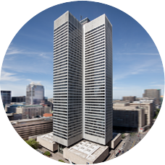
Fig 2 Skyscraper and cross
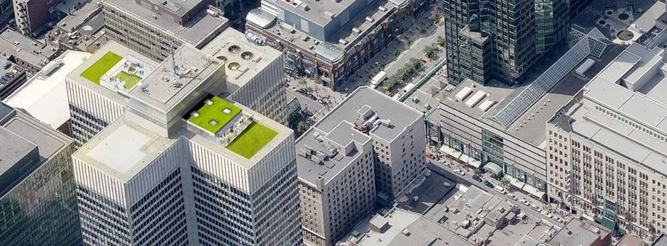
Fig 3 Galleries PVM
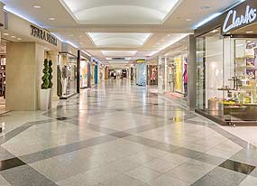

Fig 4 Light beam
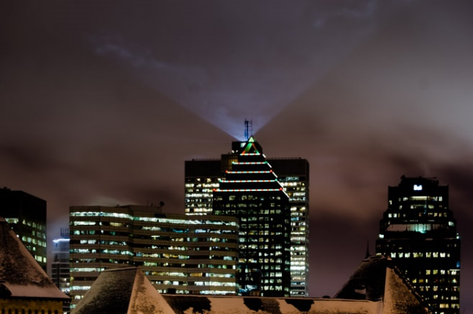
Fig 5 RBC Tower 1
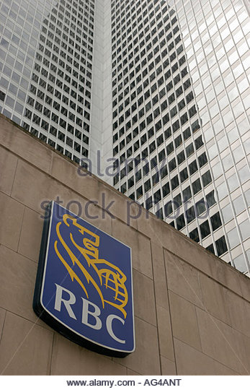
Fig 6, 2-3 PVM
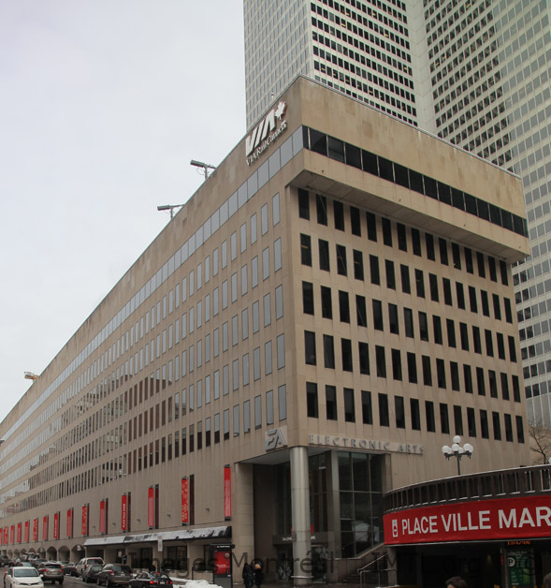
Fig 7, 4 PVM
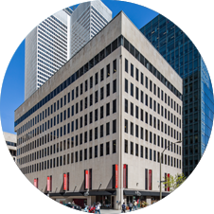
Fig 8, 5 PVM
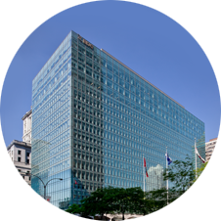

Fig 9 Christmas Tree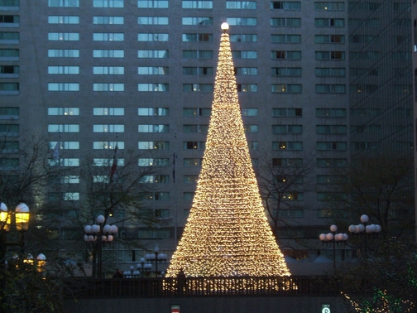
Fig 10 fountain
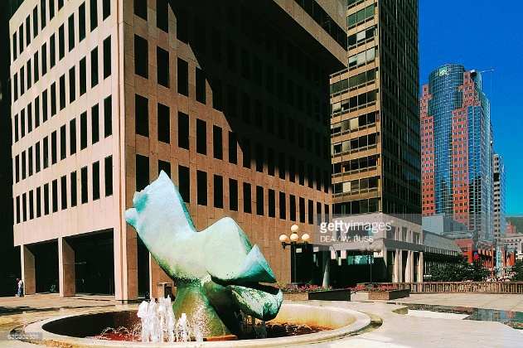
Fig 11, 737 Club
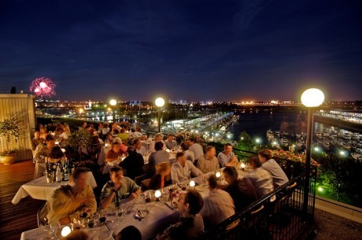
Fig 12 courtyard
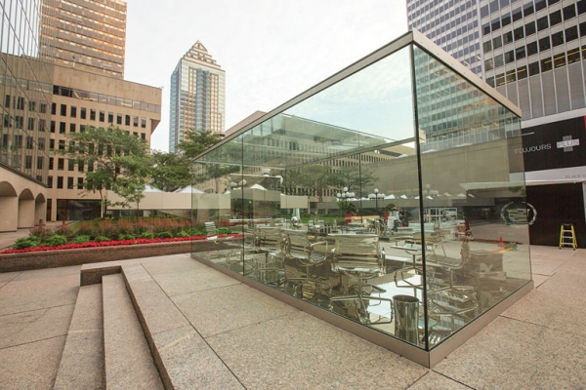
Bibliography

http://www.thecanadianencyclopedia.com/en/m/article/ville-marie-colony
http://www.pcf-p.com/a/p/5503/s.html
http://www.cchahistory.ca/journal/CCHA1941-42/Atherton.pdf
http://ici.radio-canada.ca/nouvelles/Economie/2013/08/14/004-ivanhoe-alta-placevillemarie.shtml
http://www.pcf-p.com/a/i/loc/can/can.html
http://placevillemarie.com/en/offices/1-place-ville-marie/
http://www.thecanadianencyclopedia.ca/en/article/place-ville-marie/
http://www.imtl.org/montreal/building/Place-Ville-Marie.php
http://guides.ivanhoecambridge.com/en/guides/place-ville-marie/galerie_march_en
http://www.tourisme-montreal.org/blog/montreals-iconic-rotating-beacon/
http://www.imtl.org/montreal/building/Place-Ville-Marie.php
http://www.imtl.org/montreal/building/2-3_Place_Ville-Marie.php
http://placevillemarie.com/en/offices/4-place-ville-marie/
http://www.ivanhoecambridge.com/en/office-buildings/properties/place-ville-marie-5
http://montrealinpictures.com/blog/2012/11/06/project-365-day-311-place-ville-marie-christmas-lights/
http://montrealinpictures.com/blog/2012/11/06/project-365-day-311-place-ville-marie-christmas-lights/
http://www.tourisme-montreal.org/What-To-Do/Attractions/female-by-gerald-gladstone
http://www.tourisme-montreal.org/What-To-Do/Attractions/female-by-gerald-gladstone
http://www.montrealplus.ca/montreal/venues/737-le

