Evaluate drivers, motivations and advantages of SME’s in the global market
Evaluate disadvantages and barriers in SME internationalisation

LO
- SME’s entering a foreign market, with focus on export management
- Evaluate barriers/constraints, opportunities, market entry modes and strategic choices facing SMEs going international and the process of internationalisation
- Apply theories and knowledge learned from the course to operational issues associated with export

Key research questions
- What are the definitions of SMEs adopted in NZ, the European Union and the U.S?
Ways of categorization
- The number of employees
- Sales revenue
- Capital value
The number of employees:
- 100 employees below in NZ
- 250 below in the EU
- 500 below in the US
A larger proportion of employment was account for micro enterprises in the EU compared to NZ, but large enterprises accounted for less employment in the EU compared to NZ.

SME’s employ a larger amount of part time workers than larger firms.
Most small to medium enterprises are between 1-5 years. Main age is between 35-39.

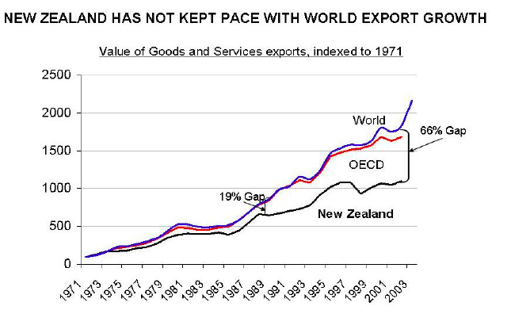

- How do SMEs contribute to a country’s economy?
Exports make up 28% of our GDP (gross domestic product), which is very high compared to Japan, which is 8.9%. BUT compared to countries similar to our size it is very low. For example:
NZ exports 28% of GDP  USA 8.5%  Japan 8.9  Australia 15.1%  UK 22.5  France 18.8%  Italy 20.7% | Canada 34.9%  Finland 32.4%  Ireland 68.5%  Netherlands 51.5%

We need to be comparing ourselves to smaller countries/economies. We can do better. We are importing more than we are exporting. Our balance is decreasing; we need to be exporting more. Trade deficit.

- How did NZ SMEs perform in economic measures compared to larger firms?
Advantages of being small:
- Being agile and flexible (collaborative)
- Low capital requirement (niche focused)
- Being efficient (low overhead)
- Technology/design/marketing focused)
- Open-minded culture (less hierarchical)
- Owner-manager control (quick decision making)
- First mover advantage (focus on unmet needs)

A strong relationship exists between higher levels of participation in exports and higher productivity. The more we produce the more efficient we are, because of competition. Smaller companies have this advantage.

We need to be more brand focused and we do this by becoming productive.
Export creates wealth. Exporters sustain high value jobs.

Third party logistics (3PL) help SME’s for example packaging
You need economy scale for a big product

- What are the key benefits of exporting for a country?
E-Commerce – Key Benefits
- Reduce market entry barriers for SMEs
- Lower set-up costs and maintenance for e-commerce presence than for physical outlet
- Ability to quickly change
- Faster and cheaper communication flows leading to reduced transaction costs for businesses and consumers
- Improve customer reach
- Speed of transactions, cut middlemen in supply chain

- How is NZ’s trade performance in the world?

Femme Fatale – born global
Tait’s story –competing with big boys globally
Icebreaker – marketing and innovation led internationalisation
Exporting NZ wine to Japan



