- Regulation of Protein Function
- Protein Structure:
- - Properties:
- - Size (molecular weight)
- - Shape (secondary structure/fold)
- - Charge (+/- patches)
- - Hydrophobic/hydrophilic properties
- - Representations:
- - Same protein different ‘views’
- - Understand how a protein works by looking at it at the atomic level
- - Structure/function relationship
- Reversible Modulation of Protein Function:
- - Proteins are dynamic molecules
- - Function is influenced by interactions w other molecules
- - Very stable interaction = prosthetic group
- - Prosthetic group = a compound/cofactor that is permanently associated w a protein and required for its function
- Protein-Ligand Interactions:
- - Transient/short-lived interaction = protein-ligand interactions
- - Ligand = a molecule that is bound reversibly by a protein
- - Binding site = position on a protein that interacts w a ligand
- - Complementary in size, shape, charge and hydrophobic/hydrophilic properties
- - Interaction is highly specific
- - Proteins = dynamic and flexible, and can have >1 binding site
- - Induced fit = structural adaptation between protein and ligand
- - Conformational change = binding of ligand changes the conformation of the protein to make the binding site more complementary
- - ie. induced fit = conformational change in hexokinase induced by binding of D-glucose
- - Key Concepts in Protein-Ligand Interactions:
- 1) Reversible binding
- 2) Specificity
- 3) Conformational change
- 4) Regulation
- Enzymes: A Special Case of Protein-Ligand Interaction:
- - Substrate (~ligand) = molecule changed by an enzyme
- - Catalytic site/Active site (~ligand-binding site) = binds substrate and facilitates its chemical transformation
- Enzymes vs. Proteins:
- - Protein-mediated transport – modulates protein function
- - ‘Structural proteins’ – control protein assembly/disassembly
- - Not having enzyme activity does not mean it has no function
- Oxygen-Binding Proteins:
- - O2 = poorly soluble in aqueous solutions, and inefficient diffusion through tissues
- - We require mechanisms for transporting O2
- - Interactions of “transporter” w O2 must be specific (not N) and reversible
- - O2 is complexed w transition metals that have high affinities for O2 (ie. Fe or Cu)
- - Free Fe can promote the formation of highly reactive O2 species – this tendency is reduced when Fe is incorporated into heme
- - Heme = a prosthetic group = protoporphyrin IX + Fe3+
- Porphyrins:
- - 4 pyrrole rings connected by methane bridges (one double bond one single bond) w substitutions at ‘X’
- - A conjugated C=C double bond system (resonance)
- - 4 N atoms that can bond w Fe2+
- 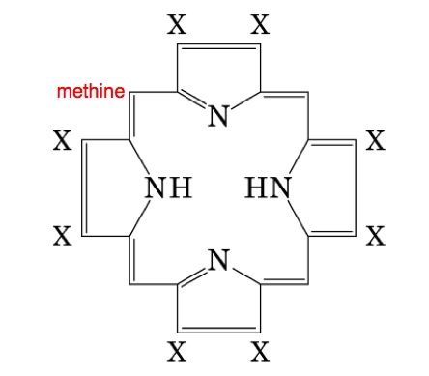
- 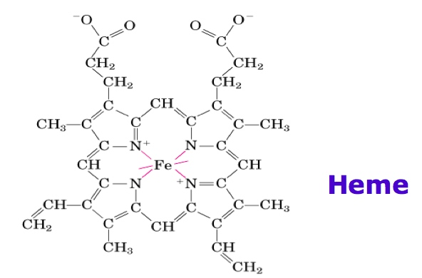
- - Fe2+ binds O2 reversibly, Fe3+ does not bind O2
- - Irreversible oxidation of Fe2+ by O2 is prevented by: heme being buried within the protein, one coordination bond is occupied by a side-chain N of a His residue, and then O2 binds reversibly at remaining position
- 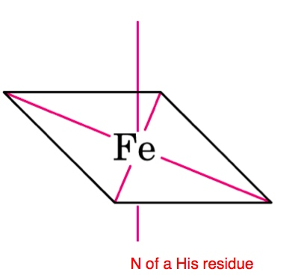

- Structure of Globins I:
- 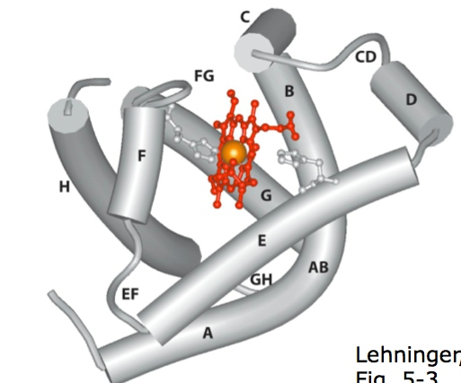
- - Myoglobin = monomer, binds and stores O2 in muscle
- - Hemoglobin = tetramer (2 alpha and 2 beta globins), O2 transporter
- - Leghemoglobin = found in leguminous plants, sequesters O2, protects O2-sensitive enzymes in N2-fixing bacteria
- Outline of Globin Structure:
- - Globins can be divided up into 8 alpha-helical segments denoted: A-H
- - These fold together (globular protein)
- - Connecting loops are identified by the 2 adjacent helices
- - Identified by a relative position
- - Ie. F8 = 8th amino acid in helix F
- - Ie. CD1 = 1st amino acid on loop between helices C and D
- Evolutionarily Conserved Structure of an O2 Carrier:
- - Heme-binding pocket formed by E and F helices
- - Propionate side chains of heme are near the surface (top=more hydrophilic) of the globin
- - The rest of the heme is surrounded by nonpolar residues except for 2 His
- - Proximal His (F8) is directly bonded to Fe2+ (5th coordination bond)
- - Distal His (E7) is close but not bonded to heme
- - O2 binds to Fe2+ on the E7 side of the atom (6th coordination bond)
- Myoglobin (Mb):
- - Single polypeptide
- - 153 residues
- - 16.7 kDa
- - Mb is a simple O2-binding protein
- - Binding of O2 Depends on:
- - Structure around the ligand-binding site
- - Flexibility of the protein
- - ‘Breathing’ = small molecular motions of amino acid side chains
- Measuring O2-binding by globins:
- - The conjugated double bond system of heme causes strong absorption of visible light
- - O2-binding affected e distribution and alters the absorption of light by heme – this property also affects the absorption of light by globins
- - Oxy-heme absorbs more blue light
- - Deoxy-heme absorbs more red light
- - Opposite of what you think
- - Arterial blood = oxygenated = red
- - Venous blood = deoxygenated = blue

- [P] = concentration of free protein (not bound to any ligand)
- [L] = ligand concentration
- [PL] = concentration of ligand-bound protein
- Kd = dissociation constant = [L] at which ½ of the ligand=binding sites are occupied
- Ka = association constant

- Quantitative Description of Reversible Protein-Ligand Interaction:
- 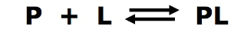
- 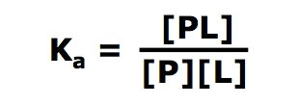
- 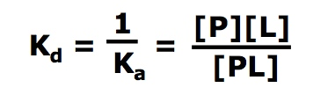
- - High Kd value = weak binding/Low Kd value = strong binding
- 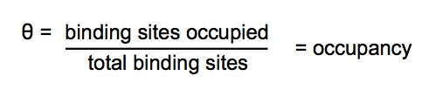
- - 0 (no sites) to 1 (all sites)
- 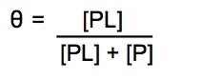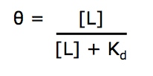

- 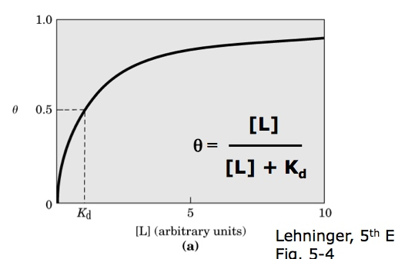
- - Ligand-binding curve
- - Fraction of ligand-binding site occupied (theta) = hyperbolic function of [L]

- For O2 Binding Proteins: **
- 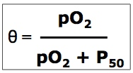
- pO2 = partial pressure of O2
- theta = occupancy
- P50 = partial pressure of O2 at which ½ the ligand-binding sites are occupied
- 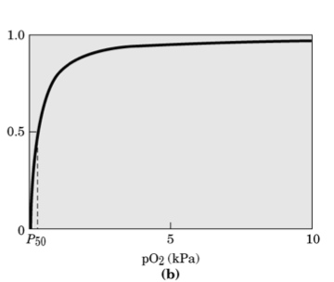
- Protein Conformation Critical for Specificity of Protein-Ligand Interaction:
- - Presence of globin reduces the binding of CO to heme in Mb and Hb
- - Bc of:
- - Steric hindrance – between His E7 and CO
- - Favourable H-bond between O2 and His E7
- - When theta decreases = O2 becomes unable to occupy = death
- O2-Binding by Myoglobin:
- - Mb binds O2 w high affinity
- - For a wide range Mb is insensitive to pO2
- - pO2 in tissues = 4kPA therefore Mb is essentially saturated
- - Why doesn’t Mb carry O2 in the blood? Bc Mb binds O2 too strongly in the tissues

- Comparing Globin Structures:
- - At the same position in each globin the amino acids are similar (ie. all hydrophobic or all small) or sometimes conserved
- - Amino acids that are in positions beside each other share similar properties
- - Segments of (mostly) different amino acids form similar structures
- Hemoglobin (Hb):
- - Major carrier of O2 in animals
- - Tetramer – 4 polypeptide chains, 1 heme each
- - In humans, adult Hb contains 2 types of globin: 2 alpha chains (141) and 2 beta chains (146)
- 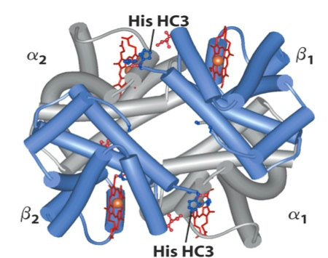
- - His HC3 C = C terminal = last amino acid
- - Interactions That Hold the Subunits Together:
- 1) Hydrophobic interactions – inside away from water
- 2) H Bonds – polar side chains, backbone atoms
- 3) Ion pairs (salt bridges) – oppositely charged functional groups forming an electrostatic interaction
- - Stabilize the conformation of Hb
- - Beta1 subunit His HC3 (partical pos) forms salt bridges within the beta1 subunit at Asp FG1 (pos) and w the alpha2 subunit at Lyc C5 (pos)
- - Don’t forget the C-terminal charge
- - 30 (not a lrg #) residues are involved in the interface between alpha1-beta1 and between alpha2-beta2 – symmetric
- - 19 (fewer contacts) residues are involved in the interfaces between alpha2-beta1 and between alpha1-beta2
- - These interactions are affected by denaturation first bc they are weaker and there is less of them
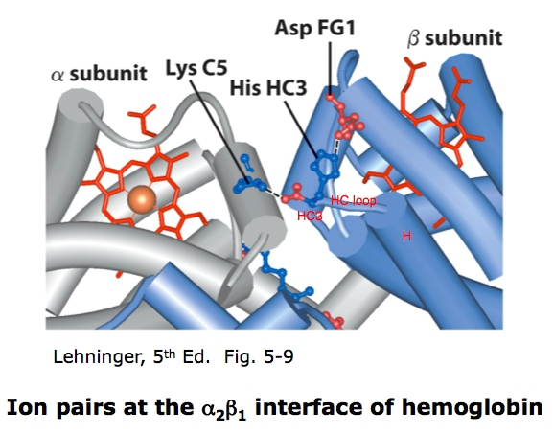
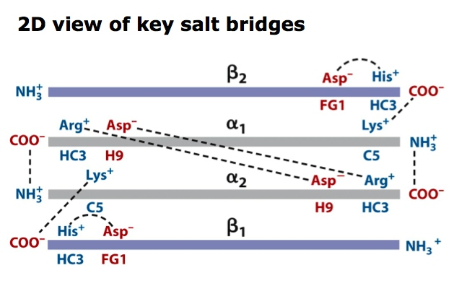
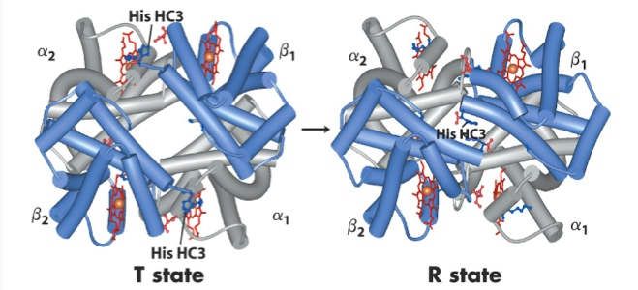
- Hb can undergo a conformational change from a low affinity state (T – Tense) to a high affinity state (R – relaxed)
- T = tense = a lot of ion pairs = in tissues
- R = relaxed = ion pairs broken = able to bind O2 efficiently in lungs
- O2 binding to one subunit of Hb alters the affinity for O2 in adjacent subunits
- Induced conformational changes push adjacent subunits into the R state – these then bind O2 w higher affinity = cooperative binding
- Cooperative binding = an allosteric effect = affect on structure elsewhere
Allosteric:
- Allosteric protein = a protein in which the binding of a ligand to one site affects the binding properties of another site
- Allosteric modulators:
- Homotropic = ligand and modulator are identical (ie. Hb)
- Heterotropic = ligand and modulator are different
- Activators (+) or inhibitors (-)
- For Hb: O2 is a ligand AND an activating homotropic modulator
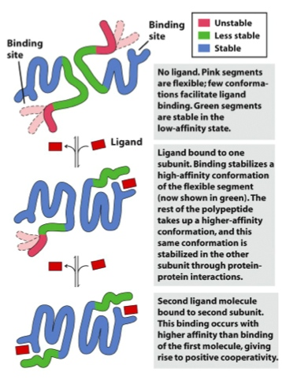

Binding of O2 in Hb:
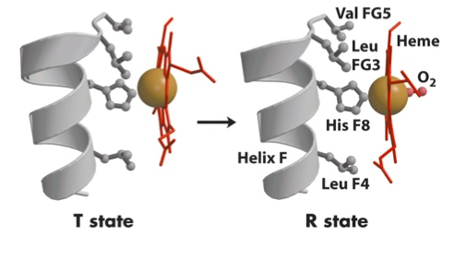
- Causes repositioning of the Fe2+ within heme (reducing the ‘pucker’ of the porphyrin ring)
- The change in shape of heme causes a shift in the position of helix F – this adjustment triggers the T R transition which includes breaking the ion pairs formed by His HC3
- In the R state (oxy-Hb), His HC3 is not participating in ion pairs that stabilize the T state (deoxy-Hb)
- T to R transition is induced by O2 binding to Hb*
Hb Sigmoidal O2-Binding Curve:
- S shape
- Middle line in the graph
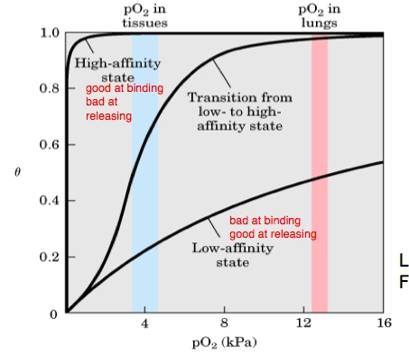
- Changes in quaternary structure of Hb (T to R transition) have dramatic effects on its function as an O2-binding protein
- The sigmoidal O2-binding curve of Hb is diagnostic of cooperative binding
- Cooperative binding requires: 1) >1 ligand-binding site and 2) interaction between ligand-binding sites
- Quantitative Description of Cooperative Ligand-Binding:
- - For a protein w n ligand-binding sites:
- 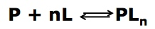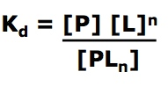

- n = # of binding sites
- 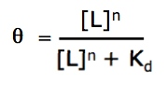
- 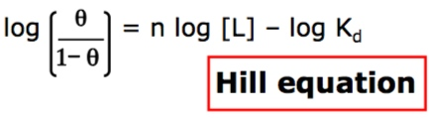
- 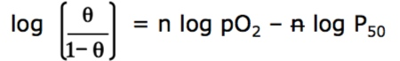

- Hill Plot:
- 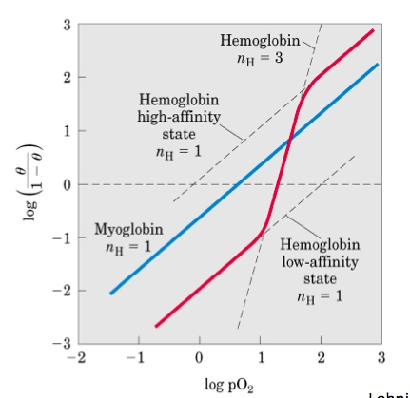
- - Slope of a Hill plot = nH vs. n
- - nH = Hill coefficient
- - n<1 = negative cooperativity
- - nH = 1 = ligand-binding is not cooperative
- - nH > 1 = positive cooperativity
- - nH greater/equal to n
- - nH less than one is possible for some proteins
- - nH is dependent on the # of binding sites in a protein
- - nH equal to one can occur for some oligomeric proteins
- - nH is NOT equal to the # of binding sites

- Models:
- 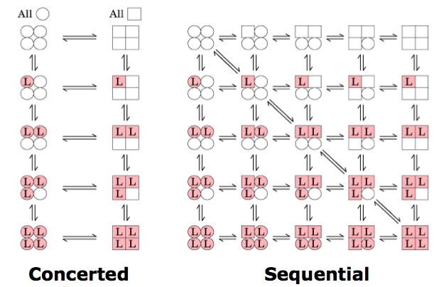
- - Circle = T, square = R

1) MWC model (concerted model)

- Subunits are functionally identical

- Subunits can exist in >1 conformation

- All subunits change conformation simultaneously

2) Sequential model

- Ligand binding can induce conformational change in subunits independently

- Conformational change in one subunit promotes conformational change in adjacent subunit
- Hb Transports H+ and CO2:
- - Inverse relationship between binding of O2 and H+ and between binding of O2 and CO2
- - Negative heterotropic allostery
- - Negative – hemo dec affinity for O2
- - Hetertropic – other binding site
- - Allostery – conformational change
- - Bohr effect = effect of pH and CO2
- - In peripheral tissues:
- - pH is lower and [CO2] is high
- - Hb binds H+ and CO2 – affinity for O2 dec
- - In capillaries of the lung:
- - CO2 is excreted and pH rises
- - Hb releases H+ and CO2 – affinity for O2 inc
- Hb Binding of H+:
- - H+ binds several side chains in Hb, including His HC3
- - Protonation of His HC3 favours formation of the ion-pair w Asp FG1 that helps stabilize Hb in the T state
- - As pH drops, adoption of the T state impedes O2-binding
- 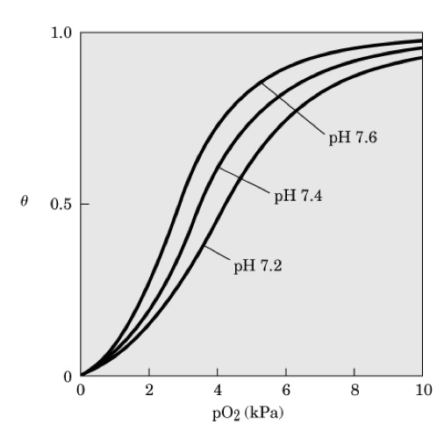
- = effect of pH on the binding of O2 to Hb
- Hb Binding of CO2:
- - CO2 reacts w the alpha-amino groups at the amino-terminus of each globin chain
- - The product is carbaminohemoglobin – containing a carbamate group
- - Carbamate groups participate in salt bridges that stabilize the T state of Hb
- - The reaction also produces H+, contributing to the Bohr effect
- - Figure on slide 76
- O2-Binding by Hb is Regulated by 2,3-bisphosphoglycerate (BPG)
- - BPG binds in the central cavity of Hb
- - Forms salt bridges w beta subunits
- - Stabilizes the quaternary structure of deoxy-Hb (more likely in T state)
- - R state when no BPG present b/c binding site is lost in R state (no gap in the middle)
- - BPG interacts w positive charge (blue) near the center (binding site) of Hb
- - BPG is important in the physiological adaptation to lower pO2 at high altitude
- - Higher BPG helps w O2 release

- BPG plays a role in the transfer of O2 from maternal blood to fetal blood

- HbF (fetal Hb): alpha2 gamma2

- HbF has a lower affinity for BPG

- Higher Kd for BPG (higher val. = weaker binding)

- HbF higher affinity for O2 (take O2 from maternal Hb)

- Lower Kd for O2 (lower val. = stronger binding)

- HbA (adult Hb): alpha2 beta2

- Binding of O2, H+, CO2, and BPG to Hb are interdependent – though these molecules are structurally different and bind Hb at separate sites

- Spatially distinct sites communicate via changes in the conformation of the protein

- Hb = a molecule capable of perceiving information from its environment

Sickle-Cell Anemia:

- Caused by a mutation resulting in an amino acid substitution in Hb

- HbA vs. HbS

- In HbS, Glu A3 on beta-globin (Glutamate beta6) is changed to Val

- HbS tetramer has 2 fewer negative amino acids

- Deoxy-HbS tetramers aggregate = abnormal hydrophobic interaction

- Sickle red blood cells contain long HbS fibers = fragile

- Capillaries become clogged

- Fewer RBC – less Hb - anemia

Enzyme Regulation

Review of Enzymes:

- Enzymes are proteins

- Catalyze the chemical transformation of a substrate (S) to a product (P)

- Inc the rate of a reaction

- Function by lowering the activation energy

- Km value can be affected by modulators
- - Vmas can be affected by modulators

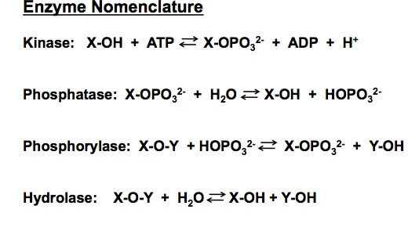

- Kinase = phosphorylated

Regulatory Enzymes:

- Multi-step metabolic pathways contain at least one rate-limiting step

- Rate-limiting step = how fast the overall pathway goes, fast or slow change

- Catalysis of rate-limiting steps is mediated by regulatory enzymes (ie. these enzymes are regulated)

- Catalytic rate of there enzymes is controlled by specific “signals”

Feedback Inhibition:

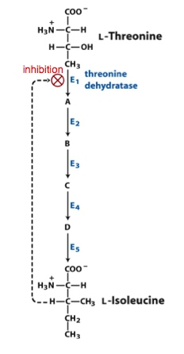

- Inhibition at first step of pathway

- No other products cause inhibition

- Isoleucine does not bind to the active site (different mechanism)

- Inhibition is reversible (relief of inhibition)

Mechanisms of Enzyme Regulation:

1) Allostery

- Reversible, non-covalent binding of regulatory compounds

- Allosteric modulators (change conformation)

2) Reversible, covalent modification

- Mediated by separate enzyme system

3) Interaction w regulatory proteins

4) Proteolytic cleavage

- Not reversible, ie. blood clotting, do not reform peptide bond once broken, enzyme turnover

Allosteric Enzyme:

- A regulatory enzyme (BEING REGULATED) w catalytic activity modulated by the noncovalent binding of a specific compound at a site other than the active site (heterotropic)

- Allosteric enzymes undergo conformational changes in response to modulator binding

- Binding of positive modular makes the enzyme more active to make the active enzyme-substrate complex

- Larger, structurally more complex (usually multi-subunit)

- Have regulatory (allosteric) sites to bind modulator

- Undergo conformational changes in response to modulator binding

- Do not obey Michaelis-Menten kinetics

PKA:

- cAMP-dependent protein kinase (kinase=phosphorylation)

- Allosterically regulated enzyme

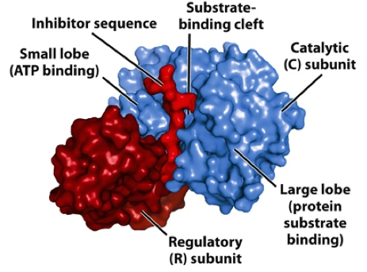

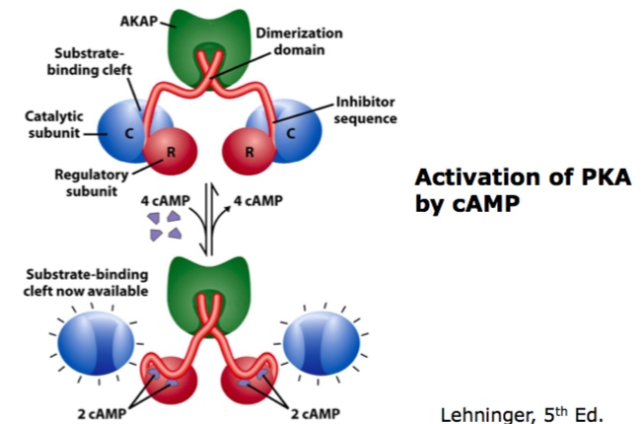

Do Not Obey Michaelis-Menten Kinetics:

- Plot of Vo vs. [S] is sigmoidal (=enzyme has alloseric regulation)

- Influenced by cooperative substrate-binding and/or binding or allosteric modulator (heterotropic)

- Km is replaced by K0.5

-For allosteric enzymes, binding of allosteric modulator can dramatically influence K0.5

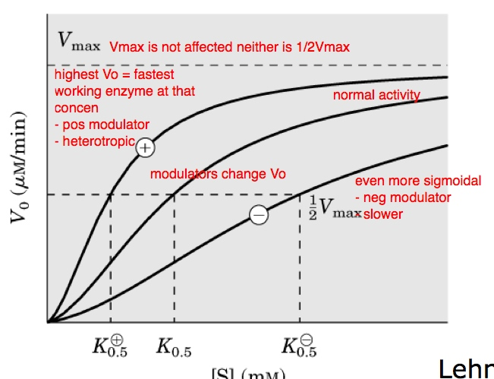

- In some cases, binding of allosteric modulator influences Vmax (through different affects) w/o altering K0.5

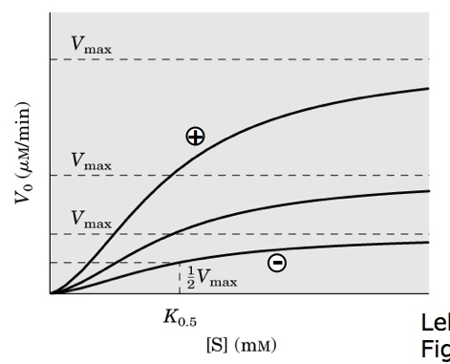

Aspartate Transcarbamoylase – Structure and Function I:

- Catalyzes committed step in biosynthesis of pyrimidine nucleotides (ie. CTP)

- Committed step = go through to completion

- Forms N-carbamoylaspartate and Pi from carbamoyl phosphate and aspartate

- Adding Asp stabilizes the R state

- Adding Asp DOES NOT cause it to be consumed by ATCase bc enzyme wont go forward unless both substrates present

- ATCase structure:

- Two types of subunits catalytic and regulatory

- The enzyme contains 12 polypeptides of the two types

- 6 regulatory (r) chains

- 6 catalytic (c) chains

- 3 c chains form each catalytic subunit (c3)

- 2 r chains form each regulatory dimer (r2)

- Fully functional enzyme (c6r6) has 2 catalytic subunits (2xc3) and 3 regulatory subunits (3xr2)

- Subunits remain bound bc of cysteines interacting w other cysteines via zinc

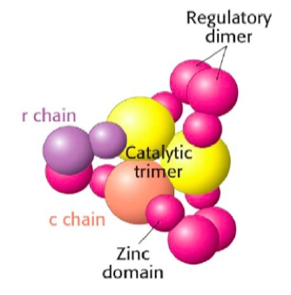

- Treatment w p-hydroxymercuribenzoate and ultracentrifugation revealed the subunit structure of ATCase

c6r6 2c3 + 3r2 (important to keep subunits together but not the dimers or trimers)

- The distance migrated is proportional to size, therefore r2 had a smaller curve than c3
- Aspartate Transcarbamoylase – Structure and Function II:
- 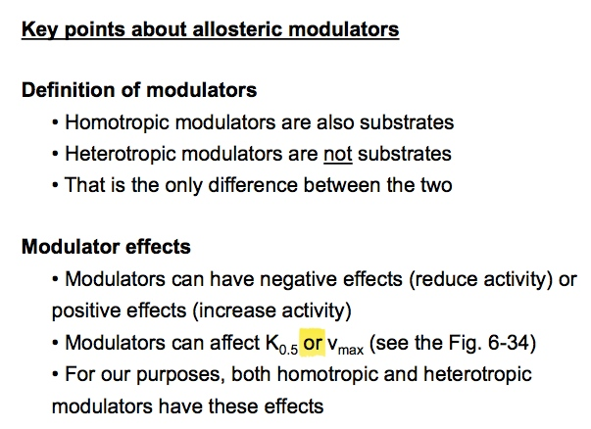
- Scientific Paper:
- 1) Carbamoyl phosphate (CP) binds
- 2) Asp binds – lrg changes in quaternary structure
- 3) Condensation reaction
- 4) N-carbamoyl-L-aspartate (CA) released
- 5) Pi released
- - As long as substrate is available, the enzyme remains in the R state
- - Asp236 on catalytic chain (D236c) and Lys143 on regulatory chain (K143r) stabilize the T state
- - Mutate either of theses residues to Ala (D236Ac or K143Ar) then the enzyme no longer exists in the T state
- - In the absences of ligands, WT (wildtype/normal) and D236Ac ATCase have different structures
- - However in the presence of PALA, WT ATCase and D236Ac are the same
- - In the absence of the negatively charged R group of D236 (Asp), or the positively charge R group of K143 (Lys), an ion pair that stabilizes the T state is eliminated
- - When bound to PALA, WT and D236Ac are very similar
- - CP (carbamoyl phosphate) has little effect on WT ATCase
- - CP mimics the effect of PALA in D235Ac (aka has an effect)
- - D236Ac in the absence of ligand is approaching the shape but not identical, R-like, but not completely in the R state

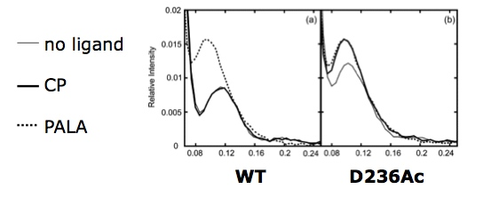

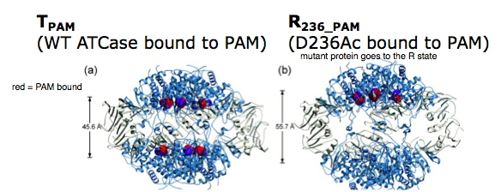

- D235Ac adopts the R state

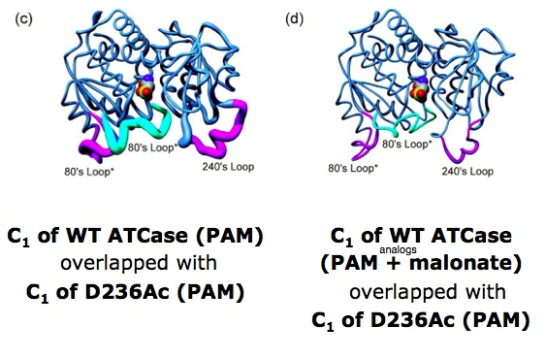

- Thin = similar

- Thick = different

- Differences in the active site = where the tubes are thicker

- C1 of D236Ac bound to PAM alone is structurally very similar to WT C1 bound to both substrates (d)

- Conclusions:

- D235Ac mutant eliminates an ion pair that forms between D236c and K143r that normally stabilizes the T state

- In the absences of the D236c-K143r interactions (which connects the c and r subunits) CP can push ATCase into the R state

- Direct interactions between the c and r subunits regulate the conformation of the enzyme by stabilizing the T state

- The net result of the D236Ac mutation is that this form of the enzyme never adopts the native T state

- Always in a partially active conformation – “trapped” in the middle of its catalytic cycle

Allosteric Modulation of ATCase:

- Substrate-binding by ATCase is explained by allosteric cooperativity = T to R state transtition

- Asp is a positive homotropic modulator

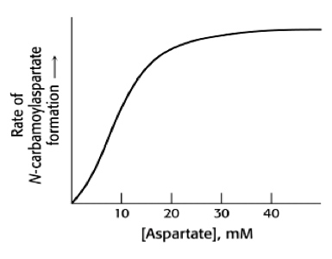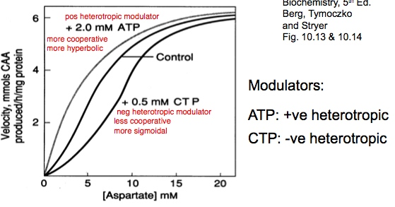

- CTP functions in feedback inhibition

- ATP and CTP bind to sites other than the active site (on the regulatory subunit)

- Substrates bound by ATCase and the heterotropic modulators are structurally very different (slide 27*)

- Substrates bind at interfaces of c chains

- Modulators (ATP, CTP) bind to r chains

- Allosteric effects in ATCase are the result of changes in quaternary structure

- T state: ATCase has a more closed conformation (poor access for substrate)

- R state: ATCase is in a more open conformation (better access for substrate)

- Obtain info. about the structure/conformation of active (R state) ATC:

1) purify it in the presence of substrate

2) purify it in the presence of substrate analogue (PALA) (analogue=very similar to original one)

3) purify it in the presence of ATP (pos modulator)

- ATCase undergoes lrg changes in quaternary structure:

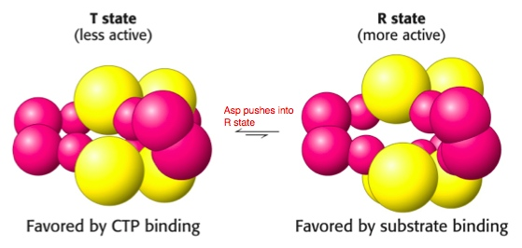

PALA Binding to ATCase:

- N-(Phosphonacetyl)-L-aspartate

- Activation of ATCase w structural changes

- A nonreactive bisubstrate (ATCase has 2 substrates) analog that mimics the reaction intermediate of ATCase

- Binds to ATCase but won’t form a product

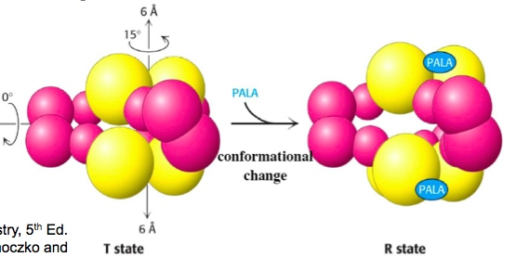

- Where PALA binds = the active site between two catalytic subunits

- Dramatic changes in quaternary structure

- R state = more active

- Binding PALA stabilizes the R state

- Within catalytic subunits:

- Flexing at interfaces between c chains (where active sites are)

- Overall:

- Catalytic trimmers move apart 12 A (each 6 A) and rotate relative to each other

- Regulatory dimers rotate

- Change in bend/angel between r chains

CTP Binding to ATCase:

- Stabilizes the T state

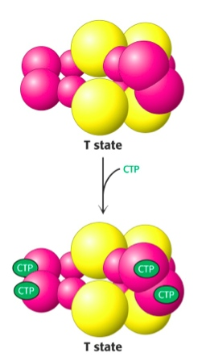

T to R Appears to be Concerted:

ATP-binding can induce T to R conversion in the absence of substrate

- Subunits all T or all R

- R state = high affinity for substrates

Regulation of Enzyme Activity by Reversible Covalent Modification:

- Enzyme activity altered by covalent addition of modifying group(s)

- Modification is reversible

- Mediated by separate enzyme system

- Common forms of reversible covalent protein modification:

- Adenylylation (Tyr = target residue)

- Acetylation (Lys, amino terminus)

- Methylation (Glu)

- Ubiquitination (Lys)

- ADP-ribosylation (Arg, Gln, Cys, diphthamide)

- Phosphorylation (Ser, Thr, Tyr, His)

Enzyme Regulation by Reversible Phosphorylation:

- Attachment of phosphoryl group is catalyzed by protein kinase

- Phosphoryl group can be removed by phosphoprotein phosphatase

- Phosphorylation is sequence-specific

- Phosphorylation can occur on multiple sites of a protein

- Phosphorylation can produce different degrees of effect on the function of a protein

Protein Kinase A (PKA):

- Phosphorylates glycogen synthase as some sites

- Phosphorylates are sites containing:

X-R-[RK]-X-[ST]-B ie. F-R-R-L-S-I

- Will fit into the catalytic site of PKA and be phosphorylated on the Ser or Thr residue

- [RK] = Arg or Lys (positive charge) interacts w something w neg. charge

- [ST] = Ser or Thr (OH groups) – *this a.a. is phosphorylated interacts w the cleft

- X = any amino acid (if it was neg. it would still function)

- B = any hydrophobic amino acid

- It can bind but not be phosphorylated unless it fits the right pattern

- Regulatory subunits of PKA contain the sequence K-R-R-G-A-I which CANNOT be phosphorylated

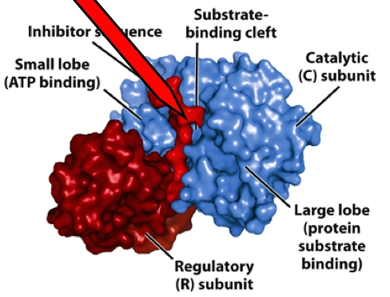

- In response to cAMP PKA regulates many cellular activities:

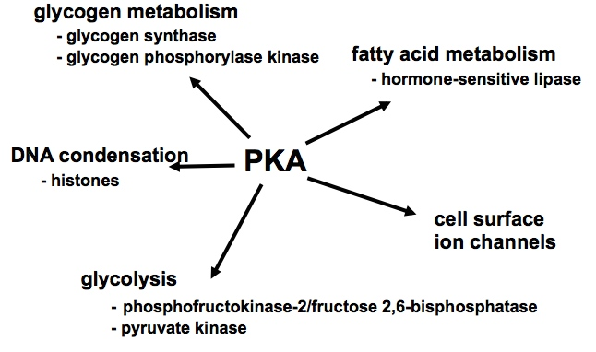

- cAMP is usually short-lived bc of the enzyme cyclic nucleotide phosphodiesterase (adds H2O) to make Adenosine 5’–monophosphate (AMP)

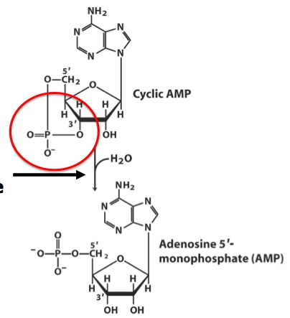

- Phosphoryl groups introduce:

1) A relatively lrg group

2) Charge – allowing electrostatic interactions (attraction/repulsion)

3) O atoms that can participate in H-bonds

4) Site for protein-protein interactions

Glycogen Phosphorylase:

- Glycogen catabolism (break down)

- Activated by phosphorylation

- Not every phosphorylation leads to activation

- Phosphorylation of Ser-14 = favours R state (more active state) = enzyme is activated

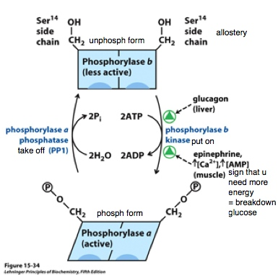

- Phosphorylase b kinase = glycogen phosphorylase kinase

- Glycogen synthase is INACTIVATED by phosphorylation

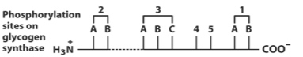

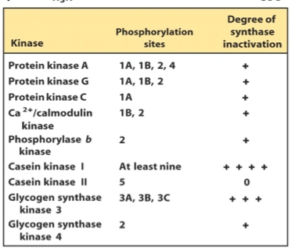

- + = degree of inhibition/inactivation

- Glycogen synthase kinase 3 (GSK3) phosphorylates glycogen synthase at different sites (than PKA) and the effect of GSK3 is a more potent inhibition of the synthase

- Phosphorylated Sites Provide Places for Protein-Protein Interactions, Including (but not limited to) Enzyme-Substrate Binding:
- Example 1: Phosphoserine-binding domains – mediate auto-inhibition and substrate-binding of glycogen synthase kinase-3 (GSK-3)
- 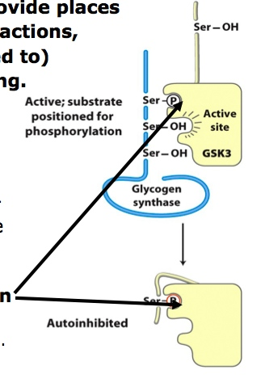

- Example 2: Src-homology-2 (SH2) domains can bind to sites containing phosphorylated tyrosines (P-Tyr)
- - Important part of insulin signaling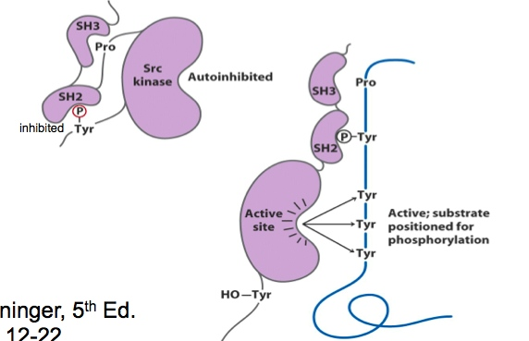

Enzyme Activity can be Regulated by Specific Proteolytic Cleavage:
- - Enzyme is synthesized as inactive precursor
- = zymogen (protease) or proenzyme (not a protease)
- - Activated by specific cleavage of peptide bond(s)
- - After cut, conformational changes in the enzyme expose active site
- - In the digestive system many serine proteases (ie. chymotrypsin)
- 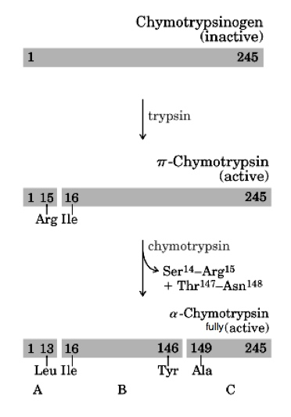
- - Enzymatic activity of chymotrypsin is highly sensitive to pH
- - His57 must not be protonated – so that His57 can act as a proton acceptor inducing nucleophilic character in Ser195 = critical to reaction mechanism
- - Alpha amino group (newly formed as a result of proteolytic cleavage) of Ile16 must be protonated – allows Ile16 to form an ion pair w Asp194 = stabilizing the active conformation of chymotrypsin

- Formation of a Blood Clot:
- - Zymogen cascade
- 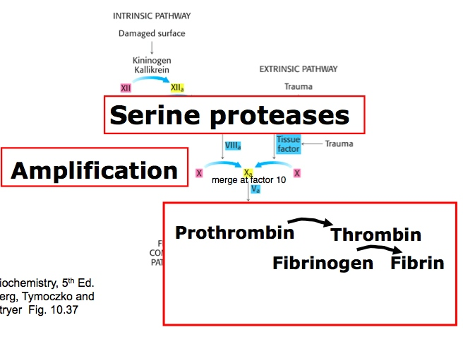
- - Pink = inactive
- - a = active
- - Blue = not enzymes, just proteins
- - *Merge at factor 10
- - Important promoters of clotting: Vit K, Ca2+, thrombin, and factor 13a (not part of cascade, but important for final steps of clotting)
- - Vitamin K = carboxylation of prothrombin
- - Carboxylation makes prothrombin a strong Ca2+ chelator (molecule that can bind to cation)
- 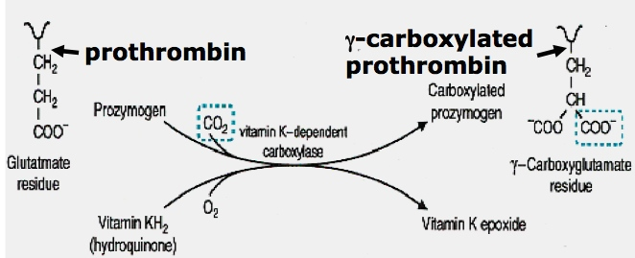
- - Carboxylation of prothrombin is required for it to be proteolysed – forming thrombin
- - Many gamma-carboxylglutamate residues are formed at the N-terminus of prothrombin
- - Gamma-carboxyglutamate binds Ca2+
- - prothrombin-Ca2+ is a substrate for factor Xa
- - Ca2+ helps to bind it near the protease that cuts it
- - Factor Xa is a serine protease: converts prothrombin to thrombin
- - Some inhibitors of clotting = antagonists of vit K = Dicoumarol and Warfarin
- Fibrinogen Structure:
- 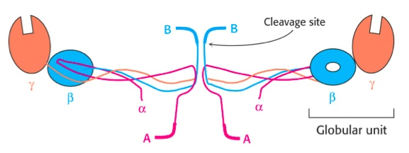

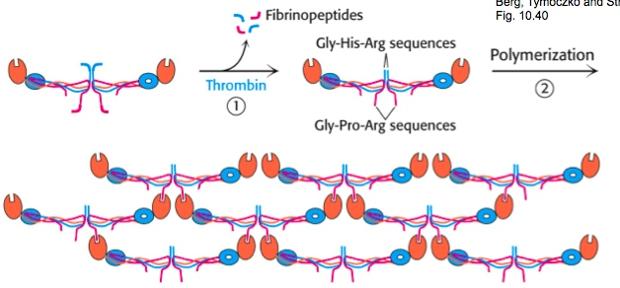

- Thrombin = serine protease

- Cleaves fibrinogen to fibrin

- Fibrin interaction = fibrin clot

Factor XIIIa:

- A transglutaminase

- Activated from protransglutaminase by thrombin

- *Covlently (strong) links fibrin monomers

- Soft clot hard clot (scab)



