The Time Value of Money
Time Value of Money


The Time Value of Money techniques enable us to compare dollars received or paid out in different time periods. This is important in making smart decisions in budgeting, investments, debt management, tax and retirement planning. Sound financial decisions are made with considerations of not only the size, but also the timing of cash flows. As it is often said, “a dollar today is not the same as a dollar tomorrow.” The reason, of course, is that, everything else being equal, today’s dollar can be invested to earn interest and grow to a larger sum in the future.
In the past, time value calculations were performed using formulas or tables derived from them. The development of technology and the advent of electronic calculators have made the calculations of time value easier.
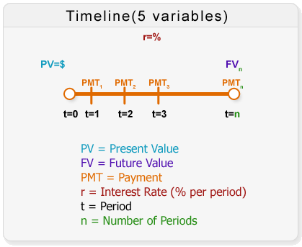
In this lesson, we will discuss nominal and effective rates and we will solve the problems using formulas and the financial calculator to find Present Value (PV), Future Value (FV), Present Value of an Annuity (PVA), and Future Value of an Annuity (FVA). The Calculator Tutorial in Lesson 0 explains some of the basics of the financial calculator; you should be familiar with them before you continue reviewing this lesson.

Nominal Rate

Definition
The nominal rate is also known as “in name only” because it has not been adjusted for inflation. Other sources might also call it Quoted Rate, Stated Rate, Observed Rate, or Annual Percentage Rate (APR). In a given problem, when we talk about the interest rate we are talking about the nominal rate, always written on a per annum basis.

Example 1
Imagine that you borrow $500 today and you are told that at the end of the year you will have to pay back $550. This means that you are being charged an interest rate of 10% per annum.
Capital | Interest | Total
500 | + 50 (10% of 500) | = 550

Effective Annual Rate

Definition
The effective annual rate (EAR) is the interest rate compounded once per year.

Example 2
If you borrow $500 at an interest rate of 10% but compounded semi-annually, it means that the lender is charging you 5% every six months. However, 5% every six months does not mean 10% per annum; it is 10.25% per annum (EAR). Therefore, the nominal rate of the loan is 10%, but the effective rate is 10.25%.

Methods to Find the EAR

Using the Mathematical Formula
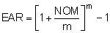

Using the Calculator
- Enter nominal rate
- Press
- Enter number of compounds
- Press
- Press
- Press

Example 3: Finding EAR
Assume that you have $1,000 in your bank account at an interest rate of 10% per annum. Find the effective rate compounded annually and semi-annually.

Solution: Part I
1. Effective rate compounded annually
Using the Mathematical Formula  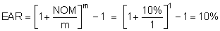  Using the Calculator | 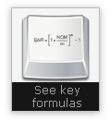
  Procedure | Applying Procedure  to Example 3
  Enter nominal rate | 10
  Press
  Enter number of compounds | 1
  Press
  Press
  Press
  Result | 10%
 | 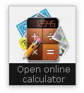

Either method provides the same result:
Period | Beginning Balance | Interest | End Balance
Year 1 | 1,000 | 100 | 1100

Example 3: Finding EAR

Solution: Part II
2. Effective rate compounded semi-annually

Using the Mathematical Formula

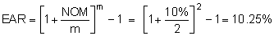

Using the Calculator
Procedure | Applying Procedure  to Example 3
Enter nominal rate | 10
Press
Enter number of compounds | 2
Press
Press
Press
Result | 10.25%

Either method provides the same result:
Period | Beginning Balance | Interest | End Balance
6 months | 1,000 | 50 | 1,050
Year 1 | 1,050 | 52 | 1,102.50

You borrowed $1,000 at a 10% interest rate per annum. What are the nominal and effective rates if interest is calculated or compounded annually, semi-annually, quarterly, monthly, weekly and daily?
Note: Try to do this exercise on your own before viewing the answer.
# of Compounding | Nominal Rate | Effective Rate
Annually | 10% | 10%
Semi-annually | 10% | 10.25%
Quarterly | 10% | 10.38%
Monthly | 10% | 10.47%
Weekly | 10% | 10.51%
Daily | 10% | 10.52%

The Five Variables and the Timeline.
Pv 0- Pmt 1 -Pmt 2 Pmt 3- FV n

PV= Present Value
FV= Future Value
N = Number of Periods
Pmt= Payment
R= Interest Rate (% per period)

Present Value

Definition
The present value is the current value that a future amount of money is worth. This value is calculated using four variables: interest rate, number of periods or compounds, future value, and payment.

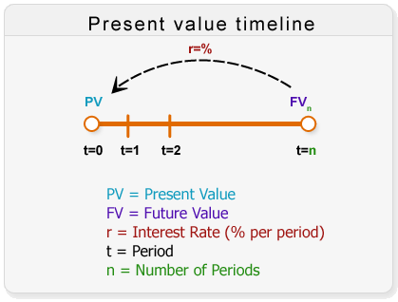

Methods to Find the Present Value

Using the Mathematical Formula
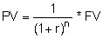

Using the Calculator
- Enter future value
- Press
- Enter number of compounds
- Press
- Enter interest rate
- Press
- Enter payment
- Press
- Press
- Press

Example 4: Finding Present Value
You will receive $1,000 one year from today at an interest rate of 10% per annum (compounded annually). What is the present value of this amount?

Solution

Using the Mathematical Formula

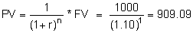

Using the Calculator
Procedure | Applying Procedure  to Example 4
Enter future value | 1000
Press
Enter number of compounds | 1
Press
Enter interest rate | 10
Press
Enter payment | 0
Press
Press
Press
Result | 909.09

Example 5: Finding Present Value of an Ordinary Annuity
You will receive $1,000 at the end of each year for 5 years. Interest rate is 10% per annum, compounded annually. What is the present value of these cash flows?

Solution

Using the Mathematical Formula

Using the Calculator
Procedure | Applying Procedure  to Example 5
Enter future value | 0
Press
Enter number of compounds | 5
Press
Enter interest rate | 10
Press
Enter payment | 1000
Press
Press
Press
Result | 3790.79

Example 6: Finding Present Value of an Annuity - Due
You expect $1,000 per annum at the beginning of each year for 5 years. Interest rate is 8% per annum. What is the present value of this annuity (annuity-due)?

Solution
Using the Mathematical Formula
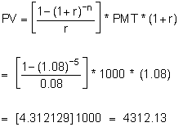

Using the Calculator
Procedure | Applying Procedure  to Example 6
Enter future value | 0
Press
Enter number of compounds | 5
Press
Enter interest rate | 8
Press
Enter payment | 1000
Press
Press
Press
Multiply partial result by (1+r)
Result | 4312.13

Example 7: Finding Present Value of a Lump Sum Amount
You will receive $5,000 10 years from today. Interest rate is 8% per annum, compounded semi-annually. What is the present value of this future amount?

Solution

Using the Mathematical Formula
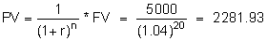

Using the Calculator
Procedure | Applying Procedure  to Example 7
Enter future value | 5000
Press
Enter number of compounds | 20
Press
Enter interest rate | 4
Press
Enter payment | 0
Press
Press
Press
Result | 2281.93

Definition

The future value is the value that a current amount of money will have at a specified date in the future. This value is calculated using four variables: interest rate, number of periods or compounds, present value and payment.

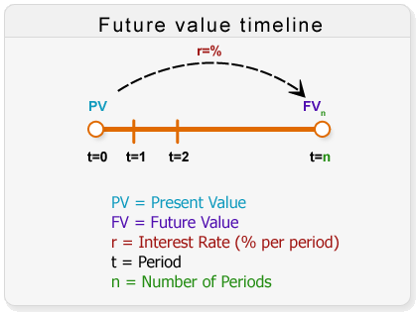

Methods to Find Future Value

Using the Mathematical Formula

Using the Calculator
- Enter present value
- Press
- Enter number of compounds
- Press
- Enter interest rate
- Press
- Enter payment
- Press
- Press
- Press

Example 8: Finding Future Value
You deposited $1,000 today in an account earning 10% per annum, compounded semi-annually. How much is your bank balance at the end of the first year?

Solution

Using the Mathematical Formula

Using the Calculator
Procedure | Applying Procedure  to Example 8
Enter present value | 1000
Press
Enter number of compounds | 2
Press
Enter interest rate | 5
Press
Enter payment | 0
Press
Press
Press
Result | 1102.50

Example 9: Finding Future Value of an Ordinary Annuity
You plan to deposit $1,000 in the bank at the end of each year for 5 years. The interest rate is 10% per annum (compounded annually). What will the future value of these deposits be at the end of the fifth year?

Solution

Using the Mathematical Formula

Using the Calculator
Procedure | Applying Procedure  to Example 9
Enter present value | 0
Press
Enter number of compounds | 5
Press
Enter interest rate | 10
Press
Enter payment | 1000
Press
Press
Press
Result | 6105.10*

Example 10: Finding Future Value of an Annuity - Due
You plan to deposit $1,000 at the beginning of each year for 5 years (5 deposits). The interest rate is 8% per annum. What is the future value of these deposits at the end of the 5th year?

Solution

Using the Mathematical Formula

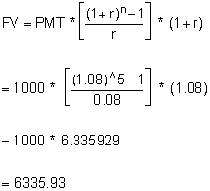

Using the Calculator
Procedure | Applying Procedure  to Example 10
Enter present value | 0
Press
Enter number of compounds | 5
Press
Enter interest rate | 8
Press
Enter payment | 1000
Press
Press
Press
Multiply partial result by (1+r)
Result | 6335.93

Example 11: Finding Future Value of a Lump Sum Amount
You deposit $5,000 today, earning 8% per annum, compounded semi-annually. How much will you have at the end of the tenth year?

Solution

Using the Mathematical Formula

Using the Calculator
Procedure | Applying Procedure  to Example 11
Enter present value | 5000
Press
Enter number of compounds | 20
Press
Enter interest rate | 4
Press
Enter payment | 0
Press
Press
Press
Result | 10955.62

Exercise 1: Present Value
You are currently saving for a dream vacation to Hawaii when you have completed your university studies in 3 years time. The total costs of the trip will be $6,000 (includes freight and accommodation). You have opened a savings account solely for this vacation. The accounts yields 2.25% annually. What is your current bank account balance in order to achieve your goal upon graduation?

Exercise 2: Present Value
You are currently saving for a dream vacation to Hawaii when you have completed your university studies in 3 years time. The total costs of the trip will be $6,000 (includes freight and accommodation). You have opened a savings account solely for this vacation. The accounts yields 2.25% per annum, compounded semi-annually. What is your current bank account balance in order to achieve your goal upon graduation?

Exercise 3: Present Value of an Annuity
Congratulations! You have just won the lottery! The terms and conditions of this lottery are as follows you will obtain $2,500 per month for 25 years. All funds obtained from the lottery will be placed in a saving account that yields 5% per annum, compounded monthly. If you had the choice of receiving an equivalent lump sum today, how much would it be?

Exercise 4: Present Value of an Annuity
Congratulations! You have just won the lottery! The terms and conditions of this lottery are as follows you will obtain $25,000 per annum for 25 years. All funds obtained from the lottery will be placed in a saving account that yields 5% per annum, compounded annually. If you had the choice of receiving an equivalent lump sum today, how much would it be?

Exercise 5: Present Value of a Lump Sum Amount
You are currently 21 years old and wish to retire a millionaire at the age of 55. The Bank of Canada indicates that the interest rate will be constant at 3.5% per annum, compounded annually (extremely unlikely) from now until then, How much do you need to have in your account today to achieve your retirement dream?

Exercise 6: Present Value of a Lump Sum Amount
You are currently 21 years old and wish to retire a millionaire at the age of 55. The Bank of Canada indicates that the interest rate will be constant at 3.5% per annum compounded semi-annually (extremely unlikely) from now until then, How much do you need to have in your account today to achieve your retirement dream?

Exercise 7: Future Value
You have just inherited a painting that is worth $100,000 from a wealthy relative. You intend to keep it for 30 years and pass it on to your children. If your children do not appreciate art and decide to sell it, how much will they get for it in 30 years? Assume a prevailing interest rate of 12.75% per annum, compounded annually.

Exercise 8: Future Value
You have just inherited a painting that is worth $100,000 from a wealthy relative. You intend to keep it for 30 years and pass it on to your children. If your children do not appreciate art and decide to sell it, how much will they get for it in 30 years? Assume a prevailing interest rate of 12.75% per annum, compounded monthly.

Exercise 9: Future Value of an Annuity
You are currently saving for new car which you want to buy in 5 years time. Upon reviewing your budget, you have determined that you can save $300 per month. This money will be invested in a savings account dedicated exclusively to your future car. This account yields 4.65% per annum, compounded monthly. How much will your car costs?

Exercise 10: Future Value of an Annuity
You are currently saving for new car which you want to buy in 5 years time. Upon reviewing your budget, you have determined that you can save $3,600 per annum. This money will be invested in a savings account dedicated exclusively to your future car, This account yields 4.65% per annum, compounded annually. How much will your car costs?

Exercise 11: Future Value of a Lump Sum Amount
Your friend kindly ask you to lend him $3,500 today and you both agree that the amount will be paid back in a single installment in 4 years time. It is understood and agreed that a minimal amount of interest will be charged so that you (the lender) are not set back financially by this personal loan. Assume the agreed upon interest rate is 1.75% per annum, compounded annually. What amount will your friend owe you in 4 years time? Do not round numbers until the very end.

Exercise 12: Future Value of a Lump Sum Amount
Your friend kindly ask you to lend him $3,500 today and you both agree that the amount will be paid back in a single installment in 4 years time. It is understood and agreed that a minimal amount of interest will be charged so that you (the lender) are not set back financially by this personal loan. Assume the agreed upon interest rate is 1.75% per annum, compounded semi-annually. What amount will your friend owe you in 4 years time? Do not round number numbers until the very end.

Exercise 1: Present Value

Answer
N = 3
I/Y = 2.25%
PMT = 0
FV = $6,000.00
PV = $5,612.56

Exercise 2: Present Value

Answer
N = 3 × 2 = 6
I/Y = 2.25%/2 = 1.125%
PMT = 0
FV = $6,000
PV = $5,610.48

Exercise 3: Present Value of an Annuity

Answer
N = 25 × 12 = 300 months
I/Y = 5.00%/12 = 0.416667%
PMT = $2,500
FV = 0
PV = $427,650

Exercise 4: Present Value of an Annuity

Answer
N = 25
I/Y = 5%
PMT = $25,000
FV = 0
PV = $352,349

Exercise 5: Present Value of a Lump Sum Amount

Answer
N = 55 – 21 = 34 years
I/Y = 3.5%
PMT = 0
FV = $1,000,000
PV = $310,476

Exercise 6: Present Value of a Lump Sum Amount

Answer
N = 55 – 21 = 34 years
I/Y = Effective Annual Rate = 3.530625%
PMT = 0
FV = $1,000,000
PV = $307,369

Exercise 7: Future Value

Answer
N = 30
I/Y = 12.75%
PV = $100,000
PMT = 0
FV = $3,660,130

Exercise 8: Future Value

Answer
N = 30
I/Y = EFF = 13.522108%
PV = $100,000
PMT = 0
FV = $4,491,728

Exercise 9: Future Value of an Annuity

Answer
N = 5 × 12 = 60 months
I/Y = 4.65%/12 = 0.3875%
PV = 0
PMT = $300
FV = $20,221

Exercise 10: Future Value of an Annuity

Answer
N = 5
I/Y = 4.65%
PV = 0
PMT = $3,600
FV = $19,754

Exercise 11: Future Value of a Lump Sum Amount

Answer
N = 4
I/Y = 1.75%
PV = $3,500
PMT = 0
FV = $3,751.51 = $3,752

Exercise 12: Future Value of a Lump Sum Amount

Answer
N = 4
I/Y = EFF = 1.757656%
PV = $3,500
PMT = 0
FV = $3,752.64 = $3,753

