Notary or Lawyer, real estate broker, home inspector.
Profit=capital gains: Longer you keep higher capital gain. Return- Investment
The Real Estate Investment

Definition

The purpose of Real Estate Investment (REI) is to buy land and all physical properties attached to it, such as houses, trees, fences, and so on, in order to generate income by selling or renting it. For example, some people might buy a house to sell it in 10 years when property value has increased; others might buy an apartment building and rent the apartments to create profit.
As other investments, REI comes with risk and return that depend on the market’s cycle. The REI cycle experiences excess when supply of properties is high; this results in a decrease in property values and indicates a good time for you to buy, but not to sell. Understanding the REI market and being able to assess the cycle’s stage is crucial to real estate investments.
Several factors affect the real estate market, such as interest rates, taxes, legal restrictions, local or provincial economy, population mobility, vacancy, property location, and public opinion of the property. We will discuss these factors in this and following lessons in the course.
The REI has advantages and disadvantages:
Advantages | Disadvantages
- Risk in REI is low. Compared to other types of investment, REI is stable and secure.  - Appreciation of real estate increases annually.The Canadian Real Estate Association found that residential real estate is increasing in value an average of 5% per year.  - Down payment is accessible. REIs are of low risk because the property is used as security; therefore, financing can cover up to 90% of the amount needed to buy a property.  - Net return will most likely be high. Real estate value increases with time. Thus, by the time you sell a property you will be receiving more than what you spent.  - Tax rates are beneficial to REI. Canadian laws allow contributors several advantages that go from tax-free to tax savings on capital gains.  - REI builds up on equity. Payments on mortgage mean acquiring equity, the part of the property that becomes yours, and that is clear of debts. | - Basic knowledge is essential to make sound decisions. Although some REIs do not require that you be an expert on real estate, you will need to allocate time to research and planning to reduce investment risks and ensure the expected outcomes.  - Cash is not available immediately. Despite having a big real estate investment, you will need to find a buyer or borrower to turn your investment into cash and this process might take some time.  - REI is a long-term investment. You might have to wait 5 to 10 years before selling the property to see the expected return.  - Advice from experts is necessary. Suggestions from legal, accounting, insurance, and real estate experts will help you plan to reach your REI objectives and avoid any potential problem that any investment might involve.

Advantages: Could invest in the stock market for 15$ a month but not real estate. Land will always appreciate in value with inflation rate. Building depreciates but maintenance= appreciation. Tenants rent will also increase with inflation rate. You could save taxes because expenses are deducted. The tax rates are beneficial. Equity increases as you pay off you loan or increase of market value of building or land.
Disadvantages. Maintenance of property. You cannot simply sell real estate to get your money back. Long term investment. Seek advice from expert. Down payment. Borrow money from back.

You can buy mutual funds. Down payment + mortgage lender. Borrow money from insurance company, mutual funds, personal, banks. 1-5 years = short period 6-10= intermediate more than 10= long
Now you rent it to tenant. Residential or commercial tenant or industrial tenant or special purpose tenant (doctor old folks home) piece of land (farmer)
You are the equity investor.
Government: important role to ensure things are legal. 4 kinds of government. You have certain property rights. Right to sell whenever. Right to rent to tenants. You have to pay money back. Property belongs to bank until money is payed. Mortgage payment= debt serviced.
Relationship between equity investor and tenant: you are leasing (lease document) allows tenant to use property as agreed. X number of years= lease hold.
Government tells investor: rules they have to follow Landlord Tenant Laws. No illegal purpose. Cant conduct business in residential place (tenant). Allowed to give investor a certain amount of money during a certain amount of time (Mortgage Laws).
Government hopes investor makes money and pays income tax. Keep property for long time to pay wealth tax when selling it.
3 limitations: police power, government can enter your property without permission.
2. Taxation: right to value property every 4-5 years for property taxes.
3. Eminent domain: government has right to takeaway building from you and give you fair market value. For general welfare of public.
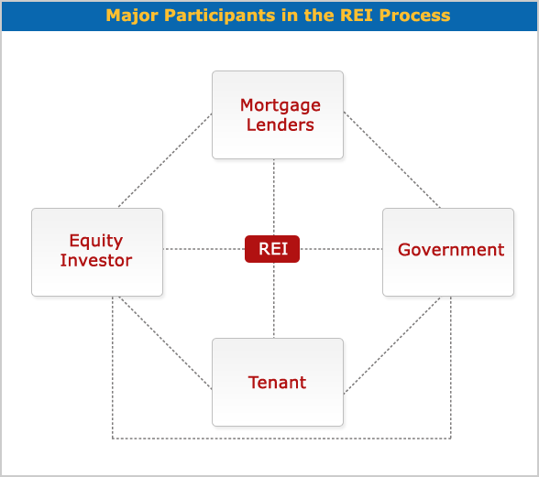
Laws Landlord Tenant Laws: disputes between landlord and tenant

Mortgage Lenders, Equity Investor, Tenant, government, REI
Major participants: Investor, mortgage lender, Tenant, government
Government encourages investment because of taxes. Tenant=cash flow. Sell building to make capital gain. Bank will use your property as guarantee.

Major Participants in REI

Equity Investor

The equity investor or landlord is the person or entity that acquires the real estate investment. The equity investor assesses how the REI will be taken, as an individual or as an organization. To make a decision, the equity investor will analyse questions such as how the organization will be created and how marketable it is, who the partners will be, how each partner will share liabilities, and what the taxation opportunities and constraints for the specific organization are.
The most common forms of equity investors are:
- Individual
- Corporation
- Partnership
- Real Estate Investment Trust (REIT)

Major Participants in REI (Cont'd)

Mortgage Lender

The mortgage lender is the entity that lends the money that the equity investor needs to start a real estate investment. Among the most common mortgage lenders are:
- Another individual
- Insurance companies
- Banks
- Real Estate Investment Trust (REIT)

Major Participants in REI (Cont'd)

Tenant

The tenant is the one who buys the right of possession and use of a property from the equity investor. The object of possession could be used for different purposes:
- Residential
- Commercial
- Industrial
- Special purposes (theatre, sports, reception halls, etc.)

Major Participants in REI (Cont'd)

Government

The government regulates the relationship between participants, and restricts participants with the imposition of taxes. Government participation in the process takes place on different levels:
- Federal
- Provincial
- Municipal
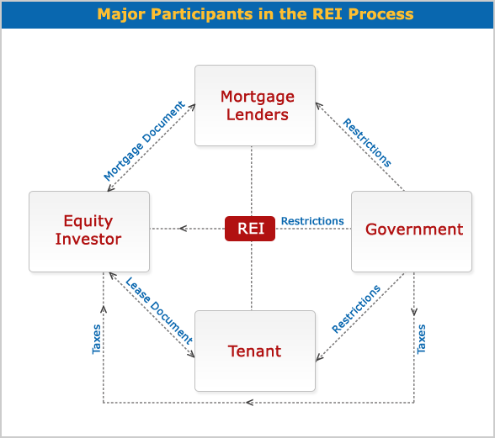

Relationship between REI Participants
Participants | Interrelation
Equity Investor and the Mortgage Lender | - The equity investor borrows money from the mortgage lender.  - As a provider of debt service, the mortgage lender expects mortgage payments that will include the principal plus the interest generated through time.  - The mortgage lender gets a mortgage document as collateral; this document specifies the method of payment, which could consist of the repayment of interest first and principal at the end, or the repayment of both principal and interest in each amortization.
Equity Investor and Tenant | - The equity investor leases the right to use a property to the tenant.  - The tenant pays rent to the equity investor to use the property.  - The lease document establishes the attributions and restrictions involved in using the property.
Equity Investor and Government | - The equity investor pays taxes to the government.  - The government sets restrictions on owners, such as police power, taxation and eminent domain.  - Police may enter a property without requiring the owner's permission.  - Most taxes are on income and capital gains. The taxes on income are for money made on rents received from tenants. The taxes on capital gains (wealth) are for gains for selling a property. The government also requests a "welcome tax" from the buyer of a property and a "goodbye tax" from the seller of a property.  - Appealing to eminent domain, the government may expropriate private property at its fair market value in order to create something that favours society in general.
Mortgage Lenders and Government | - The mortgage lender's relationship to other participants in the REI is regulated by the government.  - The government imposes restrictions on mortgage lenders which will depend on the nature of the mortgage lender; for example, restrictions on banks will be different from restrictions on corporations.  - The government also sets mortgage laws on debt service or mortgage payments for equity investors.
Government and Tenant | - The government regulates the use that the tenant can make of the property on lease.  - Landlord–tenant law has evolved to detail not only legal aspects between a landlord and tenant but also the actions that tenants should take to protect the property, such as the installment of fire alarms, smoke detectors, and so on.

The Real Estate Investment Process.
Step 1: Identify Investors objective goals and constraints: Objective: make money. Need money to invest. Restricted by wealth. Down payment=wealth. Certain level of risk. May not have tenants. Bad area risk is too high. What is minimum return and what amount of risk are you willing to take.
Step 2: Who will lend money? How much time? What inflation rate? Legal; environment, Financing environment, tax environment. Tax every time you make money need to pay taxes. 2 incomes Rental: tenant pays and you pay taxes. You may keep REI for X number of years. Then sell it. Capital gains= Selling price-original price. Capital gains taxes. Market environment where do you plan on buying, supply and demand, good or bad time. Type of risk depending on property (ex residential industrial)
Step 3” How do you crunch all these number? How do I know I will make money after expenses? Operating costs. Financing decision. How much Capital gains will I pay and make? Profits from tenants? How much taxes after bank loans? Rule of thumb approach: Payback method (how many years)
Traditional evaluation techniques. 3 approaches. 1 Cost approach 2 net income approach 3 sales comparable approach.
Discounted cash flow technique: time value of money. Learn discounted payback period. How long will I make my money back? How much will I make after X number of Periods. How much return will I make ROI. Eternal rate of return (this is ROI). Profitability index. What is the average cost of your money versus + average cost of borrowing money from bank = Weighted average cost of capital.
Step 5: Investment decision: Before you make decision go back to go to step 1. Do I have money for down payment? Happy with ROI? Able to accept risks? This is the goal go with decision if satisfied. If you do not want find another project until needs are satisfied.
Step 1: Identify investor’s objectives goals and constraints
Step 2: Analyze investment climate and market conditions
Step 3: Develop financial analysis
Step 4: Apply decision-making criteria
Step 5: Investment decision.

Step 1: Identify Investor's Objectives, Goals and Constraints
It is important to start the REI process by understanding that major participants (equity investor, mortgage lender, tenant and government) bring their own expectations and limitations to the REI.

- The equity investor is interested in the cash flow that will generate the REI.
- The mortgage lender’s goal is to obtain a rate of return from the money lent to the equity investor.
- The tenant does not receive an immediate income, but will be concerned with the legal rights to use the property.
- The government is responsible for regulating the relationships between the other major participants in the REI process, and it also places restrictions on real estate.

Step 2: Analyze Investment Climate and Market Conditions
The second step in the REI process is learning about the market, legal, financing and tax environment. The result of this analysis will have a great impact on your decision making throughout the process. We will discuss these environments in detail in later lessons; here is a brief overview of what you will learn.
- The market environment. This analysis identifies supply and demand in the real estate market at local, provincial, and state levels and how they affect the REI.
- 
The legal environment. A complex legal system regulates REI and the relationships between its participants. Analysing the legal opportunities and limitations that a REI may entail will play an important role in the acquisition decision and also in the rest of the REI process.
- The financing environment. The analysis of the cost of debt or interest rate, and the cost of equity or rate of return, shows how feasible the REI is and how profitable it might be.
- The tax environment. Taxes decrease the REI’s income; therefore, knowing the taxation system and the impact that it will have on the expected income will help in making the right investment decision to save money or to increase gains.

Step 3: Develop Financial Analysis

The financial analysis deals with financial calculations that will allow you to anticipate the cash flow of the REI. At the end of the analysis you will be able to answer questions such as:
- How much is profit per year?
- How much is the mortgage payment?
- How much is the capital gain when I sell?
- How much will taxes diminish my profit?
- How much will taxes decrease my capital gains?
- What strategies should I use to reduce taxes on profits and capital gains?

Step 4: Apply Decision-Making Criteria
In this step, you apply decision-making criteria to decide how much you are able or willing to pay for a property to obtain the desired rate of return. To do so, you may use three criteria:


- Rules of Thumb Techniques, which measure the payback period necessary to regain what was invested to acquire a property, and the methods needed to achieve the highest rate of return. Techniques are: payback method, return on investment (ROI), return on equity (ROE), return on asset (ROA), gross income multiplier (GIM), net operating multiplier (NIM) and overall capitalization method (OCR).
- Discounted Cash Flow Techniques, which calculate the value today of the REI future cash flow. These techniques take time value of money into consideration and include discounted payback period method, net present value method, internal rate of return and profitability index method.
- Traditional Valuation Techniques, which estimate the value of the property that will be used in the REI. These techniques are: cost approach, net income approach and market (sales) comparable approach

Step 5: Investment Decision
The previous steps will give you the necessary information to decide whether to acquire REI or not. If the result of the analysis is not what you expect, you will repeat the process assessing another REI until you find what meets your financial goals.
In the following lessons we will discuss each step of the process in greater detail. You will also have exercises and self-assessments to practice what you learned and to help build your confidence in order to start your real estate investment.

