MCB Exam Notes
Cell Cycle Control and Cancer
Reinoblastoma (and p53/pBRCA) are tumor supressors
- Individuals with retinoblastoma gene mutation helped identify the gene

Cancer terminology
- Caner: uncontrolled cell proliferation, named by tissue affected (3 groups)
  - Carcinoma: epithelial cells (90% of all cancers)
  - Sarcoma: connective tissue (ex. Bone/muscle)
  - Lymphoma: blood forming cells
- Metastasis: tumor cell migration from one organ/tissue to another and establishing new tumors
- Malignant tumors: invade surrounded tissues through metastasis (ex. Retinoblastoma from eye to muscle to lungs)
- Beging tumors: do not invade surrounding tissue (ex skin basal cell warts)

Genetic pathways to cancer (diverse and complex) : cancer develop through accumulation of somati mutations in proto-oncogenes and tumor suppressor genes
- Most malignant tumors due to mutations in more than one gene
- Tumor formation, growth and metastisis depends on accumulation of mutations in several genes

Hallmarks of pathways to malignant cancer
- Cancer cells acquire self sufficiency in signalling processes that stimulate division and growth
- Abnormally insensitive to signals that inhibit growth
- Cancer cells evade programmed cell death and acquire limitless replication potential
- Cancer cells develop new ways to nourish themselves (angiogenesis, can use angiostatens to prevent growth of new blood vessels)
- Cancer cells acquire ability to invade other tissues and colonize them
- Cells will grow up on plate instead of in a monolayer
- Disorganized cytoskeleton and synthesis of unusual cell surface proteins (good targets for immunotherapy and viro therapy)
- Aneuploidy, lacking one chromo of a pair of having an extra
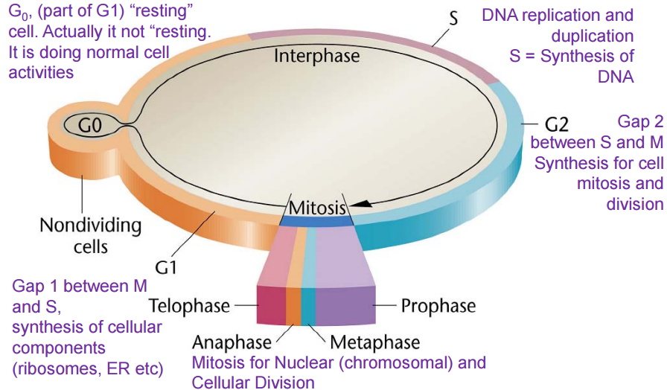
- Less differentiated, loses normal function of a cell

Cell cycle control: role of cyclins and cyclin dependent kinases (CDKs)
- Cyclins: proteins formed and degraded during each cell cycle
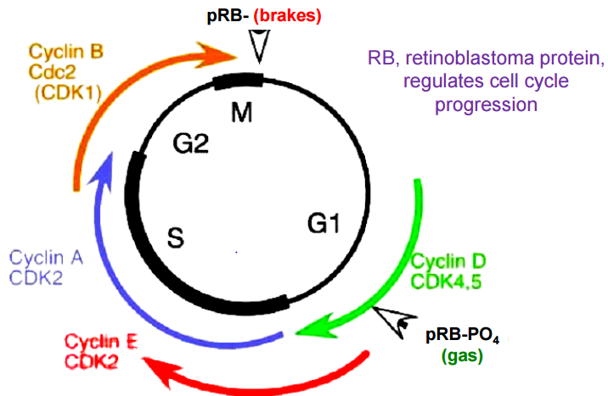
- Cyclin dependent kinases : protein kinases that regulate proteins involved in cell cycle control by phosphorylation
- Cyclins bind to CDKs to form CDK/cyclin complexes *regulates CDK activity)
- Cell cycling requires alternate formation and degradation of cyclin/CDK complexes

Restriction point in mammalian cell cycle (START checkpoint for yeast)
- Regulated by cyclin D/CDK4 that are regulated by prB
- In tumor cells, checkpoints are disregulated due to mutations in CDK4 or cyclin D or pRD, p53 or other checkpoint regulators
- Checkpoint; a decision point in cell cycle to proceed or half
- Transitions between different phases in the cell cycle regulated by checkpoints
- Restriction point (START in yeast) at G1/S mid G1 which needs cyclin D/CDK4
  - G2/M checkpoint needs cyclin B and CDK1

Cancer genetics: oncogenes promote cell division and over-expression/activating mutations cause cancer
- Tumor supressing gnes (pRB, p53, BRCA1) supress cell proliferation an dloss of function mutations may result in cancer
- Both genes are normal genest htat regulate cell proliferation

Cellular and viral Oncogenes
- Cellular proto-oncogenes (c-onc): genes that code for normal components of signal transduction cascade and regulate cell proliferation (oncogenes-mutated form)
  - Mutations: point mutation, translocation (ORF fusions/promoter ORF fusion), gene amplification)
- Viral oncogenes (v-onc) viral counterpart of c-onc, contains mutations causing cancer in animals
- Orogin of viral oncogenes: host genome, retroviruses (RNA virses) pack host cell mRNA into own genome
- C-src has introns wile v-src lack introns because it was made from mRNA
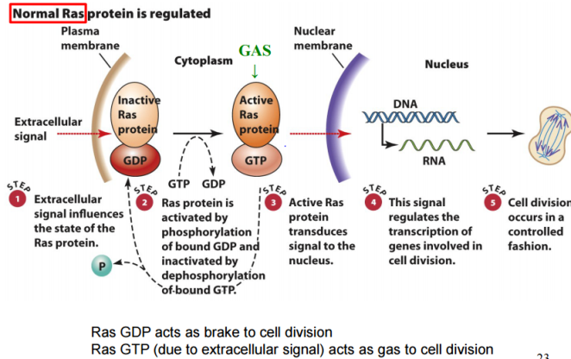
Point mutation of c-ras to cancer oncogene form: cras is a signaling molecule on inner surface of cellular membrane
- Point mutation causes c-ras to be stuck in permant ON (GTP) position, induces continuous cell division
- Causes constitutive transcription (transcribed continuously)
Cellular oncogene activation by translocation
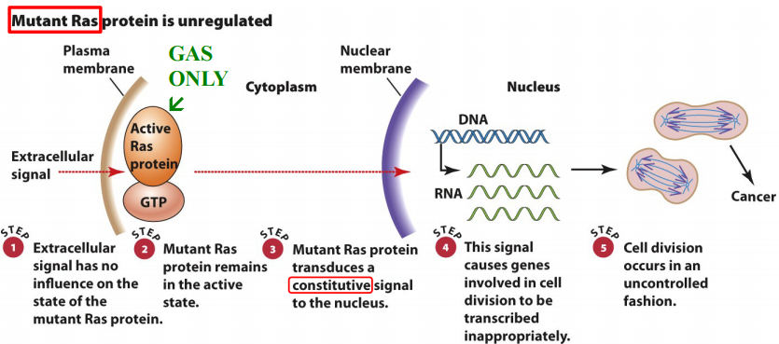
- translocation:Fusion of protoconcogene ORF with ORF of another gene
  - New fusion gene encodes new cancer inducing protein
- Translocation (new promoter/ORF fusion): protooncogene (due to chromosome cross over) in vicinity of strong promoters/enhancers cause overproduction of oncogene

Cellular oncogene activation by gene amplification: duplication of proto-oncogenes in the cellular genome cuaisng overexpression of onco-protein

Cellular oncogene activation by virus infection:
- Insertional activation of a c-onc: insertion of viral DNA near transcriptionall silent c-onc could lead to overexpression of c-onc protein
- Use of viral v-onc, ciruses expresses it’s own v-onc

Tumor supressors genes RB, p53, BRCA1, and pBRCA2
- Retinoblastoma gene (RB)
  - Familial RB (inherited) (40% of RB cases) usually affects retina of both eyes, often accompanied with other forms of cancer
  - Non familial (sportadic) RB (60%): affects only one eye
  - P53 gene : monitors DNA damage to cell, prevents cell division and causes cell death
  - pVRCA1/pBRCA2 genes: detection and repair of damaged DNA

Basis of Knudsons’s two hit hypothesis
- RB is caused by inactivation of both copies of a specific tumor suppressor gene
- In familial form, one mutation inherited, other acquired sporadically during eey development (one bad already
- In sporatic form, both RB mutations occur sporadically

What is pRB: a 105 kDA nuclear protein regulating normal cell cycle
- In active non phosphorylated from, pRB in G0/G1 bind to transcription factor E2Fcausing cell cycle progression to half
- pRB inactivated by phosphorylation by cyclin D/CDK4 in late G1 which releases E2R, allowing cell cycle to proceed
- activepRB is brake, inacrive pRB-PO4 is gas
- mutant pRD cannot bind E2F so cell cycle continuously activated

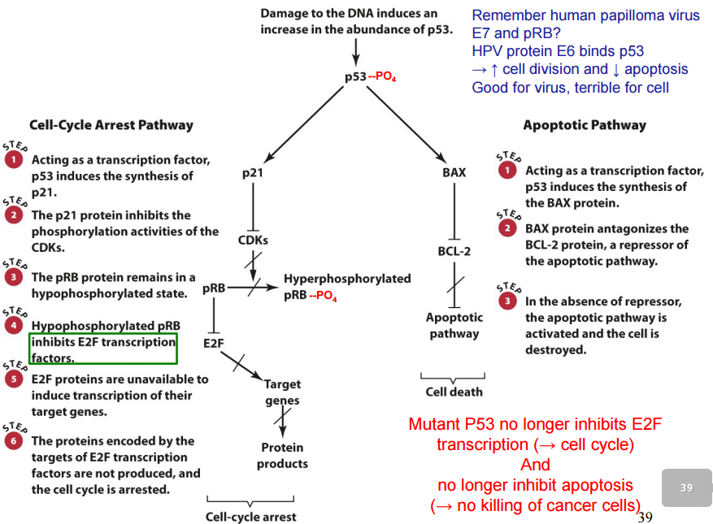
Tumor suppressor gene p53: transcription factor fod in low amounts
- DNA damage induces phosphorylation of p53
- Functional p53-P04 inhibits cell division or induces apoptosis
- P53 mutaionts implicated in 60% of call cancers
- Which pathway taken depends whether cell thinsk it can recover
- Always primed to go through apoptosis but blocked by BCL2

Nucleus

Differences between prokaryotes and eukaryotes
Prokaryotes | Eukaryotes
Nucleoid: “region where chromosome is located | Enclosed nucleus  - Nuclear envelope: boundary b/w cytosol and nucleus  - Nuclear pores: doorways in nuclear envelope
Free ribosomes | Free ribosomes and rough ER
No endomembrane system | Vast interconnected endomembrane system
No mitochondria (can derive energy form light) | Mictochondria and chorloplasts
Typically small | Larger (typically)

Nucleus: Characteristics and Functions
- Characteristics: irregular shape, typically one per cell, largest organelle
  - Muslces multinucleated to have more copies of DNA to make more proteins for proper functioning
- Two main functions: compartmentalization of the cellular genome and activities (e.g. DNA replication, transcription, and RNA processing, site where translation components synthesized
  - Coordinates cellular activities (e.g. control of metabolism, protein sysnthesis, cell division)

Structure of the Nucleus
- Nuclear envelope: nuclear membrane, nuclear lamina, nuclear pores
- Nuclear content: chromatin, nucleoplasm, nuclear matrix (controversial if exists), nucleolus (tRNA, rRNA produced here, lots of transcriptional machinery, brings all genes in close prximty to make components quick)
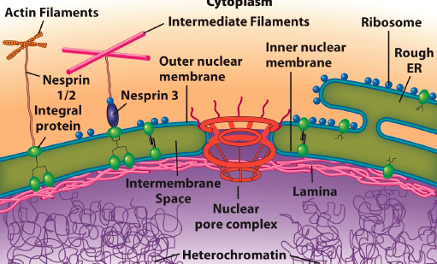
Nuclear Envelope: Structure
- 2 parallel phospholipid bilyaers separated by intermembrane space
- Outer membrane binds ribosomes, continuous with RER
- Inner membrane: contains unique protein composition distinct from outer membrane and integral membrane proteins that connect to nuclear lamina
- Intermembrane space continuous with ER lumen (some barriers to prevent free flow from one to another)
- Inner and outer membrane joins at pores

Nuclear Envelope: Functions
- Seperates nuclear content from the cytoplasm
- Selective barrier that regulates passage of molecules b/wnucleus and cytosol
  - Establishes composition of nucleus and regulates gene expression (heterochromatin stays away from the pores)
- Binds nuclear lamina for structural framework for nucleus

Nuclear Lamina: Bound to inner surface of nuclear envelope
- Structure: thin meshwork of long filament like proteins (ABC nuclear lamins related to cytosolic intermediate filaments)
- Functions: support structure for nuclear envelope and scaffold for chromatin and nuclear matrix attachment
- Progeria: mutations in lamin genes responsible, characterized by premature aging in children
  - Death by adolescence due to mutation in lamin A gene (LMNA)
  - Destabilization in nuclear lamina (abberent changes in nuclear envelope morphology and function)
  - Characterized by hair loss, wrinkles, artery damage
  - Heterozygous: OK

Nuclear pores: inner and outer membranes of nuclear envelope fuse
- All eukaryotic cells have nuclear pores
- 75 different genes/proteins make up pore complex

Nuclear Pore complex: protein structure that fills nuclear pore
- Complex supramolecular complex made up of 100s of polypeptides (nucleoporins (NUPs))
- Fits into pore, reduces functional diameter
- Extends into cytoplasm and nucleoplasm

NPC Structure: highly conserved among all eukaryotes, includes integral and peripheral outer and inner membrane proteins
- Octagonal symmetry organized around large central channel
- Central scaffold: anchores complex to nuclear envelope, forms aqueous central channel
- Inner surface of channel lined with filament like proteins
  - GF nucleoporins (nups) have unusual amino acid composition that contain a large number of phenylalanine-glycine repeat sequence (FG domains)
  - FG domains posess highly disordered secondary structure (lots of FGs prevent folding) that has extended and flexible organization
    - Extends into central chanel as hydrophobic mesh which limits the diffusion of macromolecules larger than 40 kDA (must be selectively imported/exported using active process) (small molecuels can freely move)
- Cytoplasmic and nuclear rings: linked to the central scaffold and also the cytoplasmic filaments or the nuclear basket
- Cytoplasmic filaments: involved in nuclear receptor cargo protein recognition and import (stuffs things into the hole)
- Nuclear basket: involved in nuclear receptor cargo protein import and export

Nuclear function dependent on efficient protein import and export
- Structural proteins: nuclear lamins and matrix, DNA packing
- DNA replication and repair
- Transcription, RNA processing and export, ribosome synthesis and export

Functions of the NPC: passive diffusion of small molecules (nucleotides, solutes, histones)(100 molecules/min/pore)
- Regulates movment of larger molecules: import nuclear proteins and RNA, export RNA, ribosomal subunits, proteins from nucleus (6 molecules/min/pore)

Nuclear import of nucleoplasmin(nuclear protein detected by coating with gold particles)
- Nucleoplasmin synthesized in cytoplasm, associates with CF and translocates into nucleus

Nucleocytoplasmic transport via NPC
- Cytosol to nuclear transport: requires energy, specific protein receptor, and unique targeting signals
- Most nuclear improted protein conatain a nuclear localization signal (NLS)
  - Specific stretch of AA that are reocgnized by nuclear receptor proteins (zipcode that mediates targeting of protein from cytosol to nuelues)
    - Viruses use this to get proteins into host nucleus to influence transcription
  - Several different types of NLS based on different amino acid sequences
  - Classic NLS: most common NLS used by virus to get viral protein into nucleu
    - Consists of shoft stretch of positively charged basic AA residues
  - Bipartite NLS: two short stretches of basic AA and a 7-10 AA long spacer sequences
- NLS: an amino acid sequence that is necessary and sufficient for cytosol to nuclear targeting a
  - Necessary: if seuqnece mutated, modified protein fails to target nucleus
  - Sufficient: if sequence linked to non nuclear protein, it can be redirected to nucleus

Nuclear Transport

Cytosol to nuclear transport: characterization of different NLS led to Identification of proteins necessary for nucleocytoplasmic transport of cargo
- Transport receptors : karyopherins (importins or exportins
  - Mobile proteins responsible for ferrying protein cargo across nuclear evelop
  - Large family of receptor proteins responsible for moving macromoleclues into or out of nucleus
- Small G proteins (Ran), serve as molecular switches in the transport process

Conformational changes in G proteins: g proteins have weak intrinsic GTpase activity
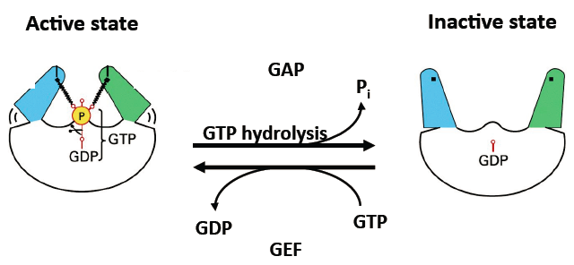
- GTP binding and hydrolysis cause conformation changes
- GAP: GTP activated protein, GEF: Guanine exchange factor
- GDP is pulled out and a new GTP is added in to reactivate it

G proteins in nucleocytoplasmic translocation
- Ran: GTP binding protein that has poor native GTPase activity
- Exists in two states: Ran-GTP active and Ran GDP inactive
  - High Ran GTp in nucleus and low Ran GTp in cytioplasm which creates concentragion gradiant that is maintained by accessory proteins
    - RCC1: nuclear protein promotes conversion of Ran GDp to GTP
    - Fan GAP1 cytosolic prtin promotes ydrolysis of Ran GTP to ran GDP
- Ran GTP deactivated by GTPase activated protein (GAP) in cytoplasm to make Ran GDp that translocates into the nucleus
- In nucleus, GDP exchanged for GTP by guanine nucleotide exchange factor (FEG) so generation of Ran GTP not phosphorylation event
- GEF in nucleus generates Ran GTP

Nuclear Import : protein import into the nucleus
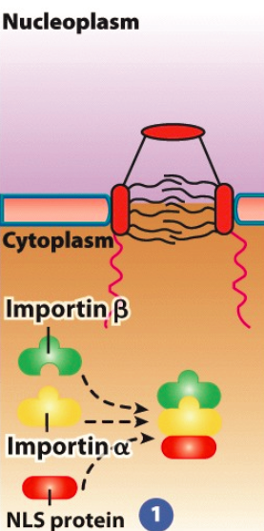
- Step 1: nascent NSL containing cargo protein recognized in cytosol by importin
  - Importain is a heterodimeric protein containing two subunits (a and B)
  - Importin a subunit recognizes and binds to basic residue in cargo protein’s NLS
- Step 2: Cargo protein importin receptor moves through cytosol towards nucleus via importins ability to bind cytoskeleton (intracellular transport highway)
  - At surface of nucleus, improtin B binds to cytoplasmic filament of NPC
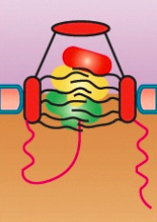
- Step 3: cargo protein importin receptor complex translocated through aqueous channel of NPC (not well understood)
  - Current model: cargo receptor complex interacts with FG domains of FG nups in central channel which dissolves FG domain network to allow translocation through the channel
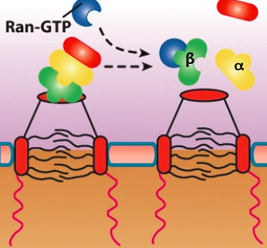
- Step 4: cargo receptor complex associates with nuclear basket, binds to Ran GTP via importin B resulting in release from NPC and disassembly in nucleoplasm
  - NLS not cleaved from cargo protein, need to get improtin a and b back out to prevent toxicity and to recycle it
- Step 5: Ran GTP bound importan B subunit moves back to cytosol due to Ran GTp gradient
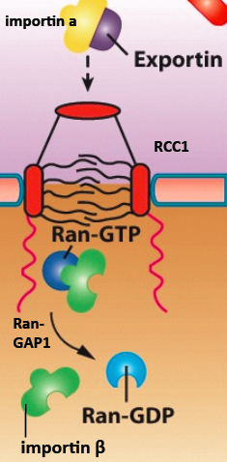
  - In cytosol, GTP hydrolyzed via accessory protein Ran Gap1 causing Ran GDP to be released for importin B
  - Importin B used for another round of nuclear protein transport and Ran GDP moves back itno nucleus to be converted back to Ran GTP via RCC1
  - Fate of imporin a has same fate as cargo proteins exported out of nucleus

Ran: small GTP binding proteins that’s conformation and activity regulated by GTP binding and hydrolysis
- Ran GTP gradient determines directionality of ncuelcytoplasmic transport
- GTP hydrolysis provides energy required fro nucleocytoplasmic transport

Nuclear Export
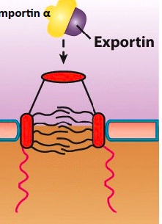
- Step 1: importin a binds to exportin which can also bind to other cargo proteins via nuclear export signal (NES) (specific sequence of AA that mediate targettinf of protein to cytoplasm)
  - Several different types of NES , all are necessary an dsufficent for nucleus to cytosol targeting
  - Most common NES consists of leucine based motif
- Step 2: importin a exportin complex binds Ran GTp in nucleus which promotes stable assembly of importin a exportin complex
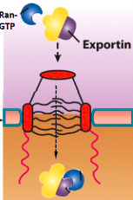
  - Imporin a exportin ran GTp complex transporte via NPC into cytosol due to conc grad
- Step 3: in cytolsol, GTP hydrolyzed by Ran GAP1 and Ran GDp released from exportin
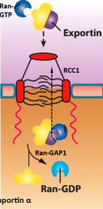
  - Causes release of importin a that is used for another round
  - Ran GDp moved back into nuclus and convered via RCC1 back to ran GtP
  - Exportin moves back into nucleus via importin for another round

Nculear import: some proteins imported into nucleus without NLS, done by piggybacking nuclear protein import
- Nascent protein binds to NLS containing protein in cytosol
- Few diseases associated with faulty NPC complexes since mutations likely cause death
- Many diseases associated with mutatiosn in NLS of certain genes Swyer syndrome, are genetically XY but develop as a female but infertile)
  - SRY gene on Y chromosome which is testis determin factor, in swyers, mutation in NLS prevents encoded transcription factor to enter nucleus and execute function

Nuclear export: mostl proteins and RNA molecules (that are compelxed as ribonucleoproteins RNPs)

Importin a contains 2 NLS recognition motifs and can transport more than one cargo at a time (can carry something other than exportin)

Nuclear content: Nucleoplasm
- Highly organized fluid fille dinteiror of nucleus consisting of >30 specialized region with specific functions (not membrane bound)

Nuclear content: choromosomes
- During interphase, organized into discrete subdomains
- Location of gene related to function, most actively transcribed genes found at periphery of chromosomal subdomains
- Interchromosomal channels: regions b/w domains serve as barriers to prevent unwanted DNA –DNA or DNA-protein interactions
- Active genes (chrmatin) from different subdomains extend into interchromosomal channels to form transcription factories where transcription factors concentrated
  - Usually occurs with genes of similar functions

Nuclear speckles: subdomains where mRNA splicing factors are concentrated, speckles via fluorescence
- In interchomosomal channels next to transcription factories
- Numerous and highly dynamic, grow and shrink with needs of cell

Nuclear content nucleolus: non mem rane bound dense granular irregularly shaped nuclear subdomain
- Size and number depends on metabolic activity of the cell
- Function: ribosomal biogenesis, site of rDNA gene transcription and rRNA processing
  - Initial stages of ribosomal subunit (rRNA and protein) assembly)
  - Final assembly occurs in cytosol

Endomembrane system

Endomembrane system: dynamic coordinated network of all of cell’s organelles and related structures
- Excluding perioxiomes, mitochondria and chloroplasts
- Large amoutns of material exchanged via small membrane bound transport cesicles
- Organelles structurally and functionally distinct from one another
  - Contain parituclar set of proteins to perform unique set of activities
  - Provides compartmentalisation and functional diversity
  - Dynamic structure that is conserved in eukaryotes
- Materiials move within endomembrane system via biosynthetic,s ecretory and endycytic pathways via transport vesciles
- ER is starting point for secretory and biosynthetic pathways : site of protein and lipid synthesis, protein folding and processing

Vesciel transport: trafficking through endomembrne system, four general steps
- Step 1: cargo containing vesicle buds off donor membrane compartment
  - Vesicle coat proteins select which donor membrane and luminar cargo proteins can enter nascent transport vesicle and regulate vesicle formation and budding
- Step 2: nascent vesicle transported through cytosol to recipient membrane compartment
  - Vesicle receptor proteins regulate intracellular trafficking of vecile to recipient membrane
  - Involves molecular motor proteins that direct vesicle movment by linking vesicle and cytoskeleton
- Step 3: vesicle fuses with proper receipent membrane which is regulated by receptor proteins
- Step 4: entire process can repeat in the reverse direction
  - Other receptor proteins regulate recycling of escaped proteins back to donor membrane compartment

Distinct trafficking pathways
- Biosynthetic pathway: materials transported from ER golgi endosomes and then either to lysosomes/vasuoles or plasma membrane
- Secretory pathways
  - Constitutive secretion: ER derived materials transported and modified from the Golgi to the PM and/or released outside the cell
    - Secretory transport vesicle membrane components incorporated into the PM
  - Regulated secretion: occurs only in specialized cells, ER derived material from Golgi stored in secretory granules
    - In response to cellular signal, secretory granules fuse with the PM
    - E.g. regulated release of neurotransmitters by nerve cells
- Endocytic pathway: oppsite direction of secretory cell
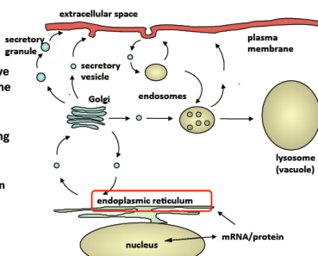
  - Material from PM / extracellular space incorporated into cell and then transported to endosomes and lysosomes
  - A lot of liganded receptors on PM are endocytosed, in endosome ligand detached and receptors recycled back to PNM

Endoplasmic Reticulum

Endoplasmic reticulu: complex network of membrane enclosed rod like tubules and sheet like cisternae
- Tubule and cisternae shapes mediated by reticulons: unique ER integral membrane protines that have hairpin B secondary structure to regulate Er membrane curving (decrease surface area on inside, causing curve)
- ER is a highly dynamic network, making new tubules in response to need of cell
- Has multiple subdomsins: distinct regions of ER network that have unique morphologies/functions due to proteins and membrane lipid composition
  - RER: mostly cisternae with bound ribosomes that are involved in protein and membrane phospholipid synthesis
  - SER: cuved tubules lacking ribosomes, for Ca storage and hormone synthesis
  - Outer nuclear membrane: continuous with RER, contains NUP and attached ribosomes
  - Mitochondria and plasma membrane associated membrnaes: regions that make direct contact with mito or PM, involved in membrane lipid exchange
  - ER exit sites (ERES): transport vesicles bud off from ER en route to Golgi

Protein synthesis: one of two main sites for proteinsytnehsis in cells
- Free ribosome in cytosol: nascent protein remains in cytosol or targets to intracellular destination (mito, chloro, nucleus)
- ER membrane bound ribosomes: remains in RER or localizes to antoher Er subdomains or targes from ER to another post ER compartment in endomembrane system
Co-translational translocation of a soluable protein ito the RER lumen
- Step 1: In cytosol, translation of mRNA begins on free ribosome
  - N terminum os nascent polypeptide contains signal sequence (analogous to NLS) which is a stretch of 8-15 hydrophobic AA that serve as ER targeting sequence
  - Signal sequence recognized by signal recognition particle (SRP) has 6 proteins and 1 small RNA
  - SRP binds ribosome and stops protein translation
- Step 2: SRP targets entire complex to surface of ER where it binds to SRP receptor (heterodimeric ER integral membrane protein complex)
  - Cytosolic facing domain of SRP is the docking site for incoming SRP
  - SRP and SRp receptor are G proteins (GTP bound)
  - Smooth ER will not have SRP receptor or translocon
- Step 3: SRP released from SRP receptor and simultaneously ribosome binds to translocon (Sec 61) responsible for rough ER aperance on microscope
  - SRP retursn to cytosol for another ound of protein import
  - Reelase step relies on GTP ydroplysis which causes conformational change in SRp and SRP receptor (receptor released for another round of import)
  - Binding of ribosome causes continuation of proteins translation (SRP gone)
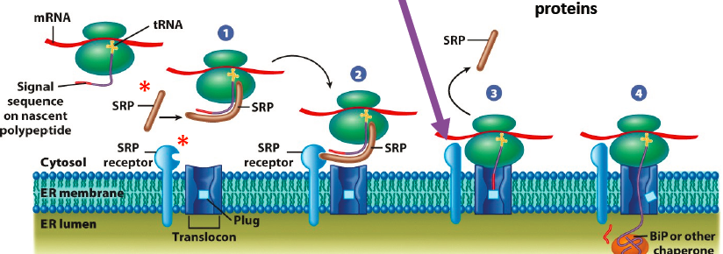
  - Singal sequence interacts with interior of trnaslocon, cuaisng conformational change in translocon subuints which widens pore ring and displaces plug
- Step 4: growing polypeptide moves through translocon and signal seq cleaved by signal peptidase as it enters the lumen (vs NLS never cleaved)
  - ER integral membrane protein protease located next to translocon, catalytic domain of signal peptidase faces ER lumen
  - As cleaved protein enters lumen, it is glycosylated and egins to be properly foleded by reticulo plasmins
    - chaperones that operate in the ER that bind to nascent protein to prevent protein aggregation, stops it form binding to other proteins)
    - Folding occurs before synthesis
    - Ex BiP, binding immunoglobulin protein, calnexin, calreticulin
  - Ribosome released from translocon following termination of translation and translocation which causes closing of tranlocon pore ring and return of plug
  - Ribosome returns to cytosol for another round of protein import

Maintenance of Membrane Asymmetry: 2 mechanisms
- Lipid composition
- Modification and orientation of integral membrane proteins (IMPS)
  - Luminal domain of IMPs remains in lumen of endomembrane comparments (glycosylated)
  - Extracellular domain on extracellular face of PM
- Cytoplasmic domain always in cytoplasm

Cotranslational insertion of intergral membrane protein into the RER
- Most membrane proteins also synthesized on membrane bound ribosomes of RER
  - Includes resident membrane proteins of ER and post ER comparments of endomembrane system
- Translocation during translation into the ER membrane in similar manner to import of soluable proteintino ER lumen except some mechanical differentces to allow protein to be inserted into ER membrane
- Step 1: N terminus of polypeptide neters translocon
  - Growing protein’s first/only transmembrane domain (TMD) enters translocon (typically alph helical hydrophobic AA)
  - TMD interacts with hydrophobic pore rings to stop further tranlocation of protein through translocon
  - Next steps depends on orientation of membrane protein (Nlumen C cytosol vs N cytosol-Clumen)
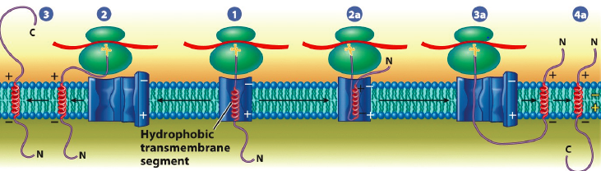
- Step 2 (N lumen- C cytosol): TMD interaction signals translocon to open laterally and TMD segment released laterally into membrane lipid bilayer
- Step 3: synthesis of cytosolic facing C terminus resumes
- Step 2 a and 3a (N cytosol- C lumen): translocon’s interior interactswith several +ve AA residues located upstream of N terminal of TMD which determine topology of all membrane proteins syntehsized at ER
  - Positive outside rule: nascent membrane eprotien TMD reorientated 9reversed) y translocon so positively charged residues face cytosol
  - Segment released laterlaly into membrane bilayer
  - Synthesis of C terminus resumes

Membrane biosynthesis at the ER: membranes arise from pre-existing membrnaes
- Most membrane proteins and lipids synthesized at the Er except glycolipids synthesized in Golgi and unique chloro and mito proteins and lipids
- Nascent Er membrane proteins an dlipids traffic to other membrane in cell resulting in each organ with unique membrane protein and lipid components
- Nascent Er membrane proteins and lipids distributed assymetirically
- Integral membrane proteins: different regions of the protein face cytosol and/or ER lumen
- Peripheral membrane proteins: located on either cytosol or luminal side of ER membrane
- Membrane phospholipids: distributed unequally b/w cytosolic and luminal leaflets of the bilayer
- Assymetry established at ER and maintained through rest of endomembrane system
  - Little switching of lipids/proteins from lumen to cytosol

Processing of newly syntehsized protines in the ER
- ER=ideal processing site for nascent proteins, first compartment in the endomembrane system
- Final steps in cotranslational translocation pathway involve processing of nascent protein in ER lumen
- Step 1: signal sequence cleavage
- Step 2: initial stages of glycosylation: addition of unique carbohydrate side chains to specific amino acids of nascent protein (glycoproteins required for proper folding, protein protein binding)
- Step 3: protein folding and assembly by molecular chaperones
- Step 4: quality control: misfolded proteisn recognized and degraded

Glycosylation of proteins in the ER
- Glycosylation: addition of oligosaccharide side chains to proteins
- Order of monomers in olisaccharide important, varies form one glycoprotein to next, impacts f’n
- Functions of olgiosaccharides on glycoproteins: assit in binding with other macromolecules, assist in folding, important in intracellular trafficking, target protein
- Most proteins synthesized in ER are glycoproteins
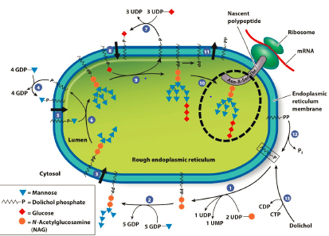
- Most common tyle of glycosylation is N linked glycosylation , ogliochaaride linked to terminal amino group of aspargine (N)
- 2 stages: core clycosylation then core modification

Protein glycosylation: core glycosylation
- Various ER membrane bound glycosyltransferases synthesize the core ogliosaccharide
  - Core-highly branched olgioscahride chain with 14 sugar residues with 3 glucose long terminal branch
- Each enzyme adds a specific sugar to a specific position on growing core
- Final step involves glycosyltransferase linking core ogliosaccharide to N residue on soluable or integral membrane protein that is still being synthesized
- Core ogliosaccharide only transferred to luman facing N resdues part of the seq N-x-S/T-
- In step 3 once 5-9 manoses are added, flippase flips it into the inside of the membrane
- Afterwards in step 9, clucose is added making a 3 glucose termination chain that is recognized
- After transfer to nascent protein, oglisaccaride 14 sugar core trimmed and modified
- First 2 of three terminal glucoses are removed by glucosidase I and II (lumanl enzymes)
- During glycoslation an dmodificaiont, glycoprotein is also properly foled and subjected to ER quality control (ensures protein possesses correct sugar attachement and properly folded)

ER protein quality control
- Nascent glycoprotein binds to calnexin (reticuloplasmin that mediates glycoprotein final folding)
  - Glucosidase Ii removes last glucose unit for core coligosaccarde to be released from calnexin
- If protein misfolded, recognized by GT monitoring enzyme (UGGT)(Er lumeanl glycosyltransferase that recognizes hydrophobic residues that are maksed by attached sugars in correctly folded proteins
- GT enzyme adds back single glocuose to terminal end of core
- Misfolded enzyme binds to calnexin again, entire process recycles until protein properly folded
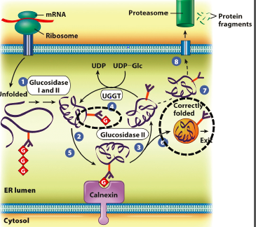
  - However manose is a timer for the time protein spends in lumen since it is slowly being chewed away, if manose disappears, protein ejected from ER and destroyed
- Misfolded protein eventually destroyed via ER associated degradation pathway
  - Protein translocated out of ER via translocon (mechanism not well understood)

ER-Associated Degradation (ERAD)
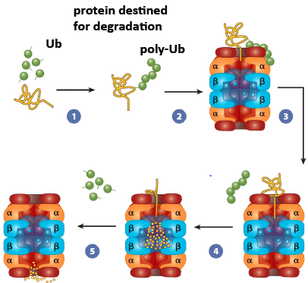
- In cytosol, oglisaccharid chains removed and misfoleded protin is linked to chain of repeating poly ubiquitin units
  - Ubiquitin: small protein involved in diverse cellular function
  - Mono Ub: signal for membrane protein import into endosomal vesciles
  - Poly Ub: signal for Er protein egredationa nd most cellular proteins destined for turnover via degradation by proteasome
  - Proteasome: barrel shaped multipsubunit protein degrading machine in cytosol and nucleus
- Ub protein bind to lid of protesome, ub chain removed and recycled, protein threaded into protesome where it is degraded and AA resued for new protein synthesis

Unfolded protein Response (UPR) pathways
- Under certain conditions, misfolded proteisn accumulate in ER at very high levels (too high for ERAD pathway)
  - E.g. in some diseases misfoleded proteisn accumulate in ER and form toxic aggregates (calnexin keep proteisn separated)
  - Results in ER stress that signals UPR pathways
- Meidated by protein sensors (ER integral membrane proteins)
  - PERK (Protein Kinase RNA like ER Kinase)
  - ATF6 (Activating Transcription Factor 6)
- Possess ER lumen facing stress sensing domains that bind to molecular chaperones (biP) in ER lumen (in non stress conditions PERK and ATF6 sensors inactive due to binding to BiP)
- In stress conditions BiP released from PERk to aid in folding of accumulating misfolded protein
  - PERK sensors dimerase, become active, cytosolic facing kinase domains phosphorylate and inhibit protein TF elF2a (cytosolic protein required for ribo mRNA binding)
  - Protein synthesis in cell ↓ and molecular chaperones can focus on pre-existing proteins
  - ER stress is either releaved or cell death occurs
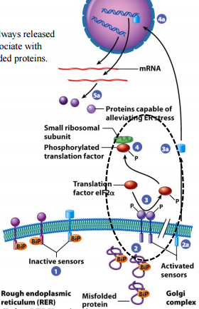
- In ER stress , BiP released from ATF6 which activtes it and ATF6 moves from Er to Golgi
  - At golgi, Cytosolic facing TF domain of ATF6 cleaved off and targets nucleus
  - ATF TF upregulates numer of genes encoding Er molecular chaperones, ER export components (moving properl folded protiens out of ER), and ERAD compoments
  - Internal ribosome entry site laternatie mechanism for ribosomes to associated with mRNA since it doesn’t’ depend on TF to make protines
    - Can still make proteisn even through global protein synthesis turned off by PERK
Cystic Fibrosis and ER Stress: one major symptom is blocked airways
- Results from mutation in CFTR gene (different mutatison cause different problems with encoded protein, including processing of translated proteins)
  - In this mutation, channel does not make it out of ER, targeted to proteasome and destroyed
  - ERAd pathway never swamped because this is single mutation, cell doesn’t die

Vescile trafficking: Er Golgi; Golgi ER

Translation: 2 Mechanisms
- Cap dependent initiation (most do cap)
- IRES mediated translation (internal ribosome enzyme site) viruses use this to avoid using cap

ER Exit Sites (ERES): distinct subdomain of ER, located next to cis face of Golgi complex
- Enriched with molecular machinery responsible for budding of membrane bound transport vesciles destined for golgi
- Machinary also responsible for proper packaging of vesicles with correct luminal and membrane cargo proteins (and lipids) destined for Golgi
- Resident ER proteins prevented from entering Golgi destined transport vesciles (cannot dock)
- Most proteins in secretory pathways specifically transported b/w comparments via unique targeting signals and receptors
  - (a lot of proteins respsible for vesicle formation taken to golgi but returned)

Transport vesicle assembly at ERES: vesicles small, fuxxy apearnace b/c of Coat proteins on membrane
- COP serve two main functions
  - Recognize and concentrate specific protein and lipid components to be incorporated into budding vesicle (ex cargo and molecular machinery for trafficking and docking)
  - Mediate membrane curvature and formation of budding vesicle
- Coa proteins: three major classes
  - COPII: move forwards (anterograde) from ERES to Golgi
  - COPI: Move backwards (retrograde) from Golgi to Er and backwards in within Golgi
  - Clathrin: move from golgi or PM to endosomes
- Step1: soublable COPII component Sar1 GDP recruited from cytosolic surface of ERES
  - Sar1 GDP binds a guanine exchange factor (GEF) that makes Sar GTP
- Step 2 Sar GTP integrades with ER outer leaflet resulting in membrane curvature of ERES
- Step3: Sar GTP recruits other soluable COPII from cytosol to surface of membrane: Sec 23 & 24
  - Sec 23& 24 form dimer that promotes further bending of membrane
  - Sec 24 also binds cytosolic facin domain of selected integral membrane proteins
    - Membrane cargo proteins: destined to exit ER, possess unique cytosolic facing seq recognized by Sec 24
    - Membrane cargo receptor proteins: lumanl domains binds lumanl cargo protein
    - Membrane receptor proteins (ex. SNARES) required for trafficking and docking of vesicle with acceptor membrane
  - Sec 24 boudn proteins are concentrated within coated bud
- Step 4: soluable COPII components (Sec 13& 31) recruited from cytosol to surface (act as scaffolding)
- Step 5: After COPII coat assembly bescile bud pinches off from EREs and begins to go to golgi
  - Prior to vesicle fustion with golgi, COPII coat disassembles b/c Sar 1 GTP converted back to GDP, released along iwht all other COPII proteins into cytosol

Vesciel transport ERES CGN (cis golgi network)
- CGN has interconnected network of vesicles and tubules on cis face of Golgi complex
- Movement of all vesciles through cytosol mediated by cytoskeleton highways and molecular motors (ex kinesin)

Vescile targeting and fusion at CGN
- Step 1L recognition of incoming vesicle and receipent membranes, mediated by Rab proteins
  - Large family of lipid anchored membrane proteins located on all transport bescles and recipient membranes
  - Association of Rab with membrane requires GTP
  - Unique Rabs associated with different membranes, gives vescile targeting specificity
- Step 2: tethering of incoming vesicle to recipient membrane: membrane bound GTP Rabs recruit recipient factors (tethering proteins) from cytosol to surface of vesicle/ recipient membrane
  - Tethering proteins: elongated firber like proteins or components of large multiprotein complexes (on opposite membranes, interact to form molecular bridge)
  - Mediate vesicle recipient membrane contact by brining them togheter
- Step 3: docking of vesicle at recieptn membrane mediated by SNARE protines
  - Integral membrane bound proteisn located on all recipet membranes and transport vesciles (unique, convey vesicle targeting specificity)
  - All SNARES have SNARE motify (cytosolic facing domain that extend from surface that are involved in snare-snare binding, long fivruous, tehntical like)
  - V SNARES: on transport vesciles incorporated from site of budding (ERES)
  - T Snares: found on target acceptor membranes
  - Specific v snares interact with only specific t snares to form Snare complex which pulls membranes together
- Step 4: Fusion of vesicle and acceptor membrane via SNARE complex pulling membranes together which causes
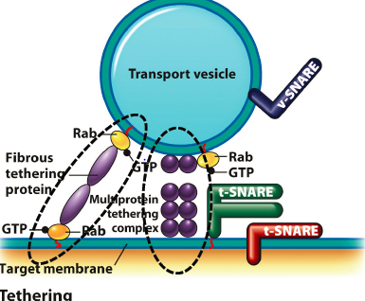
  - Lateral momvent of vescle membrane proteins into recipient membrane
  - Release of soluable cargon into acceptor organelle

Retrograde transport of “escaped” ER protiens: most resident soluable ER proteins have C terminal KDEL seq that serves as ER retrieval signal
- Escaped soluable ER proteins recognized by KDEL receptor in CGN lumen (integral membrane protein)
  - Luminal facing domain binds to KDEL seq of escaped soluable ER protein and cytosolic facing domain binds COPI components
- COPI mediates formation of transport vesicles in CGN
- COPI return soluable Er protein KDEl receptor complex back to ER where KDEl receptor releases ER protein and returns to CGN via COPII vesicles
- Most resident Er membrane proteins have C termina KKxx sequence, also recognized by COPI
- KDEl receptor also contains Kxx Er retrieval signal

Fate of newly delivered cargo at CGN: remain in golgi or move to other comparments
- Most ER proteisn retained in ER by being excluded from budding COPII coated vesicles at ERES
- Escaped ER resident proteins returned by specific ER retrieval sequences

Golgi Complex

Golgi complex: smooth flattened disk like membrane bound cisternae with specific polarity/orientation
- Cis golgi network cis cisternae media cisternae trans cisternae trans Golgi network
- Cisternae bioehmically unique and supported by protein based scaffold
- Not continuous system of membranes
- Number and distribution of Golgi vary b/w different cells (mamillian: one large in middle, plant and yeast: numerous golgi throughout cells)
- Gogli in dfifernet locations serve different pruposes because they process different components
- Organization of golgi complex mediated by golgi matrix (varios peripheral and integral membrane prtoeins, cytosolic domains form scaffold)
  - Ex. GRASP (golgi Re Assembly and Stacking proteins that link different golgi supcomparements together (tethering)
- During cytokensis golgi disassembles then reassembles due to phorporylation of GRASP
- Matrix proteisn link Golgi to sytoskeleton which allows for positioning an dmovement

Cytoskeletal dependeance : golgins long filamenous proteisnt hat tether parts of Golgi to cytoskeleton and subcellular structures
- Dimerize and are regulated by G proteisn that anchor them onto golgi membrane, each golgi has unique complement of golgins
- GMAP 210 faciliates ER to cis Golgi communication bia direct interaction with micortubules b/w organelles
- Achodrogenesis: severe disease from GMAp 210 mutation, chondrocytes most effected
- Condrocytes secrete large amount of matrix material to facilitate bone formation (material doesn’t move through Golgi in organisms deficient in GMAP 210)
  - Golgi disorganized/non existant b/c not linked to ER which is isgn that there is satlled transport ot golgi (proper bone formation can’t occur), COPII vesicles don’t reach golgi

Subcomparemnts: Golgi has several subcomparments with distinct structural and functional poles
- Cis golgi network (CGN): in cis face of Golgi complex consisting of network of nubles/vesicles adjacent to ERES
  - Sorting station, desintation of COPII vesicles and site of COPI vescle assembly for retrograde transport or anterograde transport as CGN matures into rest of Golgi
- Golgi cisternae: make up majority of organelle (cis, medial, trans), site of golgi metabolism (synthesis of complex polysaccharides, modification of proteins and lipids)
- Trans golgi network (TGN): sorting station involved in anterograde transport of material from golgi to other comparments (ex clathrin vescle assembly , site of secretory vesciles/graules assembly to PM, site of COPi vescle assembly for retrograde)
- COPI can’t short cut, need to go through each layer to end up in the desired one

Functions of the golgi complex: processing plant of cell
- Sunthesis of complex polysaccardies for extracellular matrix and cell wall
- Modification of proteins and lipids through proteylytic modification and glycosylation
- Transport and sorting occurring at CGN or TGN
- Glycosylation: most glycoproteins moving thru Golgi subjected to additional glycosylation rxn
  - Cis, medial, trans cisternae have unique glycosyltransferase enzymes to modify glycoprotein core in specific ways
  - Ex. N linnkd glycosylation competed in golgi, (cis, a mannosidase I removes 3 mannose from core oglisaccaride

Modification ofproteins in golgi can contribute to protein targeting
- Lysosomal protein arrives in CGn from RER
- In cis Golgi, mannose phosphorylated by phosphotrasferase that reocgnizes signal path in protein
  - N acetylglucosamine 1 phosphate (orange) transferred to specific mannose residue from nucleotide sugar donor
- In medial Golgi, N acetylglycosamine group removed by glycosidase, leaving mannose 6 phosphate group
- Recognized by mannose 6 phosphate receptors in TGN,
- Cargo protein without M6P packaged into other TGN transport vesciles destined for PM

Protein glycosylation in Golgi
- N linked ogliosaccharide synthesis begins in ER
- O linked ogliosacchardie: synthesis and modification occurs entirely in golgi (responslbe for protein function, not just targeting)

Movment of materials through the golgi
- Vesicular transport model (least favoured): cargo carried in anterograde direction via vesciles
  - Composition of each subcomparment changes with incoming membrane and cargo
  - Golgi compelx persist overall b/c transport vesciles (COPI) move resident golgi preoteins back to proper subcomparment
- Cisternae progression/maturation model (most favoured): each subcomponent moves from cis to trans side,
  - composition of each comaprment changes hwile moving form cis to trans through stack
  - golgi complex persists because transport vesicle (COPI coated) move resident golgi proteins back to proper subcomparment (can also go from lysosome back to golgi)
  - lots of signalling to prevent protein from going too far back but mechanism unknown
  - TGN eventually disprses into various types of vesicles
    - Clatherin coated vesciles : cargo to endosomes/lysosomes, including M6P tagged cargo proteins
    - Secretory vesciles: transport cargo to Pm and extracellular space
    - Secretory granules: eventually fuse with Pm and rlease cargo into extracellular space
Lysosome

Lysosome (similar to plant/yeast vacuole but vacuoles have wide range of function ): digestive organelle that degrade all tyles pfo macromolecules
- Key role in degradation of cellular organelles/components (autophagy)
- Has differen soulable hydrolyase enzymes only active at low pH of lysosome LUMEN
  - Resident lysosomal membrane proteins shielded from degradation by lumen facing carboyhydrate groups (added in protein to ER and Golgi)
- Products of degredation transported into cytosol to be reused
- Low pH of lysosome lumen maintained by ATPase proton pump
- Highly dynamic, prossess wide variety of sizes, shapes depending on organism that htye reside
  - If highly metabolic tissue, more lysosomes b/c constantly turning things over

Trafficking soluable proteisn to the lysosome
- Biosynthetic pathway: lysomal proteisn sysnthesized and N glycosylated in RER then transported to cis Golgi where further modified (M6P)
  - Different form other targeting elemnets b/c not encoded in AA seq,
- In TGN, soluable M6P lysomal proteisn recognized by M6P receptor (integral membrane, luminal facing domain binds to M6P groups
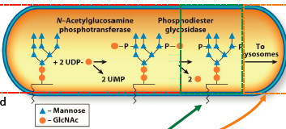
- M6P receptors mediate concentration of lysomal protesin into clathrin coated vesciles
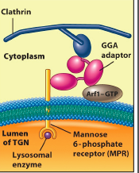
- Cytosolic face domain of M6P receptor binds to GGA adaptor goat protein
  - GGA proteins is linker in clatin coat assembly b;c of multiple binding domains

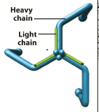
Clatrin coated vesciles: assembly at TGN, recruitment of GGA adaptor proteins from cytosol mediated by ARF 1 (GTP binding regulatory protein)
- ARF 1 GTP binds to TGN (ARF-GDP cytosolic) resulting in outward curvature of membrane
- GGA protein also binds rest of bescle coat clathrin (linked to MPR)
- Clathrin lattice assembly promotes further bending of membrane
  - Initially assemble to form hexigons and then swithch to pentagons when they need to curve more (driving force for membrane curvature)
- Release mediated by dynamin (large soluable GTP binding protein)
  - Recruited from cytosol to connection b/w clathring coated bud and TGN membrane
  - Polymerizes to form dynamin ring around stalk
  - GTP hydrolysis causes ring to twith and pinch off vescle
  - Y GTP (non hydrolysable GTP) cause dynamin ring t polymerization to continue, making extended stalk
- After pinching off vescle’s clathrin coat disassembles Arf1 GTp GDP (also GGA and triskelions)
- Nasent bescle targets and fuses with late endosome using specific Rabs and SNARES
- At late endosome, acidic interior casuses dissociated of M6P receptors from cargo proteins and they are recycled back from late endosome to TGN for another round
  - In late endo, there is stuff form PM and TGn going to lysosome
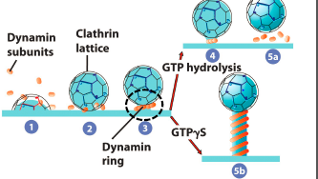
  - Early endo collects stuff from PM
- Clathrin: one molecule has three light chain polypeptides and three heavy chain polypeptides
  - Forms 3 leggeded triskelion that self assemble to form lattice of coat on growing vescle
  - Ly somal cargo protein concentrated into growing bud
- Lysosomal cargo protein portioned into portion of late endosomes that detaches (multivescular body (MVB) which allows degredation of PM material
  - Has unique morphology, has intraluminal vesicles formed by invagination of MVB membrane
  - Containts intralumen vesicles with PM derived materials destined for degradation in lysosme
- MVB fuses with lysosome, MVB membrane proteins move laterally into lyssomal membrane and all contents released into lumen
- Lysomal cargo protesin (soluable hydrolase enzymes active due to acidic PH)
- Intralumeinal vesicles with PM materials (receptors, degraded)

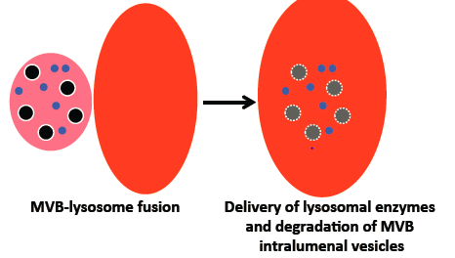
Endocytic pathway: opposite direction of ceretory pathway
- Materials move into cell via vesiculation of PM and either recycled back or transported to lysosome for degradation
- 2 main internailization processes
  - Endocytosis : selective interalizaiton of PM compoentns (receptors and bound ligands)
  - Phagocytosis: uptake of large particulate materials done by specialized cells

Endocytosis: 2 forms bulk phase (pinocytosis, nonspecific uptake of cellular fluids and Pm protein turnover) and receptor mediated
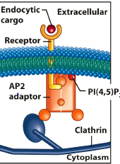
Receptor mediated: concentrating and internalizing specific extracellular ligsnad bound to receptors (involves clatinr coated vesciles, also PM protesin destined for turnover)
- Can include receptors on PM that binds hormones
- Turn of signals by internalizing receptors
- PM transmembrane receptors activated by binding to specific ligand
- Receptor ligand complex difuse laterally in PM and accumulate in coated pits (specialized regions where internalization takes place)
- Inner leafelt of PM at coated pits enriched with quine membrane phoslopid (PIP2) which signals recruiting cytosolic adaptor protein AP2 to pit
- AP2: soluable adaptor with multiple binding domains (PIP2- PI (4.5.)P2, cytosolic domain of recetor, clathrin)
- Similar to GGA adaptors at TGN, AP2 adaptors at cytolic face of inner layer of coat
- Clathrin triskeletons self assemble to form outer scaffolding
- Early endosome: responseible for sorting and recycling extracellular materials via endocytosis
- Acidic interior of early endosome cauess dissasociateion of transmembrane repetors with ligands and separated and concentrated into differen portions of endosome
- Recycling comparments detach and traffics back to PM (if protein damaged or not useful, will be kept in early endosome to be destroyed)
- Sorting compartment matures into late endosome, lowering pH from 6-5.5 using ATPase pumps
- Lower pH causes dissasoication oc M6P lysomal cargo protein
- Endycytoic cargo proteins concentrated into protion of late endosome that detaches (MVB)

MVB formation at late endosome: contain endycytic cargo and soluable cargo protein from TGN and has intraluminal vesciels from invaination of own boundries
- Fuses with lysosome and all MVB luenal material released into lumen of lysosome

Mitocondria

Origin of mitochondria, 2 theories
- Less domain: mitochondria evolved from ER (portion of ER came up)
  - However ER has only one membrane and mito has two
  - Also Mito has own DNA content
- Dominatn theory: endosymibotic relationship (mito was incorporated into cell, gave nucleus most DNA so cell can take care of protein synthesis)
Mitocondira morphology: essential and unique role in generating metabolic energy
- Mito: energy from carbohydrates and lipid catabolism
- Chloro: energy production and carbyodrate synthesis via photosynthesis
- Contains own DNA genome and codes for some factors involved in biogenesis and f’m
- Organelle biogenesis: includes protein targeting, membrane assmeblty, motility, replication, degradation, and inheritance during cell division
- Mito and chloro semi autonomous: religaction controlled by both the cell and oragenelle itself
- Mito and chloro arise only from pre-existing organs, do not for denovo unlike other organs
- Double membrane bound organelles (inner and outer membrane differ functionally and composition of lipd is and proteins)
  - Outer: permable to ions/small molecules (porins: barrel shaped integral membrane proteins with large internal channel)
  - Inner: adjacent to outer membrane, forsm folds that extends orgelle’s Surface area
    - Impermeable, maintains H graidesn, iste of ATP synthase
  - Matrix: aqueous interiros: sit eof TC cycle, ATP fomr oxidative phosphorylation
    - Contains mito genome (circular DNA) varies b/w species in size, copy #
    - Contains ribosomes for translation of genome encoded proteins
- Mito in different cell and tissue tyes have different shapes and sizes
- Forms mito network: higly branched, long interconnected series of tubules
- Bean shaped images of mito due to sectioning of single tubules of mito network
- Mito network allows for cell wide coordination of orgelle functioning and biogenesis
- Tubules are mobile and fuse with one another or split in response to stiuli, developmental statis, and energy requirements of cell
- Rate of fission vs fusion controsl number, size and interconnectsion f mito network
- Defects in mito network correlate with progression of numerous neurogenetive disesases

Mitocondrial dynamics: fusion and fission controlled by distinct porteib machinery
- Overactiviation of fis1 to slice mito in half causes a shift in balance, fusion can’t keep up so higly segmented mito network

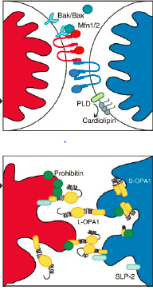
MItocondrial fusion: in reposne to cell stress (increased need for coordinated functioning)
- Outer membranes fuse then inner membrane, order essential to maintain mito comparments
- Step 1: outer membrane tethering, GTPase mitofuisn (Mfn 1 and 2) on adjacent mito link together 9dimerize) in GTP dependent manner to form organelle tethering complex
  - Integral outer membrane proteins both having long coiled protein protein interaction domain and cytosolic facing GTPase domain
  - Proper Mfn binding regulated by outer membrane proteins (Bax) that prevent them from binding to each other (circles)
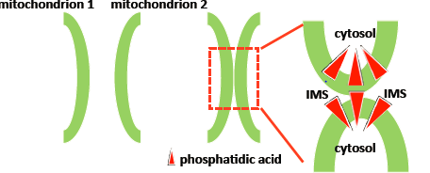
- Step 2: outer membrane fusion: formation of outer membrane lipid microdomains at tethering site
  - Phospholipid D ocnverts cardiolipin (lipid unique to outer membrane) into phosphadic acid (cone shaped lipid that causes outer membrane to curve inward , promoting fusion
- Step 3L inner membrane fusion mediated by OPA1 (integral inner membrane bound GTPase)
  - Has intrmembran epsace facing GTPase domain
  - OPA1 on adjacent inner membranes interact in GTP dependent manner to promote membrane fusion
  - Bidning regulated by other mito membrane proteins (prohibitin, ensures OPA1 fusion only occurs b’w different membranes and not within same one)

Mitochondrial fission
- Step1: assembly of Drp1 ring, Fis1 proteint hat binds outer membrane recrutie dto lipid microdomain that form at fusion scission site
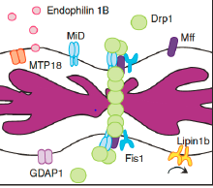
  - Fis1 in conjuction with MiD (mitocondiral dynamics proteins) and MFF mitochondrial fision proteins) recruit Drp1 (*dynamin related protein 1)
  - Drp forms rign around outer membrane
- Step 2L mitocondiral scission, Drp1 protein bound to GTp during ring formation and hydrolysis causes Drp 1 ring to constrict and scission to occur

Mitocondrial protein targeting : 3-4 different spots where it can end up
- Majority of mito proteins nuclear encoded, synthesized on free ribosomes, targeted post translationally to organelle (highly efficient)
- All mito proteins have unique targeting seq (specific set of AA) that mediate targeting form cytosol to mito and to specific mito subcomaprment
- Multiple mito targeting pathways that vary depending on protein’s final location
- Different pathways rely on different sub-mito targeting signals and shared/different import machinery
- Most matrix destined proteisn have AA targeting signal presequence on N terminus of ampihpahtic alpha helix with positively charged AA
- Pre sequence responsible for targeting matrix protein to cytosolic surface then to across membranes inner and outter
- Intermembrane space positively charged becase protons permable to outer membrane (not inner membrane though)

Matrix protein targeting and import
- Step 1: newly syntehsized protein recogniq=zed by cytosolic chaperones
  - Maintain nascent protein in unfolded import competent state (no secondary structure)
  - Nascent mito proteins enriched at mito surface b/c of mRNA localization and diffusion (mito cloud, mediated by cytoskeleton and RNA binding proteins on outer mito surface)
    - Unique seqences in mito mRNA untranslated reiongs can link to cytoskeleton, move to mito then bind to cytosolic domains of outer membrane proteins
    - Translation occurs close to mito surface allowing for spatial control of mito protein gene expression (facilitates fast protein targeting)
- Step 2: at surface of mito, matrix protein’s N terminal preqezence recogned by TOM (tranlocase of mito outer membrane) complex
  - Multiprotein complex consisting of integral membrane proteins
    - Receptor: binds to preseq (+ve charged)
    - Channel: barrel shaped mediating protein translocation across outer membrane
    - Accesory proteins: scaffold to mediate protein transfer (receptor channel)
- Step 3: matrix protein passed from TOM to TIM23 (translocase of mito inner membrane 3)
  - Multiprotein complex forming channel that allows protein to cross inner membrane
    - TOM and TIM are physically connected (intermembrane space facing domains interact with each other allowing translocation across both membranes sequentially)
  - Because more proteins in intermembrane space, mito membrane polarized so +ve charge preseq attracted to less +ve matrix
  - Other TIM complexes involve din different sub mito targeting pathway
    - Ex Tim 22 repsonsble for insertion and assembly of inner membrane proteins (transferred laterally from TIM 22 to lipid bilayer)
- Step 4: as matrix protein’s N termal preseq exits TIM23, binds to matrix localized mito chaperone (mtHSP70) which acts as moelecular motor
  - Undergoes ATP dependent conformational change that pulls protein into matrix and prevent sliding back into cyto
  - N terminal preseq cleaved by matrix loacalized protease
  - Mthsp70 and other cochaperones involved in proper folding of cleaved mature protein
    - If long poly peptide MPP will chop of preseq even if some of protein still in intermembrane space, this can cause backsliding
Mitocondria and parkinson’s disease: most causes of parkinsons have no cause but remaining cases are genetics, 3 of these genes relate to mito function (neurons highly metabolic)
- Healthy mito import PINK1 into intermembrane space via TOM
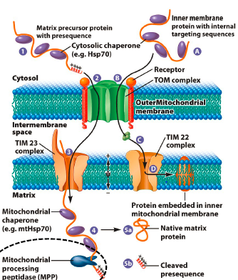
- Mito targeting sequence in PINk cleaved by MPP in matrix but remainder of PINK associated with inner membrane in inter membrane space (only targeting seq passed through TIM)
- PINK1 partilaly degraded by PARL1, integral inner membrane protease (not pulled all the way in matrix)
- Final degradation occurs via unkonw protease associated with either inner memtrane or intermembrane space
- Stressed of damaged mito are depoliarized where H= levels are equal in and out, PINK cannot pass through TOM and Tim bc needs H= gradient
  - Intermembrane space no longer depolarized
- PINk accumulates on outer membrane and reqcruite parkin
- Parkin (through mahy protein protein interactions) stimulates poly ubiquintation of outer membrane eproteins which signasl commencement of autophagy
- In Parkinsons disease caused by PINK1 or Parkin mutaitons, damaged mito not degraded via this pathway and accumulate in cell, impairing cell function and indues apoptosis
- Only dopaminergenic neruson dies because thye are ighly metabolic and sensitive to loss of energy source

Autophaghy: damaged mito and other organelles removed
- Damaged mito wrapped in phagophore (doule membrane structure that matures into autophagosome (orogin not known, may be from ER or other mito membrane)
- Autophagosome fuses with lysosome, making autolysosome
- Inner membrane of original phagophore along with mito degraded
- Residual body released into cyto of retained indefinitely as lipfuscin pigment granule

Chlororplasts and perioxisomes

Chloroplast: semiautonomous plant cell organells from photosynthetic cyanbacterium (dynamic)
- Other than photosynthesis, involved in other important metabolic processes (fatty acids, amion acid biosytnehsis, nitrogen and sulfur assimilation)
- Highly mobile in cells, move along cytoslekelvon via molecular motors
- Double bmembrane bound orgelle: outer membrane has porins but not as permeable as mito
  - Inner membrane space: highly impermeable, comtaining transporters (functionally distinct from outer membrane via protein an dlipid composition)
  - Protein import does not require positive charge like mito
- Thialkoid is the 3rd internal membrane system and they are flattened membrous disks arranged in stacks (grana thylakoids) or bw stacks (stroma thylakoids)
  - Thylakoid membrane is the site of ATP synthasis , miantina H= gradient in lumen
  - Thylakoid lumen: aqueos interior, high in H+
- Stroma: aqueous interior inside evnirovelope, outside thylakoids containing enzymes for carbyhydrate syshtesis and contains plastid genome
  - Circular, size and copy number varies b/w paltn species
  - Encordes ribo proteins, some P proteins, tRNA, rRNA and some RN polymerase subunits
  - Has ribosomes for translation
  - Others encoded by nuclear genomes
- Choroplasts connected via stromules that are stomra filled tubules that are highly dynamic
  - Allow for metabolite transfer, communication b/w chloroplast and other organeels

Chloroplast Protien Targetting
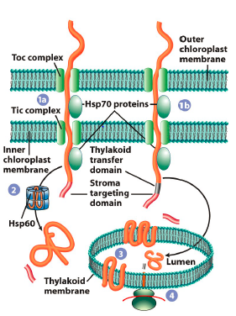
- Majority of chloro protein nuclear ncoded, synthesized on free ribo in cytosol and targeted psot translationally (efficient but complex process) because chloro has 6 subcomparments
  - Outer membrane, intermembane space, inner membrane, stroma, thalkoid membra,en thylakoid lumen
- Al chrloroplast proteins have unique targeting sequence of AA
- Many subchlrooplast targeting pathwyas depending on protein’s final location in chlror
  - Different pathways need different targeting sinals and import machinaries
- Import into stroma best understood process (most stomral destined proteisn have N terminal targeting signal-transit peptide)
- Transist peptide recognized by TOC complex ~TOM and binds to receptor ptoeins of complex in GTP dependent manner
- Partially unfolded stromal protein moves through TOC complex channel then through TIC compelx chanle ~TIM
- As stromal protein’s transit peptide exits TIC, stromal chaperone prtoien Hsp 93 drives translocation using rachet ~mtHsp70
- Unlike mito, protein translocation not mediate by electrochmiecal poteintial
- Transit pepetid cleaved by stromal processing enxyme and Hsp 60 ensures proper folding
- outer an dinner envelope membrane eprotines transferred laterlaly from TOC/TIC
- Most thylakoid proteins nuclear encoded and targeting in 2 steps
  - Step 1: imprt from stroma as seen above
  - Thyalioid transfer domain mediates protein import into lumen or insertion into membrane via unique thylakoid translocation compelxses
  - (maksed until stromal targeting domain once it is cleaved, unmaks thylakoid transfer domain that takes over)
  - Some encoded by chloroplast gene (synthesized on stomraal ribosome bound to surface of thylakoid and inerted into membrane stimultenously (cotranslational translocation)

Perioxisomes: Function and morphology
- Lipid metabolism and oxidation of fatty acids and amino acids
- Neturalization of free radicals that produce large amoutns of toxic H2O2 that is converted into water and oxygen
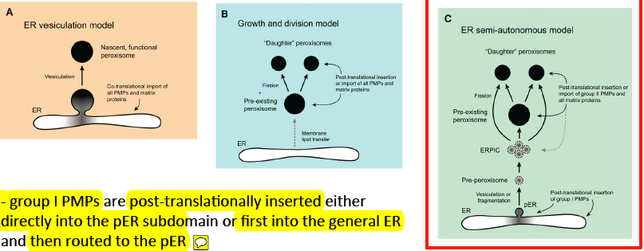
- Ctystaline core: location of urate oxidase that actalizes rxn of uric acid to allatonin in most mamals but in humasn sand certain primate, this has been lost (uric acid buildup leads to gout)
  - We have genes for it just not expressed (stranscription start site may be mutated)
Perioxisome biogenesis
- PMPs are post translationally inserted either intp pER subdomain of rist into general ER ten routed to PER
- All matrix proetins and group 2 PMPs are sorted psot translationally from cytosol to daughter perosixomes and perexisting perosiximes
- Model A: everything functioning in peroxisome from concentrated an dinserte dinto Er then buds off into peroxisome
- Model B: Disocevered peroxisomes that can divide, same event happens with ER but when cells need more, periosiomes can divide (like mitochondrial fission)
- Model C: Some protein elements embedded in Er, bud outm pre preosisomes accumulate in ERPIC that fuse to form mature peroxisome sthat can then mature and divide

Protein targeting: FOLDED INSTEAD OF UNFOLDED in mito and chloro
- Cytosolic PEX 5 and Y recoginze cargo and bind specific targeting seq PTS1 and 2
- Caro loaded PEX 5 associates with membrane via interaction with PEX 13 and 14 (PEX 7 cannot dock to membrane eon it’s own)
- PTS1 and 2 bound cargo released into matrix, receptors recycled back into cytosol via mechanism that requires ATP dependent upbiquination of PEX 5 by PEX 4 and RING compex (PEX 2, PEX 10, PEX 12)
- Ubiquinated PEX% removed from membrane via action of ATPase PEX1 and 1 that are tethered by APEM(
- PEX 7 route unknown

