Psychology Lecture Notes

Lecture 6 –
Inferential Statistics: allows us to determine whether differences between groups or levels of the independent variable are “real’ and “big enough” differences. This is important as possible that

Validity of Research: how well a experiment actually tests what it’s supposed to test
Internal: degree to which experiment support clear, causal conclusions
External: degree to which experiments can be generalized to other populations

Threats to Internal Validity
- Confounding variables: variables that are intertwined with the internal validity, prevents us from knowing whether it was the IV or confounding variable that actually causes the effect
- Third Variable Effect: both variables are related to a third variable
- Placebo: a substance that has no pharmacological effect
- Experimenter Expectancy: experimenter should be blind too

Chapter 3 – The Brain
Brain: 2 parts
- Neurons (3 types): sends and receives signals
- Sensory neurons: detect and send signals
- Interneurons: processes info from other neurons and passes them along
- Motor neurons: carry signal to muscles
- Glial cells: supports the neurons
Neuron Structure:
3 main components
- Dendrites: receives messages from other neurons; the little string like things on the egg side
- Cell body: the egg part that processes info
- Axon: the stringy part where electric signals are passed along
Glial Cells (nurse cells):
- Surround the neuros and takes care of them
- The brain contains 10x as many of these as neurons
- Feed them
- Protection
- Guide the neurons to the right place
- These make up the myelin sheath (the fat that allows the signal to travel faster)
- Forms the blood brain barrier, prevents toxins from coming in by surrounding the blood vessels
- May also alter how many neurotransmitters that’s released or regulates how sensitive a neuron is to neurotransmitters

September 29, 2014

Electrical Activity of Neurons
Like all cells, cells have cell membranes that contain channel proteins that allow ions to flow in and out.
These allow sodium and potassium to flow through, sodium in, potassium out.

Resting Potential
This is when the neuron is at rest. This is when they have built up a charge and is ready to fire. When a signal comes, 3 sodium ions leave, 2 potassium flow in via each sodium potassium pump. This results in a negative charge inside compared to the positive charge on the outside.
When one side of the neuron is differently charged, the neuron is said to be polarized. The difference is about –70 mV. The sodium and potassium wants to balance itself out through diffusion, but the channels are closed.

Action Potential
The depolarization of the cell occurs when the channels open and the electrical difference becomes +40 mV.

The Steps
- Rest potential
- First sodium channel opens
- Sodium rushing into the cell (depolarization)
- Sodium channels close and potassium channels open
- Electrical gradient re-established, but ions are on the opposite side from the origin

Terms to Know:
- Polarized
- Depolarized
- Repolarization
- Hyper-polarization

Behaviours of Neurons
All of Nothing Principle:
Action potentials always at the same intensity or not at all. Threshold of -50mV must be meet for it to fire
Several potentials can add up to meet the threshold.
Myelin Sheath:
This allows the signal to jump from one Node of Ranvier instead of signal passing from adjacent pump to pump

How Neurons Communicate
Synapses: neurons don’t ever touch each other
Neurotransmitters are what the neurons use to transmit specific signals to the next neuron

5 Step Process
- Synthesis: making of neurotransmitters
- Store: stored in synaptic vesicles
- Release: the action potential releases neurotransmitters
- Binding: neurotransmitters binds to adjacent neuron, starting the next action potential
- Deactivation: neurotransmitters are pulled apart, ending signal

Excitation and Inhibition
Excitation: some neurotransmitters make the post-synaptic neuron more likely to fire
Inhibitory: some neurotransmitters make the post-synaptic neuron less likely to fire. This is done by making the inside more negative
Both: the type of receptors determines the kind of neurotransmitter

Deactivation
2 parts
- Enzymes break down neurotransmitters, even if its bound
- Reuptake: pre-synaptic neuron re-absorbs the neurotransmitter

Neurotransmitters
There are over 100 types of neurotransmitter. Different parts of the brain have different amounts of receptors

6 Types of Neurotransmitters:

Neurotransmitter | Type | Involved In | Too much causes | Too Little Causes
Glutamate | Excitatory | Learning and memory | Seizures
Acetylcholine | Excitatory | Muscle movement & memory | Convulsions | Alzheimer’s disease
Dopamine | Both | Reward, pleasure, voluntary motor control, control of thoughts | Schizophrenia | Parkinson’s disease
GABA | Inhibitory | Motor control & lowering anxiety | Inhibits brain function (like being drunk) | Huntington’s disease; tremors
Serotonin | Inhibitory | Mood, pleasure |  | depression
Endorphins | inhibitory | Inhibit pain | Insensitive to pain | Hyper sensitive to pain

Drugs
Most drugs increase or decrease the actions of neurotransmitters

- Agonist: increases the activity of a neurotransmitter by adding more
- Antagonist: decrease the activity by removing or storing more
- Neuromodulators: increase of decrease sensitivity of neurons to neurotransmitter
Some neurotransmitters and glial cells themselves are neuromodulators

The Nervous System
Split into two categories which are then split into more.
- Peripheral Nervous System: functions to transmit info to and from CNS
- Autonomic nervous system: controls glands and smooth muscles. The two subdivisions work together to maintain homeostasis
- Sympathetic division: prepares body to react; fight or flight response
- Parasympathetic division: calms body down
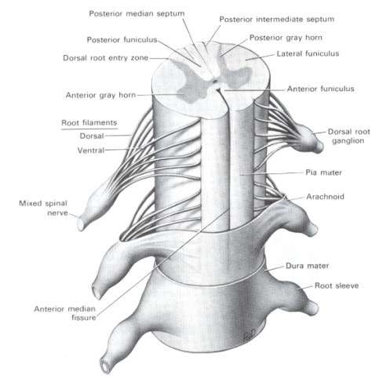
- Somatic nervous system: controls of skeletal muscles
- Central Nervous System
- Brain: info processing
- Spinal Cord: info pathways connecting CNS to PNS
The H shaped gray area is made up of neuron’s cell bodies. White area is made of myelinated axons
Spinal Reflexes: these signals are processed at the spinal cord without involving the brain at all.
Reflex Loop
- Receptor
- Signal to spine via sensory neurons
- Interneuron
- Signal back to motor neurons
- Reflex triggered

How the brain is studied
4 methods:
- Neuropsychological Tests: measures verbal and non-verbal behaviours known to be affected by specific types of brain damage. Scores can tell you type and severity of damage
- Destruction and Stimulation:
- Destruction: experimental method (usually in animals, only human case studies can be used)
- Ablation: removes a part of the brain
- Lesions: damage in specific area
- Stimulation: using low electric current to stimulate specific brain area
- Electrical Recording: uses electrodes to measure electrical activity in the brain
- EEG: measures activity of groups of neurons. Measures changes as well, good for ongoing activity
- Brain imaging
- Computerized Axial Tomography (CT Scans): power xray, taking narrow slices of the brain and putting them together to give 3D picture of brain
- Magnetic Resonance Imaging (MRI): magnetic field aligns molecules, all the polar molecules align then drops when it turns off
- Positron Emission Tomography (PET): glucose is used as energy for brain, radioactive glucose is used to see which parts of the brain is most active
- Functional Magnetic Resonance Imaging (fMRI): measures which areas of the brain are using oxygen in real time

October 1, 2014

The Hierarchical Brain
3 hierarchical divisions of the brain going from the simplest to the most complex
- Hindbrain (oldest)
This is the stalk at the end of the spinal cord
Three parts of hind brain we’re interested in
- Medulla:
- heart rate and respiration
- this is also where motor and sensory nerve tracts cross to the opposite side
- Pons:
- sleeping,
- walking,
- respiration,
- bridge between the higher and lower levels of the brain.
- Cerebellum:
- movement and balance.
- Does not initiate movement, but helps to coordinate the timing of muscles.
- Also known as the little brain. Involved in certain types of learning and memory.
- Midbrain:
Connects higher and lower parts of the NS. Relays info about visual and auditory info to the forebrain. Involved in eye movements
- Reticular Formation:
- Extends through hindbrain through to the forebrain.
- Involved in sleep/wake cycles.
- Gate keeper of attention, selectively chooses via input from forebrain about what to pay attention to
- Forebrain (newest and the outmost) (AKA cerebrum)
This is what distinguishes humans from other animals, made of 2 halves.
Made up of five sections
- Thalamus:
- relay station for sensory input
- Basal Ganglia:
- initiating voluntary movement
- Parkinson’s disease is when this fails
- Hypothalamus:
- connects to the pituitary gland to control hormones
- controls biological urges
- pleasure
- Limbic System: three parts
Gives us urges, and limbic system satisfies.
Organizes behaviour into 4 F’s
- Fleeing
- Fighting
- Fucking
- Feeding
- Nucleus Accumbens: reward and motivation, sex, drugs and favorite foods activate this area
- Amygdala: emotional response; mainly aggression and fear. Can produce emotions with higher brain areas knowing
- Hippocampus: forming and retrieving memories. Damage means one cant form long term memories. Critical to processing spatial info (ex. Navigation)
- Cerebral Cortex:
The think wrinkly layer on the outside of brain, making of grey (unmyelinated) neurons. This part of the brain contains 80% of neurons in the entire brain.
The brain has the same folds, based on these, we can divide the brain into anatomical regions
- Longitudinal fissure: divides the brain into hemispheres
- Central sulcus: front and back portions
- Lateral fissure: upper and lower portion

Cerebral Cortex Regions
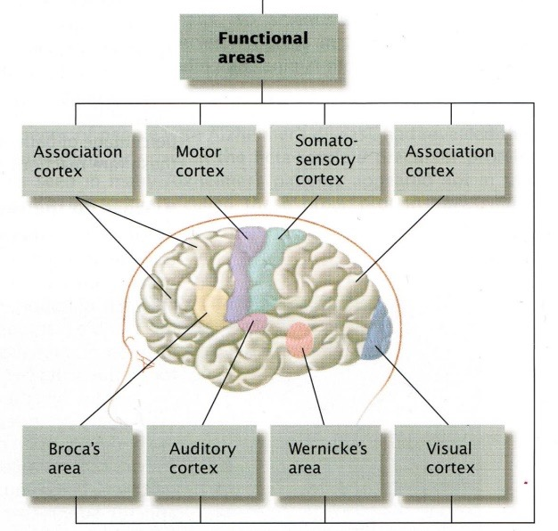
The regions of the cerebral cortex can be defined by what they do.
4 Major Regions
- Occiptal Lobe
Primpary visual cortex is here, visual signals go here. The visual signal then heads to the parietal and temporal.
- Temporal Lobe:
Auditory cortex is here, the auditory signal goes here first.
- Parietal Lobe:
Contains the somatosensory cortex, detects sense of touch, temperature and pain.
- Frontal Lobe
Contains the motor cortex, controls all voluntary movement. The more complex a body region is, the more cortex devoted. This cortex mirror the somatosensory cortex, motor is in front of the central sulcus, and sensory is behind.

Inolved in:
- speech production
- voluntary movement
- any higher function activity
- planning
-emotion
-self awareness
-responsibility
Damage lose ability to plan ahead
lose emotional ability
Prefrontal Cortex:
The area at the very front of the frontal lobe that plans ahead; goals, plans, judges situation

Association cortex:
Areas not directly involved in a specific area that is found in all four lobes and assists in higher mental processes, helps to combine multiple types of sensory info.

Language
Broca’s Area: found in frontal lobe, responsible for speech production; articulation.
Damage difficulty speaking, damage does not affect speech comprehension
Wernicke’s area: found in temporal lobe, comprehends language.
Damage babbling, damage does not affect speech production

The Association Cortex is also involved in aspects of language
Verb Impairment: difficulty with verbs, not nouns
Foreign Accent Syndrome

October 6, 2014
Right brain vs Left brain
Two hemispheres in our brain connected by the corpus callosum, the somatosensory and motor signals are crossed in the brain

Lateralization
Some mental processes use more of one side of the brain than the other

Left side of the brain is more focused on language and comprehension
Right side is focused more on the arts

Cortical interference:

Brain Plasticity
The ability of neurons to change structure and function in order to adapt to new stimulus, brain damage.
Surviving neurons try to form new connections to stay alive, after brain damage, surviving brain cells reorganize

October 8th, 2014

Chapter 4 – Genes, Evolution and Behaviour

Genes:
These are sections of DNA that contain the instructions for building proteins in our body
We have 23 pairs of chromosomes, 23 from each parent

There are multiple copies of a gene called alleles, for each gene, some are dominant and some are recessive

Genotype: the genetic makeup of the individual

Phenotype: observable characteristics. People with different genotypes can have the same phenotype. Due to genes and environment
Polygenic Transmission: most traits aren’t determined by a single gene, many genes combine to determine the end result of the phenotypic trait.

Mapping and Engineering Genes

Recombinant DNA Procedure:
Use enzymes to cut out a piece of DNA from one organism and insert it into the DNA of another. Typically, human genes are inserted into bacteria as they built bacterial cells reproduce very quickly, making many identical copies and can quickly manufacture proteins that are normally produced by the human body.

Gene Knockout Procedure:
A specific gene is altered to prevent it from carrying out its function. However, because many traits are determined by a combination of genes.

Behavioural Genetics
The idea behind this is: how much is due to genetics and how much to the environment

Heritability Coefficient
This means the extent to which a variation of a trait is accounted for by variation in their genes
Ex. height, how much is due to difference in genes as opposed to environmental factors?

This coefficient only tells us about the variability of a trait within a group of people, cannot be generalized for other groups

Techniques in Behavioural Genetics

Breeding:
Animals can be selectively bred for certain characteristics, including both physical and psychological
Certain behaviour or psychological traits have a genetic component. When selectively breeding for oen trait, it can lead to many unselected traits as well

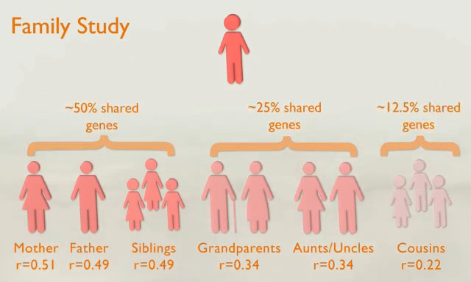
Concordance Rates:
Meaning the likelihood that two people share a given trait

Adoption Studies:
These make for very important studies as the adoptive kid share 0% of their DNA with their adoptive parents. So this is the perfect time to test nature vs nurture

Genes and environment can combine to produce behaviours

Twin Studies:
Ideal for studying concordance studies as they share 100% of their DNA.
Some of the best study:
- identical twins raised together
- identical twins raised apart
- fraternal twins raised together

Nature and Nurture

Intelligence
If intelligence was purely genetic, identical twins should have identical IQs, fraternal twins would have less intelligence than identical and should be no more similar than non-twin siblings
In general, more genes shared, more similar. But intelligence is determined by a combination of both environment and genes.

Reaction Range:
Genes determine the upper and lower limits for a person, while environment determines where they’ll fall

Personality
Twin studies have shown evidence for genetic components to personality, beliefs and attitudes. Including things such as: personality, political interest, reading books, sports, roller coasters

October 15, 2014

Evolutionary Psychology
Many genes have a genetic basis (including height, weight, eye color and IQ)
The popularity of a particular trait (gene), also known as frequency is determined by the mechanism of evolution; natural selection

Mutations: random mistakes in gene copying and through meiosis.
Natural Selection: this mechanism selects individuals who have the highest fitness to pass on their traits. Traits that increase survival/reproduction are more likely to be passed onto the offspring.

The goal of evolution is all about passing genes onto the next generation:

Fitness: how successful an organism is at passing on their genes into following generations
3 tasks related to fitness:
- survival
- mate-finding
- reproduction
This is how evolution happens, natural selection selects the traits it favours. Traits that increase fitness are more likely to be passed onto their offspring, these are called adaptation
Types of Adaptations:
- Maladaptive traits: less likely to be passed on
- Neutral traits: no effect
- Adaptation: the most likely to be passed on
If the environment changes, different changes can become adaptive
Evolutionary psychology also looks at psychological traits and behaviours as adaptations

Assumptions of Evolutionary Psychology:
- Certain psychological traits/behaviours are inherited
- In the past, certain psychological traits/behaviours were more adaptive than others
- The traits/behaviours that we currently see are the product of past selection pressures

Evolution and Parental Investment
The definition of fitness also includes whether our children survive and reproduce

2 Reproductive Strategies
- Quantity
- Quality: small number of kids that you heavily invest in
Parental investment: the amount of effort and risk associated with caring successfully for offspring, including everything from conception onwards
Different species have different levels of investment as well as there is a difference between genders

Triver’ Parental Investment Theory
- Sex differences in reproductive potential leading to different parental investment strategies being selected for:
- Low reproductive potential – higher parental investment
- High reproductive potential – lower parental investment
In many species, females have a lower “reproductive potential”: how many offspring an individual can produce per unit of time
- Sex differences in reproductive potential/parental investment lead to differences in “choosiness”
- The female, if she is going to put in a lot of investment is going to want the best possible genetic material for her offspring
Intra-sexual competition; direct competition between members of the same gender for limited mating opportunities
Inter-sexual competition; competition for attention, still between members of the same sex
- Sex differences in “choosiness” lead to sexual dimorphism
- Both types of competition lead to sexual dimorphism
- Intra-sexual competition: leads to larger stronger males
- Inter-sexual competition: brighter colors, more elaborate ornamentation and mating rituals
Reproductive potential parental investment strategies choosiness competition sexual dimorphism

Mating Systems
- Polygyny: many females mate with one male
- Polyandry: many males with one female
- Monogamy: one with one
- Polygynandry: many with many
Human Mate Preferences:
- Mutual attraction
- Dependability
- Emotional stability & emotional maturity
- Pleasing disposition
- Education/health/sociability
Males: emphasis on physical attractiveness
Females: emphasis no earning potential, social status and ambition

Cooperation
Both individuals gain some advantage
Altruism
The person helping risks potential harm

2 Theories of Altruism:
- Kin selection
- Helping relatives who share genes with you also helps spread your genes (indirect fitness)
- Natural selection favours those who behave altruistically towards their kin
- Hamilton’s Law: rB > C r = relatedness b=benefit c=cost
This theory says that altruism is more likely between relatives, and is more likely when cost is low
Spiteful behaviour can occur if there’s a negative relatedness coefficient
- Reciprocal altruism
- Essentially karma
- Treats altruism as long term cooperation
- Also works the other way around, if one didn’t help another, the other will remember that
- Reputation can develop (ex. develop rep as a helpful person)

Aggression
The competition for mates, food leads to aggression. This has developed as a way of protecting access to important resources.
Controlled aggression is adaptive
Some species have a dominance hierarchy due to aggression

Dominance Hierarchies
Because direct competition may lead to injury in both parties, many animals have developed better memory; remembering past fights and giving up

Coalitions (cooperative aggression)
Coalitions attack other members of the species as a group

Personality

Evolutionary Personality Theory
Views dimensions of personality as adaptations
The Big 5 Personality Dimensions
- Extraversion
- Emotional stability
- Conscientiousness
- Agreeableness
- Openness to experience

Fallacies
- Genetic Determinism
Idea that genes have invariant and unavoidable effects that cannot be altered (ex. genes destiny)
- Social Darwinism
Survival of the fittest (ex. upper class people are there because of genetic superiority, lower class is like animals, so it’s okay to suppress them)
- Nature’s Plan
Idea that if something is found in nature, it’s somehow moral or right (cheating, rape)

October 20th, 2014
Transduction
The process of converting a physical stimulus is converted into an action potential that is sent to the CNS where the signals are given meaning.
This process applies to all senses

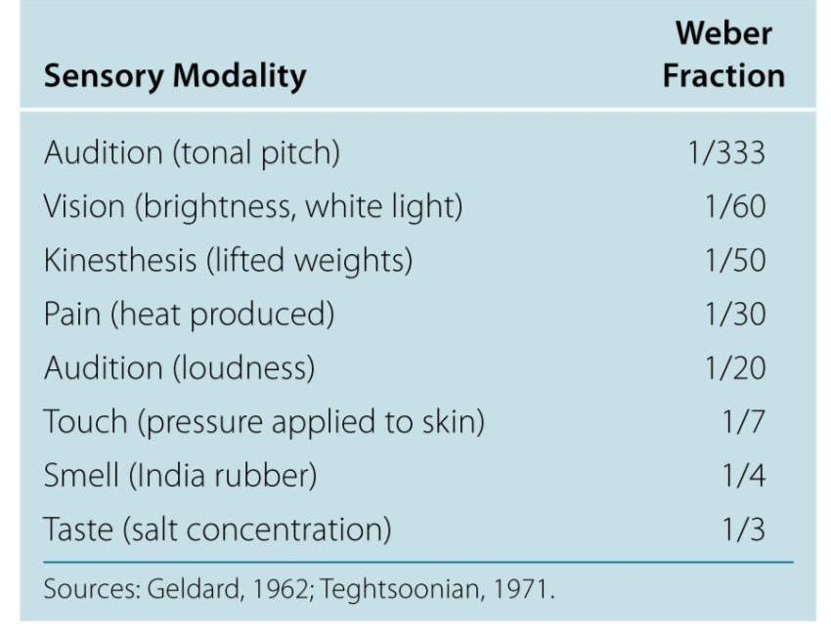
Psychophysics
The study of how physical stimuli is translated into psychological experiences
There are 3 subjects that this subject studies:
- Absolute Threshold
The lowest intensity necessary for a stimulus to be detected 50% of the time. The lower the threshold, the more sensitive.
- Difference Threshold (Just-Noticeable Difference)
The smallest difference between two stimuli that people can detect 50% of the time.
Weber’s Law: size of difference is inversely proportional to the magnitude of the 1st stimulus. In other words, as stimuli get more intense, difference must also increase for us to perceive it

- Magnitude Estimation
Constant increase in stimulus intensity produce smaller and smaller increase in the perception of intensity
Signal Detection Theory: detecting stimuli involves not only perception but also decision making.
Other influences other than stimulus influence decision making; personality, fatigue, rewards.
According to this theory, there is no fixed level of sensitivity.

Perception Outside Awareness
Subliminal Perception: registering sensory input without conscious awareness
Whether these ads affect consumer behaviour is still ambiguous. However, it is known that subliminal effects emotions do exist

Visual Agnosia: inability to identify object visually
Prosopagnosia: subtype of visual agnosia where patients are unable to recognize faces. However in both cases, visual receptors are intact

Facial recognition involves multiple brain areas,
- Fusiform Face Area
- Lateral Occipital Area

Sensory Adaptation vs Habituation
Sensory Adaptation: gradual decline in sensitivity to a stimulus over prolonged stimulation
Habituation: decreased response to a repeated stimulus, this is a result of the learning processes in the CNS, not the sensory neurons
All senses with the exception of pain adapt to help us concentrate on what’s important (ie. Things that are new and different). This occurs at the neuronal level, this happens in our vision all the time, our eyes are constantly moving to look at something new and different and taking it in.
Experiment: Pritchard (1961):
Attached a projector to contact lenses worn by a participant so they would always see the image. Participants reported image fading/reappearing as a result of visual sensory adaptation.

The Visual System

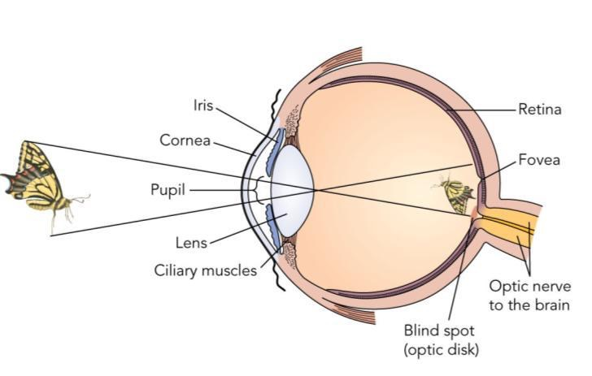
Vision:
The sensory stimulus is light. Only a portion of the electromagnetic spectrum is visible to us.

Basic Anatomy
- Cornea: Protective bump at the front of the eye that helps focus light (about 80%) onto retina
- Pupil: a opening that allows a certain amount of light into the eye controlled by constriction or dilation.
- Lens: elastic, crystalline structure that also helps focus light. The purpose of the lens is to focus light precisely where its needed by changing shape in order to focus light from different distances by becoming thinner or thicker.
To view distant objects, the ciliary muscles relax and the lens flatten and thin to minimize the bending of light
To view nearby objects, the ciliary muscles contract and the lens becomes more rounded. The point at which the image of a close object becomes blurred is called the near point of vision.
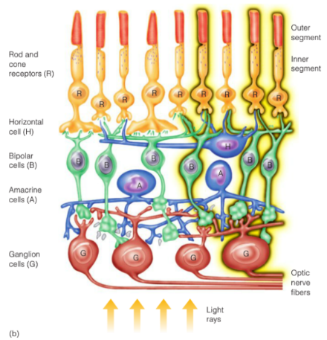
- Retina: the multi-layered structure at the back of the eye that sends signals to the brain
- Photoreceptors (rods/cones)
- Cones: color vision, low sensitivity to light, fast recovery and lower numbers in eye, high resolution
- Rods: no color vision, used in low light.
- Horizontal cells
- Bipolar Cells
- Amacrine cells
- Ganglion cells (these cell axons = optic nerve)
The light passes through all of the retina to reach the photoreceptors at the back of the eye. The signal then goes through the layers to the ganglion cells to the brain
- Fovea: small area in the center of the retina where the majority of vision is involved. This is the highest density of photoreceptors, only cones will be here.
- Blind Spot: ganglion cell axons make up the optic nerve. There are no receptors there but brain fills in the missing info using the surrounding area

Visual Transduction
Rods and cones have different photo-pigments; proteins that change shape when they absorb light. This changing of light causes sodium channels to open, releasing an action potential which releases neurotransmitter
Over time, these photo pigments change back to original shape; 10 min for cones, 20 min for rods
Dark Adaptation: in bright light, a portion of photo-pigments are used up any given time. In a dark environment, the likelihood of a proton hitting a ready photopigment is much higher.
This is a not a smooth increase in sensitivity over time, due to the difference between rods and cones; rods are very sensitive to light but takes longer to regenerate, while cones are less sensitive but faster

Properties of Color
Vision is the conversion of light waves into electrical signals
Frequency: color
Amplitude: brightness

Color Mixing: mixing light is different than mixing paint. Some combination of these light can produce any hue in the visible spectrum

Theories of Color Vision
- Young Helmholtz Trichromatic Theory: we have three types of cones, each more responsive to a either blue, green or red. Each sends signals to the brain depending on how much it is activated by a given wavelength. The visual cortex could then add up the inputs and figure out the original color. Flaw is that yellow is supposed to be based on red and green input, however, people with red green color blindness can still see yellow
- Opponent Process Theory: thought that each cone responded to 2 opposite colors (red/green, blue/yellow, black/white).
- Dual Process Theory: cones are sensitive to blue, green and red. Opposite process do occur, just not at the level of cones. Sends it to ganglion cells and cells in the visual cortex

Problems
- Myopia (nearsightedness): eyeball too long and lens focus light in front of the retina
- Hyperopia (farsightedness): eyeball too short and lens focuses light behind the retina
- Color Blindness: most people have 3 types of cones, but some people have only 2 kinds

Bottom up and Top Down Theories of Perception
Bottom up Perception: basic individual sensory signals are combined to produce a unified perception. The patterns of neuron firing combine in order to build complex signals
Visual Pathway to Brain:
optic nerve thalamus primary visual cortex

Topographic Organization
The retinal cells activate cortical cells in the primary visual cortex
The magnification of different scenes are distorted as more of the visual cortex is dedica
ted to the fovea

In the visual cortex, ganglion cell signals are combined.
Feature detectors cells fire more for a certain line or line of a specific angle. These cells give what you’re seeing meaning, the brain uses these cells to make assumptions

Parallel Processing of Features:
Many types of feature detectors that see their own map; color, brightness, shape, distance, movement.. so on
All these maps are processed in parallel to give vision
Visual Association Cortex: this is important for action with an object
- Object Perception (ventral stream)
- Dorsal Stream (action with object)

The visual signal (the pattern of receptors detecting light) primary visual cortex complex vision (detection of lines and colors) put together for picture

Feature Detection Theories:
States that object recognition is all about recognizing patterns of specific features
- The Pandemonium Model:
The feature detectors receive and export signals, the receptors reports what they see as components, cognitive cells then processes these signals from the feature cells and then processes the info to understand the scene
- The Recognition by Components (RBC) Model:
Says that there are volumetric shape which make up all real world object.

The Componential Recovery
As long as we can tell the relative size and placement of the geons, we can recognize it

Problems with Bottom Up
Perception is more than just patterns of receptors firing, other factors include; context, attention, organization and structure
Experiment: S Palmer: asked participants to name line drawn objects and showed them a picture of a scene (context)
People’s reaction were quick when they knew the context
Follow up studies showed that when asked to draw the object they saw, participants drew what looked more like what they perceived

The Top – Down Perception:
Expectations about the world influences how you perceive the world
Existing knowledge, ideas, or expectations about the whole affect how we interpret sensory input
Hypothesis (what is important) (what am I likely to see) examine features to confirm (compare what I actually see against what I expect to see) recognize stimulus or whole
- Organization/Structure:
Gestalt psychologist says that the whole is greater than the sum of its parts. Assumes that the real world tends to be relatively predictable.
Our knowledge of the physical laws of the world influences perception
Identified many “laws” of perceptual organization
- Law of continuity: points that when linked together, would make a straight or smoothly curved continuous line is seen as belonging together
- Law of similarity: similar things tend to be grouped together
- Law of proximity: elements that are near one another tend to be perceived as going together
- Law of closure: tend to close edges or fill in gaps in an incomplete figure to make it more complete
- Law of figure vs ground: tend to perceive figures I the fore group on top of a continuous background
- Law of meaningfulness or familiarity: tend to perceive things in terms of meaningful or familiar groupings
- Principle of Pragnanz: tend to perceive things in which the structure is as simple as possible
Suggests that perceptions are based on unconscious assumptions about the world. We perceive objects that are most likely to have produced that pattern of stimulation. Perception involves heuristics; rule of thumb that often works to solve a problem, but not always

- Context
The context which something appears often guides how we will perceive it; expectations are formed
Perceptual Set: a readiness to perceive things a certain way. This primes a specific perceptual schema where we compare
Perceptual Constancies: tendency to experience the same stable perception despite changes in sensory input
- Size constancy: size perception is not determined solely by the size of image on the retina, the object is always perceived as constant, even across different distances
- Brightness Constancy: lightness of an object is general perceived as constant, even across different lighting conditions. Perception of brightness is not determined solely by the amount of light reflected
- Shape constancy: shape perception is not determined solely by the receptor firing. The shape of the object is perceived as constant, even across different viewpoints
- Color Constancy: object color is not determined solely by the wavelength of light reflected from its surface, the color of an object is perceived as constant across different lighting conditions despite different colors of lights will affect the wavelengths of light that are reflected back. No matter the lighting conditions, color remains generally consistent
- Attention:
This is failure to register unattended stimuli in consciousness
Factors that grab attention:
- Intensity (loud sounds)
- Strange (plane flies into room)
- Movement
- Personal interest
- Evolutionary relevant stimuli

Bottom Up & Top Down
The best theory of perception is both

October 29, 2014
The retina is like a projector screen as light is projected onto it. But, its still only in 2D, so how is perception is 3D?
- Monocular Depth Cues
The difference between monocular and binocular is: if we use them in drawings and paintings, they are monocular
- Linear perspective: parallel lines converge into the distance
- Texture/clarity: texture appears finer in the distance
- Clarity: distance objects less clear
- Interposition: objects in front cut off parts of objects behind
- Height in horizontal plane: near objects tend to be lower on the horizontal plane
- Relative size: further objects take up less space than equally sized objects
- Light and Shadow: gives sense of depth
- Motion Parallax: nearby objects seem to zip past while far away ones seem to slowly move with us
which of the monocular cues isn’t a picture one, this is this one
- Binocular Depth Cues
- Convergence: to focus on an object, both eyes must be pointed towards it, the muscles give feedback about how crossed our eyes are and how close they are
- Binocular Disparity:
Each eye sees a different image of the world
Predators have eyes in front of them (stereoscopic), prey have better peripheral vision
- Two cues to perceiving movement:
Motion is due to actual movement, or the object is moving relative to the background
i. primary cue: motion across retina
ii. motion relative to background: the object is moving relative to the background
- Stroboscopic movement: illusion of movement caused by a light flashing on at one position, then another light turns on in a different position

November 3rd, 2014

Audition
Hearing is made up of sound waves which gets turned into electrical signals through our ears.
Properties of waves:
Frequency, which is how many cycles of the wave pass through a certain point in a second. The frequency determines the pitch.
The amplitude is the loudness and is measured in decibels using a log scale.

Structure of the Ear:
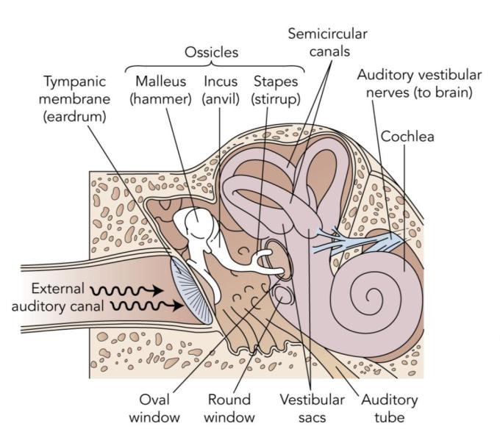

Steps in Hearing
Common exam question – what is the smallest bone in the human body? stapes
- Vibration in air molecules
- Makes the ear drum vibrate
- Vibration of tiny bones (malleus, incus, stapes) amplify the vibrations more than 30x
- Vibration reaches the oval window
- Which ultimately goes through the cochlea
- Makes waves in the cochlear fluid
- Bends the auditory hair cells causing receptors to fire
- Auditory cortex in the brain processes stimuli

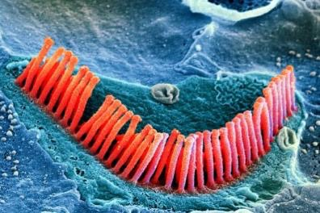
Cochlea:
This is a spiral shaped coil that is filled with fluid. The Organ of Corti rests on top of Basilar Membrane on the bottom of the cochlea. This Organ of Corti contains 16 000 receptors (auditory hair cells)
This is actually 2 pieces of carpet on top of each other. The top carpet (organ of corti) can bunch up when hearing sound and the bottom (basilar membrane) always stays straight. Sound ripples between these two

Hearing Loss
- Conduction deafness:
Any type of deafness caused by damage to the physical system (ex. ear drum). Treatable
- Nerve deafness:
Any type of damage involving neurons. Untreatable

Loudness & Pitch

Loudness
Louder sounds causes more bending of hair cells, which equals higher rates of neuron firing. Some neurons only fire if the hair cell is heavily bent. So loudness is coded by both the firing rate and which specific cells are sending siganals
Pitch
- Frequency theory:
Since sound waves have a certain frequency, maybe nerve hair cells fire at the same frequency. However, neurons can only fire so fast, and there’s a refractory period
- Place theory:
Waves in the cochlear fluid peak at different points depending on the frequency, so high frequency sounds peak early while low peak later.
Both theories are partially correct, frequency applies to sounds with lower frequencies while place theory applies to sounds with higher frequencies. So pitch is coded both by firing rate and the specific cells are sending signals

Sound localization
To determine where the sound is coming from depends on:
- Differences in timing between the years
- Difference in loudness between the ears

Chemical Senses
Taste & smell are called the chemical senses as they respond to chemicals, but not energy. These two are very intertwined
Taste:
Taste buds contain receptors, there are several receptors per taste bud. Mostly 1-2 types of receptors per bud
There are 4 types of receptor: sweet, sour, salty and bitter. And all tastes are a combination of these. Evolutionally, humans have an innate preference for sweet and aversion for bitter.
Umami enhances sensitivity to other tastes

Olfaction (Smell)
This is not a very well understood sense.
Guesses in steps for how smells work:
- Individual receptors for unique smells?
- Receptors like neurotransmitter binding sites
- Receptors send signals to olfactory bulb in the forebrain with specific smells activate specific parts of the bulb

Pheromones:
These are chemical signals found in natural body scents.
There’s a debate on whether humans have pheromones; unclear
Menstrual Synchrony: this is when close friend’s periods are more in synch

Sexual Pheromones:
Mass marketed ones are frauds, but certain smells do increase arousal (aphrodisiacs).
The sweaty t-shirt study showed that women were more attracted to the smell of men who had different deleterious alleles, in other words, less genetically similar to themselves

Skin & Body Senses
Tactile Senses:
We have different receptors that respond to 4 tactile sensations
- Pressure
- Pain
- Warmth
- Cold
Combinations of these produce other sensations with many touch receptors being located at base of hair follicles
These tactile signals go to the somatosensory cortex

Pain
These receptors exist in most body tissues. The brain processes pain faster than other tactile stimuli. Pain signals are also sent to the limbic system.
Processing of these signals doesn’t just involve neurons, glial cells release cytokines when we get sick causing inflammation and aching all over
Suffering: is the emotional despair while pain is the physical pain

Controlling Pain
Gate Control Theory:
There are gatekeepers such as the reticular formation that allows or blocks pain signals. With certain sensory input/thoughts given the ability to close gates

Endorphins:
This is an inhibitory neurotransmitter affecting the sensory cortex, thalamus, amygdala
Targets the same receptors as major painkillers such as opium and morphine

Phantom Pain:
Phantom Limb Pain:
When individuals experience pain in a missing limb. This is due to firing of the nerves that were connected, they actually get more sensitive when they lose connections

Mirror Box:
This is one way to treat phantom limb pain. The patient sees their missing limb which is actually a reflection. Patients report significantly decreases in pain

Body Senses:

Kinesthesis:
Feedback about the position and movement of our muscles and joints

Vestibular Sense:
Sense of orientation, our sense of which way is up and down which is regulated by receptors in the ear

Restoring Senses:
Probably not on the exam

Sensory Prosthetics:
- Sonicguide:
this is a camera in glasses that reports visual info as sounds
Distance pitch
Size loudness
Texture static
Differences in timing/loudness location
- Seeing Tongue:
144 electrode grid stimulates the tongue’s tactile receptors by recreating the pattern seen on the tongue
- Cortical implants
Stimulates receptors in the visual cortex
- Cochlear implants
22 electrodes implanted around cochlea to stimulate auditory nerve directly. However, its 22 electrodes vs 16 000 auditory hair cells
- Smarthand
Links both sensory and motor nerves in the arm allowing for great control of movement

Removing cataracts:
Cataracts is when the lends of the eye is cloudy. It is possible to surgically remove cataracts and replace them with an artificial lends
Synesthesia is caused by activation of different areas of sensory cortex
The thalamus sends auditory signals to visual cortex
Or direct links between auditory and visual cortex
Or lack of inhibitory processes in the brain

November 5, 2014

States of Consciousness
Consciousness: the moment to moment awareness of our environment and ourselves. This includes thoughts, feelings, perceptions and other mental processes at any given time
Not a unique mental process, but instead many processes put together.
Selective attention focuses an individual’s conscious awareness on some things while excluding others

There are different levels on conscious; these are variations in the degree to which one is aware of mental events. Different tasks occur at different levels of consciousness

There are different states of consciousness, these are variations in the quality/pattern/nature of mental activity available to awareness. Different tasks occur at different levels of consciousness

Characteristics of Consciousness (4)
Basically awareness of the environment and ourselves.
- Subjective & private; no one else can know your experiences
- Self-reflective and central; we are aware of our own consciousness
- Dynamic (ever changing); drift in and out of various states
- Related to selective attention: can focus on some things while excluding others

Ways of Measuring Consciousness (3)
- Self – Report: most common method, individual describes their feels and thoughts
Pros: direct insight
Cons: subjective
- Physiological Measures: EEG, fMRI, relates bodily states and mental processes
Pros: objective
Cons: says nothing about the subjective experience
- Behavioural Measures:
Pros: objective
Cons: again, must infer mental state

The rouge test is when a researcher put blush or lipstick on a monkey and the monkey recognizes themselves in the mirror

There are a number of species of animals that pass this test; elephants, dolphins, killer whales, major apes (excluding monkeys), magpie (some sort of bird)

Levels of Consciousness
Freud’s Levels of Consciousness:
- Conscious:
Thoughts perceptions and other mental events we are currently aware of
- Preconscious
Mental events not currently in awareness but can be accessed
- Unconscious
Cannot be brought into the conscious mind under normal circumstances

Recent Psychodynamics:
- Emotional unconscious: this suggests that motivation and emotion often operate at the unconscious level to influence behaviour

Cognitive Levels of Consciousness
This perspective says that unconscious is not repressed memories and urges. But instead conscious & unconscious levels are complementary ways of processing information
- Controlled processing
Conscious thought, often involving effort and voluntary
- Automatic processing
Unconscious, often requiring minimal mental activity
This kind of thinking frees up mental space for one to think about other things. Forcing conscious thought can actually screw thoughts up.
Divided Attention: has limits (ex. driving and talking on the phone)

In some cases, automatic processing comes up with better decisions. The conscious can only focus on a few pieces of information, unconscious processing seems limitless

Recent Cognitive Ideas
- Modular Mind: treats the mind like a series of separate but interacting modules
Modules are networks that perform specific tasks, and the consciousness is the combination of all these different modules

Vegetative State
This state is when you’re wakeful but not aware. There is nothing there to indicate that they have a sense of where they are, who they are or what’s happening around them.
When “Kate”, the first vegetative state person to be scanned, the brain responded normally when showed pictures of her family
Adrian Owen took fMRI’s of normal subjects and asked them to
- Imagine playing tennis
- Imagine walking around their house
Between trials, asked them to relax and think of nothing. When asked vegetative patients to do the same, they demonstrated full consciousness
This then progressed to asking yes or no questions with answers being yes = imagine playing tennis and no = walking around house
When asked 5 questions in a row, Kate answered 100% correctly. Meaning the patient had a basic understanding of who they were, and self-awareness is one of the basic characteristics of consciousness

Circadian Rhythms
These are 24 hour cycles in physiological functions that regulate blood pressure, temperature, urine production and levels of certain hormones.
This functions as our biological clock and varies between people.

These cycles affect our mental functioning; causing shifts between sleeping and waking states

Temperature and Wakefulness
Body temperature varies throughout the day;
Peaks in the afternoon and lowest in the middle of the night
People tend to feel sleepy as their body temperature drops. This is why people feel awake after a shower and hypothermia causes drowsiness

This cycle suggests that people are primed to fall asleep most easily at certain times of the day

This is the difference between early birds and night owls
- Early birds:
Due to the body temperature and blood pressure peaking earlier in the day, these people go to bed earlier and wake up earlier. Alertness and problem solving ability better during the day. Children tend to be extremely early birds
- Night owls:
Due to body temp and blood pressure peaking later on in the day, these people sleep later and wake up later. Alertness and problem solving ability better later during the day

The culture around an individual influences one’s sleep cycle. Colombia, Spain and India tend to be night owls while England, US and Nehterlands tend to be early birds

Causes of Circadian Rhythms
- Biology
The suprachiasmatic nuclei (SCN): is found in the hypocampus and serves as the brain’s clock. This is connected to the pineal gland and the SCN tells the pineal gland to stop producing melatonin (sleepy hormone, makes us drowsy)
Mice that have a lesion in this region messes up their clock; sleeping whenever they want. When the mice with the damaged SCN received a transplanted SCN, their clock starts working again

 | SCN  (active/inactive) | Melatonin  (incr./decr.) | Feel  (sleepy/awake) | Body Temp.  (incr/decr)
Day | active | increase | awake | increase
Night | inactive | decrease | sleepy | decrease

- Environment
Normal circadian rhythm is 24 hours, but our body could also be responding to associations with certain times of the day such as hunger during noon

People in isolated environment still have circadian rhythms, but they are longer, instead of 24 hours, they have 24.5 to 25 hour long clocks.
These are called free-running circadian rhythms because they have no other input. This means that the clock does not exist purely based on biology.

Normal circadian rhythms are a result of sunlight, receptors in the eye detect light and sends the signal to SCN which resets the body’s clock every morning.

November 10, 2014

Disruptions to the Circadian Rhythm
- Seasonal Affective Disorder:
Depression like symptoms in the fall and winter. Explained by less total sun due to late sunrise. Perhaps the individuals affected are extra sensitive to light, hence the reason their circ. rhythms become affected
Can be treated with phototherapy; which is exposure to full spectrum lights
- Jet Lag:
Insomnia and overall decrease alertness and cognitive ability caused by travelling across multiple time zones within a day. This is due to sudden de-sync of biological and environmental rhythms
Can be treated by carefully planning light exposure
Faster recovery flying west than east

Example: as demonstrated by the sports team stat, visiting teams flying west wins 44% of games
- Night-Work:
Caused by de-sync of biological and environmental rhythms which disrupt sleep patterns. This is associated with fatigue, stress and increased errors.
Can be treated by carefully planning light exposure.

Treatments

Melatonin:
While it seems to work, the long term effects unknown, as well, unsupervised self-medication can actually make disruptions worse
Regulating Activity:
Works quite well
- Exercise before bed extends circadian rhythm (good for flying west)
- Adjusting sleeping/eating schedules by about an hour a day (good for flying east)

Forward – Rotating Shifts
For shift workers if they have to work during day time, gradually change time, taking advantage of free-running circadian rhythm, hence that its easier to extend the day than to compress it

Sleep
This is not a period when one shuts down or inactivity. Waking consciousness is actually a number of different states of alertness and awareness

Sleep is also a collection of alertness and awareness, there are 5 states that we cycle through during sleep every 90-ish minutes.

Sleep Labs
Participants are asked to come in and sleep in the lab for a few days
Electric activity of the brain are measured throughout the night in the form of waves
- Electroencephalogram (EEG): measures electrical activity in the brain
- Electro-oculogram (EOG): records eye movement
- Electromyogram (EMG): records muscle tension and movement

Stages of Sleep (7 stages + awake)
- Awake and Alert:
brain activity characterized by beta waves (highest frequency, lowest amplitude waves)
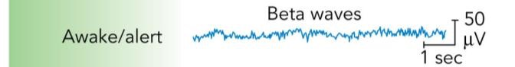
- Awake (but drowsy):
brain activity characterized by alpha waves (waves are slower, slightly higher amplitude)
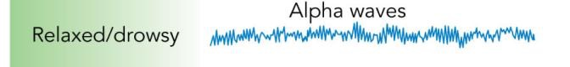
- Stage 1:
Lightest sleep level; can be easily awakened. May seem like a daydream, but is actually sleep. This is where people twitch. Brain waves characterized by theta waves (waves with even slower, and higher amplitude)
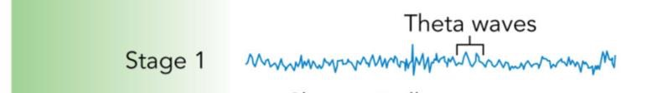
- Stage 2:

Slightly deeper sleep; muscles more relaxed and heart rate slower. The defining features is sleep spindles which are bursts of rapid brain activity

- Stage 3:
This is deep sleep, more difficult to awaken; muscles very relaxed and heart rate slower. Theta waves still present, some delta waves (less than 50%) (slowest frequency, highest amplitude brain waves)
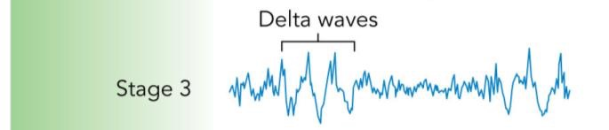
- Stage 4:
Deepest level of sleep, most difficult to awaken, if awake, groggy and disoriented. Muscles very relaxed and heart rate slow. General decrease in brain activity. Mostly delta waves instead of theta.
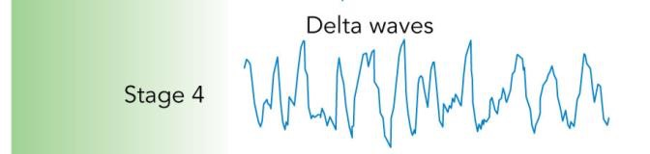
- REM:
Unique level of sleep characterized by rapid eye movements.
Also accompanied by vivid story like dreams.
Sleep paralysis, other than the occasional twitch, the body is completely relaxed
Increased heart rate, breathing and arousal.
Brain activity resembles stage 1 or even awake person; mostly beta and theta waves, but body is completely relaxed.

More REM sleep as the night goes on

Summary:
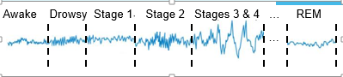
The levels of sleep are characterized by these brain waves:

- Beta
- Alpha
- Theta
- Sleep Spindle
- Delta
- Beta
BATS Drink Blood
Each cycle takes 90 minutes, typically going through 4-5 cycles per night. However, with each cycle, we get less and less “slow-waves” sleep (stages 3 & 4) and get more and more REM
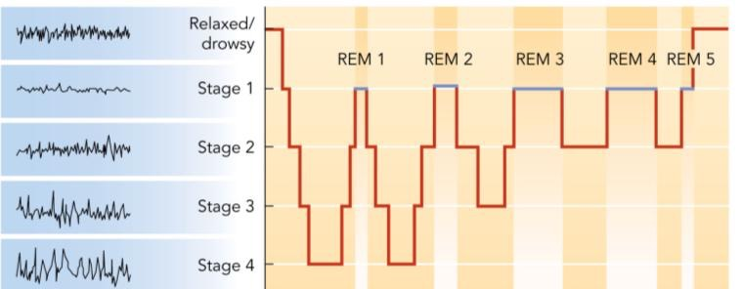

Brain Regions & Sleep:
Different stages of sleep are controlled by different areas of the brain, sleep isn’t just turning off different areas
The reticular formation and pons are mostly involved in initiating REM sleep
The basal forebrain is involved in falling asleep

Stage 3 & 4 sleep is crucial to the physical body; exercise prompts deep sleep. REM sleep is crucial to learning & brain activity; studying prompts more REM sleep.
Evolutionally, physical body recovering sleep is more important as if you were to be awoken early, you are still prepped to escape from predators.

Age and Sleep:
As one ages, they get less sleep as well as less REM sleep

Newborns:
sleeps about 16 hours a day. Only has 2 stages of sleep, non REM and REM, split 50-50 amongst the 2
Children:
Amount of sleep declines to 10 hours. 5 stages of sleep established, REM sleep declines to 20%
Adults:
Amount of sleep continues to decline through lifespan. Young adults sleep about 8.5 hours while seniors sleep anywhere from 5-8.
REM still holds steady at 20%. By late adulthood, individuals get very little stage 3-4

The individual decides how much sleep is needed. Most sleep 10-12 hours without clocks, 8-10 is needed.

Sleep Deprivation:
Studies on sleep deprivation examined 3 types of deprivation
- Short term: up to 45 hours without sleep
- Long term: more than 45 hours without sleep
- Partial deprivation: less than 5 hours per night
Studies report that all three groups showed severe impairments. These people functioned like someone in the bottom 10% of the IQ bellcurve. For all three types of deprivation, the parts affected followed the order of: mood, cognition then coordination
All- nighters before an exam are a bad idea as actual scores are much lower despite people think they concentrate better and try harder.
Pilcher & Walter (1997)
Studies showed that when students stayed up all night and performed a critical thinking task showed that sleep deprived students performed worse, but they thought they performed better as they believed they concentrated harder which made them do better.

Sleep Deprivation Psychosis
Confusion, disorientation, delusions and hallucinations are associated with extreme sleep deprivation, this can lead to death

Reasons for Sleep (2):
- Restoration Model:
Allows us to recharge our batteries; helping us recover from physical and mental fatigue.
Evidence: shows that ultra-marathon runners sleep longer and spend more time in slow-wave sleep and that people sleep slightly longer after exercise
Increased adenosine concentrations cause sleepiness
- Evolutionary/Circadian Model:
Sleep increases chance of survival
With each species has its own unique sleep patterns that are adaptive.
Two Factor Model:
Metabolism slows slightly during sleep, so this helps us conserve energy compared to awake resting, another evolutionary adaptation

Sleep Disorders
- Insomnia:
Frequent persistent difficulty in falling asleep. It’s more than inability to fall asleep, its difficulty getting restful sleep or staying asleep. This is the most common disorder, affecting 10-40% of the population in various countries.
Often feels worse than it actually is as they overestimate how long they take to fall asleep
Caused by:
- Biology: genetics, medical conditions, mental disorders, drugs
- Environment: stress, lifestyle, “bedroom associations”; (associations with other things other than sleep with the bed)
Stimulus Control: treatment for these associations
- Narcolepsy:
Extreme daytime sleepiness and sudden uncontrollable sleep; lasting minutes to hours
Can be associated with cataplexy: sudden loss of muscle tone triggered by laughter, excitement or other strong emotions; essentially REM’s sleep paralysis
This is caused by biology-environment interactions. Genes increases chances of getting this, but no guarantee of prevention.
- REM Sleep Behaviour Disorder:
Lack of paralysis during REM sleep makes the individual act out their dreams
Caused by brain abnormalities?
- Sleepwalking:
Typically occurs during stage 3 or 4 of sleep. More common in children.
Waking a sleepwalking person is not harmful
Caused by:
- Biology: genetics, illnesses, drugs
- Environment: stress
Treatment: wait for child to outgrown, psychotherapy and drugs can also help

November 12, 2014

Dreaming
Dreams occur throughout the sleep cycle, people tend to dream more as morning approaches.
- REM dreams have a vivid story like quality, this is the stage when most dreaming occurs. Most nightmares also occur during REM sleep
- Slow-Wave Sleep: brief dreams, often a single vision/feeling/image
This is when night terrors occur; this is when very intense panic settles in

Most dreams are actually really boring, some are slightly illogical or implausible, but involving realistic worlds with familiar family, friends and colleagues
Just like real life, only exciting things tend to be remembered.

Not all dreams are blissful, 80% contain negative emotions, 50% aggressive acts, 33% involve misfortune. Experiences shape our dreams, around 50% of dreams reflect our previous day.

Theories of Dreaming:
- Wish Fulfillment (Freud):
Our unconscious urges, needs and desires are fulfilled in dreams
- Manifest content: the surface story
- Latent content: the disguised psychological meaning
However, this view is extremely subjective
- Problem – Solving:
Dreams help us find creative solutions to our problem as they’re not constrained by reality. Criticism of this theory is that just because a problem shows up in a dream, doesn’t mean that one solves anything. Also, one might solve the problem after waking up.
- Activation – Synthesis:
When we are awake, the cerebral cortex makes sense of neural activation in order to make meaningful perceptions. When neural activity occurs randomly (activation) in lower areas of the brain, the cerebral cortex just does its regular job and makes sense of the signals by creating a best fit story line (synthesis)
Suggests that dreams have little meaning – they are just the brain making sense of random activity.

Does Dreaming Equal Learning?
- Memory performance is better following a night of sleep, relative to the same amount of time awake (but is this sleep or due to distraction free environment)
- After learning a new task/skill, people show more eye movement during REM sleep (biggest increases in eye movement did best next day)
- During and after exam season, students spend more time in REM sleep and have more REM eye movements
- Selective deprivation of REM sleep prevents learning. While learning still occurs if slow wave sleep is removed.
Modified Activation Synthesis:
Brain activity during learning seems to be repeated during REM sleep. It’s like the learning is replayed.
The Modified Activation – Synthesis Model states that:
Neural activity replay what we learned and possibly some random stimulation (activation)

Study:
REM Rebound Effect; selective REM sleep deprivation results in brain trying to get more REM sleep. Shifting more often into REM sleep on subsequent nights
When one finally get to have REM sleep, they spend a higher proportion of time in that stage

Drugs
Most psychoactive drugs either increase or decrease the actions of neurotransmitters
- Agonist:
increases the activity of a neurotransmitter
Can enhance a neuron’s ability to release more neurotransmitters
Can directly mimic the neurotransmitter and bind with the receptor site
Can either stop or slow re-uptake, increasing the effective time of neurotransmitters

Examples include:
- Opiates: bind to endorphin receptors
- Amphetamines: cause increased release and prevent reuptake of dopamine and norepinephrine
- Antagonist:
Decreases the activity of a neurotransmitter
Can reduce a neuron’s ability to release more neurotransmitters. Can prevent the neurotransmitters from binding to the receptor site by blocking it

Examples include:
- Anti-psychotic drugs: block dopamine receptors

Drug tolerance & Withdrawal
Decreased responsiveness to taking a drug; same dosage produces smaller and smaller effects; hence larger doses needed to get same effect
The body is always trying to maintain homeostasis, and drugs often cause an imbalance if the brain produces a compensatory response (a reaction that is opposite to the drug).
Over time, compensatory responses become faster and stronger, leading to higher drug tolerance

Withdrawal:
Withdrawal happens when the drug is discontinued. The experience of symptoms opposite to the drug. This is the body way of producing compensatory response to the drug, but there’s no drug to balance it out.
Compensatory responses can be classically conditioned. Taking drugs at the same time of day, in the same setting leads to strong and fast compensatory response and leading to higher tolerance.
New setting does not produce (full strength) compensatory response, but person believes they need the same high dose.

Overdose:
Heroine addicts who have had near fatal overdoses: few had actually taken a larger than usual dose, but 70% took it in a new environment

Mouse studies:
When mouse is put in box with blue walls and a metal floor, the mouse showed signs of pain when the floor was heated. When given morphine, the mice no longer did. To keep the same level of tolerance, more morphine had to be given.
When the mouse was moved to a box with white walls and the same high amount of morphine was given, the mouse died 100% of the time.
Misconceptions:
- Drug Tolerance always leads to significant withdrawal symptoms:
While often true, but not always; marijuana and LSD produce tolerance but small effects of withdrawl
- Physiological dependence is the major cause of drug addiction:
Not always true. Increase sense of pleasure from some drugs seems to contribute more to their addictive properties.
Some drugs have minor withdrawal but high addiction (cocaine). These people who have quit often have relapse, well after withdrawal symptoms have gone away

November 17, 2014

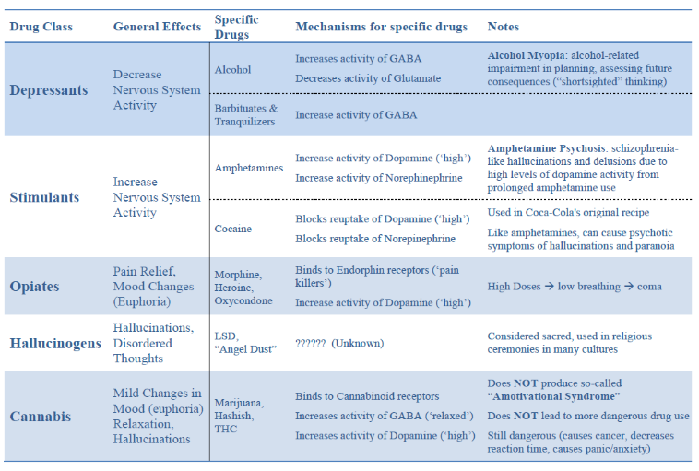
Classes of Drugs
- Depressants: decreases nervous system activity
- Alcohol:
Tolerance is gradual, but powerful. There’s a physiological dependence
Increases activity of GABA, which is a inhibitory neurotransmitter resulting in an overall decrease in brain activity
Decreases activity of glutamate, which is a excitatory neurotransmitter, resulting in an overall decrease in brain activity

The initial high feeling for some is caused by the fact that the inhibitory control centers of the brain are slowed first (literally less inhibited)
Then thinking and coordination get disrupted and fatigue and depression kick in
These are both effects of a depressant

Alcohol myopia: this is shortsighted thinking caused by inability to concentrate on anything that isn’t super-obvious. This leads to reckless behaviour, actions without considering consequences.

Beer Google Effect
- (Pennebaker et al, 1979)
The idea is that the more fucked some is, the more attractive they find others. When people were asked to rate the general attractiveness of people in a bar at various times throughout the night, ratings for opposite sex increased (especially between 10:30PM to 2AM)

- Gladue & Delaney (1990)
They did attractive ratings based on people in the bar and photographs of people not present. If the beer goggle phenomenon were to exist, both sets of ratings would be expected to increase.
They also took into consideration the approximate blood alcohol levels of participants.

The results were that the attractiveness of people in the bar increased while the photos stayed constant.
These increases in attractiveness ratings were not related to alcohol consumption as alcohol does not cause universal impairment in ability to distinguish attractive/unattractive

The conclusion of the study states that there is no such thing as a beer goggles effect, but instead, the closing time effect where people tend to become more attractive as closing time comes closer. In evolutionary terms, this is due to an adaptive trait to find the “best of the rest”

- Barbituates & Tranquilizers (not very important)
Commonly prescribed as sleeping pills and anti-anxiety medications
Tolerance is extremely powerful, physiological dependence is possible and withdrawal & overdose can be fatal.
Increases activity of GABA causing overall decrease in brain activity
- Stimulants: increases nervous system activity
- Amphetamines (speed, meth, e) (know details)
Tolerance is also extremely powerful and withdrawal/overdose fatal.
Increased dosages is caused by frequent use, causing heart failure or strokes
Increases dopamine, causing feelings of pleasure
Increases activity of norepinephrine, causes overall increase in activity
Often a massive crash after amphetamines use; norepinephrine and dopamine supplies have been depleted and take time to recover

amphetamine psychosis: heavy repeated use of amphetamines can cause schizophrenia like symptoms (hallucinations and paranoid delusions) believed to be caused by increased dopamine.

- Cocaine
Very little withdrawal symptoms.
Works by blocking reuptake of dopamine to lengthen feelings of pleasure and euphoria
Works by blocking reuptake of norepinephrine, leading to an overall increase in activity
Psychotic symptoms in high doses, and frequent use results in heart failure and stroke
- Opiates: causes pain relief, often with euphoric feeling
Contains morphine, codeine, heroine
Tolerance is extremely powerful, with physiological dependence.
Activates endorphin receptors, killing pain
Increases dopamine activity
The chemical structure is similar to endorphins, attaches to the receptor sites, causing body to believe it is endorphins.
- Hallucinogens: hallucinations
Tolerance develops quickly, but decreases quickly too
It’s currently unclear how it works, but seems like something to do with serotonin

Marijuana
Weed does not fall under hallucinogen or sedative categories, and might be its own category
Works by binding to cannabinoid receptors (unclear why we have these receptors)
Increases activity of GABA, inhibitory neurotransmitter, causing decrease in brain activity
increases activity of dopamine; pleasure
Misconceptions:
- Causes people to become unmotivated bums (amotivational syndrome does not exist)
- Causes people to start more dangerous drugs
- It is completely harmless
- Weed smoke contains more cancer causing substances than tobacco
- Impairs reaction time and thinking
- High doses cause negative changes in mood, hallucinations, and can cause panic/anxiety

Other Determinants of Drug Effects
- Biology:
Genetic predisposition
Some genetic predisposition can breed alcoholic mice, some are super tolerant and some are super sensitive
Identical twins are more similar in terms of alcoholism than fraternal twins
- Environment:
Culture
Cultural norms about which drugs are okay. Western culture drinks alcohol very often. As well, cultures behave differently when drunk; feeling effects of alcohol as we expect to feel them. Western culture is aggressive, while Bolivia is calm and happy

Hypnosis
This is a condition of enhanced suggestibility

Hypnotic induction: this is the process that induces hypnosis. The procedure involved is very similar to those involved in meditation

Not all people can by hypnotized, one cannot be hypnotized against their will. As well, different people differ in terms of susceptibility

Hypnotic susceptibility scales:
10% of people are completely non-responsive
10% of people act on all suggestions

This scale is based on three characteristics
- Suggestibility: uncritically accept direction and information
- Absorption: can focus attention and block out extraneous info
- Dissociation: can separate from conscious awareness
People under hypnosis feel like actions are involuntary:

Hypnosis & acting against your will
Orne & Evans (1965)
Asked participants under hypnosis to dip their hands in acid and throw it in another’s face,
and almost all hypnotized subjects did
When asking a different group of non-hypnotized people to pretend they were hypnotized, almost all people did it
The results indicate that there’re may not be anything unique about the hypnotic effects on behaviour (milgram obedience study)

Hypnosis & Physiology
Ikemi & Nakagawa (1962)
All participants were blindfolded (none of which had allergies})
Were told that a non-toxic leaf rubbed on left arm was toxic and that a toxic leaf rubbed on the right arm was not
The results showed that hypnotized people had the rash on the wrong arm, but so did the non-hypnotized participants
The results indicate there may not be anything unique about the hypnotic effects on physiology (placebo)

Hypnosis & Pain Tolerance:
- James Esdaile: more than 300 major surgeries using hypnosis as anasthetic
- Joseph Barber: 11 minutes to hypnotize 99/100 patients for dental work
These effects were not due to placebo effect, fMRI showed that the brain activity is actually altered. However, non-hypnotic techniques do the same thing; ental imagery, visualization techniques
There may not be anything unique about hypnotic effects on pain tolerance

Hypnosis & Memory:
Post-hypnotic amnesia: actually can be induced in about 25% of hypnotized people (when you wake up you wont remember a thing kind of thing)

Under hypnosis, you’ll remember more details.
While people do report more info, most of it is wrong. Hypnosis increases confidence in false “memories”.

Theories of Hypnosis
- Dissociation Theories:
Believe that hypnosis is essentially dividing consciousness into 2 streams
- Steam responds to the hypnotist
- Steam is aware of everything else going on, and hangs out in the background. Called the hidden observer

Evidence of this claim is when hypnotized subjects were asked to put their hand into buckets of ice, pain ratings from hypnotized half showed low pain
However, when asking “the other part of you that is more aware than your hypnotized part (hidden observer), higher pain scores
- Social Cognitive Theories:
This theory believes that people take on the role of someone being hypnotized, does not mean they are faking it
Rather, its like top-down perception; they see what they expect to see (perceptual set). This theory say that the individual experiences what they expect to experience
Ex. If we expect involuntary actions, we perceive our actions as involuntary

Learning and Adaptation

Learning:
This is the process of experience producing relatively enduring changes in behaviour or capabilities
Learning is knowing how
Performance is different, it’s the process of doing something, the process of applying learning

Unfortunately, often times performance is used to measure learning
Learning is like adaptation, but within a lifetime, unlike evolution across generations

Behaviorism:
This is the school of thought that states psychology should only focus on the observable behaviours of the organism; focusing on performance. That knowledge is the same as performance because you cannot observe learning.
This school of thought is built on the foundation of tabula rasa; so focuses on how experiences influence behaviour

Behaviourism assumes there are universal laws of learning

This meaning that if the laws are universal, we can study animals in highly controlled lab settings
This is exactly what happened, and behaviourism identified two principles of learning
- Classical conditioning
- Operant conditioning
However, cognitive and biological factors also play a role in learning:
Sensory Adaptation: gradual decline in sensitivity to a stimulus over prolonged period
Is the result of sensory neurons firing less and less

Habituation: decreased response to a repeated stimulus
Is the result of simple learning processes in the CNS (not the sensory neurons, which are in the PNS); selective attention

Habituation: decreases in the strength of response to a repeated stimulus
Sensitization: increases in the strength of response to a repeated stimulus (helps us avoid potentially dangerous stimuli)

November 24, 2014

Classical Conditioning (pavlovian conditioning)
Association between two stimuli such that one comes to produce a response that was initially produced by the other stimulus.
This is one of the most basic forms of learning. The responses initiated include behaviour mood, physiological response.

Pavlov’s Research:
While studying digestion in dogs, became interested in saliva and stomach responses to food.
His method includes three different stages:
- Baseline measures: the responses before the experiment began
- Learning/Acquisition: the organism learns to associate the 2nd stimuli with the response from the first
- Testing: present just one stimulus that did nothing initially
The important lesson here is that our bodies can predict when something is going to happen and make a response without us ever being conscious of it.

Terms involved with Classical Conditioning
Replace the word conditioned with learned
- Unconditioned stimulus (UCS): the thing that produces the unconditioned response (the food for the dog)
- Unconditioned Response (UCR): reflexive, innate response to something (the drooling in response to the food)

These responses are seen during baseline measures.
- Conditioned Stimulus (CS): the thing that produces the conditioned response (the bell)
- Conditioned Response (CR): the learned response (the drooling)
- Acquisition (Conditioning): the production of the conditioned response only happens in response to the conditioned stimulus after the processes of learning.
- Extinction: after a while of presenting the conditioned stimulus without the food in the dog’s case, and it learns that the bell is no longer associated with food.
Spontaneous Recovery: this occurs after extinction, when the conditioned response can suddenly re-appear without any new training. This usually happens after a break period, and the response is usually fairly weak compared to before and extinguishes very quickly.
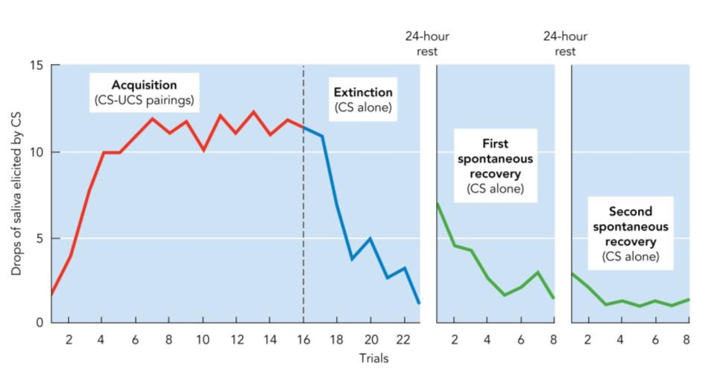

The above graph shows the responses the dog was giving. It can be seen that early during the extinction process, the dog still associates the bell with food. And after the conditioned response is gone, spontaneous recovery happens after a break, but it goes away fairly quickly.

Generalization
This is the act of generalizing the response to something new, a tone that is similar to the original CS will still produce the CR. The greater the difference, the weaker the response.
This is important to survival as its useful to be able to classify similar things into groups, example being growling.

Discrimination
Being able to tell the difference between two things. A tone that is not very similar to the original CS will not produce the CR. Also, learning also occurs so the organism can learn to differentiate between things that they initially could not.
Important to survival because if everything in the generalized group induced a response, it would waste energy.

Types of Classical Conditioning
Forward conditioning means the conditioned stimulus starts before the unconditioned stimulus
Backward conditioning means that conditioned stimulus starts after the unconditioned stimulus
- Forward short delay: conditioned stimulus (bell) happens right before unconditioned stimulus (food presented) and the conditioned stimulus (bell) continues throughout the duration of the unconditioned stimulus.
- Forward trace pairing: conditioned stimulus (bell) turns off before unconditioned stimulus starts. Only leaving a memory trace of the tone when they begin eating, but no actual tone.
- Simultaneous pairing: conditioned stimulus comes on and turns off the exact same time as the unconditioned stimulus does
this tone doesn’t work as well as forward pairing due to the fact that the conditioned stimulus doesn’t predict the unconditioned stimulus, but instead just accompanies it.
- Backward pairing: the conditioned stimulus comes on after the unconditioned stimulus. Can be either short delay or trace pairing, but both are terrible for learning.

Higher order conditioning
This is where multiple conditioned stimuli is linked with one another.
This is when one conditioned response is paired with a different stimulus so that eventually the 2nd conditioned stimulus invokes the original unconditioned response. This is called the 2nd order-conditioning
The higher order conditioned response is weaker and extinguishes faster

The example is: the dog first associates the bell with the food, then is taught that seeing a black square means the bell will be rung so eventually, the thought process becomes black square tone food

Learning in Classical Conditioning
We learn the fastest or best through forward conditioning. As well, learning is faster when the unconditioned stimulus is really strong.
Conditioned Aversion:
This is when people avoid certain foods or tastes because they have become sick when they ate that food in the past.
Quinine is used to treat alcoholism

Fear Conditioning:
Fear can also be learned through classical conditioning. Conditioned stimulus comes to elicit physiological indicators of fear, where is actually activates the amygdala.
If the unconditioned stimulus is strong enough, fear conditioning only requires one trial.
Reintroduction to Endangered Species:
Wallaby population is decreasing due to predation by foxes. Through classical conditioning and introducing the fox as the conditioned stimulus with the unconditioned stimulus being large scary dogs.

While most cases of fear conditioning are adaptive, like learning avoiding scary dogs.
However sometimes fears can be maladaptive, such as in the case of phobias.

Watson scared the shit out of some little kid by conditioning him to be scared of anything white and fuzzy things

Post – Traumatic Stress Disorder (PTSD):
Exposure to an extremely traumatic event often leaving the person with flashbacks and other symptoms of extremely high levels of fear. These flashbacks can happen when the person is exposed to something similar.
fMRI scans of these patients show::
- Increase in amygdala activity
Especially on the right side
- decrease in frontal lobe activity.
Makes it hard to talk yourself down

Overcoming Fears
Classical conditioning helps treat fears too. If a fear can be learned, it can be unlearned.
- Exposure therapy:
Method is to expose people to the conditioned stimulus in a safe environment. Basically setting up an extinction trial so the fear response eventually becomes extinguished
- Systematic desensitization:
Type of exposure therapy in which patients learn relaxation techniques and gradually work up to the object of their phobia. Learn to relax at one level, then move on to the next.
- Flooding:
Patient immediately and often drastically exposed to the object of their phobia
Both types of exposure therapy are extremely effective, supporting the idea that fears are learned.

Conditioned Emotion:
Emotions can be classically conditioned

November 23, 2014

Operant Conditioning
Instrumental Learning:
Edward Thorndike
Placed cats in puzzle boxes and they needed to perform a certain series of actions to get out. Cats would only get out by chance at first, but got faster and faster at getting out with fewer and fewer mistakes.

Came up with the fact that improvement in performance was gradual, theres no aha moment, just trial and error.

Law of Effect (foundation of instrumenal learning)
- Increased Likelihood: a response that is followed by a satisfying outcome will become more likely to occur
- Decreased Likelihood: a response that is followed by an unsatisfying outcome will become less likely to occur

Operant Conditioning

BF Skinner:
Expanded on the work by Thornlike, based on the principles of instrumental learning,
This theory states that the likelihood of behaviours are influenced by their consequences. Kind of resembles natural selection for behaviour, beneficial behaviours survives and increases in frequency while harmful behaviours gets weeded out by selection.
Skinner Box:
Included lever for food for rats to press. When lever was pressed, food was released.
Cumulative recorder was used that shows the number and timing of lever presses.

Classical VS Operant Conditioning

Classical
Associates two stimulis (conditioned stimulus and unconditioned) where the conditioned predicts the unconditioned.
Association happens before the behaviour (conditioned response) occurs
This is mainly focused on involuntary (elicited) behaviour

Operant
Associates behaviours with consequences in a cause and effect way
Association happens after the behaviour occurs
Focused on voluntary (emitted) behaviour

ABC Principle:
Antecedent:
Stimuli presented before behaviour (context, setting)
- Discriminative stimulus: antecedent stimulus that signals certain consequences if a response is made (ie, the bell in school is the discriminative stimulus that signals time to go home)
Behaviour:
Consequences
- Reinforcement: something that increases a behaviour
- Positive: something is being added to the scenario or person
- Negative: something is being taken away
- Punishment: something that decreases a behaviour
- Positive: something is being added to the scene
 | Behavior increases | Behavior decreases
Adding Something | Positive Reinforcement | Positive Punishment
Taking Something  Away | Negative Reinforcement | Negative Punishment
- Negative: something’s taken

Primary VS Secondary Consequences
Primary:
Have some innate biological importance (electric shock)
Secondary:
Only important because of relationship to primary consequence (money)

These can apply to any of the four types of consequences

Immediate VS Delayed Consequences
While animals learn immediate consequences faster, humans are a little more complicated as we can picture the future

Delayed Gratification:
Ability to forfeit a smaller immediate reward for a larger delayed one.
Varies between children and those that cannot delay gratification have a tough time with stress and frustration later

Operant Conditioning Principles:
- Operant extinction:
Like extinction in classical conditioning, the consequence is no longer paired with the behaviour and the association goes away.
- Operant generalization:
Like classical conditioning, the organism’s behavioural response is similar to similar antecedents (ie, similarly looking electrical fences will probably both produce the same kind of avoidant behaviour)
- Operant discrimination:
Like classical conditioning, organism learns to distinguish between antecedents (stimuli). (ie, its okay to swear in front of friends and not family) The presence of parents in this case is the discriminative stimuli

Training:

Shaping:
Reinforce behaviours that are closer and closer to desired behaviour. In the example of shaping a prof’s behaviour, when the prof goes to the left side of the room, attentive, right, nothing.

Chaining:
Develop a sequence of responses by successfully reinforcing the next behaviour in line.

Schedules of Reinforcement
Patterns of reinforcement

Continuous Reinforcement:
Every response or behaviour is reinforced. This is the fastest to learn and the fastest to extinguish

Partial Reinforcement
Only some responses or specific behaviours are reinforced. These schedules produce different patterns of learning, extinction and performance
Ratio means that a certain proportion of responses are reinforced
Interval means that a certain amount of time must pass before reinforcement happens.
Fixed means always the exact same amount (the 5th lever press is reinforced)
Variable means it varies around a average (3rd and 7th lever press reinforced)

- Fixed Ratio:
Reinforcement always after a fixed number of responses.
Leads to high rate of responding, but there’s usually a brief pause in responding after each reinforcement as one knows they’re not getting anything for the next one
- Variable ratio:
Reinforcement is given after a variable number of responses
This produces the highest rate of responding as one doesn’t know when the next might be reinforced.
The most resistant to extinction
- Fixed interval:
Reinforcement given for the first response after a fixed amount of time
Produces scalloped pattern of responding (pause after reinforcement, then more and more frequent responses as time draws near)
- Variable interval
Reinforcement is given for the first response after a variable amount of time.
Produces stead response rate

Learning happens fastest with continuous reinforcement as it’s really easy to pick up
Extinction happens fastest with continuous reinforcement as it’s really easy to see if consequences have stopped
Variable schedules are the hardest to extinguish as it’s difficult to tell if possibility of consequences have stopped

Escape & Avoidance Conditioning

Escape Conditioning:
Organism learns a response or behaviour that terminates the unpleasant stimulus after the fact ie putting on a sweater when its cold)
Escape responses are positively reinforced

Avoidance Conditioning
Organism learns a response to terminate a behaviour before it begins (ie putting on a sweater before going outside because it looks cold)
Avoidance responses are also positively reinforced

Two-Factor Theory of Avoidance
Avoidance involves both classical and operant conditioning

The fear is first learned through classical fear conditioning, a conditioned stimulus is cultivated
Next, the conditioned stimulus through operant condition.
Fleeing from the conditioned stimulus takes away the feeling of fear which leads to negative reinforcement which makes extinction really difficult as one doesn’t hang around long enough to unlearn the association.

Biology and Learning

Biological Preparedness

Behaviourism:
Assumed that any behaviour that an could be conditioned

Biological Preparedness
Directly opposes the above assumption and says that behaviour is influenced by evolution (organisms born prewired to learn certain behaviour)

Prewired to make taste nausea association.

Demonstration of Preparedness:
All rats exposed to 3 potential conditioned stimulus at the same time
- Unique taste
- Brighter light
- Buzzer sound
Half of rats exposed to strong xray (unconditioned response) which gives rise to nausea (unconditioned response) and the other half given electric shock (unconditioned stimulus) to give rise to fear (unconditioned response).
Rats that ill avoid sweet water, but not the light or buzzer.
Rats that received a shock avoid light/buzzer

Rats easily learned taste – illness association and sight-fear/sound-fear association
This is due to the fact that organisms pre-wired to learn certain association or behaviours.

The principle is now applied frequently for people who need chemo, these patients would develop aversion to all their favorite foods, but instead they are given a unique flavor of candy beforehand.
Phobias: seems to by biologically prepared to fear certain things

November 26, 2014

Cognition and Learning

Behaviourism:
Under behaviourism learning means automatically forming associations between stimuli and responses. Behaviourism didn’t focus on the thinking processes that occurred, just the responses. This is known as stimulus-response (S-R) psychology

Cognitive Models
Under cognitive models, it is believed that the organism’s mental representation of the world is critical to learning. Focused on a stimulus-organism-response (S-O-R) psychology

Cognitive Insight

Insight:
The sudden perception of a useful relationship that helps solve a problem, this is the opposite of trial and error as the animal realizes what has to be done. This has been shown in ravens and other animals

Wolfgang Kohler & Chimps

Cognitive Maps
This is a mental (spatial) representation of space. In experiments with rats, shown that if learning was simply responding to a stimulus, the rat would choose central paths due to generalization, but instead, the rat chose the path leading directly to food.

Cognition in Classical Conditioning

Cognitive Perspective:
The organism forms expectation that the conditioned stimulus predicts the unconditioned stimulus. Learning depends on how well the conditioned stimulus predicts the unconditioned stimulus.
Traditional behaviourist theories think it’s the number of times we pair the conditioned stimulus and unconditioned stimulus is paired together.

Group 1: Tone (CS) + Shock (UCS) 10 times
Group 2: Tone (CS) + Shock (UCS) 10 times
Shock alone also presented 10 times
The result was that the second group did not learn to fear the tone

Cognitioin in operant condiitoning

Cognitive perspective:
Latent Learning:
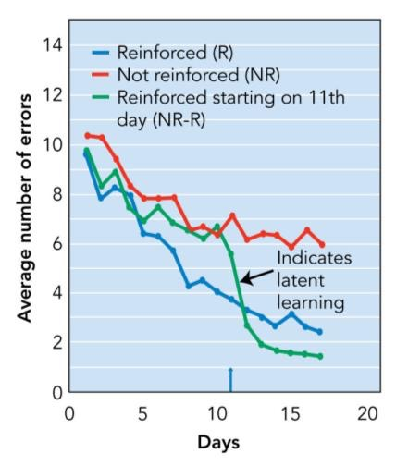
This is when organism learns even when its not reinforced. This is usually not evident until theres incentive to perform

Experiement (Tolman)
Group 1: gets food reinforcement for finishing maze
Group 2: gets no reinforcement
Group 3: 10 days with no reinforcement, then reinforcement is added

The results of the experiment is that learning is not just pairing response with outcome, learning is forming a mental model of the world

Self evalution:
Reinforcement/punishment doesn’t have to come from the external environment, it can be internal (Ex. Feeling proud of yourself).
The cognitive perspective says that there are still mental processes involved in operant conditioning. This may be a special type of secondary consequence that is related to social reinforcement and punishment

Observational learning
This is when one learns by watching someone else and is an extremely common form of learning in humans. This is an extremely form of learning as it saves time for the individual as well as reduces the potential danger.
This is against the principles of traditional behaviourism as its not related to trial- and error, but rather involving a mental model of the world.

Bandura’s Social – Cognitive Theory
Bandura was a pioneer in the observational learning research

He developed the social learning theory, which is now known as the social cognitive theory.
This theory emphasized that people learn by observing the actions of others (model behaviour)
Self – Efficacy: the belief that you have the ability to perform behaviours that will produce desired outcomes.

4 requirements
- Must pay attention to the behaviour
- Must remember the behaviour
- Must be physically capable
- Must be motivated to perform the behaviour
Bobo Doll Experiment:
Children watch video of someone attacking an inflatable clown.
Group 1: saw the person rewarded for this behaviour
Group 2: saw the person punished
Group 3: saw no consequences

The results showed that when left in a room with the clown, the first group hit the clown significantly more than the other 2 groups
When promised a reward for the behaviour, all kids attacked the doll

Lassie Experiment
Children watched one of three videos before the experiment:
Group 1: saw lassie’s owner risk life to save puppy stuck in well
Group 2: human didn’t save puppy
Group 3: saw unrelated video

The children were asked to press a button as soon as a light came on. Faster resposnes meant more points that could ultimately be exchanged for prizes.
If they heard barking through headphones, they had to hit a different button as the dogs were in trouble

The results showed that group 1 pressed the help button faster and more often than the other groups
Hence, TV can teach violence or pro-social behaviour

Memory
This is a set of processes that allow us to record and later retrieve experiences and info.
This incredibly complex process is critical to everyday functioning.

Three Basic Processes of Memory
- Encoding:
Translating information into a code for the brain to understand. This is the input processes
- Storage:
Retaining info over periods of time. This is the storage process
- Retrieval:
Pulling info out of storage. This is the output process

The difference between things that go into short term memory and things that are stored for the long term is explained by:

Three Component Model (Atkinson – Shiffrin Model)
Developed by Atkinson and Shiffrin, takes into account the three basic processes and the fact that different forms of memories seem to exist
While these components are functionally different, but don’t correspond to specific brain areas
- Sensory memory:
Allow a complete sensation to linger in memory for a brief time after it has actually ended. Stores all info for very brief period of time (<2 seconds)
Different senses have different sensory registers:
- Visual info iconic store (complete visual picture lasts for 0.5 seconds)
- Auditory info echoic store (complete auditory lasts for 2 seconds)
Sperling’s Experiment:
Different letters were presented for 1/20th of a second
Whole report: usually got 4.5/12 (37.5%)
Partial Report (when asked to identify immediate tone, 80-90% correct)
Delayed tone was the worst, after a delay of <0.5 seconds, individual had lost most of the info

- Short term memory:
Most info in sensory memory fades, but some info is passed to here, selective attention
What we’re currently focused on thinking about, including things we’re trying to learn and remember (rehearsal) and things we’ve remembered (retrieval).
Coding:
- Auditory (phonological): remember what was said, mistakes are often made in similar sounding tones
- Visual
- Semantic: focused on the meaning.
The duration is about 20 seconds
Maintenance Rehearsal:
Repeat info over and over to keep the info in the short term memory. This is not good for long term retention
Elaborative Rehearsal:
Focus on the meaning, relate to things you already know, keeps info in the short term memory and is way more effective for long term retention. In fact, in order for things to be stored for he long term, it must go through this process.

Also known as working memory because this is where process info (doing more than just recalling)
This system of the working memory system includes 4 parts:
- Phonological loop

- Visuospatical sketchpad
- Episodic buffer (combines the info from the above 2)
- Central executive (allocates attention)
- Long term memory
Library of more durable stored memories, rehearsal is part of encoding (the process mentioned above).
This kind of memory contain unlimited capacity and unlimited duration.

There are different types of long term memory:
- Explicit vs implicit
- Serial position effect:
Items learned near the beginning and end of a long list are remembered better than items in the middle
Primacy Effect: better memory for first few items (due to lots of rehearsal)
Recency Effect: better memory or last few items (due to short term memory, only works with immediate testing)
- Implicit:
- Declarative vs procedural
- Episodic & semantic VS Procedual, priming & conditioning

Encoding:
Getting info into the memory system. This processes translates info into a neural code for storage. The better the process of encoding, the better chance of remembering

Levels of Processing Theory:
- Automatic processing:
Unintentional and requires little attention
This shallow level of processing produces a poor memory
- Effortful processing
Intentional and requires conscious attention.
This deep level of processing produces a strong memory
- Maintenance rehearsal:
Repeating something over and over
- Elaborative rehearsal
Elaborate on info and relate to something known.
Focused on meaning and is much better for long term retention
Types of Encoding:
Chunking:
Combining individual pieces into larger units
Short term memory can only handle so much information (7+/-2). The process of chunking organizes the information so it only occupies one of the 5-9 slots.

Visual Imagery

Dual Coding Theory
Proposed by Alan Paivio, says that encoding things both ways is better than just one (odds are better), but its easier to visualize concrete objects

Method of Loci
Link every item on a list to a well known physical environment with distinct locations.
Schema
A mental model that captures the idea behind what was heard. These frameworks can help organize our memory

Experiment: Expert Schumata
Chase and Simon studied expert vs novice chess player’s memory, each were given 5 seconds to encode the exact positions of the 24 pieces on the chess board.

The results showed that experts were much better than novices at memorizing mid game arrangement, but in terms of random arrangement, both were equally bad.
The conclusion says that experts does not have a better memory overall, but instead used schemas and chunking to organize the meaningful board into patterns to aid encoding.
The same thing is found for expert football coaches vs novices when trying to remember player positions

Storage

Declarative VS Prodcedural:
Declarative:
Memory that you can talk about (declare)
- Episodic memory
Our personal experiences (episodes of our lives)
- Semantic memory
General facts and knowledge

Procedural Memory (non declarative)
Memories for skills or actions that’s harder to describe what ones thinking about.
- Memories for skills
Skills like how to ride a bike
- Conditioning
Classical and operant conditioning

Patient HM:
Normal prodcedural memory, but no episodic memory past his 20s
Shows that the two kinds of memories are distinct

Explicit VS Implicit Memory

Explicit memory
Conscious or intentional memory about something; something you’re explicitly trying to remember
- Recognition
Decide whether something looks familiar.
Answer is usually provided; MC tests, criminal line up
- Recall:
You have to remember it all on your own
Ex. Fill in the blanks, short answer

Implicit memory
When memory influences our behaviour without our conscious awareness.
Any example of automatic processing generally falls under implicit memory

Dec 5th Missing

Jan 5th, 2015

Language

Basic Properties and Functions of Language
Language: a system of symbols and rules for combining them which can generate an infinite number of possible messages and meanings
Psycholinguistics: the scientific study of the psychological aspects of language; including how people understand, produce, use and learn language

The importance of language
      - Cognition: the functions of cognition such as thinking, reasoning, problem solving involve language. Consciousness may depend on language?
      - Social: language allows for sharing of thoughts
      - Universal: all cultures have language

Adaptive Functions of Language
Language helped humans build bigger social groups as language was able used to divide up the work amongst group members

5 Properties of Language
        - Symbolic: arbitrary symbols represent specific objects and actions
        - Structured: rules for meanings and phrase combinations
        - Conveys Meaning: can be used to communicate ideas and thoughts
        - Generative: can combine into an infinite number of messages
        - Permits Displacement: can refer to objects or events that are not physically present

Structure of Language
            - Hierarchical: sounds/letters wordsphrasessentencesconversation
            - Phonemes: most basic unit of speech sounds. Each language has their own specific set of phonemes, changing a phoneme changes meaning of the word
            - Morphemes: smallest unit of meaning in a language; can refer to a word or suffixes or prefixes (pig) (pre-)(-ed)
            - Semantics: meaning of words and sentences
            - Syntax: grammatical rules that govern how we organize words into sentences; grammar encompasses this area and morphology
            - Pragmatics: knowledge of the practical application of language; social rules and context that can affect understanding and word choice

Surface VS Deep Structure:
Surface: the words that are actually spoken
Deep: the underlying meaning

Understanding and Producing Language

Bottom – up Processing
Combine elements and then combine the combinations, all about combing very simple elements into more and more complex things
This applies to language because of the hierarchical properties of it. For both spoken and written, its made up of sounds of strokes that combine to form meanings

Top Down Processing
This is the idea that knowledge and expectations affect perception
This applies to language as we interpret the letters easily based on the context of the letters and words around it

Speech Segmentation:
Speech is perceived as a series of separate words, but unlike written language, there isn’t a space between them. There are usually bigger decreases in energy output within words (probably due to different phonemes) than between words. Part of why foreign language sounds so fast
When speaking, phonemes overlap and affect each other; as a person is saying a phoneme, the mouth is already starting to form the next one. So in order to deal with this, the brain uses top down knowledge and breaks the sounds apart.

Knowledge
We grow up learning the statistical probabilities of which words tend to go together.
Context:
Since phonemes overlap and affect each other, the context of the words are very important as to what the sentence means

Pollack and Pickett

Recorded people’s convos as they waited to take part in a study, when the word was played back individually, only 50% of the guesses were correct. However, when 3-4 words were played, 80-100% were correct.

The conclusion is that we aren’t good at perceiving words based on sound alone, we use knowledge and context in the top down perception to understand.

Brain Parts associated with Language

Broca’s Area:
This is located in the left frontal love and is responsible for language production; used for grammar, articulation and producing words.

Broca’s Aphasia: impairment to language production due to damage to this area, this damage does not affect comprehension.

Wernicke’s Area:
Located in the left temporal lobe, responsible for language comprehension.
Wernicke’s Aphasia: this is impairment in language comprehension. Words are pronounced correctly, but the meaning is not clear
Other parts of the brain behave as expected; auditory, visual and motor areas of the brain are all used
When reading, hearing or speaking about sensory/action words, it tends to activate areas of the brain responsible for that sense/action

Hemispheric Specialization
Broca’s and Wernicke’s areas are both in the left hemisphere, so it is concluded that language specific abilities are lateralized on the left
Problems can arise:
      - Some People are Less Lateralized: women and left handed people are less lateralized
      - Recent Research Show Right hemisphere Specific Functions: while the left hemisphere is heavily involved in speech perception, it also searches more actively for word meanings and reading high-imagery sentences. In contrast, the right hemisphere is more involved in putting elements of a story together as well as resolve ambiguities.

Acquiring Languages

Nature and Nurture
Both are important to acquire language

Biological Foundations:
            - Innate Ability: young children learn quickly
            - Language Development Stages: all progress through the same stages of language developement
            - Universal: children are all born with language acquisition device which can be programmed for specific language

Social Learning Process:
The social learning environment builds upon the biological foundations
      - Child-directed speech: high pitched voice
      - Direct teaching of vocab
Acquiring language is more than just operant conditioning. Skinner thought that it was all reinforcement and punishment, but there are many things that children say that are not reinforced, as well, studies show that parents rarely correct grammar, instead only focusing on the whether the statement is true is not.

Developmental Timeline:
Children of all culture go through the through the same stages when learning their 1st language
        - Cooing: can distinguish speech from non speech
        - Babbling: will vocalize in response to others
        - Phoneme Discrimination: narrowing sounds to those used by people around them
        - 1st word
        - Single word request
        - Telegraphic Speech: non essential words left out
        - Vocab explosion: more complete sentences
        - Basic grammar used

Sensitive Period in Development
Sensitive periods are times when one is especially responsive to language input
The previous stages apply to children with normal levels of social contact, but with children with no social contact. If a person with no social contact is rescued after puberty, they will not gain full proficiency

The Second Language
The cons of this is that bilingual children tend to have a smaller vocab, and having less accuracy in naming pictures or making judgments. This is possibly due to bilingual having less experience with each language individually
The pros is that in performance tests, they score at least as high as monolinguas. Bilingual individual may be better at controlling their attention, thoughts and tuning out irrelevant info as they must inhibit one language while speaking the other.
Bilinguals tend to have lower incidences of dementia and Alzheimer’s Disease

Research suggests that there may be a sensitive period for learning additional language, which extends though adolescence

People who are bilingual brain use the same brain areas for both languages.

Jan 7th, 2015

Language & Thought
Linguistic Relativity Hypothesis:
Suggests that language determines how we think. I.E. color perception, different languages divide the spectrum differently (different number of basic colors), this effects the way people think
Winawer (2007)
Experiment with 3 coloured squares, one on top and two on the bottom. The two squares on the bottom were named different things. The names were in russian, and russian were able faster judgement calls when the two bottom colors were categorized under different names
Gilbert (2006)
Oddball task: participant sees a ring of coloured squares, and language is a big part in determining how fast one can differentiate between colors.
The original hypothesis is generally rejected, most objections are over the strength of the claim, but most psychologists agree that language does influence thought, not determining it.

Language and Math
Like previously stated, language influences thought, butit also influences how well we think. Asian children consistently score higher in basic math skills like addition and subtraction by age 5 due to Asian languages using a different number systems.

3 Modes of Thought
            - Propositional: inner speech type of thought
            - Imaginal: images that we picture in our mind
            - Motoric: mental representations of motor movements

Concepts and Propositions
Concepts: mental categories
2 methods of classification
      - Classical categorization: this is the definition approach, and is categorized according to specific rules or definitions. The problem with this approach is that it is sometimes hard to define characteristics that make up an object.
Fuzzy Boundaries: Some items have fuzzy boundaries, some category members have typical or characterstic features rather than defining ones
Graded Membership: some items are better members of their categories

      - Prototype approach: suggests that we categorize things based on their similarity to a category prototype
Prototype: mental representation of the typical or average member of a category. This can account for graded membership, items that resemble the prototype better are considered better members of the catergory.
Typicality Effect: objects that are more prototypical are verified as category members more quickly

Propositions: express ideas that link different concepts (eg. Owls LIKE skateboarding)

Reasoning and Problem Solving

Syllogism and Logic

Deductive Reasoning:
Taking general principles and reasoning about a specific case, usually involving syllogism (set of 3 statements, 2 premises and logical conclusions).

Inductive Reasoning:
Taking specific cases and reasoning about a general principle; generalize and based on limited number of observation. The conclusions are less certain, but about what’s likely
Any time the past is used to predict the future, this kind of reasoning comes into play.

Errors in Reasoning

1. Belief Bias:

Tendency to abandon logic when something contradict our own personal belief.

Validity: conclusion is logical, based on premises
Truth: conclusion is false, because premise 2 is false
The difference between validity and truth is that while a statement can be logical, it doesn’t make the statement anymore true.

2. Emotions and Framing:
Tendency to abandon logic in favor of emotions, or change the way the information is presented.
I.E. glass half empty vs glass halsf full
3. Distraction
Focusing on the wrong information

January 12, 2015

Problem Solving (The 4 steps)
      - Framing the problem: how to think of the problem
      - Generate potential solutions: which solutions might work
      - Test solutions
      - Evaluate the results: choose best solutions

Problem Solving Schemas

Problem Solving Schemas:
This is a mental blueprint for how to go about solving a particular type of problem
Algorithms:
Formulae or procedures guaranteed to produce the correct solution

Heuristics:
Educated guess, not guaranteed to work

Means Ends Analysis and Subgoals

Special Heuristics

Means-ends analysis:
Identify present state, and end goal, then make changes to keep reducing the difference
Starting State: 170
Goal state: 180

Sub-goal analysis:
Identify smaller goals that will get you there

Obstacles in Problem Solving

Mental Set
Preconceived notion of how to solve a problem based on past experience, someone who is set in their ways
Luchin’s Water Jug Problem
Given three jugs of different sizes, combine to get specific amounts of water. One group were given 7 problems that could be solved using the same way which was very complicated and time consuming. Another was only given 6 and 7, which could be solved in an easier way. As a result, the second group solved it faster. Group A got stuck in a mental set.

Functional Fixedness
This is a kind of mental set, and its where an object is restricted to its familiar functions

Creativity
Creating something new and valuable, this requires divergent thinking; new ideas that are different from the norm. Solutions sometimes arise after incubation (giving up or otherwise setting the problem aside)

Judgment and Decision Making
While people tend not to know exact probabilities, so people tend to use heuristics; educated guesses
There are three types of commonly used heuristics:
        - Availability heuristics:
Events that are more easily remembered are judged to be more likely, probable or common
        - Representativeness heuristic
the likelihood that someone is a member of a particular group depends on how well someone resembles the properties we typically associate with the group
conjunction rule: probably of 2 events cannot be higher than the probability of either event alone
base rate: the relative proportion of different groups
        - Confirmation bias
Tendency to seek, favour, and selectively attend to info that conforms to our beliefs and ignore the other info. Partially stems from overconfidence in our own level of knowledge and decision making abilities.
Lord et al (1979) – Confirmation Bias Experiment
Two groups, one in favor of capital punishment and one against. Both groups were given descriptions of research studies, some articles showing it decreased crime, others showing no effect. Responses were in line with people’s initial beliefs.
This showed confirmation bias, that the info they received either conformed to their previous beliefs, or they ignored the other info.

Knowledge, Expertise and Wisdom

Schemas and Scripts
Recall knowledge is building schemas
Schemas
The mental framework or model of some aspect of the world

Script
Special type of schema for series of events (eg. Script for going on a date, going out to dinner…)

Expertise
Recall the chase and simon study about experts and novices to chess. Recall that experts did not have a better memory overall, but instead used schemas and chunking to organize the board into meaningful patterns to aid encoding.
Experts differ from novices in 2 ways
              - Developed more schemas as they gain expertise
              - Better at deciding when one schemas vs another should be applied

Wisdom
Knowledge about the meaning and conduct of life

Baltes 5 Components of Wisdom
      - Rich factual knowledge about life:
Human nature, social relationships, major life events
      - Rich procedural knowledge about life
Strategies for decisions, conflict resolution and giving advice
      - Understanding of lifespan contexts
Life involves all of family, friends, work and leisure
      - Awareness of relativism of values and priorities
Different priorities for different people and culture
      - Can recognize and manage uncertainty
The future cannot be fully known

Jan 14th, 2015

Mental Imagery
A mental image is the representation of a stimulus that originates inside the brain, rather than from external sensory input
Focus is on visual imagery, auditory is also common, tactile, olfactory and gustatory imagery is also a thing.
Exam question: which of the following is not a type of mental imagery – usually none of the above

The three modes of thought
            - Propositional: inner speech type of thought
            - Imaginal: images we picture in our mind
            - Motoric: mental representations of motor movements
Philosopher debated whether thought requires imagery, Aristotle states that thought is impossible without imagery. Behaviorism; the school of thought that says only observable behavior should be taken into account, killed any serious thought into this subject.

Imagery Debate
Debate about whether imagery is perception; are the same brain regions as perception activated?

Stances on the Debate
      - Perceptual Position: suggests that imagery involves many of the same processes as physical perception. Mental images retain visuo-spatial information
      - Propositional (language) Position: suggests that mental representation of something is stored as language. Mental images have no visuo-spatial component, but instead a series of
propositional (words giving only basic spatial relationships, like behind, in front;) relationships
Mental Rotation Task
Asked people if the images are the same object, measured accuracy and reaction time
Perceptual Position:
This position states that it would take longer to make larger rotations
Propositional Position:
This position predicts similar reaction times no matter how large the angular difference because linguistic description wouldn’t vary with rotation.

The results of the study showed a near perfect linear trend; that it took longer periods of time to make larger rotations
The mental rotation supports the perceptual position
One exception to this rule is deaf people that serves as an outlier, they are used to flipping 180 degrees as they flip images all the time while signing to others.
This is groundbreaking as it showed that private cognitive processes could be studied with objective data.

Kosslyn’s Mental Scanning Task
Person created a mental image of something, then scans it with their minds eye. The map contains 7 locations, participants were asked to go from 1 location to the next and were asked to do it 21 times.
The results showed that longer distance between points takes more time to scan, just like real distances. Also showed a nearly linear correlation
Again supported perceptual position

The neuroscience of things

Imagery & Neurons

If the same neurons activate during mental images and seeing specific objects, certain neurons would respond to a specific object, and whether the patient was imaging the object or actually seeing the image, the same neuron pathways are activated.
Supports perceptual position

Lebihan et al (1993)
Compared activation in the visual cortex vs mental imagery of the same objects,
activation in higher order visual areas increased under both conditions
supporting the perceptual position

Case Studies:
Does brain damage affect perception and visual imagery in the same way?

Unilateral Spatial Neglect (Visual Neglect):

Unilateral damage means that only one side of the visual field is seen, ignoring one side of vision.

When these people imagine an object, they showed the same pattern of neglect for seen and imagined images. ~10% of these patients did draw a complete image, unless asked to copy a picture, then they would only copy half

Conclusion:

Most studies show that perception and mental imagery are very similar
Lots of overlap in the brain regions of perception and mental imagery suggesting similar mechanisms in imagery and perception.

Metacognition
This is awareness/understanding of your own person cognitive abilities.
Think about what meta means in latin, analysis of cognition.

Basically this is how accurately one can judge their own level of knowledge.

Metamemory: how accurately one can judge their own memory capabilities
Metacomprehension: how accurately one can judge their own comprehension

Thiede & Anderson
Had intro psych students read 6 passages of text material, assigned them into 3 groups
        - no summary (control group)
        - immediate summary (read passage a, summarize, read b….)
        - delayed summary (read all 6, then summersize)
Afterwards, students were asked to rate their understanding of the material
The results were that no difference in test scores, and all groups beliefs were in line with performance. But delayed summary group’s beliefs were much more accurate, and they knew which sections they needed to study more.

Improving Metacognition
            - Practice tests and study guides: helps if one rates confidence when you pick answers so one knows how confident you know the material
            - Summarize the chapter section, section or lecture
            - Try to answer textbook’s focus question

Intelligence
Intelligence is the ability to acquire knowledge, to think and reason effectively and to deal adaptively with the environment.

History of Intelligence Testing
Francis Galton (1870s):
1st systematic attempt to measure intelligence, stated that intelligence was hereditary

Alfred Binet (1900s)
Made 2 major assumptions:
              - mental abilities increase with age
              - person’s rate of increase is roughly constant over their development (ie. Someone whose lagging at age 5 will still lag at age 10)
devised tests with questions that a typical child of age X could age to determine mental age
William Stern
Used Alfred Binet’s concept of mental age and made it into a score called the intelligence quotient. IQ no longer uses idea of mental age. Works well for kids, but not adults
Also, elderly people show intellectual decline

Lewis Terman
Introduced Binet’s test to North America. This test was known as the Stanford – Binet Intelligence Test.
This consisted mostly of a single IQ score

Arthur Otis
Developed mass-administered tests of intelligence in order to screen US army recruits.
Army Alpha – mostly verbal test
Army Beta – non verbal test
The success of this fuelled interest in administer intelligence tests in school

David Wechsler (1939)
Believed Stanford – Binet test focused too much on verbal skills and not enough on non verbal as Wechsler believed that intelligence was made up of both verbal and non-verbal skills

Revised versions of his test are currently the most popular tests of IQ in north America

Jan 19th, 2015

Terman and IQ
Suggested that IQ to determine whether advanced education should be given or tradesman
Supported the idea of Social Darwinism, that his tests provided strong evidence for justification of actions.

Thomas Blind Tom Wiggins
While couldn’t speak more than 100 words, but could reproduce any piece he heard, and could also repeat flawlessly a 15 minute convo without losing any word

Intelligence

Factor Analysis:
Reduced a large number of correlated items (tests, questions) to a smaller number of groups called clusters
Clusters: groups of variables that are highly correlated
Factors: the underlying characteristic that is assumed to account for the link between these variables. This pretty much describes the cluster
This kind of analysis is often used in personality and cognitive research

Example:
Graduate Record Examination (GRE)
              - vocab
              - reading comprehension
              - sentence completion
              - arithmetic
              - relational info (a is to b as x is to___)
              - algebra
              - geometry
Correlation Matrix
Shows the correlation between all the variables
Clusters means that some groups of variables are highly correlated, applying that ot the GRE, a,b,c,e is considered, these groups of variables were correlated by factors
A, b, c, e deal with verbal reasoning, and d,f,g deal with quantitative reasoning

Intelligence: Multiple Abilities

Thurstone’s Primary Mental Abilities
Factor analysis and IQ tests tend to have clusters,
Suggested 7 Primary Mental Abilities:
  - verbal comprehension
  - number facility
  - special sense
  - word fluency
  - perceptual speed
  - rote memory
  - reasoning
The primary mental abilities is a popular idea in education

Spearman’s g Factors
Kids doing well in school usually do so in many subjects, same thing with those that do well on the Stanford – Binet test. None of the clusters on the IQ test are non-correlated, but they all influence each other.
Spearman’s suggested that intellect is partly based on a general intelligence factor (g) that influence all tasks. While verbal and quantitative abilities are clearly distinct, there must be one core of intelligence called g. Essentially, intelligence is one score.

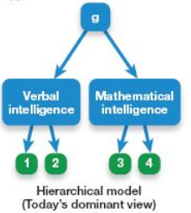
Hierarchical Models of intelligence
Combines aspects of the 2 previous approaches by nesting specific abilities under g. The current modern idea is that g is split and then further subsplit into smaller categories.

Crystallized VS Fluid Intelligence
Cattell – Horn Model
Divides g into 2 sub-types
      - Crystallized Intelligence:
Applying previous knowledge; facts, problem solving schemas, mostly depends on the long term memory
      - Fluid Intelligence:
Ability to deal with new situations, using the skills of inductive reasoning, creative problem solving. Depends on efficient CNS, using mostly the working memory
Different brain areas are activated when the two brain areas are used
Suggests that fluid intelligence may become crystallized. Over the course of one’s life, they move from using fluid intelligence to crystalized. One gains experience with more problem types, which becomes crystallized intelligence, potentially leading to wisdom
While crystallized intelligence remains strong, fluid intelligence declines into late adulthood

Carrol’s Three Stratum Theory
This combines the multiple abilities, the g factor, and the crystalized and fluid into one

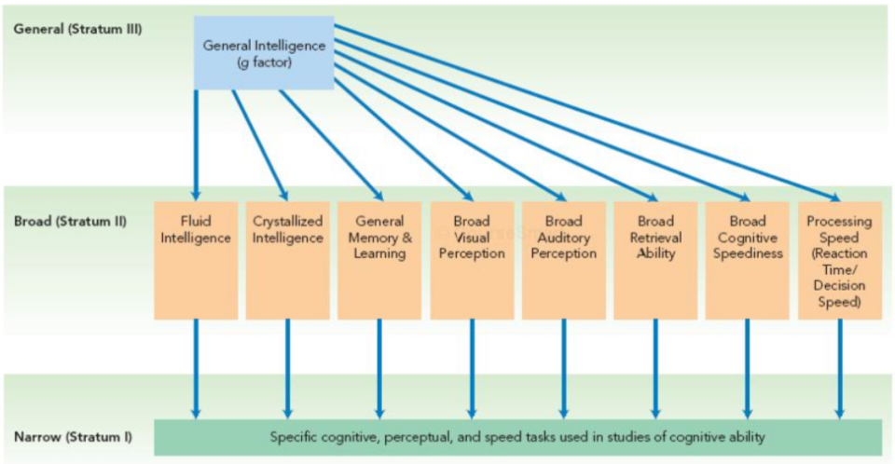
The g underlies 8 intellectual factors; this is different from Thurstone’s original primary mental abilities. These 8 intellectual factors underlie about 70 specific cognitive abilities, the more a factor is influenced by g, the farther to the left it is in the model

Cognitive Process Approach

Cognitive Process Theories:
Explore the info processing and cognitive processing that underlie intellectual ability

Triarchic Theory of Intelligence:
There are 3 types of intelligence, and there are 3 major cognitive components that underlie them
            - Metacomponents: higher order, complex processes. Related to planning, framing the problem, formulating strategies.. Intelligent people tend to spend more time framing and planning while less intelligent people jump right in.
This is mostly related to fluid intelligence
            - Performance components: processes to actually perform the task. The ability to retrieve appropriate memories, schemas from the long term memory and perceptual processing. This cognitive process uses strategies outlined by the metacomponents
            - Knowledge – Acquisition components: allows us to learn from experience, store info and combine new and old info
Cognitive components 2 & 3 are both related to crystallized intelligence
The Triarchic theory also has 3 types of intelligence associated with it
      - Analytical intelligence (book smart): academic, traditional intelligence
      - Practical Intelligence (street smart): skills needed to cope in everyday life, to manage yourself and others
      - Creative Intelligence (creativity): mental skills needed to deal adaptively with novel problems
The theory states that the 3 types of intelligence are distinct

Gardner’s Multiple Intelligences
States that the current definition of intelligence are too limited,

Instead stating that there are 8-9 intelligences
            - Linguistic
            - Logical/mathematical
            - Naturalistic
            - visuospatial
            - Musical
            - Bodily – kinesthetic
            - Interpersonal: understanding and relating well with others
            - Intrapersonal: understanding self
            - Existential: philosophical, spiritual, cosmic intelligence

Emotional Intelligence
The ability to read other’s emotions, respond appropriately , motivate oneself and be aware and regulate one’s own emotions

This consists of 4 major abilities:
              - perceiving emotions
              - using emotions to facilitate thought
              - understanding emotions
              - managing emotions
Positives:
- better in careers, marriages, and child rearing,
- less depression, anger, anxiety
- better at setting and sticking to long term goals
- more life satisfaction
Criticisms:
- claims that isn’t really intelligence and would prefer term emotional competence
- claims that the positives have little scientific backing

Jan 21st, 2015

Measuring Intelligence
Intelligence Testing
The most popular tests are the Wechsler Tests, consisting of the WAIS and WISC tests. The WAIS-IV test includes 4 index scales
              - verbal comprehension
              - perceptual reasoning
              - working memory
              - processing speed
These 4 index scores are given along with a full scale IQ score
The WISC-IV (the test aimed at children) has one difference in the indexes, and that is freedrom from distractibility instead of working memory.

Other Tests
- Stanford Binet Test
- Woodcock – Johnson: includes specific tests for crystallized vs fluid intelligence
- Sternberg Triarchic Ability Test: measures the three forms of intelligence (analytical, practical and creative)
These tests demonstrate how theories can influence how intelligence is tested

Testing Aptitude VS Achievement
Achievement Testing: examines what a person has learned so far, largely focused on crystallized intelligence. Its very difficult to write a tst that doesn’t use some sort of past knowledge.
Aptitude Testing: goes beyond prior learning by examining the individual’s future potential for learning. Largely focused on fluid intelligence. Supposedly more fair

Key Concepts in Psych Testing
These three concepts are involved in all psychological testing
      - Reliability: a measure of how consistent a measurement is
a. Test-Retest Reliability: how stable scores are overtime
b. Inter-judge Reliability: would different people agree on the same scores
c. internal consistency: do the section in the test all measure the same thing
      - Validity: How well a test measures what its suppoed to
a. Construct validity: does the test measure the construct of interest? This section also deals with if theres anything other than intelligence that might affect scores
Construct: intelligence
Operational definition: scores on the test
b. Content validity: does the test measure all aspects of ____
c. Criterion related validity: does score correlate with something meaningful

      - Standardization: developing control variables and developing of norms
a. Define controlled testing procedures: everyone should take test under same conditions
Static Testing: typical type of testing, question and answer
Dynamic Testing: some tests involve the examiner giving the individual new information and seeing what they do with it
  - Developing Norms: establishing normal bell curve for different populations

Flynn Effect – Changing Norms
This refers the phenomenon of stead, population level increases in intelligence over time. While average is always 100, the average increases
While it is not known why this occurs, several guesses include: better nutrition, technological advances and more complex environmental demands

Intelligence, Culture and Ethnicity
While the WAIS includes general knowledge taught in Western schools, other types of intelligence like building a shelter would qualify under practical intelligence.

Non Western Intelligence
Because so many aspects of intelligence testing rests on language, methods of not using language to test intelligence has been developed.
There are 2 methods
      - Non – culture knowledge: typically measuring fluid intelligence
      - Create measures tailored to skills valued by a particular culture: hard to find tests

J Phillipe Rushton
Suggested that there were innate distinct racial effects on intelligence.
Richard Herrnstein suggested the same thing.

Race and IQ
There are racial differences in IQ, when using the north American standard, the Japanese average was 111.

Reasons for the difference in test results
            - Test Bias: tests largely based on euro-american culture.
Outcome bias: how much a test underestimates a person’s true ability
Predictive bias: whether a test successfully predicts criterion measures for some but not others
            - Stereotype Threat: when negative stereotypes about a group cause group members to underperform on tests. This occurs because when people hear the stereotype, they don’t want to reflect poorly on the group, hence part of time spent worrying and less attention to actual test.
            - Environment: Ethnic minorities in Canada and USA tend to experience different environments,
            - IQ: IQ has a high heritability coefficient (0.7). But different between groups or over time aren’t necessarily genetic, could be attributed to the environment
There are early childhood intervention programs that helps disadvantaged kids that don’t do much for middle to upper class kids. This is because of availability of books.

There are two view on how IQ changes that directly influence the grades of kids
Entity Theory: intelligence is fixed
Incremental Theory: idea that intelligence can be shaped by experience, practice and effort
Other factors that induced IQ gains are:
- less emphasis on fact memorization, and more on how to learn, critical thinking and application.
- Teach specific cognitive and problem solving skills that underlie success in a given subject
- Teaching how to learn

Dweck (2002)
Did experiment that showed the kids who believed in incremental theory had improved their grades and were more likely to keep trying to experiencing difficulites.

Jan 26th, 2015

Sex Differences in Intelligence
There are no difference on average in general intelligence (g), but there are slight differences in average performance on certain cognitive skills.

Male
Males have an advantage on tasks involving:
- Spatial measures
- Target directed motor skills
- Mathematical reasoning (problem solving)

Females
- Perceptual speed
- Verbal fluency
- Precise manual task
- Mathematical calculations (arithmetic)

Sex differences could potentially be explained by:

Environmental explanations:

Socialization: boys and girls are steered into sex typed activities that will eventually lead to differences on skills they develop

There is some evidence that cite evolutionary environment that human ancestors had to go through

Biological Explanations
Structural differences in the brain: boys have more grey matter that could potentially allow for better mental rotation while girls have more white matter, which could potentially lead to better verbal skills
Hormones:
Organizational effects: relatively permanent effects of hormones on the structure of the body and brain (usually in the mother’s womb)
Activational effects: immediate, temporary effects of hormones that come and go with its presence/absence

Hampson & Kimura (1988)
Hormonal Fluctuation Studies

Studied the effects of endogenous hormone fluctuation on various performance tasks; including perceptual & motor tasks and mood survey.
Women were tested twice, 6 weeks apart. Once during the menstrual phase – low estrogen and low progesterone – and once during the mid – luteal phase (higher levels of both)

The results showed that during the menstrual phase, women were significantly better at perceptual tasks and worse at motor tasks
There were no significant difference in mood, so mood could not account for the differences.

Separate study of oral contraceptive users showed even greater differences
As well, sexual orientation has an effect on throwing tasks;
heterosexual males > homosexual males
homosexual females . heterosexual females

Activational effect can also be found for testosterone fluctuation in males, intermediate testosterone equaled better spatial performance.

Brain and IQ
Overall, brain size increases through evolution.
Modern research is looking at the brain again
              - Einstein had a smaller than average brain, however, he had a bigger and denser parietal lobes for math and visuospatial functions. People with higher g scores have larger frontal prefrontal parietal lobes
              - Rather than skull size, MRI of actual had correlation of ~0.6 with IQ score
              - Brain Connectivity: speed with which the brain transmits information does correlate with IQ
              - Brain Metabolism: intelligent people’s brain use less glucose when they are thinking hard, meaning that smarter people use their brains more efficiently.

Extremes of Intelligence

Intellectually Disabled (IQ <~70)
This encompasses 3-5% of North Americans.
Mild Disability (50-70): is the most common. These individuals can still hold a job, raise family
Moderate (35-50)
Severe (20-35)
Profound (<20)
IQ is no longer the sole determinant this, current tests also include measures of adaptive functioning.

Causes
      - Genes: heritability; the most common for mild disability. Profound disability doesn’t run in familiies, but mild disabilities does
      - Accidents/Diseases/Drugs: things that happen during pregnancy

Intellectually Gifted (Top 10%, IQ >130)
Many are exceptional in one area, and not as exceptional in other areas.
Training at a early age causes changes in structure and function of certain brain parts. The earlier the training, the greater the change. These brain changes can carry over to other areas of their lives, (eg musical training leads to better language and reading)

Eminence (fame or recongized superiority)

3 factors to Eminence
            - Highly developed mental abilities related to the person’s chosen field
            - Can come up with creative unconcentional ideas
            - Motivational and dedication; working harder and more dedicated than those people who are just gifted.

Motivation & Emotion

Motivation
This is defined as something that Influences direction, persistence and vigor of goal directed behavior

Instinct Theory
Instinct: inherited predisposition to act in specific predictable way when encountering a stimulus. This is a genetic basis, and not learning.
Modern theories emphasize adaptive significance in human behavior (eg, humans are social because this produced a fitness advantage)

Homeostasis and Drive Theory
Homeostasis: internal physiological equilibrium that the body maintains.
              - sense changes and send signals to control center
              - control center activates response (control center has a set point)
              - response restores equilibrium (responses can be physiological or learned)
Drive Theory: disrupted homeostasis gives rise to tension, this motivates individuals to act in order to reduce the tension. This drives helps the individual maintain homeostasis.
Allostasis: motivation in anticipation of future needs

Incentive Theory
Incentive: environmental factors pulls you to do ____. Individual wants incentive, therefore one does ____. While this isn’t a biological need, but rather a desire.
Some behaviours can be explained by drive and/or incentive theory

Expectancy Theory
This theory states that some incentives hold more value. As well, some people have different values for some incentive. This is a very cognitive approach
Motivation = expectancy x incentive value
Expectancy: how much one believe a given behavior will actually lead to the incentive (goal)

Intrinsic VS Extrinsic Motivation
Modern cognitive theories also differentiate between the two
Intrinsic: performing an activity because you want to
Extrinsic: motivation to obtain an external reward, or to avoid external punishment

Intrinsic and extrinsic are on a continuum, some behaviours can be partially motivated by both factors

Overjustifcation effect: giving a person a extrinsic reward for something they intrinsically enjoy tend to decrease the intrinsic motivation and also decrease the frequency of the behavior.

Psychodynamic Theories
Unconscious urges = motivation
Conscious urges = ways to channel the urges in to socially acceptable actions
Modern ideas include other needs such as self esteem and belonging

Humanistic Theories:
This theory is all about personal growth and self actualization.
Deficiency needs: motivate actions related to physical and social survial
Growth needs: motivates us to develop our potential. Leads to self actualization
Maslow’s Hierachy of needs can be split into deficiency needs and growth needs
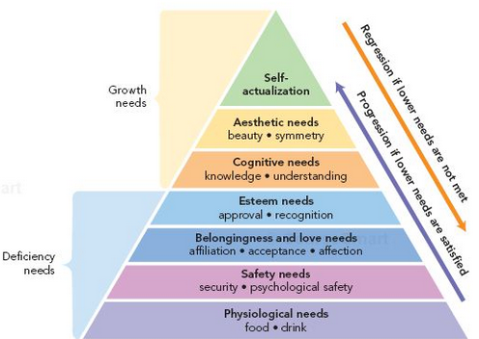

The modern humanistic perspective states is the:
Self – Determination Theory:
This theory states that psychological well being requires:
      - competence: need to master new challenges, skills
      - autonomy: need to be in control of decisions
      - relatedness: desire to form meaningful bonds

Jan 28th, 2015

Hunger and Weight Regulation

Metabolism & Homeostasis
Metabolism: Rate of energy/caloric utilization
Basal Metabolism: the base amount of energy the body needs, accounting for about 2/3rds of the body’s energy demands

There are several mechanisms that try to maintain homeostasis
Short Term: hunger vs safety signals
Long Term: based on body fat content

Three Notes About Hunger
            - Hunger not directly linked to energy levels:
One isn’t hungry when they’re low on energy and feel full when energy levels restored
            - Typically, hunger happens before energy levels gets low
            - Set point theory vs setting point

Set Point Theory
Says that there is a given weight range, fat level that our body thinks is optimal. This determines what body shape you have

Settling Point Theory
Similar idea, but body doesn’t return to set point, but settles on a new point. (ie, trying to lose weight, as more weight is lost, it becomes harder and harder to lose weight, body adapts)

Hunger Signals
There are 6 molecules, make a chart
Hunger is not just stomach contractions, even if people without stomach still feel hunger/safety.

Glucose
Body’s major source of immediately useable fuel
Hypothalamaus and liver monitor blood glucose levels, and when low, liver converts stored molecules to glucose.
Drop-Rise Pattern: this pattern of blood glucose seems to be involved in initiating hunger

Peptides
Here are hormones released by intestines
CCK (cholecystokinin): released by small intestine, acts as appetite suppressant
Ghrelin: released by small intestines and stomach, major signal for hunger in humans; increases hunger, highest levels before meals

Appetite/Weight Signals
Leptin:
These are hormones secreted by fat cell, the more fat cells, the more leptin. This decreases appetite and increase energy expenditure. This is a long term signal, unlike CCK.

Genetically altered mice, one with gene mutation that makes no leptin, and the other group lack leptin receptors, and both sets of mice become obese.

Hunger and the Hypothalamus
Early research:
Lateral hypothalamus: turns hunger on, stimulation of this leads to hunger. Lesion here leads to refusal to eat
Ventromedial hypothalamus: hunger off, stimulation leads to stop eating. Lesion here leads to nonstop eating

Modern research:
Paraventricular nucleus (PVN): seems to integrate both short term and long term signals to influence metabolism.
neuro-peptide Y is released by neurons here, it’s a powerful appetite stimulant. Leptin inhibits neurons that release neuro-peptide Y.

Psychological Aspects of Hunger

Stress
Stress modulates ghrelin, which increase hunger
Stress suggests that one views an upcoming situation as somehow threatening.

Attention
When one is distracted eating, they typically eating more
Wansink (2005)
Bottomless Soup Bowl

Two groups were told they could eat as much as they wanted to till they were full.
One group had the bowl continually refilled from a tube at the bottom of the bowl without them noticing while the other refilled their own. The ones that had their bowl refilled automatically, they ate 70% more than those who refilled their own bowl. But this group believed they ate the same as others.

Food Taste and Variety

Food Taste
Good tasting food positively reinforce for eating, usually increases good comsumption, and increases dopamine through the anterior cingulate cortex

Food variety:
Same food over and over and the food loses incentive value. Greater variety equals more food consumed.

Social Context

Social Facilitation
Hosts (ie grandma) encourages people to eat more. More time at the table equals more food eaten

Modelling:
One eats what others eat; whether that’s more or less

Impression Management:
Self conscious control of behavior so that one will be seen a certain way

Culture and Hunger
Cultural factors influence food intake

Unit Bias:
tendency to assume that the unit for sale is an appropriate amount to consume.

Food Availability:
Scarcity limits consumption in impoverished areas, but food abundance in many countries leads to obesity

Body Image
Fallon & Rozin (1985)

Women’s Beliefs:
Think ideal is thin, think men prefer thinner than they actually do and that they are quite a bit HEAVIER than ideal

Men’s beliefs:
Think male ideal is quite muscular, think women prefer more muscular than they do, think they are quite CLOSE to the idea

The results showed that they men are quite satisfied with their figure
The women feel pressured to lose weight.

Objectification Theory
Says that western culture teaches women to view their bodies as objects, and restrict food in order to restore self-esteem.

Obesity
Definition based on BMI.

BMI
Weight (kg)/height(m)^2
Overweight = 25 – 29.9
Obese = 30 or more

This is a societal trend due to:
              - abundance of cheap, high fat food
              - culture emphasizes value (buying in bulk to save money)
              - Technology advances leads the person to spend more time sitting

Anorexia
This is self-starvation that comes with intense dissatisfaction with body.

Activity Anorexia:
This is when body weight drops and both food and exercise becomes more reinforcing

Activity as Reward and Punishment
For Acivity anorexic rats, wheel running is reinforced.
Other studies show conditioned taste aversion to tastes followed by exercise.

Studies shows that rats show a conditioned place preference for rooms in which they exercised vs didn’t exercise in
Naloxone injections blocks opioid receptors, which also blocks conditioned place preference formation.
Exercise leads to endogenous opioid receptors. Drugs also show conditioned aversions and preferences

Genes and Weight
Weight has a genetic component, with heritability coefficient 0.4 and 0.7
~200 genes involved, but a combination of genes and environment

Weight Control
Nutritionally rich foods make people feel more full than equal volumes of junk food.
Environmental cues can induce hunger via ghrelin.
Appetizers such as snacks before meals actually increase the amount one eats at the meal. The variety increases insulin, drops glucose and increasing hunger.

Sexual Motivation
Evolution may have selected for individuals for whom sex was enjoyable.

4 – Stage Sexual Response Cycle
      - Excitement phase: blood pumping (vasocongestion)
      - Plateau phase: respiration, heart rate, muscle tension continue to build
      - Orgasm Phase: rhythmic contractions
      - Resolution phase: returns to normal

February 2nd, 2015

Sexual Motivation

Physiology (Hormones) and Sex
Hypothalmaus: this controls the pituitary gland, which in turn regulates the gonadotropin secretion; this signals the sexual organs to release sex hormones
The sex hormones are:
Androgens: masculine hormones (testosterone)
Estrogens: feminine hormones (estradiol)

Organizational Effect of Hormones
Hormones have 2 types of effects:
            - Organizational Effects: relatively permanent effects on the structure of the body and brain (eg. Critical period for male genital development)
            - Activational Effects: immediate temporary effects that come and go with hormone presence/absence (activational effects of sex hormones start at puberty).
Andriogens are most influential in sexual desire. A baseline of testosterone is needed for drive to happen, when testosterone producing organs are removed, a gradual drop in sex drive occurs.

Fantasy & Desire:
Arousal isn’t just physiological. This can trigger arousal and possibly orgasm in some. Most people fantasize at least occasionally during sex as well.

Psychological factors also inhibit desire. Stress, anger, distrust, fatigue and other issues are emotional reasons which lead to inability to become aroused.

Sexual dysfunction:
Some have the desire, but have difficulty becoming or staying aroused. This is defined as chronic impaired sexual functioning that distresses the person. This can sometimes be attributed to performance anxiety, or past negative experiences.

Cultural Norms
Marquesas Islands vs Inis Beag
Marquesas island culture is super for sex
Inis is against.

Gender Roles
Accepted attitudes and behaviors for males and females in a given society.
These change with time. For example, friends with benefits came about in the mid 90s.
Sex Guilt: negative emotions and feelings for having violated culturally-accepted standards for appropriate sexual behavior.

Porn
Watching, reading, listening can trigger arousal.
Watching a person undress is the 2nd most appealing activity for men

Heiman (1975)
Students listened to audiobooks of different categories, including erotica. They then measured gential and self reported arousal. Men and women become aroused by explicit sex descriptions, but not other conditions. This is the highest for both when the story focused on the female, and she initiated the sex.

Men are more likely than women to report enjoying porn.
Exposure to lots of porn can change attitudes about sex. For example, more liberal attitudes like cheating. As well, possible dissatisfaction with own sex life as porn may create unrealistic expectation.

Exposure to normal porn leads to higher likelihood of overt sexual activity.
Exposure to aggressive porn (depicting violence against women)
Rape Myth: initial resistance force enjoyment?
There are 2 theories about porn and assault:
      - Social Learning Theory: essentially observational learning, predicting that porn increases aggression
      - Psychodynamic Theory: The Catharsis principle says that inborn aggressive and sexual desires build up and up and gets safely released by viewing or fantasizing about such acts. Which predicts that porn decreases aggression
Donnerstein & Berkowitz (1981)
Showed male student videos about non sexual, consensual, rape myth, rape. These males were then intentionally angered (or not) by a female. The males were supposed to give the girl administer electric shocks as the girl gets questions wrong.
The result is that the groups that watched the videos that depicted the rape myth administered higher intensity shocks, whether the men were angered or not.

Sexual Orientation
Early work by Kinsey in 1948 says theres a scale
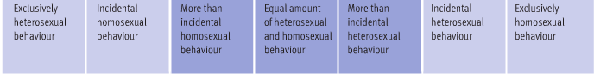
Modern work says that there are 3 dimensions of sexual orientation:
            - Sexual Behaviour:
            - Sexual Attraction
            - Self – Identity:
Determinants of sexual orientation:
              - environment? (societal pressure)
              - Biological? (some genetic basis) (people who are more genetically similar tend to be more likely to be homosexual)

Achievement Motivation

Achievement Need
Desire to accomplish task, to attain excellence. This can be driven by one, or both of these reasons:
      - Motive for Success: want to master a skill
      - Fear of Failure: avoid making mistakes, don’t want to be seen poorly
Both motivates together are worse than just the first reason. This is due to fear of failure leading to anxiety which leading to choking.

Achievement Need:
The difference in individual motivation depends on intrinsic motivation as well as the situation
High achievers perform no better than low when a task is relaxed or easy. The difference comes when there is a challenge or a high importance to the task.
High achievers try hardest when they think they’re personally responsible for outcome, perceive some risk of not succeeding or may receive performance feedback.

Family and Cultural Influence

Parenting and Achievement Need
Parents that encourage reward and achievement but don’t punish failure have high achievement need.
Parents that assume success and punish failure have low achievement need.

Culture and Achievement Need
Individualistic culture leads to desire personal success
Collectivist cultures leads to desire to meet family expectations, as well as desire for personal success.

Achievement Goal Theory
Combines parenting and culture achievement needs with intrinsic and extrinsic.
Mastery vs Performance: intrinsic and extrinsic
Approach vs Avoidance: motive for success vs fear of failure

4 Types of Achievement Goals
        - mastery- approach: want to master the task, learn as much as you can
        - mastery – avoidance: avoid mistakes, or doing something poorly
        - performance – approach: competitive focus: outdoing others, being noticed
        - performance – avoidance: avoid losing, being outdone

Sex differences in Motivation Style
Men are more likely to report performance – avoidance goals than women.
Women more likely to report mastery – avoidance.

This also predicts course grades, course evaluations.
Mastery-approach: do well, consider the exams positive kind of challenge, say course is interesting
Performance – approach: actually score higher, but less enjoyment out of the course
Performance – Avoidance: think everything is terrible

Motivational Conflict
Sometimes, there is a need to balance motivation.
When something is attractive, one approach it. Closer you get to the goal, desirability increased as there’s a stronger pull towards it

When something is undesirable, avoid it. Closer you get to the negative outcome, the more repellent it becomes (stronger avoidance). Avoidance increase faster than approach.

Approach – Approach Conflict
One must choose between 2 attractive options. Moving towards one option makes it more desirable, according to the motivational conflict listed above, and that option dominates.

Avoidance – Avoidance Conflict
One must choose between 2 undesirable options. Moving toward one option makes it seem more repellant, then one avoids, then end up back where you started.

Approach – Avoidance Conflict
Involved being both attracted to and repelled by the same option.
The most stressful part is the approach, but the avoidance gets super strong, so then they back off, but then the negative aspects seem lower, so approach again. The point where the avoidance motivation equals the approach motivation is called the point of maximum conflict.

Double Approach Avoidance:
Being attracted to and repelled by each of 2 different options
Example:
Living in the country = fresh air, but long commute
Living in the city = noisy , but night life

Delay Discounting:
Incentive value decreases with greater delay
Example: study now for exam or watch tv? As exam approaches, incentive to study increases.

Feb 4th, 2015

Emotions
3 part definition
              - positive or negative feelings
              - consist of cognitive, physiological and behavior reactions to events (these events can be both internal or external)
              - have relevance to goals and motives
Emotions have adaptive value
- fear, anger (part of the flight or flight” response to threatening stimuli
- excitement, happiness and love; possible adaptive benefit in mating
- direct attention to important events

The 4 Common Features of Emotions
      - Response to Stimulus/Event:
Remember that this can be to internal or external events. All sorts of emotions, from happy, to proud, to in love
There might be a biological preparedness for some emotions
      - Cognitive Appraisal:
How we personally interpret something influences our emotional response.
By changing the appraisal can change someone’s emotional response to something. This emotional response is somewhat determined by past experiences and learning and partly by cultural norms.
      - Physiological Response:
The body’s nervous system reacts on a bunch of levels
        - Autonomic Nervous System (made up of 2 componenets)
          - Sympathetic nervous system: prepares the body for stress, preparing the fight or flight response, controlling multiple parts of the body to respond
          - Parasympathetic nervous system: slows the body down and brings it back to normal levels.
These 2 systems work together to maintain homeostasis.
Polygraphs (lie detectors) work on the assumption that lying causes anxiety
Stress related sympathetic effects may be enough to cause a heart attack in those with weaker hearts
Parasympathetic Rebound: following prolonged periods of intense emotion, some may have excessive parasympathetic activity where their hearts might actually stop beating
  - Endocrine System: this system releases hormones when the sympathetic systems becomes activated. Similar effects to the sympathetic nervous system, but longer lasting.
  - Neurotransmitters: there are different neurotransmitters released based on the person’s mood
  - Brain Structures: basic emotions is controlled by the limbic system. Emotional regulation takes place in the prefrontal cortex.
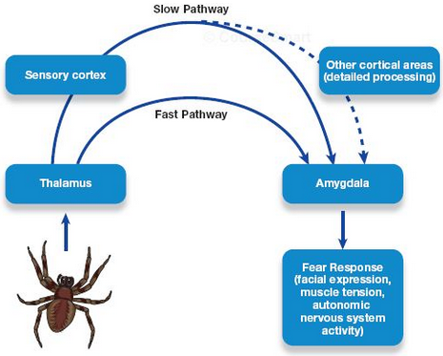
However, there’s another kind of emotion called the unconscious emotion, which we feel upset before we even see something
2 Pathways of Emotion
Joseph LeDoux proposed there are 2 pathways of emotion, explaining the idea of unconscious emotion.
    - Sensory info goes to the thalamus, which in turn, sends it to the amygdala. The cortex not being involved means this process if unconscious. This activates the sympathetic nervous system for a fast response
    - Sensory Cortex and other cortical areas process the sensory signal by deciding on the appropriate emotional response and then signals the amygdala. This is a slower, conscious emotional response.

The two pathways can result in 2 simultaneous emotional responses. Empirical data also supports this model, after conditioning for specific faces and loud noises, the amygdala activates when the faces are presented subliminally.

Lateralization
The brain is lateralized with respect to emotion, the left activates positive and the right activates negative.
This difference in activity reflects the individuals difference in affective style.
This includes the threshold for emotional response, speed, strength and duration of response.
If there is more baseline left prefrontal activity, individual more sunny and happy
If there is more baseline right, individual more negative.
Anything that increases left and right activity from the baseline induces positive and negative emotional responses

- Behavioral Response

Expressive Behaviours: these including any emotional displays such as facial expressions, or empathy when another’s expressive behaviours trigger the same emotional response within another
Instrumental behaviours: behaviours or actions that help achieve a goal.
Expressive behaviours might actually contribute to a species survival as noted by the fact that many animals have similar expressions. One example is that the expression of anger prevents a fight and helps both parties survive.

Fundamental emotional Patterns
Some expressions are innate and similar across all cultures. This is further proven by children that are blind and deaf from birth.
Most suggest that there are 8-10 basic emotions, and others are combinations and are of greater or lesser intensity of the basic ones.
However, some people are more stoic( (blank faced). The accuracy for an individual is much higher when we can see context. Women are usually better at judging expressions, but men can be just as good.

Culture and Universal Expressions:
Norms for emotional expression differ between cultures. These rules typically say when and how their emotional expressions should be expressed.

Kinesics
This is the study of communication through body movement, posture, gesture.
While gestures are very much culturally determined, other signals are a little more universal. One example is relaxation vs tension, with relaxation as casual limb position, usually spreading them or leaning back.

Instrumental Behaviours:
Behaviours or actions that helps achieve a goal.
5 broad categories:
- Move toward (eg. Love)
- Move away (eg. Fear)
- Move against (eg. Anger)
- Helplessness
- Submission
Success of behavior depends on how appropriate the action is, how well its done and level of emotional arousal. The function is an inverted u, too little or too much is both bad.
Depending on the task complexity, different emotional modes are needed
Complex tasks remain calm
Simple get amped up

Theories of Emotions
      - James – Lange Somatic Theory:
Suggests that conscious emotions arise as a result of physiological responses
      - Cannon – Bard Theory:
Suggests that both physiological and emotional responses must be controlled by the brain. Either one is caused by the other. Tested theories by severing nerves from internal organs to brain in animals, found that they still exhibited fear. This means that the James Somatic Theory is wrong, as brain can still feel emotions
Facial Feedback Hypothesis:
Suggests that the brain interprets these signals to decide what emotions we are feeling.

Strack
Had people rate how funny the cartoons were, half the group held a pencil in their teeth and had to simile (forcing smile), this group found the cartoons funny
      - Cognitive – Affective Theories:
Emotions depend on one’s interpretation of whatever is going on.
Schacter’s Two – Factor Theory of Emotion:
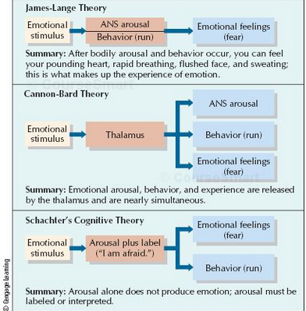
Says that there are 2 key ingredients to determine emotion.
        - physiological response: this is how strongly you feel
        - cognitive labeling: what you feel (example, if someone scares you, depending who it is, how funny it is)
Valins & Truax
Males shown nudes, while viewing, heard amplified heartbeat that they thought was their own. Heartbeat become louder and stronger when certain slides were shown. Afterwards, when asked to rate which slides were the most attractive, it was consistently shown that they choose the ones where their heart was pounding the hardest.
This shows that

Dutton and Aron:
Attractive female research assistants approached males as they crossed one of the two bridges, either the capilano suspension bridge (that one in BC) or a sturdy cedar bridge
Participants completed a questionnaire, and wrote a short story about a photo given to them. The ones that had an increased heart rate more likely misinterpreted as attraction
The people in the group that were on the suspension bridge were more likely to have sex in their story and were more likely to call up the hot female research assistant.

Feb 9th, 2015

Human Development

Developmental Psychology:
This field examines changes as we change, including biological, physical, psychological and behavioural processes.
Studies may use different types of designs; cross sectional, longitudinal, sequential

Designing a Study
Cross Sectional Design:
People of different ages all tested at the same time. Compare different age groups (cohort) to compare abilities
Advantage: data can be quickly collected
Disadvantage: people grow up and influenced by different factors

Longitudinal:
Repeatedly test the same group as they age.
Advantages: cohort exposed to same historical time
Disadvantage: long time to complete, sample shrinks as people move or due.

Sequential Design:
Combines previous approaches, tests multiple cohorts, repeatedly over time.
Advantage: most comprehensive
Disadvantage: time consuming and costly

Prenatal Development
There are 3 periods of prenatal development:
            - Germinal: about 2 weeks, this is the first period that marks growth from zygote (the fertilized egg)
The act of implantation, where the egg attaches to the uterine lining happens somewhere from the 7th-9th day.
            - Embryonic (5 weeks):
Egg now called embryo
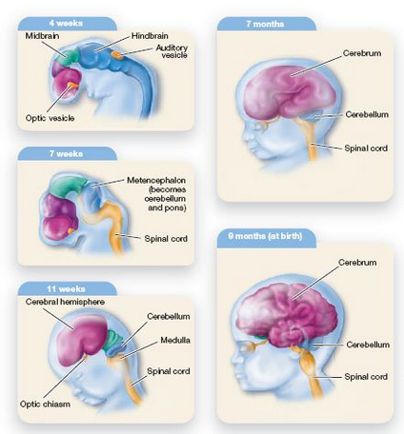
Placenta; filter for nutrients into umbilical cord, and umbilical cord; carries nutrients and oxygen to embryo, developed.
This stage, the organs, brain and muscles develop, buds for limbs, and basic parts of the human body begins to form. The heart is beating by week 8.
            - Fetal (9 weeks – birth)
Now called fetus.
3rd month, the lungs expand and contract and sex visible on ultrasound
2nd trimester mother feels movement and brain mass increases
3rd trimester fetus spends more time awake
Age of Viability: likely to survive, even if birth is premature (at least 24 weeks)

Sex Determination
Women have XX chromosomes
Men have XY, with sperm determining the sex of the baby. The Y chromosomes contains gene for testis determining factor (TDF) for developing testes.

Environmental Effects
Teratogen:
An environment agent that causes abnormal prenatal development (such as harmful chemicals)
The effect depends on specific activities of the teratogen, its dose, heredity, time of exposure.

Some common teratogen:
- Rubella (german measles)
- STDS
- Alcohol (can lead to fetal alcohol syndrome)
- Nicotine
- Heroin and cocaine

Perception and Learning

Prenatal Senses:
Even before birth, most senses are quite well developed.
DeCasper and Spence (1986)

Asked mothers to read Cat in the Hat aloud for last 6 weeks of pregnancy. 2-3 days after birth can change what it hears based on how it sucks on its soother. When given choice between Cat in the Hat vs new rhyme, most children who hear Cat in the Hat preferentially chose to hear a familiar story.

Prenatal Learning
Learning and habituation and recovery also happens in the womb. The fetus responds a lot to a new stimulus and gradually less for repeated stimulus.

Newborn Senses
TOUCH: Newborn reflex to touch on mouth, hands, feet, also turns towards touch on cheek
SOUND: Prefers sound of mother’s voice at birth, and orient attention towards off center sounds.
TASTE: Sweet taste preference at birth, and develop liking for salty at 4 month
SMELL: smell preferences affected by mother’s diet during pregnancy
VISION: gradually gets better vision as they age.
When given options of things to look at, complex > simple shapes, prefers mother’s face, new>familiar

Visual Development:
Visual abilities develop both quickly and slowly:
By the age of 4, vision reaches peak condition (20/20)
- 2 months improve focus and color vision
- 3-4 months gestalt principles of closure and proximity
- 3-12 months depth perception
- 3 months binocular cues
- 5-12 months use pictorial cues
- 6 months improve acuity, scanning and tracking

Auditory Development
Sound localization
There is a U shaped trend, starts good, then worsens (2 months) , then back
Not sure why there’s a drop

Phoneme Perception:
Ability to detect all the world’s phonemes at 1-2 months, but lose most by 12 that’s not in own language

Music:
At 2 months old, when repeated the same melody 15x, baby can distinguish between it and new melody.
At 6 months old, prefer pleasant (consonant) pitch change to an unpleasant (dissonant) one.

Just like in utero habituation, new borns habituate to old stuff, and recover for novel things.
According to DeCasper & Spence, babies who had heart Cat in the Hat wanted to hear it again and again. This not only demonstrates in utero audition, but represented operant conditioning in newborns (rewards vs punishment).

Classical conditioning in newborns also happens, when babies pair touch with milk, they cry when touch is not followed by the expected milk.

Feb 11th, 2015

Physical, Motor and Brain Development

Physical Maturation
Genetically programming biological process that governs growth of body and brain. While the rate varies between kids, but happen in the same order.

Cephalocaudal Principle:
Develop typically proceeds from head downwards

Proximodistal Principle:
Development typically proceeds from center of body outward

Brain Development
As one grows, they gain more connections and brain weight, from 25% to 90% at the age of 5
Synaptogenesis: this is the formation of new synapses.
Happens through life, but happens super fast until 2.
Brain regions mature at different times, simple processes happen before complex.
Example: heartbeat and breathing, visual, auditory system, language, frontal cortex

Synaptic Pruning: lost of unused neuron connections.
This happens until adolescence, and improves neuron efficiency.

Other aspects of brain development include:

Myelination:
When the neurons becomes coated in glial cells, improving conduction speed.
Rates of myelination differ fro different parts of the brain. Simple first.
As well, increased specialization of 2 hemispheres

Motor Development
While most children follow the same order, the age at which they reach the age is different.
Some skills the u-shaped pattern, where they become worse and then reappear later

Environmental Effects
Some environmental and cultural influences includes:

Food:
Breastfeeding usually leads to improved cognitive performance
Malnutrition leads to stunted growth and brain development

Touch and Social Interaction:
Enriched environment leads to thriving babies
Touch and massages to the baby accelerates weight gain in pre-term babies, as well as increasing neurological development.

Culture/Experience:
Some cultures frequently help babies stand, these babies tend to walk earlier
Other cultures actively restrict walking, these babies walk later (~2 years)

Three Notes on Environmental Effects

Biology sets limits on how much environment can actually influence
Good nutrition can help achieve max potential height

Environmental influences can be powerful
Can drastically change a life

Biology and environment interact
Enriched environment leads to enhancing brain development
Enhanced brain development, better able to learn and benefit from enriched environment.
This becomes a cycle

Cognitive Development

Jean Piaget
Stated that children are little scientists and want to understand their world.
Believed that children’s thinking changes qualitatively with age, that all kids make similar kinds of mistakes at same age because they use similar kinds of thought

There are 2 principles that Piaget thinks are involved in the learning process
Assimilation: new experiences are incorporated into existing schemas (an existing way of thinking, or previous knowledge)
Accommodation: process by which schemas are adjusted or changed. When something or an idea throws the kid into disequilibrium, kid adjust scheme and restores equilibrium.

There are 4 major stages that children pass through

Sensorimotoer Stage:
Kids learn about the world through senses and actions.
The kid develops object permanence, realizing that when something disappears, it still exists at the 8 months
The kid however, doesn’t understand perseveration until 12 months. The kid however doesn’t understand perseveration, the A not B error.

Preoperation Stage (5-7)
Child can represent the world in words and images, but don’t quite understand the mental operations yet. This symbolic thought allows pretend play.
The child does not fully understand conservation yet (mass, volume, quantity)
One common mistake with the principle of conservation is the idea of reversibility. Child’s thinking typically shows irreversibility, and they cant mentally undo changes. As well as the idea of centration, that they can only focus on one dimension.

The child is very egocentric
Believing that others see the same thing they do
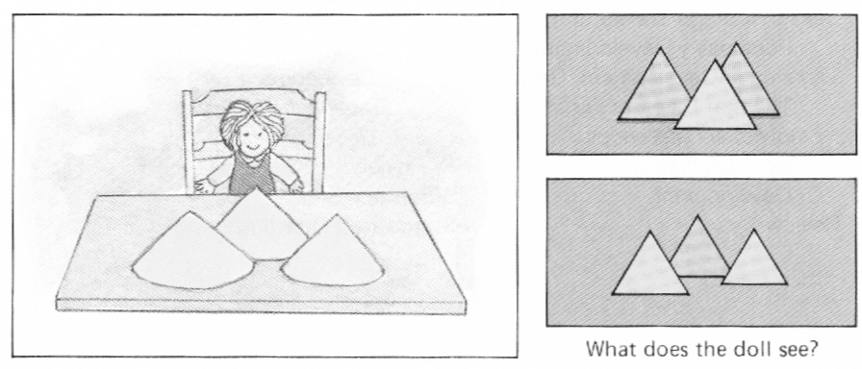

Concrete Operational Stage (7-12)
Child can do tasks that involve concrete objects or situations. Serial ordering is one of these tasks; one example is lining objects in terms of biggest to smallest.
While the child can mentally represent a series of actions, they cannot yet do hypothetical or abstract problems.

Formal Operational Stage (12+)
Individual can think logically about both concrete and abstract problems. Begin enjoying brainteasers that require creative thinking.

Piaget’s Theory VS Modern Perspectives

Piaget’s theory was that kids progress through these set stages. But what was different from Piaget’s thoughts was that these modes of thinking tend to arise much earlier than expected.
Some even say that kids are born with core knowledge
When kids at the age of ______ were shown different pictures that showed different number of objects, they were able to correctly match the number of objects

Cognitive development isn’t consistent within each stage
Some kids are at one stage in some task and another stage with respect to other tasks. This adds a new dimension to Piaget’s theory as there shouldn’t be a qualitative change in how children think from one stage to next

Culture determines ideas of cognitive development
Piaget’s own western upbringing influenced his idea of a cognitive endpoint as the ability to think logically and scientifically. Other cultures can hold different values as the endpoint, such as interpersonal relationship skills.

Lev Vygotsky
This man noted that there is a sociocultural aspect to cognitive development.
Introduced the concept of:

Zone of Proximal Development
This is the difference between what a child can do on their own vs with guidance.
It was stated that social interaction that promotes cognitive development, and that teachers and parents should always be teaching at the high end of this zone in a process called scaffolding.
Example, using slightly advanced language at home.

Information Processing Approach
Says that development is all about better processing of information, that developing better methods of information processing strategies is development.
Processing speed and ability to inhibit: impulsive responses increase with age (example, faster results in visual search tasks).
Information search strategies also become more advanced, progressing from random to systematic comparison.
Working and long term memory improves

Theory of Mind
This is the ability to understand or relate to what other people are thinking. This is very related to Piaget’s egocentrism.

Feb 23rd, 2015

Social and Personality Development

Early Emotions
Early childhood emotions are mostly determined by facial expression behavior.
With interest, disgust and happiness coming first.

By 6 months, a sense of joy and surprise are developed.

By 18 months, a sense of self is developed. This leads to the development of embarrassment, envy and empathy.

By 2-3 years, self conscious emotions are developed.
Shame, embarrassment, guilt, envy and pride all build
These emotions require self-identity and knowledge of performance standards. While initially adults let children know when to feel these, by 3, the child self-evaluates.

Emotional Regulation
This is a part of emotional competence and influences social relationships and popularity.

Temperament
This is a biologically based general style of reacting emotionally and behaviourally.
Most infants can be classified in 3 catergories
        - 2
        - Difficult: irritable, fussy, dislike of new situations
        - slow to warm up: lest active, mildly negative response to new situations
An individual’s temperament is not very stable over the first 2 years of life, but relatively stable at the age of 3.

Erikson’s Psychosocial Theory
Says that personality developes through 8 stages with related crises. While each crisis is present through life, the response during the stage determines how the child reacts for the rest of their lives.
            - Trust VS Mistrust (Age 1):
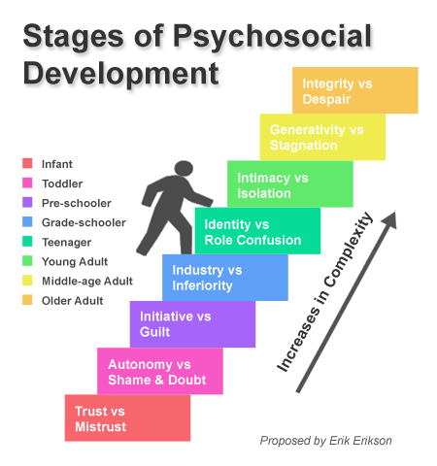
depending on love, attention and response to the infant’s needs, they develop trust or mistrust towards the world
            - Autonomy VS Shame/Doubt (1-2):
Restricting demanding parents during toilet training leads to develop of shame or doubt in one’s own abilities.
            - Initiative VS Guilt (3-5):
If curiosity is encouraged, the child will show initiative instead of feeling guilty about their desires and suppress questions
            - Industry VS Inferiority
Praise and encouragement for mastering skills vs failure and no praise leads to the kid to be either feel competent or inferior
This theory says that personality is not fixed in childhood, but instead, each stage of life offers something new

Attachment
This is a strong emotional bond that develops between children and their primary caregivers.
Some animals form this bond by imprinting. This sudden biologically primed form of attachment occurs during a critical period.

Human attachment, while not involving imprinting or any critical period, does involve a sensitive period that is the first few years of life.

Harlow’s Experiment
Rhesus monkeys separated from parents at birth and given 2 artificial mothers, one with a wire frame body with milk bottle attached and the other had a cloth cover over the wire frame.
The better development of the monkeys exposed to the mothers with the cloth cover demonstrated the importance of contact comfort.

Development of Attachment
Bowlby’s 3 Phases of Attachment
              - indiscriminate attachment: the child cries, smiles and vocalizes for everyone in order to receive care
              - discriminate attachment (3 months): child directs more of these behaviors towards familiar caregivers than strangers

              - specific attachment: by 7-8 months, child has first meaningful attachment to specific caregivers, giving the child a secure base for exploration.
Stranger anxiety (6-18 months):
Separation Anxiety (1-3)

This amount of these anxieties felt by the individual is in an inverted U function, meaning they feel less anxiety as they grow older. This might be an evolutionarily adaptive trait

Stranger Situation Test:
The child is tested in a range of new situations
Child plays with toys in new room with caregiver (mother) there
Stranger enters and interacts with the child, the child then leaves with the stranger. Stranger than comes in and interacts with the child. Stranger leaves. Mother returns

How the child acts in these sorts of situations determines what kind of attachment they have
              - Securely Attached: when caregiver’s around, willing to explore something new and reacting positively to new people.
              - Anxious – Resistant: afraid even when mom is around, upset when mom leaves and remains upset upon return
              - Anxious – Avoidant: few signs of attachment, doesn’t cry when mom leaves and doesn’t seek contact on return

Attachment Deprivation
Isolated monkeys, when artificially inseminated by a highly abusive parent, returned to the colony at 6 months and acted indifferent, terrified or aggressive
Isolated human children when rescued, some react well to foster family and become well adjusted. This is more possible when the children are rescued younger.
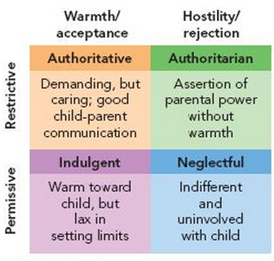

Parenting Styles
There are 4 styles of parenting, authoritative is the best and neglectful is the worst

Gender Identity
This is the sense of femaleness or maleness that becomes a central part of our personal identity. This develops at the age of 2-3.
But the problems with gender identity is called gender constancy.

As a gender identity develops, kids acquire sex role stereotypes, such as appropriate behaviors or characteristics for boys and girls to have. These beliefs are acquired through socialization. By age 7-8, strong gender stereotypes happen.
During adolescence, some teens develop a more flexibly thinking about gender, that one can have both masculine and feminine traits.

Sex Typing:
Treating people differently based on their genders.

Moral Development

Kohlberg’s Stage Model
When analyzing reasoning in moral dilemmas, 3 main levels of moral reasoning have been identified.
              - Preconventional Moral Reasoning:
Focused on punishments (stage 1) and rewards (stage 2)
              - Conventional Moral Reasoning:
Conforming to social expectations (stage 3) and laws/duties (stage 4)
              - Postconventional Moral Reasoning
Well thought out moral principles
Stage 5 recognizes the importance of societal law, but also individual rights
Stage 6 bases moral judgements more on abstract ethical principles that are viewed as universal.
Moral development across cultures all show shifts from pre-conventional to conventional from childhood to adolescence.
A person’s answers don’t always reflect on their level or stage

Developing a Conscience
To conform to cultural moral standards:
              - must understand moral rules
              - control impulses to engage in wrong actions
              - experience negative emotions when breaking rules

Conscience:
Internal regulatory mechanism, when parental relationship is positive, the child internalizes the parents’ values to develop a conscious
Fearful kids internalize quickly and easily
Fearless kids internalizes better when they have a secure attachment with parents

Feb 25th, 2015

Adolescence and Puberty

Puberty:
Biologically defined period of rapid physical maturation. This is regulated by the hypothalamus sending signals to the pituitary gland to produce hormones

Adolescence:
Broader, social construction encompassing the period between childhood and adulthood.
Different cultures have different ideas of what makes an adult

Adolescents

Adolescent Egocentrism:
Teens spend a lot of time thinking about themselves and their social circumstances, holding onto a distorted sense of importance and uniqueness.
This distorted image of importance is brought about by 2 components:
  - Personal Fable: overestimate own uniqueness (example, no one has ever felt a love like this)
  - Imaginary Audience: feeling like you’re always on stage and everyone notices how you look and behave.
The more egocentric someone is, the more risky behavior they show
At this stage, teens’ abstract and hypothetical reasoning becomes enhanced. This is stated in Piaget’s formal operational stage as well where the indiivudla can begin to reason inductively and deductively.
Their information processing becomes more advanced, with speed, working memory and ability to ignore unimportant information continuing to improve.

Personality
Erikson’s psychosocial model says that teens in this stage undergo identity vs role confusion, going through identity crisis, unsure of who they are and what they believe in.
There are 4 possible identity status classifications:

        - identity diffusion: haven’t gone through crisis and are completely unconcerned about it. These individuals eventually begin to think about their identity
        - foreclosure: also haven’t gone through crisis, instead, using their parent/peer’s values. These individuals usually begin to reconsider these values they’ve adapted from other people
        - moratorium: currently undergoing identity crisis
        - identity achievement: have undergone the crisis and successfully resolved it, resulting in coherent values
Erikson’s model might have been too simple, there are multiple components to identity:
              - attributes: (gender, ethnicity, social group)
              - personality characteristics: (shy vs friendly)
              - goals and values
Typically, identity in some components are achieved before others. Changes in personal circumstances can trigger new crisis, leading the individual to reevaluate their prior goals and values

Social Psychology

Attributions and Attributions Theory

Attribution
An explanation of the cause of a person’s behavior

Attribution Theory:
A description of how we go about explaining the causes of people’s behavior. This theory doesn’t necessary concern itself with the right answer, but rather, the process of how an individual formed an opinion about the cause of a behavior.

Internal VS External Attributions
When trying to assign a reason for someone’s behavior, we decide first if the cause is internal or external

Internal Attributions
The inference that a person is behaving a certain way because of something about that person (personality, intelligence, effort; this is not always a consistent output)

External Attribution
The inference that a person is behaving a certain way because of something outside the person (environment, situation, task difficulty)

Kelley’s Co-Variation Model
This model says that we look for a pattern between the behavior and the presence or absence of possible causes in order to determine if it’s an internal or external behavior
To use this model, 3 key variables will be looked at:
  - consensus: focused on the environment. This states the degree to which other people’s behavior is similar in that situation, if there’s a high consensus, it usually leads to a high possibility of external attribution.
  - Consistency: focused on the individual. This states the degree to which the person behaves similarly in similar circumstances. High consistency leads to high possibility of internal attribution.
  - Distinctiveness: the degree to which the person behaves the same way to different stimuli. Low distinctiveness (treating everyone the same) leads to high possibility of internal attribution

Biases in Attribution
Attributions are not always correct, most don’t take a perfectly scientific approach of the co-variation model.

Fundamental Attribution Error:
The tendency to over attribute the behavior of others to internal causes

Actor – Observer Bias:
The tendency to over attribute other’s behavior to internal causes while attributing our own behavior to external causes

Self Serving Bias
The tendency to attribute one’s own success to internal characteristics while blaming failures on external causes

Ultimate Attribution Error
Judge members of our in group (gender, ethnicity, political part, team) more favorably than members of another out group.
This is a self serving bias, but applied to group, that members of the in group must be succeeding due to intelligence while members of the outgroup are succeeding due to external circumstances.

Making an Impression
The classic saying, you’re never get a 2nd chance to make a 1st impression turns out to be good advice.

Primacy Effect:
Tendency to attach more importance to the initial information we learn about a person. While new info can change an opinion, but it has to work harder to overcome initial impression
Applying this to information about set and schemas:
Perceptual Set: readiness to see stimui in a particular way
The primacy effect and mental sets work much in the same way, activating specific schemas.

Schemas: mental representation of something
Once a schema is activated, its easier to fit out perceptions to match that schema than another, also plausible one

Self Fulfilling Prophecies
While perceptual sets mean we see what we expect to see
This theory says that our expectations cause us to subconsciously act towards others in a way that brings about the expected behaviour

March 2nd, 2015

Attitudes and Behaviour
Attitudes affect behavior
Having a certain attitude towards someone is going to affect your behavior towards them

Behaviour relationships strongest when opposing incentives/pressures are weak
General attitudes predict general behavioural trends, not specific behaviours.

Behaviors can also affect attitudes
Example: when one participates in the world’s most boring lab, but experimenter says that its important that people come in with a good attitude. So when you see the next person waiting outside, you tell them it was really fun. For these troubles, the experimenter pays you either:
Group A - $1 for lying
Group B - $20 for lying

Results were, the people that were paid LESS money thought the task wasn’t as bad, or maybe even mildly enjoyable.

Cognitive Dissonance Theory
This is when 2 thoughts/beliefs don’t match, and thus the uncomfortable dissonance feeling (im typically truthful VS I just lied)
To reduce dissonance, one tries to justify behavior (by changing one thought/action or add a new one
In terms of the study, if a person lied for a dollar, the person thinks that the money wasn’t a lot of money, and justifies the fact by saying it was kinda fun, and thus not that big of a lie
For the second group, they think they’re justified by lying through receiving money.

Self Perception Theory
This states that the individual looks at what they just did and infers their attitude about the situation.

Social Influences on Behaviour

The Presence of Others
Triplett made a simple observation that people go faster when racing against others than they do against the clock (themselves)
It was identified that the audience doesn’t have to be competitors. This applies to little kids and even ants

Social Facilitation and the Dominant Response
But some people choke under pressure, this can be explained through a theory

Zajonc’s Dominant Response Theory
Says that the presence of others increases arousal (psychological response, not actual arousal) and amplifies our dominant response (natural way abilities tend to sway towards)
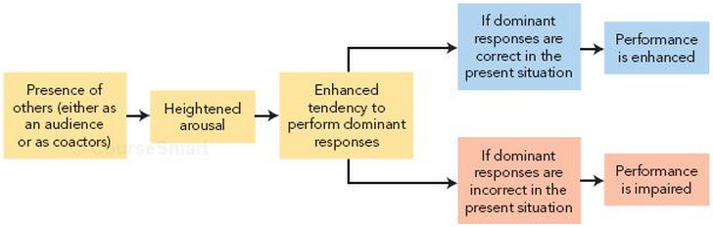
This amplification here is called social facilitation:
If bad, tend to be worse
If good, tend to be better

Social Norms
These are shared expectations about how people should think, feel and behave in a particular social position
While some normal are formal, some are unwritten rules

Role conflict
When 2 people’s social roles have conflicting sets of norms

Conformity
Adjusting individual behaviors or attitudes to a group standard

Normative Social Influence:
Conforming in order to be accepted by the group (basically peer pressure)

Informational Social Influence:
Conforming because we think others might be right
Asch’s line length experiment:
5 others all give wrong answer, and when it’s the individual’s turn, they conform on 37% of trials

Obedience to Authority

Milgram Obedience Study
Participants told they were doing experiment on the effects of punishment on memory.
Participants served as the teachers and read out memory questions, and the learners, in the other room, answered via intercom. For each wrong answer, the teacher would administer an electrical shock.
They also heard the learners in pain, asking to be let out.
If the teacher asked to stop experiment, the head researcher would ask them to continue 4 times. The experiment ended after the teacher persisted after the 4 responses.

Results: 65% of people went all the way to fatal shock

Factors Affecting Obedience
  - remoteness of victim (20% drop when you can see person, 35% drop when you make physical contact
  - proximity and legitimacy of authority figure (20% drop when the man in the white coat leaves, or gives order by phone) (drop when ordinary person takes over in room)
  - Cog in a wheel (when someone else actually flips the shock switch, obedience tends to increase (up to 93%)
Personal characters make little to no difference

Resisting Compliance

Compliance Techniques
Methods of manipulating people into doing something they do not wish to do.

Norms of Reciprocity:
Compliance techniques takes advantage of the fact that we feel like we owe someone who’s been nice to us

Door in the Face Technique
Don’t initially ask for what one wants, instead, asking for way more. The person being asked feels the request is unreasonable, and says no. The person then asks for a much smaller amount, much more reasonable by comparison.

Foot in the Door Technique
Don’t ask initially for what the person wants, but for a very small thing. The person may end up saying yes, and once they’ve done it, add on a larger request

Lowballing
Similar to foot in the door, but the bigger request comes after the person has agreed to the smaller one, but before they actually do it

Crowd Compliance and More

Deindividuation
Loss of individuality or sense of anonymity that comes with being in a crowd. This usually tends to result in a less inhibited behavior

Social Loafing
When people have to work together, they almost always do less than they would alone.
This is especially common when:
        - people think individual performance wont be monitored or noticed
        - goal is less valuable
        - group is less important

Social Compensation
Working harder when part of group because you expect others to be incompetent or lazy

Group Polarization
When like minded people discuss an issue, the average opinion of group members become more extreme.
When like minded people in a room, lead to crazy conclusions.
How this applies to normative social influence is that individuals take extreme positions in order to gain approval
How this applies to informational social influence is that individuals hear new arguments and think, wow, they must be right

Groupthink
When group members suspend their critical thinking because they are striving to agree, this creates illusions of unanimity.
This is most common when:
High pressure to reach a decision quickly
Little to no outside input
Directive leader with personal agenda
High cohesiveness, ability to work together

March 4th, 2015

Attractiveness

Beautiful Bias
Tendency to assume that attractive people have more positive personality traits than unattractive people

Averageness
The averaged face is more attractive than the average face. This average means a mathematical average vs normal everyday person.
The preference for average comes from enhanced facial symmetry, which indicates good genes. Most diseases in womb change the facial symmetry. Clear skins suggests good genes, fewer wrinkles suggests youth and or less stress over lifetime.
Problems with the averageness is that attractive is more than just comparing someone to the prototypical face, the averaged face is only 7/10. The most attractive faces tend to systematically differ from the average.
Facial Sexual Dimorphism where sex typical faces are rated as highly attractive.

Sex Typical Faces

Female Faces
Estrogen increase lip size, cheeks size, inhibits jaw growth to give sex typical face
Estrogen is also associated with likelihood of conceiving a child.

So men evolved preferences for feminine face.

Male Faces
Female preferences are more complex

When some guy created an average face, he made it more masculine or feminine, and most women showed a preference for the feminized male face.
But 25% also prefer the masculine face

Testosterone is responsible for masculinized face, but high testosterone also hurts immune function.

Handicap hypothesis:
If the guy is still healthy despite his high testosterone, he must have amazing genes
Higher testosterone also associated with higher aggression, lower warmth, lower trustworthiness, lower cooperation, lower friendliness, worstparenting skills
EP suggests women evolve ways to maximize reproductive potential too; try to get best genes and best provider/father of child

Mating Market Hypothesis
Three ideas
            - Desirable people have more money
            - Desirable people cost more
            - People try to spend their mating currency to get the best possible mate
Some will be too expensive
Some will be too cheap

Matching Hypothesis
People will end up with someone with similar levels of attractiveness to themselves

Mere Exposure Effect
Repeated exposure to a stimulus typically increases our liking for it. Doesn’t depend on interaction, just exposure.

Love and Cognitive Arousal

Cognitive Arousal Model of Love
Suggests that passionate love involves both cognitive and physiological components. If we experience physiological arousal in the presence of someone desirable, may misattribute love as being the cause.

Transfer of Excitation
Transferring the reason from physiological arousal to a person.

Aggression, Prejudice and Discrimination

Aggression
Biological causes of aggression
Testosterone was mentioned earlier
Also included is the
- Amygdala
Aggression and fear
- Hypothalamus
Basic urges, including hunger an aggression
- Frontal Lobe
Impulsive murders, low baseline frontal lobe activation
- Serotonin
Kind of a chill neurotransmitters

Frustration – Aggression Hypothesis
Two main ideas:
      - frustration inevitably leads to aggression
      - all aggression is the result of frustration
Turns out both are wrong, frustration can also lead to despair, resignation…
2 other major theories about aggression

Social Learning Theory:
This is observational learning

Psychodynamic Theory
Catharsis Principle
Inborn aggressive and sexual desires build up. Need to safely discharge aggressive energy.
If no release, beware of over controlled hostility

Social Learning VS Catharsis
Most evidence favors social learning theory.
But other factors also come into play, personal characteristics

Discrimination: refers to overt behavior – treating people unfairly based on the group to which they belong

Prejudice: negative attitudes towards people because of their membership in a group
Can test bias with the implicit association test, using the principle that words that belong together make the people respond faster

Cognition and Prejudice
In-group Favoritism: favors member of our in group and attribute more positive qualities to us vs them
Out-group derogation: attribute more negative qualities to them
As well, out group homogeneity bias; they’re all alike, when combined with attribution biases and stereotypes leads to bad images

Roots of Prejudice

Realistic Conflict Theory:
Competition for limited resources leads to prejudge. Prejudice increases with a worsen economy. This applies to one’s in group, not just their own personal welfare.

Social Identity Theory
States that prejudice stems from need to enhance self esteem.
Self esteem is based on personal identity and group identity. Prejudice occurs when person takes pride at being part of an in group

Prosocial Behaviour

Altruism
Helping another without regard for self

Some say it doesn’t exist, but motivated by self-reinforcement (pride, satisfaction)

Empathy Altruism Hypothesis
Says altruism exists, is produced by empathy; the ability to put oneself in another’s position, feeling what they feel

Negative State Relief Model
Says altruism doesn’t really exist, instead people act a certain way to reduce their own personal distress. Even if one feels empathy, helping reduces the empathetic pain

March 9, 2015

Personality
The distinctive and relatively enduring ways of thinking, feeling and acting that characterize a person’s responses to life situations
Thoughts, feelings and actions all reflect personality
Components of identity distinguish individuals, these are behaviours that have internal causes, not external.

Psychodynamics and Personality

Psychodynamic Theory:
Looks at causes of behavior at the unconscious level

Psychoanalysis:
Analysis of internal (usually unconscious) psychological force

Freud:
Treated patients with conversion hysteria, blindness, paralysis with no physical causes
Under hypnosis, or free association patients would begin to remember past traumatic events
After remembering, symptoms disappear

Psychic Energy
Symptoms caused by the unconscious mind, and that personality is an energy system
Instinctual sexual and aggressive drives generate psychic energy which presses for releases
Over-reliance on defense mechanisms lead to maladaptive and dysfunctional behavior

Levels of Consciousness
            - Conscious:
Thoughts, perceptions and other mental events of which we are currently aware of
            - Preconscious:
Mental events not currently in awareness, but can be easily recalled
People think that the conscious and preconscious are the most prominent mental events
            - Unconscious:
Cannot be brought into the conscious under ordinary circumstances. These include unacceptable urges and repressed memories that only revealed when discharged

The Three Interacting Structures of Personality

            - Id (instincts) :
Only exists on the unconscious level, and is the source of all psychic energy. This part of the brain has no contact with reality, and has no sense of right and wrong
Operates using the pleasure principle that demands immediate gratification
            - Ego (reality):
Span all levels of the conscious, but functions mostly at the conscious level.
Tries to control the instincts of the id according to the reality principle
Tests reality to see when the id can safely discharge impulses, delays gratifciaiton until conditions are safe and appropriate

Communicates between the id and superego
            - Superego (morality):
Spans all levels of consciousness.
Learns moral values and ideals via identification with parents and through training of right and wrong
The superego, like the ego controls the id. But instead of delaying gratification by waiting for the right time to release impulses, the superego tries to block it completely

Conflict and Anxiety
The ego and superego are constantly fighting with the instinctive urges of the id.
When the id’s impulses threaten to get out of control, we feel anxiety
Typically, realistic coping strategies can help reduce anxiety, but when these strategies fail to reduce anxiety, the ego resorts to defense mechanisms.

Defense Mechanisms
This is the ego’s way to distort or deny reality
      - Repression:
the primary defense mechanism where the ego uses energy to push anxiety causing impulses down into the unconscious. These may be released in dreams or through slips of the tongue
      - Sublimation:
Another potential defense mechanism is channeling repressed impulse into socially desirable behaviours
This completely masks forbidden urges
- Displacement:
repressed impulse is then directed toward a safer substitute target
- Reaction Formation:
Repress impulse, release energy by doing exaggerated versions of the opposite behaviour
- Intellectualization:
Repress emotional response and treat situation as an intellectually interesting event
Example: gets dumped, and talks in rational manner
- Projection:
Repressed impulse is attributed to others
- Rationalization:
Create a false plausible explanation or excuse for an anxiety.
- Denial:
Refuse to acknowledge for the cause of anxiety

Freud’s Psychosexual Theory
Said personality is shaped by early experiences. There are psychosexual stages which is defined by which erogenous zone the id is focused on
Oral phase (weaning)
Anal phase (toilet training)
Phallic phase (resolve Oedipus complex)
Latency (develop social relationships)
Genital phase (mature social sexual relationships)

Deprivation or overindulgence at a certain stage leads to fixation; arrested development where focus remains on a particular psychic theme

When these ideas went through clinical observation, it received very little research as its hard to operationally define the impulses of the id

Neo – Analytic Approaches
Still psychodynamics, but psychoanalysts who disagreed with certain parts of Freud’s theories .
Placed too little emphasis on social and cultural factors
Too much emphasis on childhood sexuality, as well as too much emphasis on childhood in determining adult personality

Alfred Adler:
Says that humans are inherently social beings, and are motivated by social interest more than selfish urges
Social Interest: desire to advance welfare of others
Coined the striving for superiority motive, this motive drives us to compensate for real or imagined defects (inferiority complex) and become more and more competent

Carl Jung
Developed analytic psychology
Suggested the idea of the collective unconscious. Consists of memories accumulated throughout the entire history of the human race, and these memories are represented by archetypes.
Archetypes are inherited tendencies to interpret experiences in certain ways, often expressed in symobls

Object Relations Approach
Most common current neo-analytic approach. Focused on the mental images and representations that people have of themselves and others.
Results from early experiences with caregivers, and images become lenses through which all later social interactions proceed
Example: people who have trouble with social relationships have negative self-images and negative images of others

Bowlby’s Attachment Theory
This comes out of the object relations approach.
Those from abusive parents have mental representations involving punishment and rejection
Avoidant: dont want to get too close
Anxious: come across as too clingy/needy

Also attachment is related to emotional distress:
Avoidant and anxious is linked to depression
Anxious also linked to anxiety issues

Attachment and Abusive Relationships:
Zayas and Shoda (2007):
Study shows that victims and perpetrators of psychological abuse will have differnet mental models of what a relationship is.
Abused women were just as likely to choose an abusive male as desirable male.
Abusive males were most likely to choose women who were high in attachment anxiety (clingy)
Non abusive males were likely to chose women who were low in attachment anxiety

Psychodynamics is often criticized by science. Some ideas have been disprove and others can never be disproven

Humanistic Perspective
This perspective offers a positive view on the inherent dignity and goodness of the human spirit
Emphasizes consciousness, creative potential and striving of self-actualization; realization of one’s potential

Kelly’s Personal Construct Theory
This theory states that primary goal is life is to make sense of the world and find personal meaning in it
This is achieved via personal construct:
Cognitive categories that helps us organize and understand the world (each person has a personal definition of what being successful is)

Kelly focused on consequences of categorizing events in a certain way (ending a relationship can be interrupted many ways). If the construction leads to negative outcomes, then task is to find a more useful healthy construction

Developed fixed role therapy:
Basically assuming a role, acting and thinking like the person you would like to be

Roger’s Self Theory
Believed behavior is directed by conscious forces leading to self actualization
The self is an organized set of perceptions and beliefs about oneself, and once developed, but tend to maintain self concept.
So have needs for self-consistency (no conflict among self perceptions) and congruence (self perceptions and experiences match up)

When an incongruence occurs, there are two kind of responses by different individuals:
  - Well adjusted individuals:
Resolve the incongruence by modifying the self concept
  - Others:
Resolve incongruences by denying or distorting reality
The conclusion is that well adjusted people have a flexible self concept

Need for Positive Regard:
Rogers also believed that we are born with a need for acceptance, sympathy, love
There are two types of this positive regard

        - unconditional positive regard:
this kind of regard is independent of behavior and suggests that a person is inherently worthy of love
        - conditional positive regard:
when a child is given conditional love (love only if they meet certain standards), they develop conditions of worth that dictate self – approval or disapproval

Fully Functioning Person:
This is a person that has achieved self actualization, doesn’t hide behind masks or adopt artificial roles. Someone who can be true to themselves.

Research on Humanism

Self-Esteem:
How positively or negatively we view ourselves.
High self esteem: less susceptible to social pressures, better relationships, higher achievement
Low self esteem: anxiety, depression, possible physical illness

Esteem seems to be fairly stable over time and independent of gender by the time one is in adulthood

Esteem and Reactions
Success boosts self esteem, but only for those who begun with high self esteem
Positive life events correlate with better health for those with high self esteem
Mood regulation: when in a bad mood, people with low self esteem report less desire to improve mood. When in good mood, low esteemed individuals will deliberately seek to lower their excitement.
Expressive behaviours: expressive behaviours leaves one open to rejection, and those with low self esteem are less likely to engage in these

Conditions for developing high self-esteem:
- unconditional parental love
- clear guidelines for behavior
- reinforce compliance, but also allow child freedom to make decisions or express opinions within guidelines

Self Verification:
This is the attempts at preserving self-concept by maintain self-consistency and congruence.
Words and Self Consistency
Students given lists of words that they were told others had used to describe them, when asked to recall the words later, the students were more likely to recall words that were congruent with their self consistency

Even marital partner is affected by this, more likely to choose partner whose view of you is similar to own self concept. So those with positive self images are more likely to find someone who views them positively as well.

Self Enhancement:
Try to gain and preserve positive self-image

Culture and Gender:
Cross cultural differences in self-concept exist as an result of the way their culture is structured
Individualistic: defines self in terms of personal attributes (smart, honest)
Collectivistic: defines self in terms of social identity (is the eldest child, student)
Sex differences in self concept exist as well
In western culture (individualistic), gender schemas suggest males develop more individualistic concepts while women develop more collectivisitic

Humanism has received some criticisms, that it relies too much on self report (hence, not objective enough).
As well, its difficult to define self-actualization except in terms of produced behaviours.
Example: why did he achieve success? Self actualization. How do we know it was self-actualization, because he achieved great success.

March 11, 2015

Trait and Biological Perspective

Trait Theories of Personality
Trait theories try to identifty the basic classes of behavior that define someone’s personality. The problem is that there ar 18000 words for describing different traits.
There are 2 major approaches for trait theories:
            - Factor Analysis:
These look for descriptions and behaivours that are so highly correlated that they are probably reflective of the same underlying (basic) dimension of personality.

Cattell’s 16 Personality Factors
Performed factor analysis based on questionnaires of behavioral characteristics and identified 16 basic factors. This lead to the widely used Cattell’s 16 personality factor test.

Different trait theories often list different number of basic underlying personality dimensions

Eysenck’s Extraversion Stability Model
Originally only had 2 factors
  - introversion – extraversion:
inhibited, passive, cautious vs sociable, active and risk taker
  - stability – instability:
emotional stable, poise vs moody, anxious, easily feeling guilty
  - later added psychoticism self control
dimensions are independent of each other

5 Factor Model
        - Openness (to ideas):
Curious, imaginative, unconventional
        - Conscientiousness:
Organized, efficient, thorough
        - Extraversion
Sociable, adventurous, outgoing, enthusaistic
        - Agreeableness
Warm, sympathetic, trusting, forgiving
        - Neuroticism:
Tense, moody, unstable, anxious, lack self confidence

This is very similar to Eysenck’s model as extraversion is common, and neuroticism = unstable.
Conscientiousness and agreeableness sort of relate to eysenck’s later added psychoticism self control
Modern versions include 6 aspects for each of the big 5

Traits Biological Basis
Many people tried to link biology to traits
Eysenck said that personality dimensions were related to overall brain activation

Introversion – extraversion are caused by brain arousal levels, introverts are always over aroused, so they seek quiet to minimize over stimulation

Stability – Instability = speed of autonomic nervous system, unstable people have very rapid shifts in arousal

Neuroscientific Studies
Extraversion is correlated with the orbitofrontal cortex
Openness correlated with the dorsolateral prefrontal cortex activity as well as intelligence
This relates to novelty seeking dopamine levels
This is the only one that is related to intelligence
Neuroticisim is correlated with low activity insular cortex, superior temporal gyrus

Predicting Behaviour
Proponents say that your score on these traits capture core of personality.
Modern 5 factor test is actually the best as it includes 30 factors that fall under the big five
But these scores don’t predict specific behaviours well.
Part of the problem is that some traits aren’t very stable

Problems with Prediction

Stability of Traits
Some traits are more stable than others
Stable
- Introversion – extraversion
- Temperament traits
- Some habits of thought
- Optimistic vs pessimistic but only for negative events
Unstable
- Honesty
People may lie, cheat or steal in certain situations
- Conscientiousness
Person may be conscientious about some things but not others
More problems:
            - Traits Interact with Each other and Situation:
Many variables to take into account
Example: will this person steal? Looking at factors of agreeableness (honesty), extraversion, neuroticism (anxious)
            - Importance of the Trait to the Person’s Self concept:
Example, someone for whom honesty is central to will be stable across situations
            - People differ in self monitoring:
Self monitoring is the tendency to tailor behavior to what is called for by the situation

High monitoring means being attentive to situational cues and adapt behaviours
Extreme monitoring means changing completely from one context to the next
Low monitoring means acting in terms of internal beliefs, rather than external demands

Criticisms of the Trait Approach
Good:
Made progress in identifying, measuring classifying personality dimensions
Bad:
Much research tries to predict behavior based on a single personality trait
While very descriptive with little explanatory power (example, someone is outgoing and fun loving because they are high in extraversion)

Social Cognitive Theories
These theories combine behavioural and cognitive perspectives

The thinking here is that human (cognitive) and social environment provide learning experiences
Assumes that behaviours has both an internal and external cause

Reciprocal Determinism
A person, their behavior and their environment all influence each other

Rotter’s Model
Said 2 factors affect likelihood of a behavior
      - Expectancy:
How likely we believe certain consequences will be if we do behavior x in a given situation
      - Reinforcement Value:
How much we desire or dread that consequence
Locus of Control: how much personal control we have over our lives
Internal locus of control: believe life outcomes are largely under your control
These people tend to be more:
- self determined
- have better grades than equally intelligent people
- seeks information needed to succeed
- better self esteem
- cooperative, but independent
- healthy behaviors (exercising, eating well)
External locus of control: believes that own behaviours will do little and more about fate

March 16th, 2015

Albert Bandura
He was a major contributor of this approach, helped meld behavioral and cognitive perspectives
Bandura’s Bowling Game
Had 7-9 year olds play bowling game, they were told to reward themselves for performance, the amount of reward was up to the child.
Three groups, control seeing no model, one group seeing a model reward themselves for ony high scores, and the last group saw the model reward themselves for low or high scores.
The game was fixed, so the children received the same pattern of scores across all their attempts.

The results were that the control children took candy independently of their performance. And the children tended to adopt the reinforcement pattern of their model.
This demonstrates the power of self-reinforcement and self-punishment on behavior. The consequences are not just environmental, but instead have both a social and cognitive component.

Human Agency
This is the idea that humans are active agents in our own lives

We act according to 4 principles
            - Intentionality: we act with a purpose in mind
            - Forethought: anticipate outcomes, set goals
            - Self-Reactiveness: modify our behaviours or strategies or goals with necessary
            - Self-Reflectiveness: evaluate our own motivations, goals and values

Self Efficacy
Belief about whether you are able to perform the behaviours necessary to achieve a desired outcome
This is a strong predictor of actual performance
There are 4 types of information about efficacy beliefs:
      - Performance Attainment (Experience):
Past successes/failures in similar situations, very specific. This is the most important factor in self efficacy
      - Observational Learning:
Seeing someone else (similar to you) succeed or fail in similar situation
      - Verbal Persuasion:
Someone encouraging you
      - Emotional Arousal:
Can interpret high arousal as enthusiasm or as anxiety. Controlling negative interpretations leads to increased efficacy

Improving Self-Efficacy
            - Set specific behavioural (measurable) goals:
The goals must be measurable, and make sure that prorgress can be tracked.
            - Set difficult but realistic goals:
Moderately difficult goals motivate for a sense of accomplishment, but also give hope of success
            - Set performance goals (not outcome goals):
Performance goals keep the focus on the behaviours necessary to achieve the goal
            - Set positive goals (not negative goals)
Get better at x is better than stop failing at x
            - Set short term and long term goals
Short term goals can be sub goals leading to the long term goals
            - Set definite time spans for goals
Keeps you on track

Walter Mischel
Expect people to usually behave consistently. Often make excuses (external attributions) for other’s atypical behavoiurs
Mischel found consistency across situations is actually quite low.
Consistency paradox: people are consistently inconsistent

Mischel’s Cognitive – Affective Personality System
Essentially, both the person and situation interact to determine behavior. That while personality is relatively stable, the situation changes and because of the situation, leads to inconsistencies.
Also noted that people were actually consistent, but in a different way
If__Then___Behaviour Consistencies: behavior is consistent across similar situations.
Example: if bob is mad at his friend, he’ll yell. If he’s mad at his boss, then he’ll sulk quietly in a corner

Evalutation the Soc-Cog Approach
Highly scientific approach: when compared to other approaches, can easily define and measure constructs
Combines different approaches: combines the behavior and cognitive approaches, as well, many have successfully translate ideas from other perspectives into cog-behave concepts
Able to solve the consistency paradox

Personality Assessment

Personality/Social Website
These are not used in research and not a very good source of information. But the person does have full control of the information, so isn’t it accurate? The results say yes, there is high agreement with established measures
This also applies to how that person carries themselves personally, how their room is set up, their appearance..
This is a possible future of personality research.

Common Methods
      - Interview:
Focus on what was said and how it was said (tone, expressions, posture, general appearance, grooming, speech patterns). The validity partly depends on person’s honesty.
      - Behavioural Assessment:
Involves an explicit coding system. People trained to label specific behaviours. Count up frequency of specific types of behaviours. Don’t just focus on the behavoiur, but its frequency and conditions under which it occurs
      - Remote Behaviour Sampling:
Participants carry around small device (or phone), when it beeped (signal), the person recorded their thoughts, feelings or behaviours
Considered subjective
Response depends on researcher’s interests.
Data collected over weeks or months, allowing researcher’s to get a glimpse of patterns of behavoiur in real world
      - Personality Scales
Considered objective measures. Standard set of questions and used a scoring key
Some tests include validity scales that measure a person’s tendency to respond in socially desirable (or undesirable) ways
- rational approach: questions based on theory (example: what would be a good question to differentiate introversion from extraversion).
- empirical approach: previous research showed that introverts and extraverts answered this questions different (example: Minnesota multiphasic personality inventory is the most widely used personality scale)
      - Projective Tests:
Favorite method of psychodynamics, theory saying that unconscious is beyond awareness, projective tests help to reveal it.
Projective tests give ambiguous stimuli; assumes that interpretation ahs to come at least partially from within (you project your unconscious into it)
        - Rorschach inkblot test:
10 inkblots, 5 in color, 5 in B&W. Asks what they look like, or what they might be. Responses, including words, tones, gestures, mannerisms attitudes all recorded. The problem with this test is that the same response may be interpreted different by different examiners
  - thematic apperception test:
shown series of ambiguous pictures and asked what is happening. Stories are examined for recurring themes. Problem once again is non standard interpretation.

Personality Profiling
Idea is that people can piece together a very accurate profile of a person’s personality based on crime scene, apparent motives…
Amny countries including Canada use profilers
Compared to non-professionals, profilers show slightly more accurate predictions of future behaviours, but in some other instances, are actually worse
Profilers enjoy high level of fame and public credibility
Hit (predictions that are correct) are reported and memorable.
In one instance, one had 82% incorrect predictions

Forer Effect: made general statements are generally considered to be believable

March 18th, 2015

Stress, Coping and Health

Definition of Stress
Stress can be defined and viewed in 3 different ways
      - as a Stimulus: defined in terms of things causing it (these are stressors)
      - as a Response: defined as a reaction that may include cognitive, physical or behavioral aspects
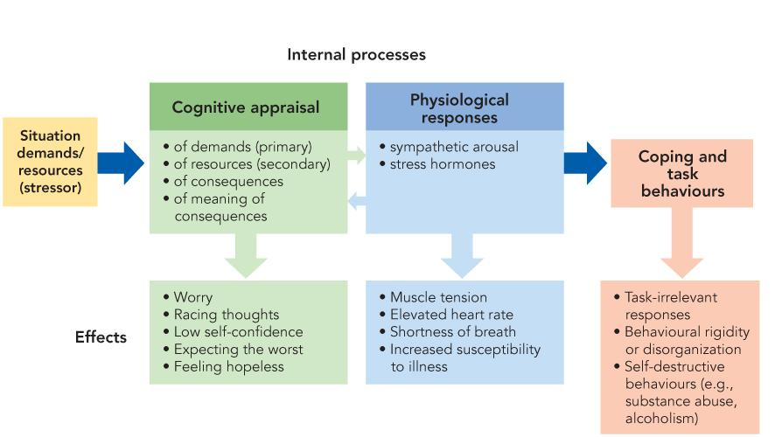
      - as an interaction: defined as an interaction between the person and situation. Person makes cognitive appraisals and has physiological or behavioural response in reaction to environmental demands (stressors).
Specifically, feel stress when we perceive demands as being greater than our available abilities or resources to cope with them. The greater the imbalance, the greater the stress

Stressors
An eliciting stimulus that places demands on us to adapt in some way
        - microstressors: daily hassles and annoyances
        - major negative event: happens at a more personal level
        - catastrophic event: unexpected catastrophe that usually affects many people
stressors not only differ in terms of intensity or severity, but also differ in
          - predictability: sudden unpredictable
          - duration: long lasting
          - controllability: no control over it
          - chronicity: happens repeatedly (wears you down to exhaustion)

Measuring Life Stress
How do we quantify the amount of stress a person’s been under?

Life Event Scales
Asks someone if any of the above has happened to them
                - indicating whether an event occureed
                - was it a major event or more of a day to day event?
                - Was it positive or negative
Modern stress definitions only refer to it in negative terms

The Stress Response
Stress response starts with cognitive appraisal; our perception of situation
There are 4 major aspects of cognitive appraisal
      - Primary appraisal (appraise the demands): what is the situation?
      - Secondary appraisal (appraise your available resources): can I deal with this? And how? Looks at ones level of knowledge, verbal skills, social skills, social support system
      - Appraise the consequences of not coping: how serious are the consequences, and how likely
      - Appraise the personal meaning: if you fail, what does that mean to you as a person
Each appraisal depends on your perceptions. Inaccurate perceptions leads to an inappropriate stress response. May account for variation between people
Physiological response comes after cognitive appraisal
If the demands are greater than the resources, physiological stress response occurs (blood pressure, skin conductance)
Even though the cognitive appraisal starts the process, physiological can change the appraisal too

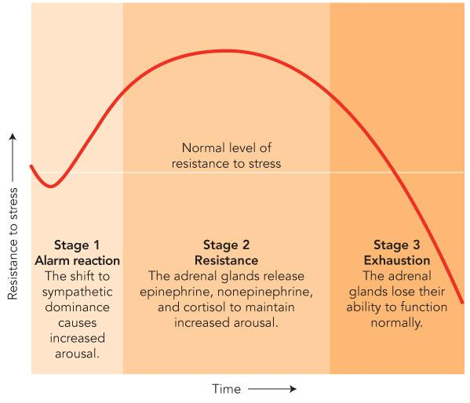
General Adaptation Syndrome
This is a physiological response pattern to strong and prolonged stressors
There are 3 phases

            - Alarm Reaction: rapid increase in physiological arousal.
Sympathetic nervous activation and stress hormones, with sympathetic system responding and cortisol (hormone) is released
            - Resistance: if stressor continues, body stays on alert. Resistance can last a while, but depletes the body’s resources
            - Exhaustion: stressor so strong or continues for so long that the body’s stores become dangerously low. Can result in collapse, illness or death

Stress and Health

Stress and Illness

Psychosomatic Illness:
Illness or condition caused or aggravated by mental factors, such as stress or internal conflict
This can be take form in immediate effects or long term health, such as increased risk of developing conditions
More stressors in life increases risk of chronic condition

Traumatic events can also worsen already existing medical conditions

Stress leads to illness in 3 ways
      - Impacted Immune Functioning:
      - Effects of chronically high stress hormones: damage artery lining through decrease in fat metabolism which increases chance of heart attack.
As well, deterioration of hippocampus impairs memory
      - Decrease healthy behaviours: more likely to stop exercising. As well as increased likelihood smoking, drinking using drugs.

Stress and Psychological Wellness
Some stressors are strong enough to have lasting psychological impact.
These include natural disasters, and wars
Rape Trauma Syndrome: leads to nightmares, fear, decreased sexual enjoyment that can last months or years

More common stressors are also related to psychological wellness. People who report more negative events on life event scales tend to also report more symptoms of psychological distress.
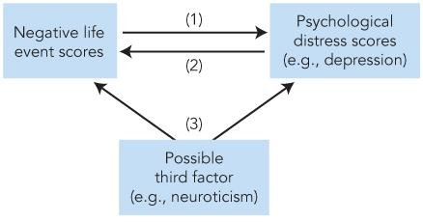
Neuroticism is related to both stressful events and psychological distress

Post Traumatic Stress Disorder
This is a severe anxiety disorder caused by exposure to traumatic life events
There are 4 major groups of symptoms:
            - severe anxiety, physiological stress response, distress
            - painful, uncontrollable re-living of the event
            - emotional numbing, avoiding stimuli associated with trauma
            - intense survivor guilt (if others died)
some may also show more impulsive and self-destructive behaviors
27.8& of Vietnam veterans develop PTSD
Civilians in war regions more likely to develop it

Women more likely to develop it
Human perpetrated trauma is more likely to produce PTSD than natural disasters

March 23rd, 2015

Vulnerability and Protective Factors

Protective Factors:
These are environmental or personal factors that help one cope more effectively with stressful events (ex. Social support network, coping skills, personality factors)

Vulnerability Factors:
Increase susceptibility to stressful events (ex. Poor coping skills, lack of social support)

Social Support
This is the knowledge that we can rely on others for help in a time of crisis
This is a major environmental protective factor

One study shows that those with weak social ties are 2x as likely to die during the study when controlling for age, smoking, blood pressure….

Baron et al.
Did study about spouses of cancer patients. Injected them with antigen to trigger immune response

The results showed a greater immune response for spouses with high self ratings of social support. The difference was especially high when high concentrations were injected.

For many, marriage is the primary social relationship.
Married individuals have better mental and physical health than same age unmarried people and tend to have better health habits and behaviours

In heterosexual marriages, men and women benefit unequally
When compared to married women, unmarried women are 50% more likely to die from heart disease, cirrhosis of the liver, certain forms of cancer and some other preventable diseases
Compared to married men, unmarried men are 250% more likely to die from the same causes

Social support protects against stress through:
            - Greater self-identity: greater sense of identity and meaning of their lives which leads to greater psychological well being
            - Reduced risk exposure: reduced social isolation and increases feelings of control over stressor
            - Peer Pressure to avoid maladaptive coping strategies: use of drugs, alcohol to deal with stress

Neuroscience and Social Support
Social Support affects stress through:
      - Those with social support may find fewer situations stressful:
fewer stressful situations means less stress. There might even be differences in amygdala activation when faced with stress
      - Those with social support may have support to recover faster/better during initial stress response:
Finds situation stressful, but have either lower stress response or faster recovery after. There might be a difference in prefrontal cortex because of emotional regulation which shuts down stress hormone system
Eisenberger study;
Paged students randomly over 10 days about most recent social interactions
These students later did the trier social stress task where they do:
- a 5 minute speech while videotaped in front of 2 other non-responsive students and told it’ll be analyzed by experts too
- Then must count backwards from 2083 by 13’s, and if there are errors, must restart

Aslo asked to do Cyberball where they play catch on computer with 2 other players (actually computer) while in fMRI.
    - game 1 where 50% of throws go to participant
    - game 2: receives 7 throws early then computer stops throwing to person. Exclusion causes social distress, frustration…
Measured cortisol levels and brain activity under stress conditions and the results showed that more social support results in less cortisol (less stress response)

The results for the cyberball task is that the more social support resulted in less activity in anterior cingulate cortex (including amygdala) that said those who felt more social distress tended to have greater amygdala response.

Social support results in decreased sensitivity and decreased response to potential stressors.

Coan et al
16 highly satisfied married couples
wife goes into fMRI and watches screen

red x means 20% chance of shock in 10 seconds
blue 0 means no chance of shock

There were 3 phases

        - wife holds husbands hands: resulted in decreased subjective stress rating and physiological stress response
        - wife holds male RA’s hands: partially effective, decrease in physiological response and less brain activatity in stress regions but less
        - no hand holding: high satisfaction with marriage resulted in less hypothalamus activity

Hardiness
This is a characteristic that help one cope with stress

3 C’s of Hardiness
            - Control: believe they have control over outcomes
            - Commitment: committed to work, families and other pursuits, believe what they’re doing is important
            - Challenge: see demands as challenge/opportunity, not threat

Resilience
Unexpectedly good recovery after stress or adversity, often includes positive personal growth.
Resilient people tend to use humor, positive emotions, social support or other forms as positive thinking. These kinds of behaviours aren’t as rare as originally thought

The difference between hardiness or resilience is one is for before stressor and one for after

Coping Self – Efficacy
This is the belief that we are able to perform the behaviours necessary to cope successfully.
Related to secondary appraisal
This is a very important protective factor and is specific to every situation’s demands

Bandura’s regular self-efficacy is influenced by:
-previous successful and failure in similar situations
-observational learning
-persuation
-emotional arousal

Optimism
This is associated with better adjustment to negative life events and fewer feelings of helplessness
Linked to better immune functioning and health
Optimists get half as many illnesses as pessimists
Pessimists die sooner
Pessimism at age 25 predicts poorer health beginning later in life, this can be attributed to optimists tend to engage in healthier behaviours

Personality Factors

Type A Personality:
Tends to be impatient, easily angered, competitive, and highly motivated
Displays behaviours through exaggerated sense of time urgency, rapid talking, aggressive or irritated by delays and obstacles

Type B Personality:
More laid back, patient, easygoing and relaxed

Type A personalities have about 2x the risk of coronary heart disease. This doesn’t seem to be due to high ambition or fast paced lifestyle, but due to negative emotion (time pressure of own making or anger at barriers to a goal) type a overreact to anger physiologically

In terms of the big 5 personality traits, conscientiousness is linked to good health

Spiritual Beliefs: Finding Meaning
Often helps in coping with stress, especially for losses, illnesses, setbacks

But can actually increase stress in some cases. Especially for marital programs, abuse, may add guilt, and pressure to stay in bad relationship
Can sometimes just result from perceptions, feeling like it was God’s punishment

Coping with Stress
Three types of coping strategies:
              - problem focused coping: attempt to confront and deal directly with situation or change the situation
              - emotion focused coping: try to manage the emotional response (include avoidance, denial, or grim acceptance)
              - seeking social support: turn to others for assistance and support
The most effective strategies are problem focused and seeking social support. Some emotional focused strategies involve avoiding or distorting reality which leads to poor adjustment

But some emotional focused strategies are good.
Example: identifying and changing irrational negative thinking , learning relaxation skills, physical exercise

In some cases, emotion focused may actually be the best strategy. This is when we cant change the situation, problem focused coping does little
Overall, all three are effective. Depends on situation, appropriateness of the technique and the skill with which strategy is applied. Better to have multiple techniques

Worst Coping Strategies
        - Self-medication: using unprescribed drugs to regulate negative stress related emotions. While effect of drug does lessen emotional impact of stress, the negative reinforcement cycle can lead to dependence.
        - Self-injury: deliberately harming oneself without suicidal intention
Sloan & Marx
Examined students who experience a traumatic event. Before the study, completed measures of stress, depression and reported number of sick days
Experimental group asked to write about traumatic event, control did not. Completed same measures, 30 days later

The results show more disclosure lead to less stress, depression and illness
Perhaps disclosure allows for extinction?

Gender, Culture and Coping

Sex difference in coping strategies:
Men often use problems focused as 1st strategy, perhaps due to socialization of male independence?
Women tend to seek social support as 1st option, women more likely to use emotion focused coping than men

Cultural Differences
North Americans and Europeans are more problem focused
Asian, Hispanic are more social support and emotionally focused
Asians avoid interpersonal stressors more due to cultural emphasis on interpersonal harmony

Mindfulness
Three components:
              - full and deliberate awareness of one’s emotions, thoughts, actions and environment
              - focus attention on present
              - experience each moment as it is, without bias or judgement based on expectations, wishes, fears
training can help reduce stress, regulate emotions, and improve health and well-being

Roasdf

Roeser et al
54 teachers get mindfulness training programs, 59 teachers assigned to control group
before the study, the groups didn’t differ in age, teaching experience or stress

At the end of the training, and after 3 months, the experimental group had less self-reported job stress, fewer symptoms of anxiety, depression, fewer symptoms of burnout

March 25, 15

Promoting Health, Preventing Illness

Behaviour & Illnesses
Most current major illnesses are due to misbehavior and environmental conditions (rather than infectious diseases)
50% of early mortalities from top 10 leading causes of death are due to preventable behavior

Health Psychology

Health Psychology:
This sector of psychology studies psychological and behavioural factors in health maintenance and illness prevention
Health Enhancing Behaviours:
Maintain or increases health (ex. Exercise, healthy diet)
Health Compromising Behaviours:
Promote development of illness (ex. Smoking, fatty diet)

Model for How People Change

Transtheoretical Model
Model of the processes by which people modify their behavior in positive ways. This change can be a result of one’s own ambitions or with help.
The model does not suggest that people go smoothly from one stage to the next, some go backwards and some people make repeated attempts before succeeding
There are 6 major stages in the change process:

      - Precontemplation:
No desire to change, often failing to see behavior as a problem. May deny negative consequences of behavior, or feel powerless to change
      - Contemplation
See problem with current behavior or desirability of alternative behavior. Still haven’t decided to change
      - Preparation:
Have decided to change but have not actively begun to do so. Often are developing a plain to take action
May have begun making small changes
      - Action:
Actively being to modify behavior and environment. This stages uses the greatest amount of effort and energy
      - Maintenance:
Stage after one has controlled the behavior and avoided relapse for 6 months
Many still relapse here, key is to not give up. Most changes have 3-5 setbacks/relapses overall (occurring at any of the stages)
      - Termination:
Once the new behavior is so ingrained and under personal control that the original behavior will never return
Hard to define when someone is actually here

Stage Matched Interventions
Different procedures are needed to help people in different stages of the model.
Example:
precontemplation stage usually require an emotional wake up call experience to realize there is a problem
preparation stage requires person to develop a specific plan to achieve goal

Conversely, tips during wrong stage won’t work.

Healthy Behaviours

Exercise

Aerobic Exercise
Sustained activity that elevates heart rate and increases body’s need to oxygen
The physiological benefits are:
- slower, more efficient heart beat
- faster adaptation to stressors
- more calories burned per day
- longer life
there is no real difference between moderate and high exercise

There are interventions to increase exercise, typically provide education on benefits of exercising
Dropout rates are consistently about 50% that are not due to attitudes towards fitness
5 Major Causes of Dropout
            - low self-efficacy
            - Type A personality
            - Inflated sense of current fitness
            - Inactive leisure time activities
            - Lack of social support

Weight

Obesity
Risk factor for cardiovascular disease, kidney disease and diabetes
Abdominal fat is worse than hips, thighs or butt

Yoyo dieting increases abdominal fat

Behavioural interventions for weight loss begins with recording eating patterns. Then taught to control antecedent conditions or use of stimulus control.
Eating behaviours are also changed, such as chewing food thoroughly

HIV & AIDS
Human Immunodeficiency Virus (HIV)
Cripples the human immune system and causes acquired immune deficiency syndrome (AIDS). Incubation between initial infection and appearance of disease is up to 10 years.

There is no vaccine for HIV/AIDS
The best prevention is to target behaviours
      - educate about risks
      - motivate change
      - guidelines
      - support for change

Combatting Substance Abuse

Psychological Approaches

Motivation Interviewing
Motivates people to change behavior by asking questions about current state and ideal self-image, desired behavior and desired outcomes
This does not confront people with the problem, but instead lets them come to their own conclusion

After decision to change, counselor helps set specific goals
4 sessions of this is as effective as standard 12 session problems (like AA)

However, substance abuse is difficult to overcome as there is a psychological craving
Conditioning has created cues that trigger cravings

Multimodal Treatment approaches
Most effective approach

Essentially uses anything that works, including different practices including both biological and psychological ones
The practices used are:
            - Aversion Therapy: electric shock or nausea paired with drugs
            - Relaxation & Stress Management Training: includes mindfulness meditation
            - Self-Monitoring: person identifies antecedents and consequences of abuse behaviours
            - Coping Skills and Social Skills Training: for when person is in a tempting situation
            - Marital and Family Counseling: help increase social support for change
            - Positive Reinforcement:

Relapse Prevention
Relapse: return to undesirable behavior pattern

There are high dropout rates
A.A is reasonably successful if you complete it, but only 10% actually do
Of those that try to change, only 40% maintain it past 4 months

Relapse often occurs after a lapse; a one time slip when in a high risk situation (stressful event, interpersonal conflict, social pressures)

Abstinence Violation Effect
After lapse, person becomes upset and self-blaming over the failure to remain abstinent. Viewing the lapse as proof that they will never be strong enough to resist temptation
The self blame and hopelessness leads to abandon attempt to change which then leads to full relapse

Relapse Prevention Strategies
Involving teaching that a lapse means nothing more than one encountering a situation beyond current coping skills
Instead viewing lapses as a valuable info about specific situational, cognitive, or emotional antecedents that one needs to learn to handle

Harm Reduction
Goal is not to eliminate the behavior, but to reduce the harmful effects when it does occur

Positive Psychology
This field says that psychology is too focused on pathology (treating illness, repair) and instead puts equal focus on positive experiences(happiness, well-being, life satisfaction)

It doesn’t just focus on what makes a person sick, it also explores what makes one healthy

8 Tips on How to be Happy
      - spend time with others and work to develop close relationships: good relationships leads to strongest basis for life satisfaction
      - help others, reach out to the less fortunate: increases sense of self worth and adds meaning. Puts problems into perspective
      - seek meaning and challenges in work: don’t spend life doing something you don’t love
      - set meaningful personal goals and make progress towards them: moving towards goals lets one feel in control of life
      - make time for enjoyable activities
      - nurture physical well being
      - be open to new experiences
      - cultivate optimism-be grateful

March 30, 15

Psychological Disorders

Mental Disorders
- 1 in 5 Canadians currently suffer form a diagnosable mental disorder
- 50% of North Americans 15-54 will experience a psychological disorder at some point
- 1 in 4 North Americans will have a substance abuse disorder
- The 2nd leading cause of disability
- Medications for anxiety and depression are among the most frequently prescribed drugs
- 4000 Canadians commit suicide each year, 90% of these individuals were diagnosed with a mental disorder
- Each year, over a million students withdraw from university due to emotional problems

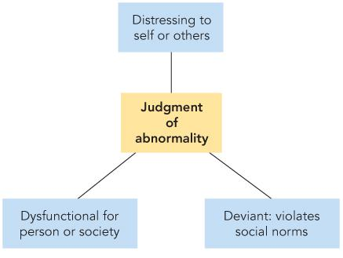
Abnormal
Abnormal behavior: behavior that’s personally distressing, dysfunctional and/r culturally deviant that other people judge it as inappropriate or maladaptive
(distressing to self or others, dysfunctional for person, deviant from social norms)

There are 3 components to abnormal definition
            - Distress: feeling anxiety, depression, especially if individual has no control over the reactions. This definition is weak because: Must be disproportionately intense or long lasting, and some people might completely lose touch with reality and not feel any distress at all
            - Dysfunction: interferes with person’s life or other’s (society) (example, depression – interferes with daily life)
            - Deviance: violates social norms, espeically if it cannot be attributed to environmental causes

History and Diagnosis

Historical Perspectives
Supernatural Explanations
Deviance was seen as the work of the devil, and the treatment in some cultures was to remove bone of tissue in order to release the evil spirit

Demonological Models:
Disturbed people were either involuntarily possessed by the devil or made a dark pact
This view was particularly popular in medieval Europe

Biological Breakthrough:
Syphilis lead to brain degeneration, which lead to general paresis (muscle weakness caused by nerve degeneration), this lead to mental deterioration and bizarre behavior

Freud introduced the psychological interpretation of disordered behavior

Modern Perspectives

Vulnerability Stress Model
This is the current model

Vulnerability:
These include biological, personality, environmental or cultural factors that increase or decrease odds of developing a psychological disorder when given sufficient stress. (examples include: genotypes, hormones, neurotransmitters, self esteem..)

Stressor:
These are combined with vulnerability to trigger disorder

Example: genetic predisposition towards depression, triggered by loss of loved one

Classifying Disorders
Scientific classification systems must have:

Reliability:
This is the consistency of categorization. Helps if classification is based on observable behavior, minimizes subjective judgement

Validity:
Does the category capture (accurately describe) the disorder?

Diagnostic & Statistical Manual of Mental Disorders (5th Edition)
This manual uses both categorical and dimensional approaches.

Categorical Systems
Uses detailed and specific checklists of behavioural criteria to make a diagnosis
The 4th edition only used this approach. The problem with that approach was that it was so specific that many didn’t fit neatly into 1 category, and individuals with the same disorder might only share some symptoms, making them appear different. The third problem is that it didn’t capture severity

Dimensional Approach
Relevant behaviors rated along severity scale, viewing psychological disorders as different from normal by degrees (example, OCD is merely a maladaptive level of normal personality factor conscientiousness (desire to do what is right))

Issues of Diagnostic Labeling

Social and Personal Implications
Labeling is often seen as a description of the person rather than their behavior, leading to damaged interactions with the person

Legal Consequences
Danger to self and others are institutionalized
Competency: state of mind at the trial
Insanity: state of mind during the crime

Incidence VS Prevalence
There are two main statistics in epidemiological research
Incidence: number of new cases that arise during a given time period
Prevalence: total number of people who have a disorder during a given time period (both new and existing)

Anxiety Disorders
This is defined as disproportionately frequent and intense responses to a situation that interferes with daily life
There are many different types of anxiety:
- Phobic disorders
- Generalized anxiety disorder
- Panic disorders
There are 4 components to anxiety
      - subjective-emotional: includes feeling tension or apprehension (feeling like something bad will happen)
      - cognitive: sense of danger, inability to cope
      - physiological response: pulse, nausea, dry mouth, more frequent urination

      - behavioral response: avoid certain situations, impaired performance

Phobic Disorders
Phobia: A strong, irrational fear of certain objects or situations.
Most realize that the fear is disproportional to the danger, but feel helpless to deal with them

Agoraphobia: fear of open and public places
Social anxiety disorder: excessive fear of situation where the person might be evaluated and possibly embarrassed
Specific Phobias

For men, height is the most common phobia
For women, some sort of animal fear is more common
Many phobias develop in childhood, and may broaden and intensify over time

Generalized Anxiety Disorder
This is a chronic state of anxiety not attached to any specific situation or object

Panic Disorder
Sudden and unpredictable and highly intense anxiety. Often happens completely out of the blue
This can lead to agoraphobia because they fear an attack in public

Obsessive Compulsive Disorder
This is not in the DSM-5, but is related
Obsessions: repetitive and unwelcoming thoughts, images, or impulses that invade the consciousness that are difficult to dismiss or control
Compulsions: repetitive behavioral responses to obsessions. Function is to reduce obsession based anxiety
Failure to do said behaviour leads to extreme anxiety or panic attack
These behaviours avoids anxiety, so this negatively reinforces the compulsive behaviour

Most cases involve both the cognitive obsessions and behavioral compulsions

Neuroscience & OCD

Executive Dysfunction Model
This suggests that OCD is an issue with impulse control and inhibiting behaviours that are inappropriate for a given situation. This best examples compulsions

Modulatory Control Model
Suggests OCD is an issue with controlling socially appropriate behaviours. Best explains obsessions

Biology and Anxiety, OCD

Genetics
40% identical twins concordance vs 4% fraternal
Other studies suggest 44-61% of the variance in anxiety disorders is genetically influenced

Physiology:
Early life stressors affect neurotransmitter system develop and increases stress response
Panic disorder patients have low GABA, leading to highly reactive nervous system and makes classifcal fear conditional easy
Serotonin may also be involved in anxiety

Sex
Women exhibit anxiety disorders more often

Biological Preparedness
Evolution may have evolved for us to develop conditioned fears for some stimuli more easily

Psychology and Anxiety, OCD

Psychodynamic Theories
Neurotic Anxiety: this is when unacceptable impulses threaten to overwhelm ego’s defenses, so the ego resorts to defense mechanisms, which result in anxiety disorders
(example, panic disorders is the displacement of neurotic anxiety into symbolic objects or situations
similarly, OCD’s obsessions symbolically relate to unconscious impulses. Comlusions take back, or undo the urge

Cognitive Theories
Emphasizes maladaptive thought patterns and beliefs in anxiety disorders
Example: anxious patients catasrophize (view a situation as far worse than it actually is) feel powerless, magnify demands into major threats and expect the worst
Example: social phobics believe in high likelihood of embarrassing themselves in social situations and that the consequences of this would be high

Behaviorist Theories
Anxiety disorders result from conditioning.
In some cases, learn via classical conditioning or through observation

Cues then trigger fear response, for phobias, cues are external objects, for panic disorder, cues are internal (heart rate, or mental images of something bad happening)
Once fear response triggered, operant conditioning takes over. Behaviours that reduce the unpleasant feeling of fear are negatively reinforced. The problem is that avoidance prevents extinction

Sociocultural Theories
Some disorders are culture bound; only happening in certain places

April 1st, 2015

Mood (Affective) Disorders

Mood Disorders
These are other groups of emotion based disorders, including depression and mania
There are high co-morbidity with anxiety disorders, about half of people with depression also experience an anxiety disorder

Mood disorders occur just less than anxiety disorders, and the prevalence is on the rise. These disorders affect all age groups, including 6 months olds.
The rate of children and adolescents now equals adults

Sex Differences
There are no difference in bipolar disorder

But women are 2x are likely to suffer from depression, but this only holds true for women for western nation
Women also have their 1st episode earlier, in their 20s vs men in their 40s
Some possible reasons for this have been attributed to genetics, nervous system, PMS. Other guesses are due to sex roles; expectations of women to be passive, dependent and focused on feelings

Time Course
Depression often dissipates over time, and untreated, will usually last 5-10 months

After the 1st depressive episode, there are 3 possibilities
        - (50%) depression will occur
        - (10%) no recovery, chronic depression
        - depression will never reoccur after recovery

Depression
Almost everyone experiences the symptoms of depression in mild or temporary forms, experiencing loss leads to sadness, discouragement.
These symptoms usually fade away

Clinical Depression
This is frequent, intense and long durations of depressive symptoms that are disproportionate to the person’s life situation.
Example: minor setback triggering major depression, this being so severe that the person is unable to function effectively. 10-15% of people will suffer from this at some point during their lives
Dysthymia: less intense feeling of depression, but more chronic and long lasting.

There are 4 classes of symptoms for depression
            - Emotional: negative mood state, this is characterized by sadness, misery, loneliness, losing capacity to experience pleasure in hobbies or even biological pleasures (sex, food)
            - Cognitive: difficulty concentration, or making decisions. Often pessimistic and hopeless, experiencing low self esteem and feelings of inadequacy, and blames self for any setbacks.
            - Somatic: loss of appetite, often leading to weight loss or maybe even weight gain. Sleep disturbance happens, and lack of energy occurs as well
            - Motivational: difficulty or inability to begin behaviours that might cause pleasure/accomplishment

Bipolar Disorder
Individual experiences depression, but with brief period of mania; this is the opposite of depression, with the individual experiencing a euphoric mood, grandiose thoughts, hyperactive, rapid talking

Genetics & Depression

Genetics
When comparing identical twins, there is a 67% concordance (agreement) between identical twins and 15% for fraternal
Adopted people are more 8x more likely to have a biological relative with depression than an adoptive one

The stats above suggest that there might be a genetic vulnerability factor that may be genetically inherited into components of an individual’s personality or temperament, these factors might be triggered with a stressor

Personality & Mood Disorder

Personality Factors
Behavioral Activation System (BAS)
Reward – oriented, anticipation of pleasure
Related to extraversion

Behavioral Inhibition System (BIS)
Avoids pain; involved in fear and anxiety
Related to neuroticism

Individual’s with depression have low activation (BAS), but high inhibition (BIS)
Mania is the opposite pattern

Physiology
Depression may be related to under activity of norepinephrine, dopamine and serotonin, these are all involved in the behavioral activation system and feelings of reward and pleasure. In fact, most anti depressants are agonists for one of more of the neurotransmitters

fMRI results reveal low emotional activity for happy AND sad pictures for depressed individuals while manic individuals have over activity of the same cluster of neurotransmitters

Psychoanalytic Theories
This theory claims early traumatic stress cause grieving and rage to become part of one’s personality, and later loss or rejection reactivates original loss. So the reactions (depression) is not only to a current stressor, but to unresolved past one too

Actually, early loss is a vulnerability factor
Example: losing a parent early in life is associated with greater risk of later depression

Humanistic Theories
The me generation places too much emphasis on individuality and personal control
Many define self worth in terms of achievement, but this leads to belief that failures reflect inadequacy.

Cognitive Theories
Focus on roe of maladaptive though processes that act as a trigger in vulnerable people

Beck’s Depressive Cognitive Triad
States that there are three areas of negative thought:
      - self
      - world
      - future
Thoughts enter unbidden, automatically and cannot be controlled or suppressed leading to distortions of attention, perception, memory
People with depression are faster at picking out negative and sad faces than positive happy ones and carry a better memory for own failures than successes

Beck’s Depressive Attributional Pattern
Non depressed people attribute successes to themselves and failures to external causes. Depressed individuals instead attribute success to luck and failures to themselves

Learned Helplessness Theory
This is when individuals expect bad things to happen, and think that one can do nothing to prevent or cope with them
This includes the depressive attributional pattern, but also includes feelings like you cant do anything that will change it

There are 3 characteristics of negative attributions made by people with depression
        - personal: individual thinking its all their fault
        - stable: individual thinking that it’ll always be that way
        - global: individual thinking that they’re terrible at everything

Behaviorist Theories
There are a couple of assumptions made about depression
              - negative event: depression triggered by a negative event (ex. Punishment)
              - vicious cycle: depression leads to one not enjoying usually enjoyable activities, which can lead to greater depression
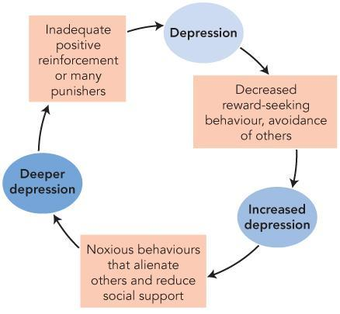
              - behaviour change: this leads to behaviors that isolate the individual from their friends and result in alienation
According to behaviorism, the only way to break the cycle is to engage in different behaviours.

Behavioral Activation:
This is when an enjoyable activity or change in social behaivour is used to positive reinforce positive feelings in order to counteract depression

Sociocultural Theories
Cultural factors influence prevalence, as well as manifestation of depression

Depression is less commin in hong kong, Taiwan compared to the US. This is assumed to be due to stronger family connections providing better social support
The reported symptoms vary by culture, in north America and Europe, depression causes guilt and inadequacy. While in Latin America, Eastern culture or African culture, depression causes fatigue, loss appetite and sleep difficulties

Suicide
Worldwide, there are 1.4 people per minute. In Canada, there are about 4000 people per year,

Sex Differences
Women make3x more attempt than men, but 3x as many men succeed as they choose more lethal methods (ex, gun, buildings)
Men motivate to suicide by failures in occupation
Women motivate to suicide by failures in love

Motivation to suicide can be due to hope to succeed or manipulation
56% of attempts are the result of a desire to end intolerable hopelessness & distress
13% of attempts result from a desire to change other’s behaviours (ex. as a threat to prevent relationship from ending), these kinds of suicide typically involve less lethal methods and reasonable assurance that help is nearby

Risk Factors & Warning Signs
Verbal or behavioral warnings:
it’s a myth that people wont talk about it, but 80% of people give warning in some way

Depression:
Suicide does not occur at the lowest point, but instead, as the person is going back into the depression

History of sexual or physical abuse is also a reason

Suicide Prevention
- If you suspect something, ask the person
- Provide social support and empathy
- Getting the individual to get professional assistance

April 6th, 2015

Somatic Symptom Disorder
These are involuntary physical complaints or disabilities with no biological cause

Pain Disorder: feel pain with no physical cause, or disproportionate amount of pain given cause
Functional Neurological Symptom Disorder: formerly known as conversion hysteria, this is when paralysis, blindness or loss of sensation with no physical cause. This is associated with la belle indifference, a strange lack of concern about the symptoms
In some cases of this, it is actually anatomically impossible to have a specific pattern of symptoms
Example: glove paralysis; person loses feeling and movement below the rest, but retains it above. But the nerves involved serve other portion of the forearm too, so if there were actual damage, those areas would be gone too

Somatic symptom disorder is different from psychophysiological disorders; this is where a psychological factor causes medical condition with an actual, real biological cause.
Example: stress leads to high blood pressure, peptic ulcers

Also different from hypochondriasis ; this is an anxiety disorder where the individual thinks they will get a serious illness

Factors that are present in somatic symptom disorders:
- Individual not faking it
- Individual has traumatic experience
- Individual immersed in cluture that discourages speaking about emotions, or stigmatizes psychological disorders

Dissociative Disorder
This is breakdown of the normal unity/coherence of personality, or sense of self

Dissociative Amnesia: extensive, but selective memory loss where in some cases, the person canont remember specific events, people, places, and in extreme cases, the person cant remember their past

Dissociative Fugue: loses all sense of personal identity, give up customary way of life and wanders far away to start a new life that is usually triggered by stress. These can last years before person wakes up

Dissociative Identity Disorder (Multiple personality disorder): this is when 2 or more separate personalities coexist within the same person. Host personality appears more often than the alter personalities, and each personality has their own integrated set of memories and behaviours and may not know about the others.
The personalities can differ in terms of age, gender, even physiological characteristics

These changes can include different voice prints, different glasses prescriptions, different dominant hands, different physiological diseases existing like epilepsy, allergies, menstrual timing

Dissociative Identity Disorder (DID)
The behaviours and characteristics shown by the diferernt personalities cannot all be acted out.

One study looked at EEG recordings in response to visual stimuli and showed multiple personalities showed different neural response pattern

Causes of Dissociative Identity Disorder
Putnam’s Trauma Dissociation Theory
This theory suggest that new personalities develop as a way of coping with severe stress
A vast majority of cases involved abuse as children, when identity wasn’t as well established. The alternate identity allows person to detach from stress, transferring it onto “someone who can handle it”

Another theory is that it may be caused by therapists. This is because some uncover personalities and memories of abuse through hypnosis.

Schizophrenia
This is a psychotic disorder involving severe disturbances in thinking, behaviour, perception, emotion and speech.
Disorder of thought often include delusions; false beliefs that are maintained in the face of evidence that would normally destroy them.

Delusion of persecution: brain is being turned to glass by enemies using space rays
Delusions of grandeur: Jesus is a special agent of theirs

Those with schizophrenia often have perception that include hallucinations; false percepts with a compelling sense of reality, these include auditory hallucinations, which are the most common

Language can include plausible but made up words, or rhymes

Emotion disturbances are also possible:
blunted affect – less emotion than regular
flat affect – apparent absence of emotion
inappropriate affect – wrong emotions

Type 1 Schizophrenia
Mostly positive symptoms, mostly something positive added to normal, hallucinations, delusions, disordered thoughts

Positive symptoms is good, associated with better functioning before hospitalization and better prognosis for recovery

Type 2 Schizophrenia
Mostly negative symptoms, something removed from normal, lack of emotion, loss of motivation

Biology & Schizophrenia

Genetics
Strong evidence that genes play a role (but which ones remains unclear, higher concordance for closer genetic relatives

Neurotransmitters
Dopamine Hypothesis: over activity of dopamine system produces schizophrenia, patients have more dopamine receptors. Anti psychotic drugs are dopamine antagonists
Dopamine more related to positive symptoms

Brain Abnormalities
Neurodegenerative Hypothesis: destruction of neural tissue can cause schizophrenia
Degradation or loss or neurons in cerebral cortex and limbic system
Abnormalities also exist in the thalamus
Structural abnormalities are more common in negative symptom pattern, this may explain poorer prognosis for recovery

Psychological Factors

Freud
Defense mechanism of regression; retreat from unbearable stress & conflict to an earlier, more secure infantile stage

Cognitive Theories
Possible disorder of attention, or of executive control network
Attention system can’t filter out irrelevant info, executive control system can’t put thoughts in order or distinguish reality from fantasy

Environmental Factor

Stress
Acts as a trigger, in vulnerable people
People who emotionally overreact to stress have higher odds of developing schizophrenia

Family Dynamics
Family stress acts as a trigger, again, in vulnerable people
Also family life can influence relapse rates, high levels of expressed emotion are bad

Sociocultural Factors
Schizophrenia most common among low SES:
Social Causation Hypothesis: low incomes, especially in urban cities cause high levels of stress that leads to trigger
Social Drift Hypothesis: schizophrenia leads to decreased social, occupational functioning that leads to drift into poverty

There is no cultural differences in prevalence, but in developed countries like Canada shows worse recovery than developing countries

Personality Disorders

Personality Disorders
Stable, ingrained, inflexible, and maladaptive ways of thinking, feeling and behaving

Narcissistic Personality Disorder:
grandiose fantasies of behaviour, lack of empathy, constant need for admiration, proud self display, oversensitivity to evaluate
Avoidant Personality Disorder:
Extreme social discomfort, timidity, feeling of inadequacy, fear of being negatively evaluated
Obsessive Compulsive Personality Disorder:
no consider anxiety disorder
Schizotypal Personality Disorder:
odd thoughts, appearance, behaviour, extreme discomfort in social situations
Kind of like mild schizophrenia (odd beliefs)
Antisocial Personality Disorder (Psychopaths, sociopaths)
Seem to lack a conscience
There are 2 cluster of symptoms
              - Selfish, lack empathy, manipulative
              - Impulsive, unstable, socially deviant
Need both cluster for diagnosis, subclinical often have 1st cluster but not the 2nd, the second often have great success in business or politics

These individuals are often intelligent and charming and can talk themselves out of trouble
A diagnosis requires the patient to 18+, AND there must be evidence of antisocial behaviour before 15
These individuals lack anxiety and don’t respond to punishment

Biology & Antisocial Persistence Disorder

Genetics
Heritability high for identical vs fraternal twins and for biological vs adoptive relatives

Brain Abnormalities
Dysfunctional amygdala, prefrontal cortex that results in chronic under arousal and impulsivity

Psychology & Antisocial Personality Disorder

Psychoanalysis
This view says that individual has under developed superego that lacks conscience

Cognitive Theories
This view says that the individual fails to consider negative consequences before acting, so to treat, help the individual develop skills to think before acting

Learning Theories
Often, parents were aggressive or inattentive. Therefore, the individual learns aggression and disregard for others.
Also, some may learn deviant behaviours from peer groups

Borderline Personality Disorder
Serious instability of behaviour, emotions, identity and interpersonal relationships

Emotional disregulation: inability to control negative emotions in response to stressful events (many of which the patient causes)
Also characterized by chronic extreme anger, loneliness, emptiness
Often, the individual does repetitive self destructive behaviours

Splitting: failure to integrate positive and negative aspects of someone else’s behaviour. Instead reacting as though that person is composed of 2 separate entities, one worthy of love/worship and the other worthy of extreme hatred. This meaning that the individual with the disorder switches back and forth often between extreme emotions

Disorders of Childhood & Age

Childhood Disorders

Attention Deficit Hyperactivity Disorder:
Inattention or hyperactivity or both. 7-10% of children meet the criteria.
This is not exclusive to children, 50-80% still have ADHD as adolescents and 30-50% still have it as adults
There is a possible genetic aspect, but there are no clear neurological differences that cause it

Autistic Spectrum Disorder
Extreme unresponsiveness to others, poor communications skills, highly repetitive and rigid behaviour patterns. There is a lack of social responsiveness
2/3 cases have severe deficits (less than 70)

These individuals have language deficiencies, with half not developing language. In those that do, they often repeat words or phrases with little meaning

Repetitive behaviours, sameness, routine. May do same behaviour all day, and become very upset with changes to routine

These changes typically appear by age 3

Rare cases show extraordinary intellectual abilities

Causes of Autism
Genetics play a big role, with 4-6 major genes and 20-30 others playing a role as well

Psychodynamics??????? NOT CLEAR

Cognitive theories say there are problems with theory of mind, that the individual can tell what others are thinking, feeling which leads to poor communication and emotional understanding

Dementia in Old Age

Dementia
This is the gradual loss of cognitive abilities and functioning due to brain deterioration. This is often seen as memory impairment, confusion, language impairment. Memory loss occurs through recent memories being lost first, then procedural
This is twice as common in women
This is often caused by illness, injury
Can take many forms, alzheimers, parkinsons, Huntington’s

Senile Dementia: dementia that begins after 65 for any reason
Alzheimer’s Disease: This is the leading cause of dementia, deterioration of frontal and temporal lobes by destroying cells that produce acetylcholine
One cannot be 100% sure that one has alzheimers without autopsy by looking for tangled clumps of neurons and nerve cell branches

April 9, 15

Treatment of Psychological Disorders

