Experiment 1: Thin Layer Chromatography

Introduction:
Chromatography is used to separate mixtures of substances into their components by using the differences in solubilities of two solvents or phases. One is held stationary while the other is mobile. The mobile phase flows through the stationary phase and carries the components of the mixture along. The different components of the mixture will travel at different rates due to differences in polarities which causes a separation of the mixture into the components.

Thin layer chromatography is used for reaction monitoring, sample purification and determination of purity of samples. In this experiment, the absorbent used (stationary phase) is silica gel which is a polar material. The mobile phase is an organic solvent. More polar compounds are attracted to the silica plate rather than the solvent. Since polar attracts polar, if the compound dabbed on the plate is polar, it will be strongly attracted to the TLC plate covered in silica gel and will therefore move more slowly. On the other hand, if the compound is non-polar, it will be less attracted to the silica and move more quickly up the TLC plate.

The TLC plate is placed in a jar such that the bottom of the plate is immersed in the organic solvent. The jar is closed to allow saturation of the atmosphere with the solvent vapour. This prevents the solvent from evaporating as it rises up the plate.

Part A Observations and Calculations:

Figure 1.0: Sketches of TLC plates for unknown sample #51 and using 2:8 mixture ethyl acetate and hexanes as organic solvent and reference of a) Benzophenone and b) Biphenyl.

a) Benzophenone
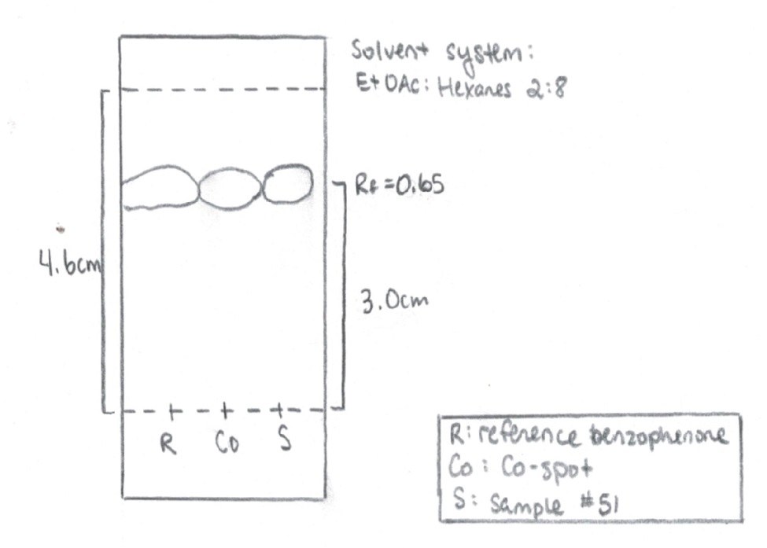
b) Biphenyl
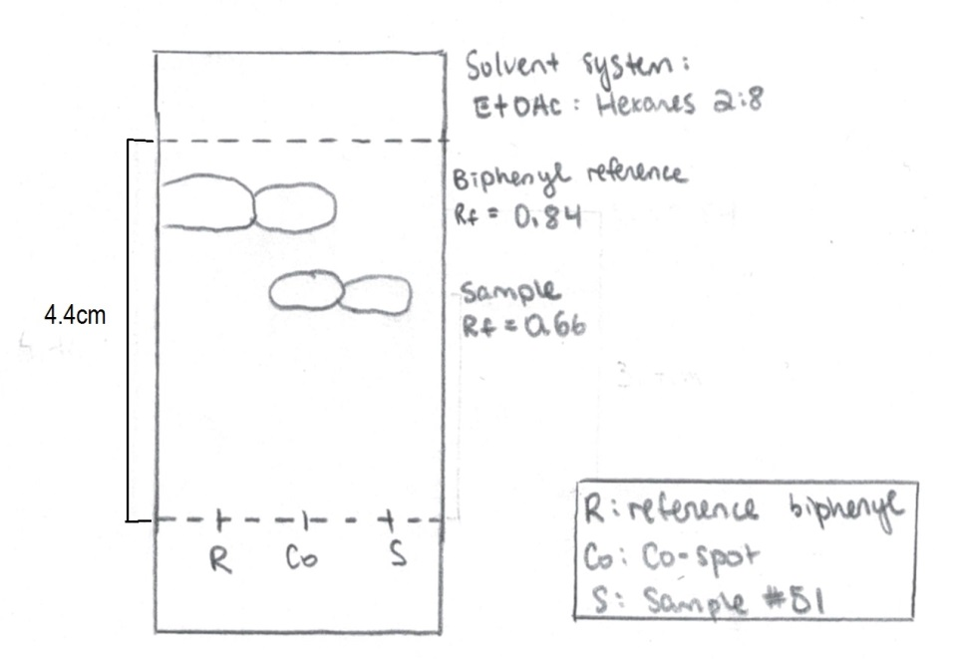

Sample Calculation of R_{f} Value:
a) Benzophenone:
R_{f} = $\frac{{displacement}_{compound}}{{displacement}_{solvent}}$
R_{f} = $\frac{3.0 cm}{4.6cm}$
R_{f} = 0.65
Table 1.1: R_{f} values of 2:8 mixture of ethyl acetate and hexanes as solvent with benzophenone as reference
Spot | Compound | R_{f} Value
Reference Lane | Benzophenone | 0.65
Co-Spot Lane | Benzophenone | 0.65
Sample Lane | Benzophenone | 0.65

Table 1.2: R_{f} values of 2:8 mixture of ethyl acetate and hexanes as solvent with biphenyl as reference
Spot | Compound | R_{f} Value
Top Reference Lane | Biphenyl | 0.84
Top Co-Spot Lane | Biphenyl | 0.84
Bottom Co-Spot Lane | Benzophenone | 0.66
Bottom Sample Lane | Benzophenone | 0.66

Part B Observations and Calculations:
Figure 2.1: Sketches of TLC plates for unknown sample #51 and using ethyl acetate as organic solvent and reference of a) Benzophenone and b) Biphenyl.
a) Benzophenone
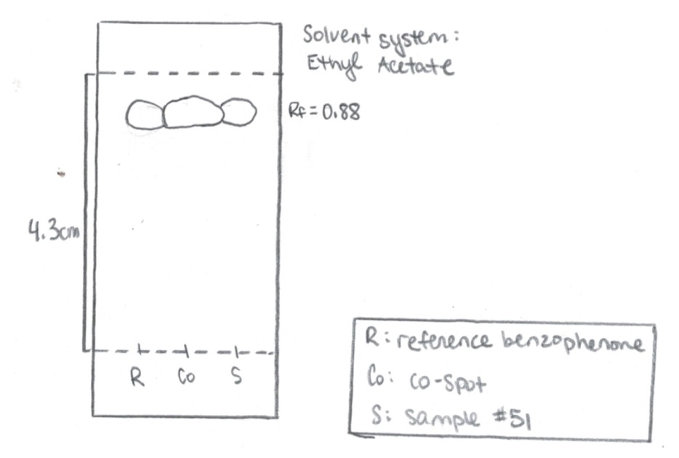

b) Biphenyl
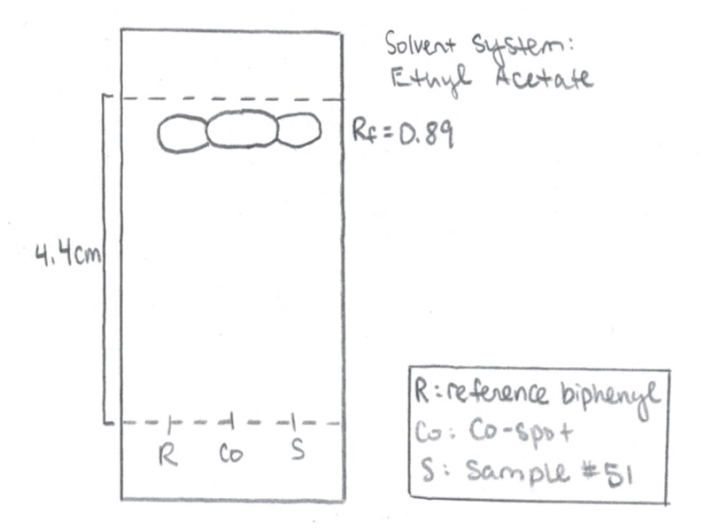

Figure 2.2: Sketches of TLC plates for unknown sample #51 and using hexanes as organic solvent and reference of a) Benzophenone and b) Biphenyl.
a) Benzophenone
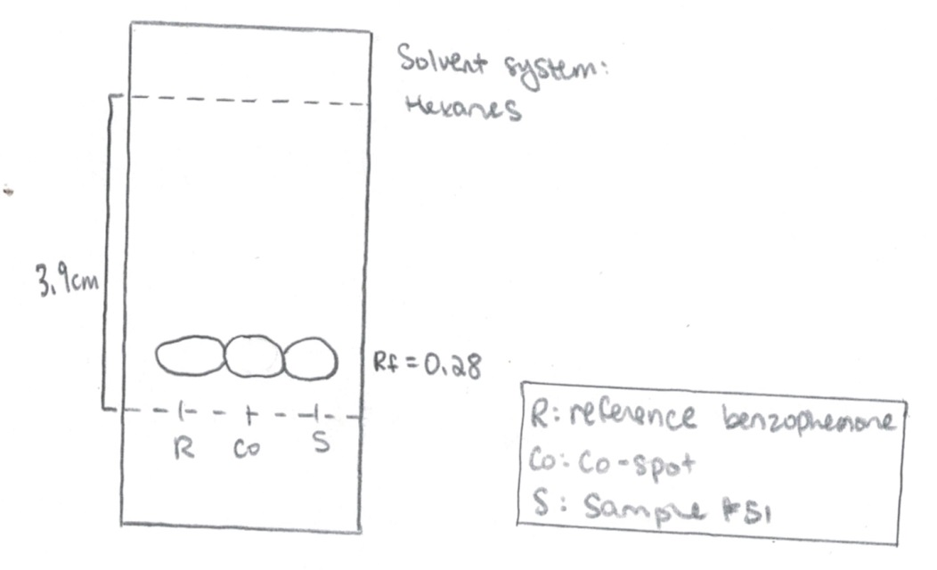

b) Biphenyl
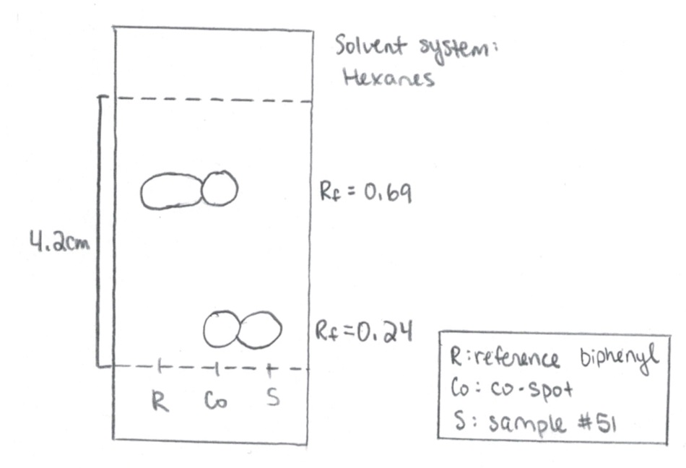

Table 2.1: R_{f} values of ethyl acetate as solvent with benzophenone as reference
Spot | Compound | R_{f} Value
Reference Lane | Benzophenone | 0.88
Co-Spot Lane | Benzophenone | 0.88
Sample Lane | Benzophenone | 0.88

Table 2.2: R_{f} values of ethyl acetate as solvent with biphenyl as reference
Spot | Compound | R_{f} Value
Reference Lane | Biphenyl | 0.89
Co-Spot Lane | Biphenyl | 0.89
Sample Lane | Biphenyl | 0.89

Table 2.3: R_{f} values of hexanes as solvent with benzophenone as reference
Spot | Compound | R_{f} Value
Reference Lane | Benzophenone | 0.28
Co-Spot Lane | Benzophenone | 0.28
Sample Lane | Benzophenone | 0.28

Table 2.4: R_{f} values of hexanes as solvent with biphenyl as reference
Spot | Compound | R_{f} Value
Top Reference Lane | Biphenyl | 0.69
Top Co-Spot Lane | Biphenyl | 0.69
Bottom Co-Spot Lane | Benzophenone | 0.24
Bottom Sample Lane | Benzophenone | 0.24

Part C Observations and Calculations:

Figure 3.0: Image of unknown sample XX using 9:1 hexanes: ethyl acetate as organic solvent and reference of a) o-bromonitrobenzene b) m-bromonitrobenzene and c) p-bromonitrobenzene
- b) c)
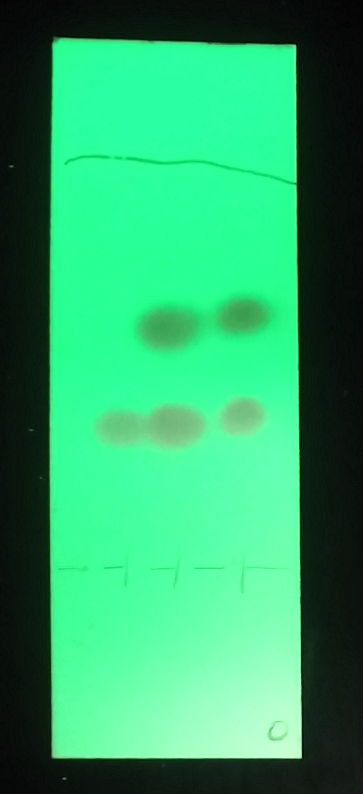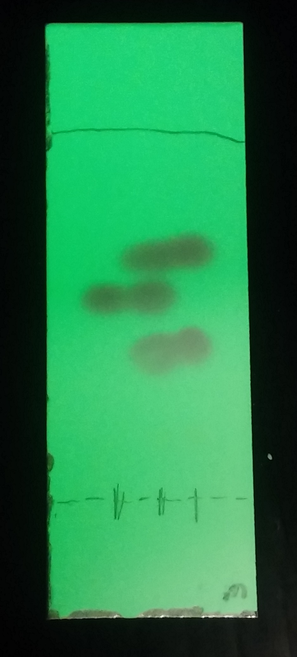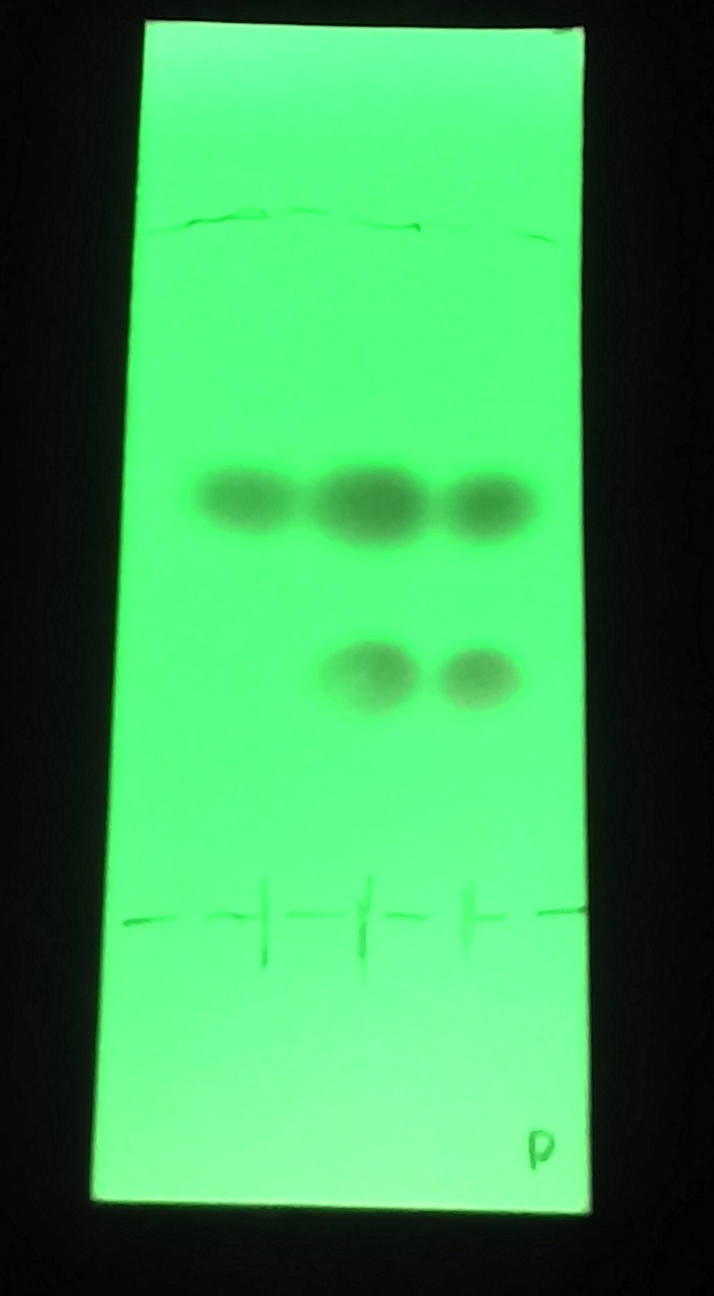

Ortho peak areas:
Lane 1: peak 1: 2187.004
Lane 2: peak 2: 17654.116; peak 3: 5202.288
Lane 3: peak 4: 16249.510; peak 5: 2701.288

Sample Calculations of peak percentage using ortho-bromonitrobenzene as reference

Lane 2 (Co-Spot):
% peak 2 = $\frac{area of peak 2}{area of peak 2+area of peak 3} x 100\%$

% peak 2 = $\frac{17654.116}{17654.116 +5202.288} x 100\%$

% peak 2 = 77.24%

Lane 2 (Co-Spot):
% peak 3 = $\frac{area of peak 3}{area of peak 2+area of peak 3} x 100\%$

% peak 3 = $\frac{5202.288}{17654.116 +5202.288} x 100\%$

% peak 3 = 22.76%

Sample calculations for actual percentages after calibration using meta-bromonitrobenzene as reference

From image J, the peak % calculated are (using same calculation method as above):
Ortho: 19.35%
Meta: 42.29%
Para: 38.36%

Excluding Para, we obtain:
Ortho = $\frac{19.35}{19.35+42.29}$= 31.39%

Meta = $\frac{42.29}{19.35+42.29}$= 68.61%

Using the calibration curve for actual values of mole %:
Ortho = 60.69%
Meta = 39.31%

Repeating the procedure for Meta and Para, we obtain the actual values of mole %:
Meta = 52.91%
Para = 47.09%

Ortho: Meta = 18:12
Meta: Para = 12:10.7

Ratio of Ortho: Meta: Para = 18:12:10.7 or 44.23% Ortho, 29.48% Meta, 26.29% Para.

Table 3.0: Summary of peak percentage and mole percentage of various references
Reference | Lane | Peak Number | Compound | Area | % peak | Mole %
O-bromonitrobenzene | Co-Spot | Peak 2 | Para | 17654.116 | 77.24 | 78.37
O-bromonitrobenzene | Co-Spot | Peak 3 | Ortho | 5202.288 | 22.76 | 21.63
M-bromonitrobenzene | Co-Spot | Peak 2 | Para | 12056.128 | 38.36 | 26.29
M-bromonitrobenzene | Co-Spot | Peak 3 | Meta | 13292.555 | 42.29 | 29.48
M-bromonitrobenzene | Co-Spot | Peak 4 | Ortho | 6081.907 | 19.35 | 44.23
P-bromonitrobenzene | Co-Spot | Peak 2 | Para | 17991.581 | 66.45 | 64.83
P-bromonitrobenzene | Co-Spot | Peak 3 | Ortho | 9084.823 | 33.55 | 35.17

Part A Discussion:
- The R_{f} value of benzophenone is found to be 0.65 and the R_{f} value of biphenyl is 0.84
- Compound in the mixture is benzophenone
- The R_{f} value in the benzophenone reference lane is the same as the R_{f} value of the sample lane and the co-spot lane shown in Figure 1.0 a)
- When using biphenyl as reference, the R_{f} value of the sample still was very similar to that of benzophenone of the previous trial
- Dichloromethane used to dissolve the compound is irrelevant because it is a volatile solvent so it evaporates off of the TLC plate when it was taken out to dry

Part B Discussion:
- Moved very slowly in hexanes solvent
- Benzophenone is slightly polar due to its carbonyl group
- Hexanes isn’t very polar while silica is polar so benzophenone will attract to the silica plate and move very slowly
- R_{f} value of the benzophenone is 0.28, much smaller than in Part A

- Moved very quickly in ethyl acetate solvent
- Ethyl acetate is polar (a lot more than hexanes) so the benzophenone, being polar as well, is more attracted to the ethyl acetate and as much to the silica plate and will therefore move up a lot farther and faster
- R_{f} value of biphenyl is 0.69, which is also smaller than in Part A

- As seen from the experiment and in Figures 2.1 and 2.2, polar solvents attract the polar compound and causes the compound to move up the plate faster
- Less polar substances don’t attract the polar compound which causes the compound to attract more to the silica plate and move up the plate slower

Part C Discussion:

