CHAPTER 1 – SCIENTIFIC THEORY AND BIG BANG

Temperature Scales
  - Celsius: for everyday environment temperatures
  - Kelvin: for very low temperatures

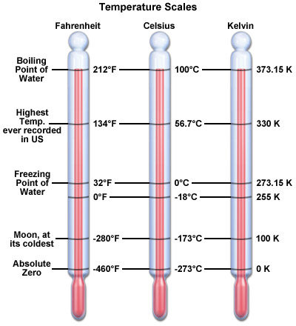

- Scientific Method
  - Hypothesis: educated guess based upon observation
  - Theory: summarizes a hypothesis that is supported by repeated testing and observation (why)
  - Law: explains a body of observations with no exceptions (how)

The Big Bang
  - Singularity: area in space-time where gravitational force is so high that all known laws of physics break down and do not apply.
    - Time and space were created in a gigantic expansion that emanated from a singularity (big bang)
  - The Observation/Evidence: “Three Pillars of Proof”
    - Recession of stars/galaxies (Hubble’s Law)
    - Cosmic microwave background radiation
    - Abundance of light elements

1st Pillar of Proof: Hubble’s Law - Edwin Hubble
  - Discoveries: multiple galaxies, universe expansion, space distance measurement
  - Doppler Shift/Effect: when an object coming toward you makes a sound, the sound waves are compressed by the motion of the noisy object and sounds differently to you than when the same sound waves are being carried off away from you
    - Hubble realized that light acts this way too
  - Light Redshift: if the light source is moving toward the observer, the light wavelength appears to shorten (blueshift on the spectrum); if the light source is moving away from the observer, the wavelength appears to lengthen (redshift on the spectrum)
    - Hubble realized that the faster the light-emitting object moves, the greater the shift
    - Speed of light is fixed
    - Stars were moving away from Earth (expanding universe)
    - Redshift is used as a measure of a star or galaxy’s distance from Earth
  - Hubble Law: v = H_{o}d
    - v = speed in km/second
    - d = distance of star/galaxy from Earth in parsecs
      - 1 parsec = 3.26 times the distance light travels in one year)
    - H _{o} = Hubble constant
      - speed of expansion in the universe
    - you can calculate how far from earth and object is by dividing its velocity by rate of expansion factor

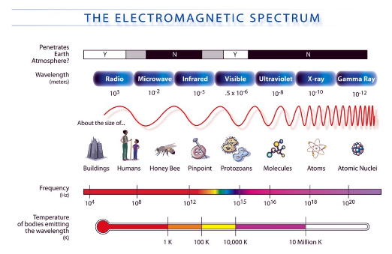
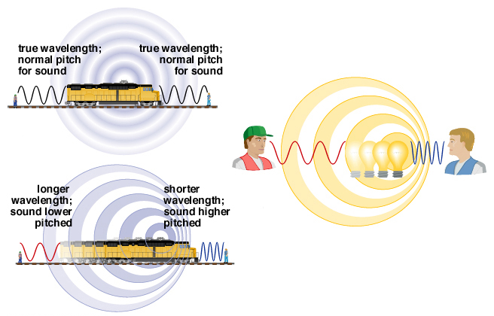

- 2nd Pillar of Proof: Cosmic Microwave Background Radiation
  - The universe was very hot and then cooled as it expanded
  - Hot light photons lost energy and dropped from visible light energy range into microwave energy range which constitutes the cosmic microwave background (CMB)
  - CMB: cosmic microwave background that represents the last remnants of light/heat energy of the Big Bangs initial expansion
    - Seen the same from anywhere in the universe
    - Discovered in 1965 as noise

- 3rd Pillar of Proof: Abundance of Light Elements
  - 3 lightest elements:
    - Hydrogen (75%)
    - Helium (25%)
    - Lithium (trace)
  - The abundance of all the different atoms of those elements can be explained only if they originated from one single ratio of the first subatomic particles of matter that can be formed from a super hot environment
    - Big Bang is the only way it could’ve happened

- Shape of the Universe
  - Most important reason for knowing the shape of the universe is to know how it will end
  - 3 unique shapes:
    - 1. Sphere
      - positive curvature
      - closed universe
      - finite in size without a boundary
      - will eventually stop expanding and then contract in a Big Crunch
      - gravity will make this a cyclical event
      - density parameter more than 1 (Ωo>1) – enough matter to pull everything back together
    - 2. Saddle
      - negative curvature
      - open universe
      - infinite in size without a boundary
      - will never stop expanding
      - parallel lines eventually diverge
      - density parameter less than 1 (Ωo<1) – insufficient matter to allow gravity to stop the expansion
    - 3. Flat
      - no curvature
      - flat universe
      - infinite in spatial extent without a boundary
      - will never stop expanding but can also contract
      - density parameter is 1 (Ωo=1) – critical value of matter from pulling back together or expanding indefinitely
  - What affects gravity:
    - Conventional matter: stars, planets, asteroids, comets
      - <5%
    - Dark matter: matter we have never seen because it gives off no (electromagnetic) energy but we know it exists because we can detects its gravitational attraction to conventional matter
      - 27%
    - Dark energy: acts in opposition to gravity; it repels matter; seems to control the expansion of space; when it exactly counterbalances the kinetic energy of the Big Band expansion, we are at the critical value of 1 for a density parameter (flat universe)
      - 70%

- Age of the Universe
  - There are several lines of investigation we can use to determine the age of the universe:
  - Radioactivity: observing the compositions of gases around old stars, knowing the exact radioactive processes required to produce these gas compositions from the very first elements created in the Big Band, knowing all the time factors involved in breaking down one component to yield others
    - Says that the universe is 11.5-17.5 billion years
  - Hubble’s expansion constant: Hubble Space Telescope found some white dwarf stars with the age of 12-13 billion years with an extra 1 billion years to cool off
    - Says that the universe is 13-14 billion years
    - white dwarf star: stars that have consumed all their fuel and are sitting around cooling off (entire life cycle finished)
  - Cosmic microwave background radiation: Big Bang photos have been detected and mapped, offers the most accurate view to date the universe
    - Says that the universe is 13.80±0.04 billion years

- CHAPTER 2 – TIME AND SPACE

- Light Years
  - Light years: used to measure distances in space, the distance that light travels in one year
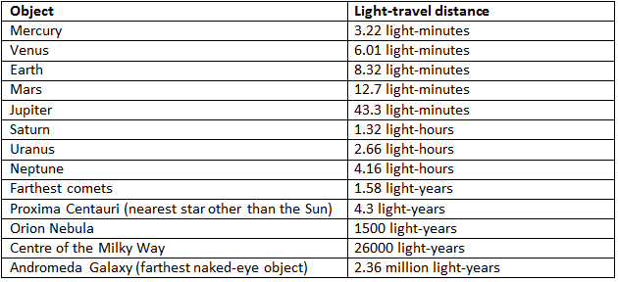

  - Measuring light years (up to 500 light year distance):
    - Trigonometric parallax: an object appearing to be at a different place relative to the background, depending on your viewpoint
  - Measuring light years (500-500 million light year distance):
    - Hertzprung-Russell diagram: relates the luminosity of stars (brightness) to their temperature (related to colour)
      - sun falls in “main sequence”
      - intrinsic brightness: true brightness
      - apparent brightness: how a star appears from earth (dimmed)
      - main sequence fitting: method of determining distance from colour
      - apparent brightness = intrinsic brightness/(4 × π ×distance2)
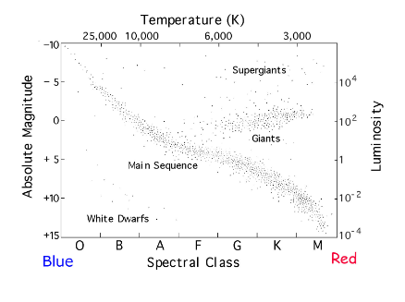

    - Cepheids: marker stars with special property – they have pulsing brightness that peaks with absolute regularity (its period) which is related to the star’s brightness
      - to find intrinsic brightness, measure a Cepheid period (time between one brightness peak and the next)
      - apparent brightness = intrinsic brightness/(4 × π ×distance2)
      - Hubble:
        - Found Andromeda (M31) which most astronomers though was a part of the Milky Way but it was a Cepheid star
        - Measured distance between earth and that star and discovered that it was a million light years away (outside milky way)
        - Recognized shape of galaxy (similar but bigger than milky way)
        - Recognized Andromeda Galaxy as our closest neighbor
  - Measuring light years (beyond 500 million light year distance):
    - Hubble’s Law: velocity/Ho
      - Velocity – obtained from the star/galaxy’s degree of redshift
      - Ho – rate of expansion; Hubble’s constant

- The Scale of Space
  - Galaxy: collection of stars, gas, and dust held together by gravitational attraction
  - Hubble Telescope: provided pictures of deep space that showed galaxies
  - Local Group: 40-50 galaxies including the 3 big galaxies
    - Andromeda (biggest)
    - Milky Way
    - Triangulum (smallest)
  - Our solar system is one of the many millions of star-planet systems on the Orion Arm of the Milky Way

- CHAPTER 3 – MATTER AND THE NEBULAR HYPOTHESIS

- The Chemical Elements
  - The big bang created matter, the most basic forms of this matter combined to form elements, and pockets of matter/elements combined to form star-planet systems
  - Element: a substance that cannot be broken down to anything simpler by any chemical means
    - Created when space neutrons, protons, electrons, anti-electrons, photons, and dark matter combined when the universe cooled after the big bang
  - Atom: a particle of matter that has the unique properties of an element (atoms are the essential particles of elements
    - Nucleus: in the center, contains one of more particles called protons and may or may not contain the particles called neutrons, overall positively charged, surrounded by one of more electrons
    - Protons: particles in the nucleus, positively charged
    - Neutrons: particles in the nucleus, neutral, or no charge
    - Electrons: particles around nucleus, negatively charged, offsets of balances the positive charge of the nucleus, making most atoms neutral (most atoms have the same number of protons and electrons)
  - Ion: an atom with either a negative charge (extra electrons) or an atom with a positive charge (less electrons)
    - Positive ions usually combine with negative ions to form neutral compounds
  - Isotope: atoms of the same element with differing amounts of neutrons
    - This slightly affects their mass
    - We identify each isotope by the sum of the protons and neutrons in its nuclei called the mass number
  - Radioactivity: the spontaneous break down of unstable atoms of an element, with the production of energy and other particles
    - Every radioactive isotope has a defined half-life
    - Fission: breakdown of the nucleus of a relatively heavy atom into at least two other lighter particles plus energy (another word for radioactivity, also meant to describe atomic nuclei breakdowns that people can make happen)
    - Fusion: the combination of two lighter atoms/isotopes to make one heavier atom/isotope plus energy (not classified as radioactivity because the heavier isotope may be radioactive or stable)
      - Vast amount of energy can be produced
  - Supernova: the explosion death of a massive star
    - Explosion is instantaneous but the bright effect can sometimes be seen for weeks
  - Periodic Table of Elements: arrangement of all known chemical elements in a table according to a defined order (increasing atomic number)
    - Atomic Number: number of protons in the nucleus of the atom
  - Hydrogen Isotopes: 1H and 2H
    - 1H: the most important and abundant
    - 2H: (deuterium) played important role in early moments of the universe, still important
      - early formed deuterium went through a reaction to form helium and a bit of lithium and that’s how those 2 elements formed

- The Nebular Hypothesis (formation of the sun)
  - Nebular Hypothesis: suggests that the solar system formed over a relatively brief span of time and all as a unit (sun, planets, etc.) from a nebula of interstellar gas
  - Nebula floated within Orion Arm > Dust cloud spread and contracted under its self gravity > Dust cloud shrunk and flattened
  - Collapse: a pocket of the cloud began to contract because it was recoiling from the shock wave produced by a nearby supernova
  - Density: very low density at the beginning and then increased as it collapsed
    - Particles and heat became so compact and built up
    - Pressure prevented any further collapse
    - Fusion reaction occurs and releases more energy
    - Star is born
  - The Sun: has an inconstant nuclear output
    - Converts hydrogen nuclei into helium nuclei
    - Fusion reaction converts part of the mass of the atoms and releases energy
    - Sun loses mass
    - When the Sun runs our of hydrogen fuel (5 billion years), it will expand into a Red Giant and destroy most planet
  - Cloud Flattening: the distended cloud with which we begin is a large, amorphous blob in space, with no particular shape to it. The solar system became flat because of conservation of angular momentum
    - Momentum: a measure of an objects tendency to move at constant speed along a straight path
    - Angular Momentum: a measure of the amount of spin (or orbital motion) or an object
    - Conservation of Angular Momentum: if no force acts on a spinning (or orbiting) object, the objects angular momentum will not change with time, no matter how the object interacts with other objects
    - Atoms of the cloud rotate with increasing speed as it contracts which leads to flattening
      - this is why the solar system is flat and why all the planets orbit in the same direction
  - Temperature Gradient: flattened nebula is hot on the inside and cools farther our
  - Compositional Gradient: nebula has the same chemical composition everywhere
    - absence of composition gradient suggests that the planets should all form with closely similar compositions but the reason they don’t is a direct consequence of the temperature gradient
  - Condensation of Planetary Disk: elements condense into molecules, small particles and droplets in the cooler outer parts but elements in the hot center remained gaseous. These elements stuck together and grew into pebbles
    - Difference in composition is caused by the fact that light gases do not condense at the high temperatures that prevail in the inner parts of the solar system
    - Refractory elements: elements that do not readily respond to heat (can condense and freeze)
    - Accretion: pebbles moving in the same direction meet and stick together
      - Gravitational forces grow as pebbles grow into stones, boulders, planetesimals, protoplanets, and eventually planets
  - Magic Broom: leftover gasses are swept out of the solar system towards the end of the formation of the planetary system
    - Solar Wind: continuous outflow of charged particles – mostly electrons – that stream out through the solar system at a high velocity. Flares or eruptions cause an increase in solar winds which makes particles hit Earth’s atmosphere which causes Northern Lights
    - T Tauri Stars: these stars have very strong winds which are strong enough to drive any remaining gas out of the solar system
      - Similar to how the sun would have looked at its time of formation
    - Atmospheres: present atmospheres are a result of the outgassing of the planets – in particular the release of volatile substances by volcanoes
      - Earth has had 3 different atmospheres over time due to the magic broom
  - Collisions: influences many things in the solar system such as:
    - Why Uranus is tipped on its side
    - Why rotation of Venus is retrograde (opposite)
    - How Earth’s natural satellite (moon) came to be
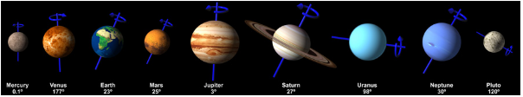
    - Why Mercury’s orbital inclination varies chaotically

- INTRODUCTION

- Solar System:
  - Composition: central star (sun) surrounded by 8 major planets, 3 dwarf planets, many comets, and a lot of space debris
  - Geocentric Model: earth is at the center of the solar system
    - Proposed by Pythagoras
    - Modified by Plato
    - Supported by Ptolemy
    - Proposed again by Tycho Brahe
      - Witnessed a supernova
      - Built first observatory (castle of the heavens)
      - Sun drags the planets around earth
      - Disagreed with Copernicus
  - Heliocentric Model: sun is at the center of the solar system
    - Proposed by Aristarchus
    - Proposed again by Copernicus
      - Earth revolved on an axis once per day
    - Johannes Kepler assisted Tycho
      - Agreed with Copernicus
      - Orbit
      - Sun’s strength gradient (magnetic)
      - 3 laws that define geometry of planets moving about stars (ellipse)
      - earth-sun distance is constantly changing
      - Perihelion: the point of nearest approach of a planet to the sun
      - Aphelion: the point of greatest separation
    - Confirmed by Galileo
      - Telescope
      - Observed moon, sun, and jupiter

- CHAPTER 4 – A STAR CALLED SUN

- Anatomy of the Sun
  - Size: small
  - Luminosity: brighter than 85% of other stars in the milky way
  - Photosphere: visible outer later of a star
    - Represents the depth within that gas at which we can see no deeper toward the core
    - No surface
  - Chromosphere: 2500km thick irregular layer of gas surrounding photosphere
    - Invisible to the eye
  - Corona: extends for millions of kilometers
    - Usually cannot see it because of the brightness of the photosphere
    - Can see it during a total solar eclipse
  - Diameter: 1.4 million km (109 times earth)
  - Volume: 1.3 million times volume of earth
  - Mass: 330,000 times mass of earth (sun contains 99.8% of the solar systems mass)
  - Age: 4.6 billion years
  - Rotation Period at the Sun’s Equator: 25 Earth days
  - Rotation Period at the Sun’s Poles: 35 Earth Days
    - Because the suns body is not rigid, as it rotates, mass is transferred to its middle, giving its body a slightly oblate shape
    - Oblate: an equatorial diameter greater than that between the poles of rotation
  - Temperature of Interior: 15,000,000 K
  - Temperature of Surface: 5800 K
    - *you can calculate K from C by adding 273

- Solar System Distance Measurements
  - Distance between Earth and Sun is about 150 million km (0.000016 light years, 8 minutes)
  - 1 AU: 1 astronomical unit; the mean average distance between the sun and earth
    - Mars is 1.5 AU from the sun
    - Pluto 39.5 AU from the sun

- Sun’s Chemical Composition
  - Spectroscopy: the measurement and analysis of energy spectra to determine the composition of matter; indirect
    - Records the spectrum of light emitted (or absorbed) by a given material, where the light can be used to determine the chemical composition of a substance because particular elements emit unique and characteristic wavelengths of energy
    - A beam of sunlight is made up of a mixture of colour, a glass prism bends/refracts the various colours unequally
      - short wavelengths (violet and blue) are the most refracted
      - long wavelengths (orange and red) are the least refracted
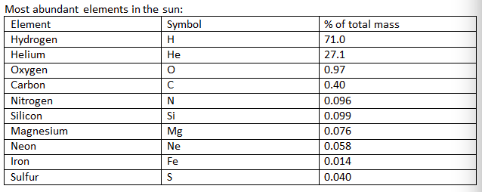
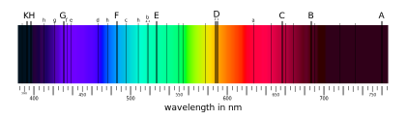
      - black lines are characteristics of particular elements

- The Genesis Experiment
  - NASA’s Genesis Mission: to understand the connection between solar wind and evolution of the solar system, set out to capture particles of the solar wind and return them for study on Earth
  - The isotopic composition of oxygen and nitrogen implanted in the wafers are significantly different to those in most of the solar system objects for which we have measurements

- The Sun in Action
  - Prominences: arcs of gas that begin on the bright surface and soar to as much as 10,000 km into the corona
    - There are prominences in the chromosphere
  - Flares: short-lived gas eruptions that generally last for no more than 20 minutes or so, though a few have been known to persist several hours
    - Flares are even more dramatic than prominences
  - Magnetic Field: produced by an interaction between an inner solid metal core inside a liquid metal layer
    - The earth has a strong magnetic field
    - Magnetosphere: the magnetic field volume around a body like Earth (which generates a magnetic field)
    - The sun has a magnetic field but we are unsure of its generator but it has to do with the interactions of the unique properties of matter in the different layers inside the sun
    - We can crudely express the magnetic fields as giant bar magnets: north at one end and south at other end, the field surrounding them are expressed as lines of different strength are orientation
    - Sun is more dynamic than earth
    - Magnetic generators can become unstable which cause the poles to switch
      - Happens on earth every few thousand – 50 million years
      - Happens on sun every 11 years
    - Solar Cycle: complete 22 year magnetic switch cycle
      - Right now we are emerging from solar maximum, and the previous time the sun did a flip was February 2001
      - The clearest manifestation of switch-time for the sun is the development of a great number of sunspots
      - Sunspots: a region of the sun’s photosphere marked by lower than average temperature, thus appearing black
  - During intense solar flares, corresponding intense magnetic storm occur on Earth. 2 obvious effects on earth:
    - 1. Interference to complete breakdown of power grids and systems carrying telemetric signal
    - 2. Northern Lights
  - Solar Wind: made up of charged particles sent out from the sun at all times and in all directions
    - Made up of a plasma
    - Electrons and protons escape due to high kinetic energy
    - Magnetosphere protects most of earths surface from bombardment by the solar wind, but not the poles
    - On their way to earths magnetic poles, solar particles interact with molecules of gas in the upper atmosphere; the result is emission of a light photon from each collision
      - Lots of collisions = lots of light photons (visible)
        - The visual effect = Aurora (borealis or australis)

- Life and Death of the Sun
  - Energy from the sun, in the form of heat and light, supports almost all life on Earth (via Photosynthesis) and drives earths climate and weather
  - The sun is halfway through its life cycle (4.6 billion years) and has been fusing hydrogen into helium, yielding great amounts of energy
  - The sun is 30% brighter than it was when it was first born
  - Red Giant: as the last of the inner hydrogen fuel is consumed, the sun will expand pas the present position of earth, and start using helium as consumption which will fuse to form carbon and oxygen
  - White Dwarf: once the outer envelope is blown off into space, its core is left to cool
  - Black Dwarf: when the white dwarf stops glowing altogether

- CHAPTER 5 – GEOMETRY OF THE SOLAR SYSTEM

- Tools of the Trade
  - Optical Telescopes: gathers up light and allows you to examine an image at a focal position
    - Twinkling of stars come from the turbulence in the air that makes up the atmosphere
    - The atmosphere basically acts like a huge distorting lens
    - Optical telescopes gather wavelengths of energy between 400nm and 700 nm (the very tiny band of energy that constitutes visible light)
    - Refractor Telescopes: collect light by means of a glass lens
    - Reflector Telescopes: Collect light with a curved mirror
    - Keck Telescopes: 2 largest optical telescopes mounted on Mauna Kea, Hawaii
      - Confirmed that stars other than the sun have planets
    - CFHT: Canada-France-Hawaii Telescope that produced many spectacular images like the Lagoon Nebula
      - Lagoon Nebula: nebula ~5000 light years away that’s home to a cluster of very young stars, developing among globules and pillars of gas
        - red colour depicts hydrogen and green depicts oxygen
        - beside Sagittarius constellation
    - HST: Hubble Space Telescope that orbits 600 km above Earth
      - In 2018, the James Webb Space Telescope (JWST) will replace HST
  - Non-Optical Telescopes: also called invisible astronomy, collects every other energy range that optical telescopes cannot
    - Radio waves
    - Lovell Telescope: 76 m dish at Jodrell Bank in the UK installed in 1957
    - Rockets, satellites, and space probes all carry one or more types of non-optical telescopes
      - Requires orbital velocity which depends on the altitude of the satellite above earth
  - Geostationary Satellite: the satellite stays right over the same spot all the time
    - With a certain velocity, it will make exactly one revolution of Earth every 24 hours
  - Escape Velocity: the minimum velocity needed for an object to just overcome earths gravitational attraction

Classification of Planets
  - Planet: a celestial body that is in orbit around the sun, has sufficient mass for its self-gravity to overcome rigid body forces so that it assumes a nearly round shape, and has cleared the neighborhood around its orbit
  - Dwarf Planet: a celestial body that is in orbit around the sun, has sufficient mass for its self-gravity to overcome rigid body forces so that it assumes a nearly round shape and has not cleared the neighborhood around its orbit, and is not a satellite
    - Therefore, our solar system contains:
      - 8 planets (Mercury, Venus, Earth, Mars, Jupiter, Saturn, Uranus, Neptune)
        - My Very Evil Mother Just Served Us Nectarines
      - 5 dwarf planets (Ceres, Pluto, Eris, Haumea, Makemake)
        - Plutoids: all dwarf planets located toward the outer regions of the solar system (Pluto, Eris, Haumea, Makemake)
  - Small Solar System Bodies: all other objects, except satellites, that orbit the sun
    - all pass the orbit of Neptune, therefore termed as Trans-Neptunian Objects (TNO)
      - Pluto fits that definition as well as the dwarf planet definition
  - Inner Solar System: consists of terrestrial planets and an asteroid belt
    - Terrestrial Planets: Mercury, Venus, Earth, Mars
      - Planets closes to the sun
      - Dense
      - Made of mostly rock and metal
      - Fairly small
      - earth and mars have satellites, mercury and venus dont
    - Asteroid Belt: band of asteroids
      - Ceres: largest object in asteroid belt, spherical, may have ocean and atmosphere, tiny fraction of moon’s size
  - Outer Solar System: consists of jovian planets/gas giants
    - Jovian Planets/Gas Giants: Jupiter, Saturn, Uranus, Neptune
      - Huge
      - Low density
      - Composed mostly of hydrogen and helium
      - Surrounded by rings and many satellites
  - Pluto: solar system body past the gas giants
    - Doesn’t fit into sequence – too small, too dense, has satellite almost as big as itself (Charon – considered its twin planet), eccentric orbit
  - Kuiper Belt: consists of icy bodies of all shapes and sizes past Pluto
    - likely the originating location of most comets that cruise through the inner solar system
    - Eris and Sedna: larger objects in Kuiper Belt
  - Oort Cloud: enormous belt of icy bodies at the outer limits of the solar system
    - Never actually seen
    - Source region of comets
  - Eris: orbiting object 27% larger than Pluto and about 3 times farther away from the sun than Pluto

Planetary Reshuffle
  - The Grand Track: the big four planets were assembled very quickly (5-12 AU) from the sun but a few million years later they started interacting with one another as their orbits were pretty close and those interactions pushed them out into different positions
    - “Nice” Model (after Grand Track for 500 million years)
    - the close small planets are there because jupiter initially migrated inward, being pulled toward the sun, and pushed rocky planetesimals inward to create a mini-disk from which the terrestrial planets were formed
    - instead of becoming locked into orbit tightly about the sun, Jupiter got caught by Saturn and both planets swung around to move back into their current positions
      - Grand Track (zigzag sailing path) (within 5 million years)
      - Explains size and distribution of terrestrial planets, how the asteroid belt came to have more rock rich material closer tin and more water rich material farther out, and how we end up with water on earth and moon formation
  - Late Heavy Bombardment: as Uranus and Neptune were ejected outward, the small orbiting bodies had their orbits disturbed and made impacts on the terrestrial planets
    - Impact craters on the moon date to 3.8-4.1 billion years ago (the end of planetary reshuffle)

Obliquity of the Planets
  - Obliquity: the angle between a planet’s equatorial plane and its orbital/ecliptic plane
    - most scientists believe that toward the end of the plant formation period – particularly during the planet shuffle stage – the final few large collisions of large protoplanets/planetesimals knocked the planets askew a bit

- INTRODUCTION

- Properties of Terrestrial Planets
  - Composition of the Rocky Material: silicon (Si), oxygen (O), aluminum (Al), magnesium (Mg), sulfur (S), iron (Fe), and basalt
  - Basalt: an igneous rock, the primary product of volcanic lava, fine grained, dark grey to black
  - Mercury is highly cratered – looks like the moon
    - Because the closer a planet is to the sun, the more often will it be bombarded by oncoming asteroids and comets
  - Venus and Earth are about the same size and nearly the same density
    - Venus is very volcanically active which has created amazing greenhouse effect and pulses of lava that have covered most of the craters
  - Earth and Mars have both had a long period of surface reworking however earth is geologically active and mars is geologically quiet

CHAPTER 6 – WHEN 2 PLANETS COLLIDE

Planets Satellites
  - Mercury: no satellite
  - Venus: no satellite
  - Mars: two satellites (deimos and phobos)
  - Earth: one satellite (moon)
    - Very large relative to earth
    - Abnormally low density for an object associated with a terrestrial planet
    - A core that amount to 2-4% of its total mass compared to 30% of earths core
    - Abnormally high angular momentum
    - 4 hypotheses explaining the origin of the moon:
      - 1. Fission Hypothesis: moon broke off from a rapidly spinning earth
        - Darwin
        - Rejected hypothesis because it would mean the earth would need to rotate once every 2.5 hours
      - 2. Condensation Hypothesis: moon and earth formed contemporaneously from the same material of a gas cloud
        - Rejected hypothesis because they don’t have the same chemical composition and the moon doesn’t orbit earth exactly on an equatorial plane
      - 3. Capture Hypothesis: moon formed as an independent planetary body that was later captured by earth during a close pass
        - Rejected hypothesis because the probability for the exact gravitational and dynamic conditions needed for an object the size of the moon to fall into orbit about earth is unlikely and their chemical compositions are too similar so there had to be some close genetic relationship
      - 4. Giant Impact Hypothesis: a planet in an unstable orbit smashed into earth 4.5 billion years ago and created kinetic energy which formed the moon
        - collision and melting of both bodies occurred
        - collision increased angular momentum of earth (spin rate)
        - metal core of impactor separated and dropped into earth, thus giving earth a large metal core and its remarkably high density
        - molten mantle material of both bodies mixed and formed debris in space just above earth
        - over a relatively short period of time, some of the debris fell back to earth, but most of it collected into a single mass to become the moon
        - tungsten (W) isotopes tell us that the moon started life at least 30 million years after that start of the solar system which is long time after a moon sized body would have formed by accretion
        - oldest moon rocks were formed when magma ocean cooled
        - isotopes of oxygen in lunar samples have almost exactly the same proportions as earth rocks

- CHAPTER 7: EARTH

- Basic Facts
  - Order: third from the sun
  - Distance: 1 AU (150 million km)
  - Size: fifth largest planet
  - Density: densest major body in the solar system (5.515g/cm3)
  - Satellite: one (moon)
  - Plane of Orbit: ecliptic; 7 degrees from the suns equatorial plane
  - Orbital Path: nearly circular
  - Tilt: 23 degrees from vertical (angle of obliquity or tilt angle)
    - Primarily responsible for the 4 seasons
  - Rotation: cone-like pattern (precession)
    - Reason why celestial poles change
    - Past north star: Thuban
    - Present north star: Polaris
    - Future north star: Vega
  - Magnetic Field: very strong field generated by electrical currents in the iron-rich core
    - Mercury=weak, mars=weaker, venus=none
  - Atmospheric Chemical Composition: 78% nitrogen, 21% oxygen, and the other 1% contains argon, carbon dioxide, water, krypton, and xenon
  - Planet Chemical Composition: The elements iron (Fe), oxygen (O), magnesium (Mg), silicon (Si) and sulphur (S) account for roughly 95% of Earth’s composition, iron alone accounting for roughly 30%
  - Accretion: the earth’s growth by accumulation of smaller bodies, dust, and gas 20 million years ago

The Iron Catastrophe
  - Heat energy from kinetic energy melted the top of earth which caused hot liquid iron to pool and sink under its own great weight
    - this caused the whole planet to melt
    - result: much of the iron from Earths outer layers was removed to form a liquid core of nearly 100% metal (mostly iron) which eventually turned into a solid core
    - lighter elements ended up at the surface (silicon, aluminum, oxygen)

A Differentiated Earth
  - Chemical Zonation: heaviest elements at the core to lightest at the top; also called differentiation
  - Zones of Differentiation: inner core, outer core, mantle, crust (oceans and atmosphere sitting on top)
  - Old Interior Division: crust, mantle, core
  - New Division: lithosphere, asthenosphere, mesosphere, outer core, inner core
    - Responsible for active processes that control things like volcanisms and earthquakes (plate tectonics)

From surface to core, pressure, temperature, and density increase

Surface rocks are generally lower density than the material they rest upon
    - Lithosphere: encompasses the crust and upper portion of the mantle; solid, relatively strong, rocky layer
    - Asthenosphere: underlying the lithosphere; heat-softened, relatively weak, slow-flowing rock located beneath the surface
      - It is within the lithosphere and asthenosphere that such large-scale geological processes as mountain building, volcanism, earthquake activity, and the creation of ocean basins originate
    - Mesosphere: wide zone underlying the asthenosphere; high pressure solid rock with a temperature high enough that the material acts like a very stiff plastic
    - Core: divided into liquid outer core and solid inner core; both nearly pure metal (iron) with an inner temperature of 5000-7000 C (hotter than the suns surface)

Magnets and Magnetism
  - Earth is a Dipole magnet
  - Magnetic field lines radiate between earths north and south magnetic poles
  - Dynamo: a mechanical device that converts physical energy to electrical energy
    - the most practical mechanism to generate a magnetic field
    - the rotation of one metal inside another is the basis of a dynamo’s construction (liquid core)
    - occasional turbulence in the liquid outer core disrupts the dynamo process
    - magnetic north pole has traveled from Canada to Russia: proof that earth’s internal dynamo is ever-changing
  - Reverse: when earths magnetic poles switch

Plate Tectonics
  - Plates: the segments that Earths lithosphere is divided into
  - Tectonics: the movement of plates as a result of processes that occur beneath them
  - Margins: plate boundaries which mark regions of interaction which are the locations of most earthquakes and volcanic eruptions
  - the processes associated with plate tectonics dictate most of the things around us (mineral compositions to atmosphere and hydrosphere compositions)
  - Continental Drift: the idea by Alfred Wegener that all continents were once all together (Pangaea) and spread apart over time
  - Rock Magnetic Pattern: magnetic patterns detected by magnometers showed a pattern of magnetization of earths crust that rapidly revived Wegener’s hypothesis
  - Paleomagnetism: the study of magnetic properties of rocks
  - Magnetite: a very common mineral found in basalt that is one of the relatively few natural materials that can become permanently magnetized
  - Curie Point: atoms are very active above this temperature but less so below
  - Basalt: the most common rock on earth that comes from lava

Plate Margins
  - Divergent Margins: plates moving apart
    - Spreading centers
    - Volcanoes and earthquakes
    - Mid-Atlantic Ridge
  - Convergent Margins: plates moving towards each other
    - Subduction zones
    - Volcanoes and earthquakes
    - Andes
  - Transform Fault Margins: plates sliding past each other
    - Strike slip faults
    - Earthquakes
    - San Andreas Fault

- Convection and Subduction
  - Reason that lithosphere moves has to do with heat transfer
  - Convection: the heat produced within earth through radioactive decay provides a tremendous driving force to move material around
    - Solid mesosphere can flow like a liquid which allows convections currents to be maintained
  - Subduction: when one plate descends beneath another subduction zone the plate might get entrained in the downward moving material, pulled down through the asthenosphere and carried down into the mesosphere
  - Seismic Tomography: seismic detection method

Mantle Plumes
  - Earths anterior boundary between core and mesosphere is messy with numerous irregular protuberances into the mesosphere
  - Plume: when the head of the core produces large pockets of hot and dense material that starts to rise through the mesosphere and the base of the lithosphere (into the mantle)
    - this will cause a volcano

- Dating Rocks – Earth’s Geological Time Scale
  - 2 ways to date rocks:
    - 1. Relative Age Dating: get an age relative to rocks around it
      - deeper layers are older
      - Proterozoic: big block of time 545 million years ago meaning development of life
        - Most life during that time was soft bodied, and constructed of simple cells
        - There were no significant hard parts to be preserved as fossils
      - Phanerozoic: Cambrian period to now
        - Abundant, complex life
        - Divided into Paleozoic (early), Mesozoic (mid), Cenozoic (recent)
      - 2 catastrophic events that killed off a large portion of life on earth:
        - 1. Asteroid impact 65.5 million years ago that killed 70-75% of all species
        - 2. Asteroid impact 251 million years ago that killed 96% of all species
    - 2. Absolute Age Dating: get absolute years old
      - radioactivity provides a clock that begins running when radioactive elements are sealed into mineral
        - the rates at which radioactive elements decay have been measured and duplicated in many labs
      - Half Life: rate of radioactive decay
      - Parent: amount of isotope that is in the process of breaking down
      - Daughter: amount of isotope produced by breakdown
      - Uranium and Thorium: most common radioactive elements used because it takes many millions to billions of years for the parent to decay
      - Carbon Method: works only for something no older than 100,000 years

- Atmosphere, Hydrosphere, and the Beginning of Life
  - Atmospheres composition, pressure, and density are all intimately related to the fact that earth is covered by vast quantities of liquid water and is teeming with plant life that uses photosynthesis
    - Oceans provide an enormous heat reservoir that stabilizes earths climate and keeps the planets surface temperature at optimal levels for the life forms inhabiting it
  - Primary Atmosphere: hydrogen and helium
  - Second Atmosphere: mostly carbon dioxide, some nitrogen
  - Present Atmosphere: mostly nitrogen, oxygen and some argon, carbon dioxide, and water vapor
  - Earths Atmospheric Pressure: 1 bar
  - Mars Atmospheric pressure: 0.07 bars
  - Venus Atmospheric Pressure: 90 bars
  - Liquid water is the essential factor involved in atmospheric pressure
  - When comets and asteroid hit earth, they delivered water which remained as vapor since it was so hot but became liquid (rain) once the planet cooled
    - Birth of the Hydrosphere(closed system – no loss or gain)
  - Biosphere changed the atmosphere in 2 ways:
    - 1. Photosynthesis: the biosphere added oxygen to the atmosphere
    - 2. Carbon Removal: formed organic matter and limestone, temperature declined

- Rise of Oxygen Fall of Carbon Dioxide
  - Water is responsible for most of the erosion and weathering of continents
  - Water can dissolve CO2 thus we can bring it out of the atmosphere and dump it into the oceans as a component of rain
  - If life were to develop in an environment containing no free oxygen, it would get energy from fermentation process
  - Most ancient fossils that have been found are single celled organisms called prokaryotes
    - Lived in an anaerobic ocean but were capable of photosynthesis (possible because of the peculiar condition that existed in the water of the ancient oceans – enriched in dissolved iron)
  - Free oxygen eventually appeared which caused new multi cellular organisms (eukaryotes) to form
    - Used oxygen for respiration
    - Grew rapidly in large colonies
    - Truly photosynthetic
    - Contributed a great amount of oxygen to the atmosphere and rapidly changed the biosphere of earth

