CHAPTER 11 – DECISION MAKING

- Decision making: process of developing a commitment to some course of action
  - Choice among several alternatives
  - Involves a process that’s more than just the final choice among alternatives
  - How the decision was reached
  - Commitment of resources like time, money or personnel
- Problem: perceived gap between an existing state and a desired state

Well Structured Problems
- Well-structured problem: problem for which existing state’s clear, desired state’s clear, how to get form one state to the other is fairly obvious
- Program: standardized way of solving problems. Aka, rules, routines, standard operation procedures, rules of thumb
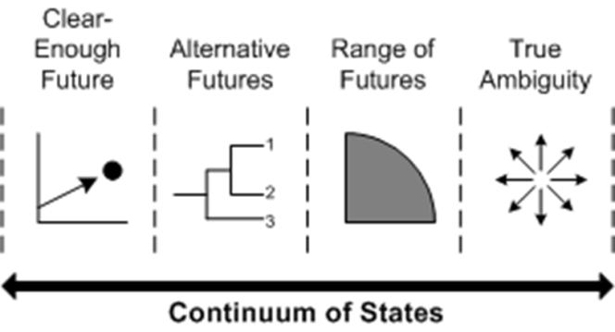
Ill-Structured Problems
- Ill-Structured problem: a problem for which the existing and desired states are unclear and the method of getting to the desired state is unknown
  - Unique and haven’t been encountered before
  - Complex and involve high degree of uncertainty
  - Arouse controversy/conflict among people interested in making decision
  - People more likely to gather more information and be more self-consciously analytical in their approach
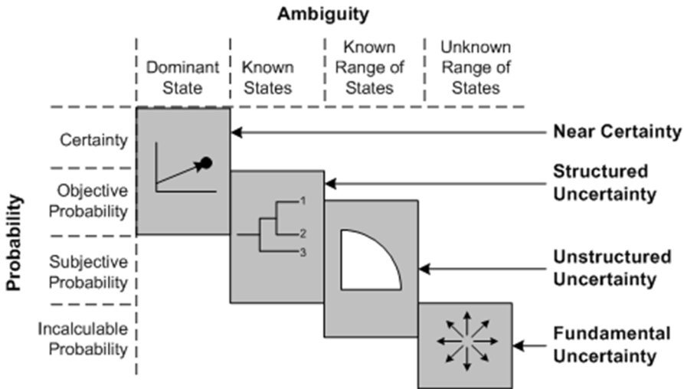
The Complete Decision Maker – A Rational Decision-Making Model

Perfect vs. Bounded Rationality
- Perfect Rationality: decision strategy 100% informed, perfectly logical, oriented toward economic gain. (the Economic Person)
  - Gather info about problems and solutions without cost, thus completely informed
  - One criterion for decision making – economic gain
- Bounded Rationality: a decision strategy that relies on limited information and that reflects time constraints and political considerations
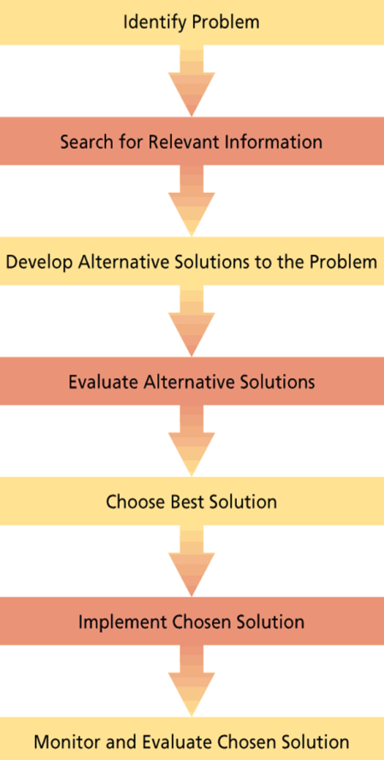
  - Impact of emotions and moods on decisions
- Framing: aspects of the presentation of information about a problem that are assumed by decision makers
- Cognitive Biases: tendencies to acquire and process information in an error-prone way

Rational Decision Making Process:

Problem Identification and Framing
- Perceptual defence – perceptual system act as defender against unpleasant perceptions
- Problem defined in terms of functional specialty – problem in domain of own speciality when other opinions should be sought out
- Problem defined in terms of solution – jumping to conclusions short-circuits decision-making process
- Problem diagnosed in terms of symptoms
- Be self-conscious about framing problems, try alternative frames, avoid overarching, universal frames

Information Search
- Too little information:
  - Not have enough info to make good decision
  - Mentally lazy, only remember recent, vivid events; may be irrelevant in context of problem
  - Overconfident in decision making, don’t search for info
  - Confirmation Bias: tendency to seek out info that conforms to one`s own definition of or solution to a problem
- Too much information:
  - Information overload: receiving more information than necessary to make effective decisions
  - Leads to errors, omissions, delays and cutting corners
  - Try to use all info, get confused, allow low quality or irrelevant info to affect decisions
  - Think more is better, but not so
  - Decision may not improve with more info, but confidence in decision increases
  - Decision makers fear being kept in the dark and associate possession of info with power
  - Use info collected after decision to justify that decision
  - Request info that they don’t use
  - Bias paid advice over free advice

Alternative Development, Evaluation and Choice
- Maximization: choice of decision alternative with the greatest expected value
  - People don’t incorporate data known on likelihood of events (base rates). Ex. firms continually launch novelty food items even though they have a high failure rate, food in tubes
  - Large sample groups should give more confidence than small ones
  - Overestimate odds of complex chain of events happening
  - Bad at revising estimate of probabilities when they acquire new information.
    - Anchoring effect: inadequate adjustment of subsequent estimates from an initial estimate that serves as an anchor
- Reduce cognitive biases if make people accountable for their decisions, accountability must be placed before decision made
- Satisficing: establishing an adequately acceptable solution to a problem and then screening solutions until one that exceeds this level is found

Risky Business
- When people view a problem as choice between losses they make riskier decisions
- When frame alternatives as choice between gains make conservative decisions

Solution Implementation
- In (bounded rationality) and most decision scenarios decision makers dependant on others to implement their decisions, difficult to anticipate their ability or motivation to do so

Solution Evaluation
- Justification
  - Prevent dissonance with decision by avoiding careful tests of adequacy of decision
  - Sunk cost: permanent losses of resources incurred as the result of a decision
  - Escalation of commitment: the tendency to invest additional resources in an apparently failing course of action; used for dissonance reduction, affected by situational causes, personality, moods and emotions, can occur in competitive and non-competitive situations
  - Prevent escalation:
    - Continuous experimentation with reframing the problem to avoid feeling of more resources need to be invested, shift frame to saving rather than spending
    - Specific goals set in advance that must be met before more resources invested
    - Emphasis on evaluation how managers make decisions not on decision outcomes
    - Separate initial decision making from subsequent so people who decide to start or assisted or others make decision to continue
  - Groups more prone to escalation of commitment than individuals
- Hindsight
  - Hindsight: tendency to review the decision making process to find what was done right or wrong
  - Knew-it-all-along effect
  - Faulty memory adjusts probabilities that we estimated before making the decision to correspond to what actually happened
  - Person responsibility for success but deny responsibility for failure

How Emotion and Mood Affect Decision Making:
- Emotions can correct ethical errors, whistle blowers say there were motivated by an emotion
- Strong/positive emotions implicated in creative decision making and proper use of intuition to solve problems which can lead to successful short circuiting when time is of the essence
- People experiencing strong/positive emotions are self-focused, distracted by actual demands of problem, “blinded by emotion”
- Excessive emotional conflict between partners provokes questionable business decisions
- Evidence that mood effects what and how people think when making decisions
- Mood most impacts uncertain, ambiguous decision types that are especially crucial for organizations
  - People in positive mood remember positive info, same for negative
  - People in positive mood evaluate objects, people and events more positively, same for negative
  - People in good mood overestimate likelihood that good events will occur and underestimate occurrence of bad events. People in bad mood do opposite
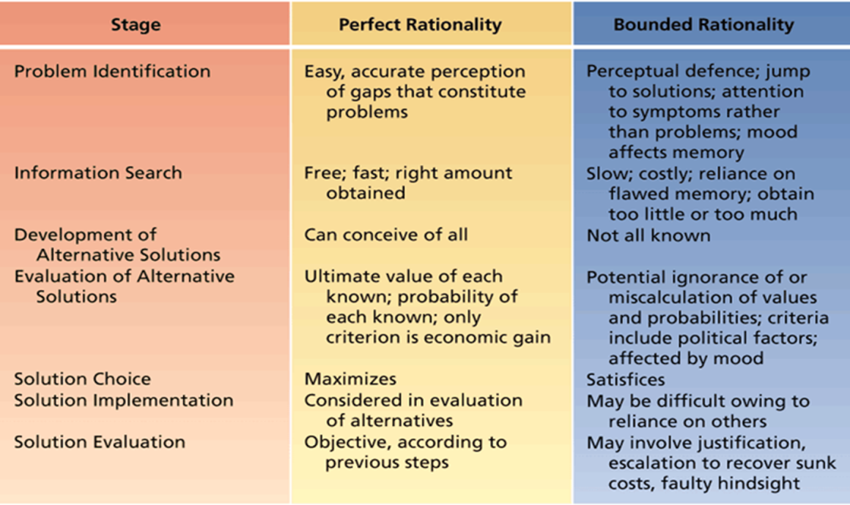
  - People in good mood simplify, short circuit/shortcut strategies to violate decision processes model, people in negative mood more deliberate and systematic in their approach
  - Positive mood promotes creativity, intuitive decision making

Perfect Rationality vs. Bounded Rationality
Summary of Cognitive Biases:
- Tend to be overconfident about decisions that they make
- Tend to seek out information that confirms their own problem beliefs, definitions, solutions (confirmation bias)
- Tend to remember and incorporate vivid, recent events into their decisions (ease of recall)
- Have difficulty ignoring sunk costs when making subsequent decisions (escalation bias)
- Fail to incorporate known existing data about the likelihood of events into the decisions (base rate insensitivity)
- Ignore sample size when evaluating samples of information (sample size insensitivity)
- Overestimate the odds of complex chains of events occurring
- Do not adjust estimates enough from some initial estimate that serves as an anchor as they acquire more information (anchoring effect)
- Fail to incorporate known existing data about the likelihood of events into the decisions (base rate insensitivity)
- Ignore sample size when evaluating samples of information (sample size insensitivity)
- Overestimate the odds of complex chains of events occurring
- Do not adjust estimates enough from some initial estimate that serves as an anchor as they acquire more information (anchoring effect)
- Individuals tend to ignore the fact that extreme events tend to regress to the mean on subsequent trials (regression to the mean)
- overestimate the probability of conjunctive events (conjunctive events bias)
- underestimate the probability of disjunctive events (disjunctive events bias)

Group Decision Making

Why Use Groups?
- Decision making quality: groups or teams can make higher quality decisions than individuals based on three assumptions
  - Groups more vigilant – more people scanning environment
  - Generate more ideas
  - Evaluate idea better
- Decision Acceptance and Commitment: decisions made this way are more acceptable to those involved; several assumptions based on this
  - people want to be involved in decisions that affect them
  - people better understand decision in which they participated
  - people more committed to decision in which they invested personal time and energy
- Diffusion of Responsibility: ability of group members to share the burden of negative consequences of a poor decisions

Groups Make Higher-Quality Decisions than Individuals?
- Groups should perform better than individuals when
  - Group members differ in relevant skills and abilities, so long differ isn’t too big that so much conflict occurs
  - Division of labour can occur
  - Memory for facts is important issue
  - Individual judgements combined by weighting them to reflect expertise of various members

Disadvantages of Group Decision Making
- Time
- Conflict – groups will make better decisions when members feel psychologically safe
- Domination – meetings dominated by single person or coalition, no decision benefit
- Groupthink – capacity for group pressure to damage the mental efficiency, reality testing, and moral judgement of decision making groups
  - Root of groupthink was high group cohesiveness
  - Symptoms of group think:
    - Illusion of invulnerability
    - Rationalization/ problems rationalized away
    - Illusion of morality
    - Stereotypes of outsiders
    - Pressure for conformity
    - Self-censorship
    - Illusion of unanimity
    - Mind guards – protect group from information that goes against it

  - Prevent groupthink:
    - Leaders be careful to avoid exerting unnecessary pressure for particular decision outcome and concentrate more on good decision process
    - Norms that encourage/reward responsible dissent
    - Outside experts brought in to challenge group views

How Do Groups Handle Risk?
- Risky shift: tendency for groups to make riskier decision than the average risk initially advocated by their individual member. If everyone kind of risky, as group make even riskier decisions
- Conservative shift: tendency for groups to make less risky decisions than the average risk initially advocated by their individual members. Ex. if everyone kind of conservative, together make even more conservative decisions
- group discussions seem to polarize or exaggerate initial position of group
  - discussion generates ideas/arguments that others haven’t considered before, this info usually favour members initial tendency toward risk or conservatism
  - group members try to present selves as basically similar to other members but even better
- communication via computers tend to polarize even more than face to face groups

Improving Decisions Making in Organizations

Training Discussion Leaders
- if leader tries to sell idea, benefits of group decision null, decision acceptance suffers
- if leader exerts no influence, group could make low quality decision that doesn’t meet needs of organization
- Skills taught to discussion leaders:
  - State problem in non-defensive, objective matter
  - Supply essential facts and clarify constraints on solution
  - Draw out all group members, prevent domination, protect members from attack/severe criticism
  - Ask stimulating questions to move discussion forward
  - Summarize and clarify at server points to mark progress

Stimulating and Managing Controversy
- Full blown conflict makes people withhold info, and becomes a fight for personal/group goals not solving organizational problems
- Lack of controversy bad b/c alternative points of view that could be very relevant never come up
- To stimulate controversy: include members with diverse ideas and backgrounds, form subgroups to tear apart problems, establish norms that favour open sharing of info
- Devil’s advocate: person appointed to identify and challenge the weaknesses of a proposed plan or strategy, recognition of pros and cons, to be effective advocate must present view in objective, unemotional manner

Traditional and Electronic Brainstorming:
- Brainstorming: attempt to increase number of creative solution alternatives to problems by focusing on idea generation rather than evaluation
- Individuals working alone generate more ideas than those in groups; because inhibition, domination of group by ineffective member, physical limitations of people trying to talk simultaneously
- Electronic brainstorming: use of computer-mediated technology to improve traditional brainstorming practices; groups of more than two, more effective in both quantity and quality of ideas

Nominal Group Technique
- Nominal group technique: structured group decision making technique in which ideas are generated without group interaction and then systematically evaluated by group
- Prevent inhibition and conformity; advantage would be time and resources required to assemble group for face to face interaction

The Delphi Technique
- Delphi Technique: method of pooling large number of expert judgements by using serious of increasingly refined questionnaires
- Nominal group, participants don’t engage in face to face interaction
- Experts don’t make final decision, provide info for organizational decision makers
- First questionnaire usually general, permit free responses to problem
- Second questionnaire shares responses and ask for suggested improvements
- Final questionnaire asks respondents to rank or rate each improvement
- Lengthy time frame, effectiveness depends on writing skills of respondents and interest in problem

CHAPTER 12 – POWER, POLITICS AND ETHICS

What is Power?
- Power: the capacity to influence others who are in a state of dependence

The Bases of Individual Power
- Power can be found in the position that you occupy in the organization or the resources that you are able to command
- Legitimate power: power derived from a person’s position or job in an organization
- Reward power: power derived from the ability to provide positive outcomes and prevent negative outcomes, positive reinforcement backs up legitimate power
- Coercive power: power derived from the use of punishment and threat, support for legitimate power
- Referent power: power derived from being well liked by others; identification, anyone in the organization
- Expert power: power derived from having special information or expertise that is valued by an organization

How Do People Obtain Power?

Doing the Right Things
- Extraordinary activities – unusual or non-routine
- Visible activities
- Relevant activities

Cultivating the Right People
- Outsiders: sometimes power is merely a reflection of the status of the outsider, but all the same it may add to one’s internal influence
- Subordinates: cultivating relationships with subordinates
- Peers: cultivating good relationships with peers is mainly a means of ensuring that nothing gets in the way of ones future acquisition of power, fears of being stabbed in the back
- Superiors: mentors and sponsors

Empowerment – Putting Power Where it is Needed
- Empowerment: giving people the authority, opportunity and motivation to take initiative and solve organizational problems
  - Authority is having legitimate power
  - Opportunity usually means freedom from bureaucratic barriers and other system problems that block initiative
  - Motivation is being intrinsically motivated by power and opportunity and aligning extrinsic rewards with successful performance

Influence Tactics – Putting Power to Work
- Influence tactics: tactics that are used to convert power into actual influence over others
  - Assertiveness – ordering, nagging, setting deadlines and verbally confronting
  - Ingratiation – using flattery and acting friendly, polite or humble
  - Rationality – using logic, reason, planning and compromise
  - Exchange – doing favours or offering to trade favours
  - Upward appeal – making formal or informal appeals to organizational superiors for intervention
  - Coalition formation – seeking united support from other organizational members

Who Wants Power?
- most effective managers:
  - have high n Pow
  - use their power to achieve organizational goals
  - adopt a participative or coaching leadership style
  - are relatively unconcerned with how much others like them
- institutional managers because they use their power for the good of the institution rather than for self-aggrandizement
- personal power managers who use their power for personal gain
- affiliative mangers who are concerned with being like over exercising power

Controlling Strategic Contingencies – How Subunits Obtain Power
- Subunit power: the degree of power held by various organizational subunits such as departments
- Strategic contingencies: critical factors affecting organizational effectiveness that are controlled by a key subunit

Scarcity
- Subunit power are likely to be magnified when resources become scare
- Tend to acquire power when they are able to secure scarce resources that are important to the organization as a whole

Uncertainty
- Subunits that are most capable of coping with uncertainty will tend to acquire power
- Able to protect other from serious problems
- Uncertainty promotes confusion which permits changes in power priorities as the organizational environment changes
- Changes in the sources of uncertainty frequently lead to shifts in subunit power, this HR departments gained power when government legislation regarding employment opportunity was first passed.

Centrality
- Subunits who’s activities are most central to the work flow of org should acquire more power than those who activities are more peripheral
- Influence work of most other subunits, ex. finance or accounting department
- Crucial impact on quantity of organizations key product or service, impact is more immediate

Substitutability
- Subunit will have relatively little power if others inside or outside the organization scan perform activities
- Works can be contracted out; power of the subunit that usually performs these activities is reduced.

Organizational Politics – Using and Abusing Power

The Basics of Organizational Politics
- Organizational politics: the pursuit of self-interest in an organization, whether or not this self-interest corresponds to organizational goals
- Political activity is self-conscious and intentional
- Politics as either individual activity or subunit activity
- Beneficial outcomes for the organization, even though these outcomes are achieved by questionable tactics
  - Sanctioned means/ Sanctioned ends: power is used to pursue agreed-on goals, accepted means of influence are employed to achieve sanctioned outcomes
  - Sanctioned means/not-sanctioned ends: acceptable means of influence abused to pursue goals that organization does not approve
  - Not-sanctioned means/ sanctioned ends: ends useful to organization are pursued through questionable means
  - Not-sanctioned means/ not-sanctioned ends: abuse of power, disapproved tactics used for disapproved outcomes
- Political activities occur under particular conditions or particular locations in organizations…research:
  - Lots of political manoeuvring in middle and upper management positions
  - Some subunits more prone to politicking, provoked by vague goals
  - Budget allocation, reorganization and personnel changes stimulate political activity
  - Scare resources, uncertainty and important issues provoke political behaviour
- Highly political climates results in lowered job satisfaction, lowered feelings of organizational support and increased turnover intentions

Facets of Political Skill:
- Political skill: ability to understand others at work and to use that knowledge to influence others to act in ways that enhance one’s personal or organizational objectives
  - Comprehend others and translating this comprehension into influence
    - Social astuteness: tuned into others needs and motives
    - Interpersonal influence
    - Apparent sincerity
    - Networking ability
      - Networking: establishing good relations with key organizational members and outsiders to accomplish ones goals
- Positively related to job performance
- Aspects of Networking (high self-esteem and extraversion):
  - Maintaining contacts
  - Socializing
  - Engaging in professional activities
  - Participating in community activities
  - Increasing internal visibility
Machiavellianism – The Harder Side of Politics
- Machiavellianism: a set of cynical beliefs about human nature, morality, and the permissibility of using various tactics to achieve one’s ends
- High Machs can deal fact to face with those he or she is trying to influence
- Interaction occurs under fairly emotional circumstance
- Situation fairly unstructured with few guidelines for appropriate forms of interaction
Defensiveness – Reactive Politics
- Reactive in that it concerns the defence or protection of self- interest
- Defensive behaviours:
  - Stalling
  - Over conforming: finding a way around an obstacle when suits political agenda
  - Buck passing: having someone else take action
- Avoid Blame:
  - Buffing: carefully documenting info showing appropriate course of action was followed
  - Scapegoating

Ethics in Organizations
- Ethics: systematic thinking about the moral consequences of decisions
- Stakeholders: people inside or outside of an organization who have the potential to be affected by organizational decisions
- Researchers find:
  - Large majority agree unethical practices happen in business
  - Have been pressured to compromise their own ethical standards when making organizational decisions
  - Managers see themselves as having higher ethical standards than their peers and sometimes their superiors
  - Women act more ethically

The Nature of Ethical Dilemmas
- Honest communication
- Fair treatment
- Special consideration: fair treatment can be altered for special cases
- Fair competition
- Responsibility to organization
- Corporate social responsibility
- Respect for law

Causes of Unethical Behaviour
- Gain
- Role conflict – protect environment (do not pollute) employment/job (don’t close don’t plant that pollutes)
- Competition
- Personality
  - Cynical, external locus of control, strong economic values, high need for personal power (Machiavellians) – less into ethical matters
- Organizational and industry culture

Whistle Blowing: disclosure of illegitimate practices by a current or former organizational member to some person or organization that may be able to take action to correct these practices

Sexual Harassment
- Form of unethical behaviour that stems from abuse of power and perpetuation of gender power imbalance
- Many organizations are slow to react to complaints of sexual harassment
- Deaf ear syndrome: inaction or complacency of organizations in face of charges of sexual harassment
- Fail to respond b/c of inadequate organizational policies and procedures for managing harassment complaints, defensive managerial reactions; organizational features that contribute to slow tendencies
- Solutions to these problems:
  - Examine if characteristics of deaf ear is in organizations (by managers)
  - Foster management support and education on how to deal with sexual harassment issues
  - Stay vigilant, monitor and remove displays of sexual nature
  - Take immediate action
  - Create state-of-the-art policy, clearly define what constitutes sexual harassment and sanctions that will be brought forward
  - Establish clear reporting procedures

Employing Ethical Guidelines: think about moral implications before making decisions
- Identify stakeholders that will be affected by decisions
- Costs and benefits of various decisions to the stakeholders
- Relevant moral expectations that surround decision
- Be familiar with common ethical dilemmas decision makers face in your specific organizational role
- Discuss ethical matters with stakeholders and others
- Convert your ethical judgements into appropriate action

CHAPTER 13 - CONFLICT AND STRESS

What is Conflict?
- Interpersonal conflict: process that occurs when one person, group or organization subunit frustrates the goal attainment of another

Causes of Organizational Conflict

Group Identification and Intergroup Bias
- Assign people to groups randomly
- Without interaction or cohesion people view their own “in-group” more positively and view the “out-group” which they are not a member of, more negatively
- Self-esteem a critical factor
- Associating self with in-group success and disassociating self with out-group failures gives feelings of social solidarity
- Group identification through:
  - Personal characteristics – race, gender
  - Job function – sales, production
  - Job level – manager, non-manager
  - Real differences in power, opportunity, clients serviced

Interdependence
- Individuals or subunits mutually dependant on each other to accomplish their own goals, potential for conflict exits
- Interact between parties necessary to coordinate interests
- Each party has power over other

Differences in Power, Status and Culture
- Power: dependence not mutual but one way, potential for conflict increases
- Status: little conflict when people of lower status dependent on people of higher status, way most organizations work and people accept it
- Culture: two+ different cultures develop in an organization, clash of beliefs and values can result in overt conflict

Ambiguity
- Ambiguous goals, jurisdictions and performance criteria can lead to conflict
- Formal and informal rules that govern interaction break down
- Hard to give praise for good outcomes and blame for bad ones when hard to see whose responsible for what
- Performance criteria basis of conflict between manager and employees

Scare Resources
- Differences in power magnified when resources become scarce
- Conflict surfaces in process of power jockeying

Types of Conflict
- Relationship conflict: interpersonal tensions among individuals that have to do with their relationship per se, not the task at hand, “personality conflict”
- Task conflict: disagreements about the nature of the work to be done
- Process conflict: disagreements about how work should be organized and accomplished
- Conflict prevents development of cohesiveness

Conflict Dynamics:
- “ winning” conflict becomes more important than developing a solution
- Parties conceal info from each other or pass distorted information
- Each side becomes more cohesive, deviants who speak of conciliation are punished and strict conformity is expected
- Contact with the opposite party is discouraged except under formalized, restrict conditions
- Opposite party is negatively stereotyped, image of owns position is boosted
- More aggressive people emerge as leaders

Modes of Managing Conflict
- How assertive one is in trying to satisfy own and groups concerns, and how cooperative one is in trying to satisfy those of the other party or group
- Avoiding: a conflict management style characterized by low assertiveness of one’s own interests and low cooperation with the other party
- Accommodating: a conflict management style in which one cooperates with the other party while not asserting one`s own interests
- Competing: a conflict management style that maximizes assertiveness and minimizes cooperation
- Compromise: conflict management styles that combines intermediate levels of assertiveness and cooperation
- Collaborating: conflict management style that maximizes both assertiveness and cooperation

Managing Conflict with Negotiation
- Negotiation: a decision making process among interdependent parties who do not share identical preferences
  - Attempt to reach a satisfactory exchange among/ between parties
- Distributive negotiation: win-lose negotiation in which a fixed amount of assets is divided between parties
- Integrative negotiation: win-win negotiation that assumes that mutual problem solving can enlarge assets to be divided between parties

Distributive Negotiation Tactics:
- Threats and Promises:
  - Threats: implying you will punish other party if they don’t concede to your position
    - Useful if one party has power over other, no future negotiations expected
    - If power balance equal, threat is crude, sidetrack negotiations
  - Promises: pledges that concessions will lead to rewards in future
    - Have merit when your side lacks power and anticipates future negotiations
- Firmness vs. Concessions:
  - Intransigence is likely to be reciprocated and results in deadlock
  - Series of small negotiations early on in process usually matched
- Persuasion:
  - 1st prong: asset technical merits of party position
  - 2nd prong: fairness of target position
  - Verbal persuasion is an attempt to change the attitudes of the other party toward your target position
  - Persuaders most effective when perceived as expert, likeable, and unbiased

Integrative Negotiation Tactics:
- Collaborative problem solving to advance interests of both parties, creative
- Copious Information Exchange
- Framing Differences as Opportunities: usually barriers, can be used to show parties real interests
- Cutting Costs: cut costs other party associates with agreement, win-win settlement increases
- Increasing Resources: way of getting around fixed pie syndrome, twice as many resources
- Introducing Superordinate Goals:
  - Superordinate Goals: attractive outcomes that can be achieved only by collaboration

Third Party Involvement:
- Intervene between negotiating parties when they’ve reached an impasse. Ex. real estate agents
Mediation:
- Third party helps facilitate a negotiated agreement
- Do anything that aides process or atmosphere of negation
- Help them clarify interests to both themselves and each other
- Imposing deadlines
- Highlight content of negotiation, points of agreement, new options, encouraging concessions
Arbitration:
- Third party is given authority to dictate terms of settlement, negotiation has broken down, arbitrator must make final allocation
- Conventional arbitration: arbitrator can choose any outcome
- Final offer arbitration: each party makes final offer, arbitrator chooses

Is All Conflict Bad?
- Promotes necessary organizational changes: CONFLICT -> CHANGE -> ADAPTATION -> SURVIVAL
- For organizations to survive must adapt to their environments, requires changes in strategy that may be stimulated through conflict
- New ideas that wouldn’t be offered without conflict
- Monitor each other’s performances more carefully, problems can’t be hidden
- Redistribution of power if necessary
- Conflict stimulation: strategy of increasing conflict to motivate change
- When is conflict a good thing?
  - Friendly rut or peaceful relationships taking precedence over organizational goals
  - Parties that should be interacting closely have chosen to withdrawn from another to avoid overt conflict
  - Conflict supressed by denying differences, ignoring controversy and exaggerating points of agreement
- Causes of conflict can be manipulated by managers to achieve change

A Model of Stress in Organizations

Stressors
- Stressors: environmental event or conditions that have the potential to induce stress
- Individual personality determines extent to which potential stressor becomes a real stressor and induces stress
* refer to figure 13.3 pg. 437

Stress
- Stress: psychological reaction to the demands inherent in a stressor that has the potential to make a person feel tense or anxious
- Stress not intrinsically bad, all people need certain level to stimulate their environment

Stress Reactions
- Stress reactions: behavioural, psychological and physiological consequences of stress
- Passive responses, with little direct control over. Ex. elevated blood pressure, reduced immune function
- Other reactions attempts to cope, dealing directly works better because better chance of terminated stressor all together

Personality and Stress
- Locus of Control: set of beliefs about whether ones behaviour is controlled mainly by internal or external forces
  - Internal confront stressors directly, externals use anxiety reduction strategies
- Type A Behaviour Patter: personality pattern that includes aggressiveness, ambitiousness, competitiveness, hostility, impatience and sense of time urgency
  - Hostility and repressed anger contribute to physiological reactions
- Negative Affectivity: propensity to view world, including oneself and other people, in negative light
  - “big five: personality dimension neuroticism
  - a) predispositions to perceive stressors in workplace, b) hypersensitivity to existing stressors, c) tendency to gravitate to stressful jobs, d) tendency to provoke stress through negative affectivity, e) use of passive, indirect coping styles that avoid sources of stress

Stressors in Organizational Life

Executive and Managerial Stressors
- Role overload: requirement for too many tasks to be performed in to short a time period
- Heavy responsibility: extremely important consequences for organization, large personal consequences, executives are responsible for people as well as things, this influence over future of others has potential induce stress

Operative-Level Stressors
- Operatives are people who occupy non-professional non-managerial positions in organizations
- Poor physical working conditions: face excessive heat, cold, noise, pollution and chance of accidents
- Poor job design: job scope either too high or too low

Boundary Roles Stressors, Burnout and Emotional Labour
- Boundary Roles: positions in which org. members are required to interact with members of other orgs or with the public. Ex. sales reps
- Burnout: syndrome of emotional exhaustion, cynicism and reduced self-efficacy, happens to people who enter into jobs with high ideals. Pg. 441 exhibit 13.4
  - Consequences: new occupation, guilt of not being able to cope with old one, same occupation but seek new job, administrative careers in same profession,

Job Demand-Resources Model and Work Engagement
- Work engagement: positive work-related state of mind that is characterized by vigor, dedication and absorption
  - Vigor involves high levels of energy and mental resilience at work
  - Dedication means being strongly involved in your work and experiencing sense of significance, enthusiasm and challenge
  - Absorption refers to being fully concentrated on and engrossed in your work
- Job demands-resources model: model that specifies how job demands cause burnout and job resources cause engagement
  - Job demands: physical, psychological, social or organizational features of job that require sustained physical or psychological effort that in turn can result in physiological or psychological costs. Ex. work overload, time pressure, role ambiguity and role conflict
  - Job resources: features of job that are functional b/c help achieve work goals, reduce job demands and stimulate personal growth, learning and development.
    - from organization: pay, career opportunities, job security
    - interpersonal and social relations: supervisor and coworkers support, team climate
    - organization of work: role clarity, participation in decision making
    - task itself: task significance, autonomy, performance feedback
  - central assumption to this model is that high job resources foster work engagement while high job demands exhaust employees physically and mentally and lead to burnout

Some General Stressors
- interpersonal conflict:
  - bullying: repeated negative behaviour directed toward one or more individuals of lower power or status that creates a hostile work environment
    - persistence/ repeated incessant teasing, demeaning criticism, social isolation or sabotaging others tools and equipment
    - degree of power or status imbalance between the bully and the victim
    - mobbing – number of individuals usually direct co-workers, “ganging up” on particular employee, restricts availability of social support
  - Work-family conflict:
    - Both parents working and single parent families increase stressors around childcare
    - Increase life spans are having people in the prime of their careers taking care of elderly
    - Occupations that require a high degree of teamwork or responsibilities for others tend to provoke the most work-family conflict. Ex. police detectives, firefighters, family doctors
  - Job insecurity and change
  - Role ambiguity: goals of one’s job or methods of performing the job are unclear
  - Sexual harassment

Reactions to Organizational Stress

Behavioural Reactions to Stress
- Overt activities that the stressed individual uses in an attempt to cope with stress
- Problem solving: directed towards terminating the stressor or reducing its potency
  - Delegation
  - Time management
  - Talking it out
  - Asking for help
  - Searching for alternatives
- Seeking social support: refers to having close ties with other people
  - People with stronger social networks exhibit better psychological and physical well being
  - People with good social networks cope more positively, buffers against stress
- Performance changes: some stressors are “hindrance” stressors in that they directly damage goal attainment
- Withdrawal
- Use of addictive substances

Psychological Reactions to Stress
- Primary involve emotions and thought processes, revealed through individuals speech and actions
- Defence mechanisms: psychological attempts to reduce the anxiety associated with stress
  - Rationalization, projection, displacement, reaction formation, compensation
  - Used occasionally defence mechanisms are useful reaction but when use becomes chronic stress might increase b/c knowledge that defence is essentially ineffective

Physiological Reactions to Stress
- Lead to heart attacks, respiratory and bacterial infections due to effects on immune system

Organizational Strategies for Managing Stress

- Job redesign: to reduce their stressful characteristics
- Family friendly human resource policies: reduce stress with dual careers, childcare and eldercare many organizations are beginning to institute “family – friendly” policies
  - Perceptions of flexibility, reasonable workload, supportive supervision and supportive culture are associated with less work-family conflict and higher job satisfaction and organizational commitment
- Stress management programs: meditation, muscle relaxation exercises, biofeedback training to control physiological processes, training in time management, training to think more positively and realistically about sources of job stress
- Work-life balance, fitness, and wellness programs: variety of leisure activities combined with healthy diet and physical exercise can reduce stress and counteract some of the adverse physiological effect of stress

CHAPTER 14 – ORGANIZATIONAL STRUCTURE

What is Organizational Structure?
- Causes and consequences of organizational structure
- How organizations individuals and groups are put together or organized to accomplish work
- To achieve goals organizations must: divide labour among members and coordinate what has been divided
- Organizational Structure: manner in which an organization divides its labour into specific tasks and achieves coordination among these tasks

The Divisions and Coordination of Labour

Vertical Division of Labour
- Apportioning authority for planning and decision making
- Separate departments, units, functions within organization also often vary in the extent to which they vertically divide labour
- Autonomy and Control: domain of decision making and authority reduce as number of levels in hierarchy increase
- Communication: timely communication and coordination become harder to achieve as number of hierarchy levels increase

Horizontal Division of Labour
- Groups basic tasks that must be performed into jobs and then into departments so that organization can achieve its goals
- Required workflow is the main basis for this division
- Job design: affects degree of coordination necessary, implications for vertical division of labour and where control over work processes should logically reside
- Differentiation: the tendency for managers in separate units, functions, or departments to differ in terms of goals, times spans, and interpersonal styles

Departmentation
- Assignment of jobs to all departments, core aspect of horizontal division of labour

Functional Departmentation: employees with closely related skills and responsibilities are assigned to the same department
- Ex. people with skills in go to finance department
- Employees grouped according to kind of resource they contribute to overall goals of organization
- Advantages:
  - Efficiency
  - Communication within departments should be enhanced
  - Career ladders and training opportunities within function enhanced
  - Performance of functional specialists should be easier to measure
- Disadvantages:
  - Differentiation can occur between departments
  - Poor coordination and slow response to organizational problems
  - Open conflict between departments, needs of customers ignored
- works best in small – medium sized firms, few product lines/services
Product Departmentation: departments are formed on the basis of a particular product, product line or service
- operate autonomously because has own set of functional specialists dedicated to output of that department
- Advantages:
  - Better coordination among functional specialists who work on product line
  - Flexibility
  - Evaluations of profits and losses
  - Serves customer or client better
- Disadvantages:
  - Professional development suffer
  - Economies of scale threatened
  - Inefficiency b/c of no coordination
  - Work on similar problem without knowing
  - Work at cross purposes

Matrix Departmentation: employees remain members of functional department while also reporting to a product or project manager
- What gets crossed with functional areas to form matrix and degree of stability of matrix relationships
- Could be based on short term projects
- Advantages:
  - Balance between abstract demands of product or project and people who can actually do work, results in better outcome
  - Flexible
  - Better communication among representatives from various functional areas
- Disadvantages:
  - No guarantee product managers and functional managers see eye-to-eye, creating conflict
  - Role conflict because employees report to 2 bosses (functional and project manager) during times of performance reviews especially
  - Cultural limitations

Geographical departmentation: relatively self-contained units deliver an organization`s products or services in a specific geographic area
- Shortens communication channels, caters to regional tastes, appearance of local control to customers

Customer departmentation: relatively self-contained units deliver an organization`s products or services to specific customer groups;
- provide better service to each customer group

Hybrid departmentation: structure based on some mixture of functional, product, geographic and customer departmentation

Basic Methods of Coordinating Divided Labour
- coordination: a process of facilitating timing, communication and feedback among work tasks
  - direct supervision
  - standardization of work processes
  - standardization of outputs (profit targets, budgets)
  - standardization of skills, ex. surgery team
  - Mutual adjustment: information communication to coordinate tasks. Used of simple and complicated divisions of labour
- Degree of discretion they permit in terms of task performance
- Enriching jobs on right side
- Routine - direct supervision, standardization of processes or outputs
- Staffed by professional – skill standardization and mutual adjustment
- Methods of coordination changes as task demand change

Other Methods of Coordination
- Integration: the processes of attaining coordination across differentiated departments
- Who is accountable for what, enables one department to predict activities of another, creates shared understanding of goals
- Three methods for achieving integration:
  - Liaison role: person who is assigned to help achieve coordination between his or her department and another department
  - Task forces and Teams:
    - Task force: temporary groups set up to solve coordination problems across several departments
    - Teams useful in achieving coordination for new product development or introduction
    - Integrators: organizational members permanently assigned to facilitate coordination between departments that are 1) highly interdependent, 2) diverse goals/orientations, 3) operate in very ambiguous environment. Ex. high tech companies

Traditional Structural Characteristics

Span of Control: number of subordinates supervised by a manager
- Larger the span less potential for coordination by direct supervision
- Lower levels span bigger, higher levels span smaller

Flat Organization: relatively few levels in its hierarchy of authority
Tall organization: relatively many levels in its hierarchy of authority
- Flatter push decisions powers downward, enhance vertical communication

Formalization: extent to which work roles are highly defined by an organization

Centralization: extent to which decision-making power is localized in a particular part of an organization
- Centralized – power to make key decisions with one person, president
- Decentralized – power to make decisions dispersed through hierarchy and across departments

Complexity: the extent to which an organization divides labour vertically, horizontally and geographically

Summarizing Structure – Organic vs. Mechanistic

Mechanistic structures: organizational structures characterized by tallness, specialization, centralization and formalization
- Organizations external environment is more stable and its technology more routine

Organic Structures: organizational structures characterized by flatness, low specialization, low formalization and decentralization
- Environment is uncertain, technology is less routine, innovation is important

Contemporary Organic Structures

Ambidextrous organization: an organization that can simultaneously exploit current competencies and explore emerging opportunities; part organic, more mechanistic

Network organization: liaisons between specialist organizations that rely strongly on market mechanisms for coordination
- Emphasis placed on who can do what most effectively and economically

Virtual organization: a network of continually evolving independent organizations that share skills, costs and access to ones another’s markets

Modular organization: an organization that performs a few core functions and outsources other activities to specialists and suppliers

Boundaryless organization: organization that removes vertical, horizontal and external barriers so that employees, managers, customers and suppliers can work together, share ideas, and identify the best ideas for the organization

Impact of Size

Size and structure:
- Larger organizations more complex than smaller organization
- Complexity means coordination problems
- Bigger organization less centralized that smaller ones
- Top mgmt. too far removed from action to make operating decisions
- Large organizations tent to be more formal than small organizations
- When growth comes from acquisitions in other firms it doesn’t lead to decentralization
- Product departmentation has more complexity and decentralization than with functional departmentation
- Size is only one factor of organizational structure

Downsizing: intentional reduction in work force size with the goal of improving organizational efficiency or effectiveness
- As size decreases firm should reduce complexity, centralize, become less formalized
- Downsizing doesn’t occur is all parts of organization and not always opposite factors that led to organizational growth in the past
Problems with Downsizing:
- When serious decline, become more formalized and centralized where have negative impact on customers or clients
- Think carefully about the work that needs to be done and who should do it before downsizing
- If only mgmt. thinned, larger spans and less support above them
- Impact on structure and moral should be anticipated and managed
- Leads to reduced satisfaction and commitment, increased absenteeism and damaged health
- Negative outcomes due to poor implementation and lack of supporting activities

Symptoms of Structural Problems:
- Bad job design
- Right hand doesn’t know what left hand is doing
- Persistent conflict between departments
- Slow response times
- Decisions made with incomplete information
- Proliferation of committees

CHAPTER 16 – ORGANIZATIONAL CHANGE, DEVELOPMENT AND INNOVATION

Concept of Organizational Change
- Way changes implemented and managed that is crucial to both customers and members

Why Organizations Must Change
- Organizations open systems that take inputs from environment, transform some input, put back in environment as outputs
- Organizations try hard to stabilize their inputs and outputs
- Limits on extent of control over environment
- Environmental changes must be matched by organization changes if organization is to remain effective
- Low productivity, conflict, strikes, sabotage, employee opinion, high absenteeism and turnover signal that change is necessary
- Use threat as motivator to change
  - Some unfreeze and adapt
  - Other paralyze and show extreme sluggishness
- Change requires investment of resources, usually money and mgmt. time, modification of routines and processes

What Organizations Can Change
- What aspect of an organization can change:
- Goals and strategies
- Technology
- Job design
- Structure
- Processes
- Culture
- People
- Change in one area often calls for change in others
- Change requires organizations give serious attention to people changes; necessary skills and favourable attitudes should be fostered before changes introduced

The Changing Process
- Changing involves a sequence of organizational events or psychological process that occurs over time
- Unfreezing: recognition that some current state of affairs is unsatisfactory
  - Stimulated by crises
  - Employee attitude surveys, customer surveys, accounting data used to anticipate problems and initiate change before crises are reached
- Change: implementation of program or plan to move the organization or its member to a more satisfactory state
- Refreezing: condition that exists when newly developed behaviours, attitudes or structures become an enduring part of the organization

The Learning Organization
- Organizational learning: process through which an organization acquires, develops and transfers knowledge throughout the organization
  - Knowledge acquisition: acquisition, distribution and interpretation of knowledge that already exists but external to the organization
  - Knowledge development: development of new knowledge through dialogue and experience
- Learning Organization: an organization that has systems and processes for creating, acquiring and transferring knowledge to modify and change its behaviour to reflect new knowledge and insights
  - Vision/ support
  - Culture
  - Learning systems/dynamics
  - Knowledge management/infrastructure
  - Learning organization better able to change and transform themselves because greater capacity for acquiring and transferring knowledge

Issues in the Change Process

Diagnosis
- Diagnosis: the systematic collection of information relevant to impending organizational change
  - Contribute to unfreezing, clarify problem and suggest just what changes should be implemented
- Change agents: experts in the application of behavioural science knowledge to organizational diagnosis and change
  - Change agent brings independent, objective perspective to diagnosis while working with people who are about to undergo change

Resistance
- At unfreezing stage defence mechanisms activated to deny or rationalized signals that change is needed, plan for change might be resisted
Causes of Resistance:
- Resistance: overt or covert failure by organizational members to support a change effort
  - Politics and self interest
  - Low individual tolerance for change
  - Lack of trust
  - Different assessments of the situation
  - Strong emotions
  - Resistant organizational culture
- Change unnecessary b/c small gap between organizations current identity and ideal identity
- Change unobtainable because gap between current and ideal identity too large
Dealing with Resistance:
- Low tolerance for change overcome with supportive, patient supervision
- Politics and self-interest root of resistance, give desirable role in change process or negotiate special incentives for change
- Misunderstanding, lack of trust or different assessments make resistance, good communication
- Involving people who are targets of change in change process often reduces their resistance
- Transformational leaders skilled at overcoming resistance
  - Sensitive to when followers are ready for change
  - Dissent encouraged
  - Environment scanned for objective info about organization true performance
  - Members sent to other organizations to see how things done elsewhere
  - Organization compares itself with competition

Evaluation and Institutionalization:
- Evaluate changes to determine if they accomplished what they were supposed to and if that accomplishment is now considered adequate
- Consider:
  - Reactions – measure resistance
  - Learning – reflects change
  - Behaviour – successful refreezing
  - Outcomes – dictate refreezing useful tool for organization

Organizational Development: Planned Organizational Change
- Organizational development (OD): a planned, ongoing effort to change organizations to be more effective and more human
  - Behavioural science knowledge – doesn’t rely solely on principles of accounting, finance, engineering
  - Cultural norms and roles – organization remains self-conscious and prepared for adaptation
  - Focus on interpersonal and group processes – all organizational change affects members and their cooperation is necessary to implement change

Some Specific Organizational Development Strategies

Team Building: an effort to increase the effectiveness of work teams by improving interpersonal processes, goal clarification and role clarification
- Diagnostic session where team explores current level of functioning
- Data generated through: sensitivity training, open ended discussion, attitude survey result, production figures
- Then try to implement changes indicated by diagnosis

Survey Feedback: the collection of data from organizational members and the provision of feedback about the results
- Suggest and formulate change that emerges from data
- Change agent should decide on these things before collecting data:
  - Who should participate in the survey
  - What questions should the survey ask
    - Standardized surveys
    - Info gathering in face-to-face interactions and meetings

Total Quality Management (TQM): a systematic attempt to achieve continuous improvement in the quality of an organizations products and services
- Customer satisfaction, good relations with suppliers, improvement of work processes, prevention of quality errors, measurement and assessment, extensive training, high employee involvement and teamwork
- Improvement is continuum ranging from responding to product/service problems (reactive strategy) to creating new products/services to please customers (proactive strategy)
- Continuous improvement in TQM is:
  - Come from small gains over time or radical innovation, goal is long-term improvement not quick fix
  - Measurement and data collection to see where we stand in the first place
  - Teamwork among employees, suppliers and customers
  - Training to achieve continuous improvement
- Tools for diagnosis:
  - Flowcharts of work processes: graphically show operations and steps in accomplishing some task, who does what and when
  - Pareto analysis: frequency data on causes of errors and problems showing where attention should be directed for maximum improvement
  - Fishbone diagrams: cause-and-effect diagrams show factors that contribute to particular quality problem
  - Statistical process control: hard data about quality of own output that enables them to correct deviations from standard
Reengineering: radical redesign of organizational processes to achieve major improvements in such factors as time, cost, quality or service
- Organizational processes: activities or work that have to be accomplished to create outputs that internal or external customers value
- gains form reengineering greatest when process is complex and cuts across number of jobs and departments
- factors that prompt interest in reengineering:
  - satisfying bureaucratic procedures rather that tending to customer
  - new information technology – modified to fit technological capabilities rather than simply fitting the technology to existing jobs
- reengineering process:
  - number of mediating steps in process is reduced, making process more efficient
  - collaboration among people involved in process is enhanced
- other aspects:
  - job redesign and enrichment
  - strong emphasis on teamwork
  - work performed by most logical people
  - unnecessary checks and balances removed
  - advanced technology is exploited

Does Organizational Development Work?
- Most OD techniques have positive impact on productivity, job satisfaction or other work attitudes
- OD seems to work better for supervisors or mangers than blue collar workers
- Changes that use more than one technique have more impact
- Great difference across sites in success of OD interventions
  - Differences in skill and seriousness with organizations that have undertaken OD projects
- TQM and reengineering most successful when accompanied by organizational culture
- Problems:
  - OD efforts involve complex series of changes
  - Novelty effect or participants want to receive special treatment produce short term gains that don’t last
  - Self-reports of changes after OD involve unconscious attempt to please change agent
  - Organizations reluctant to publicize failures

The Innovation Process

What is Innovation?
- Innovation: the process of developing and implementing new ideas in an organization
- Product innovations have direct impact on cost, quality, style, availability of product or service
- Process innovations new ways of designing and making products or delivering services to help organization perform more effectively, invisible to customer
- IDEA GENERATION -> IDEA IMPLEMENTATION -> IDEA DIFFUSION
  - Idea generation due to serendipity
  - Beginning of innovation can be chaotic, conditions necessary to create new ideas be very different from conditions necessary to get them implemented
  - Innovation might be resisted
  - Highly political process
  - Generation of good ideas no guarantee that they will be implemented or diffused

Generating and Implementing Innovative Ideas

Individual Creativity:
- Creativity: production of novel but potentially useful ideas
- Creative people have excellent technical understanding of their domain
- Creativity relevant skills – tolerate ambiguity, withhold early judgement, see things in new ways, open to new and diverse experiences
- These skills can be improved by training people to think in divergent ways and withhold early evaluations of ideas
- People can be experts and have necessary skills but not be creative because not intrinsically motivated

Idea Champions:
- Idea champions: people who recognize an innovative idea and guide it through to implementation
- Informal emergent role
- “guiding” - telling peers, selling to mgmt, getting resources for development, protecting it from political attack from guardians of status quo
- Traits of idea champions:
  - Broad interest and saw their roles as being broad
  - Active in scouting for new ideas, variety of media for stimulation
  - Present innovation as opportunity not threat
  - Signs of transformational leadership, charisma, inspiration, intellectual stimulation
  - Made people want innovation despite disruption of status quo

Communication:
- Effective communication with external environment and organization are vital for innovation
- Recognize relevance of new external info, import and assimilate info and apply it
- Gatekeepers: people who span organizational boundaries to import new information, translate it for local use and disseminate it
  - in key positions to receive and transmit new technical or scientific information
- getting close to customer not just doing large research samples, b/c doesn’t prompt information but talking directly to users does
- organic structures facilitate innovation more easily than mechanistic structures
- decentralization, informality and lack of bureaucracy foster exchange of information
- internal communication can be stimulated with in-house training, cross functional transfers, varied job assignments
- high communicating, medium-longevity groups being best performers
- groups get old, sometimes get comfortable and isolate themselves from critical sources of feedback
- mechanistic structures often better for actually implementing innovations

Resources and Rewards:
- funds for innovations seen as an investment not cost
- availability of funding is anarchic and multisource
- time can be crucial factor
- should avoid punishing failure
- freedom and autonomy were the most cited organizational factors leading to creativity
- dual career ladders that enable people to be extrinsically rewarded while still doing actual science or engineering
- innovation depends on individual factors (creativity) social factors (dedicated champion and good communication) and organizational factors (resources and rewards)

Diffusing Innovative Ideas
- Diffusion: the process by which innovations move through organizations
- Poor record of diffusion:
  - Lack or support and commitment from top management
  - Differences between technology or setting of pilot project and those of other units in organization
  - Diffuse techniques rather than goals that could be tailored to other situations
  - Management reward systems that concentrate on traditional performance measures while ignoring success at implementing innovation
  - Union resistance to extending negotiated exceptions in pilot project
  - Fears that pilot projects begun in non-unionized locations could not be implemented in unionized portions of firms
  - Conflict between pilot project and bureaucratic structures in rest of firm
- Determinants of rate of diffusion:
  - Relative advantage
  - Compatibility
  - Complexity
  - Trailability
  - Observability

Knowing Doing Gap:
- Knowing-doing gap: mangers know what to do but have trouble implementing knowledge in form of action
- Reasons:
  - Organizational cultures value short term talk instead of long term action
  - Cooperation between organizational units hard when foster internal competition
  - Techniques adopted without understandings of underlying philosophy

