Exam Review: Definitions
Chapter 10: Lifespan Development
Developmental Psychology- the study of human physical cognitive, social, and behavioral characteristics across the lifespan
Cross-sectional design- used to measure and compare samples of people at different ages at a given point in time
Longitudinal design- follows the development of the same set of individuals through time
Cohort effects- differences between people that result from being born in different time periods
Sensitive period- a window of time during which exposure to a specific type of environmental stimulation is needed for normal development of a specific ability
Zygote- the initial cell formed when the nuclei of egg and sperm fuse
Germinal stage- the first phase of prenatal development, which spans from conception to two weeks
Embryonic stage- spans weeks two through eight during which the embryo begins developing major physical structures such as the heart and nervous system, as well as the beginnings of arms, leg, hands and feet
Fetal stage- spans week eight through birth, during which time the skeletal, organ, and nervous systems become developed and specialized
Teratogens- substances such as drugs or environmental toxins that impair the process of development
Fetal alcohol syndrome- involves abnormalities in mental functioning, growth, and facial development in the offspring of women who use alcohol during pregnancy
Preterm infants- are born earlier than 36 weeks
Reflexes- involuntary muscular reactions to specific types of stimulation
Synaptogenesis- describes the forming of new synaptic connections
Synaptic pruning- the loss of weak nerve cell connections
Cognitive development- the study of changes in memory, thought, and reasoning processes that occur throughout the life span
Assimilation- a conservative process, whereby people fit new information into the belief systems they already possess
Accommodation- a creative process, whereby people modify their belief structures based on experience
Sensorimotor stage- from birth to two years, during which infants thinking about and exploration of the world are based on immediate sensory (eg. seeing, feeling) and motor (eg. Grabbing, mouthing) experiences.
Object permanence- the ability to understand that objects exist even when they cannot be directly perceived
Pre- operational stage (ages two to seven) - devoted to language development, using symbols, pretend play and mastering the concept of conservation
Conservation- the knowledge that the quantity or amount of an object is not the same as the physical arrangement and appearance of that object
Concrete operational stage (ages seven to eleven years) - when children develop skills in logical thinking and manipulating numbers.
Formal operational stage (ages eleven to adulthood) - involves the development of advanced cognitive processes such as abstract reasoning and hypothetical thinking
Core knowledge hypothesis- proposes that infants have inborn abilities for understanding some key aspects of their environment
Habituation- refers to a decrease in responding with repeated exposure to an event
Dishabituation- an increase in responsiveness with the presentation of a new stimulus
Zone of proximal development – development is ideal when children attempt skills and activities that are just beyond what they can do alone, but they have guidance from adults who are attentive to their progress
Scaffolding- a highly attentive approach to teaching in which the teacher matches guidance to the learners needs
Attachment- the enduring emotional bond formed between individuals
Strange situation- a way of measuring infant attachment by observing how infants behave when exposed to different experience that involve anxiety and comfort
Secure attachment- the caregiver is a secure base that the child turns toward occasionally, “checking in” for reassurance as he or she explores the room. The child shows some distress when the caregiver leaves and avoids the stranger. When the caregiver returns the child seeks comfort and her distress is relieved
Insecure attachment- (Two sub-types)-
- Anxious/ Resistant- the caregiver is a base of security, but the child depends to strongly on the caregiver, exhibiting clingy behavior rather than being comfortable exploring on his/ her own. The child is very upset when the caregiver leaves, and is quite fearful towards the stranger. When the caregiver returns, the child seeks comfort but then also resists it and pushes the caregiver away, not allowing his distress to be easily alleviated.
- Avoidant- The child behaves as though she does not need the caregiver at all, and plays in the room as though she is oblivious to the caregiver. The child is not upset when the caregiver leaves, and is unconcerned about the stranger. When the caregiver returns, the child does not seek contact.
- Disorganized- instability; the child has learned (typically through inconsistent and abusive experiences) that caregivers are both sources of fear and comfort , leaving the child oscillating between wanting to get away and wanting to be reassured. The child experiences a strong ambivalence, and reinforces this through his own inconsistent behavior, seeking closeness and then pulling away, or often simply “freezing” paralyzed with indecision.
Self- awareness- the ability to recognize one’s individuality
Egocentric- meaning that they only consider their own perspective
Theory of mind- the ability to recognize the thoughts, beliefs and expectations of others, and to understand that these can be different from one’s own
Attachment behavioral system- which I focused on meeting our own needs for security
Caregiving behavioral system- which is focused on meeting the needs of others
Introjection- the internalization of the conditional regard of significant others
Inductive discipline- which involves explaining the consequences of a child’s actions on other people activating empathy for other’s feelings
Primary sex traits- changes in the body that are part of reproduction
Secondary sex traits- changes in the body that are not part of reproduction
Menarche- the onset of menstruation (12 years of age)
Spermarche- their first ejaculation of sperm (around 14 years of age)
Delay gratification- putting off immediate temptations in order to focus on longer term goals
Preconventional morality- characterized by self interest in seeking reward or avoiding punishment. Preconventional morality is considered a very basic and egocentric form of moral reasoning
Conventional morality- regards social conventions and rules as guides for appropriate moral behavior. Directives from parents, teachers, and the law are used as guidelines for moral behavior
Post conventional morality- considers rules and laws as relative. Right and wrong are determined by more abstract principles of justice and rights
Identity- a clear sense of what kind of person you are, what types of people you belong with, and what roles you should play in society
Menopause- the termination of the menstrual cycle and reproductive ability
Dementia- refers to mild to severe disruption of mental functioning, memory loss, disorientation, poor judgement, and decision making
Alzheimer’s disease- a degenerative and terminal condition resulting in severe damage of the entire brain
Generativity- being engaged in meaningful and productive work, as well as making contributions to future generations
Chapter 11: Motivation and Emotion
Motivation- concerns the physiological and psychological processes underlying the initiation of behaviors that direct organisms toward specific goals
Drive- a biological trigger that tells us we may be deprived of something and causes us to seek out what is needed, such as food or water
Homeostasis- the body’s physiological processes that allow it to maintain consistent internal states in response to the outer environment
Allostasis- motivation is not only influenced by current needs, but also by the anticipation of future needs
Glucose- a sugar that serves as a primary energy source for the brain and the rest of the body
Satiation- the point in a meal when we are no longer motivated to eat
Social facilitation- Eating more. Dinner hosts (and grandmothers) may encourage guests to take second and even third helpings, and individuals with a reputation for big appetites will be prodded to eat the most. Perhaps the strongest element of social facilitation is just the time spent at the table: the longer a person sits socializing, the more likely he or she is to continue nibbling
Impression management- Eating less. Sometimes people self- consciously control their behavior so that others will see them in a certain way
Modelling- eating whatever they eat. At first exposure to a situation, such as business dinner, a new employee may notice that no one eats much and everyone takes their time. The newcomer will adapt to this.
Anorexia Nervosa- an eating disorder that involves self- starvation, intense fear of weight gain and dissatisfaction with one’s body and a denial of the serious consequences of severely low weight.
Bulimia Nervosa- an eating disorder that is characterized by periods of food deprivation, binge eating and purging
Libido- the motivation for sexual activity and pleasure
Sexual response cycle- describes the phases of physiological change during sexual activity, which comprises four primary stages: excitement, plateau, orgasm, and resolution
Refractory period- a time period during which erection and orgasm are not physically possible
Sexual orientation- the consistent preference for sexual relations with members of the opposite sex (heterosexuality), same sex (homosexuality), or either sex (bisexuality)
Gender roles- the accepted attitudes and behaviors of males and females in a given society
Sexual scripts- the set of rules and assumptions about the sexual behaviours of males and females
Testosterone- a hormone that is involved in the development of sex characteristics and the motivation of sexual behavior
Sex guilt- negative emotional feelings for having violated culturally accepted standards of appropriate sexual behavior
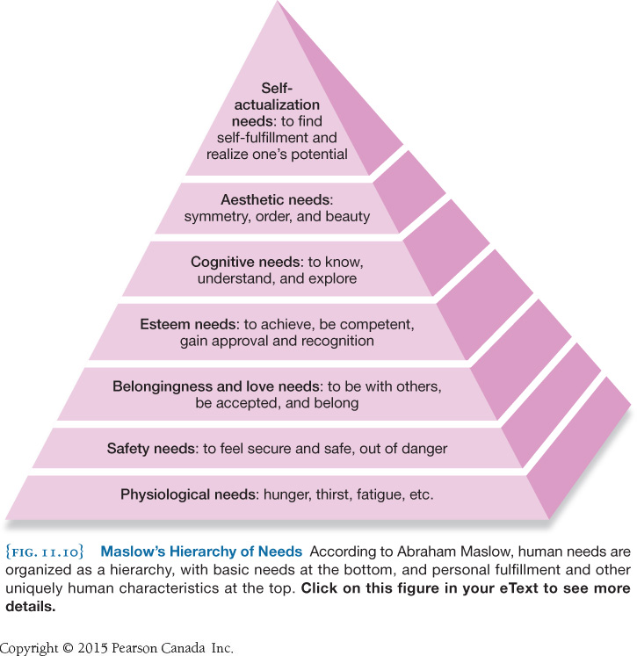

Need to belong- sometimes known as affiliation motivation is the motivation to maintain relationships that involve pleasant feelings such as warmth, affection, appreciation, and mutual concern for each person’s well-being
Passionate love- is associated with a physical and emotional longing for the other person
Companionate love- related to tenderness, and to the affection we feel when our lives are intertwined with another person
Achievement motivation- the drive to perform at high levels and to accomplish significant goals
Approach goal- an enjoyable and pleasant incentive that a person is drawn toward, such as praise, financial reward, or a feeling of satisfaction
Avoidance goal- an attempt to avoid an unpleasant outcome such as shame, embarrassment, losing money or feeling emotional pain
Self-efficacy- an individual’s confidence that he or she can plan an execute a course of action in order to solve a problem
Self-determination theory- an individual’s ability to achieve their goals and attain psychological well-being is influenced by the degree to which he or she is in control of the behaviors necessary to achieve those goals
Extrinsic motivation- also known as performance motive; motivation geared toward gaining rewards or public recognition, or avoiding embarrassment
Amotivational- s feeling of having little or no motivation to perform a behavior
Intrinsic motivation (mastery motive)- the process of being internally motivated to perform behaviors and overcoming challenges (a genuine desire to master a task rather than being motivated by a reward)
Framing effect- when the correct course of action is not obvious, the different phrasing of the question or problem can produce different results
Emotion- a behavior with the following three components:
- A subjective thought and or experience with
- Accompanying patterns with neural activity and physical arousal and
- An observable behavioral expression (an emotional facial expression or changes in muscle tension)
James- Lange theory of emotion- this view suggested that our physiological reactions to stimuli ( a racing heart) precede the emotional experience (the fear)
Cannon Bard theory of emotion- the brain interprets a situation and generates subjective emotional feelings, and that these representations in the brain trigger responses in the body
Facial feedback hypothesis- suggests that our emotional expressions can influence our subjective emotional states
Two factor theory- holds that patterns of physical arousal and the cognitive labels we attach to them form the basis of our emotional experiences
Emotional dialects- variations across cultures in how common emotions are expressed
Display rules- refer to the unwritten expectations we have regarding when it is appropriate to show a certain emotion
Chapter 12: Personality
Personality- a characteristic pattern of thinking, feeling and behaving that is unique to each individual, and remains relatively consistent over time and situations
Idiographic approach- creating detailed descriptions of a specific person’s unique personality characteristics
Nomothetic approach- examine personality in large groups of people, with the aim of making generalizations about personality structure
Personality trait- a person’s habitual patterns of thinking, feeling and behaving
Factor analysis- used to group items that people respond to similarly
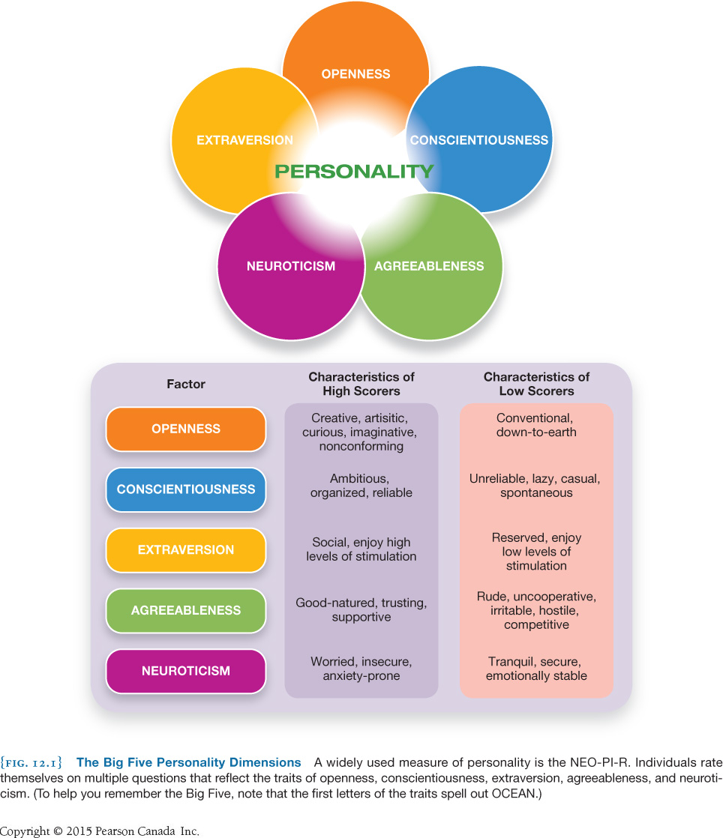
Five factor model- a trait based theory of personality based on the finding that personality can be described using five major dimensions

HEXACO model of personality- a six-factor theory that generally replicated the five factors of the FFM and adds one additional factor: Honesty- Humility
The dark triad- refers to the three traits- Machiavellianism, psychopathy, and narcissism- that describe a person who is socially destructive, aggressive, dishonest, and likely to commit harm in general
Machiavellianism- a tendency to use people and to be manipulative and deceitful
Psychopathy- a general tendency toward having shallow emotional responses
Narcissism- reflects an egotistical preoccupation with self-image and an excessive focus on self- importance
Right- Wing Authoritarianism- a highly problematic set of personality characteristics that involve three key tendencies:\
- Obeying orders and deferring to the established authorities in a a society
- Supporting aggression against those who dissent or differ from the established social order
- Believing strongly in maintaining the existing social order
State- a temporary physical or psychological engagement that influences behavior
Situations that are most likely to affect our behavior: Locations, associations, activities and subjective states
Reciprocal determinism- behavior, internal (personal) factors, and external (situational) factors interact to determine one another, and that our personalities are based on interaction among these three aspects
Theory of humourism- explained both physical illnesses and disorders of personality as resulting from imbalances in key fluids in the body
Phrenology- the theory that personality characteristics could be assessed by carefully measuring the outer skull
Arousal version of extraversion- arguing that extraversion is determined by people’s threshold for arousal
Ascending reticular activating system- plays a central role in controlling this arousal response
Behavioral activation system- a “GO” system, arousing the person to action in the pursuit of desired goals
Behavioral inhibition system- more of a “danger” system, motivating the person to action in order to avoid punishments or other negative outcomes
Conscious mind- your current awareness, containing everything you are aware of right now
Unconscious mind- a cast and powerful but inaccessible part of your consciousness, operating without your conscious endorsement or will to influence and guide your behaviors
Id- a collection of basic biological drives including those directed toward sex and aggression
Superego- compromised of our values and moral standards
Ego- the decision maker, frequently under tension, trying to reconcile the opposing urges of the id and superego
Defense mechanisms- unconscious strategies the ego uses to reduce or avoid anxiety
Fixation- becoming preoccupied with obtaining the pleasure associated with a particular stage
Projective tests- personality tests in which ambiguous images are presented to an individual to elicit responses that reflect unconscious desires or conflicts
Rorschach inkblot test- a test in which people are asked to describe what they see on the inkblot, and the psychologists interpret this description using a standardized scoring and interpretation method
Thematic Apperception Test- a test in which respondents are asked to tell stories about ambiguous pictures involving various interpersonal situations
Analytical psychology- focuses in the role of the unconscious archetypes in personality development
Personal unconscious- a vast repository of experiences and patterns that were absorbed during the entire experiential unfolding of the person’s life
Collective unconscious- a separate, non- personal realm of the unconscious that holds the collective memories and the mythologies of humankind, stretching deep into our ancestral past
Archetypes- images and symbols that reflect common “truths” held across cultures, such as universal life experiences or types of people
Inferiority complex- the struggle many people have with feelings of inferiority, which stem from experiences of helplessness and powerless during childhood
Person- centered perspective- founded on the assumption that people are basically good, and given the right environment their personality will develop fully and normally
Self-actualization- the drive to grow and fulfill one’s potential
Chapter 13: Social Psychology
Mimicry- taking on for ourselves the behaviors, emotional displays, and facial expressions of others
Chameleon effect- people copy others’ behaviors even without realizing it
Social norms- the (usually unwritten) guidelines for how to behave in social contexts
Social loafing- occurs when an individual puts less effort into working on a task with others
Social facilitation- occurs when one’s performance is affected by the presence of others
Groupthink- the stifling of diversity that occurs when individuals are not able to express their true perspectives, instead having to focus on agreeing with others and maintaining harmony in the group
Normative influence- a social pressure to adopt a group’s perspective in order to be accepted rather than rejected, by a group
Informational influence- occurs when people internalize the values and beliefs of the group, coming to believe the same things and feel the same ways themselves
Bystander effect- the presence of other people actually reduces the likelihood of helping behavior
Diffusion of responsibility- the responsibility for taking action is spread across more than one person, thus making no single individual feel personally responsible
Pluralistic ignorance- occurs when there is a disjunction between the private beliefs of individuals and the public behavior they display to others
Social roles- a more specific set of expectations for how someone in a specific position should behave
Explicit processes- correspond to “conscious” thought: deliberative, effortful, relatively slow, and generally under our intentional control
Implicit processes- correspond to the “unconscious” thought: intuitive, automatic, effortless, very fast, and operate largely outside of our intentional control
Dual process models- models of behavior that account for both implicit and explicit processes
Person perception- the process by which individuals categorize and form judgements about other people
Thin slices of behavior- very small samples of a person’s behavior
Self- fulfilling processes- a first impression (or and expectation) affects one’s behavior, and then that affects other people’s behavior, leading one to “confirm” the initial impression or expectation
False consensus effect- tendency to project the self-concept onto the social world
Naïve realism- the assumption that the way we see things is the way that they are
Self-serving biases- biased ways of processing self- relevant information to enhance our positive self- evaluation
Internal attribution- the observer explains the behavior of the actor in terms of some innate quality of that person
External attribution- the observer explains the actor’s behavior as the result of the situation
Fundamental attribution error (FAE)- tendency to over emphasize internal (dispositional) attributions, and under- emphasize external (situational) factors
Ingroups- groups we fee positively towards and identify with
Outgroups- those “other” groups that we don’t identify with
Ingroup bias- as positive biases toward the self get extended to include one’s ingroups, people become motivated to see their ingroups as superior to their out group
Minimal group paradigm- a description of how easily people will form social categories. Us vs. Them, even using criteria that are meaningless
Stereotype- a cognitive structure, a set of beliefs about the characteristics that are held by members of a specific social group; these beliefs function as schemas, serving to guide how we process information about our social world
Prejudice- an affective, emotionally driven process, including negative attitudes toward and critical judgements of other groups
Discrimination- (1) occurs when an organism learns to respond to one original stimulus but not to new stimuli that may be similar to the original stimulus (2) behavior that disfavors or disadvantages members of a certain social group in some way
Implicit Associations Test (IAT)- measures how fast people can respond to images or words flashed on a computer screen
Contact hypothesis- social contact between members of different groups is extremely important to overcoming prejudice
Elaboration likelihood model- a model of persuasion that states when audiences are sufficiently motivated to pay attention to a message and they have the opportunity for careful processing they will be persuaded by the facts of the argument, the substance; when either of these two factors, motivation and opportunity, are missing, people will tend to be persuaded by other factors
Central route to persuasion- occurs when people bay close attention to the content of a message, evaluate the evidence presented, and examine the logic of the arguments
Peripheral route to persuasion- depends upon features that are not directly related to the message itself, such as the attractiveness of the person delivering the information
Construal- level theory- describes how information affects us differently depending on our psychological distance from the information
Identifiable victim effect- people are powerfully moved to action by the story of a single suffering person compared to information about a whole group of people
Experiential system- operates implicitly, quickly, and intuitively and is predominately emotional
Analytic system- operates at the explicit level of consciousness, is slower and methodical, and uses logic and discursive thinking
Attitude inoculation- a strategy for strengthening attitudes and making them more resistant to change by first exposing people to a weak counter- argument and then refuting that argument
Processing fluency- the ease with which information is processed
Door-in-the-face technique- involves asking for something relatively big, then following with a request for something relatively small
Foot-in-the-door technique-involves making a simple request followed by a more substantial request
Cognitive dissonance theory- when we hold inconsistent beliefs, this creates a kind of aversive inner tension, or “dissonance”; we are then motivated to reduce the tension in whatever way we can
Chapter 15: Psychological Disorders
Asylums- residential facilities for the mentally ill
Medical model- sees psychological conditions through the same lens as western medicine tends to see physical conditions- as sets of symptoms, caused, and outcomes, with treatments aimed at changing physiological processes in order to alleviate symptoms
Diagnostic and Statistical Manual of Mental Disorders (DSM)- a standardized manual to aid in the diagnosis of disorders
Etiology- origins or causes
Mental disorder defence- claims that the defendant was in such an extreme, abnormal state of mind when committing the crime that he or she could not discern that the actions were legally or morally wrong
Personality disorders- particularly unusual patterns of behavior (relative to one’s culture context), that are maladaptive, distressing to oneself or others, and resistant to change
Borderline personality disorder- characterized by intense extremes between positive and negative emotions, an unstable sense of self impulsivity, and difficult social relationships
Narcissistic personality disorder (NDP)- an inflated sense of self- importance and an excessive need for attention and admiration, as well as intense self- doubt and fear of abandonment
Histrionic personality disorder- an excessive attention seeking and dramatic behavior
Antisocial personality disorder- a profound lack of empathy or emotional connection with others, a disregard for others’ rights or preferences, and a tendency toward inserting their own desires, often violently, onto others regardless of the consequences for other people or, often when younger, other animals
Comorbidity- the presence of two disorders simultaneously, or the presence of a second disorder that affects the one being treated
Dissociative disorder- a category of mental disorders characterized by a split between conscious awareness from feeling cognition, memory, and identity
Dissociative identity disorder (DID; multiple personality disorder) - a person experiences a splint in identity such that they feel different aspects of themselves as though they were separated from each other. This can be severe enough that the person constructs an entirely separate personalities, only one of which will generally be in control at a time
Anxiety disorders- a category of disorders involving fear or nervousness that is excessive, irrational, and maladaptive
Generalized anxiety disorder (GAD) - involves frequently elevated levels of anxiety, generally from the normal challenges and stresses of everyday life
Panic disorder- an anxiety disorder marked by occasional episodes of sudden, very intense fear
Agoraphobia- often associated with panic disorder, results from an intense fear of having a panic attack in public; as a result of fear, the individual may begin to avoid public settings and increasingly isolate him/herself
Phobia- a severe, irrational fear of a very specific object or situation
Specific phobia- an intense fear of a specific object, activity or organism
Social anxiety disorder- a very strong fear of being judged by others or being embarrassed or humiliated in public
Exposure- repeatedly and in stages exposing an individual to the object of his fear so that he can work past his emotional reactions
OCD- plagued by unwanted, inappropriate, and persistent thoughts (obsessions) and tend to engage in repetitive almost ritualistic behaviors (compulsions)
Major depression- prolonged periods of sadness, feeling of worthlessness and hopelessness, social withdrawal, and cognitive and physical sluggishness
Bipolar disorder- extreme highs and lows in mood, motivation, and energy
Prodromal phase- phase of schizophrenia during which people may become easily confused and have difficulty organizing their thoughts, they may lose interest and begin to withdraw from friends and family, and they lose their normal motivations, withdraw from life, and spend increasing amounts of time alone, often deeply engrossed in their own thoughts
Schizophrenia- a brain disease that causes the person to experience significant breaks from reality, a lack of integration of thoughts and emotions, and problems with attention and memory
Active phase- phase of schizophrenia during which people typically experience delusional thoughts, hallucinations, or disorganized patterns of thoughts, emotions and behavior
Residual phase- phase which people’s predominant symptoms have disappeared or lessened considerably, and they may simply be withdrawn, have trouble concentration, and generally lack motivation
Hallucinations- alterations in perception, such that a person hears, sees, smells, feels or tastes something that does not actually exist, except in that person’s own mind
Delusions- beliefs that are not based on reality, (at least from the perspective of the person’s general culture)
Disorganized behavior- the considerable difficulty people with schizophrenia may have completing the tasks of everyday life
Paranoid schizophrenia- symptoms include delusional beliefs that one is being followed, watched, or persecuted, and may also include delusions of grandeur or the belief that one has some secret insight or power or some other characteristic that makes one particularly special
Disorganized schizophrenia- symptoms include thoughts, speech, behavior, and emotion that are poorly integrated and incoherent. People with disorganized schizophrenia may also show inappropriate, unpredictable mannerisms
Catatonic schizophrenia- symptoms include episodes in which a person remains mute and immobile sometimes in bizarre positions- for extended periods. Individuals may also exhibit repetitive, purposeless movements
Undifferentiated schizophrenia- this category includes individuals who show a combination of symptoms from more than one type of schizophrenia
Residual schizophrenia- this category reflects individuals who show some symptoms of schizophrenia but are either in transition to a full blown episode in remission
Positive symptoms- the presence of maladaptive behaviors, such as confused and paranoid thinking, and inappropriate emotional reactions
Negative symptoms- the absence of adaptive behavior, such as absent or flat emotional reactions, lack of interacting with others in a social setting, and lack of motivation
Neurodevelopmental hypothesis- the adult manifestation of what we call “schizophrenia” is the outgrowth of disrupted neurological development early in the person’s life

Chapter 16: Therapies
Clinical psychologists- have received Ph.D. level of training and are able to formally diagnose and treat mental health issues ranging from the everyday and mild to the chronic and severe
Counselling psychologists- mental health professionals who typically work with people needing help with more common problems such as stress, coping, and mild forms of anxiety and depression, rather than severe mental disorders
Psychiatrists- medical doctors who specialize in mental health and who are allowed to diagnose and treat mental disorders primarily though prescribing medications
Deinstitutionalization- a social movement in North America in the 1960s which sought to relocate the mentally ill from living in institutions to living within their community
Residential treatment centers- housing facilities in which residents receive psychological therapy and life skills training, with the explicit goal of helping residents become reintegrated into society as well as they can
Community psychology- an area of psychology that focuses on identifying how individuals’ mental health is influenced by the neighborhood, economics and community resources, social groups, and other community based variables
Empirically supported treatments- treatments that have been tested and evaluated
Bibliotherapy-the use of self-help books and other reading materials as a form of therapy
Insight therapies- a general term referring to therapy that involves dialogue between client and therapist for the purpose of gaining awareness and understanding of psychological problems and conflicts
Psychodynamic therapies- forms of insight therapy that emphasize the need to discover and resolve unconscious conflict
Free association- clients are encouraged to talk or write without censoring their thoughts in any way
Dream analysis- a method for understanding the unconscious by examining the details of what happens during a dream (the manifest content) in order to gain insight into the true meaning of the dream, the emotional, unconscious material that is communicated symbolically (the latent content)
Resistance- occurs as the treatment brings up unconscious material that the client wishes to avoid, and the client engages in strategies for keeping the information out of conscious awareness
Transference- a psychoanalytic process whereby clients direct the emotional experiences that they are reliving toward the therapist, rather than the original person involved in the experiences
Object relations therapies- a variation of psychodynamic therapy that focuses on how early childhood experiences and emotional attachments influence later psychological functioning
Phenomenological approach- the therapist addresses the clients’ feelings and thoughts as they unfold in the present moment, rather than looking for the unconscious motives or dwelling in the past
Client- centered therapy- focuses on individuals’ abilities to solve their own problems and reach their full potential with the encouragement of the therapist
Systematic desensitization- gradual exposure to a feared stimulus or situation is coupled with relaxation training
Virtual reality exposure- a treatment that uses graphical displays to create an experience in which the client seems to be immersed in an actual environment
Aversive conditioning- a behavioral technique that involves replacing a positive response to a stimulus with a negative response, typically by using punishment
Cognitive behavioral therapy- a form of therapy that consists of procedures such as cognitive restructuring, stress inoculation training and exposing people to experiences they may have a tendency to avoid
Negative explanatory style- the tendency to make internal, stable, and global attributions for negative events
Internal attribution- the observer explains the behavior of the actor in terms of som innate quality of that person
Stable attributions- thoughts like “it’s never going to change,” coming to see a situation as permanent and irreversible
Global events- thoughts like “my whole life is ruined” blowing things out of proportion rather than seeing a negative event as simply that, one negative even and not something that need s to spiral into greater problems
Decentring- occurs when one is able to step back from one’s normal consciousness and observe oneself more objectively, as an observer
Mindfulness- based cognitive therapy – involves combining mindfulness with standard cognitive- behavioral therapy tools
Systems approach- an orientation that encourages therapists to see an individuals’ symptoms as being influenced by many different interacting systems
Psychopharmacotherapy- the use of drugs to attempt to manage or reduce clients’ symptoms
Psychotropic drugs- medications designed to alter psychological functioning
Blood- brain barrier- a network of tightly packed cells that only allow specific types of substances to move from the bloodstream to the brain in order to protect delicate brain cells against harmful infections and other substances
Antidepressant drugs- medications designed to elevate mood and reduce other symptoms of depression
Monoamine oxidase inhibitors- work by deactivating monoamine oxidase, an enzyme that breaks down serotonin, dopamine, and norepinephrine at the synaptic clefts of nerve cells
Tricyclic antidepressants- appear to work by blocking the reuptake of serotonin and norepinephrine
Selective serotonin reuptake inhibitors- a class of antidepressant drugs that block the reuptake neurotransmitter serotonin
Mood stabilizers- drugs used to prevent or reduce the severity of mood swings experienced by people with bipolar disorder
Lithium- one of the first mood stabilizers to be prescribed regularly in psychiatry, and from the 1950s to 1980s, was the standard drug treatment for depression and bipolar disorder
Antianxiety drugs- affect the activity of gamma- aminobutyric acid (GABA), an inhibitory neurotransmitter that reduces neural activity
Antipsychotic drugs- generally used to treat positive symptoms of psychosis, including delusions, hallucinations, and severely disturbed or disorganized thought
Tardive dyskinesia- a movement disorder involving involuntary movements and facial tics
Atypical antipsychotics- drugs that reduce positive symptoms of schizophrenia and are less likely to produce extrapyramidal side effects including movement disorders that commonly occur when first generation antipsychotics are prescribed
Frontal lobotomy- surgically removing regions of the cortex
Leucotomy- the surgical destruction of brain tissues in the pre-frontal cortex
Focal lesions- small areas of brain tissue that are surgically destroyed
Electro conclusive therapy- involves passing an electrical current through the brain in order to induce a temporary seizure
Transcranial magnetic stimulation- a procedure in which an electromagnetic pulse is delivered to a targeted region of the brain in order to increase or decrease its activity; it is sometimes used as a therapeutic technique to help treat the symptoms of psychological disorders like depression
Deep brain stimulation- a techniques that involves electrically stimulating specific regions of the brain

