1)
a) $-36a^{8}$
b) $–3x^{-2}y^{3}z^{7}=\frac{-3y^{3}z^{7}}{x^{2}}$
c) $\left(–7^{3}\right){\left(k^{8}\right)}^{3}$
$$\left(-343\right)\left(k^{24}\right)$$
$$-343k^{24}$$
d)$\frac{(2^{5})(a^{15})(b^{30})}{(-3^{2})(a^{8})(b^{8})}$
$$\frac{32a^{15}b^{30}}{9a^{8}b^{8}}$$
$$\frac{32}{9}a^{7}b^{22}$$
$$3.5a^{7}b^{22}$$
e) $\frac{b^{2a(2a+3)}}{b^{3a(a-6)}}$
$$\frac{b^{4a^{2}+6a}}{b^{3a^{2}-18a}}$$
$$b^{a^{2}+24a}$$

2)
a) $3^{x}=\frac{1}{81}$
$$3^{x}=\frac{1}{3^{4}}$$
$$3^{x}=3^{-4}$$
$$x=-4$$
b) $7^{x}=1$
$$x=0 because a^{0}=1$$
c) $3^{-2}=x$
$$\frac{1}{3^{2}}$$
d) $x^{2}=0.0625$
$$x=\sqrt{0.0625}$$
$$x=0.25$$
e)$\log_{4}{{16384}^{2}=x}$
$$\log_{4}{268435456}=x$$
$$4^{x}=268435456$$
$$4^{x}=4^{14}$$
X=14
Or another solution:
$$\log_{4}{4^{14}}=x$$
14=x
f)$\log_{9}{9}⟶1 and \log_{3}{3}⟶1 so:$
$$1^{1}=x$$
X=1
3)
a)$\log_{6}{9}+\log_{6}{4}=\log_{6}{36 }$
$${=log}_{6}{6^{2}}$$
$$=2\log_{6}{6}$$
=2
b)$=\log_{2}{1024}$
$${=log}_{2}{2^{10}}$$
$$=10\log_{2}{2}$$
=10
c)$\log_{8}{4^{5}-\log_{8}{8^{3}+\log_{8}{4}}}$
$$\log_{8}{4^{5}*4-\log_{8}{8^{3}}}$$
$$\log_{8}{4096-3\log_{8}{8}}$$
$$\log_{8}{8^{4}-3}$$
$$4\log_{8}{8 }-3$$
4-3=1

4)
a) ${\left(2^{4}\right)}^{5a-1}*{\left(2^{8}\right)}^{3a}=2^{7}$
$$2^{20a-4}*2^{24a}=2^{7}$$
$$2^{44a-4}=2^{7}$$
$$44a-4=7$$
$$44a=11$$
$$a=\frac{11}{44}=0.25$$
b) ${(3}^{x})×3^{4}-5\left(3^{x}\right)=684$
${81(3}^{x})-5\left(3^{x}\right)=684$
$$\left(81-5\right)\left(3^{x}\right)=684$$
$$3^{x}=\frac{684}{76}$$
$$3^{x}=9$$
$$3^{x}=3^{2}$$
X=2

c) $7\left(4^{2x}\right)=28(4^{x})$
$$7{\left(4^{x}\right)}^{2}=28\left(4^{x}\right)$$
Let $4^{x}=a$
$$7a^{2}=28a$$
$$7a^{2}-28a=0$$
$$7a\left(a-4\right)=0$$
7a=0 or a-4=0
a=0 or a=4
$$4^{x}=0 or 4^{x}=4$$
$$for 4^{x}=0 there is no solution$$
$$4^{x}=4$$
X=1 (the solution is x=1)

5)
$$Y=-\frac{1}{3}\log_{2}{8\left(x+4\right)+0}$$
$a=\frac{1}{3} (vertical compression) , negetive sign refers to reflection$
K=8 (horizontal compression)
$d=-4$
C=0

6)
A) to graph a function, we have to set a table for X and Y . as well as we put some values as x variable, then the function will produce Y values. Now by (x,y) values in each row of our table, we can graph the function. For graphing the invers function there are two ways: 1-substitude x by y and y by x in the table value. for instance if we have(2,-4) we must switch them as (-4,2).the graph that is going to be created by switching x and y values is the inverse graph.in addition, the other way for graphing inversely, is to inverse the function, then set table values for inversed function, put several values as input for inversed function and produce output as y values . to inverse a function we apply as:
1: change f(x) to y.
2: switch x and y.
3:re-isolate the equation for y.
4:change y to $f^{-1}(x)$
b) 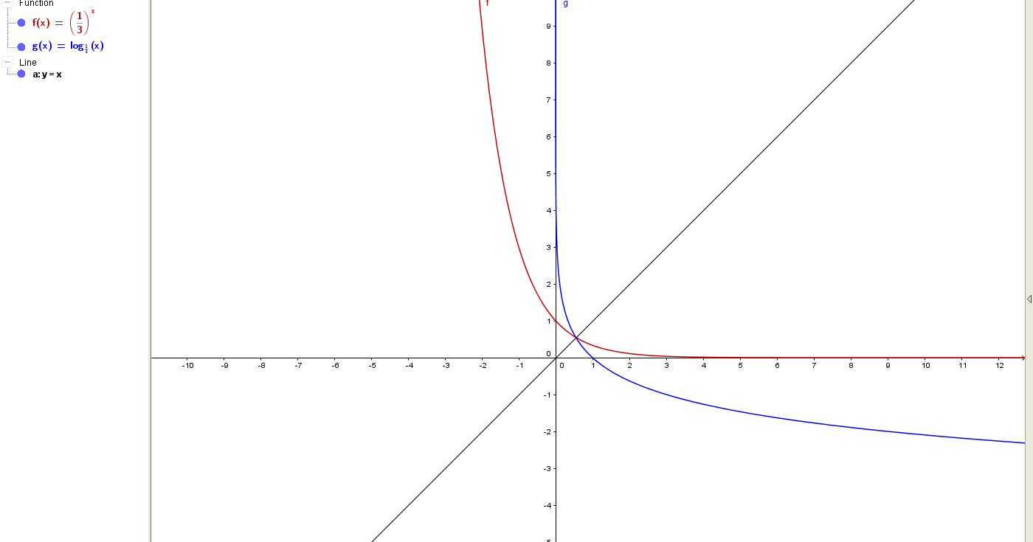
c) Exponential function features:
D:{xЄR}
R:{Y>0,YЄR}
There is no x-intercept.
y-intercept is at (0,1).
There is no vertical asymptote.
There is horizontal asymptote at y=0 , the x-axis)
**the inverse features (logarithm function):
R:{yЄR}
D:{x>0,xЄR}
There is no Y-intercept.
x-intercept is at (1,0).
There is no horizontal asymptote.
There is vertical asymptote at x=0 , the y-axis)

D)Yes, the inverse is a function too. Because if we trace a vertical line, the direct vertical line will create just one point by graph.in other word, the graph and direct vertical line have a crossing point just in one point .

7)
a) 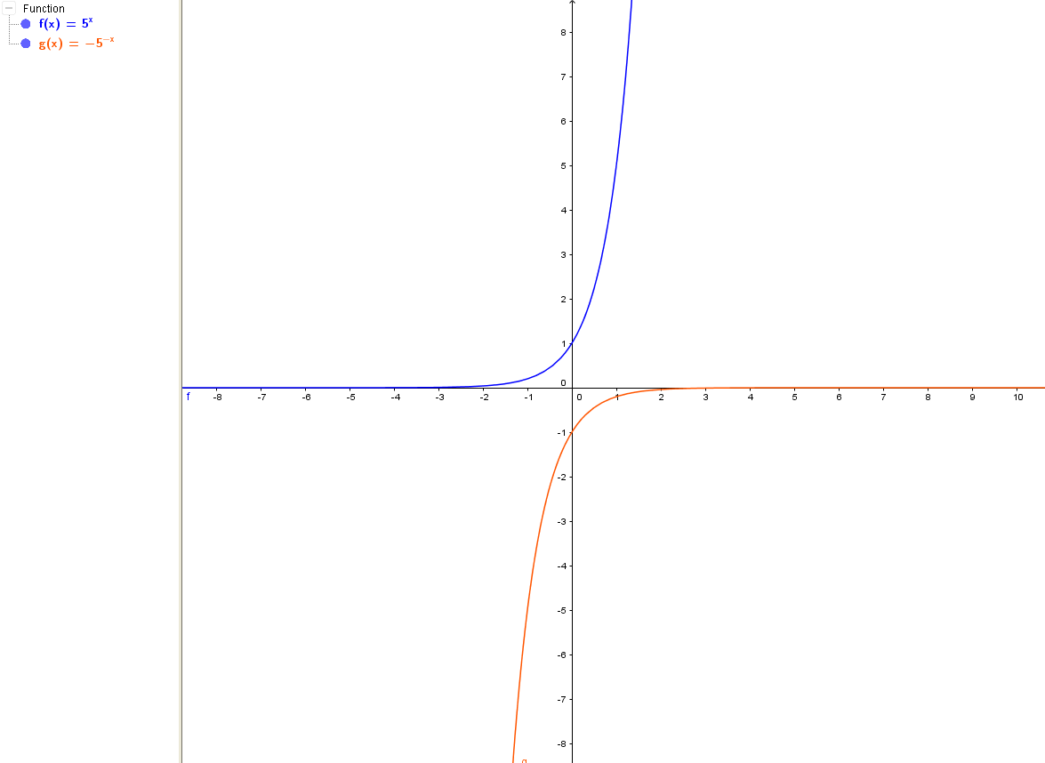
b)because 5 changes to -5, so there is a vertical reflection by factor of 5.(a=5). In addition, because x changes to –x, so there is a horizontal reflection by factor of $\frac{1}{|k|}$ or $\frac{1}{1}$. (k=1).
c) $x=5^{y}$
$$5^{y}=x$$
$$y=\log_{5}{x}$$

d) 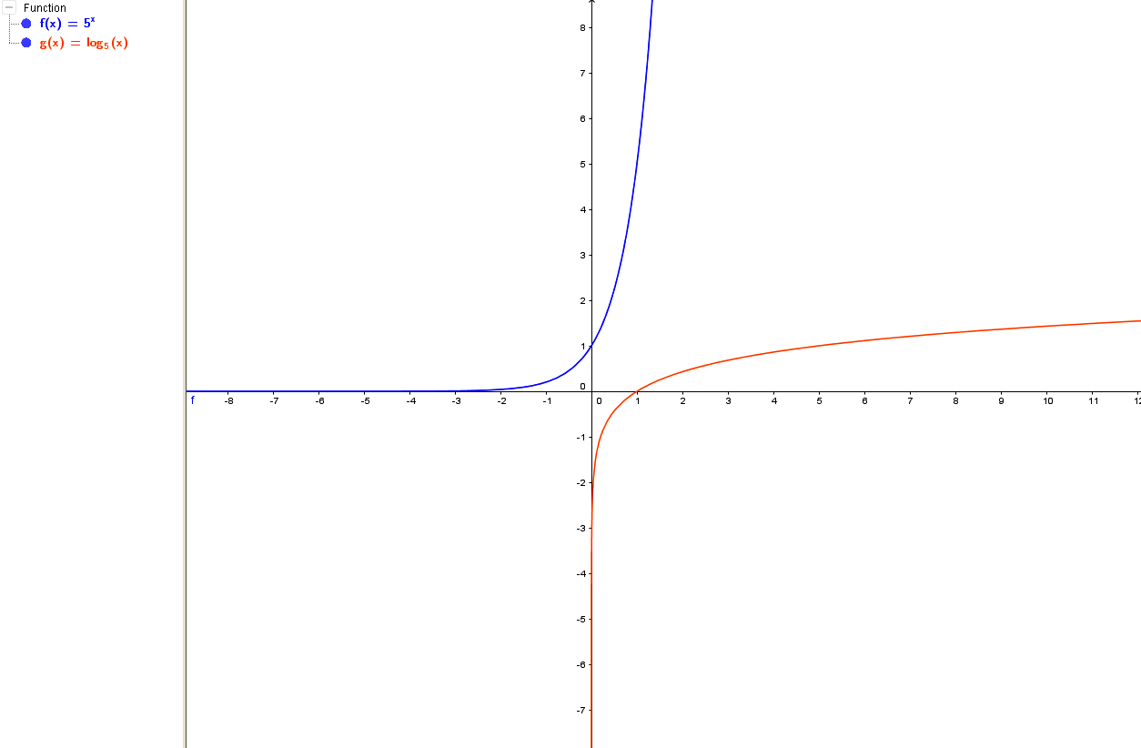
e)
 | $$f\left(x\right)=-5^{-x}$$ | $$g\left(x\right)=\log_{5}{x}$$
Domain | {xЄR} | {x>0,xЄR}
Range | {Y<0,YЄR} | {YЄR}
X-intercept | No x-intercept | At (1,0)
Y-intercept | At (0,-1) | No y-intercept
Vertical asymptote | No vertical asymptote | y-axis ,x=0
Horizontal asymptote | x-axis , y=0 | No horizontal asymptote

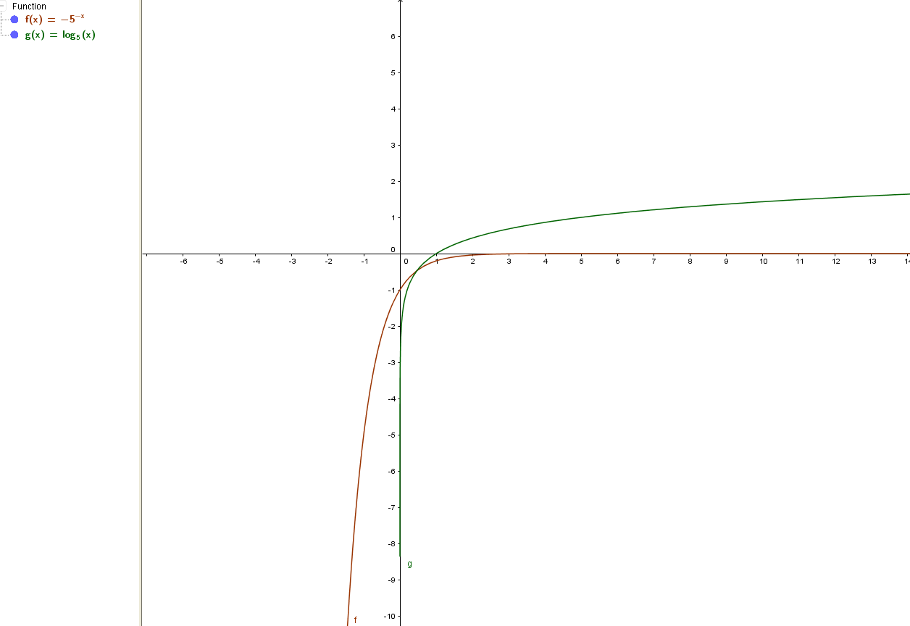
8)
$$y=\frac{1}{4}\log_{2}{{\left(8x-56\right)}^{16}-12}$$
$$y=4\log_{2}{(8x-56)}-12$$
$$y=4\log_{2}{(8\left(x-7\right))}-12$$
y= $4\log_{2}{8}+4\log_{2}\left(x-7\right)-12$
$y=4\log_{2}{2^{3}}+4\log_{2}{(x-7)}-12$
y= 4(3) + 4$\log_{2}{(x-7)}$ - 12
y= 4log2(x-7) , where x>7
As you can see, the first equation has vertical compression by factor of1/4, and the second one has vertical stretch by factor of 4. Compare (20,15) and (-20,19) The vertical asymptote is x=7 for both equation. The simplified equation is the same in graphing by the original the graph of equation just when x>7. There is no range for simplified equation when x<7.literaly no graph.
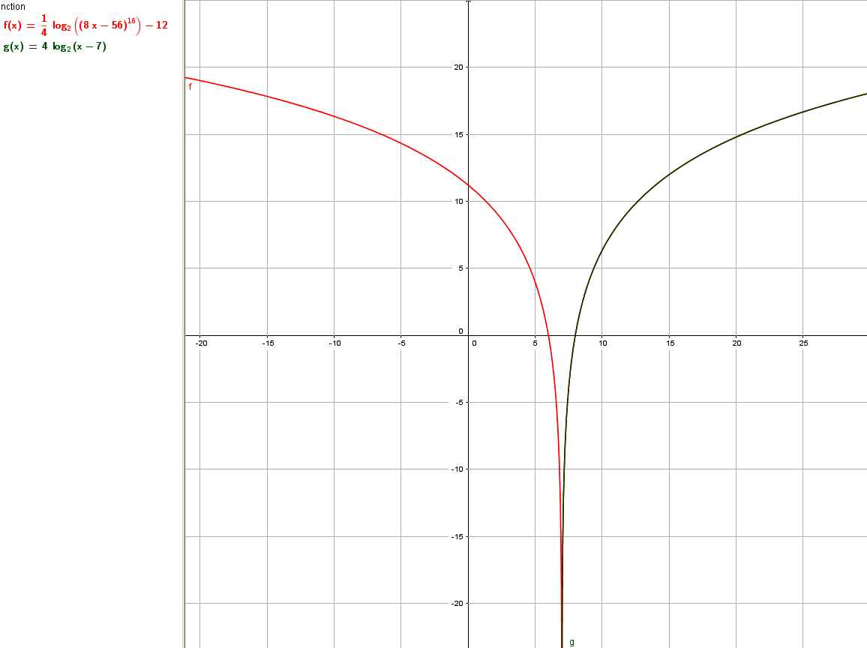

9)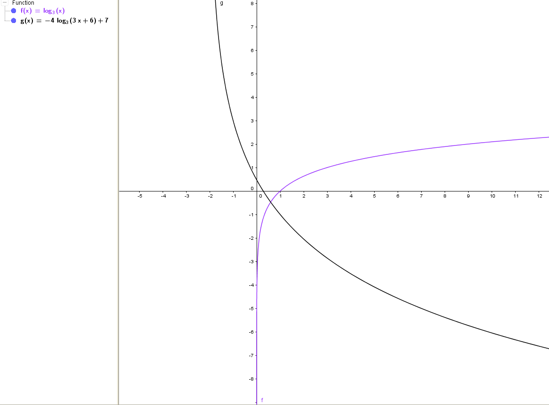

There is a vertical stretch by factor of 4 (a=4) .Also because there is a negative sign, so there is a vertical reflection on x-axis.
There is a horizontal compression by factor of $\frac{1}{3}$. (k=3).also, because k value is not negative, so there is no horizontal reflection.
d=-6, so there is a horizontal transformation (shift) 6 unites to the left.
C=7, so there is a vertical transformation (shift ) upwards.

10) $2\log_{7}{x}=4\log_{7}{3}-\log_{7}{9}$ :because it’s an equality, so we separate variable and invariables values.
$$2\log_{7}{x}=\log_{7}{3^{4}}-\log_{7}{9}$$
$$\log_{7}{x^{2}}=\log_{7}{81}-\log_{7}{9} :based on formula \log_{a}{b^{n}}=n\log_{a}{b}$$
$\log_{7}{x^{2}=\log_{7}{\frac{81}{9}}}$ : based on the formula that when the base of two logarithm are the same, their division and subtraction are the same. $\log_{a}{b}-\log_{a}{c}=\log_{a}{\frac{b}{c}}$
$$x^{2}=9 :because the bases are the same$$
X=$±3$ x=-3 is a extraneous root, because when we put it on the main equation instead x, it will produce negative value for ${2log}_{7}{x}$.so the only valid answer for this equation is x=3
Another solution:
$$\log_{7}\left(9\right){\left(x\right)}^{2}={4log}_{7}{3}$$
$$\log_{7}{9x^{2}=\log_{7}{3^{4}}}$$
$$9x^{2}=3^{4}$$
$$x^{2}=\frac{81}{9}$$
$$x^{2}=9$$
X=$±3$ x=-3 is a extraneous root, because when we put it on the main equation instead x, it will produce negative value for ${2log}_{7}{x}$.so the only valid answer for this equation is x=3

11)${ first: log}_{3}{-4}=\frac{\log{-4}}{\log{3}}=\frac{undifined}{0.477}=undifined$
The exponential form of $\log_{3}{-4}{=x≪=≫} 3^{x}=-4$
A positive number raised to any power is positive. So, there is no such x at least in real numbers.
The logarithm to any base is a constant times some other logarithm. Consider y=log(x). It is defined only for x > 0.
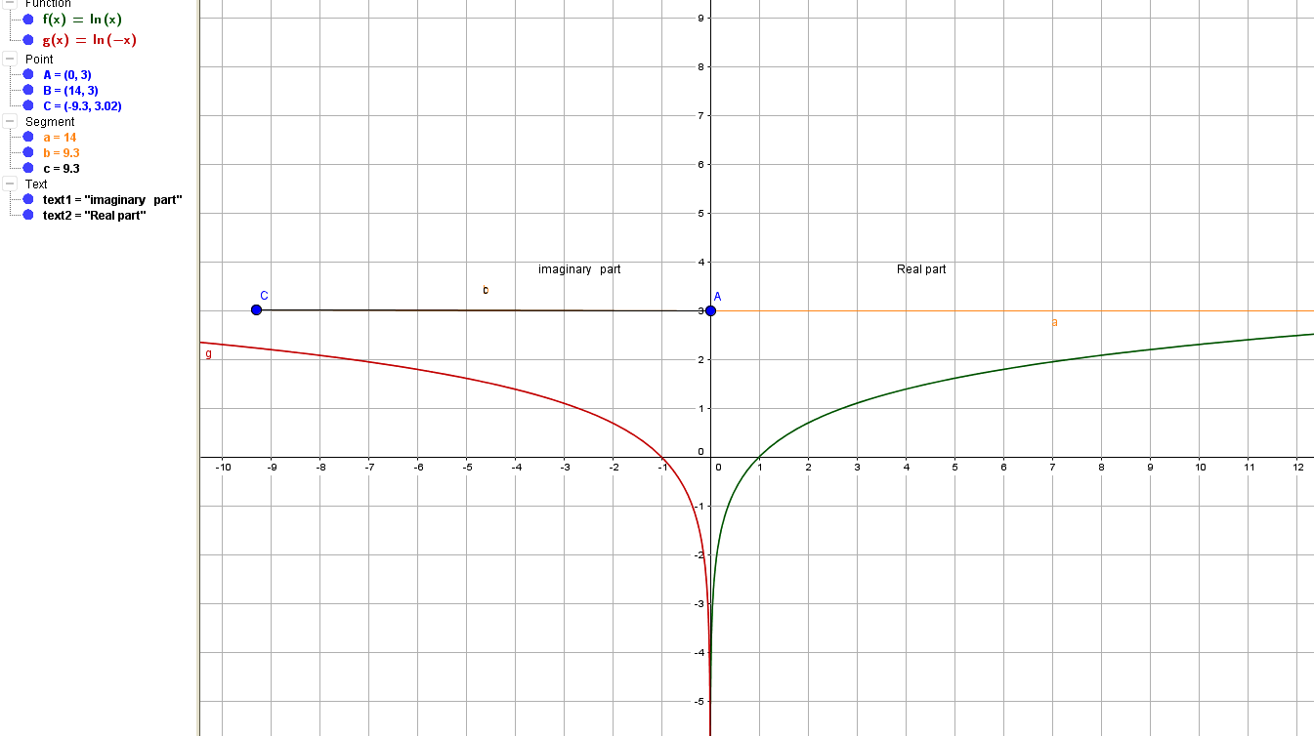
12) A function is a special type of relation between two variables where every input value (such as x) has only one output value (such as y).we can calculate the value of y(output) when determine and put (input)x value in an equation. If the equation produced just one y value for that x value, so it’s a function. For instance, if we want to determine that is $y=x^{2}$ a function or not, we will test a value for x.
x | y
-2 | 4
-1 | 1
0 | 0
1 | 1
As you can see for each input, we have just one output. so, this equation is a function.
(-2,4),(-1,1),(0,0),(1,1)
Also if we graph it, by vertical line test, we determine that is that a function or not. If the vertical line intersects the graph of equation just in one point , then the equation is a function. On the other hand, if the vertical test line has more than one crossing point with the equation, in consequent, the equation in not a function. As you can see at the following graph, the vertical line has intersect point with graph just at c point. Obviously, it is a function.
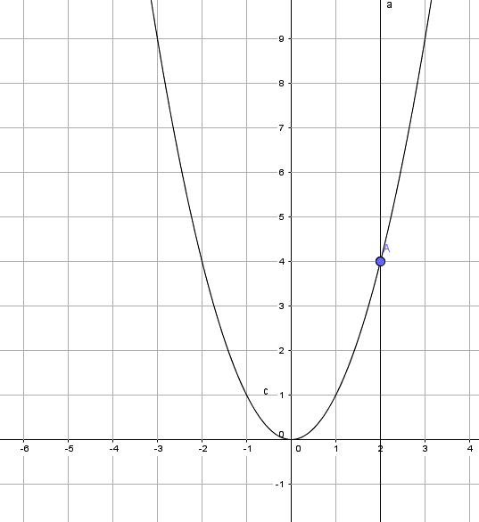
another example is $x^{2}+y^{2}=9$ : as you can see, if I determine x=2, as an input for equation, then we have two different output for that x.
$$2^{2}+y^{2}=9$$
$$y^{2}=9-4$$
$y^{2}=5y=±\sqrt{5}$ so, this equation is not a function. As a proof, the vertical test line intersects graph in 2 points (B and C).
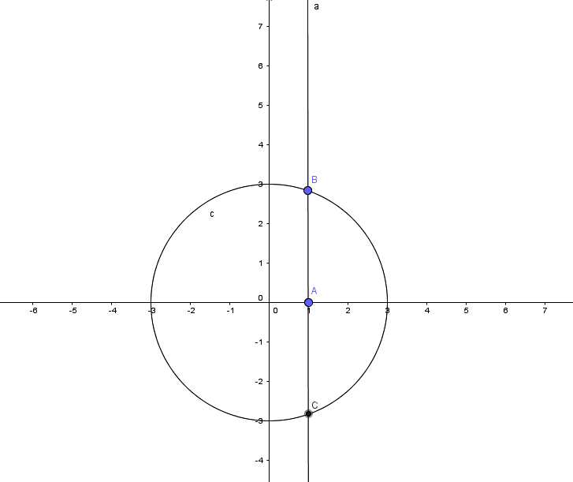

13)
a) Domain: The domain of a function is the set of all possible input values (often the "x" variable), which produce a valid output from a particular function. It is the set of all real numbers for which a function is mathematically defined.
b) Asymptote is a line that a graph gets closer and closer to, but never touches or crosses it. There are two different asymptote: vertical asymptote and horizontal asymptote.
c) the simplest function of a family of functions that preserves the definition (or shape) of the entire family. For example, for the family of quadratic functions having the general form $=ax^{2}+bx+c$ ,
the simplest function is $y=x^2$ .
d) An inverse function is a function that "reverses" another function. That is, if f is a function mapping x to y, then the inverse function of f, maps y back to x.
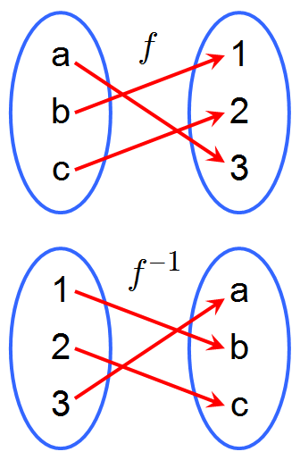
e) In exponent form, $2^{3}=8$, as 2 is base, 3 in exponent, and 8 is the value of power. In logarithm form we express it as, $\log_{2}{8}=3$, in fact we are looking for exponent. In other word, log is a number that shows how many times a base number (2) is multiplied by itself to produce a third number(8).

14)
$$A=P{\left(1+i\right)}^{n}$$
$$3500=1750{\left(1+0.048\right)}^{n}$$
$$3500=1750{\left(1.048\right)}^{n}$$
$$\frac{3500}{1750}=\frac{1750}{1750}{\left(1.048\right)}^{n}$$
$$2={\left(1.048\right)}^{n}$$
$$\log{1.048^{n}}=log2$$
$$nlog1.048=log2$$
Now dividing both sides to log1.048:
$n=\frac{log2}{log1.048}=14.8$ it takes 14.8 years to double the initial amount.

15)
$A=I{\left(2\right)}^{\frac{t}{d}}$
$$A=50{\left(2\right)}^{\frac{720}{40}}$$
$$A=50{\left(2\right)}^{18}$$
A=13107200 There are 13107200 bacteria after 12 hours.

16)
$$A=I{\left(1-i\right)}^{t}$$
$$324.5=I{\left(1-0.15\right)}^{5}$$
$$I=\frac{324.5}{{\left(0.85\right)}^{5}}$$
I=731.34 It was worth $731.34 when it was new.

17)
$$\left[H^{+}\right]={10}^{-PH}$$
$\left[H^{+}\right]=10^{-2.7}=0.001995262$ M
$\left[H^{+}\right]=10^{-3}=0.001$ M
$Ratio=\frac{0.001}{0.001995262}$⩪ 0.5
The solution with a pH of 3 is 1/2 of the strength of the original solution. In order to dilute the original solution to 1/2 of its strength, it must be 1 part solution to 1 parts water. So we have to add 2 liter of water.

18)
$$\frac{I}{I_{0}}=10^{M}$$
$$\frac{I}{I_{0}}=10^{6.3}$$
$$\frac{I}{I_{0}}=1995262.315$$
Aftershock is 25 times weaker, so: $\frac{1995262.315}{25}=79810.4926$
$$M=log\left(\frac{I}{I_{0}}\right)$$
$$M=log79810.4926$$
M=4.9 The second earthquake registered 4.9 on the Richter scale.

19)
$$L=10log(\frac{I}{I_{0}})$$
$$45=10log (\frac{I}{I_{0}})$$
$$4.5=log(\frac{I}{I_{0}})$$
$10^{4.5}=(\frac{I}{I_{0}})$
Restaurant $\frac{I}{I_{0}}=31622.7766$
$\frac{conversation}{31622.7766}$=100
100×31622.7766=3162277.66 conversation intensity
$$l=10log3162277.66$$
L=65 the loudness for conversation is 65dB

20)
$$A=I{\left(3\right)}^{\frac{t}{2}}$$
$$500=2{\left(3\right)}^{\frac{t}{2}}$$
$$250=3^{\frac{t}{2}}$$
$$\log{3^{\frac{t}{2}}}=log250$$
$$\frac{t}{2}log3=log250$$
Dividing both sides to log3:
$$\frac{t}{2}=\frac{\log{250}}{log3}$$
$$\frac{t}{2}=5.02$$
T=10 it takes almost 10 months to increase 500 rabbits.

