BIOCHEM 2020
Lecture 10

Midterm Review:
- Question 15
  - Which of the following is the best estimate for the overall molecular mass of homotrimeric protein whose polypeptide monomers each contain 150 amino acids
    - 3 x 150aa = 450 x 110 = 49500 = approx. 50 kDa
- Question 10 + 11
  - *in notebook

Review:
- Carbohydrates can be aldoses or ketoses
- Can be identified by the D or L form
- To number them, you choose the carbon that is closest to the carbonyl
- Chiral carbon is the furthest from carbon number 1
  - L form if on the left
  - D form if on the right
- Same chemical structure but the chiral carbon is arranged differently
- Enantiomers (mirror images)
- Diastereromers (not mirror images)
- Anomeric carbon is the one that was number 1 first, you look at this to see if you have alpha or beta

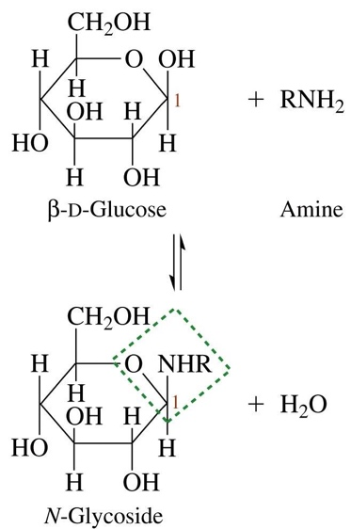
Glycoside Formation: N-glycosidic bond
- N-H group of amines substitute for OH group
- N-glycosidic bond
- 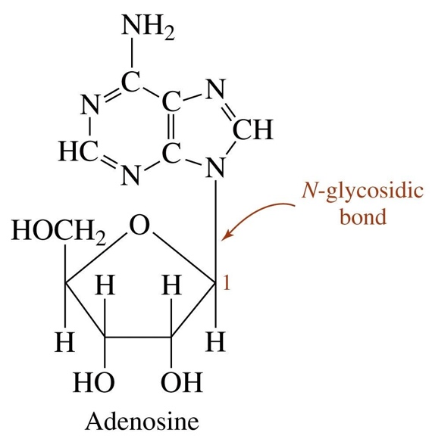
- N-glycosidic bonds/linkages are generated during nucleotide production.
- Found in nucleotides

Glycosylation Reactions
- Glycosylation Reactions attach sugars or glycans (sugar polymers) to proteins or lipids
- Catalyzed by glycosyl transferases, glycosidic bonds are formed between anomeric carbons in certain glycans and oxygen or nitrogen of other types of molecules, resulting in N- or O -glycosidic bonds

Glycoproteins: Types of Linkages
- Glycoproteins are proteins that have covalently bonded carbohydrate units attached to them.
- O-glycosidic linkage: The side chain of Ser or Thr
- N-glycosidic linkage: The side chain of Asn

Glycoproteins: O-glycosidic bond to Ser and Thr
- O-Glycosidic linkages attach the glycans to the side chain hydroxyl of serine and threonine residues or the hydroxyl oxygens of membrane lipids
- 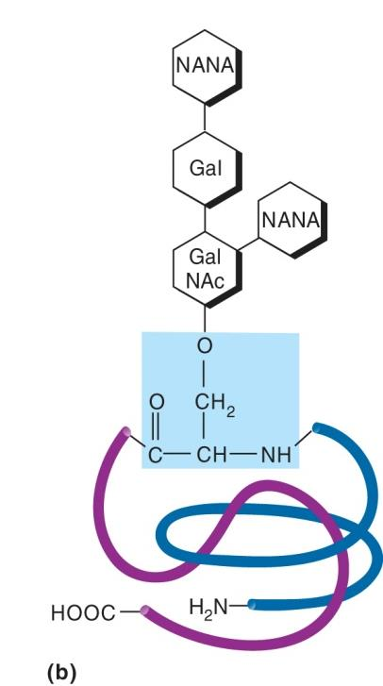

Glycoproteins: N-glycosidic bond to Asn Residues
- N-linked oligosaccharides are attached to polypeptides by an N-glycosidic bond with the side chain amide nitrogen from the amino acid asparagine
- 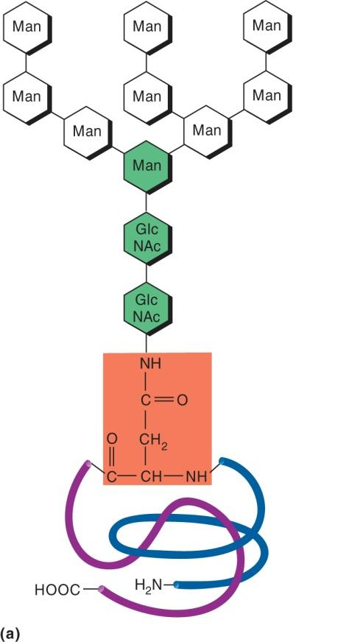
Nucleic Acids: Structures of RNA and DNA
- Uracil vs Thymine (DNA)
- RNA Single stranded form typically
- DNA Double stranded
- Ribose vs. Deoxyribose
- Nitrogenous Base:
  - Adenine Thymine (DNA) or Uracil (RNA)
  - Cytosine Guanine
- Phosphates or Phosphoryl groups
  - Mono-, Di- or Tri

Nitrogenous Bases
- Purines
  - Have two rings
  - Adenine + Guanine
  - A and G
- Pyrimidines
  - Single Ring
  - Thyme, Cytosine, Uracil
  - T, C, U

Sugar Componenent
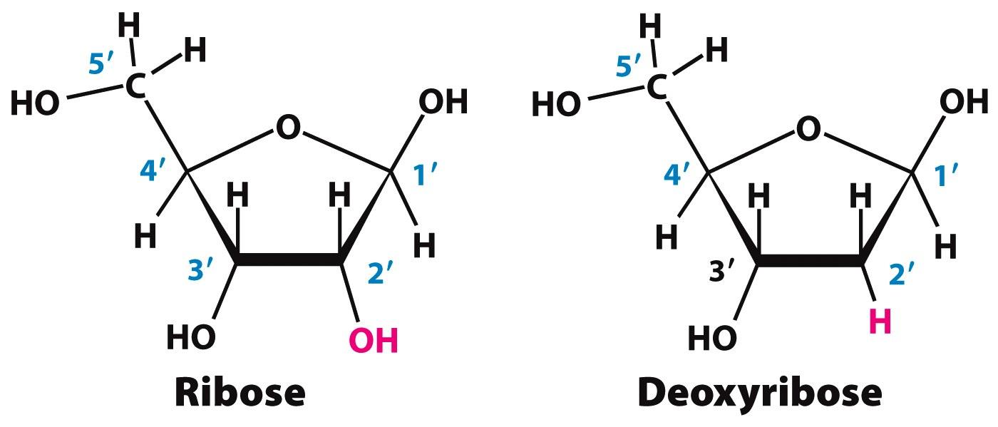

- Add prime to the sugars
- Ribose
  - Anomeric carbon in Beta position
  - Know how to number it and draw the ribose
- Deoxyribose

Nucelosides
- Base + Sugar

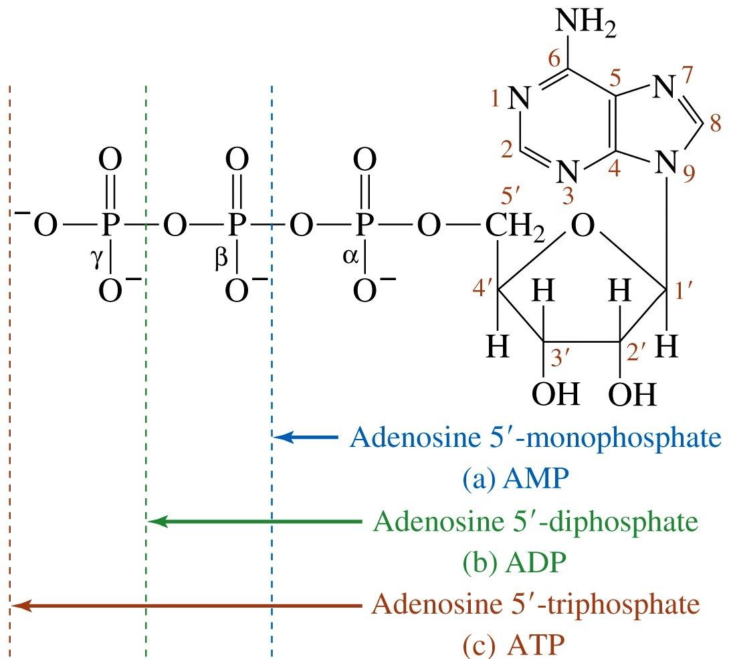
Nucleotides
- Phosphoryl group + nucleoside
- Phosphoester bond
- attached to the 5 prime position of the sugar
- Phosphate closest to the 5 prime is the alpha
- Alpha Beta Gamma

Phosphodiester Bonds: Backbone of th
- 5 prime of one carbose sugar to the 3 prime of the other
- 5 prime phosphate + 3 primse hydroxyl
- To identify, the 5 prime end will be available, but the 3 prime will be occupied
- Invariant Side Sugar Phosphate back bone
- Variable Side where all the bases are

Base Pairing DNA
- A T
  - 2 hydrogen bonds
- G C
  - 3 hydrogens bonds therefore it is stronger
- Antiparallel pairing
- Molecular Mass
  - Average molecular mass of a base pair is 660 Da
  - Average of a base single is 330
- Length
  - The length of DNA is typically measured in bp or kbp
  - RNA length is usually measured in nt

The DNA Double Helix
- One full turn of the helix: 10.3 base pairs
- The sugar phosphate backbone wraps around on two strands
- The Major groove (gives access to the bases) is followed by a minor grove

Tertiary Structure of DNA
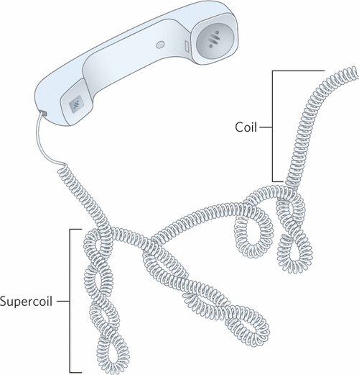
- Linear Circular
- Relaxed Circular Super-coiled circular

Supercoiling
- Coiling of a coil
- The double helix is a coil; it can be further coiled. This is referred to as supercoiling
- The tension can be relieved by creating a supercoil, if it is overwound

Negative and Positive Supercoiling
- Positive Supercoiling Increasing the tension, overwinding, the structure forming afterwards forms a positive supercoil
- Under-winding Negative Supercoiling
- Over-winding Positive supercoiling

Chromatin: Packaging of DNA with Proteins
- Histones have high content of basic amino acids
  - A lot of positive charges give affinity to the phosphate backbone, since they have negative charges
- In the nucleus of eukaryotic cells, DNA is heavily associated with proteins, i.e. it is not “naked.”
- DNA-binding proteins that package DNA in chromosomes are called histones
- They are rich in basic amino acids, giving positive charges necessary to interact with the DNA backbone (negative charges on the phosphates)
- There are five major histone proteins: H1, H2A, H2B, H3, and H4
- H2A H2B form dimers
- H3 + H4 form tetramers (2 of each)
- The nucleosome is DNA wrapped around a histone octamer
- Octamer: 2 x (H2A + H2B + H3 + H4)
- In order to modify the structure, the N terminal tails loosen of the nucleosome

Histone H1 and the Nucelosome
- Histone H1 binds to the nucleosome where the DNA enters and exits anc acts as a clamp that prevents unraveling

“Beads on a String”

