BIOCHEM 2020
Lecture 9

Carbohydrates
- Are the most abundant biomolecules in nature
- Wide variety of cellular function: energy, structure, communication, and precursors for other biomolecules
- They are a link between solar energy and chemical bond energy

Carbohydrates form Part of other Biomolecules
- Sugar component of DNA, RNA
  - Ribose, component of ribonucleotides
  - Deoxyribose, component of deoxyribonucleotides
- Covalently link to
  - Proteins (Glycoproteins)
  - Lips (Glycolipids)

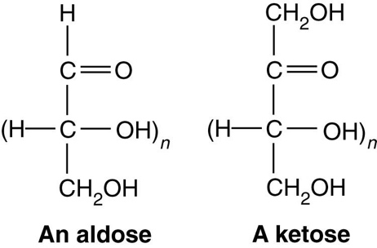
Monosaccharides
- Simple sugars, or polyhydroxy aldehydes or ketones
- Multiple ketones
- Formula: (CH₂O)_{n}
  - n = 3 triose 4 tetrose 5 pentose 6 hexose
- Sugars with aldehyde function group are aldoses
- Sugars with ketone function group are ketoses \
- Generally, you will not the name to be a pentaldose or penketose

Trioses
- You can only have two types of Trioses
- Glyceraldehyde Aldose
  - *Know the structure
  - Carbon 2 is a chiral centre
- Dihydroxyacetone Ketose

Fisher Projections of Glyceraldehyde Enantiomers (Stereoisomers)
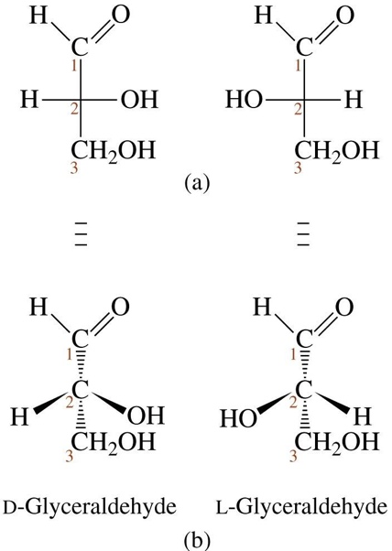
- D form has hydroxyl on the right at the chiral carbon for the Fisher projection.
- L form has the hydroxyl on the left of the Fisher projection
- Stereoisomers that are mirror images of each other are called enantiomers
- An increase in the number of chiral carbons increases the number of possible optical isomers
- 2^{n} where n is the number of chiral carbons
- Chiral carbons have 4 different function groups

Tetroses
- 3 types of tetroses
- D-Erythrose, D-Threose, D-Erythrulose (Do not need to remember names)
- The reference carbon for indicating the enantiomer is the chiral carbon that is furthest from the carbonyl, then you determine if the hydroxyl is on the left (L) or the right (D)

Diastereomoers
- Stereoisomers that are not enantiomers (mirror –image isomers)
- In order to determine line up the molecules next to one another and then look at the chiral carbon and see if they’re mirror images of one another
- Stereoisomers Same formula and sequence, but different spatial arrangement of atoms on chiral centres)
- Enantiomers Molecules are mirror images of each other
- Diastereomers Molecules are NOT mirror images of each other

Epimers
- Diasteromers that differ at a single chiral carbon are epimers
- Orientation differing at more than one carbon is not a epimers

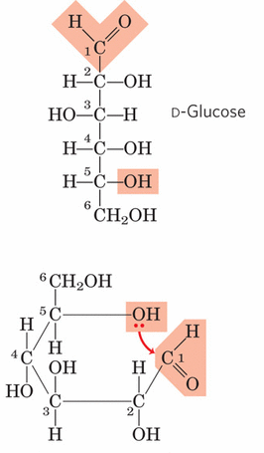
Cyclic Structure of Monosaccharides
- Sugar with 5 or more carbons exist primarily in cyclic forms
Ring formation occurs because aldehyde and ketone groups react reversibly with hydroxyl groups in an aqueous solution

Cyclic Monosaccharides: Hemiacetals and Hemiketals
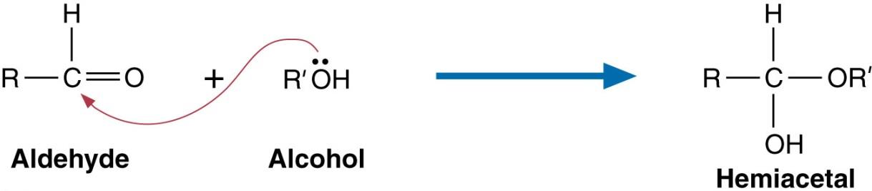
- Hemiacetal formation

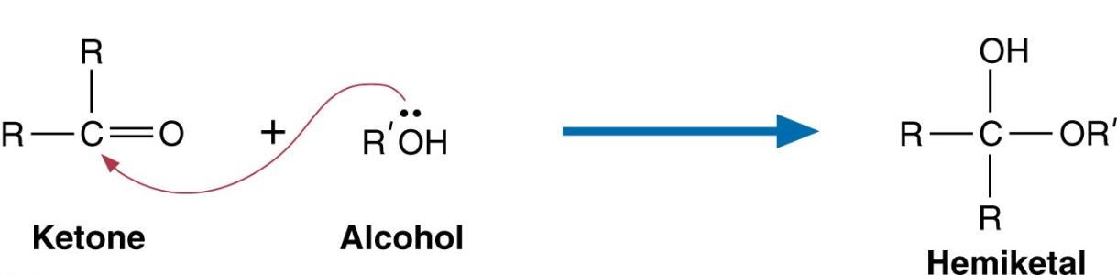
- Hemiketal formation

Anomers
- The two possible diastereomers that form because of cyclization are called anomers.
- Hydroxyl group on hemiacetal occurs on carbon 1 and can be in the up position (above ring) or down position (below ring)
- In the D-sugar form, because the anomeric carbon is chiral, two stereoisomers of the aldose can form the α-anomer or β-anomer

Haworth Perspective Formula
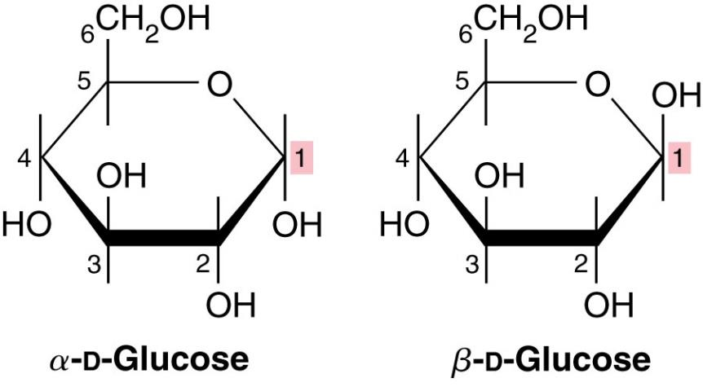
- Beta refers to Cis, Alpha refers to Trans
- Haworth Projections
  - These structures more accurately depict bond angle and length in the ring structures than the original Fischer structures
- In the D-sugar form, when the anomer hydroxyl is up it gives a β-anomeric form (left in Fischer projection) while down gives the α -anomeric form (right)
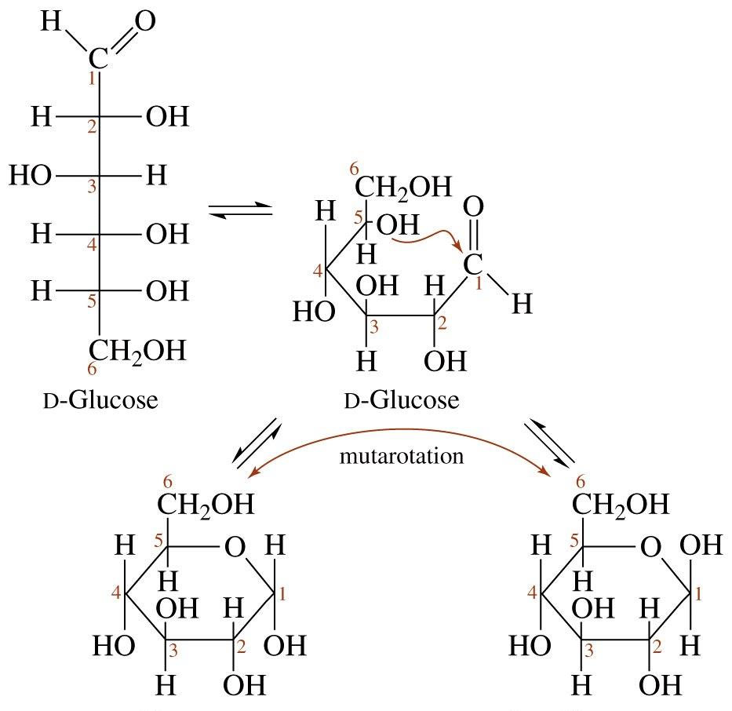
Cyclization of D-Glucose
- 1) Number the Fischer projection and identify the chiral carbon
  - Carbon with the oxygens attached becomes number 1
- 2) Identify the anomeric carbon
- 3) Identify Cis or Trans to get alpha or beta

Furonses and Pyranoses
- Five membered rings are called furanoses
- Six membered rings are called pyranoses
- The cyclic form of fructose is fructofuranose

Mutarotation
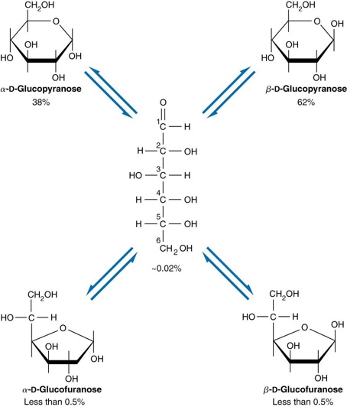
- The alpha and beta forms of monosaccharides are readily interconverted in aqueous environments
- This spontaneous process, mutaroation, produces an equilibrium mixture of alpha and beta forms in both furanose and pyranose

Reactions of Monosaccharides
- Chemically active structures
- Most important include
  - Oxidation
    - Go up one oxygen level
    - Alcohol Aldehyde
    - Aldehyde Carboxylic
  - Reduction
    - Goes down one oxygen level
  - Isomerization
  - Esterification
    - Acid and Alcohol interact to form an ester
  - Amino Sugar Formation
    - Replacement of hydroxyl group on carbohydrate by an amino group
    - Sugars used to make nucleotides are in the Beta form
  - Glycoside formation
    - Replacement with another function group
    - Interaction between sugar and an ROH group
    - When sugar combines with another sugar
    - You use an O glycosidic group for them to come together
  - Glycosylation

Disaccharides
- Two monosaccharides linked by glycosidic bond
- Linkages are named by alpha or beta conformation and by which carbons are connection
- How many Anomeric Carbons
- Identify alpha or beta
- And then determine what numbered carbons are involved

Polysaccharides
- Use for storage of energy
  - Plants/animals: store glucose in the form of polysaccharides
    - Starch in potatoes, corn and wheat
    - Glycogen in liver and muscle
- Homopolysaccharides: single type of monosaccharide subunit
- Heteropolysaccharides: two or more types of monosaccharide subunits
- Oligosaccharide: polysaccharide with 10 or fewer units
- Peptidoglycans: polysaccharides cross-linked with short peptides
- Nonreducing end Carbonyl not available to bond
- Reducing end Capable of forming aldehyde

Important Monosaccharides
- Glucose (D-Glucose) —originally called dextrose, it is found
  - in large quantities throughout the natural world The primary fuel for living cells
  - Preferred energy source for brain cells and cells without mitochondria (erythrocytes)
- Fructose (D-Fructose) – is often referred to as fruit sugar, because of its high content in fruit
  - On a per-gram basis, it is twice as sweet as sucrose; therefore, it is often used as a sweetening agent in processed food
  - Sperm use fructose as an energy source
- Galactose is necessary to synthesize a variety of important biomolecules
  - Important biomolecules include lactose, glycolipids, phospholipids, proetoglycan, and glycoproteins
  - Galactosemia is a genetic disorder resulting from a missing enzyme in galactose metabolism

