BIOCHEM 2020
Lecture 7

Enzymes
- Are biological catalysts
- Catalysts: speed up chemical reactions, but are not consumed (used up) during the reaction (or they are regenerated)
- Almost all enzymes are proteins
- Some RNA molecules have catalytic properties
- Critical for many biologically important chemical reactions
  - Life would not be possible with enzymes

Enzymes Increase the Rate of Reactions
- Very Slow
  - A + B P
- High Temperature
  - A + B P
- Presence of Enzyme
  - A + B P
- Living systems cannot increase temperature without the disk of damaging structures, so they use catalysts (enzymes)
- Enzymes can increase reaction rate up to 10⁷ to 10¹⁹
- Enzymes are also very specific for substrates

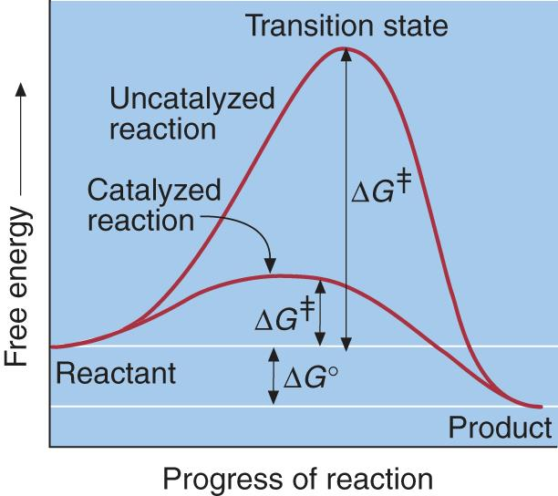
Role of a Catalyst in a Chemical Reaction
- The free energy of activation (delta G) is the amount of energy needed to convert 1 mol of substrate (reactant) from the ground state to the transition state
- Transition State
  - Unstable – can reform reactants or proceed to form products

Free Energy Change, ΔG
- Delta G – Free Energy
  - Energy that is available to do work
  - Is a value that describes spontaneity

ΔG < 0 reaction is spontaneous
ΔG = 0 reaction is at equilibrium
ΔG > 0 reaction is endergonic (requires energy to be carried out)

When are enzymes required? An Example
- Hydrogen peroxide is a waste product that is detrimental to cells if it is allowed to build up
- The reaction shown is thermodynamically favored but occurs slowly
- To increase rate of reaction:
  - 1. Increase energy level of reactants
  - OR
  - 2. Add a catalyst
    - B) Fe ³⁺
    - C) Enzyme: catalase

Characteristics of Enzymes
- Enzymes increase the rate of reactions by lowering energy barrier
- Enzymes do not change the position of equilibrium
  - They increase the rate at which the equilibrium is reached
- Enzymes are not “used up” or permanently changed
- Enzymes act by facilitating the formation of transition state (i.e. stabilizing the transition state)

Characteristics of Enzymatic Active Sites
- Active Site
  - The cleft in the surface of an enzyme where a substance binds and where catalysis takes place
  - Demonstrates specificity
    - Enzyme stabilizes the transition state by providing contacts to the substrate

Factors affecting enzyme function
- [S] – Substrate concentration (sometimes written as [A])
- [E] – Enzyme concentration
- pH – Most enzymes have a pH optimum
- T – temperature

Enzyme Kinetics
- Enzyme Kinetics
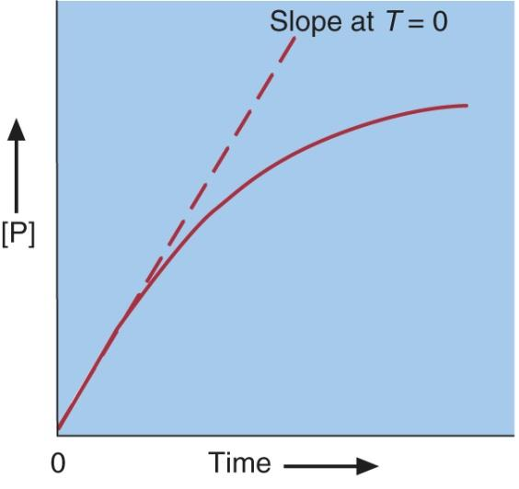
  - Provides information about reaction rates
- Reaction rate (v)
  - Slope of the curve in the time vs [P] graph
- Initial Velocity (v₀)
  - Reaction rate at time zero (Before any product can be converted back to substrate)

Initial Rate Depends on Substrate Concentration

Reaction Order
- First Order Kinetics
  - The reaction rate depends on the concentration of only one substrate
    - AP
    - Then v = k [A]
    - Unimolecuar

- Second Order Kinetics
  - Reaction rate depends on two substrates (e.g. bimolecular reactions)
    - 2A P
    - A + B P
    - Then v = k[A]² or v = k[A][B]

- Pseudo-First Order Kinetics
  - Reaction rate depends on concentration of only one of two substrates
  - Then v = k[A]⁰ = k

- Zero Order Kinetics
  - Reaction rate is independent on the concentration of the substrate (s)
    - V = k [A]⁰ = k

Reaction Order: Sample Problem
Determine the order of the following reaction, given the following rate data.
A + B C

Michaelis-Menten Equation
- The Michaelis-Menten Equation relates the rate of an enzyme with the substrate concentration.
- In 1913 Michaelis and Menten proposed the general theory for enzyme action.
- This is simplified by taking measurements close to t = 0 such that very little P is formed, and thereby the reverse reaction (as measured by k₋₂) does not take place appreciably
- From this the following equation was derived to describe the reaction
MM Eq: One enzyme active site, one substrate

Assumptions Used in Michaelis-Ment aden Equation
- To simplify the equation, the folling assumptions were made
  - The product, P, and the free enzyme, E, do not reverse to form the ES complex.
  - The concentration of ES, [ES], does not change. It is a steady- state intermediate.
  - This allows K_{m} to be defined as:
Quick Review
Rate of Reaction (v)
- Depends on the substrate concentration
- Is the slope of the curve shown
- The relevant v is v₀
  - At the very start of the reaction
  - Before P can be reconverted to S

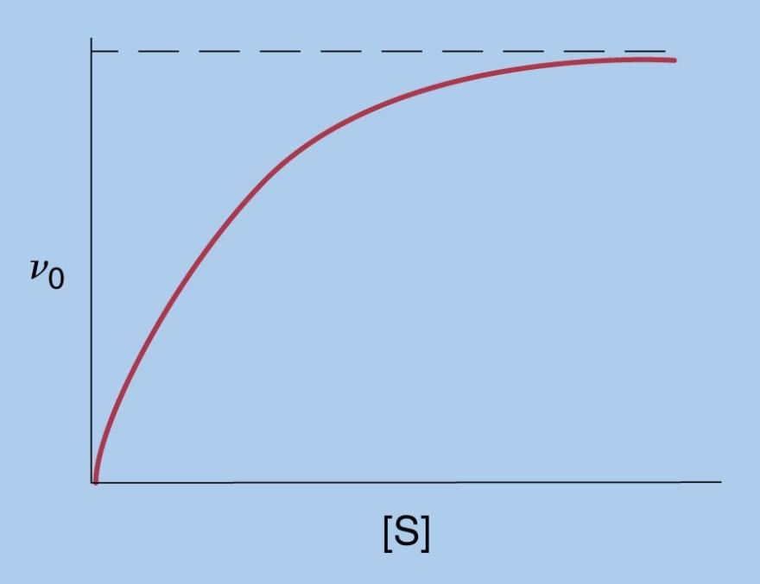
Relationship Between v₀ and [S]
- Hyperbolic curve
- At high [S] v₀ = v_{max}
- Relationship is determined by the MM
- Equation

Determination of Michaelis Constant
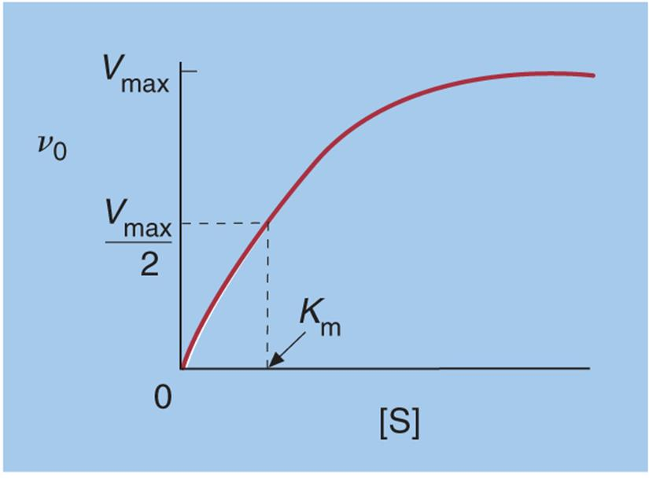

Km as an approximation of a dissociation constant

Turnover Number, k_{cat}
- Turnover Number
  - A measure of catalytic efficiency
  - V_{max} = maximal rate of enzyme-catalyzed reaction for a given value of [E]
  - [E_{t}] = Total Enzyme Concentration
  - The turnover number is the number of moles of substrate converted to product per mole of enzyme per unit time (s⁻¹)

Specificity Constant
- It is the relationship between the catalytix rate and the substrate binding affinity
- Useful when comparing different substrates for the same enzyme

Lineweaver-Burk Plots
- Allow you to calculate Km, Vmax, and k_{cat} during an experiment
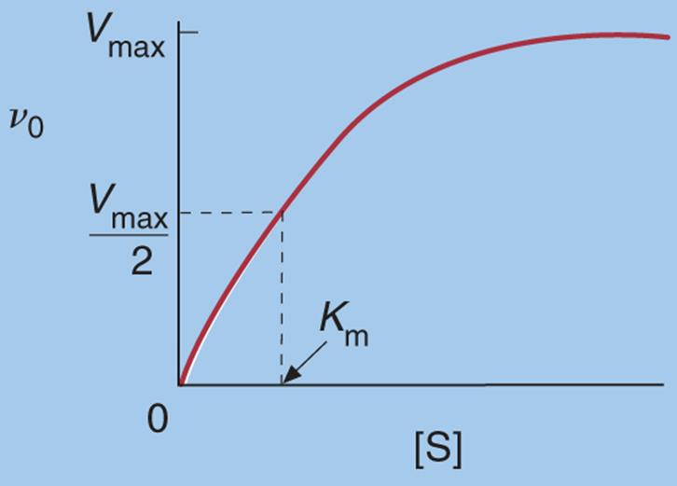
- The double reciprocal plot of 1/v₀ vs 1/[S] allows you to do so

Example
A Lineweaver-Burk plot was drawn for an enzyme following Michaelis- Menten Kinetics. The slope is 10 min and the y-intercept was 0.25 min/mM. What is the K_{m}?

Example
The data from an enzyme kinetics experiment was plotted as a Lineweaver-Burk plot. The y-intercept of the plot was found to be 20 s/mM, and the x- intercept of the curve is -1.5 mM⁻¹. What is the slope of the plot?

