BIOCHEM 2020: Biochemistry
Lecture 1

Biochemistry as a Discipline
- Biochemistry concerns the study of living things at the molecular level
- Historically, it mainly studied proteins purified from living organisms, and characterized enzymatic activities derived from organisms and tissues.
- Molecular biology emerged from biochemistry, and the two disciplines are not clearly distinct.
- Molecular biology studies the formation, structure and function of biological molecules (in particular nucleic acids and proteins) using molecular techniques and genetic manipulations.

Four major classes of biomolecules
- Proteins
  - Proteins are composed of amino acids
  - They are long linked chains
  - The functional groups are different and things that are common between the amino acids are the amino groups
  - They’re carboxyl group is another common factor
  - They have an alpha carbon that is common
  - The amino group can be protonated (NH3+) or unprotonated (NH2)
  - The same goes for the carboxyl group
  - Carbon, hydrogen and oxygen compose the protein
- Nucleic acids
  - Composed of nucleotides
  - DNA and RNA
  - Basic Structure:
    - One part is the sugar.
    - The nitrogenous base (Adenine, Guanine, Cytoside, Thymine (DNA) and Uracil (RNA)
    - Phosphate group (Mono, Di, or Triphosphate)
- Carbohydrates
  - Sugars
  - Carbohydrates have the empirical formula of (CH2O)n (The n will usually range from 4-7)
  - Two types of Carbonyls (Carbon double bonded to an oxygen)
    - Internal is a Ketone
    - Terminal is Aldeyhyde
  - Sugars with 5 or more carbons can form rings.
  - Just as amino acids can form polymers. Carbohydrates can also form polymers. Unlike proteins and nucleic acids, carbohydrates can be branched.

- Lipids
  - Any biomolecules that is insoluble in water
  - Many of them are fatty acids
  - One side is a long hydrocarbon tail attached to a carboxyl group that is a fatty acid
  - Two classes
    - Saturated
    - Unsaturated
    - Fully saturated has no double bonds
    - Any double bond indicates unsaturated hydrocarbon

- You can’t have proteins without biomolecules. The most important elements are hydrogen, carbon, oxygen, nitrogen, sulfur and phosphorus.

- All biomolecules are carbon based.

- Functional Groups
  - Page 13 of lengiher
    - Methyl ethyl phenyl
    - Carbonyl (ketone or aldehyde)
    - Carboxyl group
    - Hydroxyl
    - Amino groups
    - Disulfide bridge
    - Phosphoryl group or phosphate group (same thing)

Weak (non-covalent) Interactions

- Non-covalent Bonds
  - Weaker than covalent bonds
  - Can occur in large numbers resulting in a cumulative effect
  - They are essential for life

- Ionic Interactions (Electrostatic interactions)
  - Interaction between charged particles
  - Important for protein folding
  - Opposites attract, like charges repel
  - Critical for proper formation and function of nucleic acids, proteins and other biomolecules
- Hydrogen Bonds
  - Occurs when H is covalently bound to an electronegavtive atom, like O, N or S.
  - You have a partial charge
  - Electronegative likes to pull electrons
  - Hydrogen bonds in water
    - One molecules of water can attach to 4 other molecules of water
    - Water tends to disrupt hydrogen bonds in aqueous environments
    - If a structure of protein depends on the hydrogen bonding it will not be introduced to an aqueous environment
- Van der Waals Interaction
  - Attraction is due to permanent, transiet or induced diples between atoms
  - Occur when two unchagrged atoms approach eachother
  - Attraction is grates at a specific distance (van der Waals radius)
  - Types of Van der Waals Interactions
    - A) Dipole-Dipole interactions
    - B) Dipole-induced dipole interactions
    - C) Induced dipole-induced dipole interactions (True Van der Waals interaction)
      - Neither of the molecules have dipoles. But the affect you get is solely dependant on
- 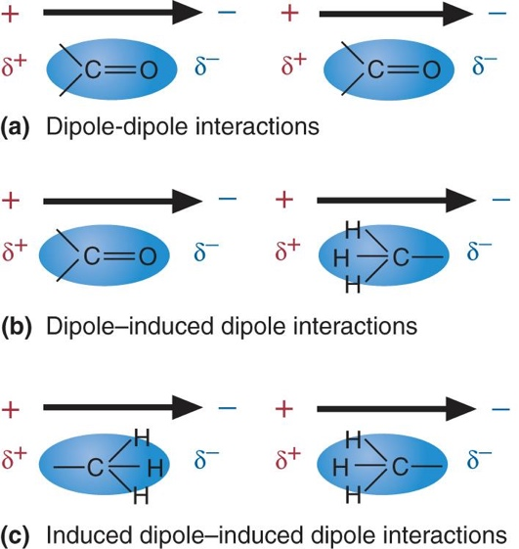

- Hydrophobic Interactions
  - Avoid water
  - Molecules that cannot form hydrogen bonds, so they come together created the hydrophobic interaction
  - Hydrophobic interactions form between non-polar molecules (or non-polar regions of molecules (or non-polar regions of molecule) in aqueous environments

Water
- Key roles of water in living organisms:
  - (1) Water is a biological solvent
    - A large number of biomolecules are soluble in water. The insolubility of others (e.g. lipids) is required for the formation of membrane
  - (2) Water molecules are part of many biochemical reactions
    - e.g. Hydrolysis –cleavage of chemical bonds by water – is necessary for the breakdown of polymers like polypeptides
  - (3) Water is essential as a buffer for regulating temperature an pH
    - proton donor and acceptor
    - Water has a high heat capacity (energy needed to change the temperature of a substance by One degrees celcius). Water plays an important role in maintaining temperature

Characteristics of Water
- Polar nature of water makes it versatile solvent for polar and ionic compounds

Water as a Solvent
      - Hydrophillic Molecules
- Small molecules dissolve easily
- Water dissolves polar and ionic molecules through H-bonding, dipole-dipole or dipole ion interactions
      - Hydrophobic molecules
- The hydrophobic effect
- 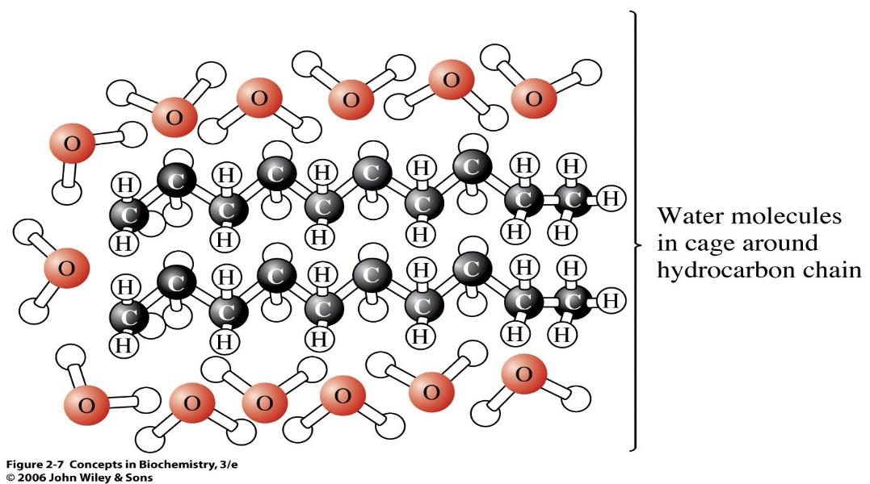

      - Amphipathic Molcules
- Contain both polar and nonpolar groups
- How biological membranes are formed

