Material Resource Planning (MRP)
Tool to manage dependent demand – Demand for one item is related to demand for another item. Master Production Schedule - Time-phased plan, obtained from the aggregate planning process, specifying how many units the firm plans to build of each end item, and when. Product Structure Tree – Bill of Materials representation Ex. Product A is composed of two units of part B and three units of component C. Part B is made of two components C and one unit of raw material D. Component C is made of raw materials D (two units) and F (three units) as well as one E sub-component. Raw materials F (one unit) and G (two units) form sub-component E. New Example
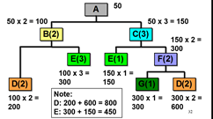
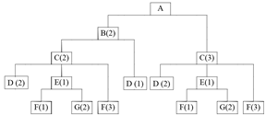
How many of each component is needed if Demand for A is 50?
Notice demand for D came from demand its PARENT x 2. Same for E’s, F, G, D
ANOTHER EXAMPLE
Total requirements of 2,000 A. 200 on hand. For every A, need 1 E. 900 E on hand. How many E must be ordered. 2,000 – 200 = 1,800. 1,800 – 900 = 900 net requirement.
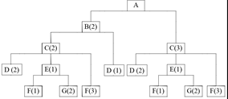
Time-Phased Product Structure Example Master Production Schedule Example
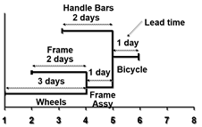
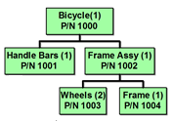
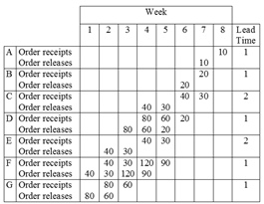
New Terminology
Note: 10 units of product A - Gross Req’ts – Quantity needed, the total expected
at start of week 8 demand for an item or raw material DURING each
Production = 8 – 1 time period without regard to the amount on hand
= 7 weeks - Net Req’ts – Quantity to be manufactured or purch,
The actual amount needed in each period
- Planned Order Receipt – Quantity due to be
finished or delivered by beginning of the period in which it is shown.
- Planned Order Release – quantity to be manufactured or to be ordered in each time period, equals planned order receipts offset by leadtime.
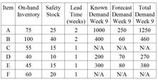
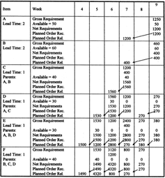
Total Req’ts – Available Inventory = Net Req’ts

Available = On hand – SS

If INFEASIBLE
- Make feasible by reducing demand
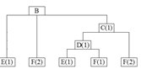
Or increasing production speed if pos.

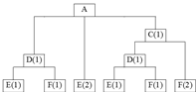

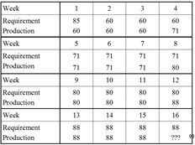
Capacity Resource Planning (CRP)
Units produced comes from MRP
# Employees = Hrs req’d / hours worked per emp per mth
Order Splitting
- Divide production in mths by weeks. Example: If making 352 units during month 4, 88/week
Due to only 3 weeks in first month (Lead time)
Inventory Management
ABC Analysis – Divides inventory into 3 classes, A – Very important, B – Mod, C – least. Used to establish policies that focus on the few critical parts and not the many trivial ones. Basis is usually annual $ volume. A = 50% and up, and so on. Purpose – establish the proper degree of control policies for each class. Examples of policies – develop class A suppliers, tighter controls on A, forecast A more carefully.
Continual Inventory Counting Periodic Inventory Counting System
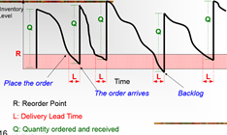
System (Fixed Quantity Models)(Fixed Period Model)
Keeps track of removals from Physically counting a sample of total inventory on a
inventory continuously. When regular basis (periodic intervals)
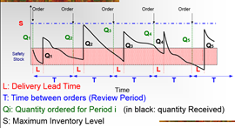
amount on hand reaches a
predetermined minimum, a
fixed quantity, Q, is ordered.

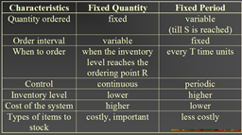
Fixed Order Quantity (Deterministic Models)
Economic Order Quantity (EOQ) – Known and constant demand, known and constant lead time, instantaneous receipt of material, no quantity discounts, only order (setup) cost & holding cost, no stockouts
1. Develop expression for the ordering cost. 2. Develop expression for the holding cost. 3. Set ordering cost equal to holding cost. 4. Solve the equation for the Optimum Inventory level, which is Q*.
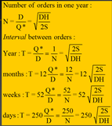
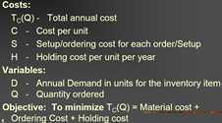
Formulas – Annual Ordering Cost = (# of orders per year) x (Order cost per year) = (D/Q) x S Annual Holding Cost = (Avg. Inventory Level) x (holding cost per year) = (Q/2) x H $Q^{*}=\sqrt{\frac{2DS}{H}}$ $T_{C}\left(Q^{*}\right)=DC×\frac{DS}{Q^{*}}×\frac{Q^{*}H}{2}=DC+\sqrt{2DSH}$
Example 1
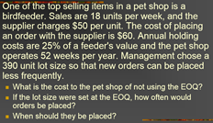
D = 936, C = $50, S = $60, H = $12.50, Q = 390
$$Q^{*}=\sqrt{\frac{2DS}{H}}=95$$
a)TC(390) = 49381.5 TC(Q* = 95) = 47984.91
b) 936/95 = 9.85 orders/yr, 52/9.85 = order every 5.85wks
c) R = d x L = 18 x 1 = 18

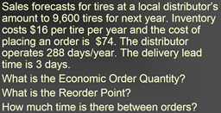
Example 2
D = 9,600, S = $74, H = $16, a) Q* = 298 b) R = d x L = (9,600/288) x 3 = 100
c) Time between orders = 288 / (9,600/298) = 8.94 days

Economic Production Quantity (EPQ) – Answers how much to order & when to order (or start production)
Let p = the daily production rate (p > d) : Slope of inventory level during production part of cycle is p – d. Slope of the inventory level during the demand part of the cycle is – d. Let Q be the quantity ordered or the production lot size. Let T1 be the length of the production part of the cycle (time required to produce Q units) (T1 = Q / p). Let $I_{Max}$ be the maximum inventory level $I_{Max}=\frac{Q^{*}}{P}(p-d)$. Let T2 be the length of the demand part of the cycle (time required to sell $I_{Max}$ units) $T_{2}=\frac{Q(p-d)}{p×d}$ . Let I be the average inventory level during a cycle $I_{Avg}=\frac{I_{Max}}{2}=\frac{Q^{*}(p-d)}{2p}$. Let $TC\left(Q^{*}\right)=DC+\frac{DS}{Q}+\frac{(p-d)}{p}×\frac{Q^{*}H}{2}$ $Q^{*}=\sqrt{\frac{2DS}{H}×\frac{p}{p-d}}$ Runs/yr = $\frac{D}{Q^{*}}$
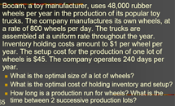
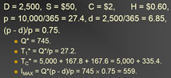
Length of prod. = $\frac{Q^{*}}{P}$
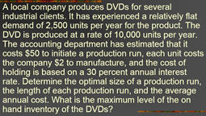

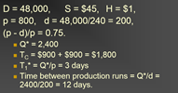
Quantity Discount Model – Trade off between lower price & increased holding cost
1. Compute EOQ for each quantity discount price. 2. Is computed EOQ in discount range? If not, a) EOQ below the minimum quantity to obtain the discount, use the lowest cost quantity in discount range, b) EOQ greater than the max quantity in the discount range, DISREGARD. 3. Compute total cost for EOQ or lower cost quantity in discount range. 4. Select quantity (EOQ) with lowest total cost.
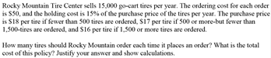
D = 15,000/yr, I = 15% of purch price in holding costs where H = IP, S = $50/order, If Q < 500, C = $18/tire, 500 < Q < 1,500, C = $17/tire, Q > 1,500, C = $16/tire
$Q_{18}=746>500, disregard, Q_{17}=767, within, Q_{16}=791, below mini quant. so use 1,500$ in cost calculation
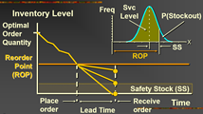
Fixed Order Quantity (Probabilistic Models)
Independent demand is not known but varies from day to day and can be specified by means of a probability distribution
For fixed order quantity, inventory level known at all times but stockout protection is needed only during lead times. WE MUST HAVE SAFETY STOCK. R = Expected Demand during lead time + SS. Answers how many and when to order. Service level is the probability that demand will not exceed supply during lead time (Service level = 1 – P(Stockout)). Higher service level means more safety stock. More SS means higher R.
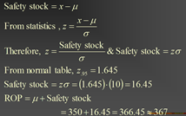
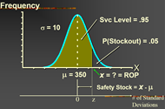
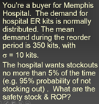
R = $μ_{L}+SS$$$=dL+zσ_{L}$$
Mu(L) = Exp demand during L
Sigma(L) = SD of dem during L

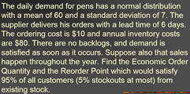
D = 60 x 365 = 21,900 units, S = $10, H = $80, L = 6 days, d = 60, $σ_{d}$= 7, p = 0.95, Q* = 74. R = ? $μ_{L}=dL=60×6=360$ $σ_{L}^{2}=L×σ_{d}^{2}=6×49=294, σ_{L}=17.15$ When service level = 0.95, z = 1.645.
$$R=360+\left(1.645\right)\left(17.15\right)=388.21$$
Therefore, order when the inventory level gets down to 389 units.
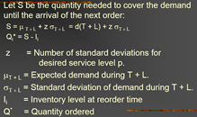
Fixed Period Model (Probabilistic Demand)
Useful when vendors visit routinely.
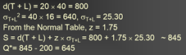
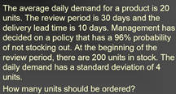

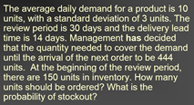
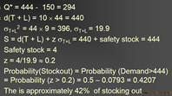

Quality Management
Variation – Natural/Common/Random – Result from process design, purely random, cannot be changed without redesigning process
Assignable – Result from operating the process, Ex. Lax procedures, untrained operators, improper machine maintenance
Control Charts – Used to distinguish natural variation and assignable causes. Natural variations are those within the UCL and LCL. Assignable are those outside the limits. Type 1 Error – Concluding not in control when it is Type 2 – Concluding in control when NOT
Chart Types – Attribute – Used when the process characteristic is counted rather than measured P-Chart – Used to monitor proportion of defectives generated by process. Use when observations can be placed into one of two categories or items (good or bad, defective/non-defective, pass/fail) and when the data consist of multiple samples, m, of n observations each. Center line $\overset{̿}{p}=\frac{Total Defects}{(number of samples)×(Sample size)}$, UCL and LCL $=\overset{̿}{p}±z\sqrt{\frac{\overset{̿}{p}(1-\overset{̿}{p})}{n}}$. C-Chart – Used to monitor the number of defects per unit of output. Use when only the number of occurrences per unit of measure can be counted; non-occurrence’s cannot be counted (scratches chips or errors per item, cracks faults per unit of distance, bacteria per unit volume) Center line $\overline{c}$= $\frac{Total Defects}{Number of Samples}$, UCL and LCL = $\overline{c}±z\sqrt{\overline{c}}$ Variables – Based on quality characteristics that are measurable on continuous scale (weight, volume), R-Chart – Range control charts, monitor the dispersion of a process. $R=\left(Sample\max{val}\right)-(Sample\min{val})$, $\overline{R}=\frac{\sum{R}}{m}, m=\# samp.$ Parameters known – Center line = $Kσ$, LCL = $KσD_{3}$, UCL = $KσD_{4}$ Parameters unknown – Center line = $\overline{R}$, LCL = $\overline{R}D_{3}$, UCL = $\overline{R}D_{4}$
$\overline{R}≅Kσ$, $σ≅\frac{\overline{R}}{K}$ Xbar-Chart – mean control charts, monitor the central tendency of a process. $\overset{̿}{X}=\frac{\sum_{i=1}^{m}{{\overline{X}}_{i}}}{m}$. Parameters known – UCL and LCL $=μ±z\frac{σ}{\sqrt{n}}$, Unknown – UCL and LCL = $\overset{̿}{X}±A_{2}\overline{R}$.
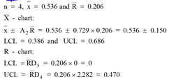
Run Test – A run is defined as a sequence of observations with a certain characteristic, followed by one or more observations with a different characteristic Ex. AAAB, run of three A’s, run of one B. Normal behaviour, in control. One plot out or below control chart, investigate, out of control. Trends in either direction, investigate cause for progressive change. Two very near lower or upper, investigate. Run of 5 above or below, investigate. Erratic behaviour, investigate.

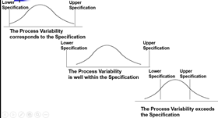
Process Capability
Capability Analysis – Determine whether the process variability output falls within the acceptable range of variability allowed by design specifications. Within specs, the process is CAPABLE of meeting specs. Exceeds, the manager must decide how to correct situation.
$$C_{P}=\frac{Upper Spec-Lower Spec}{6σ}$$
If Cp < 1, process is INCAPABLE to satisfy the specs.
If Cp = 1, process is CAPABLE to satisfy the specs.
If Cp > 1, process is MORE THAN CAPABLE to satisfy the specs.
Six Sigma requires Cp = 2
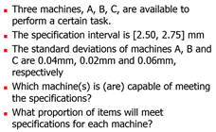
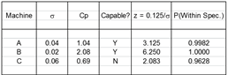
$Mean=\left(2.75-2.50\right)÷2$ $z=\frac{0.125}{σ}=0.125$ $=\frac{0.125}{0.04}$
$=3.125$
JIT
Ohnos Seven Wastes – 1. Overproduction, 2. Queues, 3. Transportation, 4. Inventory, 5. Motion, 6. Overprocessesing, 7. Defective Products

