Forecast Terminology
Period – basic time unit (week, month, quarter, year) Horizon – Number of periods to be covered in a forecast
Interval – Determines when a forecast is to be updated Short Range - < 3 mths. (purchasing, job scheduling, workforce levels, job assignments, production levels) Medium Range – 3 mths to 3 yrs (sales, production planning) Long Range – 3+ yrs (New prod. Planning, facility location, R & D) $A_{t}=Actual obs. value time t, F_{t}=Forecasted val. time t$
$E_{t}=A_{t}-E_{t}=forecast error$ ${E'}_{t}=\frac{A_{t}}{F_{t}}=relative error$ $ME=\frac{\sum{E_{t}}}{n}=Mean error$
$MAD=\frac{\sum{\left|E_{t}\right|}}{n}=Mean abs. deviat.$ $MSE=\frac{\sum{E_{t}^{2}}}{n}$ $E_{t}=0=Perf. E_{t}<0=Too high E_{t}>0=Too low$
$${E'}_{t}=1=Perf. {E'}_{t}<1=Too high {E'}_{t}>1=Too low$$
Naïve Approach
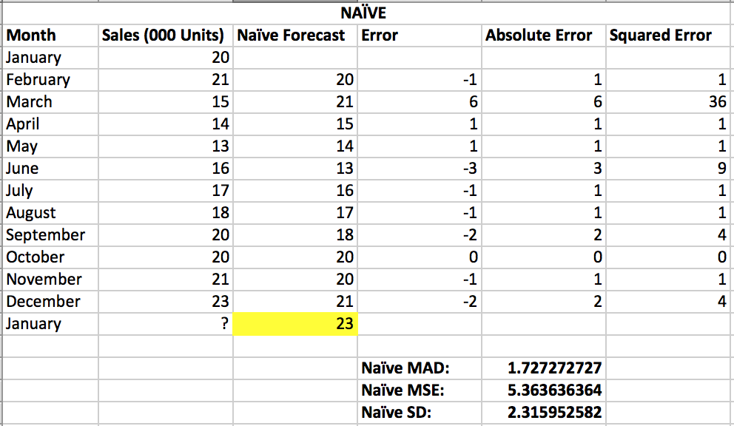
Assumes demand in next period is the same as demand in most recent period (Eg. Jan sales 68, Feb sales will be 68)

$$MAD=\frac{1+6+1+…+2}{11} \\ MSE=\frac{1^{2}+6^{2}+…+2^{2}}{11}$$
$$SD=\sqrt{MSE}$$

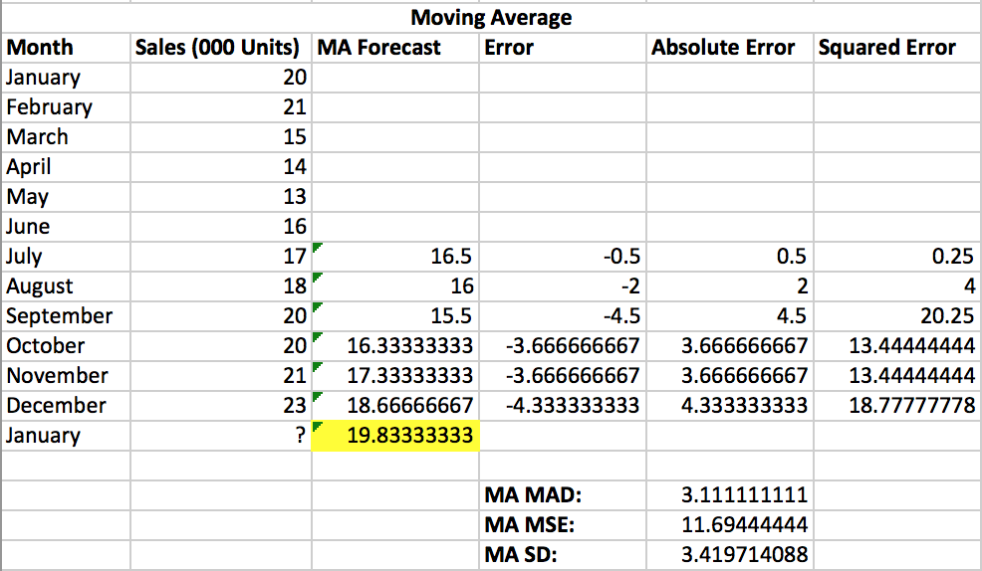
Moving Average
Used if little or no trend $F_{t}=\frac{A_{t-1}+A_{t-2}+A_{t-3}}{n}$ $F_{July}=\frac{20+21+15+14+13+16}{6}=16.5$
If n = 3, need to average last 3 actuals IF YOU INCREASE n, IT WILL REDUCE SD WHICH MEANS A BETTER MODEL
$$MAD=\frac{0.5+2+…+4.3333}{6}$$
$$MSE=\frac{{0.5}^{2}+2^{2}+…+{4.3333}^{2}}{6}$$
$$SD=\sqrt{MSE}$$

Weighted Moving Average
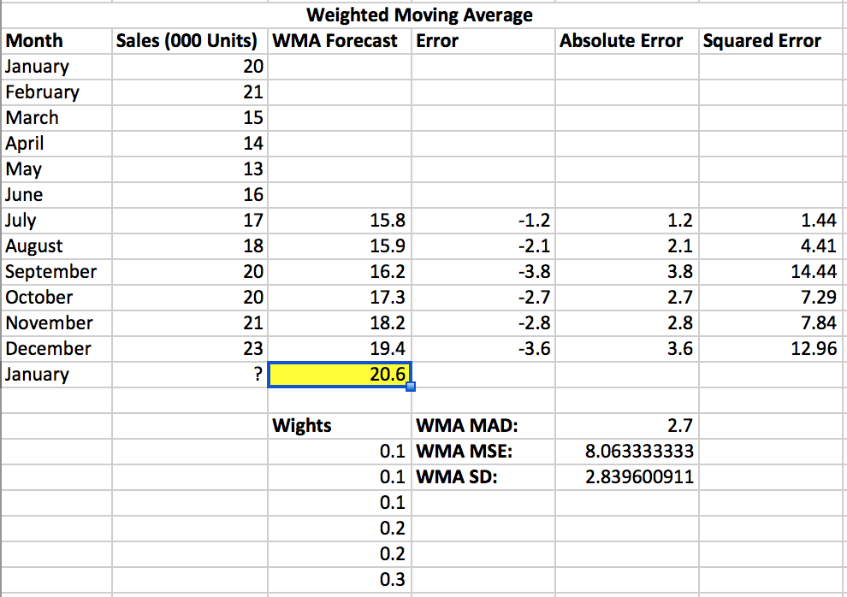
Apply heavier weights to more recent periods
$$F_{July}=0.1\left(20\right)+0.1\left(21\right)+0.1\left(15\right)+0.2\left(14\right)+0.2\left(13\right)+0.3\left(16\right) \\ =15.8$$
MAD, MSE and SD Calculated the same way
Disadv of moving average methods
- Increasing n smoothes the forecast but makes it less sensitive to changes
- Does not forecast trend well
- Require much historical data

Simple Exponential Smoothing
Alpha = 0.2
$$F_{t}=F_{t-1}+α\left(A_{t-1}-F_{t-1}\right), (0≤α≤1)$$

If time series is stable, take alpha close to 0

$$F_{1}=A_{1}$$
$$F_{2}=F_{1}+0.2\left(A_{1}-F_{1}\right) \\ =17+0.2\left(17-17\right) \\ =17$$
$$F_{3}=F_{2}+0.2\left(A_{2}-F_{2}\right) \\ =17+0.2\left(21-17\right) \\ =17.8$$
$$MSE=\frac{98.8}{11} \\ =8.9813$$
N = 11 NOT 12
Double Exponential Smoothing
At = actual demand in period t FITt = Forecast including trend in period t Ft = exponentially smoothed forecast of the data series in period t Tt = exponentially smoothed trend in period t alpha = smoothing constant for the average Beta = smoothing constant for the trend
When a trend is present, exponential smoothing must be modified
Need atleast 2 actuals
$$Forecast including Trend {FIT}_{t}=Exp. Smoothed Forecast F_{t}+Exp. Smoothed Trend T_{t}$$
Step 1 – Compute Ft $F_{t}=α\left(A_{t-1}\right)+\left(1-α\right){FIT}_{t-1}$
Step 2 – Computer Tt $T_{t}=β\left(F_{t}-F_{t-1}\right)+(1-β)T_{t-1}$
Step 3 – Calculate the forecast ${FIT}_{t}=F_{t}+T_{t}$
Chose Start to be period 3 $F_{3}=A_{1}=4,890, T_{3}=A_{2}-A_{1}, {FIT}_{3}=F_{3}+T_{3}$
Linear Regression
Quantity being forecasted (y hat), variable that influence the quantity being forecasted (x) Causal (associative) model Least Squares Method – Minimizes the sum of squared errors (deviation)
Coefficient of Correlation (R) = sqrt(R2) R2 = 0.85 85% of the variability in Y or AT can be explained by the regression equation 85% of the variability in Y or AT can be explained through the knowledge of the independent variable X or T
Coefficient of Correlation (R) – 1 – Perfect correlation (As x increases, y decreases), b > 0, positive R, b<0, negative R
To find forecast, just plug in the t into the equation
If need to find equation, say you know F5 and F4
$$F_{5}=a+5b=26.229 \\ F_{4}=a+4b=21.743$$
Solve the equation $1b=4.486$ Then, $F_{4}=a+4\left(4.486\right)$ $21.743=a+17.944 a=3.799$
Time Series Decomposition Model
Use when seasonality is present $A_{t}=T_{t}×S_{t}×C_{t}×R_{t}$ $,F_{t}=T_{t}×S_{t}×C_{t}$ CHART APPLIES WHEN EVEN n, ODD n = remove CMA Step 1 – Eliminate $S_{t}×R_{t}$: “centered moving average” = $T_{t}×C_{t}$ (3,4) Step 2 – Calculate At/CMA (5)
Step 3 – Calculate Seasonal Indices (Example – For month of January, avg out all the values of St x Rt that correspond to January = $\frac{Column 5 from Jan 13+Jan 14}{2}$ Seasonal index for Jan 2012 will be same for 2013 and 2014 Sum of the indices should equal the number of periods (n) (7) = ${Col 6}/{\frac{\sum{Col 6 for the year}}{n}}={0.7122}/{\frac{11.9357}{12}}=0.7160$ (IF 6 DOESN’T = n) Step 4 – Col 8 Deseasonalize the data: ${A_{t}}/{S_{t}}={Col 2}/{Col 7}$ Step 5 – Col 9 Trend $a+b$, Get equation from regression output then sub in numbers for col (9) Step 6 - $Forecast=Col 7×Col 9$
Which to Use
- Stable Time Series
  - Moving Average with large N
  - Weighted moving average (large number of periods)
  - Exponential smoothing with alpha close to 0

- Time Series with Changing Pattern
  - Moving Average with small N
  - Weighted moving average (small number of periods)
  - Exponential Smoothing with alpha close to 1
  - Naïve method

- Time Series with trend
  - Double exponential smoothimg
  - Linear regression (only if data are linear)
  - Trend projection
  - Naïve method that would account for trend

Aggregate Planning
Chase Strategy - involves changing the production rates or work-force levels to match the demand forecast for each period. Inventory is not used to absorb demand fluctuations. Favored by many service organizations.
Production = Demand – Beg. Inv. + SS or Req’d BIBeg. Inv. = EI from previous EI = Beg. Inv. + Production – Demand
Productivity = Number of hours avail / time to make unit Employees need. = Demand / Productivity
If work every day of the year, must figure out prod. Per month. Per employee
Level Strategy - strategy involves the maintaining of a constant daily production rate and work-force level for the duration of the plan. Inventory is built up during periods of less than average demand; alternatively, delivery lead times may be allowed to grow during periods of high demand. Stable production leads to better quality and productivity
BI = EI Previous – Backord. Previous (IF BI is neg., backorder & = 0) EI = BI + Reg. Prod. + OT + Sub + Part time – Demand (If neg. = 0) Sub = Demand – Production – Beg Inv OT = Demand – Prod – Beg Inv If work every day, then must have the same production every month which means $Prod per day=Total Prod (Chase)÷365$
Mixed – BI = EI previous – back (If neg. back) EI = BI + Reg Prod + OT + Sub + PT – Dem (can’t be neg. if neg = 0) Back = Dem – BI – Reg Prod – OT – Sub – PT Sub = Dem – Prod – BI OT = Dem – Prod – BI If EI neg, make BO BI for nxt
Preference Thresholds
Estimates the cost of each option on a homogenous unit of measure (eg. $/hr, $/mth) Compare between options using this unit cost to determine at what moment an option becomes preferable over another If demand is dropping and you have too many employees: 1. Firing/Hiring 2. Idle Time 3. Inventory Building Idle time: $20/hr
Salary = $20/hr x 8hr/day x 20days/mth = $3,200/mth/emp Inv Building: $125/unit/mth Firing/Hiring: (750+500)=$1,250 Compare Idle time and Inv. Building: Productivity = 160hrs/mth/emp $÷$ 20hrs/unit = 8units/mth/emp Inv. Building = 8 x $125 = $1,000 /mth/emp Idle time = $3,200/mth/emp
Compare idle time and Fire/hire Idle cost: $20/hr Firing/Hiring cost = $1,250 1,250 $÷$20 = 62.5 hrs Therefore, firing and hiring is better if an employee has to stay idle for more than 62.5 hrs Compare Inv building and firing/hiring Inventory cost = $1,000/mth Firing/hiring = $1,250 Better to fire then hire an employee when needed, if he has to be kept building inventory for more than 1 month Comparing OT and Subc. OT Cost = $600/unit Subc. = $650/unit Compare OT and backlogs OT = $600/unit Backlog = $250 + $400 ($400 comes from idle time /unit = 20hr/unit x $20/hr) Compare OT and hiring/firing OT @ $30/hr versus hiring an employee @ $20hr Incremental OT cost = $30/hr - $20/hr Hiring/Firing cost = 1,250 1,250/10 = 125hrs It is better to hire and fire if more than 125hrs of OT needed Compare subc and backlogs Subc = $650/unit Backlog = $250 + $400 = $650 Compare subc and hiring/firing Hiring/Firing = $1,250 Cost to produce unit reg time = $400/unit Incremental cost of subc = $650 - $400 = $250/unit 1,250/250 = 5 Better to hire/fire if more than 5 units have to be subc. Compare backlog and hiring firing Backlog = $250/unit = $2,000/mths production Hiring/Firing = $1,250 better to hire/fire
Transportation Method
Total Supply = Total Demand If Total Supply > Total Demand, we need an extra column called “excess” or “unused capacity” Intuitive Lowest Cost Approach 1. Identify the cell with the lowest cost. 2. Allocate as many units as possible to that cell, and cross out the row or column (or both) that is exhausted by this. Reduce the uncrossed row or column’s supply or demand by this amount. 3. Find the cells with the next lowest cost from among the not crossed out cells. 4. Repeat steps (2) and (3) until all units have been allocated.
Qualitative Methods
Sales Force Composite – Each salesperson proj their sales, combined at nat and dist lvls, salespers knows custm wants, overly optimistic Jury of Exec Opinion – Small group of high lvl manag, group estim demand, combines mana exper w stat models, relatively quick, group think disadv Consumer Mkt Survey – Ask cust about purch plans, what cons say and actually want is diff, difficult to answer Delphi Method – Staff make survey Respondants (peo who make val judgemts) Dec makers (Eval resp and make dec), process cont until concensus reached

