Chapter 13

The Costs of Production

- Last three chapters look at how individuals make decisions within the market.
- The goal of maximising social welfare is to improve efficiency and equity.
- When there are externalities, market allocation of resources is not efficient.

Total Revenue, Total Cost, Profit
- We assume that the firm’s goal is to maximize profit.
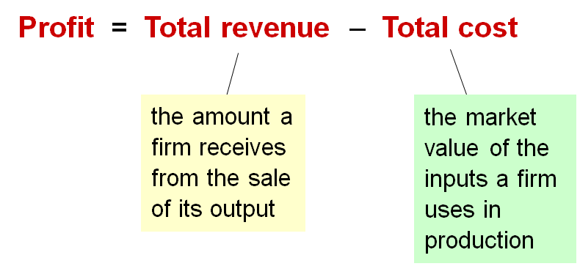
- The fundamental goal of a producer is to maximise profit

Costs: Explicit vs. Implicit
- Explicit costs require an outlay of money, e.g., paying wages to workers.
- Implicit costs do not require a cash outlay, e.g., the opportunity cost of the owner’s time.
- Remember one of the Ten Principles:
The cost of something is what you give up to get it.
- This is true whether the costs are implicit or explicit. Both matter for firms’ decisions.
Implicit costs Total
Explicit costs opportunity costs
- Opportunity cost: what you give up for something else
- i.e. the utilisation of limited resources

Explicit vs. Implicit Costs: An Example
You need $100,000 to start your business.
The interest rate is 5%
- Case 1: borrow $100,000
  - Explicit costs = $5000 interest on loan
  - This means that every year you have to use $5000 of your operational revenue to pay for the interest of your loan
- Case 2: use $40,000 of your savings, borrow the other $60,000
  - Explicit cost = $3000 (5%) interest on the loan
  - Implicit cost = $2000 (5%) foregone interest you could have earned in your $40,000 if you left it in the bank
  - Note: the forgone interest is an opportunity cost because it is the interest you could have earned on your savings.
  - This example shows that an important implicit cost is the cost of capital, the foregone returns you could have earned had you used your savings to buy bonds or other assets instead of investing them in your business.

ACTIVE LEARNING 1: Brainstorming costs
You run Ford Motor Company
- List 3 different costs you have
  - Ex of costs
    - Wages & benefits, cost of intermediate inputs (like engine parts, ties, etc.), rent, advertising (though advertising is not a production cost).
- List 3 different business decisions that have affected your costs
  - Ex. of decision affected by costs
    - How many workers to hire, what size factory to build, what price to charge, how many of each type of vehicle to produce.

Economic Profit vs. Accounting Profit
- Accounting profit = total revenue minus total explicit costs
  - Accountants keep track of how much money flows into and out of the firm, so they ignore implicit costs
- Economic profit = total revenue minus total costs (including explicit and implicit costs)
  - Economists study the pricing and production decisions of firm, which are affected by implicit as well as explicit costs.
- Accounting profit ignores implicit costs, so it’s higher than economic profit.
- Economic profit is what motivates firms that provide goods and services. If the firm is making a positive accounting profit but is not making a positive economic profit, there is no incentive for the firm to stay in business. If the firm is making a positive economic profit, it will stay in business.

ACTIVE LEARNING 2: Economic profit vs. accounting profit
The equilibrium rent on office space has just increased by $500/month
Compare the effects on accounting profit and economic profit if:
- You rent your office space
Explicit costs increase $500/month.
Accounting profit & economic profit each fall $500/month
- Your own your office space
Explicit costs do not change, so accounting profit does not change.
Implicit costs increase $500/month (opp. costs of using space instead of renting it), so economic profit falls by $500/month.

The Production Function
- A production function shows the relationship between the quantity of inputs used to produce a good and the quantity of output of that good.
- It can be represented by a table, equation, or graph.
- Example 1:
  - Farmer Jack grows wheat.
  - He has 5 acres of land.
  - He can hire as many workers as he wants.
- In this example, we’re dealing with a short-run production function, which allows the number of workers to vary but the size of land will remain the same.
  - In the long run, Farmer Jack could by additional land to increase output.

Example 1: Farmer Jack’s Production Function
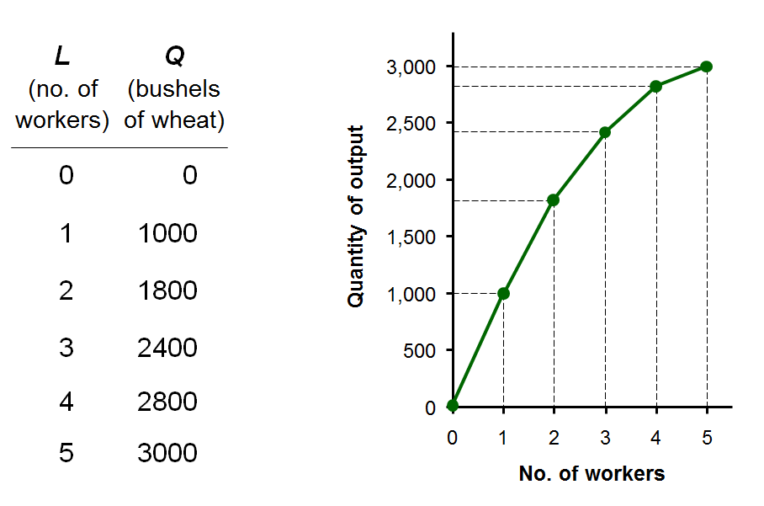

Marginal Product
- If Jack hires one more worker, his output rises by the marginal product of labour.
- The marginal product of any input is the increase in output arising from an additional unit of that input, holding all other inputs constant.
- Notation: ∆ (delta) = “change in…”
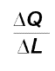
  - Examples: ∆Q = change in output, ∆L = change in labour
- Marginal product of labour (MPL) =
- Represents the incremental increase/decrease of total output

EXAMPLE 1: Total & Marginal Product
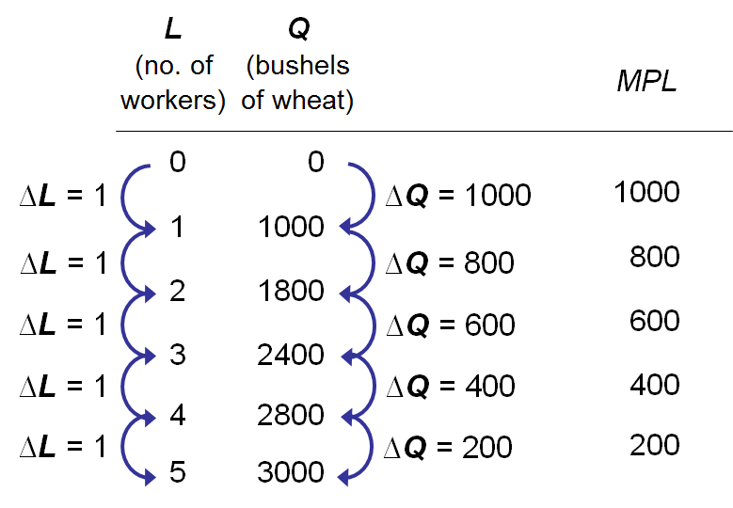

EXAMPLE 1: MPL = Slope of Production Function
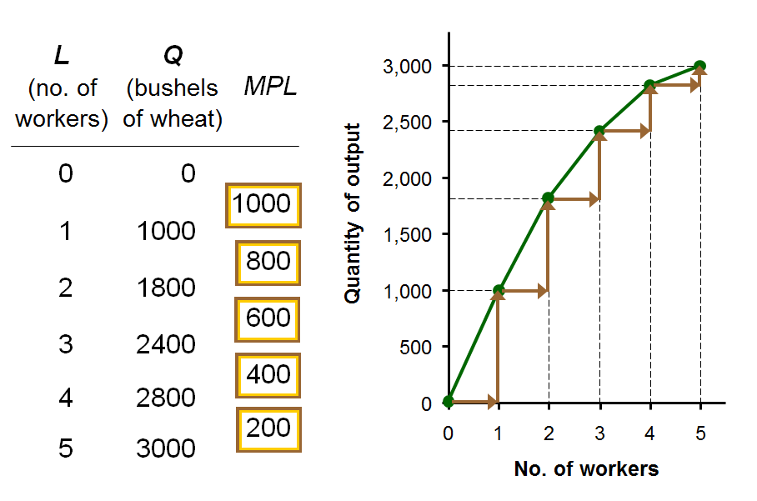

Why MPL Is Important
- Recall one of the Ten Principles:
Rational people think at the margin.
- When Farmer Jack hires an extra worker,
  - his costs rise by the wage he pays the worker
  - his output rises by MPL
- Comparing them, helps Jack decide whether he would benefit from hiring the worker.

Why MPL Diminishes
- Farmer Jack’s output rises by a smaller and smaller amount for each additional worker. Why?
- As Jack adds workers, the average worker has less land to work with and will be less productive.
- In general, MPL diminishes as L rises whether the fixed input is land or capital (equipment, machines, etc.).
- Diminishing marginal product: the marginal product of an input declines as the quantity of the input increases (other things equal)

EXAMPLE 1: Farmer Jack’s Costs
- Farmer Jack must pay $1000 per month for the land, regardless of how much wheat he grows.
- The market wage for a farm worker is $2000 per month.
- So Farmer Jack’s costs are related to how much wheat he produces….
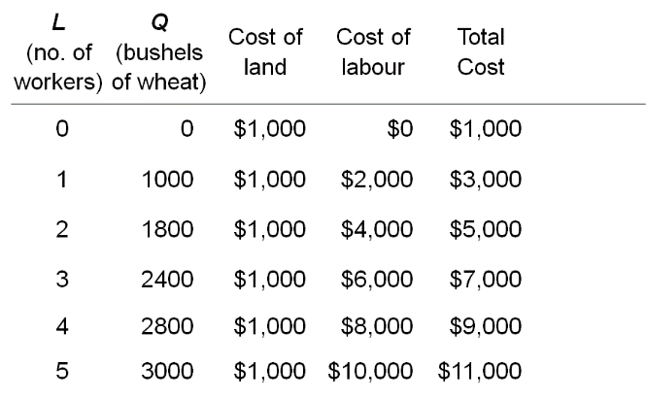

EXAMPLE 1: Farmer Jack’s Total Cost Curve
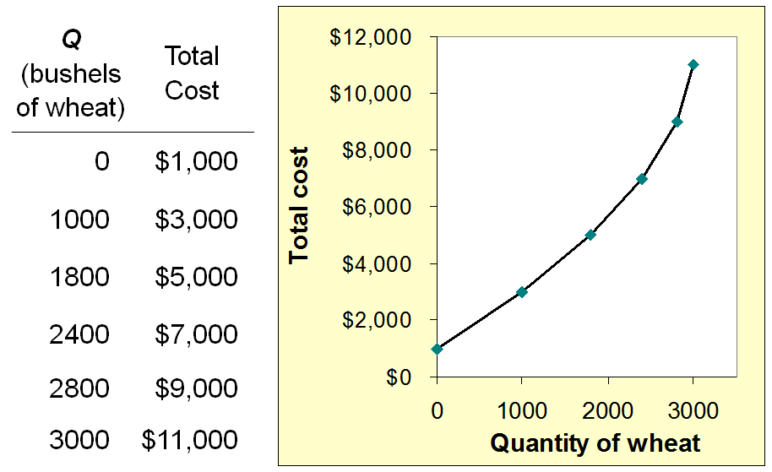

Marginal Cost
- Marginal Cost (MC) is the increase in Total Cost from producing one more unit: $MC=\frac{∆TC}{∆Q}$

EXAMPLE 1: Total and Marginal Cost
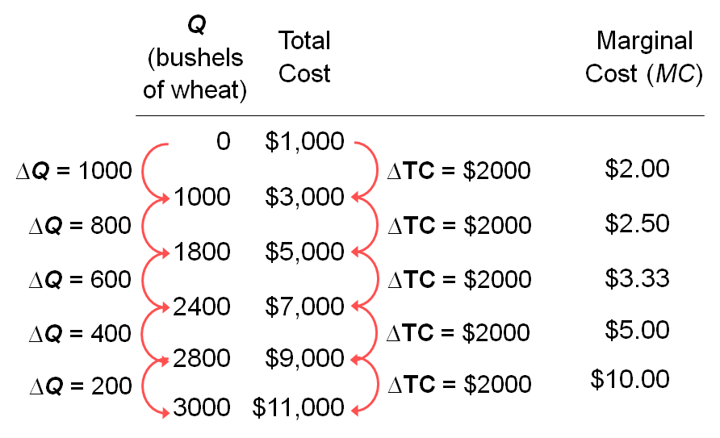

EXAMPLE 1: The Marginal Cost Curve
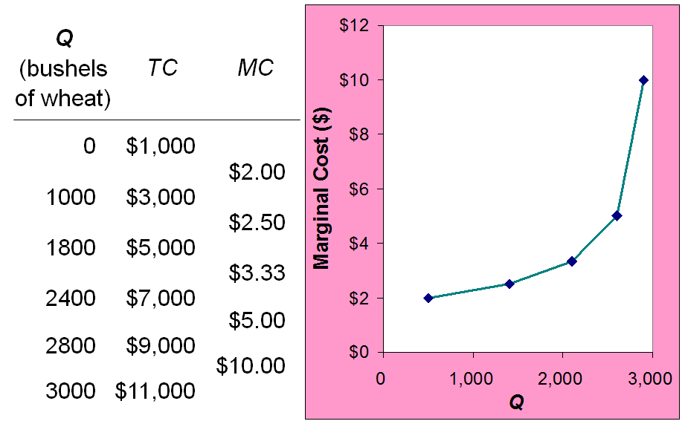

Why MC is Important
- Farmer Jack is rational and wants to maximize his profit. To increase profit, should he produce more or less wheat?
- To find the answer, Farmer Jack needs to “think at the margin.”
- If the cost of additional wheat (MC) is less than the revenue he would get from selling it, then Jack’s profits rise if he produces more.

Fixed and Variable Costs
- Fixed costs (FC) do not vary with the quantity of output produced.
  - For Farmer Jack, FC = $1000 for his land
  - Other examples: cost of equipment, loan payments, rent
- Variable costs (VC) vary with the quantity produced.
  - For Farmer Jack, VC = wages he pays workers
  - Other example: cost of materials
- Total cost (TC) = FC + VC

EXAMPLE 2
- Our second example is more general, applies to any type of firm producing any good with any types of inputs.
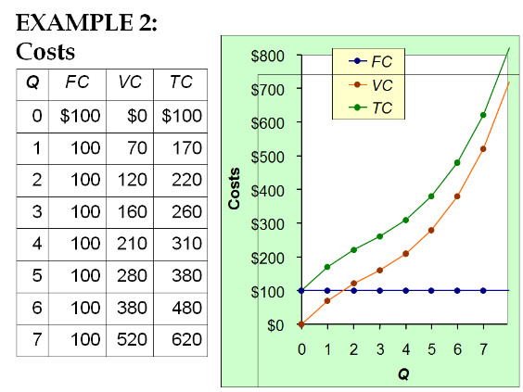

The TC curve is parallel to the VC curve but it is higher by the amount FC

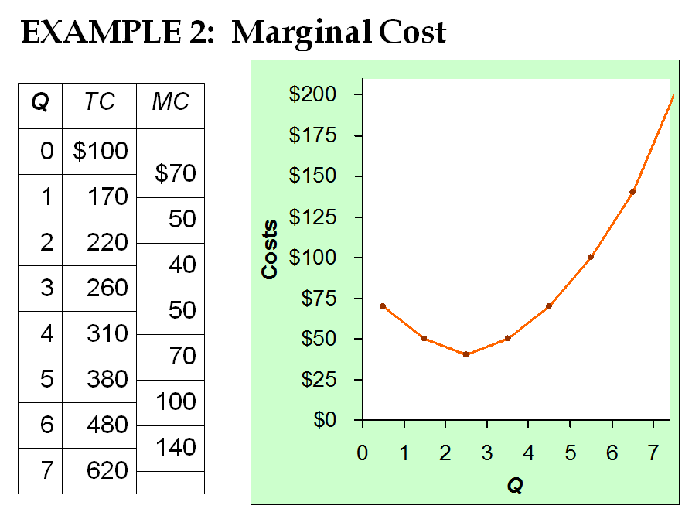

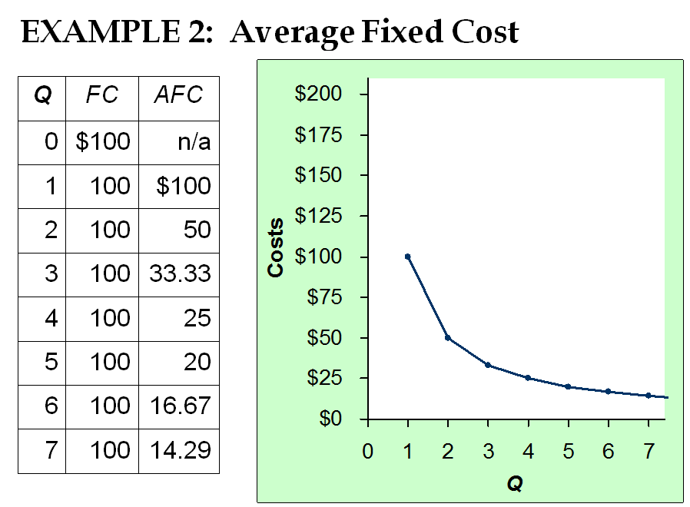
- Suppose FC = $1 million for a factory that produces cars.
- If the firm produces Q = 1 car, then AFC = $1 million.
- If the firm produces 2 cars, AFC = $500,000.
- If the firm produces 5 cars, AFC = $200,000.
- If the firm produces 100 cars, AFC = $10,000.
- The more cars produced at the factory, the smaller is the cost of the factory per car.

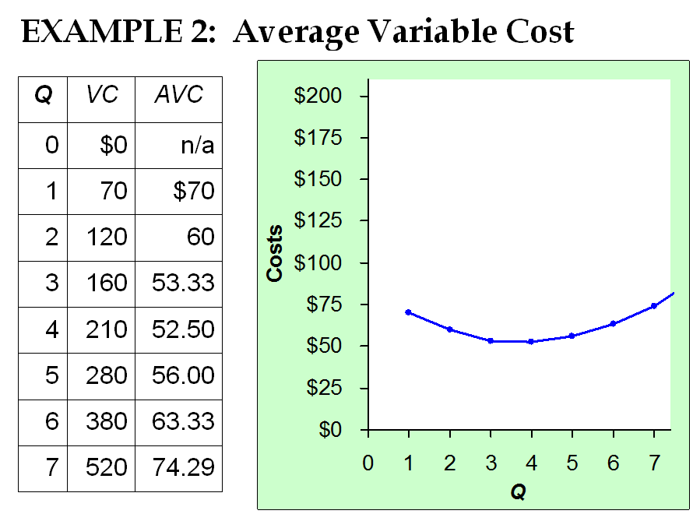

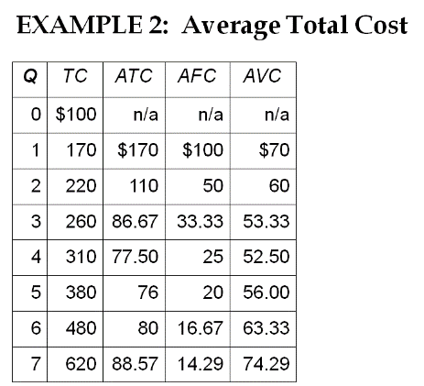
Average total cost (ATC): equals total cost divided by the quantity of output:
$ATC=TC/Q$
Also,
$$ATC=AFC+AVC$$
Note: ATC means cost per unit or unit cost

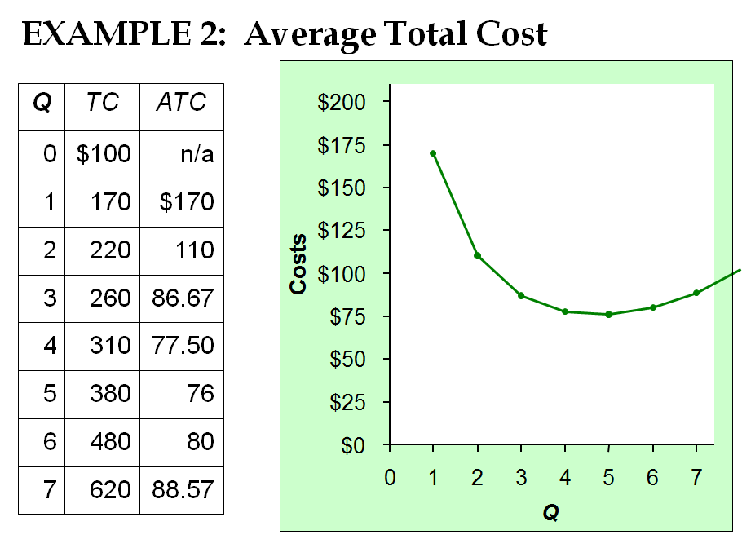

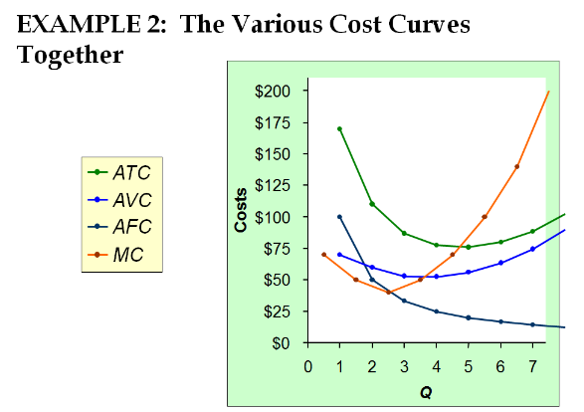

gfACTIVE LEARNING 3: Calculating costs
Q | VC | TC | AFC | AVC | ATC | MC
0 | $0 | $50 | N/A | N/6A | N/A | MC
 |  |  |  |  |  | $10
1 | 10 | 60 | $50 | $10 | $60 | $10
 |  |  |  |  |  | 20
2 | 30 | 80 | $25 | $15 | $40 | 20
 |  |  |  |  |  | 30
3 | 60 | 110 | 16.67 | 20 | 36.67 | 30
 |  |  |  |  |  | 40
4 | 100 | 150 | 12.5 | 25 | 37.50 | 40
 |  |  |  |  |  | 50
5 | 150 | 200 | 10 | 30 | 40 | 50
 |  |  |  |  |  | 60
6 | 210 | 260 | 8.33 | 35 | 43.33 | 60

Answers
First, deduce FC = $50 and use FC + VC = TC
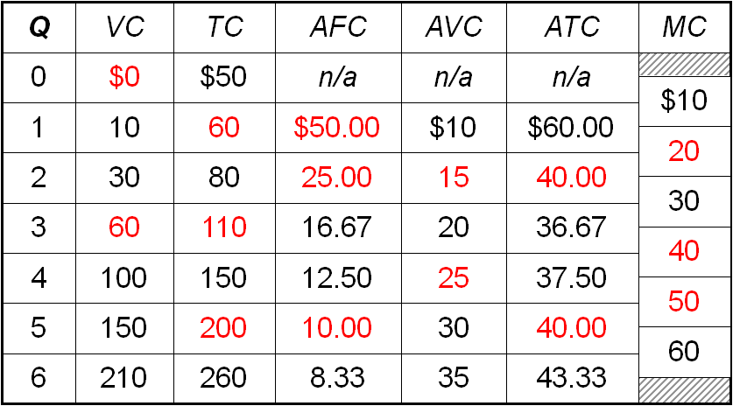

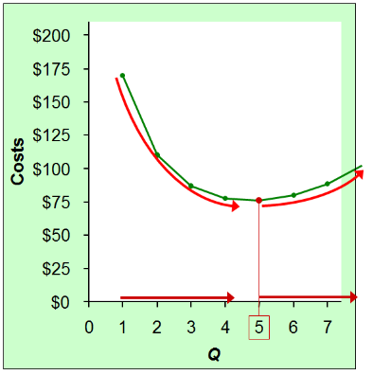
EXAMPLE 2: Why ATC is Usually U-Shaped

As Q rises:
Initially, falling AFC pulls ATC down
Eventually, rising AVC pulls ATC up.
Efficient scale: The quantity that minimises ATC
In this example, the efficient scale is Q=5, where ATC = $76.
At any Q below or above 5, ATC > $76.

EXAMPLE 2: ATC and MC
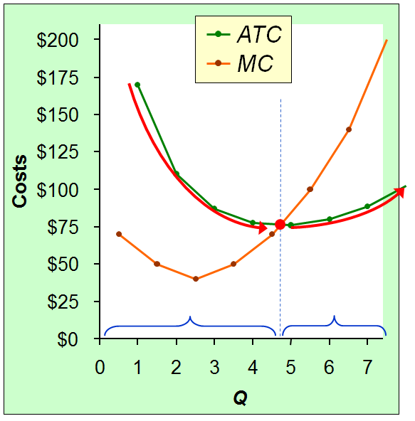
When MC < ATC, ATC is falling.
When MC > ATC, ATC is rising.
The MC curve crosses the ATC curve at the ATC curve’s minimum
Average cost is like your cumulative grade point average. Marginal cost is like the grade in your next course. If you grade in the next course is less than your CGPA, it will drop. It is higher, your CGPA would increase.
Ex. You run a pizza joint. You’re producing 100 pizzas per night, and your cost per pizza (ATC) is $3. The cost of producing one more pizza (MC) is $2. If you produce this pizza, what happens to ATC? ATC falls (albeit by a small amount). Instead, suppose the cost of producing one more pizza (MC) is $4. Then, producing this additional pizza causes ATC to rise.

Costs in the Short Run & Long Run
- Short run: Some inputs are fixed (e.g., factories, land). The costs of these inputs are FC.
- Long run: All inputs are variable (e.g., firms can build more factories, or sell existing ones).
- In the long run, ATC at any Q is cost per unit using the most efficient mix of inputs for that Q (e.g., the factory size with the lowest ATC).
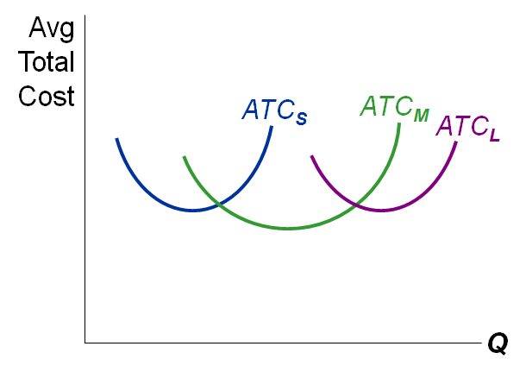
EXAMPLE 3: LRATC with 3 factory Sizes
Firm can choose 3 factory sizes S, M, L.
Each size has its own SRATC curve.
The firm can change to a different factory size in the long run, but nor in the short run.
Note: LRATC- Long Range Average Total Cost

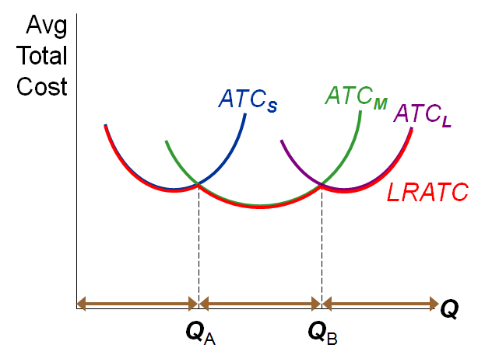
To produce less than Q_{A}, firm will choose size S in the long run.
To produce between Q_{A} and Q_{B}, firm will choose size M in the long run.
To produce more than Q_{B}, firm will choose size L in the long run.

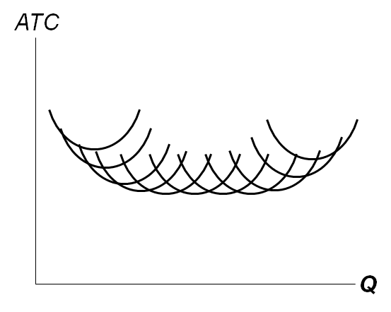
A Typical LRATC Curve
In the real world, factories come in many sizes, each with its own SRATC curve.
So a typical LRATC curve looks like this:

How ATC Changes as the Scale of Production Changes
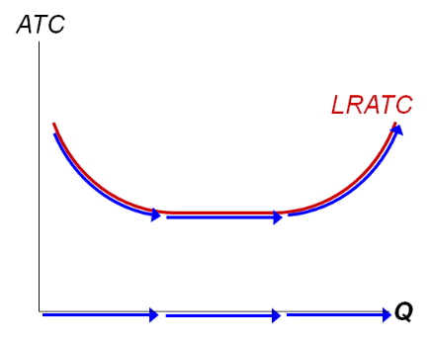
Economies of scale: ATC falls as Q increases.
Constant returns to scale: ATC stays the same as Q increases.
Diseconomies of scale: ATC rises as Q increases.

- Economies of scale occur when increasing production allows greater specialization: workers more efficient when focusing on a narrow task.
  - More common when Q is low.
- Diseconomies of scale are due to coordination problems in large organizations.
E.g., management becomes stretched, can’t control costs.
  - More common when Q is high.

CONCLUSION
- Costs are critically important to many business decisions, including production, pricing, and hiring.
- This chapter has introduced the various cost concepts.
- The following chapters will show how firms use these concepts to maximize profits in various market structures.

CHAPTER SUMMARY
- Implicit costs do not involve a cash outlay, yet are just as important as explicit costs to firms’ decisions.
- Accounting profit is revenue minus explicit costs. Economic profit is revenue minus total (explicit + implicit) costs.
- The production function shows the relationship between output and inputs.
- The marginal product of labour is the increase in output from a one-unit increase in labour, holding other inputs constant. The marginal products of other inputs are defined similarly.
- Marginal product usually diminishes as the input increases. Thus, as output rises, the production function becomes flatter, and the total cost curve becomes steeper.
- Variable costs vary with output; fixed costs do not.
- Marginal cost is the increase in total cost from an extra unit of production. The MC curve is usually upward-sloping.
- Average variable cost is variable cost divided by output.
- Average fixed cost is fixed cost divided by output. AFC always falls as output increases.
- Average total cost (sometimes called “cost per unit”) is total cost divided by the quantity of output. The ATC curve is usually U-shaped.
- The MC curve intersects the ATC curve at minimum average total cost. When MC < ATC, ATC falls as Q rises. When MC > ATC, ATC rises as Q rises.
- In the long run, all costs are variable.
- Economies of scale: ATC falls as Q rises. Diseconomies of scale: ATC rises as Q rises. Constant returns to scale: ATC remains constant as Q rises.

Chapter 14

Firms in Competitive Markets

Introduction: A Scenario
- Three years after graduating, you run your own business.
- You must decide how much to produce, what price to charge, how many workers to hire, etc.
- What factors should affect these decisions?
  - Your costs (studied in preceding chapter)
  - How much competition you face
- We begin by studying the behaviour of firms in perfectly competitive markets.

Characteristics of Perfect Competition
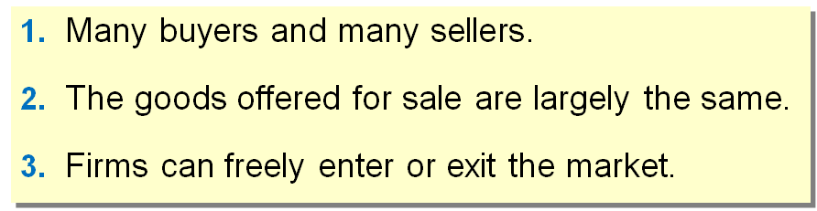
- Because of 1 & 2, each buyer and seller is a “price taker” – takes the price as given.
- “Firms can freely enter or exit the market” means there are no barriers or impediments to entry or exit. E.g., the government does not restrict the number of firms in the market.
- The third characteristic is very important.
  - In reality we know for some markets you have to get permission from the gov’t to be able sell goods/services in a market
- In reality, perfectly competitive markets are hard to find because market to don fit the exact characteristics of a competitive market. Some of example of markets that are close to being perfectly competitive include the stock market and the market for agricultural products like dairy products, maple syrup, wheat, rice, and corn.

The Revenue of Competitive Firm
- Total revenue (TR) : $TR=P×Q$
- Average revenue (AR): $AR=\frac{TR}{Q}=P$
  - Average revenue tells us how much a firm receives for a typical unit sold. Since average revenue never changes so therefore its equals the price of the Jug
  - i.e. for all firms, average revenue equals the price of the good
- Marginal revenue (MR): $MR=\frac{ΔTR}{ΔQ}$
  - The change in TR from selling one more unit.
  - i.e. for competitive firms, marginal revenue equals the price of the good
- Therefore $P=MR=AR$

ACTIVE LEARNING 1: Calculating TR, AR, MR
Q | P | TR | AR | MR
0 | $10 | n/a | n/a | MR
 |  |  |  | $10
1 | $10 | $10 | $10 | $10
 |  |  |  | $10
2 | $10 | $20 | $10 | $10
 |  |  |  | $10
3 | $10 | $30 | $10 | $10
 |  |  |  | $10
4 | $10 | $40 | $10 | $10
 |  |  |  | $10
5 | $10 | $50 | $10 | $10

Answers
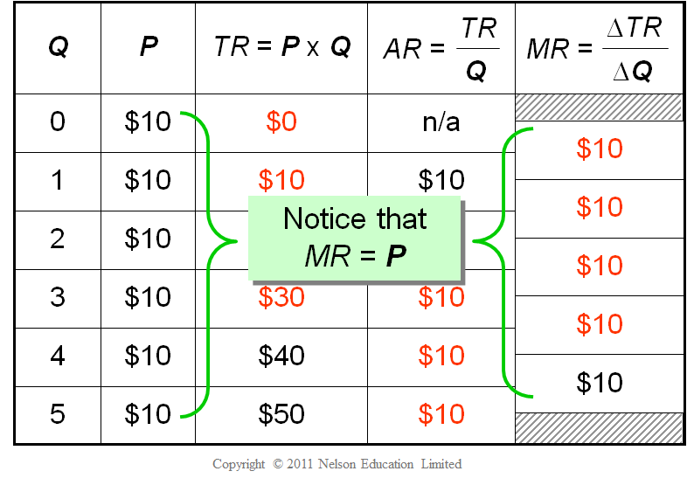

MR = P for a Competitive Firm
- A competitive firm can keep increasing its output without affecting the market price.
  - This is because the market price has already being dictated, as long as the firm continues to use the market price, it can increase its output as much as it wants.
- So, each one-unit increase in Q causes revenue to rise by P, i.e., MR = P.
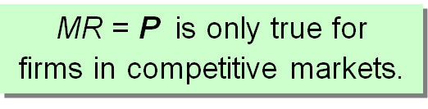

Profit Maximization
- The goal of a competitive firm is a maximise profits.
  - Profit equals total revenue minus total costs.
- What Q maximizes the firm’s profit?
- To find the answer, “think at the margin.”
- If increase Q by one unit, revenue rises by MR, cost rises by MC.
- If MR > MC, then increase Q to raise profit.
- If MR < MC, then reduce Q to raise profit.
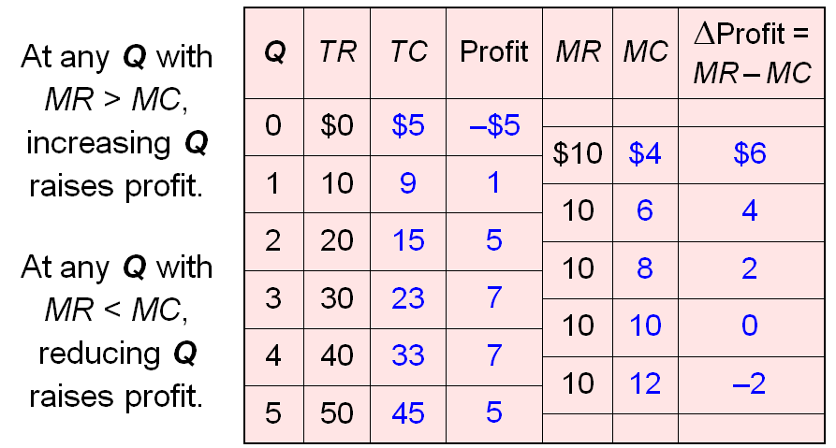

- It is profitable to increase production whenever MR > MC, such as at Q = 0, 1, or 2.
- It is profitable to reduce production whenever MC > MR, such as at Q = 5.

MC and the Firm’s Supply Decision

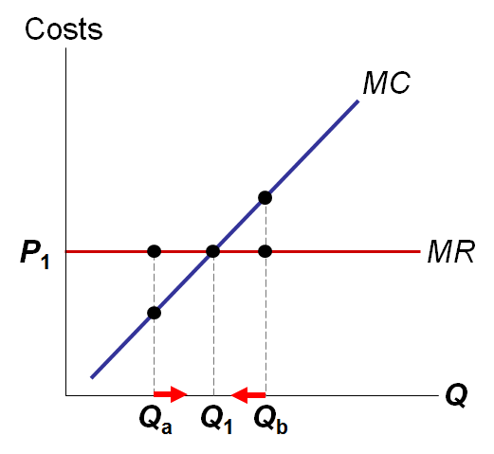
At Q_{a}, MC < MR.
So, increase Q to raise profit.
At Q_{b}, MC > MR.
So, reduce Q to raise profit.
At Q₁, MC = MR.
Changing Q would lower profit.
The intersection point of MC and MR corresponds to the profit maximisation point.
If the production level is less or greater than production at this point, the business is not being efficient.
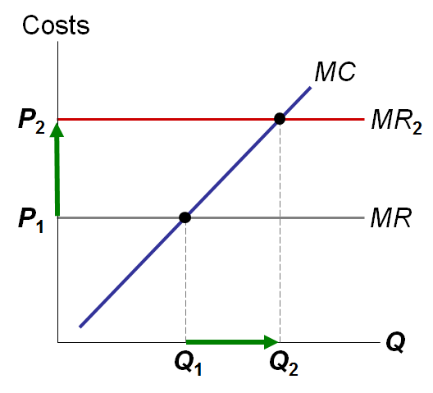
If price rises to P₂, then the profit-maximizing quantity rises to Q₂. The MC curve determines the firm’s Q at any price.
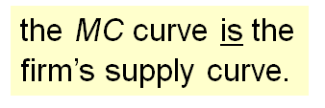
Hence,
In essence, because the firm’s marginal-costs curve determines the quantity if the good the firm is willing to supply at any price, it is the competitive firm’s supply curve
When the market price changes, market equilibrium changes as well.

Shutdown vs. Exit
- Shutdown: A short-run decision not to produce anything because of market conditions.
- Exit: A long-run decision to leave the market.
- A key difference:
  - If shut down in short run (SR), must still pay FC.
  - If exit in long run (LR), zero costs.

A Firm’s Short-run Decision to Shut Down
- When making short-run decision whether to shut down for a season, fixed costs of land is said to be sunk cost.
- Cost of shutting down: revenue loss = TR
- Benefit of shutting down: cost savings = VC
(firm must still pay FC)
  - If firm shuts down, it loses are revenue from sale of product but saves the variable cost of making the product but must still pay fixed costs.
- So, shut down if TR < VC
  - i.e. the firm shuts down if the revenue that I would get from producing is less than its variable costs of production
- Divide both sides by Q: $\frac{TR}{Q}<\frac{VC}{Q}$
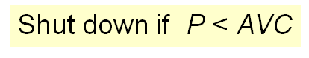
  - TR/Q is total revenue divided by quantity which is average revenue which equals price. Similarly, VC/Q is average variable costs AVC.
- So, firm’s decision rule is:
The shutdown rule: if the cost of shutting down is less than the benefit, the firm should shut down
- Therefore the price that coincides with the minimum point on the average-variable-cost curve is sometimes referred to as the shutdown price.

A Competitive Firm’s SR Supply Curve

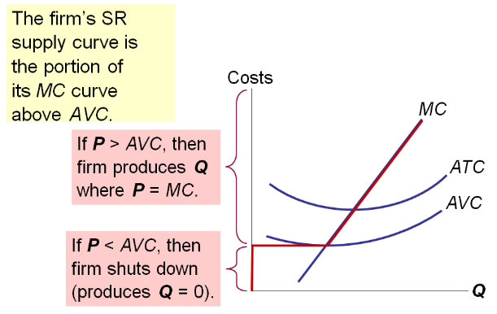

The Irrelevance of Sunk Costs
- Sunk cost: a cost that has already been committed and cannot be recovered
- Sunk costs should be irrelevant to decisions; you must pay them regardless of your choice.
- FC is a sunk cost: The firm must pay its fixed costs whether it produces or shuts down.
- So, FC should not matter in the decision to shut down.

A Firm’s Long-Run Decision to Exit
- Cost of exiting the market: revenue loss = TR
- Benefit of exiting the market: cost savings = TC
(zero FC in the long run)
- So, firm exits if TR < TC
  - i.e. the firm exists the market if the revenue it would get from producing is less that its total costs.
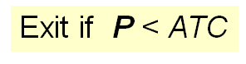
- Divide both sides by Q to write the firm’s decision rule as:
  - $\frac{TR}{Q}<\frac{TC}{Q}$, TR/Q us average revenue which equals the price P, and TC/Q is average total cost ATC.
- The decision rule for whether to exit a market: If the cost of exiting is greater than the benefit, the firm should exit.

A New Firm’s Decision to Enter Market
- In the long run, a new firm will enter the market if it is profitable to do so: if TR > TC.
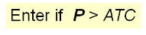
- Divide both sides by Q to express the firm’s entry decision as:
- Similarly, a prospective entrant compares the benefits of entering the market (TR) with the cost (TC), and enters if the benefits exceeds the costs

The Competitive Firm’s Supply Curve
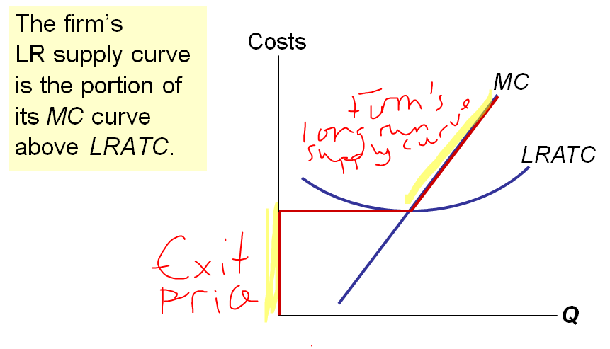

ACTIVE LEARNING 2: Identifying a firm’s profit
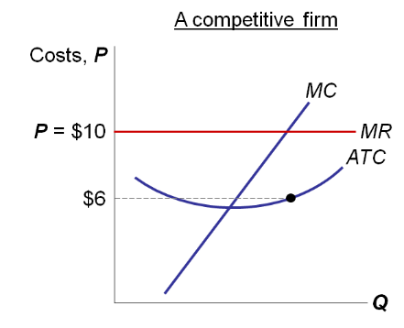

Determine this firm’s total profit.
Identify the area on the graph that represents the firm’s profit.

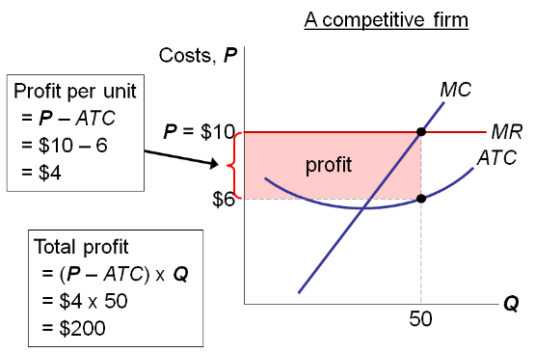
The height of the rectangle is P – ATC, profit per unit.
The width of the rectangle is Q, the number of units.
The area of the rectangle
= height x width
= (profit per unit) x (number of units)
= total profit.
Note: $Profit=TR-TC$
$$Profit=\left(\frac{TR}{Q}-\frac{TC}{Q}\right)×Q$$
$$Profit=\left(P-ATC\right)×Q$$

ACTIVE LEARNING 3: Identifying a firm’s loss
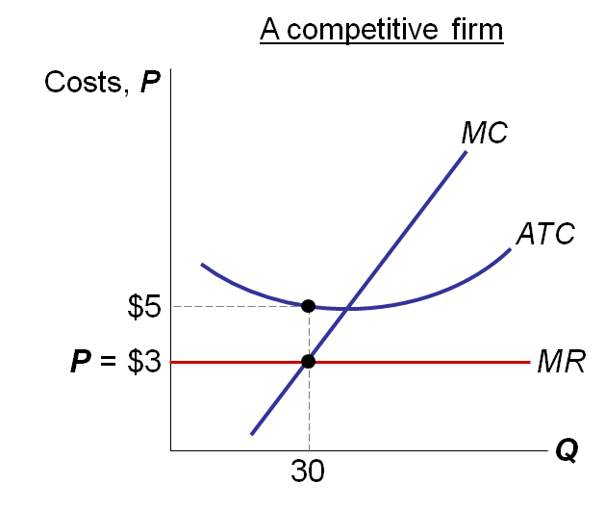
Determine this firm’s total loss, assuming AVC < $3.
Identify the area on the graph that represents
the firm’s loss.

Answers
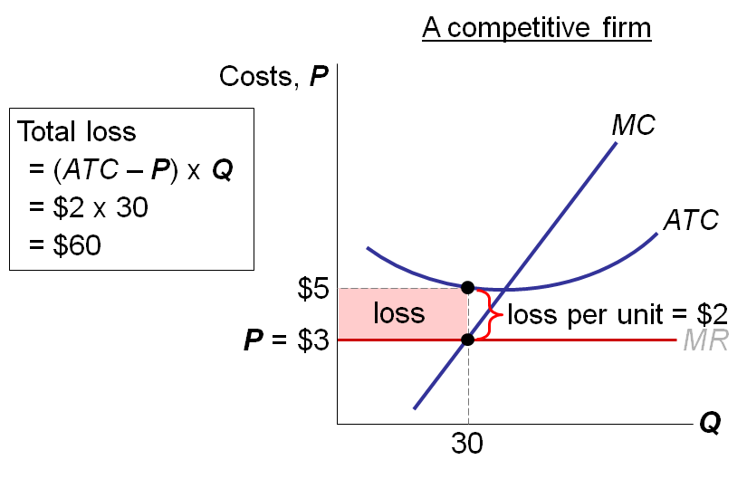
The height of the rectangle is ATC – P, loss per unit.
The width of the rectangle is Q, the number of units.
The area of the rectangle
= height x width
= (loss per unit) x (number of units)
= total loss.

Market Supply: Assumptions
- All existing firms and potential entrants have identical costs.
- Each firm’s costs do not change as other firms enter or exit the market.
- The number of firms in the market is
  - fixed in the short run (due to fixed costs)
  - variable in the long run (due to free entry and exit)
- In the real world, there are many markets in which assumptions (1) and (2) do not hold. We make them here for simplicity. Later in the chapter, we will see how our results change if we drop either of these assumptions.
- Assumption (3) is more reasonable: In the real world, it is much easier for firms to enter or exit in the long run than in the short run.

The SR Market Supply Curve
- As long as P ≥ AVC, each firm will produce its profit-maximizing quantity, where MR = MC.
- Recall from Chapter 4: At each price, the market quantity supplied is the sum of quantities supplied by all firms.
Example: 100 identical firms
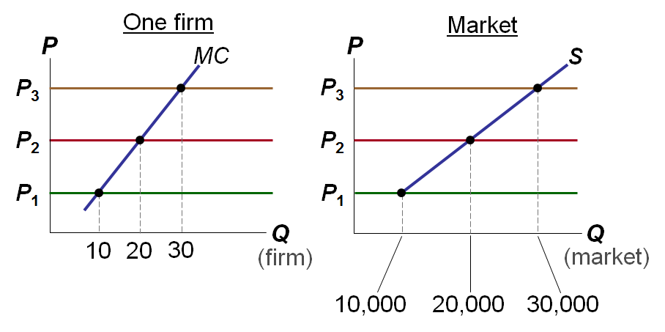
At each P, market Q^{s} = 1000 x (one firm’s Q^{s})
“Identical” means all firms have the same cost curves.
Note: P₁ is minimum AVC. At any price below P₁, each firm will shut down, and market quantity supplied will equal zero.
Hence, the market supply curve begins at price = P₁ and Q = 10,000.

Entry & Exit in the Long Run
- In the LR, the number of firms can change due to entry & exit.
- If existing firms earn positive economic profit,
  - New firms enter, SR market supply shifts right.
  - P falls, reducing profits and slowing entry.
- If existing firms incur losses,
  - Some firms exit, SR market supply shifts left.
  - P rises, reducing remaining firms’ losses.

The Zero-Profit Condition
- Long-run equilibrium: The process of entry or exit is complete – remaining firms earn zero economic profit.
- Zero economic profit occurs when P = ATC.
- Since firms produce where P = MR = MC, the zero-profit condition is P = MC = ATC.
- Recall that MC intersects ATC at minimum ATC.
- Hence, in the long run, P = minimum ATC.

Why Do Firms Stay in Business if Profit = 0?
- Recall, economic profit is revenue minus all costs – including implicit costs, like the opportunity cost of the owner’s time and money.
- In the zero-profit equilibrium,
  - firms earn enough revenue to cover these costs
  - accounting profit is positive

The LR Market Supply Curve
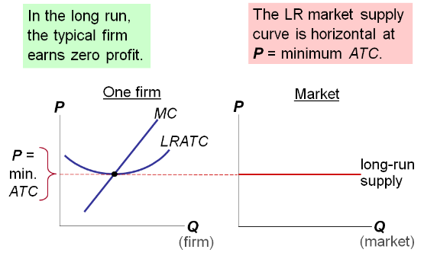

SR & LR Effects of an Increase in Demand
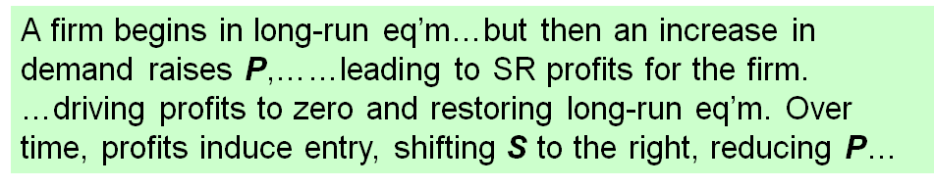
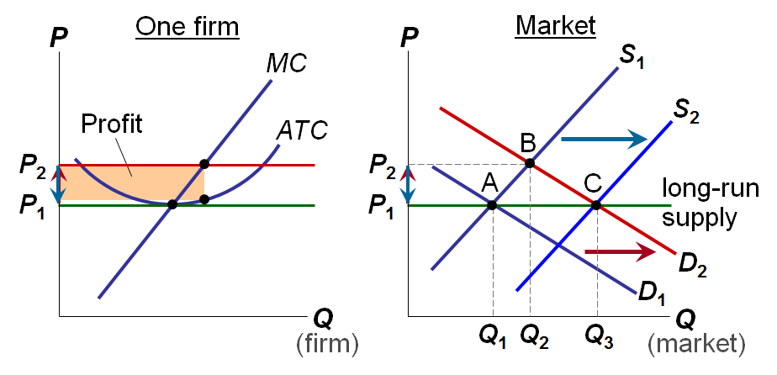

Why the LR Supply Curve Might Slope Upward
- The LR market supply curve is horizontal if:
  - all firms have identical costs, and
  - costs do not change as other firms enter or exit the market.
- If either of these assumptions is not true, then LR supply curve slopes upward.

- Firms Have Different Costs
  - As P rises, firms with lower costs enter the market before those with higher costs.
  - Further increases in P make it worthwhile for higher-cost firms to enter the market, which increases market quantity supplied.
  - Hence, LR market supply curve slopes upward.
  - At any P,
    - For the marginal firm, P = minimum ATC and profit = 0.
    - For lower-cost firms, profit > 0.

- Costs Rise as Firms Enter the Market
  - In some industries, the supply of a key input is limited (e.g., amount of land suitable for farming is fixed).
  - The entry of new firms increases demand for this input, causing its price to rise.
  - This increases all firms’ costs.
  - Hence, an increase in P is required to increase the market quantity supplied, so the supply curve is upward-sloping.

CONCLUSION: The Efficiency of a Competitive Market
- Profit-maximization: MC = MR
- Perfect competition: P = MR
- So, in the competitive eq’m: P = MC
- Recall, MC is cost of producing the marginal unit. P is value to buyers of the marginal unit.
- So, the competitive eq’m is efficient, maximizes total surplus.
- In the next chapter, monopoly: pricing & production decisions, deadweight loss, and regulation.

CHAPTER SUMMARY
- For a firm in a perfectly competitive market, price = marginal revenue = average revenue.
- If P > AVC, a firm maximizes profit by producing the quantity where MR = MC. If P < AVC, a firm will shut down in the short run.
- If P < ATC, a firm will exit in the long run.
- In the short run, entry is not possible, and an increase in demand increases firms’ profits.
- With free entry and exit, profits = 0 in the long run, and P = minimum ATC.

Chapter 15

Monopoly

Introduction
- A monopoly is a firm that is the sole seller of a product without close substitutes.
- In this chapter, we study monopoly and contrast it with perfect competition.
- The key difference:
A monopoly firm has market power, the ability to influence the market price of the product it sells. A competitive firm has no market power.
- In order for the firm to be considered a monopoly, the product it sells must have no close substitutes available from other firms.

Why Monopolies Arise
The main cause of monopolies is barriers to entry – other firms cannot enter the market.
Three sources of barriers to entry:
- A single firm owns a key resource.
  - E.g., DeBeers owns most of the world’s diamond mines
- The gov’t gives a single firm the exclusive right to produce the good
  - E.g., patents, copyright laws
- Natural monopoly: A single firm can produce the entire Q at lower cost than could several firms
  - E.g., 1000 homes need electricity
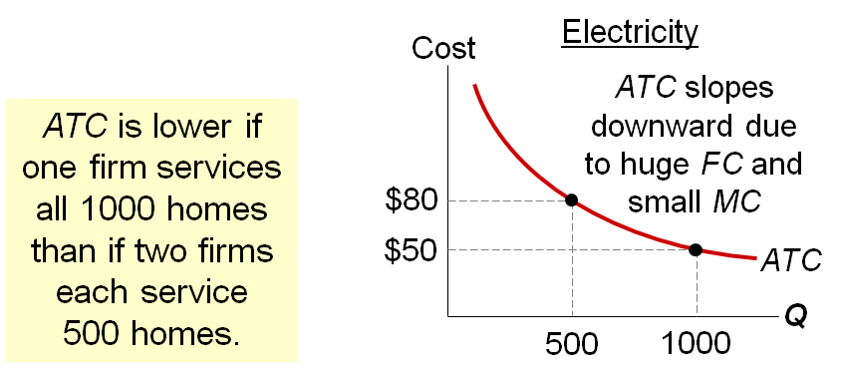
The horizontal axis of the graph measures number of homes provided electricity. The vertical axis measures the average total cost of providing electricity per home.

Monopoly vs. Competition: Demand Curves
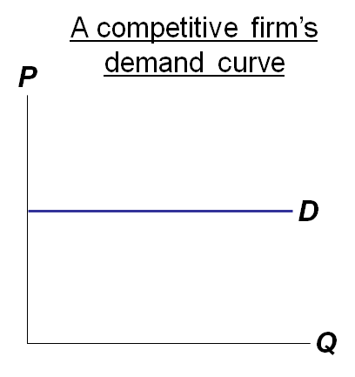
In a competitive market, the market demand curve slopes downward.
But the demand curve for any individual firm’s product is horizontal at the market price.
The firm can increase Q without lowering P, so MR = P for the competitive firm.
A competitive firm is a price-taker, can sell as much as it wants at the market price.
In effect, the competitive firm sells a product for which there are many perfect substitutes, so demand for its product is perfectly elastic; if it raises its price above the market price, demand for its product falls to zero.
The relationship between P and MR is what distinguishes a competitive firm from a monopoly firm, in terms of both firm behaviour and welfare implications.
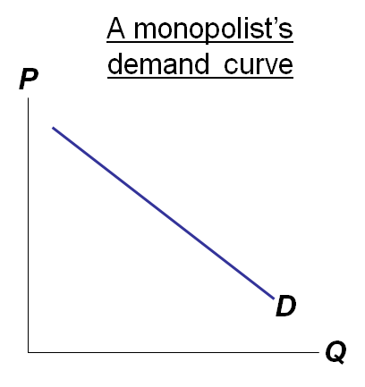
A monopolist is the only seller, so it faces the market demand curve.
To sell a larger Q, the firm must reduce P.
Thus, MR ≠ P.

ACTIVE LEARNING 1: A monopoly’s revenue

Q | P | TR | AR | MR
0 | $4.50 | N/A | N/A | MR
 |  |  |  | $4.00
1 | 4.00 | 4.00 | $4.00 | $4.00
 |  |  |  | 3.00
2 | 3.50 | 7.00 | $3.50 | 3.00
 |  |  |  | 2.00
3 | 3.00 | 9.00 | $3.00 | 2.00
 |  |  |  | 1.00
4 | 2.50 | 10.00 | 2.50 | 1.00
 |  |  |  | 0
5 | 2.00 | 10.00 | 2.00 | 0
 |  |  |  | -1
6 | 1.50 | 9.00 | 1.50 | -1
Common Grounds is the only seller of cappuccinos in town. The table shows the market demand for cappuccinos.
Fill in the missing spaces of the table. What is the relation between P and AR? Between P and MR?

Answers
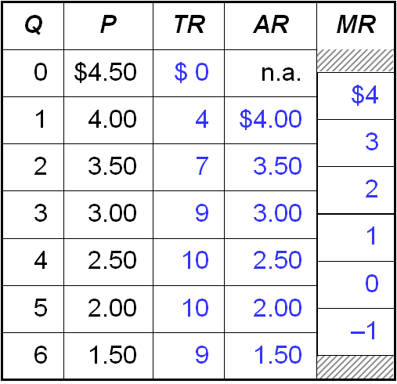
Here, P = AR, same as for a competitive firm.
Here, MR < P, whereas MR = P for a competitive firm.
When the AR column appears, note that AR = P at every quantity. This, of course, is a tautology.
When the MR column appears, note that MR is less than P. This is not as easy to see, because the MR numbers are offset from the rows of the table, just as if you were in an elevator stuck between two floors.
For example, in the range of output of Q=2 to Q=3, the price ranges from $3.50 to $3.00, but MR is only $2.

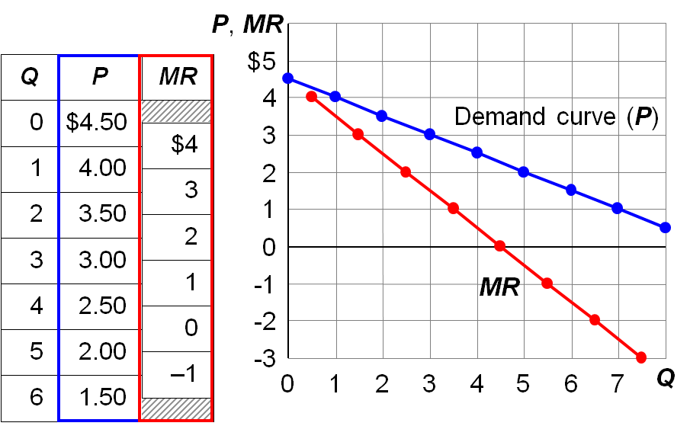
Common Grounds’ D and MR Curves

Note: The numbers in the tables are from the preceding exercise

Understanding the Monopolist’s MR
- Increasing Q has two effects on revenue:
  - Output effect: higher output raises revenue
  - Price effect: lower price reduces revenue
- To sell a larger Q, the monopolist must reduce the price on all the units it sells.
- Hence, MR < P
- MR could even be negative if the price effect exceeds the output effect (e.g., when Common Grounds increases Q from 5 to 6).
Note: a competitive firm has the output effect but not the price effect: the competitive firm does not need to reduce its price in order to sell a larger quantity, so, for the competitive firm, MR = P.

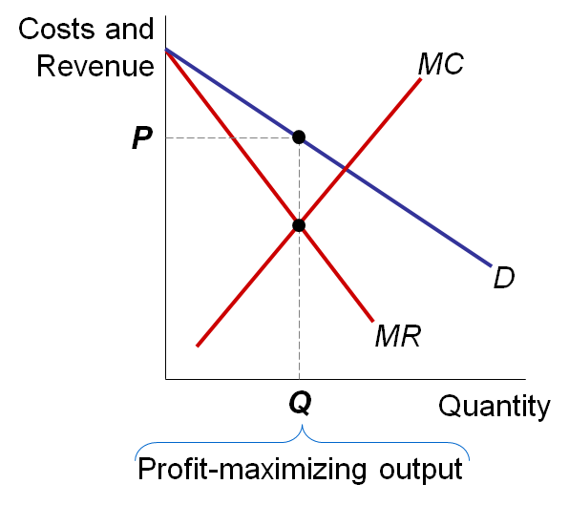
Profit-Maximization

- The profit-maximizing is where MR = MC.
- Find P from the demand curve at this Q.

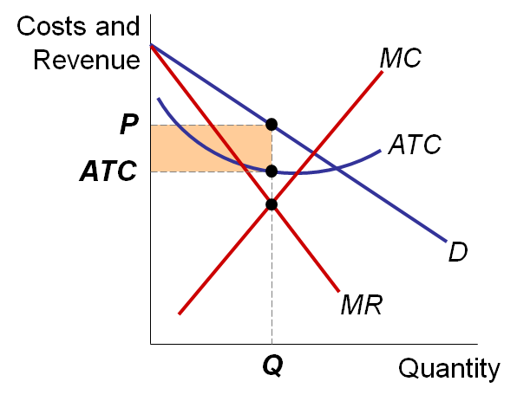
The Monopolist’s Profit

As with a competitive firm, the monopolist’s profit equals
(P – ATC) x Q

A Monopoly Does Not Have an S curve
A competitive firm
- takes P as given
- has a supply curve that shows how its Q depends on P.
A monopoly firm
- is a “price-maker,” not a “price-taker”
- Q does not depend on P; rather, Q and P are jointly determined by MC, MR, and the demand curve.
So there is no supply curve for monopoly.

CASE STUDY: Monopoly vs. Generic Drugs
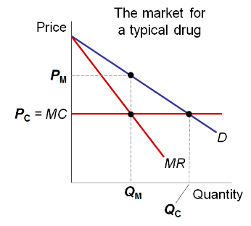
Patents on new drugs give a temporary monopoly to the seller.
When the patent expires, the market becomes competitive, generics appear.
Here, we assume constant marginal cost for simplicity.
P_{M} and Q_{M} denote the monopoly price and quantity, respectively.
P_{C} and Q_{C} denote the competitive price and quantity, respectively.

The Welfare Cost of Monopoly
- Recall: In a competitive market equilibrium,
P = MC and total surplus is maximized.
- In the monopoly eq’m, P > MR = MC
  - The value to buyers of an additional unit (P) exceeds the cost of the resources needed to produce that unit (MC).
  - The monopoly Q is too low – could increase total surplus with a larger Q.
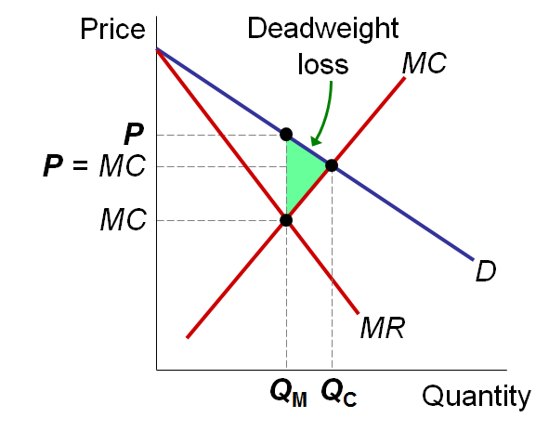
  - Thus, monopoly results in a deadweight loss.
Competitive eq’m:
quantity = Q_{C}
P = MC
total surplus is maximized
Monopoly eq’m:
quantity = Q_{M}
P > MC
deadweight loss
Monopoly changes the way the economic “pie” is divided: by charging higher prices, the monopoly gets more surplus and consumers get less surplus.
The analysis on this slide shows that the monopoly also reduces the size of the economic pie – by producing less than the socially efficient quantity and causing a deadweight loss.

Price Discrimination
- Discrimination: treating people differently based on some characteristic, e.g. race or gender.
- Price discrimination: selling the same good at different prices to different buyers.
- The characteristic used in price discrimination is willingness to pay (WTP):
  - A firm can increase profit by charging a higher price to buyers with higher WTP.
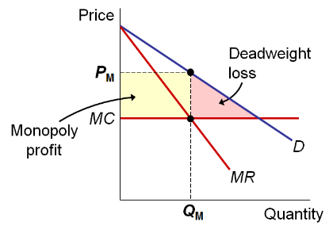
Perfect Price Discrimination vs. Single Price Monopoly
Here, the monopolist charges the same price (P_{M}) to all buyers.
A deadweight loss results.
Note: In order to keep this graph simple, we assume that marginal cost is constant
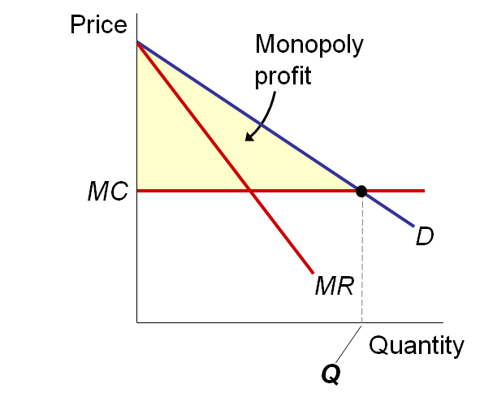
Here, the monopolist produces the competitive quantity, but charges each buyer his or her WTP.
This is called perfect price discrimination.
The monopolist captures all CS as profit. But there’s no DWL.
Here, there is no horizontal price line. The “price line”, if you will, is the demand curve:
At each Q, the height of the demand curve shows the marginal buyer’s willingness to pay, which is the price the monopolist charges that buyer under perfect price discrimination.

Price Discrimination in the Real World
- In the real world, perfect price discrimination is not possible:
  - No firm knows every buyer’s WTP
  - Buyers do not announce it to sellers
- So, firms divide customers into groups based on some observable trait that is likely related to WTP, such as age.

Examples of Price Discrimination
- Movie Tickets: Discounts for seniors, students, and people who can attends during weekday afternoons. They are all more likely to have lower WTP than people who pay full price on Friday night.
- Airline prices: Discounts for Saturday-night stayovers help distinguish business travelers, who usually have higher WTP, from more price-sensitive leisure travelers.
- Discount coupons: People how have time to clip and organise coupons are more likely to have lower income and lower WTP than others
- Need-based financial aid: Low income families have lower WTP for their children’s university education. Schools price-discriminate by offering need-based aid to low income families
- Quantity discounts: A buyer’s WTP often declines with additional units, so firms charge less per unit for large quantities than small ones
- Ex. A movie theater charges $4 for a small popcorn and $5 for a large ones that’s twice as big
    - Note: The firm is not charging different prices to different customers, but charging different prices to the same customer based on that customers’ declining willingness to pay for additional units.

Public Policy towards Monopolies
- Increasing competition with antitrust laws
  - Ban some anticompetitive practices, allow gov’t to break up monopolies.
    - E.g., Sherman Antitrust Act (1890), Clayton Act (1914)
- Regulation
  - Gov’t agencies set the monopolist’s price.
  - For natural monopolies, MC < ATC at all Q, so marginal cost pricing would result in losses.
  - If so, regulators might subsidize the monopolist or set P = ATC for zero economic profit.
- Public ownership
  - Example: U.S. Postal Service
  - Problem: Public ownership is usually less efficient since no profit motive to minimize costs
- Doing nothing
  - The foregoing policies all have drawbacks, so the best policy may be no policy.

CONCLUSION: The Prevalence of Monopoly
- In the real world, pure monopoly is rare.
- Yet, many firms have market power, due to:
  - selling a unique variety of a product
  - having a large market share and few significant competitors
- In many such cases, most of the results from this chapter apply, including:
  - markup of price over marginal cost
  - deadweight loss

CHAPTER SUMMARY
- A monopoly firm is the sole seller in its market. Monopolies arise due to barriers to entry, including: government-granted monopolies, the control of a key resource, or economies of scale over the entire range of output.
- A monopoly firm faces a downward-sloping demand curve for its product. As a result, it must reduce price to sell a larger quantity, which causes marginal revenue to fall below price.
- Monopoly firms maximize profits by producing the quantity where marginal revenue equals marginal cost. But since marginal revenue is less than price, the monopoly price will be greater than marginal cost, leading to a deadweight loss.
- Monopoly firms (and others with market power) try to raise their profits by charging higher prices to consumers with higher willingness to pay. This practice is called price discrimination.
- Policymakers may respond by regulating monopolies, using antitrust laws to promote competition, or by taking over the monopoly and running it. Due to problems with each of these options, the best option may be to take no action.

