Chapter 10

Externalities

Introduction
- One of the principles from Chapter 1:
Markets are usually a good way to organize economy activity.
In absence of market failures, the competitive market outcome is efficient, maximizes total surplus.
- One type of market failure: externality, the uncompensated impact of one person’s actions on the well-being of a bystander.
- Externalities can be negative or positive, depending on whether impact on bystander is adverse or beneficial.
- Self-interested buyers and sellers neglect the external costs or benefits of their actions,
so the market outcome is not efficient.
- Another principle from Chapter 1:
Governments can sometimes improve market outcomes.
In presence of externalities, public policy can improve efficiency.

Examples of Negative Externalities
- Air pollution from a factory
- The neighbour’s barking dog
- Late-night stereo blasting from the dorm room next to yours
- Noise pollution from construction projects
- Health risk to others from second-hand smoke
- Talking on cell phone while driving makes the roads less safe for others

Recap of Welfare Economics
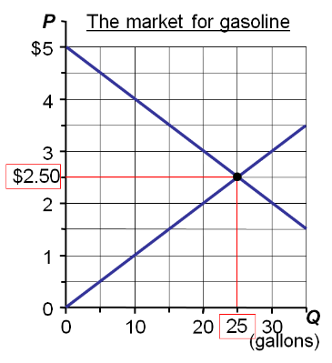
The market eq’m maximises consumer surplus
Supply curve private costs, the costs directly incurred by sellers
Demand curve shows private value, the value to buyers (the price they are willing to pay).
Note that maximizing consumer + producer surplus is NOT the same as maximizing TOTAL surplus when the trades impose external costs (or benefits) on bystanders.

Analysis of a Negative Externality
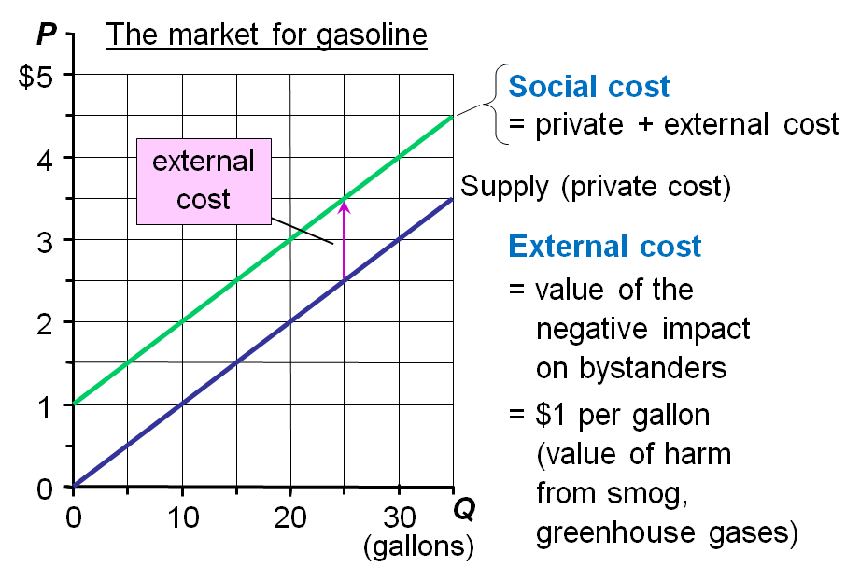
- Pollution is the cost of gasoline to the society
- This means that society has a different POV of the supply curve called the Social Supply curve
- If there is no Social supply curve it will result in:
  - More pollution being incurred
  - More resources needed to fix things like health problems
- With the Social Supply curve society tries to keep the supply of gasoline low
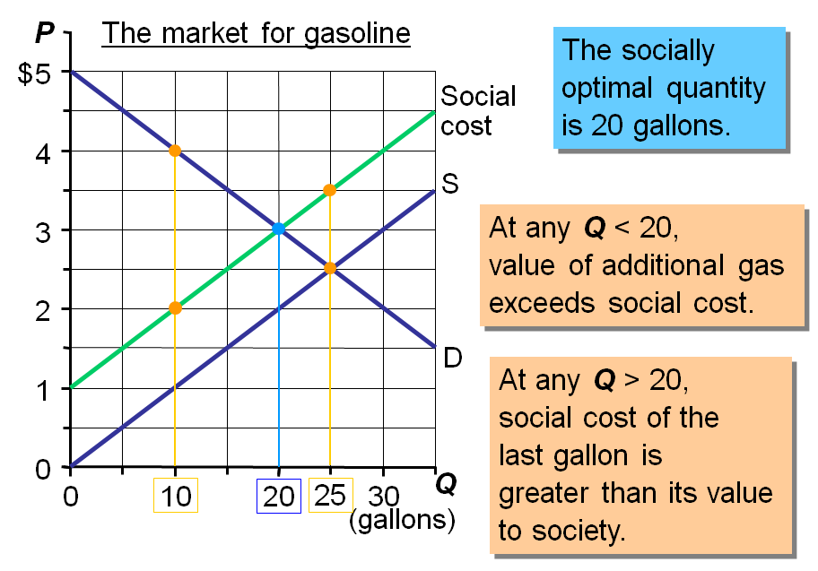
“At any Q < 20, value of additional gas exceeds social cost.”
For example, at Q = 10, the value to buyers of an additional gallon equals $4, while the social cost is only $2. Therefore, total surplus (society’s well-being) would increase with a larger quantity of gas.
“At any Q > 20, social cost of the last gallon is greater than its value.”
For example, at Q = 25 - the market equilibrium - the last gallon cost $3.50 (including the external cost) but the value of it to buyers was only $2.50. Hence, total surplus would be higher if Q were lower. Only at Q = 20 is society’s welfare maximized.
The blue point identifies the socially desirable outcome

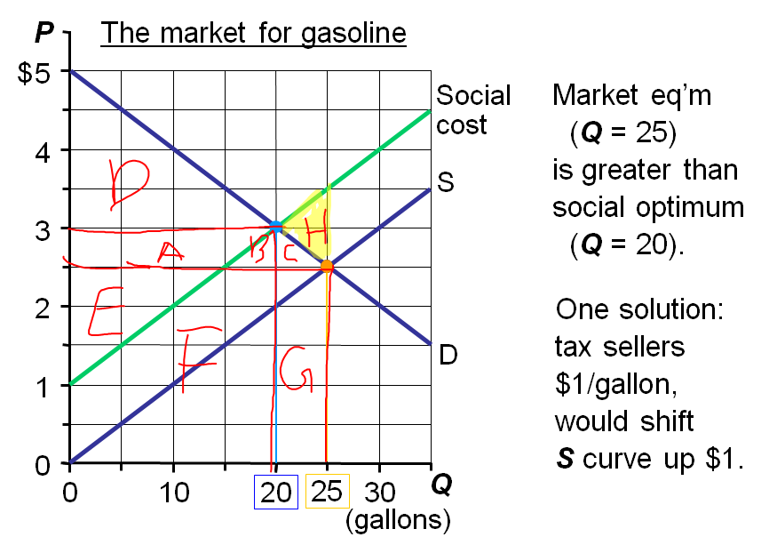
The cost to society of producing the quantity of aluminium sold is the area between the social-cost curve and the market quantity, Q_{MARKET}, area F + G + B + C + H. The amount received by the sellers is simply the quantity of aluminum sold Q_{MARKET}, times the market price of aluminium, P_{MARKET}, which is given by area E + F + G. So, producer surplus measured using the social cost to society, or (E + F + G) – (F + G + B + C + H), which simplifies to E – (B +C + H)
Socially Desirable allocation
Total Surplus = Consumer Surplus + Producer Surplus
$$TS=CS+PS$$
At Q^{M}
$$TS=\left(A+B+C+D\right)+[E-\left(B+C+H\right)]$$
$$TS=A+D+E-H$$
At Q^{O}
$$TS=D+\left(A+E\right)$$
$$TS=D+A+E$$
 | At Q_{MARKET} | At Q_{OPTIMUM} | Change
Consumer surplus | A + B + C + D | D | -(A + B + C)
Producer surplus | E – (B + C + H) | A + E | A + B + C + H
Total surplus | D + A + E – H | D + A + E | H

In cases of externalities, if you rely on market to allocate resources, deadweight loss will be created
If you choose the appropriate way to allocate resources, deadweight loss will not be created.

“Internalizing the Externality”
- Internalizing the externality: altering incentives so that people take account of the external effects of their actions
- In our example, the $1/gallon tax on sellers makes sellers’ costs = social costs.
- When market participants must pay social costs, market eq’m = social optimum.
- Chapter 6: tax incidence and the allocation of resources is the same whether a tax is imposed on buyers and sellers: (Imposing the tax on buyers would achieve the same outcome; market Q would equal optimal Q.)

Examples of Positive Externalities
- Being vaccinated against contagious diseases protects not only you, but people who visit the salad bar or produce section after you.
- R&D creates knowledge others can use.
- People going to college raise the population’s education level, which reduces crime and improves government.
  - Also better educated populations make more informed voting decision and elect higher quality lawmakers and leaders

Positive Externalities
- In the presence of a positive externality,
the social value of a good includes
  - private value – the direct value to buyers
  - external benefit – the value of the positive impact on bystanders
- The socially optimal Q maximizes welfare:
  - At any lower Q, the social value of additional units exceeds their cost.
  - At any higher Q, the cost of the last unit exceeds its social value.

Active Learning 1: Analysis of a positive externality
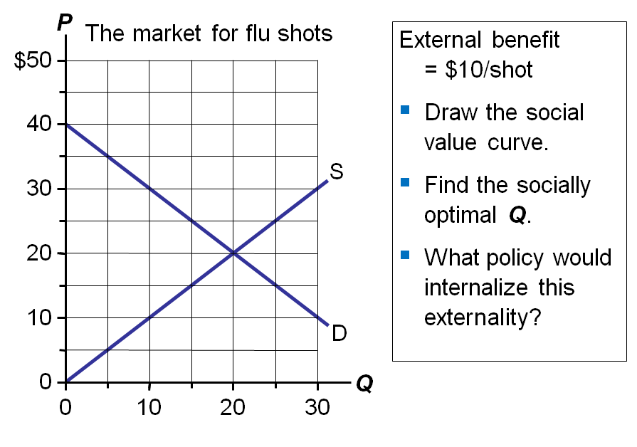
The Social value of giving out flu shots is not only for people who get the flu shots.
Direct effect: people who take flu shots have a lower. probability of getting the flu
Indirect effect: flu infections won’t spread as easily to the population of people who haven’t had flu shots.

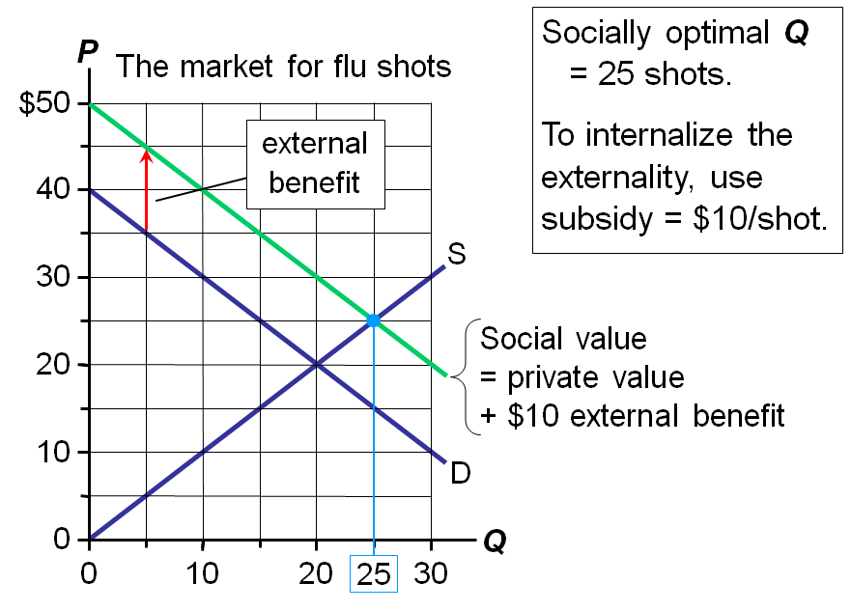

Effects of Externalities: Summary
- If negative externality
  - market quantity larger than socially desirable
- If positive externality
  - market quantity smaller than socially desirable
- To remedy the problem, “internalize the externality”
  - tax goods with negative externalities
  - subsidize goods with positive externalities

Public Policies towards Externalities
Two approaches:
- Command-and-control policies regulate behaviour directly.
  - Examples:
    - limits on quantity of pollution emitted
    - requirements that firms adopt a particular technology to reduce emissions
- Market-based policies provide incentives so that private decision-makers will choose to solve the problem on their own.
  - Examples:
    - corrective taxes and subsidies
    - tradable pollution permits

Corrective Taxes & Subsidies
- Corrective tax: a tax designed to induce private decision-makers to take account of the social costs that arise from a negative externality
- Also called Pigovian taxes after Arthur Pigou (1877-1959).
- The ideal corrective tax = external cost
- For activities with positive externalities, ideal corrective subsidy = external benefit
- Other taxes and subsidies distort incentives and move economy away from the social optimum.
- Corrective taxes & subsidies
  - align private incentives with society’s interests
  - make private decision-makers take into account the external costs and benefits of their actions
  - move economy toward a more efficient allocation of resources.

Corrective Taxes vs. Regulations
- Different firms have different costs of pollution abatement.
- Efficient outcome: Firms with the lowest abatement costs reduce pollution the most.
- A pollution tax is efficient:
  - Firms with low abatement costs will reduce pollution to reduce their tax burden.
  - Firms with high abatement costs have greater willingness to pay tax.
- In contrast, a regulation requiring all firms to reduce pollution by a specific amount not efficient.
- Pollution “abatement” simply means taking measures to cut pollution.
- Regarding the last bullet point: If all firms must reduce emissions by a fixed amount (or fixed percentage), then abatement is NOT concentrated among firms with the lowest abatement costs, and so the total cost of abatement will be higher.
Corrective taxes are better for the environment:
- The corrective tax gives firms incentive to continue reducing pollution as long as the cost of doing so is less than the tax.
- If a cleaner technology becomes available,
the tax gives firms an incentive to adopt it.
- In contrast, firms have no incentive for further reduction beyond the level specified in a regulation.

Example of a Corrective Tax: The Gas Tax
The gas tax targets three negative externalities:
- Congestion: The more you drive, the more you contribute to congestion.
- Accidents: Larger vehicles cause more damage in an accident.
- Pollution: Burning fossil fuels produces greenhouse gases.

Active Learning 2
- Regulating lower SO₂ emissions
- Acme and US Electric run coal-burning power plants. Each emits 40 tons of sulfur dioxide per month, total emissions = 80 tons/month.
- Goal: Reduce SO₂ emissions 25%, to 60 tons/month
- Cost of reducing emissions: $100/ton for Acme, $200/ton for USE
- Policy option 1: Regulation
Every firm must cut its emissions 25% (10 tons).
- Your task: Compute the cost to each firm and total cost of achieving goal using this policy.
Answers
- Each firm must reduce emissions by 10 tons.
- Cost of reducing emissions: $100/ton for Acme, $200/ton for USE.
- Compute cost of achieving goal with this policy:
- Cost to Acme: (10 tons) x ($100/ton) = $1000
- Cost to USE: (10 tons) x ($200/ton) = $2000
- Total cost of achieving goal = $3000

- Tradable pollution permits
- Initially, Acme and USE each emit 40 tons SO₂/month.
- Goal: reduce SO₂ emissions to 60 tons/month total.
Policy option 2: Tradable pollution permits
- Issue 60 permits, each allows one ton SO₂ emissions. Give 30 permits to each firm.
Establish market for trading permits.
- Each firm may use all its permits to emit 30 tons,
may emit < 30 tons and sell leftover permits,
or may purchase extra permits to emit > 30 tons.
- Your task: Compute cost of achieving goal if Acme
uses 20 permits and sells 10 to USE for $150 each.
Answers
- Goal: reduce emissions from 80 to 60 tons
- Cost of reducing emissions: $100/ton for Acme, $200/ton for USE.
- Compute cost of achieving goal:
- Acme
  - sells 10 permits to USE for $150 each, gets $1500
  - uses 20 permits, emits 20 tons SO₂
  - spends $2000 to reduce emissions by 20 tons
  - net cost to Acme: $2000 - $1500 = $500
  - Goal: reduce emissions from 80 to 60 tons
  - Cost of reducing emissions: $100/ton for Acme, $200/ton for USE.
- USE
  - buys 10 permits from Acme, spends $1500
  - uses these 10 plus original 30 permits, emits 40 tons
  - spends nothing on abatement
  - net cost to USE = $1500
- Total cost of achieving goal = $500 + $1500 = $2000
- Using tradable permits, goal is achieved at lower total cost and lower cost to each firm than using regulation.

Tradable Pollution Permits
- A tradable pollution permits system reduces pollution at lower cost than regulation.
  - Firms with low cost of reducing pollution do so and sell their unused permits.
  - Firms with high cost of reducing pollution buy permits.
- Result: Pollution reduction is concentrated among those firms with lowest costs.

Corrective Taxes vs. Tradable Pollution Permits
- Like most demand curves, firms’ demand for the ability to pollute is a downward-sloping function of the “price” of polluting.
  - A corrective tax raises this price and thus reduces the quantity of pollution firms demand.
  - A tradable permits system restricts the supply of pollution rights, has the same effect as the tax.
- When policymakers do not know the position of this demand curve, the permits system achieves pollution reduction targets more precisely.
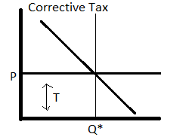
Government gives a set price to be for pollution units and an equilibrium quantity is set through this price.

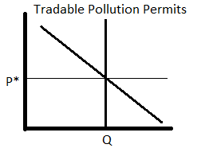

Government sets limit to quantity allowed and market chooses equilibrium price.

These two government regulations in theory may work but in reality it is difficult to measure the size of external costs

Objections to the Economic Analysis of Pollution
- Some politicians, many environmentalists argue that no one should be able to “buy” the right to pollute, cannot put a price on the environment.
- However, people face tradeoffs. The value of clean air & water must be compared to their cost.
- The market-based approach reduces the cost of environmental protection, so it should increase the public’s demand for a clean environment.

Private Solutions to Externalities
Types of private solutions:
- Moral codes and social sanctions
  - ,e.g., the “Golden Rule” taught to most children say do unto others as you have them do unto you. In economic terms, it tells us to internalize externalities
  - People don’t litter even though littering laws aren’t vigorously enforced
- Charities, e.g., the Sierra Club
  - E.g. Greenpeace a non-profit who gets its funds from private donations goal is to protect the environment.
  - Colleges and universities receive gifts from alumni, corporations, and foundations in part because education has positive externalities to society
- Contracts between market participants and the affected bystanders
- The Coase theorem: If private parties can bargain over the allocation of resources without cost, they can solve the externalities problem on their own.
  - This theorem is based on two assumptions:
    - There is not external costs; i.e. negotiation between market participants requires no extra costs.
    - Damages are accessible and measurable.
- According the Coase theorem, the initial distribution of rights does not matter for the market’s ability to reach the efficient outcome but it determined the distribution of economic well-being.
The Coase theorem says that private economic actors can solve the problem of externalities among themselves. Whenever the initial distribution of rights and interested parties can always reach a bargain in which everyone is better off and the outcome is efficient.

The Coase Theorem: An Example
- Dick owns a dog named Spot.
- Negative externality: Spot’s barking disturbs Jane, Dick’s neighbor.
- The socially efficient outcome maximizes Dick’s + Jane’s well-being.
  - If Dick values having Spot more than Jane values peace & quiet, the dog should stay.
- Coase theorem: The private market will reach the efficient outcome on its own…

The Coase Theorem: An Example
- CASE 1:
  - Dick has the right to keep Spot.
  - Benefit to Dick of having Spot = $500
  - Cost to Jane of Spot’s barking = $800
- Socially efficient outcome: Spot goes bye-bye.
- Private outcome: Jane pays Dick $600 to get rid of Spot, both Jane and Dick are better off.
- Private outcome = efficient outcome.
- CASE 2:
- Dick has the right to keep Spot.
- Benefit to Dick of having Spot = $1000
- Cost to Jane of Spot’s barking = $800
- Socially efficient outcome: See Spot stay.
- Private outcome:
- Jane not willing to pay more than $800,
- Dick not willing to accept less than $1000, so Spot stays.
- Private outcome = efficient outcome.
- CASE 3:
  - Jane has the legal right to peace & quiet.
  - Benefit to Dick of having Spot = $800
  - Cost to Jane of Spot’s barking = $500
- Socially efficient outcome: Dick keeps Spot.
- Private outcome: Dick pays Jane $600 to put up with Spot’s barking.
- Private outcome = efficient outcome.
The private market achieve the efficient outcome regardless of the initial distribution of rights

Active Learning 3: Applying Coase
Collective, the 1000 residents of Green Valley value swimming in the Blue Lake at $100,00.
A nearby factory pollutes the lake water, and would have to pay $50,000 for non-polluting equipment.
- Describe the Coase-like private solutions
- Can you think of any reasons why this solution might not work in the real world
A good Coasian solution would be for each of the 1000 residents to chip in $75, so the town can offer $75,000 to the factory to stop polluting.

Why Private Solutions Do Not Always Work
- Transaction costs: The costs parties incur in the process of agreeing to and following through on a bargain.
  - Ex. Suppose lawyers charge $60,000 to represent the two parties and draw up a contract that is enforceable in a court. Then it will be impossible for both parties to come to a mutually beneficial agreement, and the factory will continue polluting the lake.
These costs may make it impossible to reach a mutually beneficial agreement.
- Stubbornness: Even if a beneficial agreement is possible, each party may hold out for a better deal.
  - Suppose the town offers $55,000 to the factory. The factory would be better off taking this offer than nothing at all, but the factory may counter with a $95,000 price. Both parties hold out in hopes that the other will cede, but neither does. The factory keeps polluting, and the residents of Green Valley continue to be denied the joy of swimming in the lake.
- Coordination problems: If # of parties is very large, coordinating them may be costly, difficult, or impossible.
  - Getting all 1000 residents to agree to a specific offer will be difficult. Moreover, each resident has an incentive to free-ride off his neighbors.

CHAPTER SUMMARY
- An externality occurs when a market transaction affects a third party. If the transaction yields negative externalities (e.g., pollution), the market quantity exceeds the socially optimal quantity. If the externality is positive (e.g., technology spillovers), the market quantity falls short of the social optimum.
- Sometimes, people can solve externalities on their own. The Coase theorem states that the private market can reach the socially optimal allocation of resources as long as people can bargain without cost. In practice, bargaining is often costly or difficult, and the Coase theorem does not apply.
- The government can attempt to remedy the problem. It can internalize the externality using corrective taxes. It can issue permits to polluters and establish a market where permits can be traded. Such policies often protect the environment at a lower cost to society than direct regulation.

Chapter 11

Public Goods and Common Resources

Introduction
- We consume many goods without paying: parks, national defense, clean air & water.
- When goods have no prices, the market forces that normally allocate resources are absent.
- The private market may fail to provide the socially efficient quantity of such goods.
- One of the Ten Principles from Chapter 1:
Governments can sometimes improve market outcomes.

Important Characteristics of Goods
- A good is excludable if a person can be prevented from using it.
  - Excludable: fish tacos, wireless internet access
  - Not excludable: FM radio signals, national defense
- A good is rival in consumption if one person’s use of it diminishes others’ use.
  - Rival: fish tacos
  - Not rival: An MP3 file

The Different Kinds of Goods
- Private goods: excludable, rival in consumption
  - Example: food
- Public goods: not excludable, not rival
  - i.e. people cannot be prevented from using a public good, and one person’s use of a public good does not reduce another person’s ability to use it.
    - Example: national defense
- Common resources: rival but not excludable
  - i.e. people cannot be prevented from using the good but a person’s use of the good will reduce another person’s ability to use it.
    - Example: fish in the ocean
- Natural monopolies: excludable but not rival
  - i.e. people can be prevented from using the good without paying but there the benefit of excluding people is small
    - Example: cable TV
- E.g. food is a private good because:
  - it is excludable: you cannot have any unless you buy it
  - it is rival in consumption: “if you eat that fish taco, I won’t be able to eat it”.

Rival?
Excludable? |  | Yes | No
Excludable? | Yes | Private Goods  - Ice-cream cones  - Clothing  - Congested toll roads | Natural Monopolies  - Fire Protection  - Cable TV  - Uncongested toll roads
Excludable? | No | Common Resources  - Fish in the ocean  - The environment  - Congested non-toll roads | Public Goods  - Tornado sirens  - National Defence  - Uncongested non-toll roads

ACTIVE LEARNING 1: Categorizing roads
- A road is which of the four kinds of goods?
- Hint: The answer depends on whether the road is congested or not, and whether it’s a toll road or not. Consider the different cases.
Answers
- Rival in consumption? Only if congested.
- Excludable? Only if a toll road.
Four possibilities:
- Uncongested non-toll road: public good
- Uncongested toll road: natural monopoly
- Congested non-toll road: common resource
- Congested toll road: private good

The Different Kinds of Goods cont.
- This chapter focuses on public goods and common resources.
- For both, externalities arise because something of value has no price attached to it.
- So, private decisions about consumption and production can lead to an inefficient outcome.
- Public policy can potentially raise economic well-being.
- When you have a negative externality, market tends to oversupply and people tend to over-consume the externality.
Negative externality: decision made by market will not result in the most efficient
- Overutilization of limited resources.

Public Goods
- Public goods are difficult for private markets to provide because of the free-rider problem.
- Normally in a market to consume a good you must pay the price. When the good is difficult to exclude, people from that market do not pay and they are able to get a free ride
- Free rider: a person who receives the benefit of a good but avoids paying for it
  - If good is not excludable, people have incentive to be free riders, because firms cannot prevent non-payers from consuming the good.
- Result: The good is not produced, even if buyers collectively value the good higher than the cost of providing it.
  - i.e. no economic incentive to produce the good/service
    - ex. Snow removal, fireworks display, street lights
- If the benefit of a public good exceeds the cost of providing it, gov’t should provide the good and pay for it with a tax on people who benefit.
- Problem: Measuring the benefit is usually difficult.
- Cost-benefit analysis: a study that compares the costs and benefits of providing a public good
  - When making decision on whether or not to go with a public project a cost benefit analysis must first be first considered.
- Cost-benefit analyses are imprecise, so the efficient provision of public goods is more difficult than that of private goods.

Some Important Public Goods
- National defense
  - It is impossible to prevent any single person from enjoying the benefit of national defense and when one person enjoy the benefit if national defense, it doesn’t reduce the benefit of anyone else.
- Knowledge created through basic research
  - There is a difference between general knowledge and specific, technological knowledge.
  - Specific, technological knowledge like invention of a better battery can be patented and used a private good. On the other hand a new mathematical theorem cannot be patented.
- Fighting poverty
- The provision of these goods are very important but it is hard to estimate the benefit of these goods. Gov’t must first justify why these goods bring benefit.
  - i.e. if the benefit > cost, especially when there is a budget increase for these goods.

Common Resources
- Like public goods, common resources are not excludable.
  - Cannot prevent free riders from using
  - Little incentive for firms to provide
  - Role for gov’t: seeing that they are provided
- Additional problem with common resources: rival in consumption
  - i.e. because you cannot prevent people from using it and people neglect the negative externality of their use, the result is excessive use which leads to a the common resource diminishing.
  - Each person’s use reduces others’ ability to use
  - Role for gov’t: ensuring they are not overused

The Tragedy if the Commons
- A parable that illustrates why common resources get used more than is socially desirable.
- Setting: a medieval town where sheep graze on common land.
- As the population grows, the # of sheep grows.
- The amount of land is fixed, the grass begins to disappear from overgrazing.
- The private incentives (using the land for free) outweigh the social incentives (using it carefully).
- Result: People can no longer raise sheep.
- The tragedy is due to an externality: Allowing one’s flock to graze on the common land reduces its quality for other families.
- People neglect this external cost, resulting in overuse of the land.

ACTIVE LEARNING 2: Policy options for common resources
- What could the townspeople (or their government) have done to prevent the tragedy?
- Try to think of two or three options.
Answers
- Impose a corrective tax on the use of the land to “internalize the externality.”
- Regulate use of the land (the “command-and-control” approach).
- Auction off permits allowing use of the land.
- Divide the land, sell lots to individual families; each family will have incentive not to overgraze its own land.

Policy Options to Prevent Overconsumption of Common Resources
- Regulate use of the resource
- Impose a corrective tax to internalize the externality
  - example: hunting & fishing licenses, entrance fees for congested national parks
- Auction off permits allowing use of the resource: this will allow only permit holders use of the common resource
- If the resource is land, convert to a private good by dividing and selling parcels to individuals.

Some Important Common Resources
- Clean air and water
- Congested roads
- Fish, whales, and other wildlife

Exercise
There are 10 members of a group. They can earn income by either felling trees or picking mushrooms. The trees are common resources. However, the mountain has limited number of trees. Each tree felling member can earn income I=12-2n when there are n members felling trees in the mountain. A member can earn $2 a day by picking mushrooms.
- Assume that each member independently makes the decision of whether to fell tree or pick mushroom. How many members will fell tree each day? Calculate the total income of the group in this equilibrium.
Each individual will make decision by comparing the income from pick mushroom or fell tree. Income from pick mushroom is constant at $2. Individual will choose to fell tree as long as the income is larger than $2. The first individual will earn$12-\left(2×1\right)=\$10$, he will go felling tree, the second individual will earn $12-\left(2×2\right)=\$8$, he will still choose to fell tree. Following the same step, the sixth individual will be go felling tree. So in equilibrium, there will be 5 individuals go to fell tree. The total income of the group is $5×\left[12-\left(2×5\right)\right]+\left[\left(10-5\right)×2\right]=20$

- Show that when 3 members fell tree, the total income of the group is larger than the total income in.
Total income will be $3×\left[12-\left(2×3\right)\right]+\left(7×2\right)=32$
  - What prevents the group from reaching this higher income allocation of resources when they acted independently
When individual makes decision, he only compare his private opportunity costs for different options, since individual does not take into consideration the external cost to others who also fell trees. This is different for the collective decision as a group. The group will compare the potential income from different allocation plans where n members go felling tree, 10-n go picking mushroom.

- What kind of rules would be needed to help the members to achieve the allocation in (b)? If they want everyone benefit equally in the new system, what kind of tax and transfer system would they need?
To achieve the outcome in part b, a corrective tax on felling tree could be imposed, such that 12−2n−t=2, with n=3. This equation gives the amount of tax =12−2×3−2=$4. Tax revenue is equal to 3×4=$12. This tax revenue should be equally distributed to all 10 households. Thus, each household, whether felling tree or picking mushroom earns $2+1.2=$3.2, which is the same outcome as in part b.

CASE STUDY: “You’ve Got Spam!”
- Some firms use spam emails to advertise their products.
- Spam is not excludable: Firms cannot be prevented from spamming.
- Spam is rival: As more companies use spam, it becomes less effective.
- Thus, spam is a common resource.
- Like most common resources, spam is overused – which is why we get so much of it!

CONCLUSION
- Public goods tend to be under-provided, while common resources tend to be over-consumed.
- These problems arise because property rights are not well-established:
- Nobody owns the air, so no one can charge polluters. Result: too much pollution.
- Nobody can charge people who benefit from national defense. Result: too little defense.
- The gov’t can potentially solve these problems with appropriate policies.

CHAPTER SUMMARY
- A good is excludable if someone can be prevented from using it. A good is rival in consumption if one person’s use reduces others’ ability to use the same unit of the good.
- Markets work best for private goods, which are excludable and rival in consumption. Markets do not work well for other types of goods.
- Public goods, such as national defense and fundamental knowledge, are neither excludable nor rival in consumption.
- Because people do not have to pay to use them, they have an incentive to free ride, and firms have no incentive to provide them.
- Therefore, the government provides public goods, using cost-benefit analysis to determine how much to provide.
- Common resources are rival in consumption but not excludable. Examples include common grazing land, clean air, and congested roads.
- People can use common resources without paying, so they tend to overuse them. Therefore, governments try to limit the use of common resources.

