Chapter 7

Consumers, Producers, and the Efficiency of Markets

Welfare Economics
- Recall, the allocation of resources refers to:
  - how much of each good is produced
  - which producers produce it
  - which consumers consume it
- Welfare economics studies how the allocation of resources affects economic well-being.
- First, we look at the well-being of consumers.

Willingness to Pay (WTP)
- A buyers’ willingness to pay for a good is the maximum amount the buyer will pay for that good.
- WTP measures how much the buyer values the good
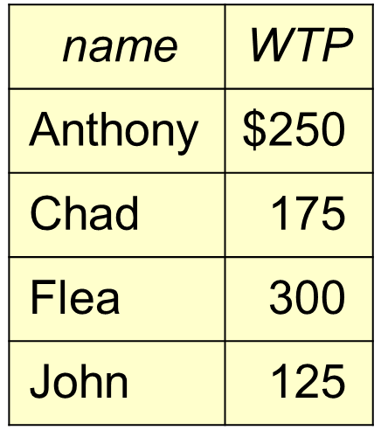
Ex. 4 buyers’ WTP for an iPod

WTP and the Demand Curve
Q: If the Price of iPod is $200, who will buy an iPod, and what is the quantity demanded
A: Anthony & Flea will buy an iPod, Chad & John will not.
Hence, Q^{d} = 2
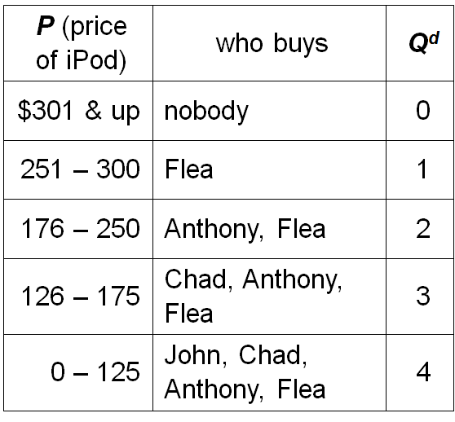
When P = $200

Derive the demand schedule

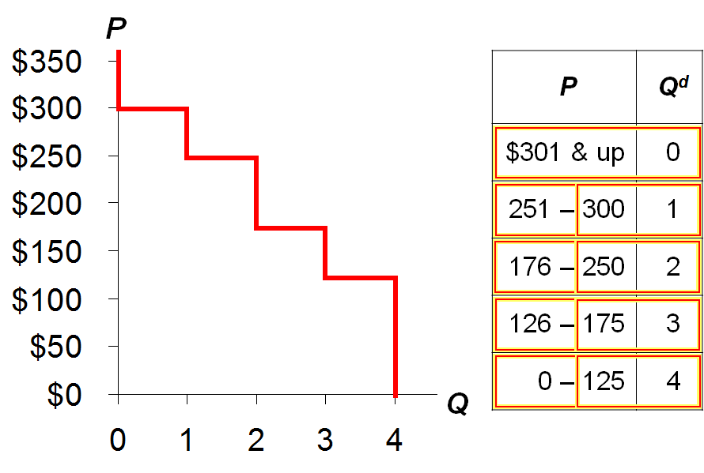
When P is $301 or higher, Q^{d} is zero. That part of the table is highlighted when the upper-most segment of the demand curve is revealed.
If the price falls to $300, then Q^{d} increases to 1.
If the price is anywhere in the range $251-300, Q^{d} = 1.
If the price falls to $250, then Q^{d} increases to 2.
If the price is anywhere in the range $176-250, Q^{d} = 2.

About the Staircase Shape…
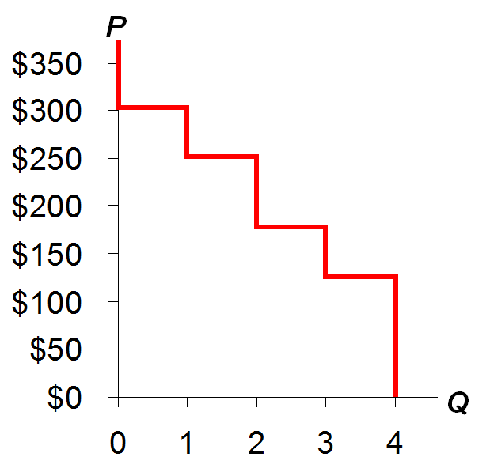
The D curve looks like a staircase with 4 steps- one per buyer
If there was a huge number of buyers, as in competitive market
There would be a huge number of very tiny steps
And it would look more like a smooth curve
The number of steps corresponds to the number of buyers. i.e. if there were ten buyers, there would be ten steps

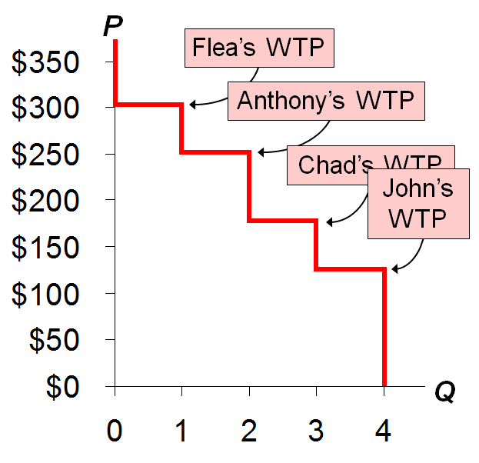
At any Q, the height of the D curve is the WTP of the marginal buyer, the buyer who would leave the market if P were any higher.
When Q =1, the height of the demand curve is $300, which is Flea’s willingness to pay, or how much he values an iPod. At any price higher than $300, Flea leaves the market; hence, at Q = 1, Flea is the marginal buyer.
When Q = 2, the height of the demand curve is $250, which is Anthony’s willingness to pay, or how much he values an iPod. At any price higher than $250, Anthony leaves the market; hence, at Q = 2, Anthony is the marginal buyer.
And so forth.

Consumer Surplus (CS)
Consumer surplus is the amount a buyer is willing to pay minus the amount the buyer actually pays:
CS = WS – P

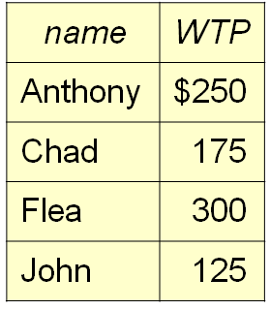
Suppose P = $260
Flea’s CS = $300 – 260 = $40.
The others get no CS because they do not buy an iPod at this price.
Total CS = $40.

CS and the Demand Curve
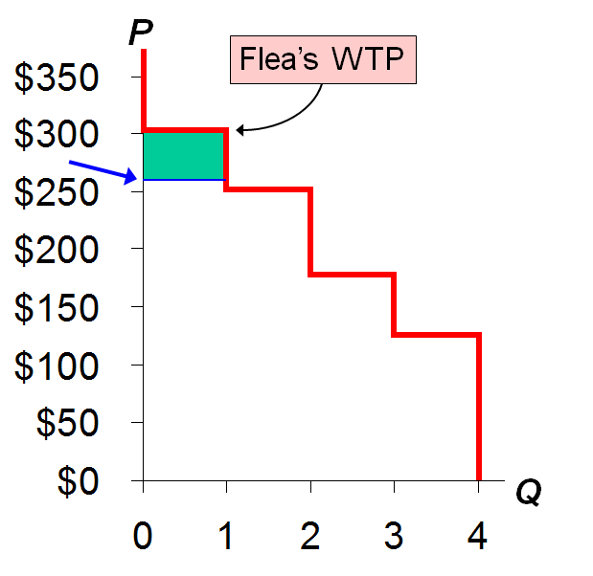
P = $260
Flea’s CS =
$300 – 260 = $40
Total CS = $40
For the green rectangle on this slide,
base = 1
height = $300 – 260 = $40
area = 1 x $40 = $40

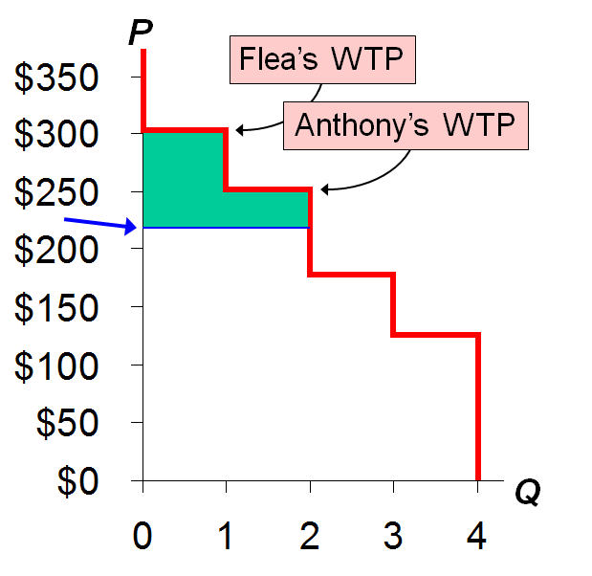
Instead, suppose
P = $220
Flea’s CS =
$300 – 220 = $80
Anthony’s CS =
$250 – 220 = $30
Total CS = $110
The entire green area (total CS) can be divided into two rectangles:
The first (and leftmost) represents Flea’s CS. It has a height of $80 and a width of 1.
The second represents Anthony’s CS. It has a height of $30 and a width of 1. The sum of these two rectangular areas equals total CS.

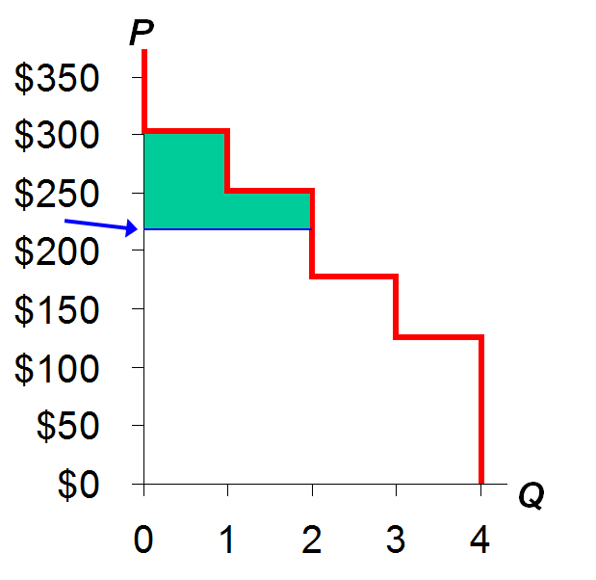
The lesson:
Total CS equals the area under the demand curve above the price, from 0 to Q.

CS with Lots of Buyers & a Smooth D Curve
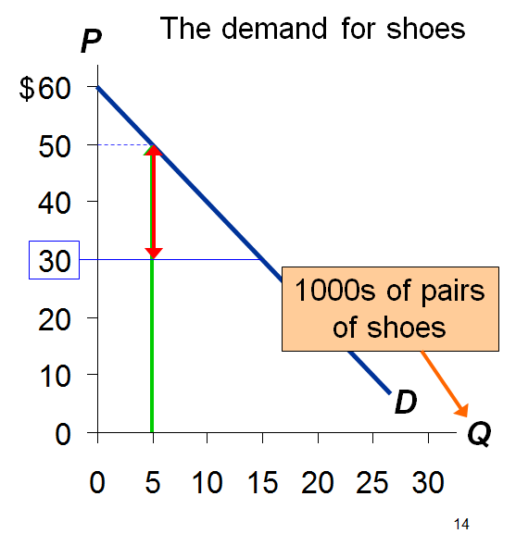
At Q = 5(thousand), the marginal buyer is willing to pay $50 for pair of shoes.
Suppose P = $30.
Then his consumer surplus = $20.

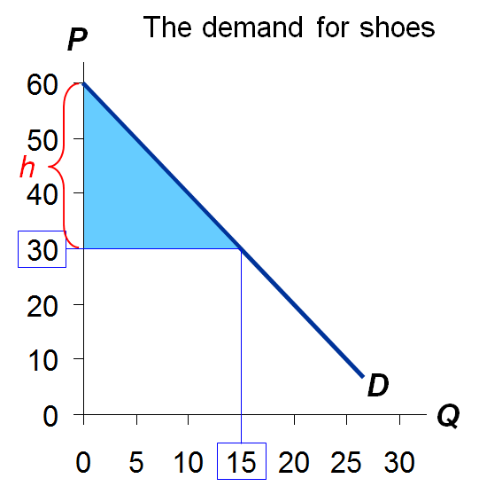
CS is the area b/w P and the D curve, from 0 to Q.
Recall: area of a triangle equals ½ x base x height
Height =$60 – 30 = $30.
So,
CS = ½ x 15 x $30
= $225.
*Note: In order to calculate the height, make sure to subtract the bottom of the triangle from the height of the top of the triangle

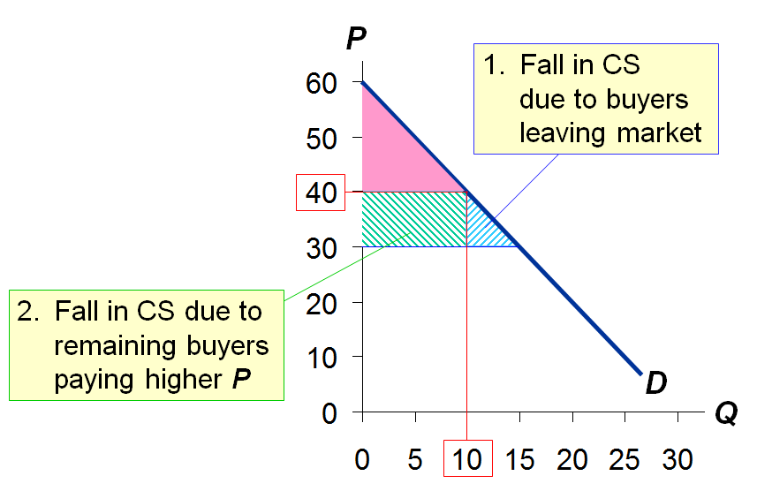
How a Higher Price Reduces CS

If P rises to $40,
CS = ½ x 10 x $20
= $100.
Two reasons for the fall in CS.
Similarly, if price decreases, consumer surplus would increase because more buyers would enter the market and existing buyers would be paying lower prices for the goods/service

Active Learning 1: Consumer surplus
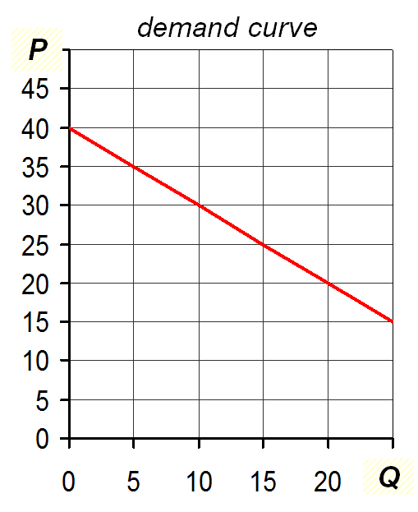
- Find marginal buyer’s WTP at Q = 10
- Find CS for P = $30
Suppose P falls to $20, how much will CS increase due to…
- Buyers entering the market
- Existing buyers paying lower price

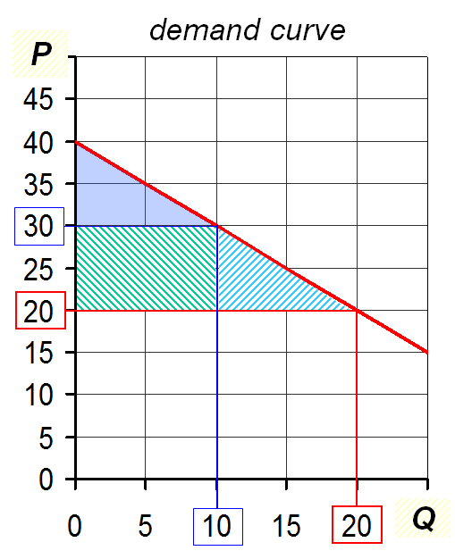
- At Q = 10, marginal buyers’ WTP is $30
- CS $=\frac{1}{2}×10×\$10$
= $50
P falls to $20
- CS for additional buyers $=\frac{1}{2}×10×\$10$
= $50
- Increase in CS on initial 10 units $=10×10$
= $100

Cost and Supply Curve
- Cost is the value of everything a seller must give up to produce a good (i.e., opportunity cost).
- Includes cost of all resources used to produce good, including value of the seller’s time.
  - Ex: Costs of 3 sellers in the lawn-cutting business.
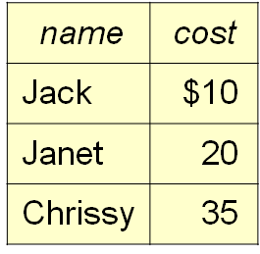
A seller will produce and sell the good/service only if the price exceeds his or her cost.
Hence, costs is a measure of willingness to sell

Derive the Supply Schedule from the cost data
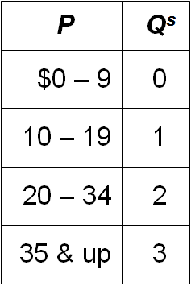
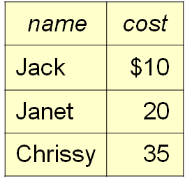

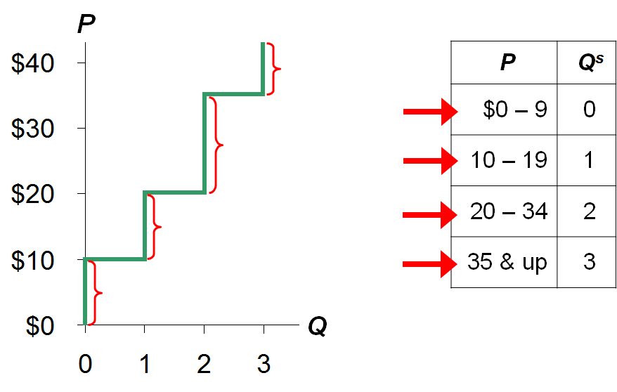

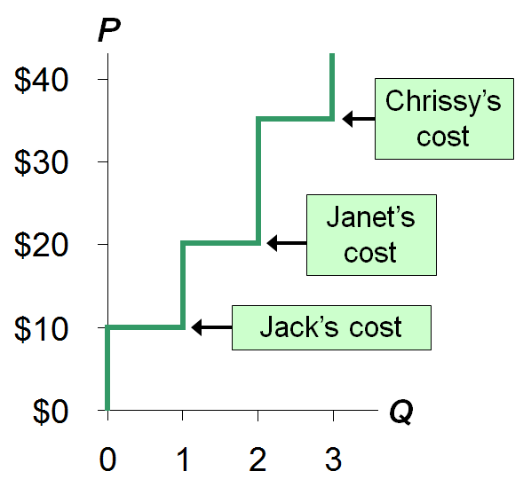
At each Q, the height of the S curve is the cost of the marginal seller, the seller who would leave the market if the price were any lower.

Producer Surplus

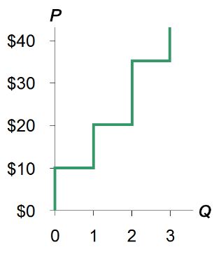

Producer surplus (PS): the amount a seller is paid for a good minus the seller’s cost

Producer Surplus and the S Curve
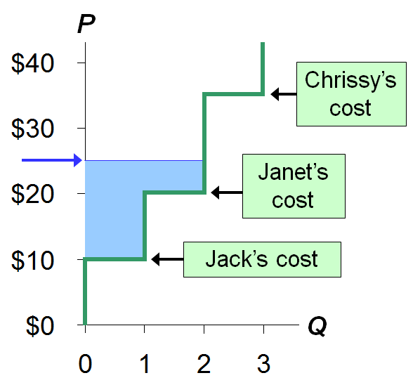
$$PS=P-cost$$
Suppose P = $25
Jack’s PS =$15
Janet’s PS = $5
Chrissy’s PS = $0
Total PS = $20
Total PS equals the area above the supply curve under the price from 0 to Q

PS with lots of Sellers & a Smooth S Curve
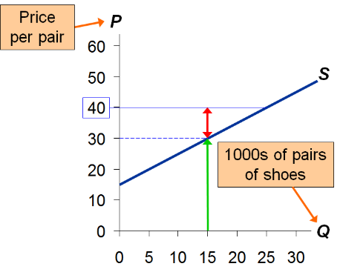
Suppose P = $40
AT Q = 15(thousand) the marginal seller’s cost is $30, and her producer surplus is $10.
This means that when market price is lower, consumer surplus is higher

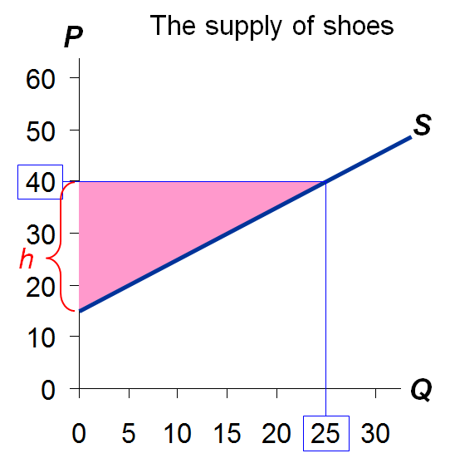
PS is the area between P and the S curve for 0 to Q.
The height of this triangle is $40 -15 = $25
So,
$$PS= 1/2×b×h$$
$$= 1/2×25×\$25$$
$$=312.40$$

How a Lower Price Reduces PS
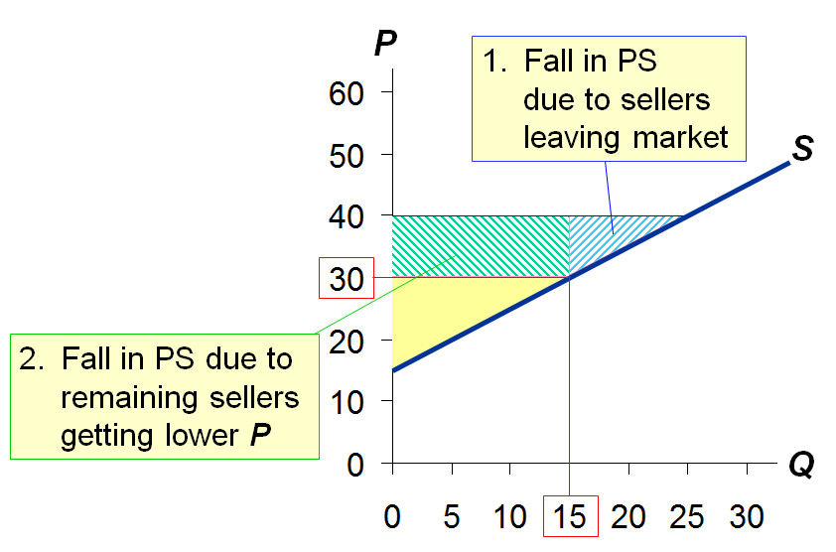
If P falls to $30,
$$PS=1/2×15×\$15$$
$$=\$112.50$$

Active Learning 2: Producer Surplus
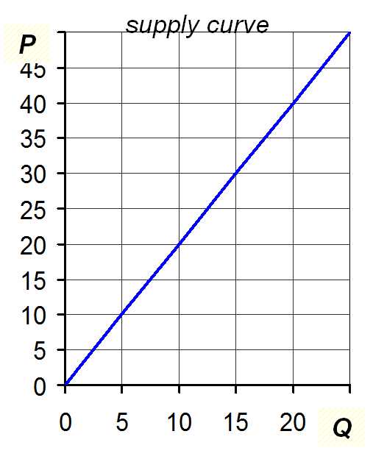
- Find marginal seller’s cost at Q = 10
- Find total PS for P = $20
Suppose P rises to $30, find the increase in PS due to…
- Selling 5 additional units
- Getting a higher price on the initial 10 units

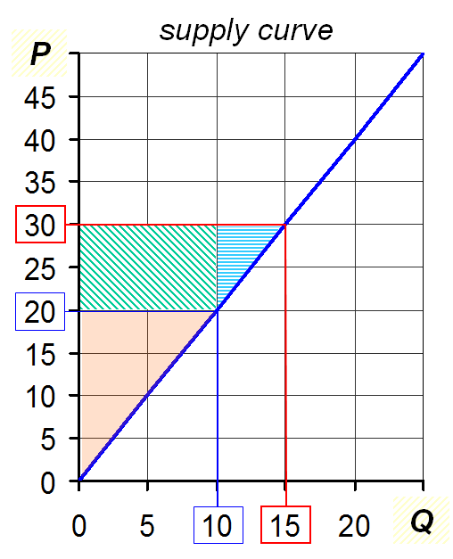

- AT Q = 10, the marginal cost = $20
- $PS=1/2×10×\$20$
$$PS=\$100$$
P rise to $30
- PS on additional units
$$=1/2×5×\$10=\$25$$
- Increase in PS on initial 10 units
$$=10×\$10=\$100$$

CS, PS, and Total Surplus
$$CS=\left(value to buyers\right)-\left(amount paid by buyers\right)$$
$$=buyers^{'}gain from participating in market$$
$$PS=\left(amount received from sellers\right)-cost to sellers)$$
$$=sellers^{'}gain from participating in the market$$
$$Total Surplus=CS+PS$$
$$=total gain from trade in market$$
$$=\left(value to buyers\right)-(cost to sellers)$$
Total surplus is also defined as the market equilibrium which is the maximization of total surplus that can be found on the market equilibrium

The Market’s Allocation of Resources
- In a market economy, the allocation of resources is decentralized, determined by the interactions of many self-interested buyers and sellers.
- Is the market’s allocation of resources desirable? Or would a different allocation of resources make society better off?
- To answer this, we use total surplus as a measure of society’s well-being, and we consider whether the market’s allocation is efficient.
(Policymakers also care about equality, though are focus here is on efficiency.)

Efficiency
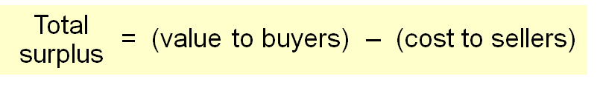
An allocation of resources is efficient if it maximizes total surplus. Efficiency means:
  - The goods are consumed by the buyers who value them most highly.
  - The goods are produced by the producers with the lowest costs.
  - Raising or lowering the quantity of a good would not increase total surplus.
  - This is consistent with the point of market equilibrium

Evaluating the Market Equilibrium
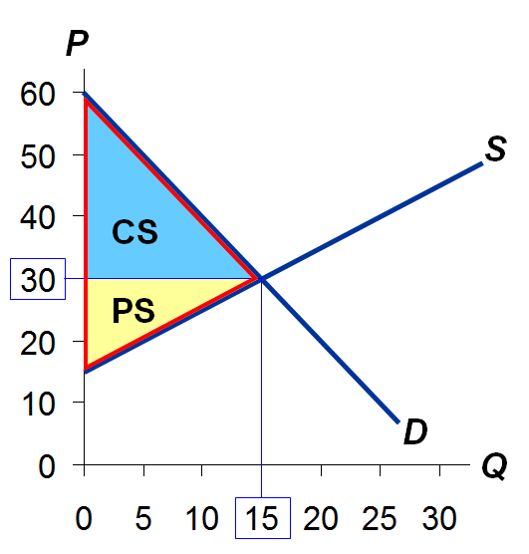
Market eq’m:
P = $30
Q = 15,000
Total surplus
= CS + PS
Is the market eq’m efficient?
TS = CS + PS
$$TS=\left(\frac{1}{2}×30×15\right)+\left(\frac{1}{2}×15×15\right)$$
$$TS=225+112.5$$
$$TS=337.5$$

Which Buyers Consume the Good?
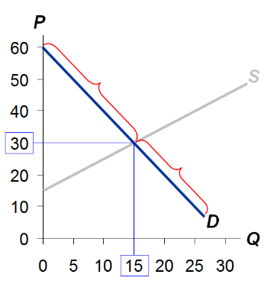
Every buyer whose WTP is ≥ $30 will buy
Every buyer whose WTP is ˂ $30 will not
SO, buyers who value the good most highly are the ones who consume it

Which Sellers Produce the Good?
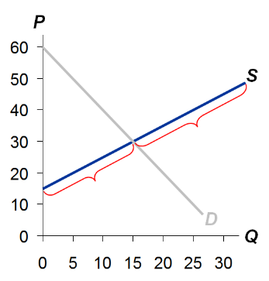
Every seller whose cost is ≤ $30 will produce the good.
Every seller whose cost is > $30 will not.
So, the sellers with the lowest cost produce the good.
Because the height of the S curve tells us seller’s costs, we can determine the following:
The sellers of the first 15 units have cost < $30, so it is worthwhile for them to produce the good.
The other sellers have cost > $30, so they will not sell the good if P = $30.

Does Eq’m Q Maximize Total Surplus?
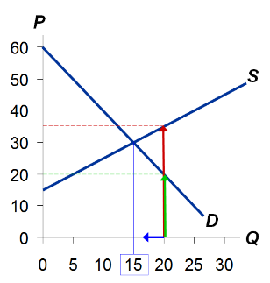
At Q = 20, cost of producing the marginal unit
is $35 value to consumers of the marginal unit is only $20
Hence, can increase total surplus by reducing Q.
This is true at any Q greater than 15.

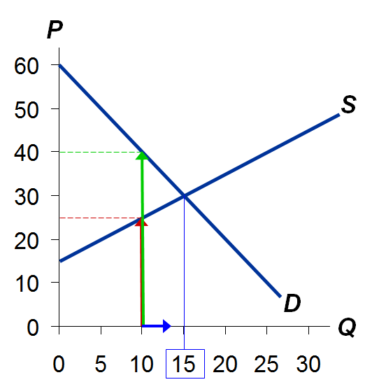
At Q = 10, cost of producing the marginal unit is $25 value to consumers of the marginal unit is $40
Hence, can increase total surplus by increasing Q.
This is true at any Q less than 15.

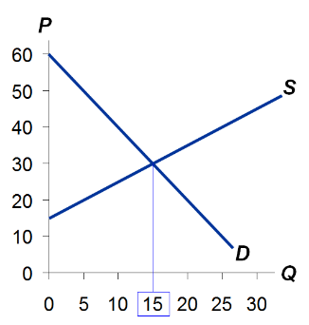

The market eq’m quantity maximizes total surplus:
At any other quantity, can increase total surplus by moving toward the market eq’m quantity.

Adam Smith and the Invisible Hand
Passages from The Wealth of Nations, 1776
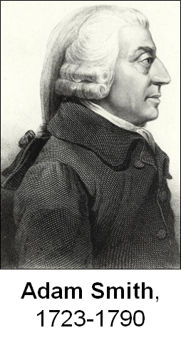
“Man has almost constant occasion for the help of his brethren, and it is vain for him to expect it from their benevolence only. He will be more likely to prevail if he can interest their self-love in his favor, and show them that it is for their own advantage to do for him what he requires of them…It is not from the benevolence of the butcher, the brewer, or the baker that we expect our dinner, but from their regard to their own interest…”
“Every individual…neither intends to promote the public interest, nor knows how much he is promoting it… He intends only his own gain, and he is in this, as in many other cases, led by an invisible hand to promote an end which was no part of his intention. Nor is it always the worse for the society that it was no part of it. By pursuing his own interest he frequently promotes that of the society more effectually than when he really intends to promote it.”

The Free Market vs. Gov’t Intervention
- The market equilibrium is efficient. No other outcome achieves higher total surplus.
- Gov’t cannot raise total surplus by changing the market’s allocation of resources.
- Laissez faire (French for “allow them to do”): the notion that gov’t should not interfere with the market.

The Free Market vs. Central Planning
- Suppose resources were allocated not by the market, but by a central planner who cares about society’s well-being.
- To allocate resources efficiently and maximize total surplus, the planner would need to know every seller’s cost and every buyer’s WTP for every good in the entire economy.
- This is impossible, and why centrally-planned economies are never very efficient.

CONCLUSION
- This chapter used welfare economics to demonstrate one of the Ten Principles:
Markets are usually a good way to organize economic activity.
- Important note: We derived these lessons assuming perfectly competitive markets.
- In other conditions we will study in later chapters, the market may fail to allocate resources efficiently…
- Such market failures occur when:
  - A buyer or seller has market power – the ability to affect the market price.
  - Transactions have side effects, called externalities, which affect bystanders. (example: pollution)
- We’ll use welfare economics to see how public policy may improve on the market outcome in such cases.
- Despite the possibility of market failure, the analysis in this chapter applies in many markets, and the invisible hand remains extremely important.

CHAPTER SUMMARY
- The height of the D curve reflects the value of the good to buyers—their willingness to pay for it.
- Consumer surplus is the difference between what buyers are willing to pay for a good and what they actually pay.
- On the graph, consumer surplus is the area between P and the D curve.
- The height of the S curve is sellers’ cost of producing the good. Sellers are willing to sell if the price they get is at least as high as their cost.
- Producer surplus is the difference between what sellers receive for a good and their cost of producing it.
- On the graph, producer surplus is the area between P and the S curve.
- To measure of society’s well-being, we use total surplus, the sum of consumer and producer surplus.
- Efficiency means that total surplus is maximized, that the goods are produced by sellers with lowest cost, and that they are consumed by buyers who most value them.
- Under perfect competition, the market outcome is efficient. Altering it would reduce total surplus.

Chapter 8

Application: The Cost of Taxation

Review from Chapter 6
- A tax
  - Drives a wedge between the price buyers pay and the price sellers receive.
  - Raises the price buyers pay and lowers the price sellers receive.
  - Reduces the quantity bought & sold.
- These effects are the same whether the tax is imposed on buyers or sellers, so we do not make this distinction in this chapter.

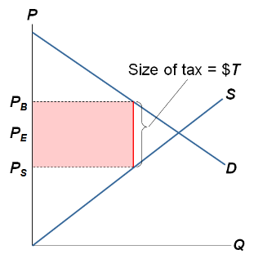
Effects of a Tax
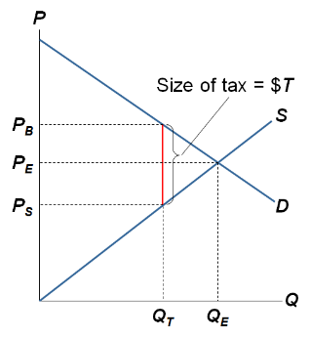
Eq’m with no tax:
Price = P_{E}
Revenue from tax:
$T x Q_{T}
Quantity = Q_{E}
Eq’m tax = $T per unit:
Buyers pay P_{B}
Sellers receive P_{S}
Quantity = Q_{T}

- Next, we apply welfare economics to measure the gains and losses from a tax.
- We determine consumer surplus (CS), producer surplus (PS), tax revenue, and total surplus with and without the tax.
- Tax revenue can fund beneficial services (e.g., education, roads, police) so we include it in total surplus.
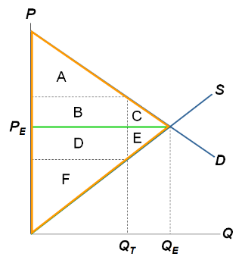
Without a tax,
$$CS=A+B+C$$
$$PS=D+E+F$$
Tax Revenue = 0
Total Surplus
$=CS+PS$
$$=A+B+C+D+E+F$$

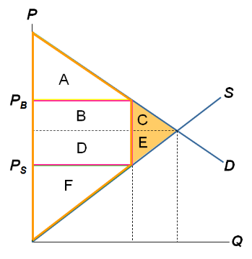
With the tax,
$$CS=A$$
$$PS=F$$
Tax Revenue
$$=B+D$$
Total surplus
$$=A+B+D+F$$
The tax reduces total surplus by C + E

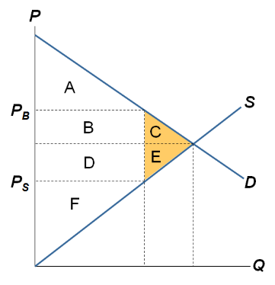

C + E are called the deadweight loss (DWL) of the tax, the fall in total surplus that results from a market distortion, such as a tax.
Deadweight loss occurs because less product are being sold in the market because consumers are demanding less and suppliers are supplying less

About the Deadweight Loss
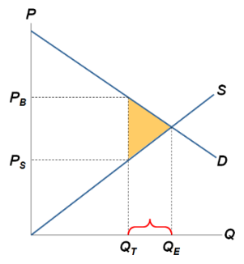
Because of the tax, the units between Q_{T} and Q_{E} are not sold. The value of these units to buyers is greater than the cost of producing them, so the tax prevents some mutually beneficial trades.
Deadweight loss is as a result of gov’t intervention. In order for a market to be as efficient as possible, gov’t intervention should be at a minimum

ACTIVE LEARNING 1: Analysis of tax
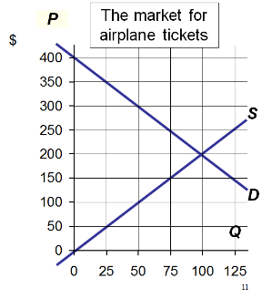
- Compute CS, PS, and total surplus without a tax.
- If $100 tax per ticket, compute CS, PS, tax revenue, total surplus, and DWL

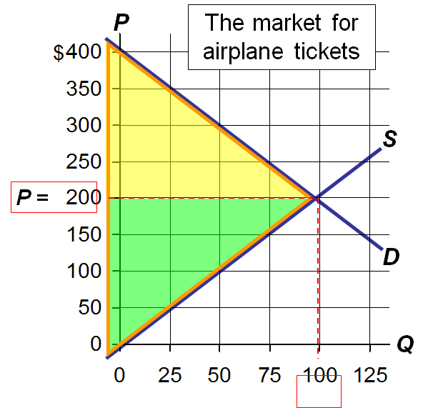
- CS
$${=1}/2×\$200×100$$
$$=\$10,000$$
PS
$${=1}/2×\$200×100$$
$$=\$10,000$$
Total Surplus
$$=\$10,00+\$10,000$$
$$=\$20,000$$

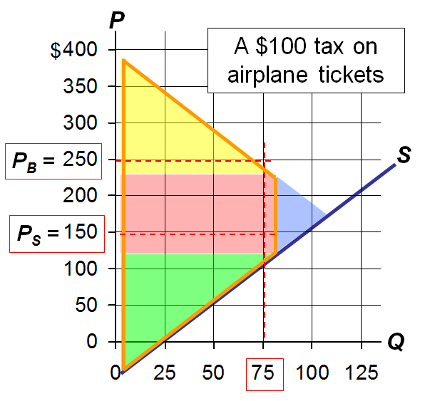
- CS
$${=1}/2×\$150×75$$
$$=\$5,625$$
$$PS=\$5,625$$
Tax Revenue
$$=\$100×75$$
$$=\$7,500$$
Total Surplus
$$=\$5,625+\$5,625+\$7,500$$
$$=\$18,750$$
$$DWL=\$1,250$$
The DWL (deadweight loss is found by subtracting the total surplus with tax from the total surplus without tax.
Deadweight Loss can also be around by calculating the area of the blue shaded triangle:
$$1/2×\left(100-75\right)×\left(\$250-\$150\right)=\$1250$$

What determines the Size of the DWL?
- Which goods or services should gov’t tax to raise the revenue it needs?
- One answer: those with the smallest DWL.
- When is the DWL small vs. large? Turns out it depends on the price elasticities of supply and demand.
- Recall: The price elasticity of demand (or supply) measures how much Q^{D} (or Q^{S}) changes when P changes.

DWL and the Elasticity of Supply
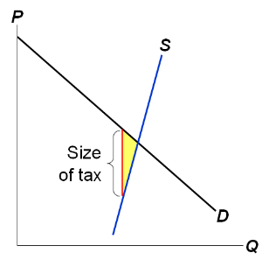
When supply is inelastic, it’s harder for firms to leave the market when the tax reduces P_{S}. So, the tax only reduces Q a little, and DWL is small.
When there’s no tax, the market equilibrium quantity maximizes total surplus.
The tax causes the price sellers receive to fall, so sellers will supply a smaller quantity, and the new equilibrium quantity falls below the one that maximizes total surplus – hence the DWL.
When supply is inelastic, sellers do not reduce Q much below the surplus-maximizing quantity, so DWL is small
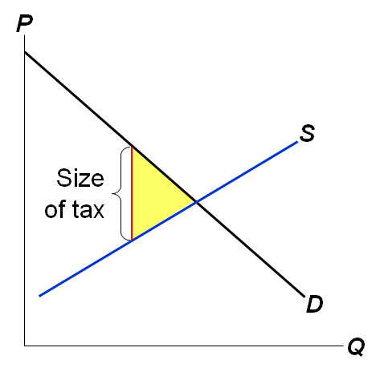
The more elastic is supply, the easier for firms to leave the market when the tax reduces P_{S}, the greater Q falls below the surplus-maximizing quantity, the greater the DWL.
In this graph, the demand curve, equilibrium price, and size of the tax are identical to those in the graph on the preceding slide. The only thing that’s different is the supply curve here is flatter; as a result, the same size tax as before causes a larger DWL.

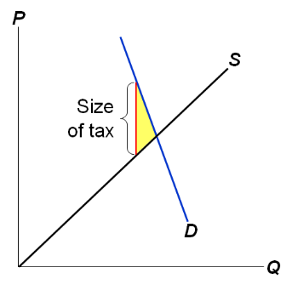
When demand is inelastic, it’s harder for consumers to leave the market when the tax raises P_{B}. So, the tax only reduces Q a little, and DWL is small.
The tax raises the price buyers pay and therefore reduces the quantity demanded. The equilibrium quantity falls below the surplus-maximizing quantity, but not by much when demand is price-inelastic.

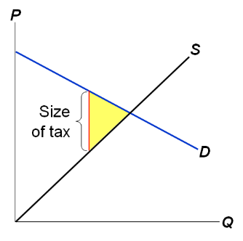
The more elastic is demand, the easier for buyers to leave the market when the tax increases P_{B}, the more Q falls below the surplus-maximizing quantity, and the greater the DWL.

ACTIVE LEARNING 2: Elasticity and the DWL of a tax
Would the DWL of a tax be larger if the taxes were on:
- Breakfast cereal or sunscreen?
Breakfast cereal because it has many other close substitutes which means its elasticity is higher
- Hotel rooms in the short run hotel rooms I the long run?
Elasticity is always greater in the long run than in the short run
- Groceries or meals a fancy restaurant?
From Chapter 5:
Groceries are more of a necessity and therefore less price-elastic than meals at
fancy restaurants.
So, a tax on restaurant meals would cause a larger DWL than a tax on groceries.

How Big Should the Government Be?
- A bigger government provides more services, but requires higher taxes, which cause DWLs.
- The larger the DWL from taxation, the greater the argument for smaller government.
- The tax on labour income is especially important; it’s the biggest source of gov’t revenue.
- For the typical worker, the marginal tax rate (the tax on the last dollar of earnings) is about 40%.
- How big is the DWL from this tax? It depends on elasticity….
- If labour supply is inelastic, then this DWL is small.
- Some economists believe labour supply is inelastic, arguing that most workers work full-time regardless of the wage.
- Other economists believe labour taxes are highly distorting because some groups of workers have elastic supply and can respond to incentives:
- Many workers can adjust their hours,
    - e.g., by working overtime.
  - Many families have a 2nd earner with discretion over whether and how much to work.
  - Many elderly choose when to retire based on the wage they earn.
  - Some people work in the “underground economy” to evade high taxes.

The Effects of Changing the Size of the Tax
- Policymakers often change taxes, raising some and lowering others.
- What happens to DWL and tax revenue when taxes change? We explore this next….

DWL and the Size of the Tax
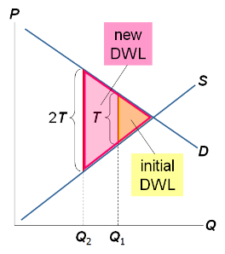
Initially, the tax is T per unit
Doubling the tax causes the DWL to more than double
The new DWL is four time the initial DWL, even though the tax is just twice as large

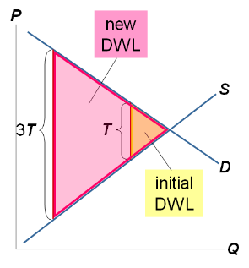
Initially, the tax is T per unit
Tripling the tax causes the DWL to more than triple
The new DWL is nine times the initial DWL even though the tax is only three times as large

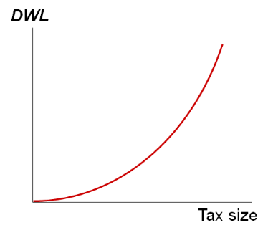
Summary
When a tax increases, DWL rises even more.
Implication
When tax rates are low, raising them doesn’t cause much harm, and lowering them doesn’t bring much benefit.
When tax rates are high, raising them is very harmful, and cutting them is very beneficial.

Revenue and the Size of the Tax
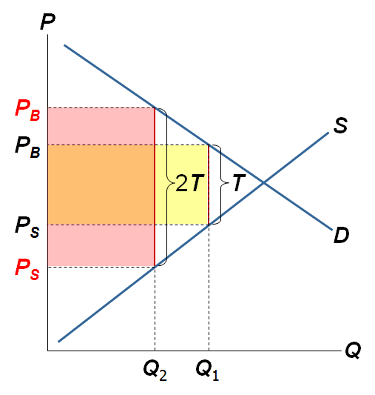
When the
tax is small, increasing it causes tax revenue to rise.
When the tax is small (namely, equal to T), the shaded yellow rectangle represents tax revenue.
When the tax equals 2T, the pink shaded box represents revenue.
The pink shaded box is larger than the yellow box.

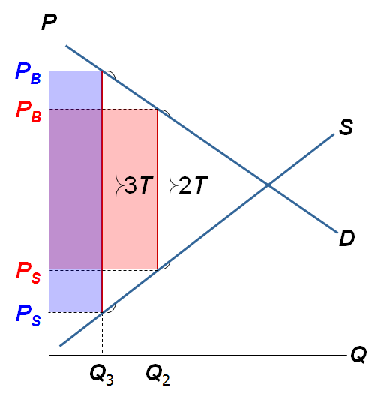

When the tax is larger, increasing it causes tax revenue to fall.
Raising the tax further – to 3T – causes revenue to fall. Revenue is now represented by the bluish-purple shaded box, which is smaller than the pink box.

Revenue and the Size of the Tax
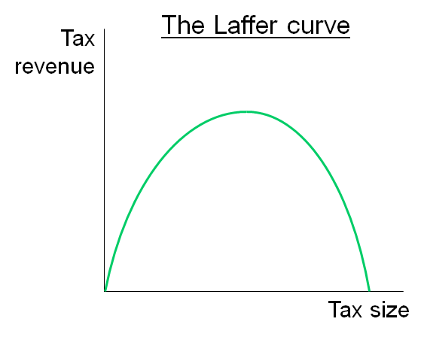
The Laffer curve shows the relationship between the size of the tax and tax revenue.
The Laffer curves shown here and in the book are symmetric, and their peak occurs in the middle. This need not and probably is not the case. However, we just don’t know where the peak is – it could be at a tax rate of 20% or a tax rate of 200% - and it surely varies across goods.
The textbook has some excellent discussion of the Laffer curve, President Reagan, and supply-side economics.
Note: How much revenue a government gains to loses from a tax change cannot be computed just by looking at tax rates. It also depends on how the tax change affects people’s behavior.

CHAPTER SUMMARY
- A tax on a good reduces the welfare of buyers and sellers. This welfare loss usually exceeds the revenue the tax raises for the govt.
- The fall in total surplus (consumer surplus, producer surplus, and tax revenue) is called the deadweight loss (DWL) of the tax.
- A tax has a DWL because it causes consumers to buy less and producers to sell less, thus shrinking the market below the level that maximizes total surplus.
- The price elasticities of demand and supply measure how much buyers and sellers respond to price changes. Therefore, higher elasticities imply higher DWLs.
- An increase in the size of a tax causes the DWL to rise even more.
- An increase in the size of a tax causes revenue to rise at first, but eventually revenue falls because the tax reduces the size of the market.

