Chapter 4

The Market Forces of Supply and Demand

Market and Competition
- A market is a group of buyers and sellers of a particular product
  - The type of market can be determined by the number of buyers and sellers
- A competitive market is one with many buyers and sellers, each has a negligible effect on price.
  - Leads to many competitors within the marketplace
- In a perfectly competitive market:
  - All goods are exactly the same
  - Buyers and sellers are so numerous that no one can affect market price – each is a “price taker”
    - Price is manipulated by the buyer
- In the real world there is relatively few perfectly competitive markets. Most goods come in lots of different varieties- including ice-cream.
  - There are many markets in which the number of firms is small enough that some of them have the ability to affect the market price
- In this chapter, we assume markets are perfectly competitive
- Oligarchy: few sellers who work together in a group
  - Price is relatively stable

Demand
- The quantity demanded of any good is the amount of the good that buyers are willing and able to purchase.
- Law of demand: the claim that the quantity demanded of a good falls when the price of the good rises, other things equal
  - In the law of demand, we must make a strong assumption that in order for all the things to be equal and work in linear fashion, thus price will be only affected by buyers decision making
    - When price increase, demand falls
    - When price decreases, demand increases
  - It is important to understand that that other things may affect the rise in demand other than price
- Demand comes from the behaviour of buyers

The Demand Schedule
- Demand schedule: A table that shows the relationship between the price of a good and the quantity demanded
  - Ex. Helen’s demand for lattes

Price  of lattes | Quantity  of lattes demanded
$0.00 | 16
1.00 | 14
2.00 | 12
3.00 | 10
4.00 | 8
5.00 | 6
6.00 | 4

- Notice that Helen’s preference’s obey the law of demand

Helen’s Demand Schedule & Curve

Price of lattes | Quantity of lattes demanded
$0.00 | 16
1.00 | 14
2.00 | 12
3.00 | 10
4.00 | 8
5.00 | 6
6.00 | 4
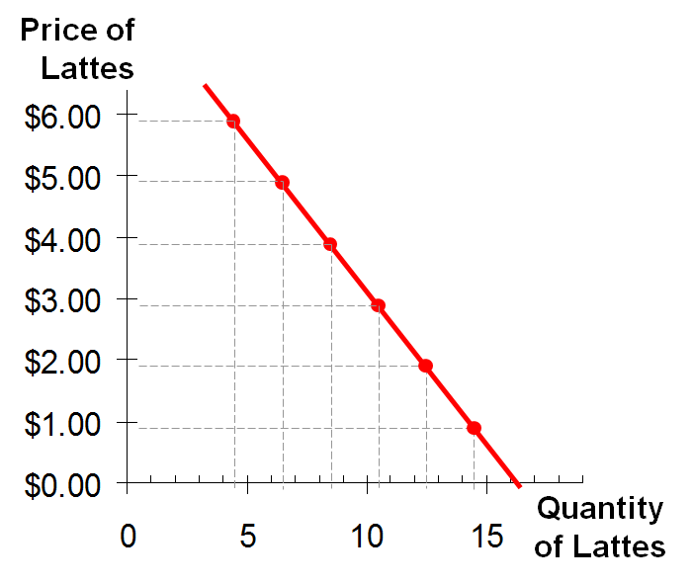

At the beginning Price is an independent variable but later affected by p.

Market Demand vs. Individual Demand
- It is possible to get market demand from the use of many buyers demand
- The quantity demanded in the market is the sum of the quantities demanded by all buyers at each price.
- Suppose Helen and Ken are the only two buyers in the Latte market (Q^{d} = quantity demanded)
- Quantity – x-axis
- Price y-axis

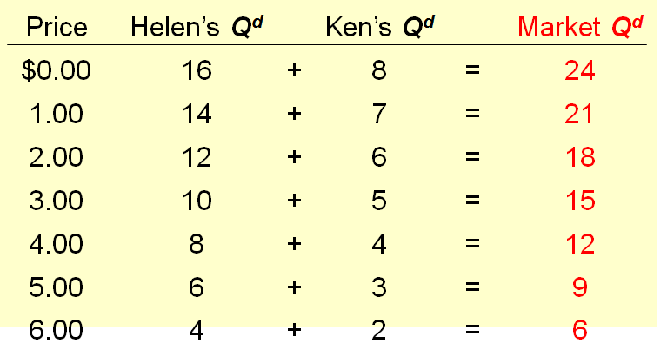
Market quantity corresponds to a different price levels

The Market Demand Curve for Lattes

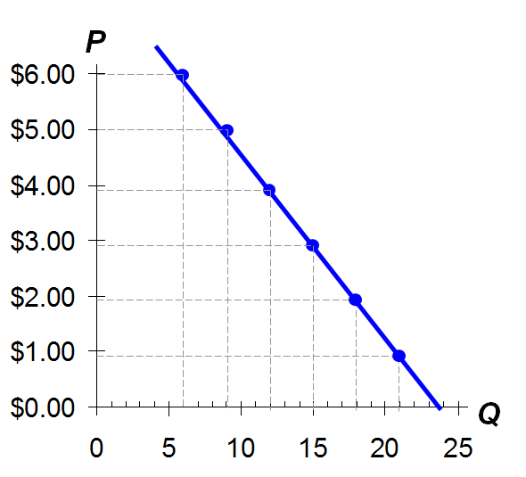
P | Q^{d} (Market)
$0.00 | 24
1.00 | 21
2.00 | 18
3.00 | 15
4.00 | 12
5.00 | 9
6.00 | 6

Demand Curve Shifters
- The demand curve shows how price effects quantity demanded, other things being equal.
- These “other things” are non-price determinants of demand (i.e., things that determine buyers demand for a good, other than the good’s price).
- A demand curve shifter is any change that increases the quantity demanded at every price
  - Ex. An imaginary discovery about the nutritional benefits of ice-cream will shift the demand curve to the right which is called an increase in demand.
  - Any change that reduces the quantity demanded at every price shifts the demand curve to the left and is called a decrease in demand
- Changes in them shift the D curve…

Demand Curve Shifters: Number of Buyers
- Increase in the # of buyers increases quantity demanded at each price, shift D curve to the
right.
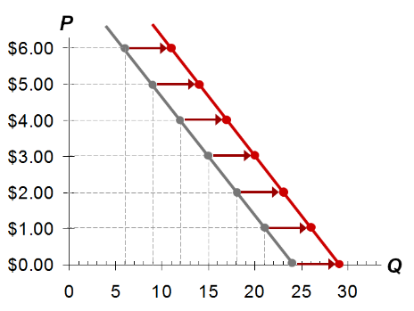
Suppose the number of buyers increases.
Then, at each P, Q^{d} will increase (by 5 in this example)

Demand Curve Shifters: Income
- Demand for a normal good is positively related to income
  - Increase in income causes increase in quantity demanded at each price, shift D curve to the right
- (Demand for an inferior good is negatively related to income. An increase in income shifts D curve for inferior goods to the left
- Normal goods: when your income increases, you would buy more of these kinds of products
- Inferior goods: when your income increases you would buy more expensive version of these goods
- Both normal goods and inferior goods are relative to the person being describes

Demand Curve Shifters: Prices of Related Goods
- Two goods are substitutes if an increase in the price causes an increase in demand for the other
- Ex: pizza and hamburgers. An increase in the price of pizza increase demand for hamburgers, shifting hamburger demand curve to the right
  - Other ex: Coke and Pepsi, laptops and desktop computers, CDs and music downloads
- Two goods are complements if an increase in the price of one causes a fall in demand for the other.
  - Ex: computers and software
    - If price of computer rises, people buy fewer computers and therefore less software. Software demand curve shifts left.
  - Other examples: college tuition and textbooks, bagels and cream cheese, eggs and bacon
  - Other ex: camera and films: the decline in photographic film cameras has led to a decline in the photographic film industry

Demand Curve Shifters: Tastes
- Anything that causes a shift in tastes toward a good will increase demand for that good and shift its D curve to right.
- Ex. The Atkins diet that became popular in the 90s caused an increase in demand for eggs, shifted the egg demand curve to the right

Demand Curve Shifter: Expectations
- Expectation affect consumers’ buying decisions
- Ex:
  - If people expect their incomes to rise, their demand for meals at expensive restaurants may increase
  - If the economy sours and people worry about their future job security,, demand for new automobiles may fall
  - Can also be used in relation to expectation of quality of goods
    - i.e. Apple IPhone 5C: didn’t meet expectations which may result in a decline in demand

Summary: Variables That Influence Buyers

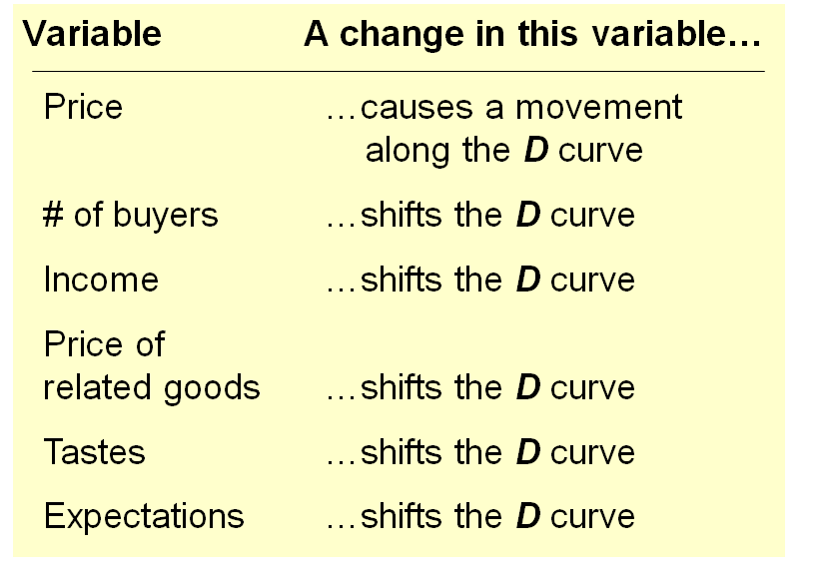
Memorize
It must be noted that Price only causes a movement along the demand curve not a shift
If the variable that is causing demand to change is NOT measured on either axis, the curve shifts

Active Learning #1: Demand Curve
Draw a demand curve for music downloads. What happens to it in each of the following scenarios? Why?

      - The price of iPods falls

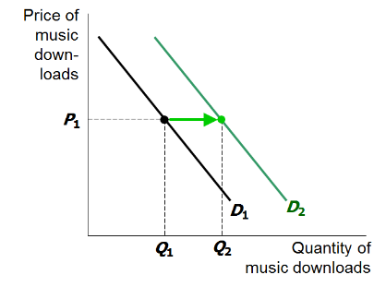
- Music download and iPods are compliments of each other. A fall in price of iPods shifts the demand curve for music downloads to the right.
- The price of downloads is the same, but the quantity demanded is now higher. At any given point the quantity is higher than before

      - The price of music downloads falls

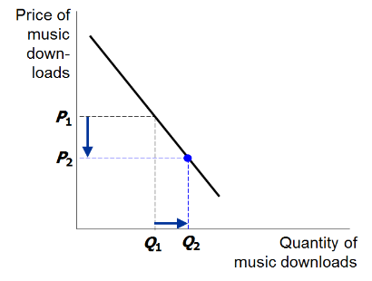
- The D curve does not shift. Move down along to a point with lower P, higher

      - The price of CD falls

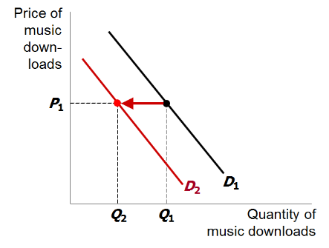
- CDs and music downloads are substitutes
- A fall in price of CDs shifts demand for music downloads to the left

Supply
- The quantity supplied of any good is the amount that sellers are willing and able to sell.
- Law of supply: the claim that the quantity supplied of a good rises when the price of the good rises, other things equal
  - When price increases, quantity increases
  - When prices falls, quantity supplied falls as well
    - This we say that quantity supplied is positively related to the price of the good
- Supply comes from the behaviour of sellers

The Supply Schedule

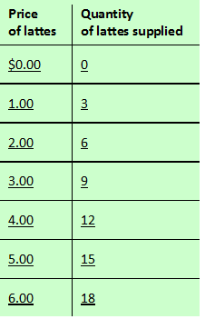
- Supply schedule: A table that shows the relationship between the price of a good and the quantity supplied.
- Ex. Starbucks’ supply of lattes
  - Notice that Starbucks’ supply schedule obeys the Law of Supply

Starbucks’ Supply Schedule & Curve
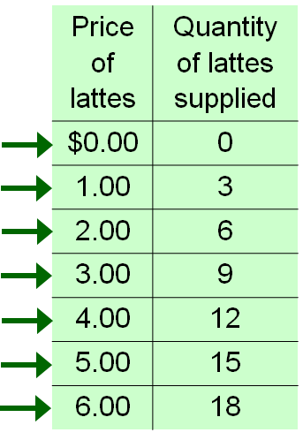
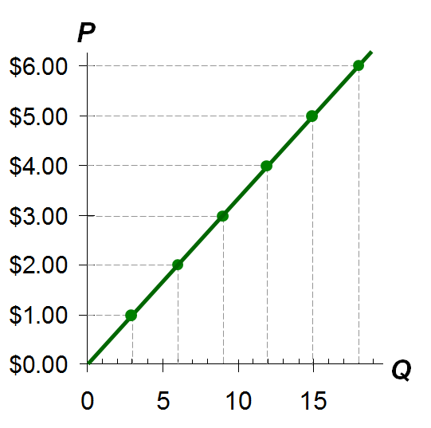

Market Supply vs. Individual Supply

- The quantity supplied in the market is the sum of quantities supplied by all sellers at each price.
- Suppose Starbucks and Jitters are the only sellers in this market (Q^{s} = quantity supplied)

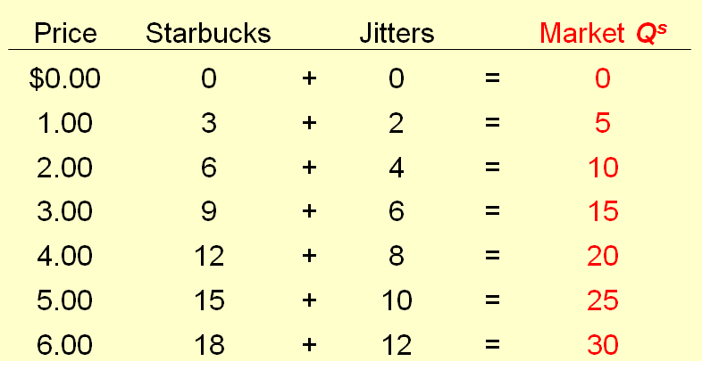

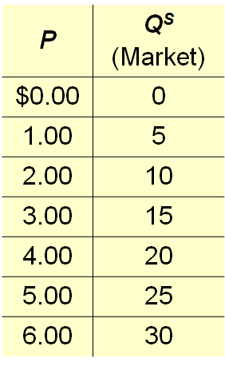
The Markey Supply Curve
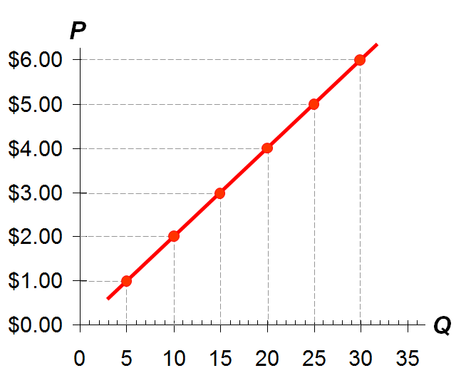

Supply Curve Shifters
- The supply curve shows how price affects quantity supplied, other things being equal.
- These “other things” are non-price determinants of supply.
- A supply curve shifter is any change that increases the quantity supplied at every price
- Changes in them shift the S curve…

Supply Curve Shifters: Input Prices
- Has direct impact of the price of the product
  - i.e. if wages/materials, etc. increase, production price will increase as well
- Ex. of input prices:
  - Wages
  - Prices of raw materials
- A fall in input prices makes production more profitable at each output price (the price of the good that firms are producing and selling), so firms supply a larger quantity at each price, and the S curve shifts to the right
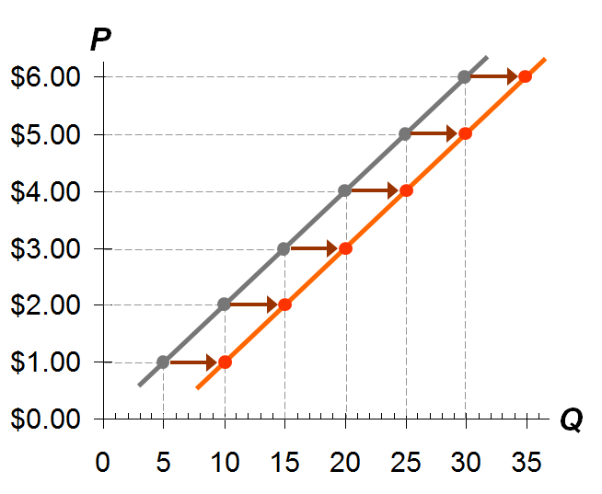

- Suppose the price of milk falls. At each price, the quantity of lattes supplied will increase (by 5 in this example)

Supply Curve Shifters: Technology
- Technology determined how much inputs are required to produce a unit of output.
- A cost-saving technological improvement has the same effect as a fall in input prices, shift the S curve to the right
  - More efficiency with productions
  - Leads to more production at lower costs

Supply Curve Shifter: Number of Sellers
- An increase in the number of sellers increases the quantity supplied at each price, shifts S curve to the right.

Supply Curve Shifters: Expectations
- Ex.
  - Events in the Middle East leads to Expectations of higher oil prices.
  - In response owners of Texas oilfields reduce supply now, save some inventory to sell later at the higher price.
  - S curve shift left
- In general, sellers may adjust supply (if good is not perishable) when their expectation of suture prices change.

Summary: Variables that Influence Sellers

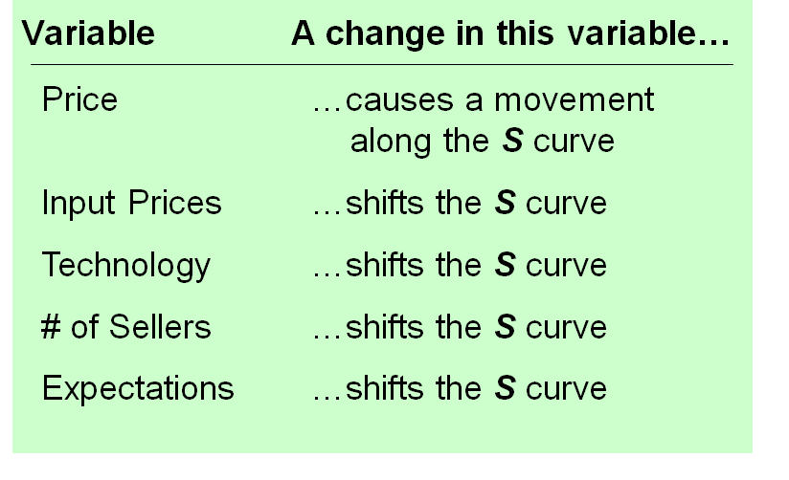
*memorise

Active Learning 2: Supply Curve

Draw a supply curve for tax return preparation software like “TurboTax” and “Tax Cut”. What happens to it in each of the following scenarios?
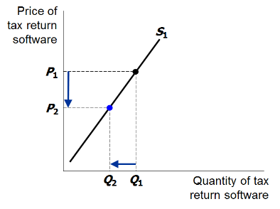
- Retailers cut the price of software

S curve does not shift.
Move down along the curve to a lower P and lower Q

- A technological advancement allows the software to be produced at lower cost.

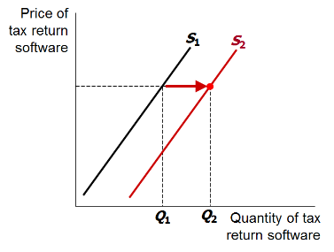
S curve shifts to the right: at each Q increases.

- Professional tax return preparers raise the price for the services they provide

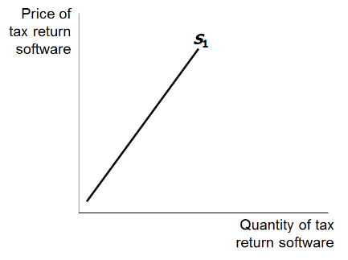

This shifts the demand curve for tax preparation software, not the supply curve.

Supply and Demand Together
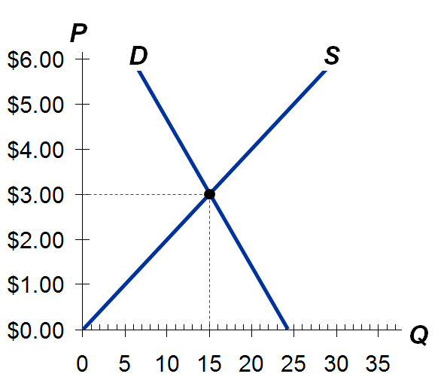
- Economy is a demand bound
  - When there is demand, there will be supply
- Equilibrium: P has reached the level where quantity supplied equals quantity demanded

Equilibrium price: the price that equates quantity supplied with quantity demanded
To graph of Supply Demands Graph find the x and y intercepts
$Q^{d}=50-2P$ $Q^{s}=2P+10$
$Q^{d}=50-2(0)$ $Q^{s}=2\left(0\right)$+10
$Q^{d}=50$ $Q^{s}=10$
$0=50-2P$ $0=2P+10$
$-50=-2P$ $-10=2P$
$P=25$ $P=-5$
Q^{d} (50, 0) Q^{s} (10, 0)
(0, 25) (0, -5)

Equilibrium quantity: the quantity supplied and the quantity demanded at the equilibrium price
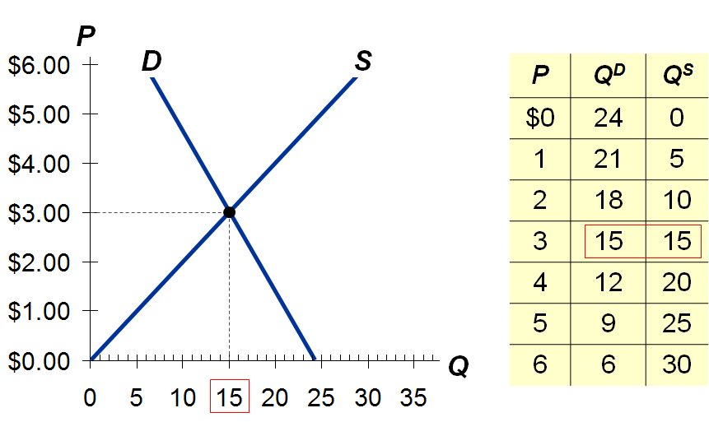
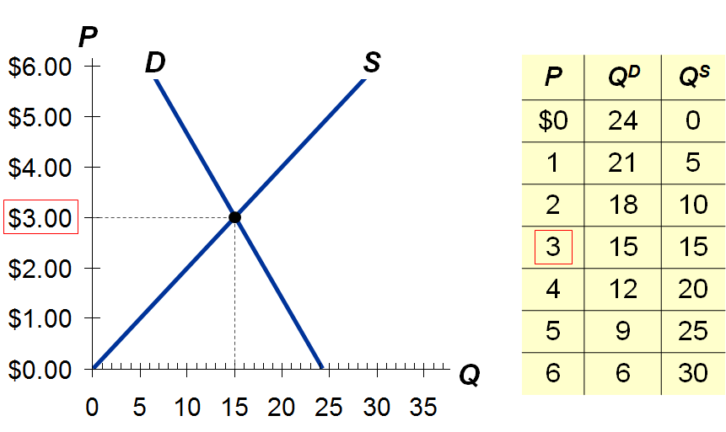

$Q^{d}=24-3P$ $Q^{d}=Q^{s}$
$Q^{s}=5P$ $24-3P=5P$
$24=8P$
$$P=3$$
$$Q^{s}=5\left(3\right)$$
$$Q^{s}=15$$

Surplus (a.k.a. excess supply): when quantity supplied is greater than quantity demanded
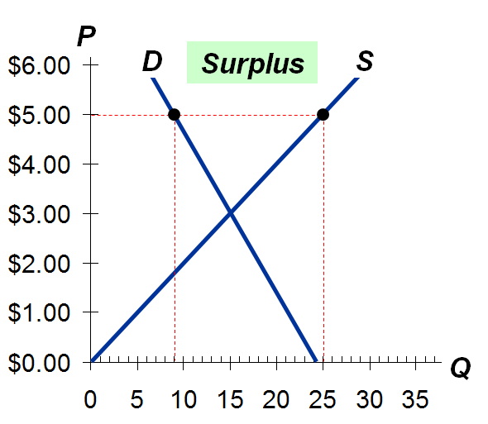
Example
If P = $5
Then
Q^{D} = 9 lattes
And
Q^{S} = 25 lattes
Resulting in a surplus of 16 lattes

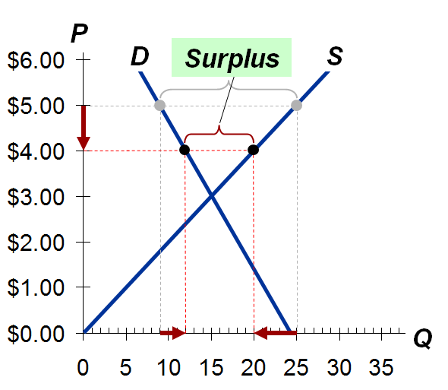
Facing a surplus sellers try to increase sales by cutting price.
This causes
Q^{D} to rise and Q^{S} to fall…
…which reduces the surplus

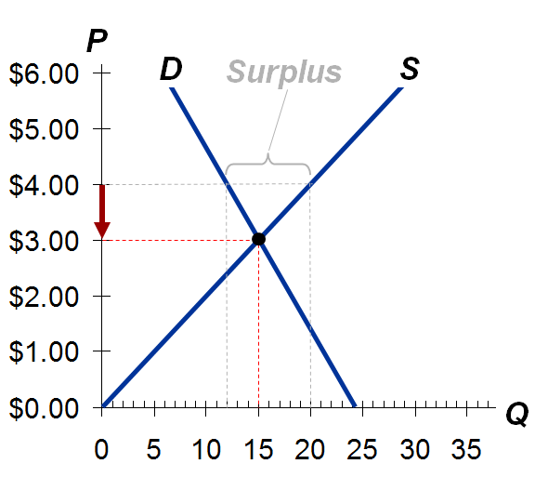
Prices continue to fall until market reaches equilibrium

Shortage (a.k.a. excess demand): when quantity demanded is greater than quantity supplied
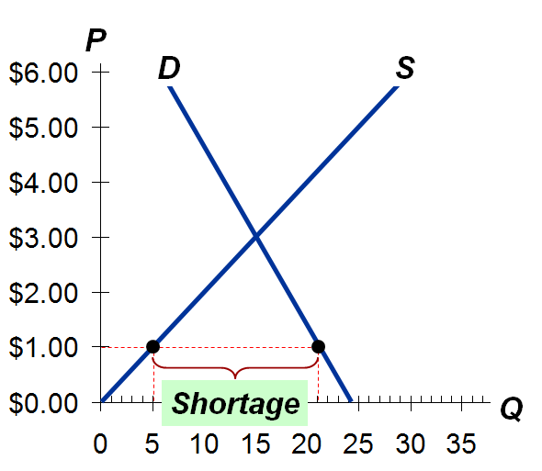

Example
If P - $1
Then
Q^{D} = 21 lattes
And
Q^{S} = 5 lattes
Resulting in a shortage of 16 lattes

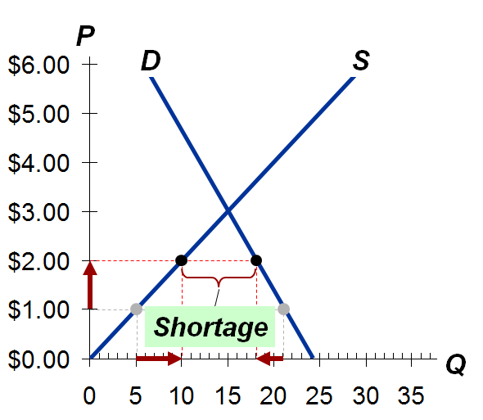
Facing a shortage sellers raise the price causing Q^{D} to fall and Q^{S} to rise …
…which reduces the shortage

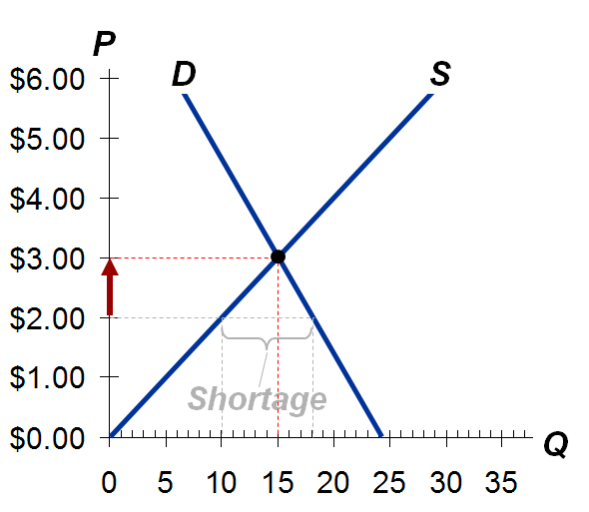

Prices continue to rise until market reaches equilibrium

Three Steps to Analyzing Changes in Equilibrium
To determine the effects of any event,
- Decide whether even shifts S curve D curve, or both.
- Decide in which direction curve shifts.
- Use supply-demand diagram to see shift changes eq’m P and Q

Example: The Market for Hybrid Cars
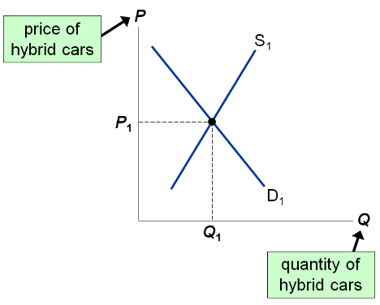
Hybrids are substitute traditional cars which are compliments of gas

Example 1: A Shift in Demand
EVENTS TO BE ANALYSED: Increase in price of gas
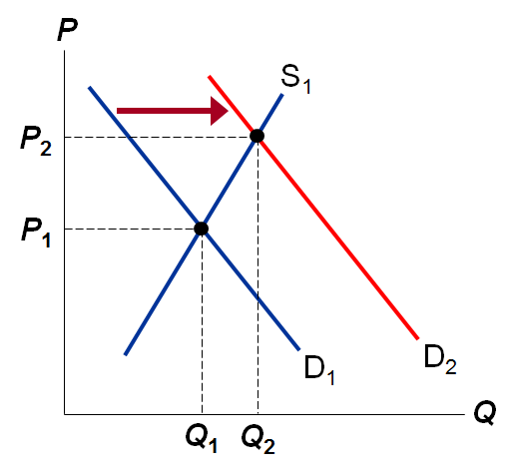
STEP 1: D curve shifts
STEP 2: D shifts right
STEP 3: D The shift causes an increase in price and quantity of hybrid cars
Notice: When P rises producers supply larger quantity of hybrids, even though the S curve has not shifted.
*Note: Always be careful to distinguish between a shift in a curve and a movement and the curve

Terms for Shift vs. Movement along Curve
- Change in supply: a shift in the S curve occurs when a non-price determinant of supply changes (like technology or costs)
- Change in quantity supplied: a movement along a fixed S curve occurs when P changes
- Change in demand: a shift in the D curve occurs when a non-price determinant of demand changes ( like income or #of buyers)
- Change in the quantity demanded: a movement along a fixed D curve occurs when P changes

Example 2: A Shift in Supply
EVENT: New technology reduces costs of producing hybrid cars
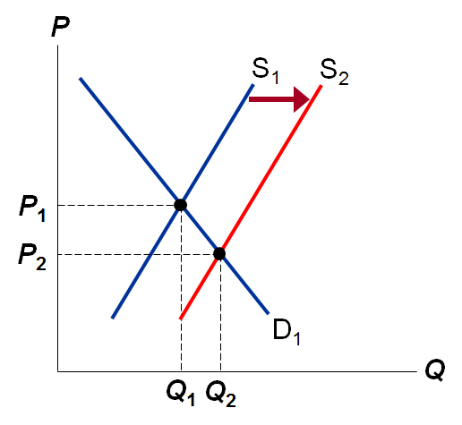
STEP 1: S curve shifts
STEP 2: S curve shifts right
STEP 3: The shift causes price to fall and quantity to rise

Example 3: A Shift in Both Supply and Demand
EVENTS: price of gas rises AND new technology reduces
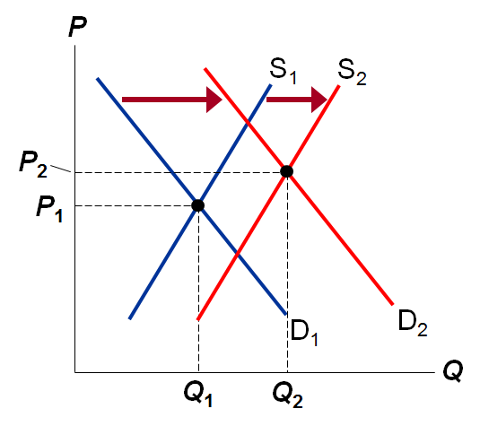
STEP 1: Both curves shift
STEP 2: Both curves shift to the right
STEP 3: Q rises, but effect on P is ambiguous: If demand increases more that supply, P rises. But if supply increases more than demand, P falls.
New market equilibrium is created from the intersection between P₂ and Q₂.
Demand is dominant in determining market equivalent price. Change in supply has little effect on P
If demand is dominant P*Q* changes in the same direction.
If supply is dominant P*Q* changes in opposite directions

Active Learning 3: Shifts in supply and demand
Use the three-step method to analyse the effects of each event on the equilibrium price ad quantity of music downloads.
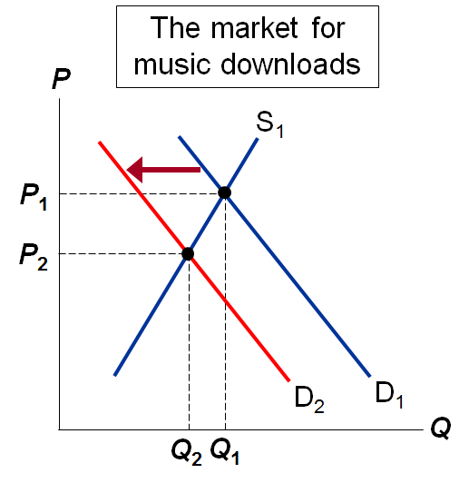
Event A: A fall in the price of CDs

STEPS
- D curve shifts
- D shifts left
- P and Q both fall

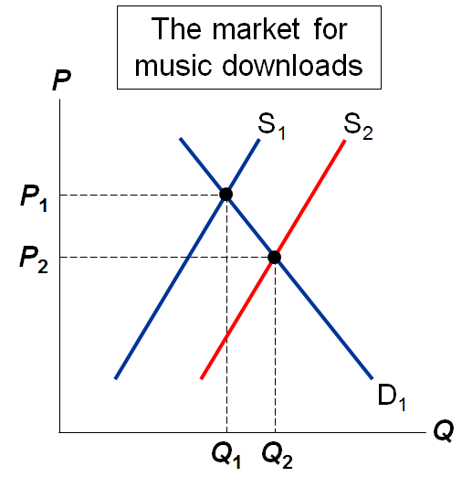
Event B: Sellers of music downloads negotiate a reduction in royalties they must pay for each song they sell
STEPS
S curve shifts
S shifts right (Royalties are part of sellers’ costs)
P falls, Q rises
Sellers of music downloads negotiate a reduction in the royalties they must pay for each song they sell. This event causes a fall in “costs of production” for sellers of music downloads. Hence the S curve shifts to the right
*Note: royalties are considered sellers’ cost of production

Event C: Event A and B both occur
STEPS
Both curves shifts (see part A & B)
D shifts left, S shifts right
P unambiguously falls. Effect on Q is ambiguous: The fall in demand reduces Q, the increase is supply increase Q.

Conclusion: How Prices Allocate Resources
- One of the Ten Principles from Chapter 1: Markets are usually a good way to organise economic activity
- In market economies, price adjusts to balance supply and demand. These equilibrium prices are the signal that guide economic decisions and thereby allocate scarce resources

Chapter Summary
- A competitive market has many buyers and sellers, each of whom has little or no influence on the market price
- Economist use the supply and demand model to analyse competitive markets
- The downward-sloping demand curve reflects the Law of Demand, which states that the quantity buyers’ demand of a good depends negatively on the good’s price.
- Besides price, demand depends on buyers’ income, tastes, and expectations, the prices of substitutes and complements, and number if buyers. If one of these factors changes, the D curve shifts.
- The upward-sloping supply curve reflects the Law of Supply, which states that the quantity sellers’ supply depends positively on the good’s price.
- Other determinants of supply include input prices, technology, expectation and the # of sellers. Changes in these factors shift the S curve
- The intersection of S and D curves determines the market equilibrium. At the equilibrium price, quantity supplied equals quantity demanded.
- If the market price is above equilibrium, a surplus results, which causes the price to fall. If the market price is below equilibrium, a shortage results, causing the price to rise.
- We can use the supply-demand diagram to analyze the effects of any event on a market: First, determine whether the event shifts one or both curves. Second, determine the direction of the shifts. Third, compare the new equilibrium to the initial one.
- In market economies, prices are the signals that guide economic decisions and allocate scarce resources.

Chapter 5

Elasticity
- Basic Idea: Elasticity measures how one variable responds to changes in another variable
  - Scenario: You design websites for local businesses. You charge $200 per website, and currently sell 12 websites per month.
  - Your costs are rising (including the opportunity cost of your time), so you consider raising the price to $250.
  - The law of demand says that you won’t sell as many websites if you raise your price.
How many fewer websites? How much will your revenue fall, or might it increase?
    - One type of elasticity measures how much demand for your websites will fall if you raise your price
- Definition: Elasticity is a numerical measure of the responsiveness of Q^{d} or Q^{s} to one of its determinants
  - Measures the sensitivity of buyers in any change
  - Buyers can react to income increase, expectation, price change of good etc.

Price Elasticity of Demand
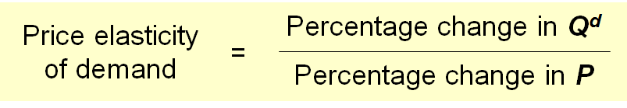
- Price elasticity of demand measures how much Q^{d} responds to a change in P
- Loosely speaking, it measures the price-sensitivity of buyers’ demand
Example
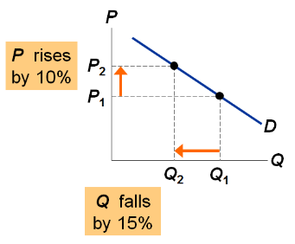
Price elasticity of demand equals
$$\frac{15\%}{10\%}=1.5$$
The percentage change in demand is always put in the numerator and the percentage change in price in the denominator.
This is demand responds to a price change
Along a D curve, P and Q move in opposite direction, which would make price elasticity negative.
We will drop the minus sign and report all price elasticities as positive numbers.

Calculating Percentage Changes
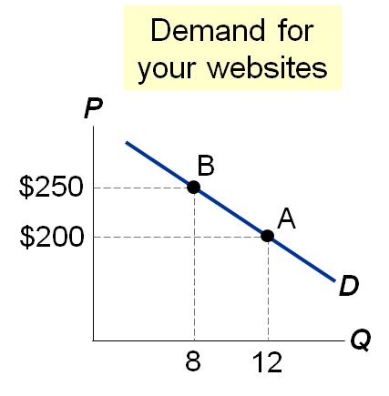
Standard method of computing the percentage (%) change:
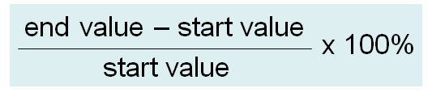
- Going from A to B, the % change in P: $\frac{\$250-\$200}{\$200}=25\%$
- Problem:
  - The standard method gives different answers depending on where you start.
- From A to B,
- P rises 25%, Q falls 33%, elasticity = 33/25 = 1.33
- From B to A,
- P falls 20%, Q rises 50%, elasticity = 50/20 = 2.50
- So we instead use the midpoint method:
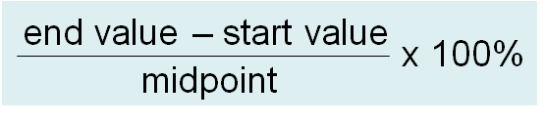
- The midpoint is the number halfway between the start and end vales, the average of those values.
- It doesn’t matter which values you use as the “start” and which as the “end” – you get the same either way!
- Using the midpoint method, the % change in P equals
$$\frac{\$250-\$200}{\$225}×100\%=22.2\%$$
- The % change in Q equals
$$\frac{12-8}{10}×100\%=40.0\%$$
- The price elasticity of demand equals
$$\frac{40}{22.2}=1.8$$

Active Learning 1: Calculate an elasticity
Use the following information to calculate the price elasticity of demand for hotel rooms:
if P = $70, Q^{d} = 5000
if P =$90, Q^{d} = 3000
Use the midpoint method to calculate % change in Q^{d}
$$\frac{5000-3000}{4000}=50\%$$

%change in P
$$\frac{\$90-\$70}{\$80}=25\%$$

The price elasticity of demand equals
$$\frac{50\%}{25\%}=2.0$$

What determines price elasticity?
To learn the determinants of price elasticity, we look at a series of examples. Each compares two common goods.
In each example:
- Suppose the prices of both goods rise by 20%
- The good for which Q^{d} falls the most (in percent) has the highest price elasticity of demand. Which good is it? Why?
- What lesson does the example teach us about the determinants of the price elasticity of demand?

Example 1: Breakfast cereal vs. Sunscreen
- The prices of both of these goods rise by 20%. For which does Q^{d} drop the most? Why?
  - Breakfast cereal has close substitutes (e.g., pancakes, Eggo waffles, leftover pizza), so buyers can easily switch if the price rises.
  - Sunscreen has no close substitutes, so consumers would probably not buy less if its price rises.
- Lesson: Price elasticity is higher when close substitutes are available.

Example 2: “blue Jeans” vs. “Clothing”
- The price of both goods rise by 20% for which good does Q^{d} drop the most? Why?
  - For a narrowly defined good such as blue jeans, there are many substitutes (khakis, shorts, Speedos).
  - There a fewer substitutes available for broadly defined goods. (There aren’t too many substitutes for clothing, other than living in a nudist colony.)
  - In the first alternative there will be a percentage decrease in the quantity of blue jeans demanded.
  - In the second scenario, the price of all clothing rises by 20%, and observe almost no percentage decrease in demand for all clothing.
- Lesson: Price elasticity is higher for narrowly defined goods than broadly defined ones.

Example 3: Insulin vs. Caribbean Cruises
- The prices of both of these goods rise by 20%. For which good does Q^{d} drop the most? Why?
  - To millions of diabetics, insulin is necessity. A rise in its price would cause little or no decrease in demand.
  - A cruise is a luxury. If the prices rises, some people will forego it.
- Lesson: Price elasticity is higher for luxuries than for necessities.

Example 4: Gasoline In the Short Run vs. Gasoline in the Long Run
- The price of gasoline rises 20%. Does Q^{d} drop more in the short run or the long run? Why?
  - There’s not much people can do in the short run, other than ride the bus or carpool.
  - In the long run, people can buy smaller cars or live closer to where they work.
- Lesson: Price elasticity is higher in the long run than the short run.

The Determinant of Price Elasticity: A Summary
The price elasticity of demand depends on:
- The extent to which close substitutes are available
- Whether the good is a necessity or luxury
- How broadly or narrowly the good is defined
- The time horizon- elasticity is higher in the long run than the short run

The Variety of Demand Curves
- The price elasticity of demand is closely related to the slope of the demand curve.
- Rule of thumb: The flatter the curve, the bigger the elasticity. The steeper the curve, the smaller the elasticity.
- Five different classifications of D curves.…

“Perfectly Inelastic Demand” (one extreme case)
$$Price elasticity of demand=\frac{\%change in Q}{\% change in P}=\frac{0\%}{10\%}=0$$

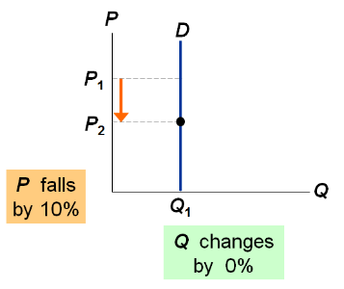
D curve:
Vertical
Consumers’ price sensitivity:
None
Elasticity:
0
- The slope of this curve is the inverse of the slope in the demand function
- When you see a vertical demand curve price elasticity equals zero
- If Q doesn’t change, then the percentage change in Q equals zero, and this elasticity equals zero.
  - Ex. Insulin: a sufficiently large price will reduce demand for insulin a little, particularly among people with v. low incomes and no health insurance.
  - If elasticity is close v. close to zero, then demand curve is almost close to vertical and we can call it “perfectly inelastic”

“Inelastic demand”
$$Price elasticity of demand=\frac{\%change in Q}{\% change in P}=\frac{<10\%}{10\%}=<1$$
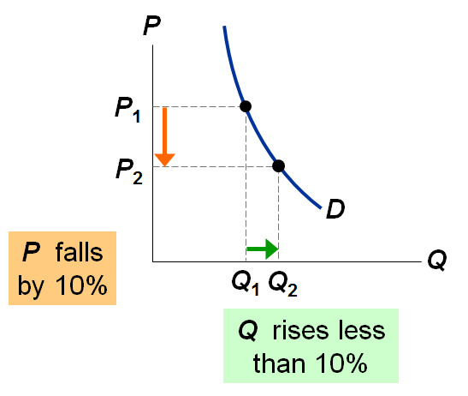
D curve:
relatively steep
Consumers’ price sensitivity:
relatively low
Elasticity:
< 1
- Price elasticity would be small, but not zero
- At a high price some students would not buy their books, but instead will share with a friend, or rather find them in the library, or take copious notes in class
- Ex. gas in the short run

“Unit elastic demand”
$Price elasticity of demand=\frac{\%change in Q}{\% change in P}=\frac{10\%}{10\%}=1$ increase
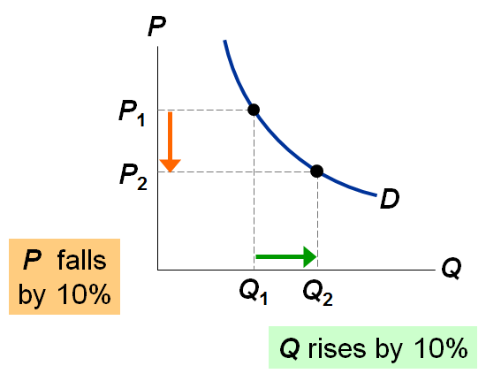
D curve:
intermediate slope
Consumers’ price sensitivity:
intermediate
Elasticity:
1
- 1 is a threshold that can divide between elastic and inelastic demand
- The price change has no effect in the revenue

“Elastic demand”
$$Price elasticity of demand=\frac{\%change in Q}{\% change in P}=\frac{>10\%}{10\%}=>1$$
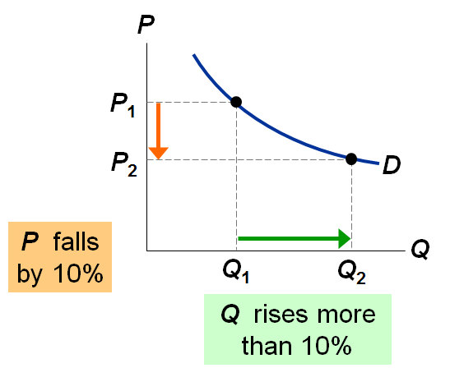
D curve:
Relatively flat
Consumers’ price sensitivity:
Relative high
Elasticity:
> 1
- Ex. breakfast cereal, or anything with readily available substitutes
- its relatively flatter than an inelastic demand curve

“Perfectly elastic demand” (the other extreme)
$$Price elasticity of demand=\frac{\%change in Q}{\% change in P}=\frac{any\%}{0\%}=infinity$$
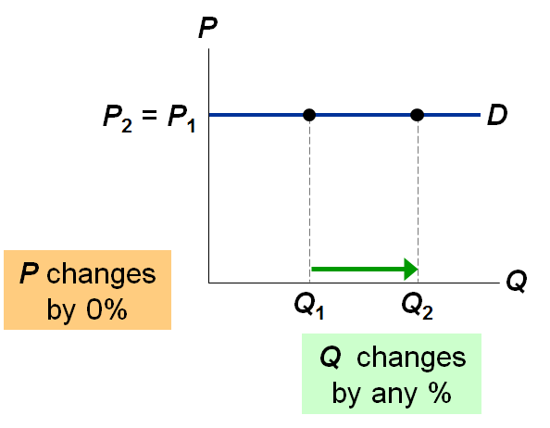
D curve:
horizontal
Consumers’ price sensitivity:
extreme
Elasticity:
infinity
- “Extreme price sensitivity” means the tiniest price increase causes demand to fall to zero.
- “Q changes by any %” when the D curve is horizontal, quantity cannot be determined from the price.
- Consumers might demand Q1 units one month, Q2 units another month, and some other quantity later. Q changes by any amount, but P always “changes by 0%” (i.e., doesn’t change).
  - Ex. a small family farm which grows wheat. The demand curve in this curve is downward-slopping, and the market demand and supply curve determines the price of wheat. Suppose that price is $5/bushel.
Now consider the demand curve facing you, the individual wheat farmer. If you charge a price of $5, you can sell as much or as little as you want. If you charge a price even just a little higher than $5, demand for YOUR wheat will fall to zero: Buyers would not be willing to pay you more than $5 when they could get the same wheat elsewhere for $5. Similarly, if you drop your price below $5, then demand for YOUR wheat will become enormous (not literally infinite, but “almost infinite”): if other wheat farmers are charging $5 and you charge less, then EVERY buyer will want to buy wheat from you.
Why is the demand curve facing an individual producer perfectly elastic? Recall that elasticity is greater when lots of close substitutes are available. In this case, you are selling a product that has many perfect substitutes: the wheat sold by every other farmer is a perfect substitute for the wheat you sell.

Elasticity of a Linear Demand Curve
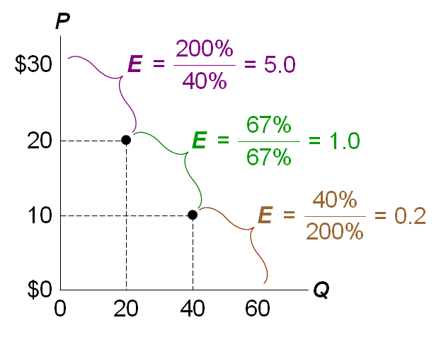
- The slope of a linear demand curve is constant, but its elasticity is not.
  - Calculations of percentage changes use the midpoint ethos
    - As you move down the linear demand curve, the slope remains constant however, the percentage changes in these variables do not remain constant.
    - Elasticity falls as you move downward & rightward along a linear demand curve
- In some bow-shaped curves the slope may not be constant but the price elasticity of demand may be constant.

Price Elasticity and Total Revenue
- Continuing our scenario, if you raise your price from $200 to $250, would your revenue rise or fall?
$$Revenue=P×Q$$
- A price increase has two effects on revenue:
  - Higher P means more revenue on each unit you sell.
  - But you sell fewer units (lower Q), due to Law of Demand.
- Which of these two effects is bigger? It depends on the price elasticity of demand.
- Elasticity of demand is very important to businesses because it helps them plan and make decisions
- The frame works sellers use to make decisions is a cost benefit comparison
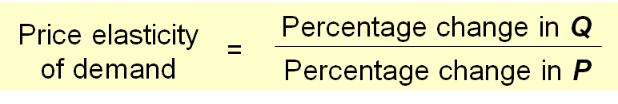
$$Revenue=P×Q$$
- If demand is elastic, then price elast. of demand > 1 and
% change in Q > % change P.
- The fall in revenue from lower Q is greater than the increase in revenue from higher P, so revenue falls.

Demand for websites
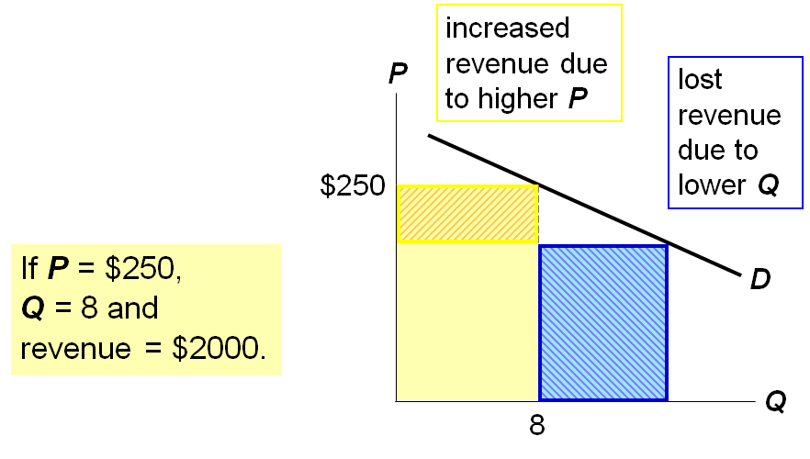
Elastic demand
(elasticity =1 .8)
If P =$200,
Q = 12 and revenue = $2400
If P =$250,
Q = 8 and revenue = $2000
When D is elastic, a price increase causes revenue to fall
- The area is outline in blue and represents lost revenue due to lower Q is larger than the area (outlines in yellow) representing increased revenue due to higher P. Hence the net effect is a fall in revenue
- If demand is inelastic, then price elast. of demand < 1
% change in Q < % change in P
- The fall in revenue from lower Q is smaller than the increase in revenue from higher P, so revenue rises.
- In our example suppose that Q only falls to 10 (instead of 8 when you raise your price to $250

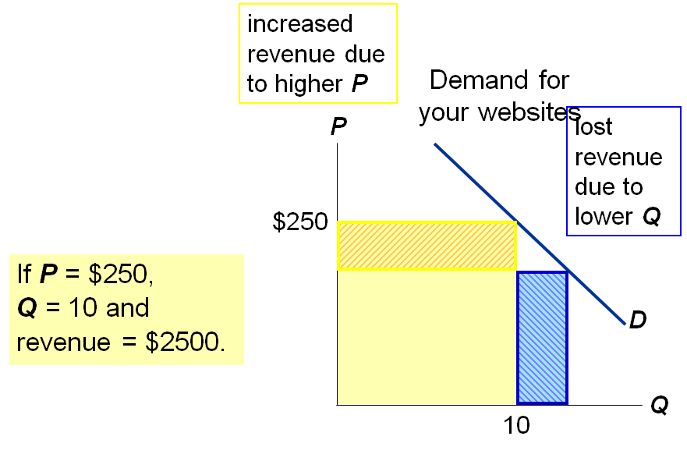
Now, demand is inelastic:
Elasticity = 0.82
If P = $200,
Q = 12 and revenue = $2400
If P = $250,
Q = 10 and revenue =$2500
When D is inelastic, a price increase causes revenue to rise
- The area represents lost revenue due to lower q is smaller than the area representing increased revenue due to higher p which leads to an increase in revenue
  - In this particular case the increase in P leaves revenue unchanged: the increase in revenue from higher P exactly offsets the lost revenue in lower Q

Active Learning 2: Elasticity and expenditure/revenue
- Pharmacies raise the price of insulin by 10%. Does total expenditure on insulin rise or fall?
Expenditure = P x Q
Since demand is inelastic, Q will fall less than 10%, so expenditure rises
- As a result of a fare war, the price of a luxury cruise falls 20%. Does luxury cruise companies’ total revenue rise or fall?
Revenue = P x Q
The fall in P reduces revenue, but Q increases, which increases revenue. Which effect is bigger?
Since demand is elastic, Q will increase more than 20%, so revenue rises.

Exercise:
A customer is about to buy 4 shirts at $20 each. When she finds that they have just gone on sale for $15, she buys 5 shirts instead. Is her demand for these shirts elastic or inelastic?
Price | Quantity demanded | Revenue
$20 | 4 | $80
$15 | 5 | $75
If lower prices caused higher sales revenue, the demand was elastic. I flower prices caused lower sales revenue, the demand was inelastic. In this case, the demand is inelastic.
Alternatively, if you used the midpoint formula,
$$\frac{(5-4)/(4+5)/2}{(80-75)/(80+75)/2}=\frac{0.222}{0.286}=0.77$$
0.77 < 1 which indicates inelastic demand
Note: any elasticity > 1 is elastic
any elasticity < 1 is inelastic

APPLICATION: Does Drug Interdiction Increases or Decrease Drug-Related Crime?
- One side effect of illegal drug use is crime: Users often turn to crime to finance their habit.
- We examine two policies designed to reduce illegal drug use and see what effects they have on drug-related crime.
- For simplicity, we assume the total dollar value of drug-related crime equals total expenditure
on drugs.
- Demand for illegal drugs is inelastic, due to addiction issues.

Policy 1: Interdiction
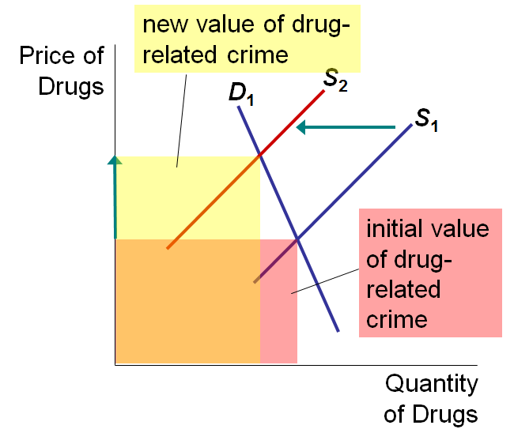
Interdiction reduces the supply of drugs.
Since demand for drugs is inelastic, P rises proportionally more than Q falls.
Result: an increase in total spending on drugs, and in drug-related crime
- The rectangle decreases showing that revenue has decreased
- The revenue increases as a result of price change is larger than the revenue decrease from quantity

Policy 2: Education
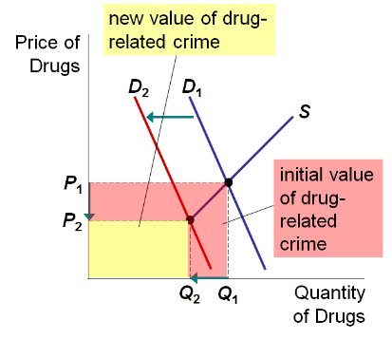
Education reduces the demand for drugs.
P and Q fall.
Result: A decrease in total spending on drugs, and in drug-related crime.

Price Elasticity of Supply
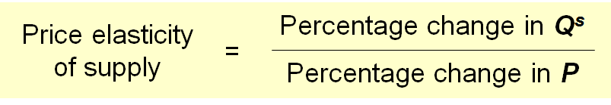
- Price elasticity of supply measures how much Q^{s} responds to a change in P.
- Loosely speaking, it measures sellers’ price-sensitivity.
- Again, use the midpoint method to compute the percentage changes.
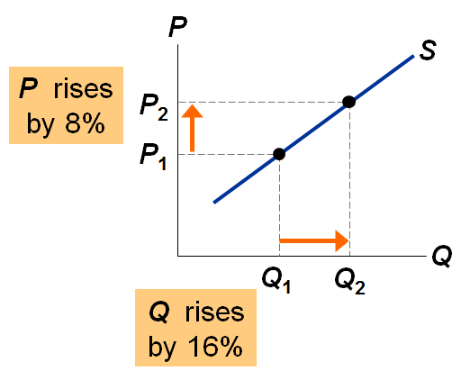

Example:
Price elasticity of supply equals $\frac{16\%}{8\%}=2.0$

The Variety of Supply Curves
- The slope of the supply curve is closely related to price elasticity of supply.
- Rule of thumb: The flatter the curve, the bigger the elasticity. The steeper the curve, the smaller the elasticity.
- Five different classifications.…

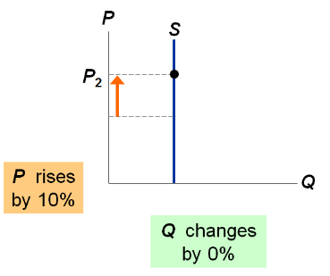
“Perfectly inelastic” (one extreme)
$$Price elasticity of supply=\frac{\% change in Q}{\% change in P}=\frac{0\%}{10\%}=$$
S curve:
Vertical
Sellers’ price sensitivity:
None
Elasticity:
0

“Inelastic”
$$Price elasticity of supply=\frac{\% change in Q}{\% change in P}=\frac{<10\%}{10\%}=<1$$
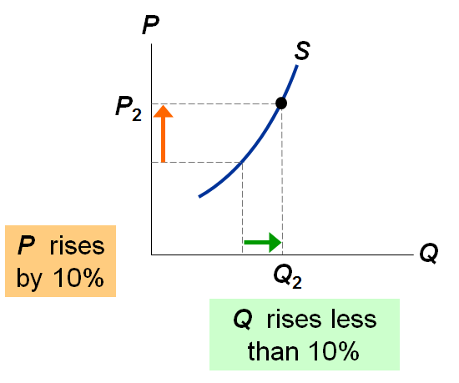
S curve:
Relatively steep
Sellers’ price sensitivity:
Relatively low
Elasticity:
< 1

“Unit elastic”
$$Price elasticity of supply=\frac{\% change in Q}{\% change in P}=\frac{10\%}{10\%}=1$$
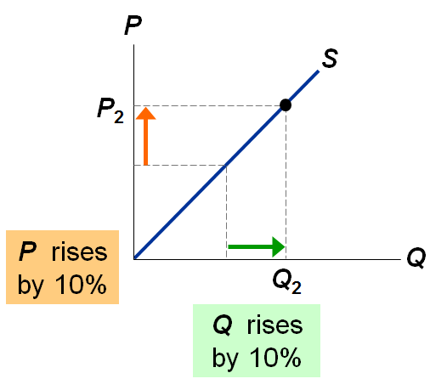
S curve:
Intermediate slope
Sellers’ price sensitivity:
intermediate
Elasticity:
= 1

“Elastic”
$$Price elasticity of supply=\frac{\% change in Q}{\% change in P}=\frac{>10\%}{10\%}= >1$$

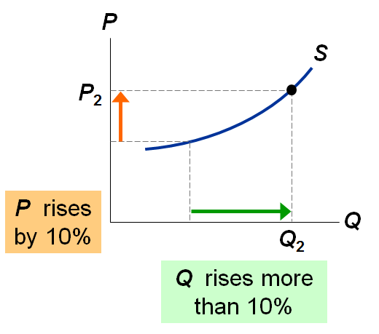
S curve:
Relatively flat
Sellers’ price sensitivity:
Relatively high
Elasticity:
> 1

“Perfectly elastic” (the other extreme)
$$Price elasticity of supply=\frac{\% change in Q}{\% change in P}=\frac{any\%}{0\%}=infinity$$
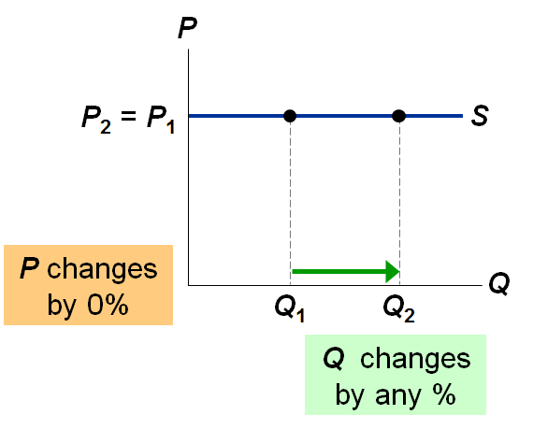
S curve:
horizontal
Sellers’ price sensitivity:
extreme
Elasticity:
Infinity

The Determinants of Supply Elasticity
- The more easily sellers can change the quantity they produce, the greater the price elasticity of supply.
  - Example: Supply of beachfront property is harder to vary and thus less elastic than
supply of new cars.
- For many goods, price elasticity of supply is greater in the long run than in the short run, because firms can build new factories, or new firms may be able to enter the market.

Active Learning 3: Elasticity and changes in equilibrium
- The supply of beachfront property is inelastic. The supply of new cars is elastic.
- Suppose population growth causes demand for both goods to double (at each price, Q^{d} doubles).
- For which product will P change the most?
- For which product will Q change the most?
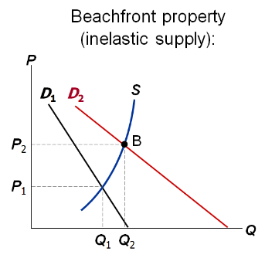
- When supply is inelastic, an increase in demand has a bigger impact on price than on quantity
- The D curve shifts to the right but not in parallel fashion: at each price, quantity demanded is twice as high, so the new D curve will be flatter than the initial one

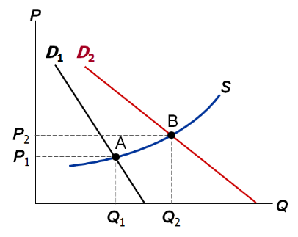
When supply is elastic, an increase in demand has a bigger impact on quantity than on price

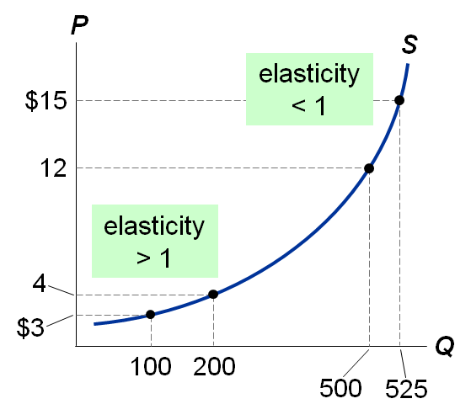
How the Price Elasticity of Supply Can Vary
- Supply often becomes less elastic as Q rises, due to capacity limits.
- When the price rises from $3 to $4 (29% increase), quantity rises from 100 to 120 (or 67%). Because 67% > 29%, price elasticity of supply is greater than one. When the price rises from $12 to $15 (22%), quantity rises from 500 to 525 (about 5%), so price elasticity of supply is less than one.
- Low output- relatively easy for firms to increase output further
- High output- relative expensive for firms to increase output further
- Short run- Eventually firms will bump up against their capacity constraints, and simply cannot increase output in response to further price increases
- Long run- firms can build more factories and new firms can enter the market depending on the market structure

Other Elasticities
- Income elasticity of demand: measures the response of Q^{d} to change in consumer income
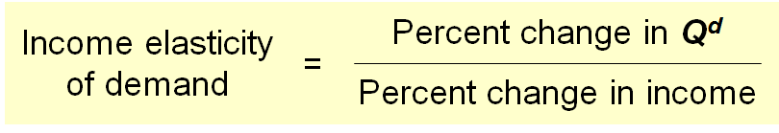
- Recall from Chapter 4: An increase in income causes an increase in demand for a normal good.
- Hence, for normal goods, income elasticity > 0.
- For inferior goods, income elasticity < 0.
- Cross-price elasticity of demand: measures the response of demand for one good to changes in the price of another good.
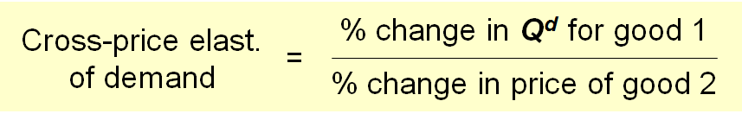
- For substitutes, cross-price elasticity > 0
  - (e.g., an increase in price of beef causes an increase in demand for chicken)
- For complements, cross-price elasticity < 0.
  - (e.g., an increase in price of computers causes decrease in demand for software)

Chapter Summary
- Elasticity measures the responsiveness of Q^{d} or Q^{s} to one of its determinants.
- Price elasticity of demand equals percentage change in Q^{d} divided by percentage change in P.
When it’s less than one, demand is “inelastic.” When greater than one, demand is “elastic.”
- When demand is inelastic, total revenue rises when price rises. When demand is elastic, total revenue falls when price rises.
- Demand is less elastic in the short run, for necessities, for broadly defined goods, or for goods with few close substitutes.
- Price elasticity of supply equals percentage change in Q^{s} divided by percentage change in P. When it’s less than one, supply is “inelastic.” When greater than one, supply is “elastic.”
- Price elasticity of supply is greater in the long run than in the short run.
- The income elasticity of demand measures how much quantity demanded responds to changes in buyers’ incomes.
- The cross-price elasticity of demand measures how much demand for one good responds to changes in the price of another good.

Chapter 6

Supply, Demand and Government Policies

Government Policies that Alter the Private Market Outcome
- Efficiency and equity are used to evaluate between a good and bad market policy
- Market outcome is relied upon in order to understand whether gov’t policy is good or bad
- Price controls
  - Price ceiling: a legal maximum on the price
of a good or service Example: rent control
  - Price floor: a legal minimum on the price of
a good or service Example: minimum wage
- Taxes
  - The gov’t can make buyers or sellers pay a specific amount on each unit bought/sold.
- We will use the supply/demand model to see how each policy affects the market outcome (the price buyers pay, the price sellers receive, and the eq’m quantity)

Example 1: The Market for Apartments
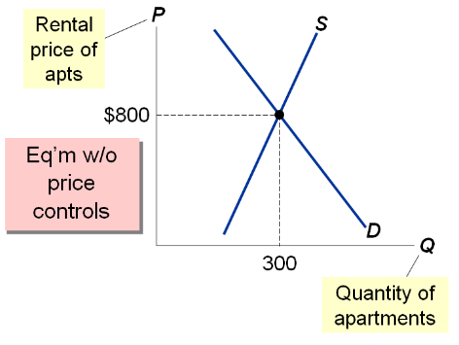
- The most common example on the effects of price ceiling is rent
- In this diagram, the market is in equilibrium
- If there is no gov’t policy enacted, the markets equilibrium price may be $800 assuming we are looking at a small community of where there’s only 300 apartments
- Because gov’t wants to help low income families, they may put a price ceiling unto the rent. For it to work, the market price must be less than the market equilibrium price

How Price Ceiling Affect Market Outcomes
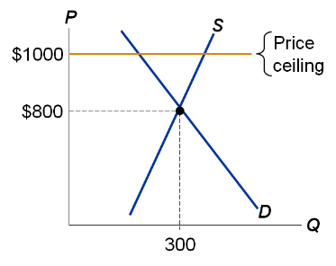
- A price ceiling above the equilibrium price is not binding- has no effect on the market outcome
Why does the price ceiling not result in a surplus?
When the price ceiling is above the equilibrium price, the equilibrium price is still perfectly legal. Just because landlords are allowed to charge $1000 rent doesn’t mean they will – if they do, they won’t be able to rent all of their apartments – a surplus will result, causing downward pressure on the price (rent). There’s no law that prevents the price (rent) from falling, so it does fall until the surplus is gone and equilibrium is reached (at P = $800 and Q = 300).
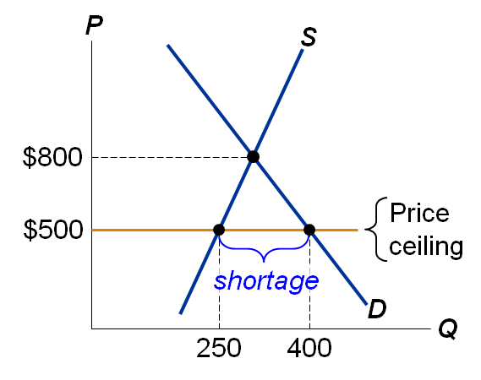
- The equilibrium price ($800) is above the ceiling and therefore illegal
- The ceiling is a binding constraint on the price, causes a shortage.
In this case, the price ceiling is binding.
In the new equilibrium with the price ceiling, the actual price (rent) of an apartment will be $500. It won’t be more than that, because any higher price is illegal. It won’t be less than $500, because the shortage would be even larger if the price were lower.
The actual quantity of apartments rented equals 250, and there is a shortage equal to 150 (the difference between the quantity demanded, 400, and the quantity supplied, 250).

Shortages and Rationing
- With a shortage, sellers must ration the goods among buyers.
- Some rationing mechanisms: (1) Long lines, (2) Discrimination according to sellers’ biases
- These mechanisms are often unfair, and inefficient: the goods do not necessarily go to the buyers who value them most highly.
- In contrast, when prices are not controlled, the rationing mechanism is efficient (the goods go to the buyers that value them most highly) and impersonal (and thus fair).
- Landlords use rationing techniques to select the tenants. Ex. No smoking, no pets
- The shortage between supply and demand because price controls will be larger when production size is smaller

Example 2: The Market for Unskilled Labour
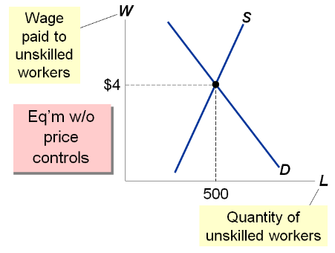
- Minimum wage is another common example
- The price of the labour is the wage measured on the vertical axis
- Horizontal axis measures the quantity of labour (# of workers)
- The demand of unskilled labour comes from firms; supply come from workers
- For a price floor to have an effect on the market equilibrium price, it must be binding which means it must be higher than the original market equilibrium price

How Price Floors Affect Market Outcome
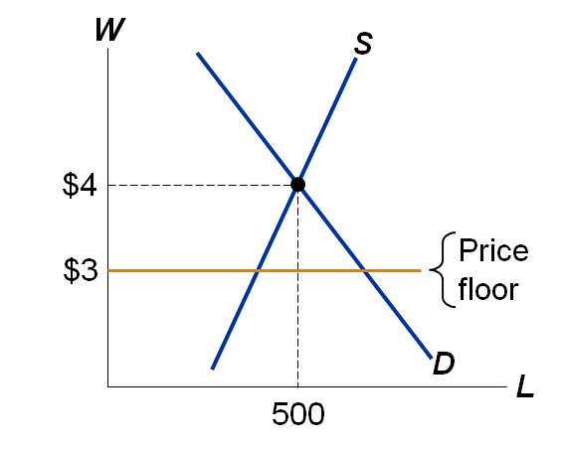
- A price floor below the eq’m price is not binding- has no effect on the market outcome
Why the $3 price floor does not cause a shortage?
After all, at a wage of $3, the quantity of unskilled workers that firms wish to hire exceeds the quantity of unskilled workers that are looking for jobs.
But the minimum wage law does not stop the wage from rising above $3. So, in response to this shortage, the wage will rise until the shortage disappears – which occurs at the equilibrium wage of $4. The equilibrium wage is perfectly legal when the price floor (i.e. minimum wage) is below it.

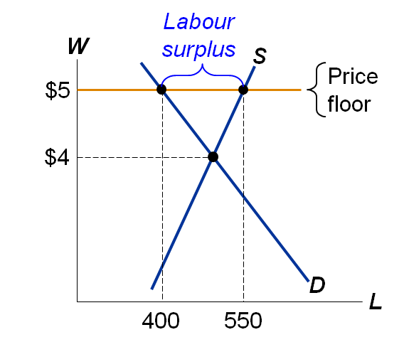
- The eq’m wage ($4) is below the floor and therefore illegal
- The floor is a binding constraint on the wage, causes a surplus (i.e., unemployment).
- The actual wage will be $5. It will not be lower, because any lower wage is illegal. It will not be higher, because at any higher wage, the surplus would be even greater. The actual number of unskilled workers with jobs equals 400. 550 want jobs, but firms are only willing to hire 400, leaving a surplus of 150 workers.
- A surplus of anything – especially labour – represents wasted resources.

Minimum Wage
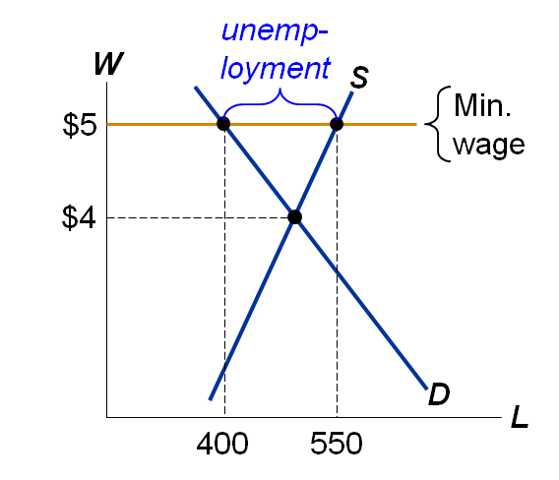
Minimum wage laws do not affect highly skilled workers
They do affect teen workers
Studies: A 10% increase in min wage raises teen unemployment 1-3%
- With an increase in minimum wages, businesses are less willing to pay more for a highly skilled labour position which results in a higher proportion of unskilled labour without jobs because businesses is unwilling to higher them
- Minimum wage market helps low-income families
- In the tradition sense, minimum wage is considered bad because it creates an unbalance within the labour market
  - in the long run, price elasticity of supply and later demand will be higher

Minimum-Wage Rates across Canada


Active Learning 1- Price Controls
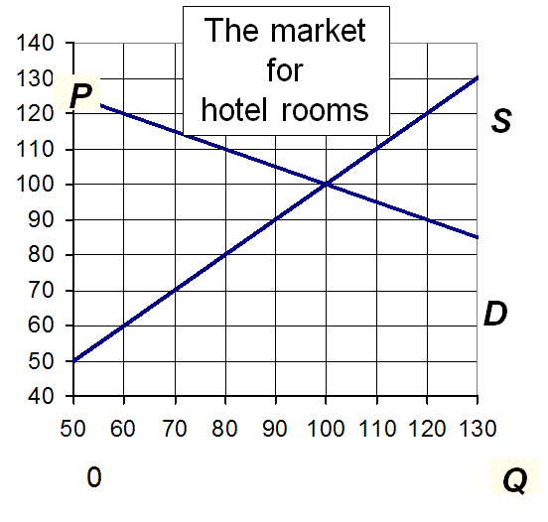
Determine the effects of:
      - $90 price ceiling
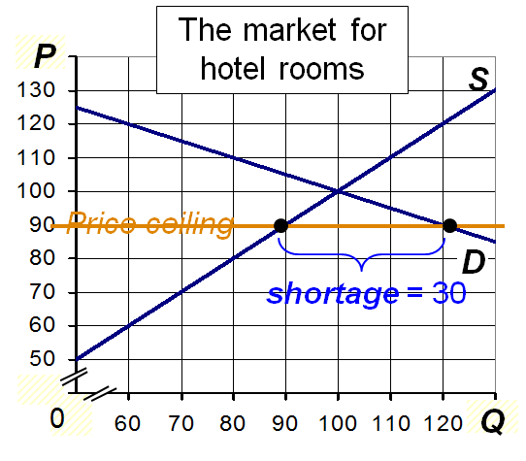
- The price falls to $90
- Buyers demand 120 rooms, sellers supply 9-, leaving a shortage

      - $90 price floor
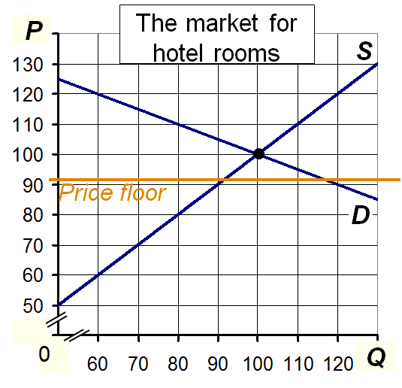
- Eq’m price is above the floor, so is not biding
P = $100
Q = 100 rooms

- $120 price floor
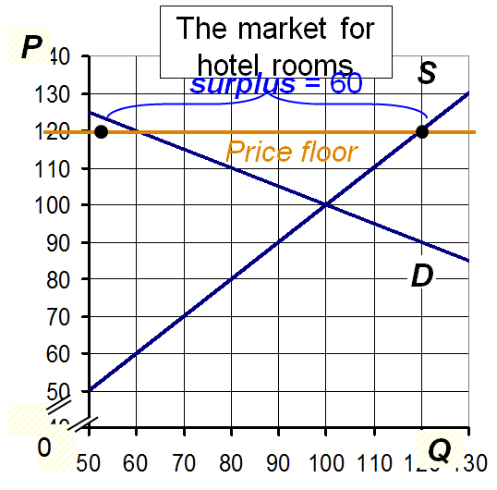
- The prices rises to $120
- Buyers demand 60 rooms, sellers supply 120, causing a surplus

Evaluating Price Controls
- Recall one of the Ten Principles from Chapter 1:
Markets are usually a good way to organize economic activity.
- Prices are the signals that guide the allocation of society’s resources. This allocation is altered when policymakers restrict prices.
- Price controls often intended to help the poor, but often hurt more than help.

Taxes
- The gov’t levies taxes on many goods & services to raise revenue to pay for national defense, public schools, etc.
- The gov’t can make buyers or sellers pay the tax.
  - The gov’t creates revenue through taxes.
  - Income tax is the largest source of gov’t revenue
    - Income/Corporate Tax
  - 2nd largest form of gov’t revenue is Consumption Tax
- The tax can be a % of the good’s price, or a specific amount for each unit sold.
  - For simplicity, we analyze per-unit taxes only.

Example 3: The Market for Pizza
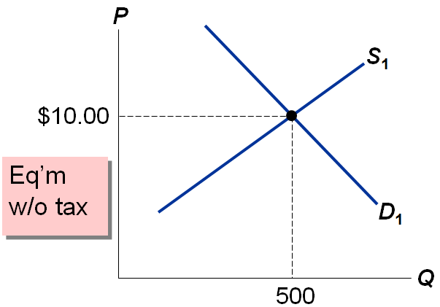

Tax on Buyers
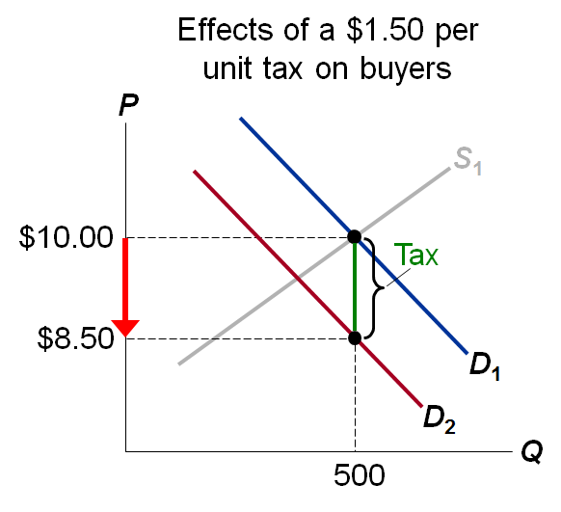
Hence, a tax on buyers shifts shift the D curve down by the amount of the tax
P would have to fall by $1.50 to make buyers willing to buy same Q as before
E.g., if P falls from $10.00 to $8.50, buyers still willing to purchase 500 pizza
The government makes buyers pay a $1.50 on each pizza they purchase. The new demand curve (D₂) reflects buyers’ demand as a function of the after-tax price. The original demand curve still reflects buyers’ demand as a function of the total price – inclusive of the tax.
Thus, buyers’ demand hasn’t really changed: at each quantity, the height of the original (blue) D curve is still the maximum that buyers will pay for that quantity, while the height of the new (red) D curve is the maximum that buyers will pay sellers for that quantity, given that buyers also must pay the tax. At any Q, the vertical distance between the blue and red D curves equals the tax.
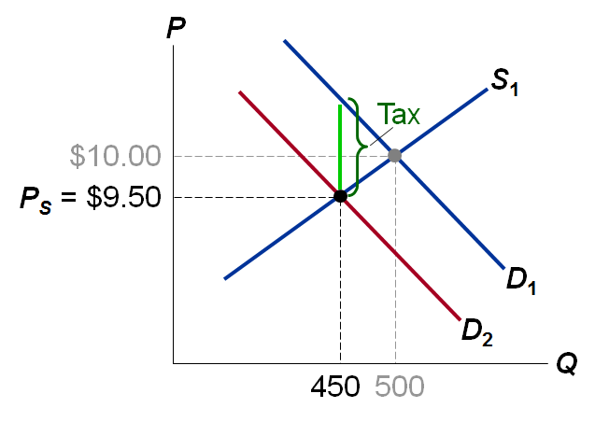
New eq’m
Q = 450
Sellers receive
P_{S} = $9.50
Buyers pay
P_{B} = $11.00
Difference between them = $1.50 = tax

The Incidence of a Tax: how the burden of a tax is shared among market participants
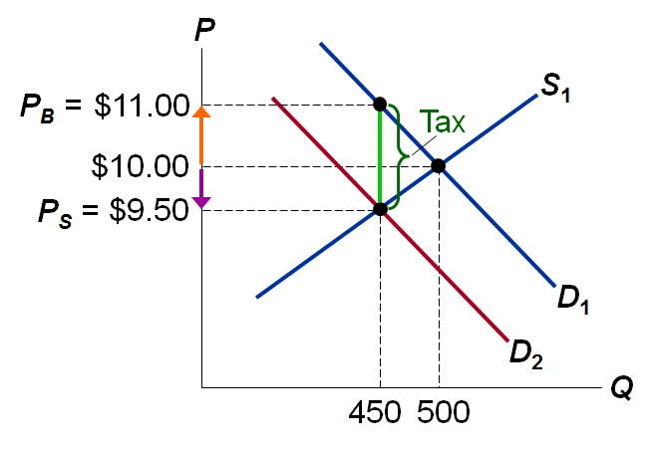

In our example,
Buyers pay $1.00 more
Sellers get $0.50 less

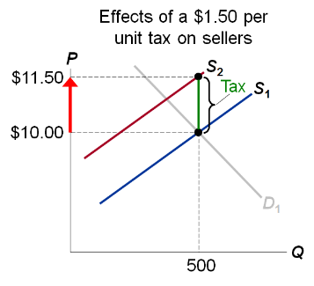
A Tax on Sellers

The tax effectively raises sellers’ costs by $1.50 per pizza
Sellers will supply 500 pizzas only if P rises to $11.50 to compensate for the tax increase

Hence a tax on sellers shift the S curve up by the amount of tax.
The government makes sellers pay $150 on each pizza they sell.
The new, red supply curve reflects seller’s supply as the function of the after-tax price
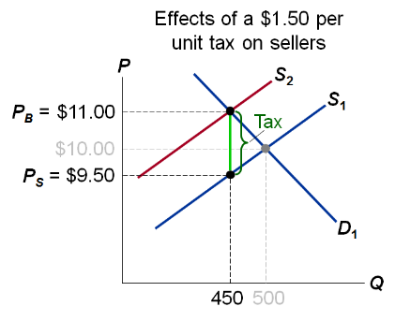
New eq’m:
Q = 450
Buyers pay
P_{B} = $11.00
Sellers
receive
P_{S} = $9.50
Difference between them
= $1.50 = tax

The Outcome is the Same in Both Cases
The effect on P and Q, and the tax incidence are the same whether the tax is imposed on buyers or sellers!
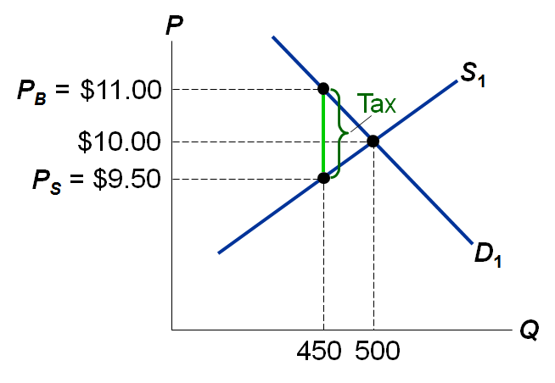
What matters in this: a tax drives a wedge between the price buyers pay and the price sellers receive
Whether the government makes buyers or sellers pay the tax, all of the effects are the same:
- the price buyers pay rises (in this case to $11)
- the price sellers receive falls (to $9.50)
- the equilibrium quantity falls (to 450)
- the incidence of the tax is the same (here, buyers pay $1 of the tax, while sellers pay $0.50 of the tax on each unit)
A tax on buyers means buyers will have to pay more, which causes their demand to fall. The fall in demand hurts sellers, forcing them to reduce their price. Similarly, a tax on sellers is like a cost increase, and sellers pass along a portion of that increase to buyers in the form of higher prices.

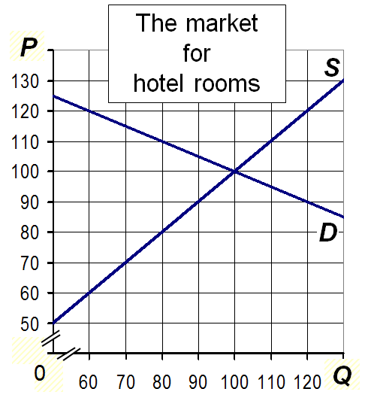
Active Learning 2: Effects of tax

Suppose gov’t impose a tax on buyers of $30 per room. Find Q, P_{B}, P_{s}, and incidence tax.

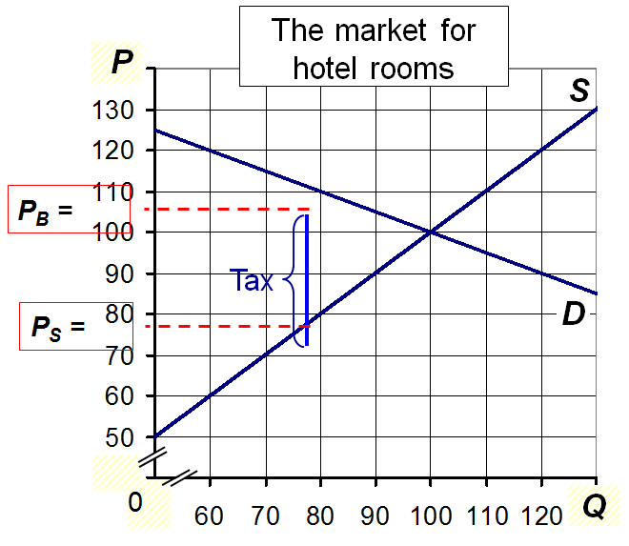

Q = 80
P_{B} = $110
P_{S} = $80

Incidence
Buyers: $10
Sellers: $20

The equilibrium quantity is the quantity where P_{B} – P_{S} = $30. This quantity is 80.
Next, to find P_{B}, start at Q=80 and go up to the demand curve to see that P_{B} = $110.
To find P_{S}, start at Q=80 and go up to the supply curve to see that P_{S} = $80.
To find incidence, just compare P_{B} and P_{S} to the no-tax equilibrium price, $100.

Elasticity and Tax Incidence
CASE 1: Supply is more elastic than demand
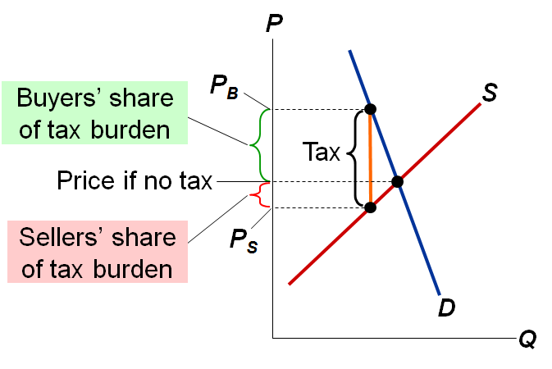
It’s easier for sellers than buyers to leave the market. So buyers bear most of the burden of the tax.
When supply is more price-elastic than demand, sellers are relatively more responsive to changes in price, and the supply curve is less steep than the demand curve. Buyers have relatively fewer alternatives, so they have to “eat” most of the price increase caused by the imposition of the tax.

CASE 2: Demand is more elastic than supply
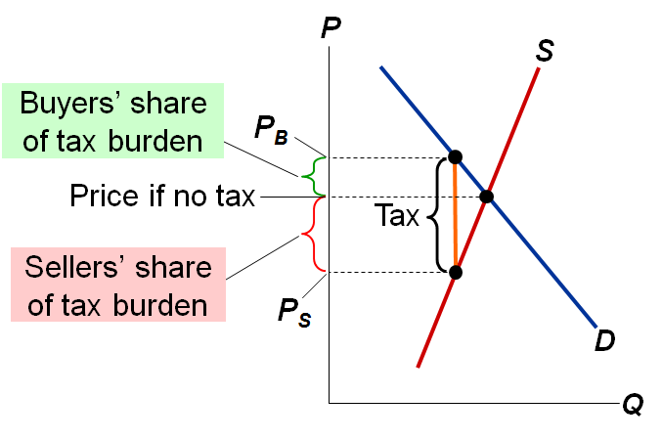
It’s easier for buyers and sellers to leave the market. Sellers bear most of the burden of tax
When demand is more price-elastic than supply, buyers are relatively more price-sensitive, and the demand curve is less steep than the supply curve. Buyers have relatively more alternatives, so they can avoid most of the tax. Sellers are less flexible, so they have to “eat” a greater share of the price increase caused by the tax.

CASE STUDY: Can Parliament Distribute the Burden of a Payroll Tax?
- In 2010, the total Employment Insurance tax for the typical worker was about 4 percent of earnings.
- The federal government uses the revenue from the EI tax to pay for benefits to unemployed workers, as well as for training programs and other policies.
- Who do you think bears the burden of this payroll tax—firms or workers?
- According to the law, 58 percent of the tax is paid by firms, and 42 percent is paid by workers.
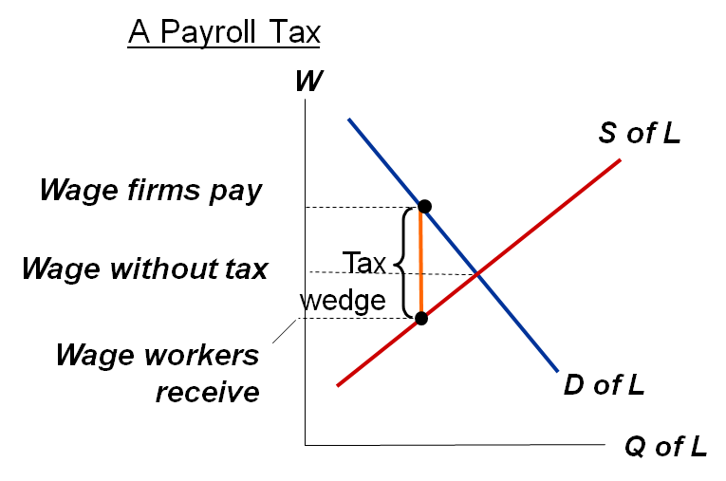
A payroll tax places a wedge between the wage that workers receive and the wage that firms pay. Comparing wages with and without the tax, you can see that workers and firms share the tax burden. This division of the tax burden between workers and firms does not depend on whether the government levies the tax on workers, levies the tax on firms, or divides the tax equally between the two groups.

CONCLUSION: Government Policies and the Allocation of Resources
- Each of the policies in this chapter affects the allocation of society’s resources.
- Example 1: A tax on pizza reduces eq’m Q.
  - With less production of pizza, resources (workers, ovens, cheese) will become available to other industries.
- Example 2: A binding minimum wage causes:
  - A surplus of workers, a waste of resources.
- So, it’s important for policymakers to apply such policies very carefully.
From the 10 Principals of Economics: Markets are usually a good way to organise economic activity. This means that, in absence of market failures, the allocation of resources resulting from the free market equilibrium is optimal. Hence, government policies which alter this allocation tend to make the economy worse off.

CHAPTER SUMMARY
- A price ceiling is a legal maximum on the price of a good. An example is rent control. If the price ceiling is below the eq’m price, it is binding and causes a shortage.
- A price floor is a legal minimum on the price of a good. An example is the minimum wage. If the price floor is above the eq’m price, it is binding and causes a surplus. The labour surplus caused by the minimum wage is unemployment.
- A tax on a good places a wedge between the price buyers pay and the price sellers receive, and causes the eq’m quantity to fall, whether the tax is imposed on buyers or sellers.
- The incidence of a tax is the division of the burden of the tax between buyers and sellers, and does not depend on whether the tax is imposed on buyers or sellers.
- The incidence of the tax depends on the price elasticities of supply and demand.

