Chapter 1

Ten Principles of Economics

Why are decisions made- To find what is best or you within your limited resources
How People Make Decisions
The first four principles discuss how individuals make decisions because the behaviour an economy reflects the behaviour of the individuals who make up the economy.

Principle #1: People face trade-off
- All decisions involve trade-off
  - ex. Going to a party the night before an exam leaves less time for studying.
- Society faces an important trade-off: efficiency vs. equality
- Efficiency: society gets the most from its scarce resources, i.e. the size of the economic pie
- Equity: when prosperity is distributed uniformly among society members, i.e. how the economic pie is divided
- The principle of Trade-off is that you cannot gain one thing without losing something else.

Principle #2: The Cost of Something is What You Give Up to get it
- All decision requires comparing the costs and benefits of alternative costs
- All decisions require opportunity costs. Ex. The cost of going to university is not only the payment of tuition costs and books but also the cost of forgone wages
- When making decisions, one must look at direct cost and opportunity costs

Principle #3: Rational People Think at the Margin
Rational People:
- Systematically and purposefully do their best they can to achieve their objectives
- Evaluate the cost and benefits of marginal changes- incremental adjustments to an existing plan. Ex. Fixing a whole car or just an important part of the car

Principle #4: People Respond to Incentives
- Incentive: something that induces a person to act, i.e. the prospect of a reward or punishment
- Rational people respond to incentives. Ex. When gas prices rise consumers buy more hybrid cars and fewer gas guzzling SUVs
- Rational people will choose the option that will give you the greatest benefit
- Rational people try their best to achieve their objectives
  - Doesn’t have to be economical or monetary incentives but can be spiritual, emotional incentives

Active Learning 1
You are selling your 1996 Mustang. You have already spent $1000 on repairs.
At the last minute, the transmission dies. You can pay $600 to have it repaired, or sell the car “as is.”
In each of the following scenarios, should you have the transmission repaired? Explain.
- Blue book value is $6500 if transmission works, $5700 is if doesn’t.
Cost of fixing transmission = $600
Benefits of fixing transmission =$800
(6500-5700)
It’s worthwhile to have transmission fixed
- Blue book value is $6000 if transmission works, $5500 if it doesn’t
Cost of fixing transmission = $600
Benefit of fixing transmission = $500
(6000-5500)
Paying $600 to fix the transmission is not worthwhile in this case
Observations
- The $1000 you previously spent on repairs is irrelevant. What matters is the cost and benefit of the marginal repair (the transmission).
- The change in incentives from scenario A
to scenario B caused your decision to change.

How People Interact
The next three principles concern how people interact with one another because many of our decision affect not only ourselves but other people as well.

Principle #5: Trade Can Make Everyone Better Off
- Rather than being self-sufficient it is more efficient for each person to specialize in producing a good or service, then trading it with other people for the things they produce.
- Countries also benefit from trade & specialization:
  - Get better prices abroad for goods they produce
  - Buy other goods cheaply from abroad than could be produced at home
  - Gives a country’s consumers access to a greater variety of goods. Ex fresh year-round products
    - Trade between two country can make each country better off

Principle #6: Markets are usually a Good Way to Organise Economic Activity
- Market: a group of buyers and sellers (need not be in a single location)
- Commodity market- goods
- Geographic market- ex. Ontario market
- “Organise economic activity” means determining
- what goods to produce
- how to produce them
- how much of each to produce
- who gets them
- a markets economy is decentralized- no government committee that makes the decisions about what goods
- a market economy is led by an invisible hand to which promotes the general economic well-being
- The invisible hand works through the price system
  - the interaction of buyers and sellers determine prices
  - each price reflects the good’s value to buyers and the cost of producing the good
  - price guide self-interest households and firms to make decisions that, in many cases maximize society’s economic well-being

Principle #7: Government can Sometimes Improve Market Outcomes
- Important role of gov’t: enforce property rights (with police, courts, etc.)
- People are less inclined to work, produce, invest or purchase if large risk of their property being stolen
- Two broad reasons for government to intervene in the economy: to promote efficiency and to promote equity
- Market failure: when market fails to allocate society’s resources efficiently
- Causes:
- Externalities: when the production or consumption of a good affects bystanders (e.g. pollution)
- Market Power: a single buyer or seller has substantial influence on market price (e.g. monopoly)
- In such cases, public policy may promote efficiency
- Gov’t may alter market outcome to promote equity
- If the market’s distribution of economic well-being is not desirable, tax or welfare policies can change how the economic “pie” is divided.

Active Learning 2- Discussion Questions
In each of the following situations, what is the government’s role? Does the government’s intervention improve the outcome?
- Public school for K-12
- Workplace safety regulations
- Public highways
- Patent laws, which allow drug companies to charge high prices for life-saving drugs

How the Economy as a Whole Works
The last three principles concern the workings of the economy as a whole. How individuals make decisions and people interact with one another together make up the “economy”.

Principle #8: A Country’s Standard of Living depends on its Ability to Produce Goods and Services
- Huge variation in living standards across countries over time:
  - Average income in rich countries is more than ten times average income in poor countries.
  - The Canadian standard of living today is about eight times larger than 100 years ago.
- Standard of living depends on productivity- the amount of goods and serviced being produced from each hour of a worker’s time.
- Productivity depends on equipment, skills and technology available to the workers.
- In the study of economics other factors (e.g. labour unions, competition from abroad) have less impact on the standard of living
- Gross Domestic Product (GDD): aggregate market value within a certain country within a certain economic period of time
  - Economics mostly only deals with potential GDP

Principle #9: Prices Rise when the Government Prints too much Money
- Causes Inflation
  - increase in the general level of price (economic phenomenon)
  - caused by excessive growth in the quantity of money which causes the value of money to fall
  - a healthy economy must have an efficient system to monitor the circulation of money
  - faster money circulates within the economy lowers the demand for money
  - too much money in the market causes inflation b/c the value of money decreases
- oversupply = rise in prices
- QE - quantitive easing: government policy that adds money into the economy in order to increase the circulation

Principle #10: Society Faces a Short-Run Trade-off between Inflation and Unemployment
- Inflation means money supply > money demand
- Inflation provides incentives to producers because their fixed costs would reduce
- Leads to increase in production which leads to increase in employees
- If inflation rate > 10% = hyperinflation- everybody loses
- 2% inflation rate is acceptable by developed countries- may affect ability to produce and actual purchasing power
- In the short-run (1 – 2 years), many economic policies push inflation and unemployment in opposite directions.
- Other factors can make this tradeoff more or less favourable, but the tradeoff is always present.

Chapter Summary
- The principles of decision making are:
- People face tradeoffs.
- The cost of any action is measured in terms of foregone opportunities.
- Rational people make decisions by comparing marginal costs and marginal benefits.
- People respond to incentives.
- The principles of interactions among people are:
  - Trade can be mutually beneficial.
  - Markets are usually a good way of coordinating trade.
  - Gov’t can potentially improve market outcomes if there is a market failure or if the market outcome is inequitable.
The principles of the economy as a whole are:
- Productivity is the ultimate source of living standards.
- Money growth is the ultimate source of inflation.
- Society faces a short-run tradeoff between inflation and unemployment.

Chapter 2

Thinking like an Economist

The Economist as Scientist
- Economist play two roles:
- Scientist: try to explain the world
- Policy advisors: try to improve it
- In the first, economist employs the scientific method, the dispassionate development and testing of theories about how the world works

Assumptions & Models
- Assumptions simplify the complex world, making it easier to understand
- Ex. To study international trade assume that there are only two countries and two goods – unrealistic, but simple to learn and gives insights about the real world
- Model: a highly simplified representation of a more complicated reality. Economist use models to study economic issues

Our First Model: The Circular-Flow Diagram
- The Circular-Flow Diagram: a visual model of the economy, shows how dollars flow through markets among households and firms
- Two types of “actors” within the economy
  - Households: they own the factors of production and consume all the goods and services that the firms produces
  - Firms: produce goods and services using inputs, e.g. Labour, land (natural resources), and capital (buildings and machines)
- Two markets:
  - The market for goods and services: in this market, households are buyers and firms are sellers. In this market, households buy the output of goods and services that firms produce
  - The market for “factors of production”: in the market, households are the sellers and firms are the buyers. In this market households provide the input that the firms use to produce goods and services

Factors of Production
- Factors of production: the resources the economy uses to produce goods & services, including
  - Labour
  - Land
  - Capital (buildings & machines used in production)
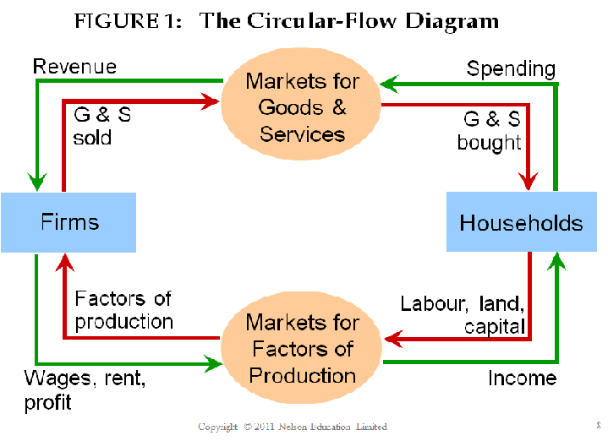
- The red arrow represents flows of goods & services (including the factors of production in the lower half of the diagram – the households sell the use of labour, land and capital to the firms in the markets for these factors of production. The firms then use these factors to produce goods and services, which are later sold to households in the market for goods and services. The FoP flow from households to firms, and goods and services flow from firms to households
- The green arrow represents the flows of income/payments – the household spend money to buy goods and services from the firms. The firms use some of the revenue from these sales to pay for the FoP, e.g. wages for their workers. What’s left is the profit of the firm owners, who are also members of households. Spending on goods and services flows from households to firm, and income of wages, rent and profit flows from firms to household
- The government financial system, and foreign sector was omitted to keep the graph simple

Our Second Model: The Production Possibilities Frontier
- The Production Possibilities Frontier (PPF): a graph that shows the combination of two goods the economy can possibly produce given the available resources and the available technology
- Ex
  - Tw goods: computer and wheat
  - One resource: labour (measured in hours)
  - Economy has 50,000 labour hours per month available for production
  - Producing one computer requires 100 hours labour
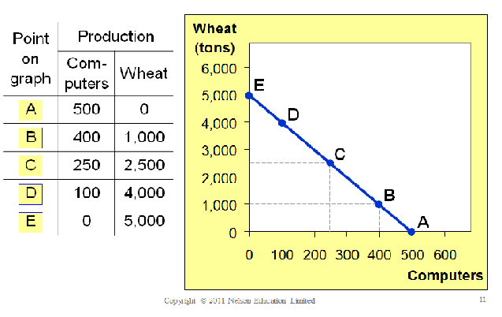
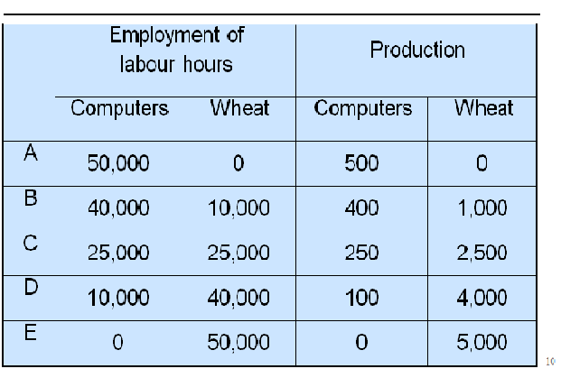
  - Producing one ton of wheat requires 10 hours of labour

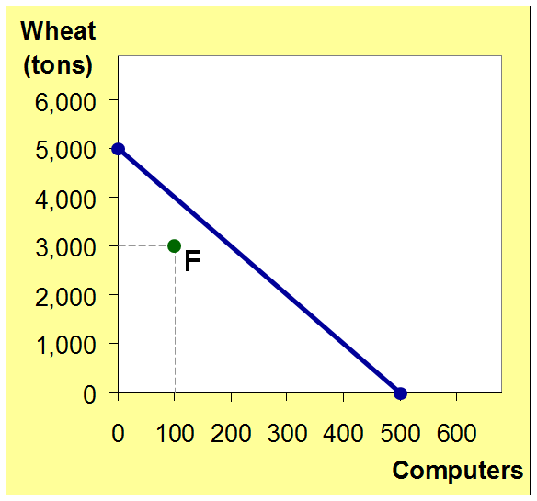
Active Learning 1: Point off the PPF
- On the the graph, find the point that represents (100 computers, 3000 tons of wheat), label it F. Would it be possible for the economy to produce this combination of the two goods? Why or why not?
- Point F: 100 computers, 3000 tons wheat
- Point F requires 40,000 hours of labour. Possible but not efficient: could get more of either good without sacrificing any of the other
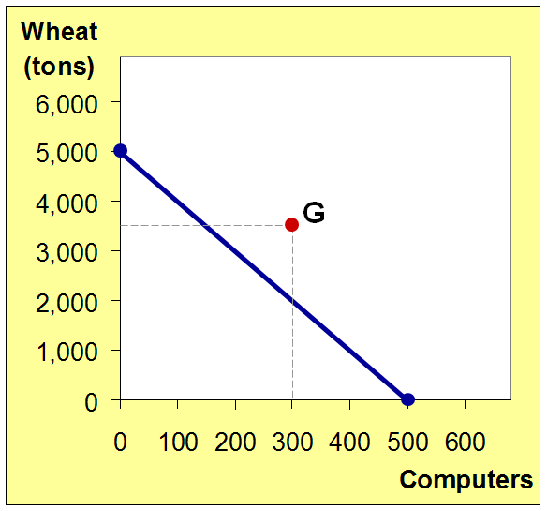
- Next, find the point that represents (300 computers, 3500 tons of wheat), label it G. Would it be possible for the economy to produce this combination of the two goods?
- Point G: 300 computers, 3500 tons wheat
- Point G requires 65,000 hours of labour. Not possible because economy only has 50,000 hours

The PPF: What we know so Far
- Points on the PPPF (like A – E)
  - Possible
  - Efficient: all resources are fully utilised
- Points under the PPF (like F)
  - Possible
  - Not efficient: some resources underutilised (e.g. workers unemployed, factories idle)
- Points above the PPF ( alike G)
  - Not possible –resources aren’t available

The PPF and Opportunity Cost
- Recall: the opportunity cost of an item is what must be given up to obtain that item
- Moving along a PPF involved shifting resources (e.g. labour from the production of one good to the other)
- Society faces trade-off: getting more of one goods requires sacrificing some of the other – first principle of economics
- The slope of the PPF tells the opportunity cost of one good in terms of the other
- Slope = rise/run
  - The amount the line rises/decreases when you move to the right one unity
  - In the example above the opportunity costs of a computer is 10 tons of wheat
  - Opportunity cost in this case means how many tons of wheat is needed to increase the production of computers
  - The steeper the slope the greater the opportunity costs
  - This slope is reversed if trying to find the opportunity cost of one ton a wheat instead of rise/run it would be run/rise

Active Learning 2: PPF and Opportunity Cost
In which country is the opportunity cost of cloth lower?
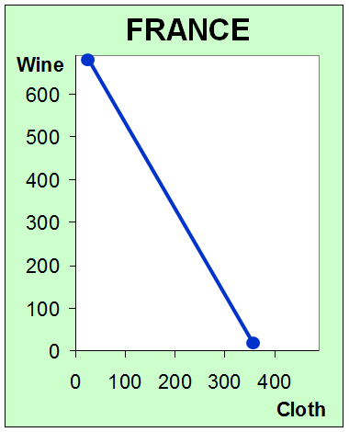
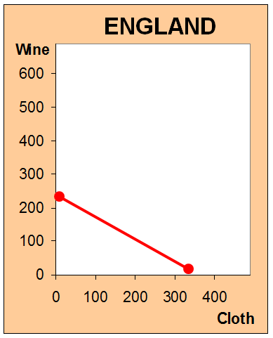
England, because PPF is not as steep as France’s
- There are two ways to get the answer.
- The hard way is to compute the slope of both PPFs.
  - The slope of France’s PPF: $\frac{-600}{300}=-2$
  - This means meaning that France must give up two units of wine to get an additional unit of cloth.
- The slope of England’s PPF: $\frac{-200}{300}=-\frac{2}{3}$
  - This means that that England only must sacrifice $\frac{2}{3}$ units of wine to get an additional unit of cloth.
- Thus, the opportunity cost of cloth is lower in England than France.
- Easy way: the slope of the PPF equals the opportunity cost of the good measured on the horizontal axis. Since England’s PPF isn’t as steep, the opportunity cost of cloth is lower in England than in France.

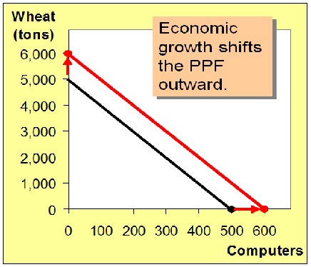
Economic Growth and the PPF
- In order as to improve a country’s standard of living, one must first improve the ability to produce.
- With additional resources or an improvement in technology, the economy can produce more computers, more what, or an combination in between
- The PPF shows the trade-off between output or different goods at a given time
  - When the PPF shift outward- economic growth

                - GDP Increases

The Shape of the PPF
- The PPF could be a straight line or bow shaped
- Depends on what happens to the opportunity costs as the economy shift its resources from one industry to the other

  - If opp. cost remains constant, PPF is a straight line
  - If opp. cost of a good rises as the economy produces more goods, PPF is bow-shaped

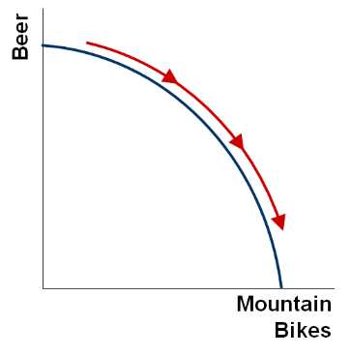
Why the PPF Might be Bow-Shaped
As the economy shift its resources from beer to mountain bikes:
- PPF become steeper
- Opportunity cost of mountain bikes increases
- People who are less experienced causes the PPF to be bow-shaped because they have lower than average production output and do not have much impact in the industry that they are in
- The people that could have been used to produce mountain bikes are now being used to produce beer and have less experience in the production of beer, therefore they won’t contribute to the total production output as the more experienced workers
  - It is the same with mountain bikes production
- Solution: Trade-off; let workers who are experienced with producing beer shift to produce beer and let workers who are experienced in producing mountain bikes shift to produce mountain bikes

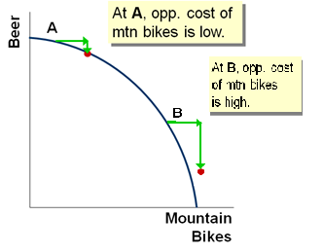
- At point A, most workers are producing beer even those that are better suited to building bikes
  - So do not have to give up much beer to get more bikes
- At point B, most workers are producing bikes. The few left in beer are the best beer brewers
  - Producing more bikes would require shifting some of the best beer brewers from beer production.
    - Would cause a big drop in output

- PPF is bow-shaped when different workers have different skills, different opp. cost of producing one good in terms of the other
- The PPF would also be bow-shaped when there is some other resource, or mix of resources with varying opportunity cost
  - E.g., different types of land suited for different uses

The PPF: A Summary
- The PPF shows all combination of two goods that an economy can possible produce given its resources an technology
- The PPF illustrates the concepts of trade-off and opp. cost, efficiency and inefficiency, unemployment and economic growth
- The bow-shaped PPF illustrates the concept of increasing opp. costs

Microeconomics and Macroeconomics
- Microeconomics: the study of how households and firms make decision and how they interact in markets
- Macroeconomics: the study of economy-wide phenomena, including inflation, unemployment, and economic growth
- These two branches of economics are closely intertwined, yet distinct- they address different questions
- 10 Principles of Economics
  - 1-7: microeconomics
  - 8-10: macroeconomics

The Economist as Policy Advisor
- As scientist, economist make positive statements, which attempts to describe the world as it is
- As policy advisors economist make normative statements that attempt to prescribe how the world should be.
- Positive statements can be confirmed or refuted, normative statements cannot.
- Positive and normative statements are fundamentally different, but they are closely intertwined in a person set beliefs. Positive statements in particular affects how the world works. This means it affects normative views about what policies are desirable.
- E.g.,
  - Polly: Minimum- wage laws cause unemployment.
  - Norma: The government should raise the minimum wage.
    - Polly’s statement is positive because it is descriptive- it makes a claim of how the world is
    - Norma statement is normative because it is prescriptive- it makes a claim of how the world ought to be
      - Polly’s claim might lead is to a rejection of Norma’s conclusion that the government should raise minimum wage. However, normative conclusions cannot come from positive analysis alone; they involve value judgements as well

Active Learning 3: Identifying positive vs. normative
Which of these statements are “positive” and which are “normative”? How can you tell the difference?
- Prices rise when the government increases the quantity of money.
Positive- describes a relationship, could use data to confirm or refute
- The government should print less money.
Normative- this is a value judgment, cannot be confirmed or refuted
- A tax cut is needed to stimulate the economy.
Normative- another value judgment
- An increase in the price of burritos will cause an increase in consumer demand for video rentals.
Positive- describes a relationship. Note that a statement needs not be true to be positive

Why Economist Disagree
- Economist often give conflicting policy advice
- They sometimes disagree about the validity of alternative positive theories about the world
- They may have different values and, therefore, different normative views about what policy should try to accomplish
- Differences in Scientific Judgement
  - This is when economist may disagree because they have different hunches about the validity of alternative theories or about the size of important parameters
    - Ex., economist disagree about whether the gov’t should levy the taxes based on household’s income or its consumption.
      - Advocates of the switch from the current income to a consumption tax believe that the change would encourage households to save more, which would later lead to more rapid growth in productivity and living standards
      - Advocates of the current income tax believe that household saving would not respond much to the change in tax laws
- Differences in Values
  - This is when positive and normative claims cannot be judged on scientific grounds alone.
    - Ex. Choosing whether or not to tax by percentage of income or at a steady rate.
      - Economist give conflicting answers because they have different values
- Perception vs. Reality
  - Ideas that what may seem good on paper may not be as good when enacted
    - Ex. Almost all economist oppose trade barriers to free trade but Parliament has often chosen to restrict the importation of certain goods
- Yet there are many propositions about which economist agree

Preposition about which Most Economist Agree (and % who agree)
- A ceiling on rents reduces the quantity and quality of housing available. (93%)
- Tariffs and import quotas usually reduce general economic welfare. (93%)
- A large federal budget deficit has an adverse effect on the economy (83%)
- Flexible and floating exchange rates offer an effective international monetary arrangement. (90%)
- Cash payments increase the welfare of recipients to a greater degree than do transfers-in-kind of equal cash value. (84%)
- A minimum wage increases unemployment among young and unskilled workers. (79%)
- Effluent taxes and marketable pollution permits represent a better approach to pollution control than imposition of pollution ceilings. (78%)

Chapter Summary
- As scientists, economists try to explain the world using models with appropriate assumptions.
- Two simple models are the Circular-Flow Diagram and the Production Possibilities Frontier.
- Microeconomics studies the behaviour of consumers and firms, and their interactions in markets. Macroeconomics studies the economy as a whole.
- As policy advisers, economists offer advice on how to improve the world.

Chapter 3

Interdependence and Gains from Trade

Every day you rely on many people from around the world, most with goods and services you enjoy
- One of the Ten Principles from Chapter 1:
  - Trade can make everyone better off.
- We now learn why people- and nations- choose to be interdependent, and how they can gain from trade.

Example
- Two countries: Canada and Japan
- Two goods: computers and wheat
- One resource: labour, measured in hours
- We will look at how much of both goods each country produces and consumes
  - If the country chooses to be self-sufficient
  - If it trades with the other country
- Note: the two goods are fundamentally different (one is agricultural, and the other manufactured), which make gains from trade based on comparative advantage very likely. An example using similar goods would not be appropriate

Production Possibilities in Canada
- Canada has 50,00 hours of labour available for production, per month
- Producing one computer requires 100 hours of labour
- Producing one ton of wheat required 10 hours of labour

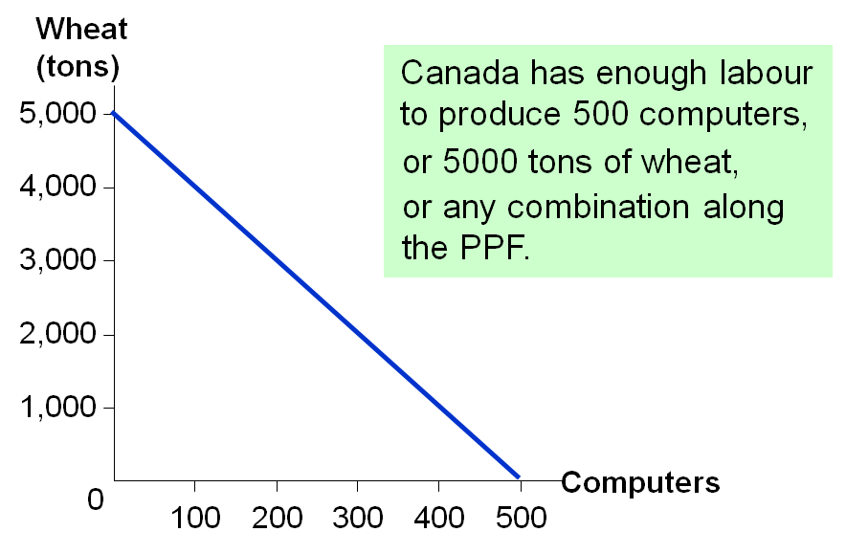
Canada PPF
- Canada has 50,000 labour hours
- It takes 100 hours to produce a computer. If Canada uses all its labour to produce computers, then it will produce $\frac{50000}{100}=500$ computers. Hence, the horizontal intercept is (500 computers, 0 wheat).
- It takes 10 hours to produce wheat. If Canada uses all its labour to produce wheat, then it will produce $\frac{50000}{10}=5000$ tons of wheat. Hence, the vertical intercept is (0 computers, 5000 tons of wheat).
- The PPF is the straight line that connect the two endpoints
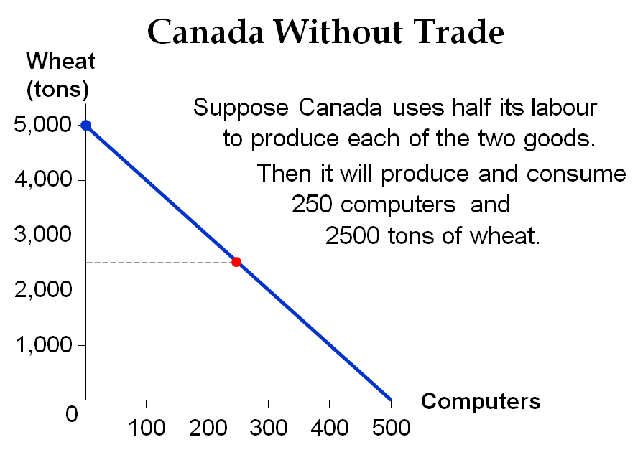

Canada could choose a different point. The actual choice will depend on the preferences of society.

Active Learning 1: Derive Japan’s PPF
Use the following information to draw Japan’s PPF
  - Japan has 30,00 hours of labour available for production, per month
  - Producing one computer requires 125 hours of labour
  - Producing one ton of wheat requires 25 hours of labour

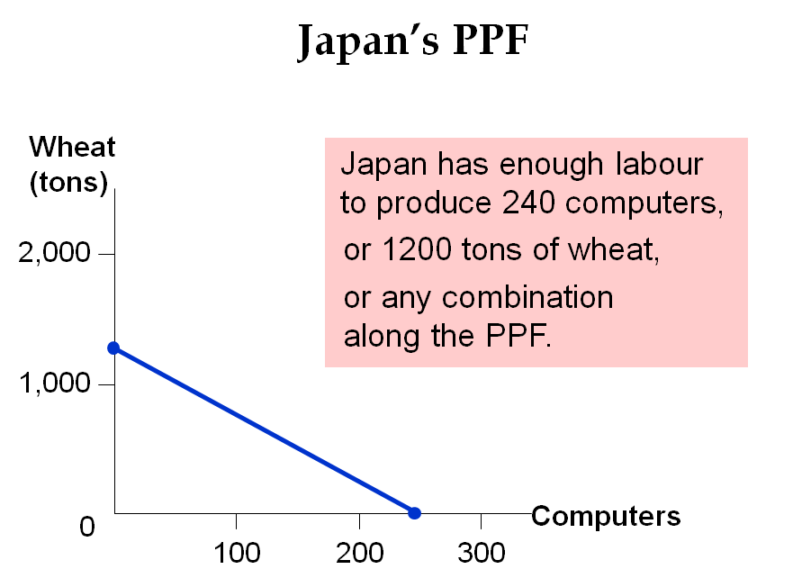
- Horizontal Intercept: $\frac{30000 labour hours}{125 hous per computer}=240 computers$
- Vertical Intercept:$\frac{30000 labour hours}{25 hous per ton of wheat}=1200 tons of wheat$

Consumption with and without Trade
- Without trade,
  - Canadian consumers get 250 computers and 2500 tons of wheat
  - Japanese consumer get 120 computers and 600 tons of wheat
- We will compare consumption without trade to consumption with trade.
- First, we need to see how much goods is produced and traded by the two countries

Active Learning 2: Production under trade
- Suppose Canada produces 3400 tons of wheat. How many computers would Canada be able to produce with its remaining labour? Draw the point representing this combination of computers and wheat on Canada PPF.

- Suppose Japan produces 240 computers. How many tons of wheat would Japan be able to produce with its remaining labour? Draw this point on Japan’s PPF.

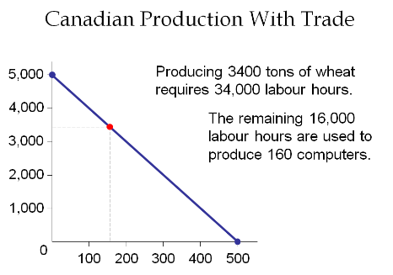
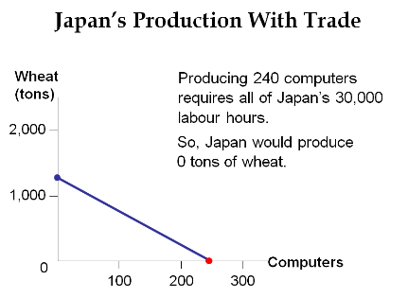

- The red dot represents the combination
  - We will assume that Japan produces a combination of 240 computers, 0 tons of wheat
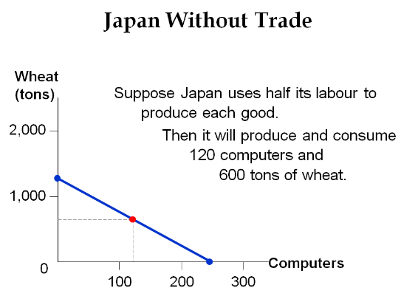
  - When trade is allowed, Japan can trade some of its computers for wheat produced in another country

Basic International Trade Terms
- Exports:
  - Goods produced domestically and sold abroad
  - To export means to sell domestically produced goods abroad
- Imports:
  - Goods produced abroad and sold domestically
  - To import means to purchase goods produced in other countries

Active Learning 3: Consumption under trade
Suppose Canada exports 700 tons of wheat to Japan, and imports 110 computers from Japan
(So, Japan imports 700 tons wheat and exports 110 computers.)
- How much of each good is consumed in Canada? Plot this combination on Canada PPF.
- How much of each good is consumed in Japan? Plot this combination on Japan’s PPF.

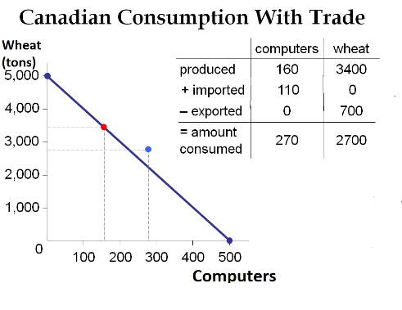
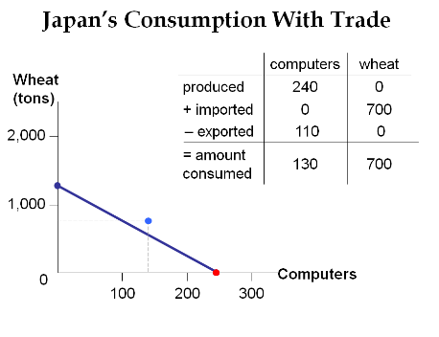

- The red point represents production
- Trade un-tethers consumption from production. The light blue point represents consumption above the PPF. Without trade, it would not be possible to consume this combination of two goods!
          - In sense international trade is like technological progress: It allows society to produce quantities of goods that would otherwise not possible

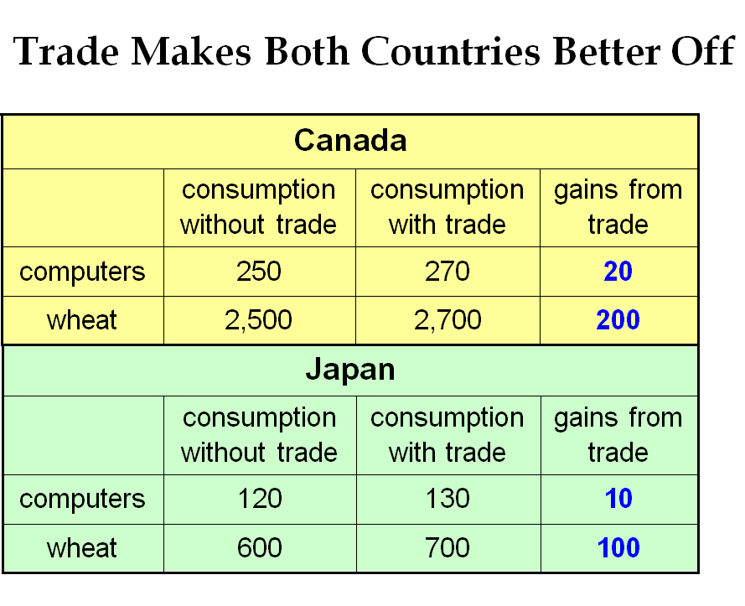

Where Do These Gains Come From?
- Absolute advantage: The ability to produce a good using fewer inputs than another producer
- Canada has an absolute advantage in both computers and wheat:
  - producing a ton of wheat uses 10 labour hours in Canada vs. 25 in Japan
  - Producing one computer requires 125 labour hours in Japan but only 100 in Canada
- If each country has an absolute advantage in one good and specializes in the good, then both countries can gain from trade.

Two Measures of the Cost of a Good
- Two countries can gain from trade when each specializes in the good it produces at lowest costs.
- Absolute advantage measures the cost of a good in terms of the inputs required to produce it.
- Recall: Another measure of cost is opportunity cost.
  - In this example, the opportunity cost of a computer is the amount of wheat that could be produced using labour needed to produce one computer
  - i.e. the benefit of selling wheat is the opportunity cost of producing more computers

Comparative Cost and Comparative Advantage
- Comparative advantage: the ability to produce a good at a lower opportunity cost than another producer.
  - it requires the comparison of two or more goods
- The opp. costs of a computer is
  - 10 tons of wheat in Canada because producing one computer requires 100 labour hours, which instead could produce 10 tons of wheat.
  - 5 tons of wheat in Japan, because producing one computer requires 125 labour hours which instead could produce 5 ton of wheat.
- Japan has lower opportunity costs of producing computers and therefore has the comparative advantage in computers
- Lesson: Absolute advantage is not necessary for comparative advantage!
  - A country can have an absolute advantage in all production but cannot have a comparative advantage in all that it produces.

Comparative Advantage and Trade
- Gains from trade arises from comparative advantage (differences in opp. costs).
- When a country specialises in good(s) in which it has a comparative advantage, total production in all countries is higher.
  - The world “economic pie” is bigger, and all countries can gain from trade.
- This applies to individual producers (like farmer and rancher) specializing in different goods and trading with each other

Active Learning 4: Absolute & Comparative Advantage
- Argentina and Brazil each have 10,00 hours of labour per month
  - Same limited input
- In Argentina,
  - Producing one pound of coffee requires 2 hours
  - Producing one bottle of wine requires 4 hours
- In Brazil,
  - Producing one pound of coffee requires 1 hour
  - Producing one bottle of wine requires 5 hours
Which country has an absolute advantage in the production of coffee? Which country has a comparative advantage in the production on wine?
- Brazil
  - Absolute advantage in coffee:
    - 1 pound of coffee: 1 labour hour in Brazil vs. 2 labour hours in Argentina
- Argentina
  - Comparative advantage in wine:
    - Argentina’s opp. cost of wine is 2 pounds of coffee, because the 4 labour hours required to produce a bottle of wine could instead produce two pound of coffee. Brazil’s opp. cost of wine is five pounds of coffee
    - Opp. cost calculation: $\frac{40000}{20000}< \frac{50000}{10000}$
$$\frac{4}{2}<\frac{5}{1}$$
$2<5$

Unanswered Questions…
- We made a lot of assumptions about the quantities of each good that each country produce, trades and consumes, and the price at which the countries trade wheat for computer
- In the real world price is determined by:
  - Interaction between suppliers and sellers
  - Interaction between supply and demand
  - Preferences of consumers
  - The technology and resources in both countries

Chapter Summary
- Interdependence and trade allow everyone to enjoy a greater quantity and variety of goods & services.
- Comparative advantage means being able to produce a good at a lower opportunity cost. Absolute advantage means being able to produce a good with fewer inputs.
- When people – or countries – specialize in the goods in which they have a comparative advantage, the economic “pie” grows and trade can make everyone better off.

