Research Methods

Introduction
- Why research methods
- What is theory
- What is research
- How do we begin to move from one to the other

Chapter 1
- Look at what influences the type of research we do and the questions we ask
- Epistemological and ontological positions
- Qualitative vs. quantitative research
- The place of politics, values and practical considerations in guiding choice of research

Epistemological Positions
- Epistemology
- What is knowledge
- How do we come to know something
—> Our everyday experiences in the world
—> our senses
—> science—> law of gravity
- In social sciences:
- What kind of knowledge is appropriate to seek?
- How may we best seek it?
- 2 positions: positivism & interpretivism

Positivism
- Knowledge in the social sciences should be gathered in the same way as the natural sciences
- Empirical (evidence based on the sense… seeing and hearing)
- There are 4 laws and principals just like the natural ones
—> things are universally true
—> we can use deduction to find support for these laws- most published research in the SS
—> Less often, we can use induction to discover new laws
- Social science can (and should be) value-free
- Terms objectivity, intersubjectivity
—> facts that everyone agrees on
- Nomative statements are not scientific
- Are certain acts or social conditions morally acceptable?
—> Place of religion or philosophy to say
—> Can’t be empirically tested

Interpretivism
- Studying people and social life is fundamentally different than subject matter in the natural sciences
- People act based on their own interpretations of the symbolic meaning of a situation
- Thomas’ theorem: situations perceived as real become real in their consequences
—> If everyone acts like its true, then it may as well be true
- Mead, weber, and symbolic interactionism
- Social scientists should be attempting to:
- Understand the meaning people attach to their environment and their actions
- See things from the point of view of the people involved
- Example: Goffman and ‘dramaturgy’

Epistemological Positions
- What is knowledge?
- Positivism: explanation of social behaviour
- Interpretivism: empathetic understanding
- Critique of positivism
- Can social science really discover social laws?
- Can it really be value-free?
- Is positivism still dominant in the natural sciences?
- Critique of interpretivism
- Social sciences interpretation of the actors interpretation
- The actors involved are subject to forces they don't identify or know about

Ontological Positions
- Ontology: What is the nature of being? of reality? of existence?
- In social sciences
- What is social reality? what is it’s nature?
- 2 major debates:
- Debate #1
—> Do social science phenomena have an objective reality independent of our perceptions?
—> Is social reality merely a set of mental constructions?
—> 3 positions on this debate
- Objectivist
- Yes, there is an objective social reality
- Social scientists should be discovering and explaining it
- Constructionist (hard)
- There is no objective reality against which our conceptions and values of the world may be tested
- There are no facts, only interpretations
- Constructionist (soft)
- There is an objective social reality, but it may not reflect our ideas about it at all
- What we see is different then what is really out there
- Debate #2
—> Objectivist: The social world is “out there”
- something that we act within, but have little control over
- Durkhiem’s social facts—> describes what we can and cannot do
—> Constructionist: The social world is created and recreated out of our everyday actions
- Having only one view point is limiting

Summery
- Deductive and inductive research
- Positivist and interpretivist approaches to knowledge
- Objectivist and constructionist views of social reality
- Can group them to distinguish between qualitative and quantitative methodologies

Chapter 2
Qualitative vs. Quantitative
- Qualitative methods
- Mostly uses words as descriptions
- Inductive approaches
- Try to determine how people interpret their social world
- See social reality as an ‘emergent’ property of peoples constructions
- Quantitative methods
- Mostly use numbers as description (measurements)
- Deductive approach
—> Theory testing and observation important
- Natural science/positivist model
- Social reality is external to the people in it (objective or intersubjective)

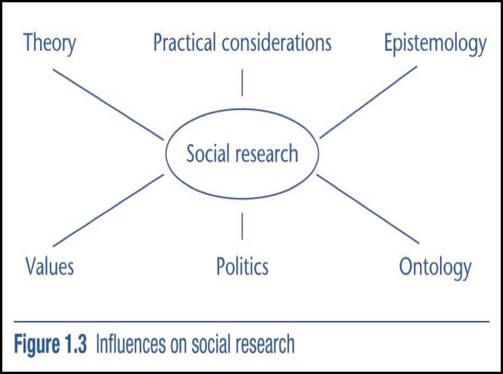

Values
- Personal beliefs and morals, feelings, preconceptions
- Can we be value-free in social research? Should we be?
- Classical Positivists: Value-free, natural, unbiased, research is both wanted and possible
- Increasingly rare attitude in science
- Social research cannot be completely value-free
- But we should try
- We should practice reflexivity
—> Understanding how you as a researcher are affected by your values, and how they impact your social research
3. Value-laden research can be good
- Sometimes certain values are necessary to an understanding of the research process, and especially those under study

Politics
- Researchers sometimes ‘take sides’
- Funding: who gets it?
- Research subjects: who gets access? under what conditions?
- Research findings: what is acceptable for publication/dissemination?

Practical considerations
- Your research question
- States the purpose of a study in the form of a question
- Example: to what extent does coital frequencies impact how intensely traditional gender roles are played out in the home?
- Guides your choice of research design
- Often starts with a general area of interest and a very general question
—> If deductive method
—> question becomes steadily more narrow
—> becomes a hypothesis linked to theory
- Characteristics of good research questions:
- Should be researchable
—> There should be a way to answer your research question
- Should have a clear focus and set realistic boundaries
- Should be possible in terms of money
- Should relate to existing theory and research in the area (and add something too)

Research Design
- What is a research design?
- A framework for the collection and analysis of data
- Both qualitative and quantitative research designs
- Nature of the research question usually important to choice of design
- Research ethics are important
- Choice of design depends first on kind of explanation you want
- Two basic traditions
—> Nomothetic (quantitative)
—> Ideographic (qualitative)

Nomothetic Designs
- Attributions of cause and effect expressed in terms of broad generalizations
- Example: The rate of suicide in a society is a function of the average level of social integration in it
- The overall health of adults is partially a function of their job prestige
—> Cause and effect
—> Generalizations
- Applied to people who were not actually in the study as well as those who were (representative sample)
- Cause and effect- two key terms in nomothetic research
- Independent variable: the proposed cause
- Dependent variable: the proposed effect

Ideographic Design
- A rich description of a person or group
- Cause and effect relations are focused on interpretation and meaning
- Think lots of words
- Usually meant to apply only to the person/people/group actually under study

Criteria for Evaluating Social Research
- In choosing a research design, 3 main types criteria need to be considered
- Replicability
- Reliability
- Validity
- Some criteria used to evaluate existing social research
- These mostly apply to quantitative methods

Replicability
- Anyone should be able to get the results you got using the same methods and samples
- Should also work on different but similar samples
—> If not, may be evidence of bias, inappropriate design, poor question, poor measures etc..
- Very important principle in science more generally

Reliability
- Is this measure/method consistent?
- Classic example- ‘The Bathroom Scale’
- Say I step on a bathroom scale 5 times, and I get
—> 115p, 100p, 125p, 110p, 130p – all close to my real weight • Not reliable b/c its different each time
- So I get another scale and step on it 5 times, and I get
—> 325p, 325p, 325p, 325p, 325p Not reliable because it is different each time
- So I get another scale and step on it 5 times
—> reliable (even though clearly wrong)
—> Consistently measured

Validity
- 3 main types of validity
- Measurement (construct) validity
- Are you actually measuring what you think you are measuring
- In the bathroom scale example, neither is valid
—> one is unstable and the other is not measuring weight
- Classic example here is IQ—> A reliable measure, but does it really measure intelligence
- Internal validity
- Has causality actually been established?
- Is it really in the direction you’ve suggested?
- Are the independent variables you’ve suggested the right ones?
- External validity
- Are the findings applicable to situations outside the research environment?
—> Naturalistic studies are best at satisfying this
- Can the finding be generalized beyond the people or cases studied
—> studies that use representative samples from a population can generalize to that population

Criteria for Evaluating Social Research (Qualitative Methods Only)
- Criterion for trustworthiness:
- Credibility: How believable are the findings?
- Parallels measurement and internal validity
- Transferability: Do the findings apply to other people in other situations?
- Parallels external validity
- Dependability: Are the findings consistent over time (where we expect them to be)?
- Parallels reliability
- Confirmability: Would another researcher reach the same conclusions?
- Parallels replicability

Experiments
- The traditional means of ‘doing’ science
- Quantitative only
• Rare in sociology (more common in psych) because:
- Many variables of interest are not subject to experimental manipulation
• ex. gender, age, ethnicity, income etc.
- Ethical concerns preclude performing experiments
- Many phenomena of interest have long-term, complex causes that cannot be simulated in experiments
• Key concepts:
- Experimental or treatment group: receives a treatment or manipulation
of some kind
- Control group: does not get the treatment or manipulation
- Random assignment: participants are placed in the experimental or control group using a random method
- Pre-test: measurement of the dependent variable before the experimental manipulation
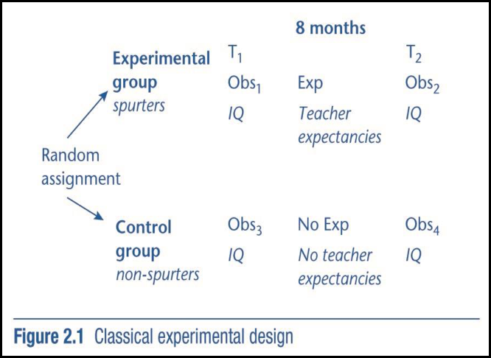
- Post-test: measurement of the dependent variable after the experimental manipulation

• Two kinds of experiments:
- Laboratory experiments: take place in artificial environments
—> Milgrim experiments
- Field experiments: are conducted in real-life surroundings
—> Rosenthal and Jacobson ‘Spurters’ experiment
• Normally very high in internal validity (best possible method)
• Threats to internal validity that are always possible:
- Mortality (Attrition): participants leave the experiment before it is over
- Maturation: participants change over time • get older, develop mentally and emotionally, etc.

Quasi Experiments
• Missing some element of a true experiment – Ex. no control, no random assignment
- Internal validity is harder to establish
• Many kinds (your text highlights one):
- Natural experiments: naturally occurring phenomena or changes introduced by people who are not researchers result in experiment-like conditions.
- Ex. Alberta and Saskatchewan in the 30s and 40s

Experiments
• Threats to internal validity that are worse if no control, or no random assignment :
- History: some event occurring after the treatment was given may have influenced the dependent variable
- Testing: the pre-test may have influenced the dependent variable – Instrumentation: changes in the way a test is administered may account for pre-test and post-test differences
- Selection: post-test differences between the control and experimental groups may have been caused by pre-existing differences
- N.B. applies to most Quasi Experiments
• Threats to external validity:
- Interaction of selection and treatment: the findings may not be applicable to the kinds of people who were not in the experiment
- Interaction of setting and treatment: the findings may not apply to settings and environments that differ from those of the experiment
- Interaction of history and treatment: the findings may not apply to other time periods, either in the past or in the future
- Interaction effect of pretesting: the findings may not apply to people who were not pretested, and few people in society are pre- tested
- Reactive effects of experimental arrangements: the findings may be invalid because they were caused by subjects behaving atypically due to the fact that they were in an experimental situation

Ethical Issues
• Often discussed in the context of experiments, but also applicable to different research designs
• A few prominent issues:
- Deception of participants vs. informed consent
- The conditions of the experiment cause Psychological/physical harm
- Related: Debriefing causes psychological harm
- Confidentiality and Anonymity
- Fair Payment, Bribery and Taking Advantage
- So how much harm is harm?
• Who decides?
- In Canada, and in many other countries
- Institutional ethics committees

Case Study Design
• A basic case study involves an in-depth study of a single case.
- Can be a person, family, organization, event, etc.
- Examples:
—> Oscar Lewis ‘The Culture of Poverty’ (Sanchez family: Mexico)
—> Rinehart ‘The Tyranny of Work’ (Auto Factory)
—>White ‘Street Corner Society’ (Italian immigrant community)
• External validity usually very low
- Not really the point of this type of research
- Almost always qualitative
- Often longitudinal
- Types of case:
- Critical: illustrates the conditions under which a certain hypothesis holds or does not hold
—> Should have higher external validity
—> Closer to quantitative approach
- Extreme (or unique): illustrates unusual cases, which help in understanding the more common ones
—> No external validity – meant to contrast the common
– Ex. Margaret Mead’s Growing up in Samoa
- Revelatory: examines a case or context never before studied, and previously inaccessible to study
—> Wikileaks has provided material for much revelatory research!

Cross- Sectional Designs
• Observations made at only one point in time
• Not experiment
- No manipulation of the independent variable (no ‘treatment’ is given)
• Instead, two or more variables are measured in order to detect patterns of association
- Examples: structured interviews, structured observation
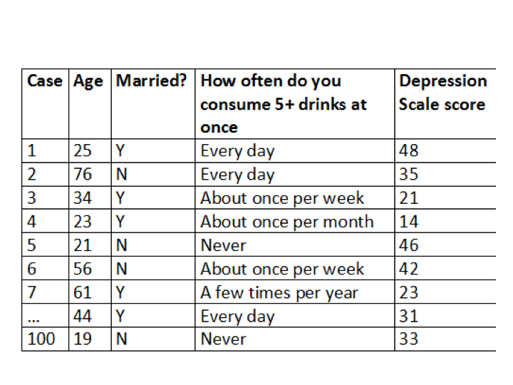
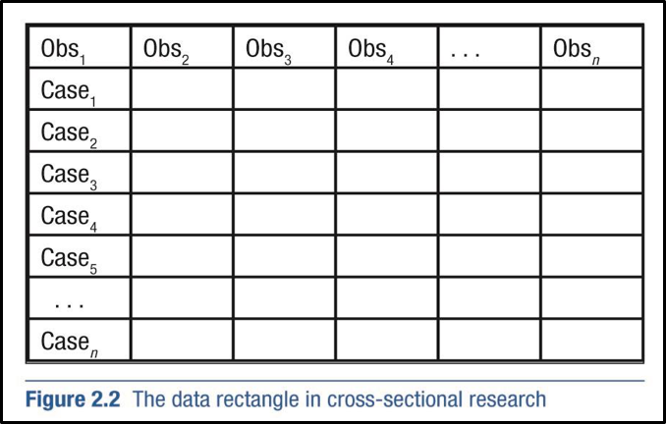

- Can be used to examine the effect of variables that cannot be manipulated in experiments
- Ex. age, gender, ethnicity, culture, social class, etc.
• Example in text: Obesity and social stigma
• Another example: Alcohol consumption and depression
• Often weak in internal validity
- Ex. Alcohol consumption and depression are found to be associated (correlated) but ...
—> Which is dependent and which is independent?
> Does alcohol consumption cause depression or does depression cause alcohol consumption?
—> Is there reciprocal causation involved?
> i.e. Is it both?
• We measured them both at the same time, so What is the temporal order here?
• Tend to be high in external validity provided:
- Proper sampling procedures used
—> Random method is used to select participants for the study
—> Also a large enough number of participants should be involved
• Also strongly replicable

Longitudinal Designs
• Two basic types:
• Panel study:
- Cases are examined at a particular time (T1), and again at a later time or times (T2, T3, etc.)
- Ex. National Longitudinal Survey of Children and Youth (NLSCY)
—> Large sample of children aged 0-11 years old in 1994
—> Exact children found again in 1996, 1998, 2000, 2002, 2004, 2006, 2008
• Time series analysis (cohort study):
- Different people are studied at each time • Sample 1 (S1) at T1, S2 at T2, S3 at T3
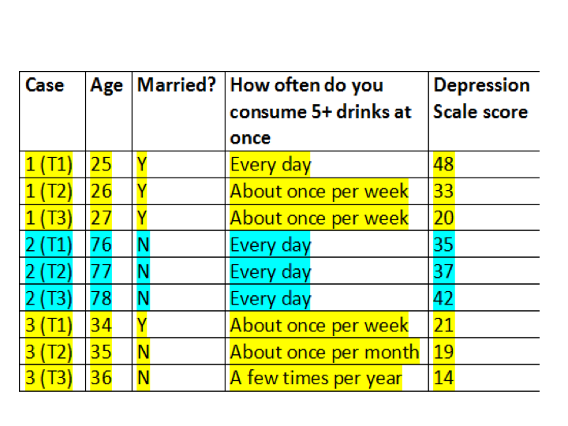
- Ex. ‘Canadian Labour Force Survey’ (LFS) new random sample of Canadians each month

- Provide information about the time-order of changes in certain variables
- potentially very high internal validity
• Drawbacks of panel studies:
- Attrition over time (people dropping out)
- Extremely $$$ and often very time consuming
- Difficult to do well
- Panel conditioning: people’s attitudes and behaviours may change as a result of participating in a panel

Chapter 3

The Nature of Quantitative Research
- The 4 main goals of quantitative research
- The 11 basic steps to doing quantitative research
- Measurement and operationalization (Step 4)
- Checking for reliability and validity in measurement (Step 9)
5. Some criticism of quantitative research

Main Goals
1. Systematic Measurement of social phenomenon:
- Need good measures/measurement for all quantitative methods
- Must know what we are looking at – detailed description is key
- Clarity in definition of our concepts very important
—> Measures/Indicators need to meet criteria of validity and reliability
2. Establishing causality: researchers want to know what causes social phenomena
- Cross sectional research – often infer cause
- Experimental and Longitudinal research can get to ‘temporal order’
3. Generalization of findings to those not studied
- Preferably make generalizations that apply to the whole population from whom the sample was taken
- In other words
- high external validity
- Nomothetic explanations
- Having a representative sample is essential for this
4. Replication: repeating a study using the same methods
- provides a check for biases and routine errors
- If the findings are not the same as those of the original study, the findings of the original are brought into question
- If the same, researchers have greater confidence in the original findings.

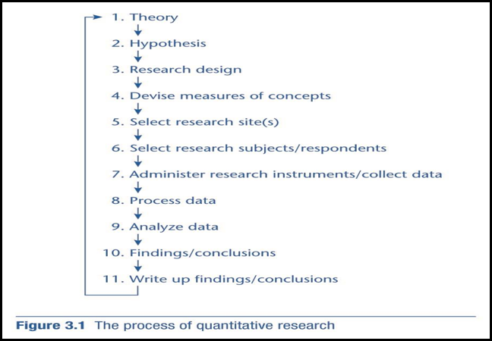
Only 11 Basic Steps

• Step 1: Theory
- Start at the Library:
—> Review past research and theoretical arguments
—> Can do keyword search on whole databases
> ex. ‘sociological abstracts’ or ‘social sciences citation index’
• Step 2: Develop a hypothesis/research question
- Discussed in chapter 1
• Step 3: Choose a research design
- Discussed in chapter 2
• Step 4: Devise Measures of Concepts
- Concept: ideas or mental representations of reality that serve as the basic building blocks of theory
—> Ex.’crime’,‘politicalorientation’‘lifeexpectancy’,‘lifesatisfaction’, ‘depression’, etc.
—> Concepts may be independent or dependent variables
- Concepts can be defined in 2 different ways:
—> Nominal definition: describes the concept in words, much like a dictionary definition
> Ex. ‘political orientation’ refers to the party to which people most closely associate themselves
—> Operational definition: describes how the concept is to be measured
> Ex. ‘political orientation’ may be measured by asking people, “Do you normally think of yourself as a supporter of the Conservatives, Liberals, New Democrats, Greens, Bloc Québécois or other?”
- Operationalization: Move from the conceptual level (nominal def) to direct observation (operational def)
—> Ex. ‘depression’:
—> nominal definition: a mental state characterized by a pessimistic sense of inadequacy and a despondent lack of activity ….
—> Can be operationalized via a set of survey questions designed to measure symptoms
> Have you over the past week:
- “felt depressed”
- “ felt everything was an effort”
- “lost interest in activities that you previously enjoyed”
- “trouble sleeping” ....etc.
> Add up the yeses and decide on a cutoff point for depression, say 5/10

- Some concepts are straight forward to operationalize:
—> Ex. Age, Sex, Family income
- Other concepts are more abstract and difficult
—> Ex ‘happiness’, ‘job satisfaction’ ‘depression’, ‘SES’
- Often use more than one indicator with abstract concepts because using only one indicator:
—> May misclassify some people
> Ex. certain indicators of depression also apply to other disorders
—> May not capture all the meaning of the underlying concept
> Ex.using only income to classify SES
—> May not allow the researcher to make fine distinctions
> Ex. Using only 1 indicator for health

- N.B. For abstract concepts, indicators are often created using Likert scales
- These scales are also used for building one indicator out of many
—> Back to depression example
>Have you over the past week:
- “felt depressed”
- “ felt everything was an effort”
- “lost interest in activities that you previously enjoyed”
- “trouble sleeping” ....etc.
- Rather than each just being yes/no, instead rank each on a 5 point scale (5 4 3 2 1 in this case) – when we add them, we get a scale out of 50 instead of 10
- Examples of the sorts of indicators that are available in quantitative research:
- Specific questions
- Ex. structured interviews, self administered questionnaires, etc.
2. Systematic and structured observations
- Ex. pre-schoolers in a classroom setting
—> Document gender & frequency of aggressive behavior
3. Rely on official statistics and other data already collected for other purposes (secondary analysis)
- Vital statistics like births, deaths, marriages, – Surveys like the NLSCY or LFS
4. Collect data through the indicators that classify “written or symbolic material” (content analysis)
• Step 5: Select research site(s)
• Step 6: Select research subjects/respondents
- Sampling (chapter 12) included here
- Steps 5 and 6 are subject very much to politics and practical considerations
• Step 7: Administer research instruments/collect data
- Experiments: pre-test, manipulate treatment group, post-test
- Structured interviews and questionnaires: Provide interview schedule and conduct interviews or provide questionnaire and collect when complete
- Structured observation: Watch setting and record info
- Secondary Data: apply for access to data, pay for it, get it from the public realm
• Step 8: Process Data
- In quantitative research:
—> our operational definition must allow for the coding of responses for eventual analysis
- Coding: transforming a measure into numbers
—> Ex. ‘Political orientation’
- Conservative
- Liberal
- New Democrat
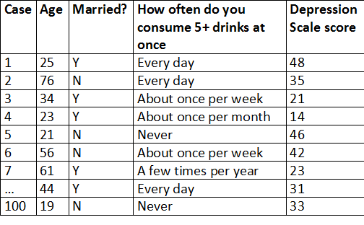
- N.B. we do this even when the numbers don’t mean anything in this context
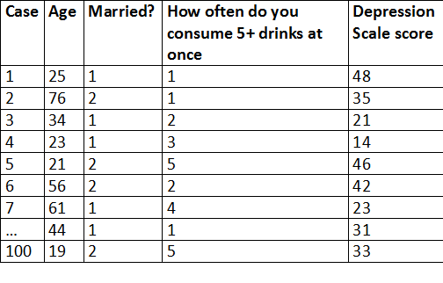

- Step 9: Analysis
- Big step! Covered in some detail later in this course and much in SOC2205
- Choose statistical techniques and test relationships between variables
- Check for validity and reliability issues
- Reliability always concerned with the consistency of measures of a concept, yet several definitions:
1. Stability over time:
- Consistency in a single measure over time (assuming no change in what is being measured)
—> The bathroom scale example from last week
2. Internal reliability:
- Consistency in measurement when using multiple indicators to measure the same concept at a single point in time
- How to test?
—> Cron bach’s alpha coefficent > .80
—> Split-half method
3. Inter-observer reliability:
- Consistency in measurement across researchers
—> Ex. coding open ended questions in a questionnaire or coding in content analysis
- There are various kinds of measurement validity:
—> Face validity: Does the measure appear ‘on the face of it’ to be valid?
> Sort of about common sense
> Do other researchers agree?
> Much easier to establish with more straight forward concepts
- Concurrent validity: does the measure correlate to another measure that is also relevant to the concept?
—> Ex. research on ’job satisfaction’
> Ask people to rate how satisfied they are with their jobs (our measure)
> Find a measure related to job satisfaction – maybe absenteeism
> Do workers who score low on absenteeism score high on job satisfaction?
> If yes, concurrent validity!

- Construct validity: concepts relate to each other in a way that is consistent with the researcher’s theory
—> Ex. theory states that child ‘hyperactivity’ is caused by ‘poor parenting’
> We see that ‘hyperactivity’ increases as parenting ‘gets worse‘
> We thus suggest that the measures used to gauge ‘poor parenting’ and ‘hyperactivity’ are valid
- N.B. Must be very careful with this!!!
—> It might not be non-valid measures, it might be real differences between theory and observation!
- Convergent validity: a measure of a concept correlates with a second measure of the same concept that uses a different measurement technique
—> Ex. Statistics Canada
> Survey based measures of income (asks respondents how much they make)
> Information from Revenue Canada on income
• If averages are close, measures are considered valid
• Step 10: Findings/conclusions
- Is your research question answered or your hypothesis supported?
- Are there implications for theory, for social life or social policy?
• Step 11: Write-up findings/conclusions
- Publish it and let others judge the quality/usefulness of your work, potentially replicate it etc.

Critique of Quantitative Methods
- Critique: Humans and their actions are fundamentally different from what is studied in the natural sciences – we shouldn’t be studying them in the same way
- Counter: Humans are a (very complex, unique) part of nature - science can, and should be used to understand the human condition
- Including consciousness, emotions, meaning etc.
- The measurement process produces an artificial and false sense of precision and accuracy
- Ex. problems can arise if people interpret the same survey item differently
—> How is your general health?
- Excellent
- Very good
- Good
- Fair
- Poor
- What do these categories mean to each person? How do they judge their own health?
- Quantitative research produces a disjuncture between research and everyday life
- A problem of external validity
—> Everyday life is more complex than we make it in experiments
—> We assume survey respondents have both knowledge and interest to answer the questions in a ‘common’ way
- Critique: An analysis of relationships between variables ignores people’s everyday experiences and how they are interpreted
- Counter: Some of the relationships we study include meaning and interpretation
- Critique: tend to assume an objectivist ontology
- A social reality exists that is independent of the observer
- The social order is fixed rather than negotiated
- Counter: some of the social order does exist outside of our perceptions of them
- N.B. soft constructionist argument

Reality and practice
- The ideals of quantitative research and how it is actually conducted may be very different
- Less attention may be paid to matters of reliability and validity than what one might think
- Some of that comes about through practical limitations of time, cost, and feasibility

Chapter 4: Survey Research

Survey Research
- By far the most common data collection techniques
- Want to know? ask people
- Often large scale
—> With representative samples
- highly adaptable
- Easily replicated
- Contain many closed-ended questions
- Two basic types
- Structured interviews
—> telephone interviews
—> face to face interviews
- Self administered interviews
—> hand copy
—> online techniques

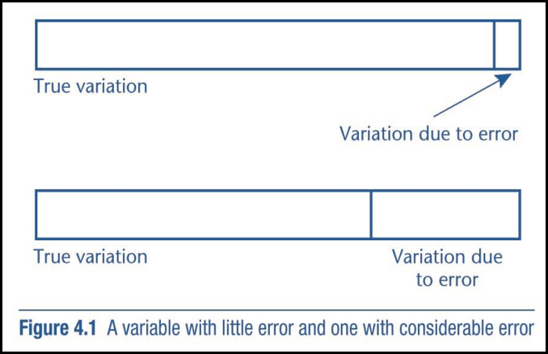
Sources of Error in Surveys
1. Poorly worded questions
2. Interviewer error in asking a question
3. Misunderstanding on the part of the interviewee
4. Interviewee lapses in memory
5. Interviewer error in recording information
6. Mistakes in entering the data into a computer file and
7. Biases caused by the innate characteristics of the interviewer and interviewees

Measurement Error

Standardization
- Key to dealing with much error in survey research:
- Concept of standardization
—> Everything done the same way each time in both asking questions and recording the questions
—> Interview schedule: a formal list of questions that the interviewer must follow in detail
- The questions must be asked in exactly the same way each time
- Must also be asked in the order given – the same order each time
- In Structured Interviews, standardization can address error sources 2 and 5 (p63/64) by:
1. Reducing interviewer variability
- Intra-interviewer variability: Interviewer is not consistent in asking questions or recording answers
—> Can happen during 1 interview, or across many
- Inter-interviewer variability: multiple interviewers are inconsistent compared to each other
2. Enhancing accuracy and ease of data processing
- By using more closed-ended questions, and taking care with question order

Question Wording & Question Answer
- The question should be asked exactly as stated
- Small differences in wording can make a large difference in meaning
- Answers should be recorded as exactly as possible
- To avoid ‘interplay’ by the interviewer
- Questions should be asked in the order they are given on the interview schedule
- Previous questions make us think differently about the current one

Question Wording

- One word makes more than a 10% difference in the answers
- Freedom was the only added word

Question Order

Do you think the US should let Communist newspaper reporters from other countries come in here and send back to their papers the news as they see it?
Question | A: There are always some people whose ideas are considered bad or dangerous by other people. For instance, somebody who is against all churches and religion. If such a person wanted to make a speech in your city against churches and religion, should he be allowed to speak, or not? | B: There are some people whose ideas are against all churches and religion. If such a person wanted to make a speech in your city against churches and religion, should he be allowed the freedom to speak, or not?
Yes, Allowed to speak | 68.7% | 80.1%
No, not allowed to speak | 31.3% | 19.9%
Number of cases | 629 | 612
 | 1948 | 1980
Asked First | 36.5%  (581) | 54.7%  (342)
Asked Second | 73.1%  (635) | 74.6%  (335)
X2 (1df) | 168.2 | 29.8
p-value | 0.001 | 0.001
 | 1948 | 1980
Asked First | 89.8%  (635) | 81.9%  (331)
Asked Second | 65.6%  (567) | 63.7%  (336)
X2 (1df) | 101.7 | 28.23
p-value | 0.001 | 0.001

Do you think a Communist country like Russia should let American newspaper reporters come in and send back to America the news as they see it?

Interviewer Effect
Interviewers effect
- Part of error source #7 pg. 63/64
- The characteristics of the interviewer may influence the responses given
- Sex, race/ethnicity, class, size, age, apparent sexual orientation, immigrant status etc…

Could you tell me who two or three of your favourite actors or entertainers are? (Asked only black respondents)
Race of Entertainment | Black Interviewer | White Interviewer
Blacks Only | 45.5% | 14.8%
Whites Only | 7.9% | 22.2%
Blacks and White | 46.6% | 63.0%
N | 101 | 54
Question follows non-racial questions on friends and neighbours
Interviewer effect: X2=31.5, df=4, p<.001

Non-Response
- Two basic types
- Item non-response: Respondents won’t (or can’t) answer specific questions
- Survey non-response: Potential respondents refuse to participate at all
- Can be a very serious problem in survey research
- Remember the importance representative samples and generalizability

Reducing Item non-Response
- Interviewer should try to develop a rapport with respondents
- Trustworthiness, friendliness, professionalism
—> Must be consistent within and across interviewers (interviewer variability)
—> Must not over do it—> being too friendly may bias responses (social desirability)
- If respondent does not answer a question at all, or as fully as hoped, the interviewer may use probes
- Tend to be standardized
- For closed-ended question
—> May simply repeat the question or answer choices
- For open-ended questions
—> Gently push for more
- “Can you give me an example?”
- “What do you thing are the reasons for that?”
- Probing is not prompting
- Prompting:
- Occurs if the interviewer suggests a specific answer for the respondent
—> “Do you think this? or this?”
- Considered very inappropriate
—> Better to record “no response”
- Easier to avoid with close-ended questions
—> Show cards help even more
- Show cards
- For closed-ended questions, possible answers are printed and given to the respondents
—> Face-to-face interviews only
- Appropriate/useful if:
—> There is a long list of possible answers
—> The question is of a personal nature
—> The same set of answer categories applies to several questions

CATI/CAPI
- Computer software programs are usually used for both face to face and phone interviews
- Interview schedule is a pre-programmed into the computer
- Interviewer simple follows the schedule of questions
—> CATI: computer assisted telephone interview
—> CAPI: Computer assisted personal interviewing
- Advantages
- Reduces errors from inconsistent wording or question order
- Capture and process data at the same time (since it goes right into the computer)
- Reduces item non-response due to interviewer error
- Very helpful with complex skip-patterns (filters)
—> These questions filter out questions that are not applicable
—> Ex: Canadian Community Health Survey
- Has a doctor ever diagnosed you with a chronic medical condition
- If the answer is no, can automatically skip all of the follow-up questions on treatment, care etc…
- No unnecessary questions, no flipping through a mountain of paper
—> much faster and efficient
- Can also randomize questions to test for order effect

Other Respondent Problems
- Response sets: The respondent is not motivated to provide a genuine response (3 types)
- Acquiescence: The respondent is just trying to please the researcher, be cooperative
- Tend to either agree or disagree with all questions
- Researchers should create lists of questions that force respondents to choose from both sides of the spectrum to maintain a consistent attitude
2. Social Desirability: Respondents give what they believe is the politically/socially correct answer
- Do so out of a desire to be liked, considered respectable etc…
- Relates to bias due to innate characteristics (error #7 pg.63)
3. Laziness or boredom: May prevent a respondent from giving a genuine response
- May just want to get it over with
- Can use same strategy as for #1

Reducing Survey Non-Response
- Begin with cover letters:
- Sent ahead of time (if face-to-face interviews)
- Explained ahead of time (phone interviews)
- Sent with questions (Self administered)
- Appropriate dress, courtesy, and tact
- Be polite
- Expect cooperation
- If respondent shows doubt:
- Reemphasize confidentiality/sampling design/ importance of survey (from cover letter)

Cover Letters
- Used to introduce the research to the potential respondent, and to establish creditability
- Not a choice: ethnics committees insist upon this
- Professional letterhead and should contain:
- Interviewer ID (if applicable)
- Name and contact information of the organization sponsoring the research (phone, fax, web page, email)
- Sometimes funding sources
- Topic of research:
—> Purpose
—> Potential utility
- How the respondent has been selected (scientific selection)
—> Can include how important it is that they participate
- Confidentiality procedures
—> Respondent cannot be identified etc…
- A note that participation is voluntary
- Tell respondents they can ask questions about the research
- Sometimes they will have access to the results

Face-to-Face or Phone interviews
- Phone interviews are:
- Cheaper
- Quicker to administer
- Easier to supervise
- Can also reduce bias from the characteristics of the interviewer(s) #7
- Use a simple directory or random digit dealing technology to choose/contact sample
- Phone interviews:
- Only people who can be contacted by phone during normal hours can be in the study
—> If directory is used, non-listed and cell phone users will be left out
—> Difficult for people with impaired hearing
- Most cannot exceed 20-25 minutes
- Sensitive issues may be more difficult to discuss in this context
—> We don’t know who is in the background to influence responses
- Cannot see if interviewee understands or is upset
- The interviewer cannot use visual aids
—> Show cards

Questionnaires
- Structured interview without an interviewer
- Fill out a form and return it to the researcher
- Compares to interviews:
- Have few if any open-ended questions
- Have very simple designs and few filters
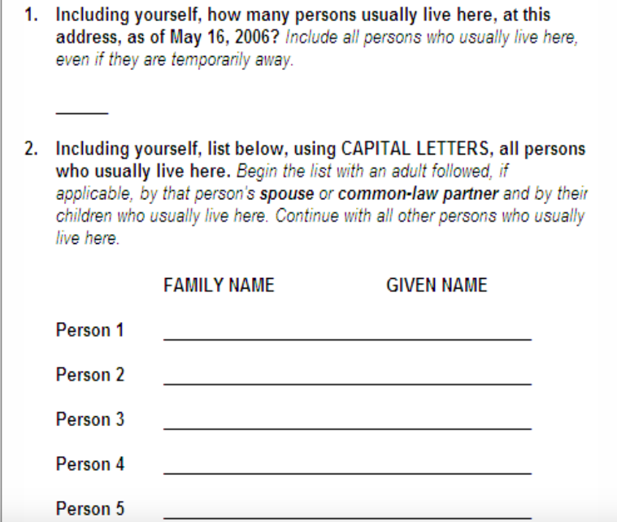
- Tend to be short
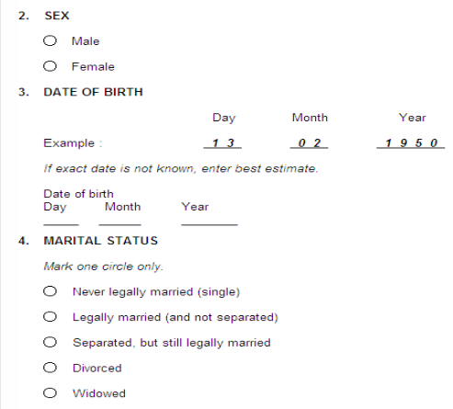

- Advantages over interviews:
- Cheaper and more convenient to administer (faster depending on context)
- No interviewer effect
- Less social desirability bias
- Respondents are more likely to answer honestly to sensitive questions
- Disadvantages:
- Greater risk of missing data (higher survey and item non-response) and respondent error
—> Researcher cannot explain the question
—> Cannot probe
- Must be kept short and simple
- Very limited number and type of questions
—> Limit misunderstanding and respondent fatigue
- Simple questions only
—> Limit open-ended questions and filters
- Can be read as a whole before completion
—> Questions are then not really independent of each other
—> Can potentially answer them in any order (order effect)
- Not appropriate for certain respondents
—> Limited literacy
—> Limited language proficiency—> high immigration in Canada
- Designated respondents may not have completed questionnaire
—> We have no way of knowing
- How to administer:
- Through mail
- In person
—> At a work place, school, social or political event
- Online
—> Online polls (non-scientific sample)
—> Email survey
—> Web survey

Online Polls
- Haphazard
- Not usually a god source of data
- No idea as to how representative it is
- Who responded?
- Did they respond more than once?

Email Surveys
- A questionnaire is attached to an email message (including cover letter)- not common
- Completed questionnaire is returned by respondent via email
- Potentially inexpensive and fast
- If a specific subpopulation is targeted (like two students) and if respondents are motivated:
- Can be a reasonable method with good response
- Otherwise, waste of time
—> Non-response will be too great (spam)

Web Surveys
- Similar to email surveys in most ways
- Respondents go to a website to complete the questionnaire instead of emailing back
- Web survey:
- Can have an attractive appearance
- Can include useful features
—> Filter questions
—> Drop down menus
—> Help features

Researcher Driven Diaries
- Can be considered a form of questionnaire
- Participants record their feelings, perceptions, actions, etc.. on a form shortly after they occur
- The diaries may be:
—> Structured much like a questionnaire with closed questions
—>Free text in which the experiences are written down like answers to open questions
- Advantages
- Provide fairly accurate data about:
—> Frequency or time spent on behaviours
—> Sequencing of behaviours
—> Text says sensitive matters like sexual practices or criminal behaviour
- Disadvantages
- More expensive than interviews or questionnaires
- attention: People may tire of using them
- Details may not be recorded quickly enough and then may be forgotten

Feminist Critique
- Some feminist theorists are opposed to structured interviews and questionnaires
- Why upset?
- These methods are exploitative
- Involve asymmetrical power relationship between the researcher and respondent
- Some opposition has declined in recent years
- Why decline in opposition?
- Increased attention given to the rights of research respondent
- Privacy rights, the right to end the interview at any time
- Rights to help formulate and have access to research
- Some findings using these methods are consisted with feminist ideals
- Findings on sexual assault, sexual harassment and forms of domination
Chapter 5: Question Asking

Types of Questions
- Personal factual questions
- Most common independent variable
—> Income, age, occupation, personal behaviour
- Problems: not many memories, honesty
- Factual questions about others
- Ex: Spouce’s income, child’s activities, sister’s personal relationship etc
- Problems: Limited knowledge, bias, memory
- Factual questions about entity or event
- Ex: accounts of a political demonstration or riot
—> How many people, what characteristics, what response etc
- Pronlems: Witness es are not researchers
—> Not specifically looking for those details
—> Some problems are above
- & 5. Questions about attitudes and beliefs
- Very common variables
- Both cause and/or effect
- Heavy use of use of Likert scales
6. Questions about knowledge
- Ex. How many census metropolitan areas exist in Canada?
- Less common is sociology
- Can lead to high item non-response

General Rules for Designing Questions
- Focus on the research question(s)
- Helps you choose what to include
—> Stay away from irrelevant questions
—> Include all of the important questions
- Make sure the question is going to tell you what you actually want to know
- Ex: How many times a week do you exercise? … What do you mean by exercise…
- Put yourself in the position of the respondent
- Try to answer your questions yourself… helps with last point

Specific Rules
- Avoid ambiguous terms in questions
- Even commonly used terms may be vague
—> What is your income? _____
—> Do you regularly take sick days? Yes _ No_
—> How many times a week do you exercise? ___
—> What do we mean by ‘income’ or ‘exercise’? What about ‘regularly’?
- Must be more specific
- Annual personal income from wages/salary only, before taxes and transfers’
- How many sick days per month on average did you take from Jan to Dec last year? ____
- Avoid questions that ask two questions
- Most obvious case:
—> double-barreled questions
—> asks two separate but equal questions in one
- Avoid Leading Questions
- Since the beginning of the war in Afghanistan, well over 100 Canadian troops have been killed. Do you think that the Federal government should withdraw from its troops from this conflict?
- Canada’s initiative in Afghanistan is meant to establish a democracy in this war torn country and to assist in efforts of international cooperation and development. Do you think that the Federal government should withdraw from its troops from this conflict?
- Both are leading questions
- Also, watch out for prestige bias
- Avoid questions that include negatives
- Esp double-negatives
- Do you oppose the rule stating that laptops not be allowed in classrooms?
- Do you support the rule banning laptops in classrooms?
- Minimize technical terms
- Use lay language where possible and define terms
- Does the respondent have requisite knowledge
- Do you agree with the current government’s position on prorogation?
—> Will your respondents know anything about prorogation of parliament or the various positions one might take on the issue?
- Ensure symmetry between a closed question and its answers
- Do the possible answers make sense to the question?
- Ensure that the answers provided for a closed question are balanced
- Are scales equal on the top and bottom?
- Memory problem
- Most people have difficulty remembering details
—> Particularly true of less important events, thoughts feeling etc
—> When did you last see the dentist
- Common problem: Telescoping
—> Bringing distant events closer to the present than they actually
occurred
- Ex. You think its been about 9 months, really been 2 years
- Problem can be limited by situational framing
—> Placing and event in the context of other events , especially well known events, or focusing on very recent past
- Question order
- All respondents should receive questions in the same order
- Early questions should be:
—> relevant to the announced research topic
—> of interest to respondents
– Later questions can be:
—> Less obviously related to topic
—> Demographic questions
—> Sensitive questions
—> only after some rapport has been established
- Related q’s should be grouped
- No jumping back and forth between topics
- Within a topic, general questions should precede specific ones
—> Ex. should ask about overall job satisfaction before asking about salary, hours, co-workers etc.
- Esp with open questions:
—> Respondents may answer a later q before you ask it – You should still ask it again at the right time
—> There could be order effects
- Avoid long questions
- Respondent fatigue, understanding
- Avoid very general questions
- Too much room for interpretation, not very informative
- Should you use Don’t know as a category?
- Esp important in attitude q’s
- If included:
—> respondents don’t have to express an opinion/attitude they
don’t have
—> But may take the easy way out rather than think about difficult questions

Advantages of Open Questions
- Respondent answers in their own words
- Get to meaning and interpretation of questions from their point of view
- Allows for rare responses
- Responses researchers have not thought of or heard of before
- Potentially greater detail
- Good for exploring new or changing areas of research
- Greater norms
- Can use the answers to come up with fixed- choice responses

Open Vs Closed Questions

Disadvantages of Open Questions
- Recording answers:
- Time consuming
- Inaccuracies/mistakes easily made
- If used in questionnaires
- high item non-response
- Answers have to be coded

Coding Open Questions
- Must first move from detailed answers to categories that we can later quantify
- Pre-coding
- Categories are decided upon before the data are gathered
- Post-coding
- Data are gathered, then themes or categories are disconcerted
- Often a mixture of both

Advantages of Closed Questions
- Easy to process answers
- Standardization of questions and answers
- No chance to interprete responses
- Fixed responses help clarify what the question means
- Easier and quicker to complete
- But categories must be mutually exclusive and exhaustive
- Mutually exclusive: No overlap of categories
- Exhaustive: everyone can answer the question (other category)

Disadvantages of Closed questions
- Spontaneity and authenticity in answers is lost
- Difficult to make answers exhaustive
- More impersonal
- Lose out on rapport in interviews
- Harder to ask difficult/sensitive questions
- Potential for response sets: the respondent is not motivated to provide a genuine response
- Acquiescence, Laziness, boredom
- Can help by changing order of potential responses
- Social desirablility/threatening questions
—> Can use lead in statements to help
- Also a problem: Recency effect
- A slight tendency to choose the last category list
- Can try to make the last category unappealing

Social Desirability
- Example 1: Voter turnout
- – Pollsters: roughly 75% of eligible voters actually voted in provincial election
- – Administrative data: closer to 50%
- • No lead-in: Did you vote in the last election?
- • Lead-in: Many people were not able to vote last election. Were you able to vote?
- Example 2: Theft
- • No lead-in: Did you ever steal as a child?
- • Lead-in: Most people have stolen something when they were children. Did you ever steal as a child?

Other Considerations
- Clear presentation
- Large print, simple layout
- Question and answer together
- Instructions on how to respond
- Should you use vertical or horizontal closed answers?

Pilot Study
- Small scale testing of your research instruments
- Used to test whether individual items or the instrument as a whole operates well
- How long does it take?
- Is it well received?
- Does it have good flow
- Provide interviewers with experience in administering the instrument
- Can identify questions that are embracing, uninteresting, difficult to understand, ambiguous
- Can be used to ensure that there is variability in the answers given
- Ex: Develop a scale attempting to measure ‘hapiness’ (0-20) but everyone in the pilot study scores 19 or 20
- Either your target population is ‘very happy’ or your scale is problematic
5. Can be useful in developing closed questions

Chapter 6: Structured Observation

Structured Observation
- Survey research:
- Data is ‘self reported’ by respondent
- Structured observation
- Research directly observes the behaviour of participants
- Two basic types:
—> natural observations
- No manipulation of situation
- Just watch and record human behaviours in a natural setting
—> Field experiments
- Manipulation of an independent variable and observe differences between groups and over time
- Also called ‘systematic observation’
- Explicit rules
- Like with surveys, standardization key here
—> Use observation schedule (like interview schedule for surveys)
- who and especially what will be observed
- How observations will be recorded
- Pre-coded categories of behaviour
- Mutually exclusive and exhaustive
- Trained observers
- Not much interpretation required for observers
- Incidents:
- Can count the incidents of a specific behaviour
—> Ex: how many times did they text over the last hour?
- Can wait for some specific incident to happen and then to see what behaviours crop up after
—> Ex: How do shoppers respond when a clerk makes a blanty racist remark?
- Time and Timing
- Can be long or short periods of:
—> Study: From hours to years
—> Observation: From seconds to days and beyond
- Observation
- Continuous monitoring
- Participants are observed at pre-selected times, either purposefully , or randomly
- Resulting data
- Capture behaviours only
—> No direct data on:
- Attitudes/beliefs- they must be inferred
- Personal factual data must be collected separately
—> Like survey data
Yields variables that can be used in statistical analysis

Unstructured Observation
- No formalized rules for observing and recording
- Narrative approach: Build a ‘story’ of explanation out of observations
- Participant observation
—> Most common and most famous
—> Researcher becomes part of the group they researched—> insider
—> Often for an extended period
—> Ex: White street corner society

Structured Observation
- Is this method for you?
- Is the topic sensitive or prone to social desirability bias?
- If yes, maybe Structured observation is for you
—> Kids don't admit to bullying on surveys, but we can see bullying if we watched kids in their normal environment
- Can you actually observe the phenomena?
- Are you trying to observe sex, crime or other hidden topic?
—> May be able to observe shoplifting, but not murder
—> May be able to observe flirting, but not affairs
3. Do you have a lot of time?
- Can be very time consuming
—> Often requires making repeat observations over an extended period, across many different settings
4. Do you want to generalize your findings?
- These studies are usually rather small scale and specific, external validity is often a problem

Advantages Over Survey Research
- Major problem in survey research: Gap between stated and actual behaviour
- Social desirerability effect/threatening questions especially with sensitive questions
- Ex: Children almost never admit to bullying when asked, only when bullied
- Problems of meaning: especially everyday behaviour
- Ex: How many texts do you send in a day
- Avoid these problems by not asking, just watching and counting etc
3. Problems of Meaning
- Ex: Do you regularly take sick days?
- Not a problem with structured observation because researcher defines these terms and applies them
- Structured observation can bridge the gap
- Often more reliable measures of events and behaviours
- Greater precision and accuracy regarding
- Duration and frequency of events and behaviour
- Time-ordering events and behaviour

Reliability
- Problems:
- Inter-observer reliability
—> Do different observers view and code the same behaviours the same way?
- Intra-observer reliability
—> Does and observer change the way they record behaviours over time or between participants
—> context change- behaviours look different in different contexts
—> observer fatigue and lapses in attention
—> N.B: Same as inter and intra interviewer reliability
- How to test:
- Cohen’s Kappa
—> Measures level of agreement between observers and observations
—> Ranges from 0-1 (0= no agreement, 1= perfect agreement)

Validity
- Measurement validity
- Same as with surveys experiments etc…
- Does this measure what you want it to measure?
—> Ex: What behaviours constitute racial descrimination on a playground
- using derogatory names
- Social rudeness
- Something more subtle
- Is the schedule standardized and administered correctly each time
—> Unreliable measures cannot be valid
- Reactive effects
—> People change their behaviours when they know they are being studied/tested

Reactive Effect
- Guinea pig effect (Hawthorne effect)
- Classic example: Trying to test methods to increase productivity in American Factories
—> Increased and decreased lighting and both produced greater productivity because workers know they were being watched therefore they tried harder and productivity was increased
- Specific Guinea Pig effects
- Role Selection
- People choose appropriate roles for themselves in most situations
- Trying to help the researcher
- Guessing what the research is about and trying to do what the observer would like
- Only a problem if the participant knows they are participating and if they are being watched
- Researcher presence as a changed agent
- Researcher changes the scenario just by being in it
- Must be invisible to avoid this
- Structured observations almost cannot avoid #3
- Possible ethic issues if participants don’t know they are being watched

Covert Observation
- Behaviours are okay to study
- Public
- Non-sensitive
- When participation id okay to study
- Harmless
- No threat to privacy (anonymity/ confidentiality is protected)
- When potential gains outweigh potential risks
- When there are no other means of gaining the same information
- Participant is a volunteer and has a right to refuse, must give informed consent
- Must outline to participants what the research is about, its purpose, risk to participants and threats to privacy
- Obviously must violate this for covert observation
- Fall back ethically for covert observation—> must inform participants after and get permission to use data

Chapter 7: Other Sources of Data

Data Sources
- Watching people as a data source
- Structured and unstructured observation
—> Experiments, field experiments, natural observations
- Asking people as a data source
- Some experiments, all survey research
—> Structured interviews and questionnaires
- Documents
- Several types
- Have texts that can be read
—> Home videos
—> Journals/ Diaries
—> Official documents
- Provide ethical unobtrusive measures
- Content analysis most common research type
- Were not created for the purpose of social research but for life
- Secondary source is not data
- Secondary data
- Collected for the express purpose of research
- Done by another researcher or organization
- Official stats
- Crime rates, unemployment rates
- Collected by official body for their own purposes, but useful to social researchers

Secondary Analysis
- Advantages
- Often high quality data
- Cost and time savings
- More time for analysis—> especially for longitudinal data
- Subgroup analysis—> Cross national research
- Replication of past research and reanalysis of existing data
- Limitations
- Potential absence of key variables
- No control over data quality
- Data is often very complex—> difficult to learn
—> Several levels of the analysis are collected

Official Statistics
- Data often based on populations not samples
- Longitudinal and cross-national research often easy to do
- Often misleading—> only include those processed by social constructed system
  - Serious reliability issues—> different definitions of police officers and judges≈Ω

Other Data Sources
- Documents
- Several types
- Have “text” that can be read
- Provide ethical unobtrusive measures
- Content analysis
- Types of documents
- Personal—> letters, diaries, photos
- Official—> government doc, private sources
- Mass media doc—> radio, T.V, newspaper
- Internet resources—> web pages, chat room, discussion group

Content Analysis
- Must be very clear about what is selected to be studied
- unit of analysis
- Ex: T.v programs, sporting events, archived photos
- In this case: newspaper articles
- Universe to be sampled from
- Ex: All olympic coverage, all newspapers?
- In this case: All coverage of asian, female, olympic athletes from a sampling of newspaper
- Period of study
- In this case: 2000-2008
- Sample selected
- 266 news articles
- Must move into measurement
- Classification/coding—> instructions on how to systematically recode info
- Allows for data similar to surveys or observation data
- 2 approaches to coding
- Manifest coding
- Emphasis on what is really being easily quantifiable/objectable
- Latent coding
- Emphasis is less straight forward

Chapter 12: Sampling

Key Terms
- Element of Unit
- A single case in the population
- Usually a person
- Can also be higher units of analysis
- Household, schools, communities, cities, nations etc..
- Can also be a non-person unit like document items or contexts
- Population
- In case you would like to say something about
- In cases from which you would select a sample
- Ex: we want to look at which aspect of women’s current work lives impact their nature of an ideal family size in Canada
- Our population might be all women of working age
- Sample: Number of units selected represents the population
- Census: Collecting data from all units in the population.. not a sample!
- Probability sample: A sample selected using a random process
- Non-probability sample: a sample selected using non-random sample
- Sampling frame: List of all units in your population from which a probability sample will be selected
- Representative sample:
- Contains the same distribution of characteristics as we see in the population
- We use this in order to generalize their findings
- Says something about population based on our sample
- One of the 4 main goals of quantitative research
- Only possible with a probability sample
- Sampling error: sample does not represent population

Sampling Related Error
- Not using a random method to pick the sample
- Issues with bias
- In judgement
—> Ex: standing outside in the daytime interviewing students on a university campus
—> Don’t approach people who appear to be older because you may thing they are faculty
- In circumstance
—> Same sample
—> Miss many part time and working students b/c they are more likely to have evening classes, e-classes, or miss classes
- Sampling frame isn't complete or inaccurate
- Your frame does not reflect the population so how can your sample
3. Non-response occurs such that those who participate in the study differ in some way than those who do not
- Ex: your population is rural ontario communities but many reserves refuse to cooperate, these communities are sometimes very different

Non-probability Samples
- Cannot generalize the results to some larger population with any confidence
- But still very useful in quantitative research
- For pilot studies
- For testing reliability of measures to be used in a larger study
- For learning how to do research
- Most are cheaper and easier to gather
- No need for a sampling frame
- Perfect for qualitative research, where generalizability is not important

Non-Probability Sample: Convenience Sample
- Cases are included because they are readily available
- Ex: The student survey from assignment 2
- Ex: You go to a pre-natal class to find a sample of pregnant couples

Non-Probability Samples: Snowball Samples
- A form of convince sampling
- Researcher makes contact with one or a few people who then introduce the researcher to more people
- An excellent strategy for “hidden” PPS
—> Prostitutes/drug dealers/ homeless etc..
- Also for people who form a network sometimes
—> Ethnic or religious communities

Non-Probability Samples: Quota Sample
- Also a convenience sample of sorts
- First make a list of proportions of the population that have certain characteristics
—> Ex: Age, Sex, ethnicity
- Then use convenience sampling to collect a sample that matches the proportions found in the population
—> Also known as filling the quota
—> Random methods are not used to fill the quota

- Primarily used in market research
- Almost never used in social science research
- For quantitative researchers
- Not likely to researchers
- Subject to bias due to judgement and circumstance
- Cannot generalize to the population
- Yet not as easy or cheap as most convenience sampling
- For qualitative researchers
- Not interested in generalizability

Qualitative Sampling
- Heavy use of the non- probability sampling discussed already
- Also, theoretical sampling
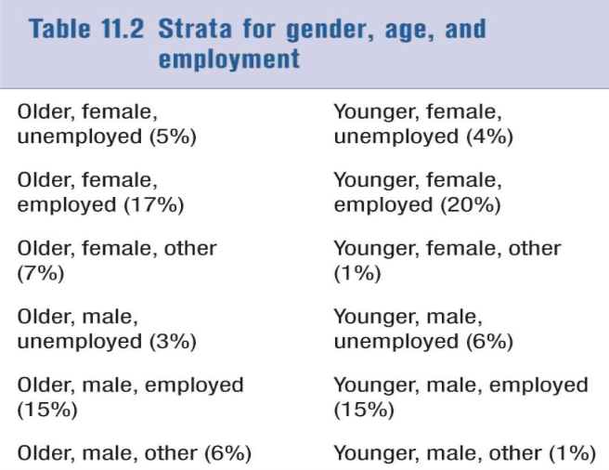
- Very different than anything discussed so far
- Part of grounded theory (inductive approach)
—> Sampling considered an emergent process, not a separate stage
—> Data is simultaneously collected and analyzed
—> Data collection is determined by whatever theoretical or conceptual issues emerge as the study progresses

Chapter 13: Quantitative Data Analysis

Types of Variables
- Nominal: There are only qualitative differences between categories
- No math
- Ex: Religion
- Buddhist 2. Hindu 3. Christian 4. Jewish
- Sex
- Categories cannot be ordered by rank (can be listed in any order)
- Cannot do arithmetic or mathematical operations with the categories
- Ordinal: The categories of the variables can be rank ordered

- Interval-ratio: Categories are ranked, ordered, and amount of difference between them is uniform

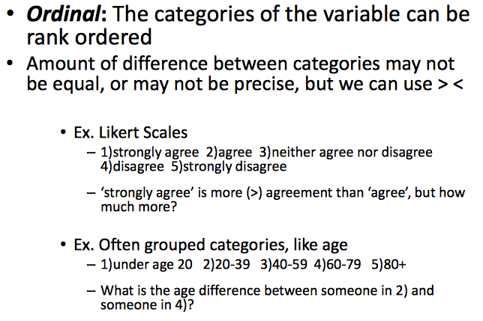
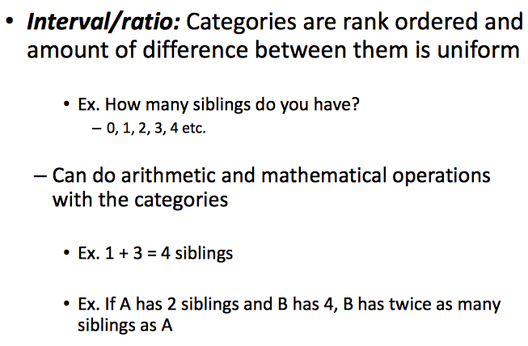

Establishing Causality
- Cause and effect
- Independent variable—> Dependent variable
- Explanatory variable (X) —> Response variable (Y)
- How can we tell what is cause and effect?
- 3 fundamental conditions
- Temporal order
- Association
- Eliminating alternative (spuriousness)
*Must have all 3 to be sure

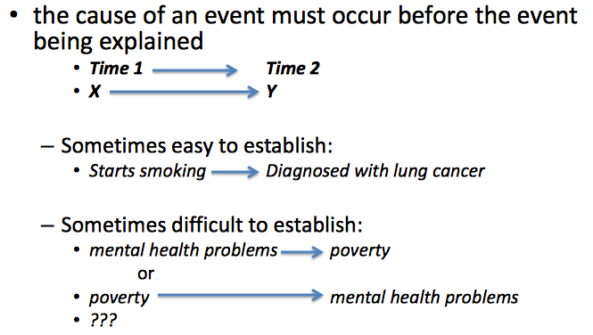
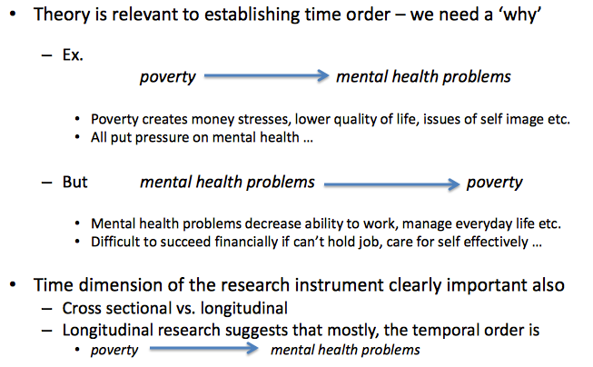
1. Temporal Order

Establishing Causality
- As education (X) increases, % in favour of capital punishment (Y) decreases- they move together
- Appears to be an association between these two variables
- As education increases, % in favour of capital punishment remains roughly the same across categories
- No association here

2. Association Between Variables
- Direction of association
—> Only for rank ordered variables
—> Positive: both X and Y go in the same direction
—> Negative: X and Y go in different directions
- Strength of association
—> how closely connected variables are
—> Can sometimes guess by looking at size of the change
—> Statistical tests are also available

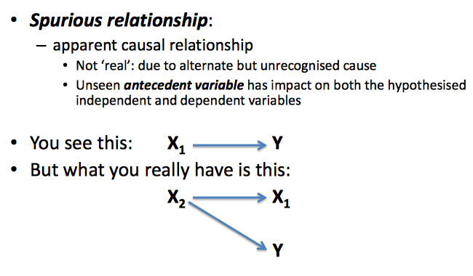
3. Eliminate Rule out Spurious Relationships

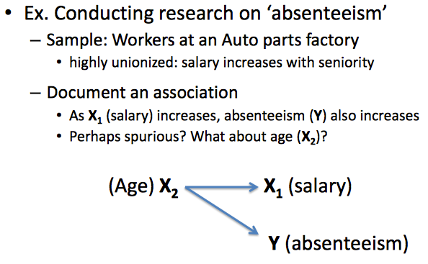

- Ice cream example

Types of Causality
- Not all cases were created equal
- 3 basic types of causes
- Necessary
- Sufficient
- Contributory

- Necessary Causes
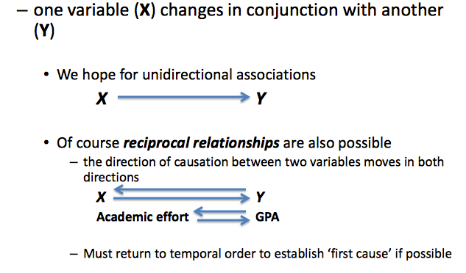
- Must be present for an effect to occur
- Implies a perfect association
- Ex: If you have down’s syndrome you must house and extra 21st chromosome
- Very deterministic
- Almost never occurs in social reality
- Rare to study in sociology
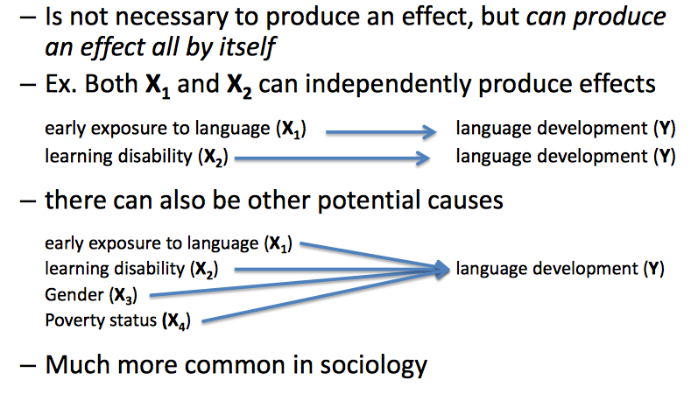
2. Sufficient Cause

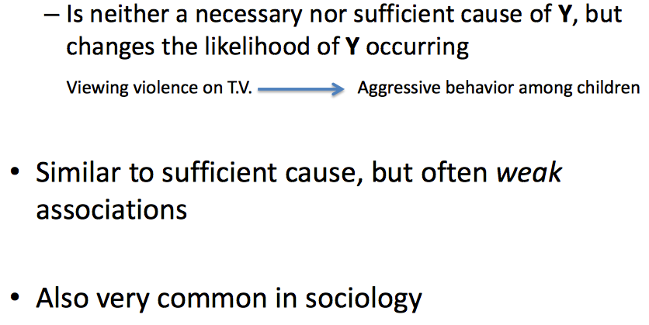
3. Contributory Causes

Inferential Statistics

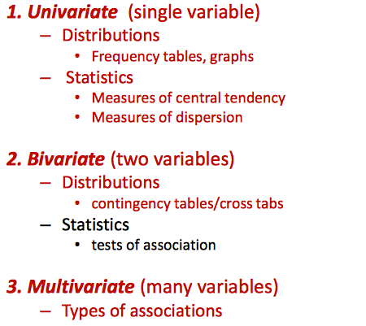

Univariate Distribution
- Frequency distribution
- Simple count across categories of a single variable
—> Mutually exclusive and exhaustive
- Possible with variables at all levels of measurement (nominal, ordinal, interval-ratio)
- Percent frequency
- Easier to understand the size difference between categories
- Becomes more useful when making comparisons across more than one group of samples
- Cumulative frequency distributions
- % of cases in each category added to the % in proceeding categories
- More useful for rank ordered variables
- Can express frequencies in graphs as well
- Many types available
- Type used depends on level of measurement and personal preference
- Bar charts and histograms
- Graph of a frequency distribution
- Suitable for nominal and ordinal variables and interval-ratio level variables with small number of cases
- Linegraph/frequency polygon
- Suitable for ordinal variables with many categories and interval-ratio data
*Always be cautious when interpreting graphs!
- Same data different scales look different on graphs
- Univariate summary indicators are also available
- Summerize the variable with single number
- Two types:
- Measures of central tendency
- The average or mid-range place
- Mean, Median, Mode
2. Measures of Variability/dispersion
- How widely dispersed the causes are
- IQV, ranges, standard deviation

Measures of Central Tendency
- Mode: Most common response
- Median: The middle score
- Half of all responses
- Range in order to find middle
- Good for any ranked category
- Mean: Average
- Mean and median are often close—> except when there are cases outliers

Measures of Variability/Dispersion
- Index of qualitative variation (IQV)
- For nominal variables
- Ranges between 0-1
- 0 if all the cases fall into a single category
- 1 if all the cases are equally distributed
- For interval-ratio variable, and ordinal variables with a large number of categories
- We can describe the range of the variables and how the scores are distributed about the mean (the standard deviation)
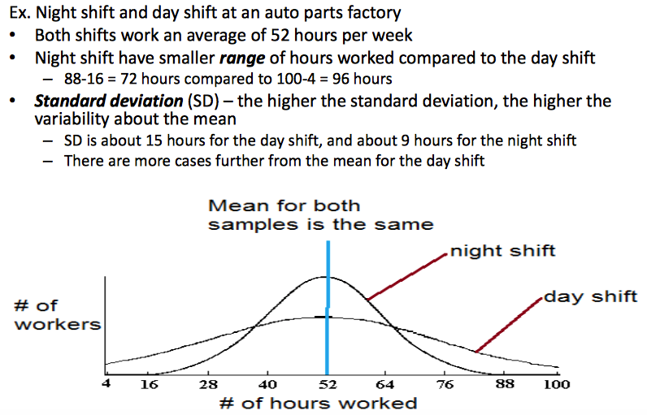
- Ex: Night and day shifts at an auto factory

- Standard deviation (SD)
- The higher the SD the higher the variability about the mean
- SD about 15 hours for the day shift and about 9 hours for the night shift
- There are more cases further from the mean for the day shift

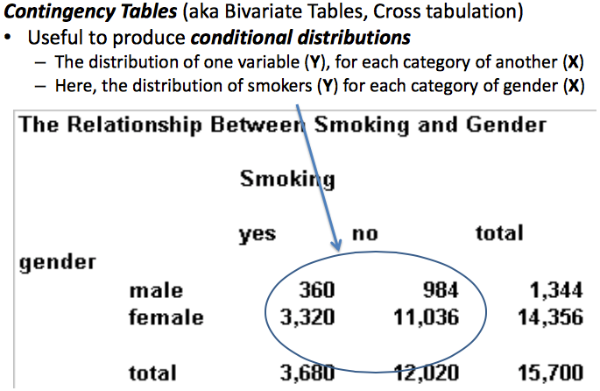
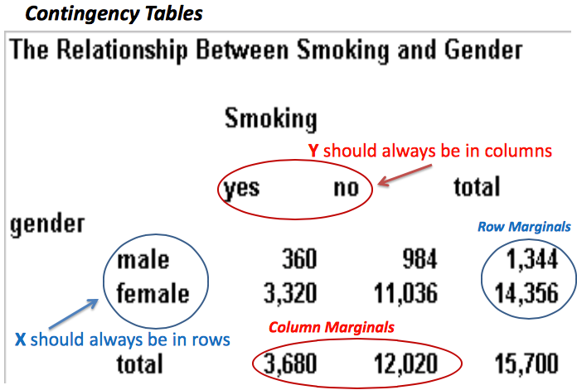
Bivariate Distributions/Statistics

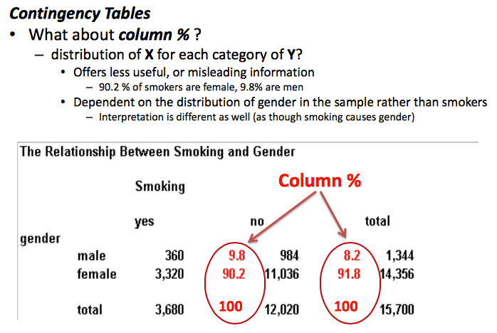
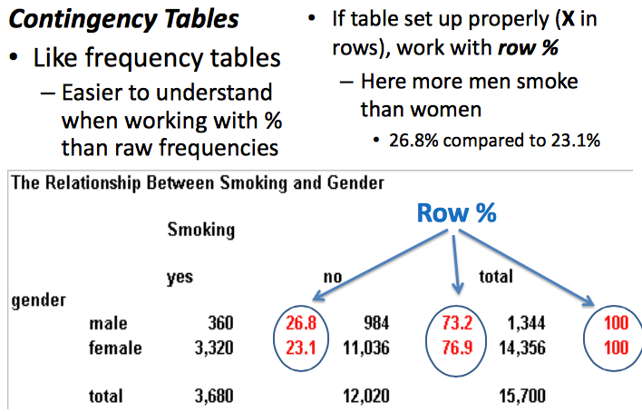

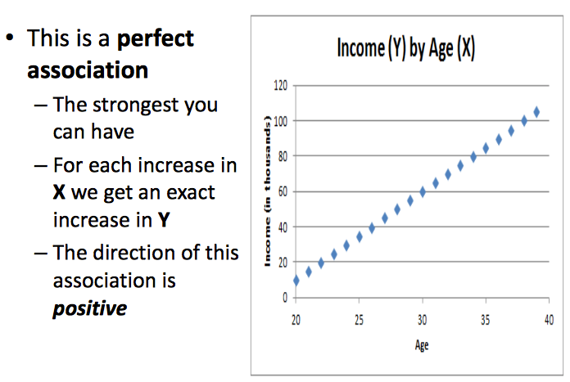

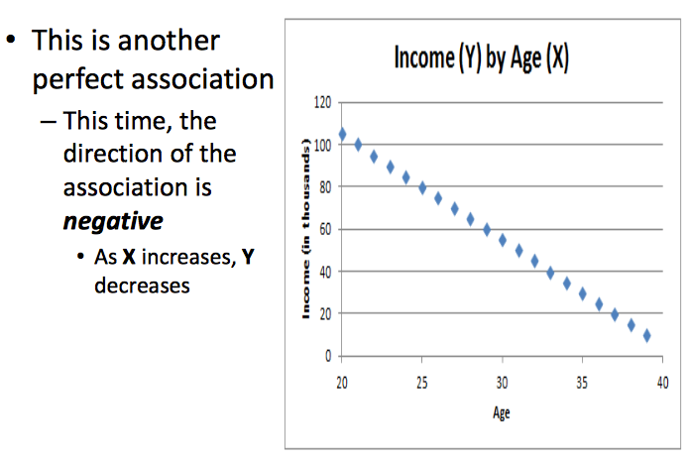
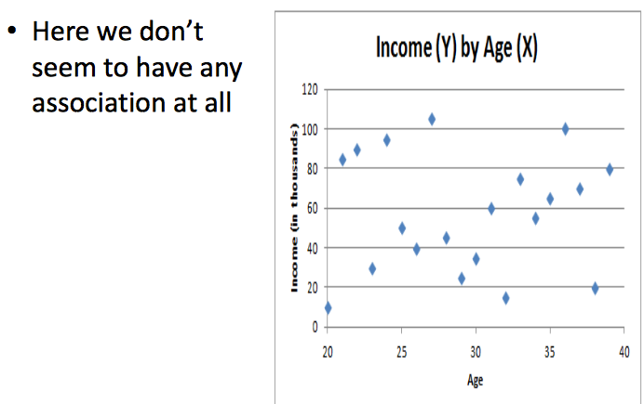

- Contigency tables are unwieldy for interval-ratio (or even large ordinal) variables
- Scatter plots
—> A sample graphic way to display distributions of Y across categories of each
—> Can not be used with nominal variables

Multivariate Relationships and Distributions/statistics
- Multivariate—> Many variables
- Types of Associations:
—> Independent
—> Intervening
—> Interactive
—> Spurious
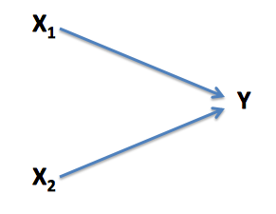
- Independent Relationships
- Each X has an independent effect on Y

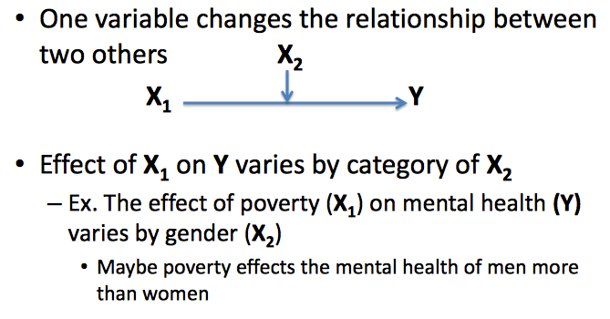
2. Intervening Relationships (chain relationships)

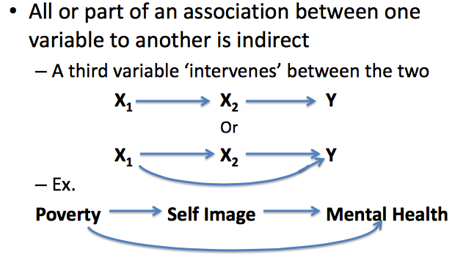
3. Interactive Relationships

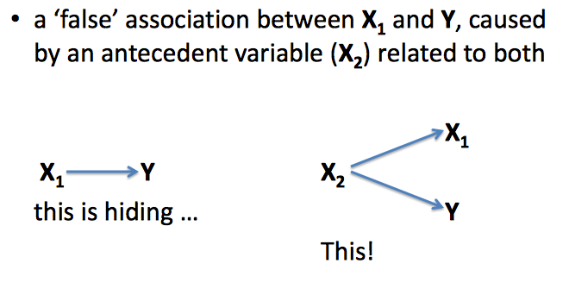
4. Spurious Relationship

Chapter 8 (9&10): Theory and Concepts

Qualitative Orientations to Research
- Usually inductive
- Tends to be interpretivist
- Is often constructionist
- Frequent use of naturalist perspective

Theory and Concepts
- Place of theory
- Involves grounded theory
—> using data to develop theories
—> Starting on the “ground” with observations
—> Often an interactive process: Going back and forth from data to theory, revising or “tightening” theory
- Creating and measuring concepts
- Quantitative research
—> Defining and measuring concepts one of 4 main goals
—> Definitive concepts
—> Defined with nominal and operational definitions
—> Refined, standardized measures
- Qualitative research
—> Not central to research process, though still useful
—> Sensitizing concepts
- Provide only a general sense of reference for empirical research
- Concept may be a “moving target”

Kinds of Qualitative Research
- Ethnography/participant observation
- Qualitative interviewing
- Focus groups
- Qualitative analysis
- Conversation and discourage analysis
- Textual and document analysis
*Often some combination

4 Main Goals of Qualitative Research
1. Empathy
- Seeing through the eyes of the people studied
- Involves probing “beneath the surface” of social behaviour
2. In-depth description and emphasis on context
- Narrow contexts: Behaviour that seems odd or irrational may be easier to understand if the context is deeply described
- Ex: Religions rite observed out of context
- Broader social context and cultural relativism: human beliefs and activities can best be understood in terms of the broader cultural context which they are situated
3. Emphasis on process
- Showing how events and patterns unfold over time
- A long time spent in the field allows the researcher to understand individuals and social change
- This can be done with semi-structured and unstructured interviewing and using a life history approach
4. Flexibility and limited structure
- Questions asked the people studied tend to be quite general, especially early in the research
- There is usually little or no theory or predefined concepts driving the research
- The topics explored in the research may change as the study progresses

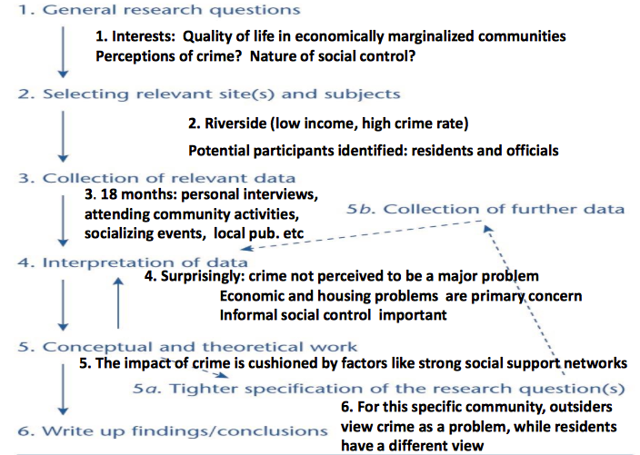
6 Basic Steps to Qualitative Research
- Inductive, often iterative progress

Reliability and Validity
- Very important in quantitative research
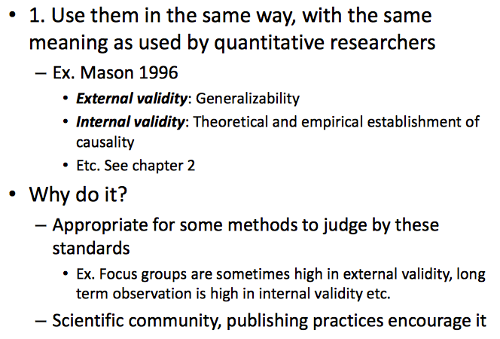
- For establishing and assessing the quality of concepts and their measures
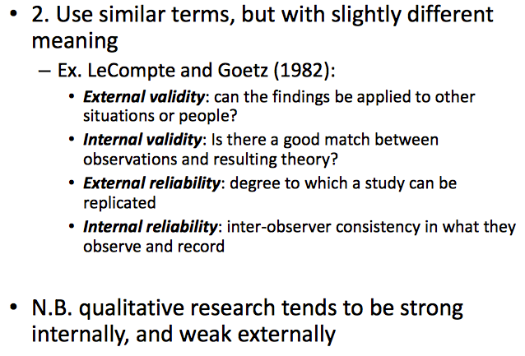
- Often not directly applicable in qualitative research
- 3 ways to approach these terms/issues

3. Use terms and ideas created specifically for qualitative research

Credibility
- Parallels measurement and especially internal validity
- How believable are the findings?
- To other researcher to consumers of the research and also for the people studied
- Can we respondent validations
—> Have participants read your notes, or pre-published work
—> Does your account seem true to them?
—> Problems:
- Defensive reactions and demands for censorship
- Loyalties to researchers and lack of honesty
- Lack of understanding
> Lack theoretical and conceptual knowledge
> Often can’t make clear sense of findings

Transferability
- Parallels external validity
- Do the findings apply to other people in other situations?
- sometimes not very important to qualitative researchers
- Often look at rare or unique cases
- Focus on thick descriptions
- Rich detailed accounts
—> Used to compare contexts/behaviours etc.. and see if they are similar if transferability important

Dependability
- Parallels reliability
- Are the findings consistent over time
- Where we expect them to be
- Do we have enough consistent findings to justify our theoretical inferences?
- Can use auditing approach
- Keep very complete rcords of whole research process and give to peers to evaluate
- Long and difficult so not popular

Confirmability
- Parallels replicability and especially objectivity
- Would another researcher with different values reach the same conclusions?
- Even in qualitative research, personal values should not blatantly influence the process or results

Critiques of Qualitative Research
- Very impressionistic and subjectivity
- Choice of simple questions or observations and findings
- Very “interpretive”
- Interpretations of selective interpretations
- Bias can result from personal relationships that develop during the research
- Problems of generalization
- Generalization may not be the goal of the research
- Lack of transparency
- Often difficult to determine how the research was conducted- why certain choices were made and the exact characteristics of those choices
—> Who was sampled and why, what questions were asked, what was the context of the interview/observations
- Difficult to replicate

Qualitative Data
- Data management and interpretations is very labour intensive
- Most methods produce huge amounts of data at a time
- Usually data is unstructured
- Often collected using multiple methods
- Often data id from multiple media
- Tape records, photographs, videos as part of the process
- Unless project is very small or very simple:
- Very unwieldy! Makes data difficult to organize, archive, access etc..
- Like with quantitative data, much software available to help

Qualitative Methods
- Questions:
- Quite general, especially early in the research
- Not theory and hypothesis driven—> search for thick data instead
- The topic explored and questions asked often change as the study progresses
- Types of interviews
- Semi structured
—> Have a sample, changeable interview schedule
—> Usually called an interview guide in this context
—> Can work with colleagues
- Unstructured
—> Have little or no interview schedule
—>Most common of qualitative methods
- Life history
—> Usually used with personal documents
—> Builds the story of one person, or one family over the course of their lives
—> Usually retrospective

Qualitative Vs. Quantitative

Focus Groups
- In-depth group interviews
- 6-10 participants usually considered optimum
- Usually meet on one occasion
- Usually recorded
- Work with specific issues
- Discussion controlled by a skilled moderator
Qualitative | Quantitative
- Unstructured interview guide  - Questions and order often tailored to respondent | - Structured survey
- Beginning and end not clear  - Interviewer can continue later | - Standardized interview schedule
- Often open-ended with many probs | - Clear beginning and end
- Interviewer shows personal interest  - More like a simple conversation | - Often close-ended
- Often informal with diversions | - Interviewer remains neutral/objective
 | - Professional tone/no jokes, anecdotes
- Success heavily dependent on his/her skills
- Makes sure everyone participates
- Exploits group dynamics to obtain conflicting view points
- Difficult skill to pick up
- Collects a lot of information quickly
- Possibly too much
- Potential problems
- Dominant or shy personalities
- Market researchers typically use this approach for private behaviour or social research

Participant Observation/Ethnography
- Ethnography is the more inclusive term
- Participant observation refers to the observational component of this sort of work
- Not all ethnography includes participants
- Researcher is immersed in a particular social settings for a long period of time, sometimes even years
- Behaviour is observed in an unstructured way
- In-depth, unstructured disscussions and interviews usually accompany observations
- Ex: Research on crime and housing complex in Britain
- Ex: Research on emotional labour among stewardesses
- Ethnography can be contrasted with structured observation and much discussion here mirrors discussion from chapter 6

Active or Passive
- Sometimes an active role is necessary
- Doing what your subject is doing
- Even when role is more observer and less participant
- Maintain credibility in the minds of the people studied d
- Sometimes just happens- comes with the territory
- Sometimes an active role is physically dangerous, illegal or has ethical implications
- Potential for “going native”
- When you genuinely join the subjects (groups, community) you are studying

Access
- Open settings
- Public setting—> Parks, downtown, side walks, cafe
- Closed settings
- Private or restricted settings
—> Meetings of private clubs, social movements, organization, centres, businesses, schools
- Covert Observation
- The public being studied do not know
- Overt
- The people being studied know
- How to gain access of closed settings
- Need a sponsor
—> Someone in the group or organization to vouch for you
—> Sometimes very difficult to find someone
—> Friends, previous contacts, colleagues
- Sponsors can also serve as key informants
—> Usually very knowledgeable and cooperative
—> Researchers may ignore other group members
—> Their view may not be representative of group
- May still need approval of gatekeepers even though you have a sponsor

Ethnographic Data
- Incredible amount of note taking and arranging takes place
- Mental notes—> memory, when can’t write things down
- Jotted notes—> written on the fly in field often key words, quotes, or symbols
- Direct observation notes-> recorded immediately after leaving field
- Analytic memos
- Insights and inferences
- Notes on how to continue
- Typically involves theoretical insight
- Making notes when looking over already written notes
- Personal notes—> purposes of reflexivity
- Feelings and emotional reactions to research etc..

