Chapter 5:
Absorption costing (full costing):
All manufacturing cost, fixed and variable, are assigned to units of products -- units are said to fully absorb manufacturing

Job order and process costing
- Process costing system:
  - A costing system used in those manufacturing situations where a single, homogeneous product flows in a continuous stream out of the production process
  - Homogeneous product that flows evenly through the production process on a continuous basis
  - Unit product cost (per kilo, liter, bottles) = total manufacturing cost / total units produced (kilos, liters, bottles)
  - Since one unit of product (kilo, liter, bottles) is indistinguishable from any other unit of product Each unit is assigned the same average cost-- applies to homogenous units following in a continuous stream out of the production process
- Job-order costing system:
  - A costing system used in situations where different products, jobs, and services are produced each period
  - Costs are traced and allocated to jobs, and then the costs of jobs are divided by the number of units in the job to arrive at an average cost per unit.
  - The essential difference from manufacturing firms is the lack of raw materials. accounting firms always involve: direct labor and overhead
  - Cost records must be maintained for each distinct product
  - Job-order costing system requires more effort than a process costing system -- used more than half the manufacturers in North America
Job-order costing
- Companies generally classify the manufacturing costs into three categories:
  - Direct labor,
  - Direct material
  - Manufacturing overhead
- Measuring the direct materials cost:
  - Bill of records: a record that lists the type and quantity of each major item of materials required to make a product
  - Production order is issued when an agreement has been reached with customers concerning the quantities, prices, and shipment date for the order------ the production department prepares a material requisition form is a document that specifies 1) the type and quantity of materials to be drawn from the storeroom 2) identifies the job to which costs of materials are to be charged
  - Raw materials & direct costs:
    - Raw material: are ingredients that are converted into finished products
    - Direct materials: are materials that can be directly traced to the product or service.
    - Semi-finished materials or supplies for service job could be considered for the direct materials if they were important enough to be directly traced to be job, but they are not the raw materials
    - Raw materials can be direct materials, but not all of the direct materials are necessarily raw materials .
- Job cost sheet:
  - A form prepared to each separate job that records materials, labor, and overhead costs charged to the job
  - After direct materials are issued, the department will transfer the total costs shown in the material requisition form to job cost sheet under the section of Direct Materials. Also the number of material requisition form will be transferred to the job cost sheet and corresponds to the Direct Materials.
  - Job cost sheet serves as a means for charging costs to jobs -- Quite Important
  - JCS is a subsidiary ledger to the “Work in Process” account because the detailed records they provide for the job in processes that add up to the balance in “work in process inventory ”
- Measuring direct labor cost:
  - Direct labor consists of labor charges that are easily traced to a particular job
  - Labor charges that cannot be easily traced directly to the job are overhead costs--- indirect labor (including tasks: maintenance, supervision, and cleanup)
  - Time ticket: is an hour-by-hour summary of the employee’s activities throughout the day
  - EXAMPLE: $75 of direct labor cost relates to xxxx. This amount is automatically posted to the job cost sheet
  - EXAMPLE: $15 of indirect labor cost relates to performance. The cost is treated as overhead cost and does not get posted on job cost sheet
Computing predetermined overhead cost:
- Manufacturing overhead must be included with direct materials and direct labour on the job cost sheet since the manufacturing overhead is also a product cost --(product cost: direct materials and direct labour and direct materials and direct labor ) (period cost: selling and administrative cost) -- assigning MO to units of product can be a difficult task, here are four reasons:
  - MO is indirect cost, and this means that it is difficult to trace these costs directly to a particular job or product
  - MO consists of many different items, ranging from grease to the salary of production manager.
  - Even though the output may fluctuate due to seasonal or other factors, MO tend to remain relatively constant due to the presence of fixed cost
  - The timing of payment of MO often varies, but we produce the finished items continuously and rather uniformly all year long
- The only way to assign MO is to use allocation base.
  - The allocation of overhead cost is accomplished by selecting an allocation base that is common to all of the company’s products and services.
  - Definition: a measure of the activity, direct-labor hours or machine-hours, that is used to assign costs to cost objects
  - Predetermined overhead rate:
    - A rate used to charge 记账overhead costs to jobs; the rate is established in advance for each period using estimates of total manufacturing overhead cost and of the total allocation base for the period
    - Predetermined overhead rate = estimated total manufacturing overhead cost / estimated total units in the allocation base
    - Predetermined overhead cost is based on estimates rather than actual results. It is computed before the period begins and is used to apply overhead cost to jobs throughout the period.
  - The process of assigning overhead cost to jobs is overhead application :
    - The process of charging MO cost to job cost sheet and to work in process account
    - Overhead applied to a particular job = predetermined overhead rate * amount of the allocation base incurred by the job

    - Overhead applied to a particular job = predetermined overhead rate * actual direct labour-hours charged to the job

    - 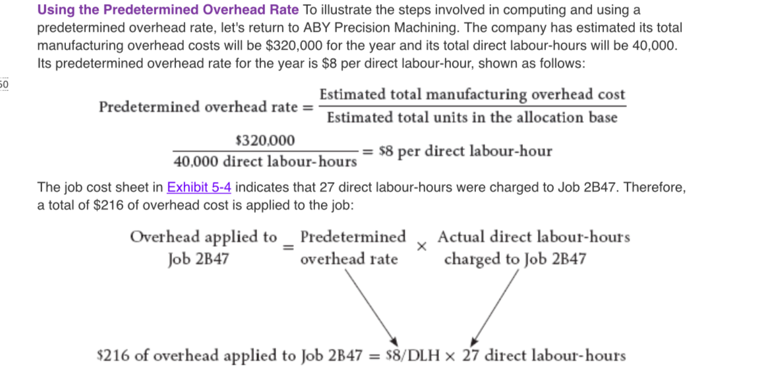
the amount of the overhead cost $216 is not the actual amount of overhead caused by the job. - There is no attempt to trace the actual overhead costs to the jobs - the overhead assigned to the job is simply a share of the total overhead that was estimated at the beginning of the year.

The overhead may be applied when direct labor hours are charged to the job or all of the overhead can be applied at once when the job is completed.

Normal cost system:
  - A costing system in which overhead costs are applied to jobs by multiplying a predetermined overhead rate by the actual amount of the allocation base incurred by the job
- The need for a predetermined rate:
  - Managers would like to know the accounting system’s valuation估价 of completed jobs before the end of the accounting period
  - If actual overhead rates are computed frequently, seasonal factors in overhead cost or in the allocation base can produce fluctuations in the overhead rates.
  - The use of predetermined overhead rate can simplify the record-keeping
- Choice of an allocation base:
  - The allocation base used in the predetermined overhead rate should drive the overhead rate.
    - Cost driver: a factor causes overhead cost, machine-hours, bed occupied, computer time, or flight hours.
  - If a base is used to compute predetermined overhead rate does not drive the overhead costs, then the results will be inaccurate
    - if direct labour-hours are used to allocate overhead, but in reality, overhead has little to do with direct labour-hours, then products with high direct labour-hour requirements will be allocated too much overhead and will be overcosted.
  - Computation of units cost
    - After calculating the assigned MO in job cost sheet, final two steps:
      - First, the totals for direct materials, direct labour, and manufacturing overhead are transferred to the Cost Summary section of the job cost sheet and added together to obtain the total cost for the job.
      - Then the total cost ($1,940) is divided by the number of units (2) to obtain the unit cost ($970).
      - this unit cost is an average cost and should not be interpreted as the cost that would actually be incurred if another unit was produced. Much of the actual overhead would not change at all if another unit was produced, so the incremental cost of an additional unit is something less than the average unit cost of $970.
- The completed job cost sheet will serve as the basis for valuing unsold units in ending inventory and determining cost of goods sold.
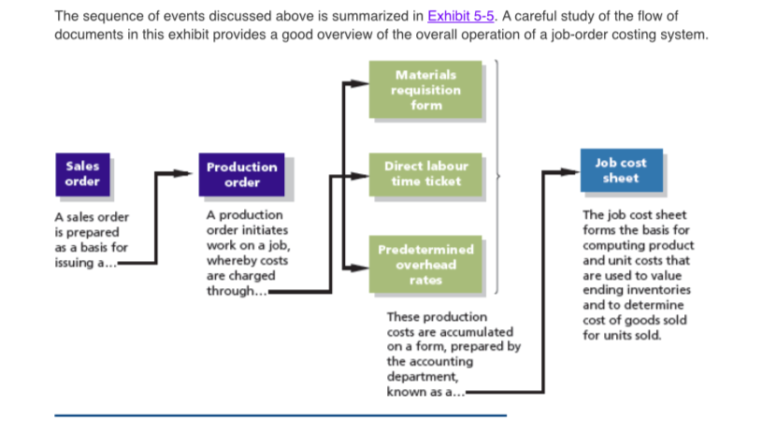

Job-order costing ----- the flow of cost:
- The purchase and issue of raw materials:
  - On April 1, Rand Company had $7,000 in raw materials on hand. During the month, the company purchased an additional $60,000 in raw materials.
  - Raw material inventory ------------------------------------------ 60,000
Accounts payable ----------------------------------------------60,000
C) raw material inventory : asset account -- when raw materials are purchased, they are recorded as an asset --- not as an expense.
- Issue of direct and indirect materials:
  - During April, $52,000 in raw materials was requisitioned from the storeroom for use in production. These raw materials include $50,000 of direct materials and $2,000 of indirect materials.
  - Work in process inventory-------------------------------50,000
Manufacturing overhead -----------------------------------2,000
Raw materials inventory ---------------------------52,000
  - Work in process inventory - direct material -- recorded in “Job Cost Sheet”
  - MO- indirect material - used in production period
  - 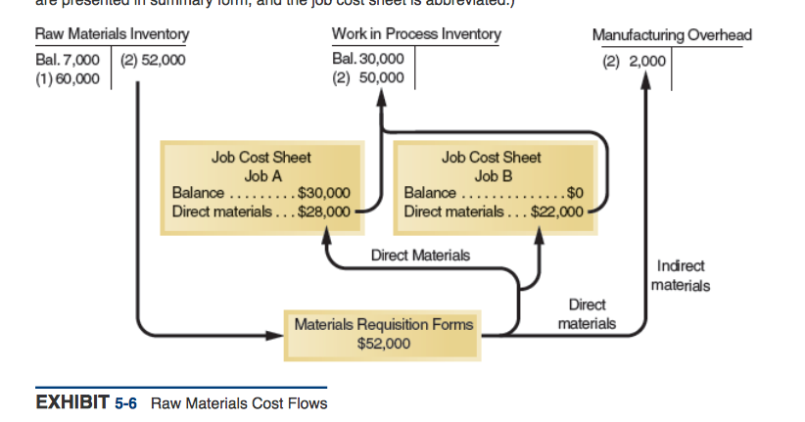
  - Job A contains a beginning balance of $30,000 represents the cost of work done during March that has been carried forward to April. The reason the $30,000 appears in both places is that the “ Work in Process account is a control account and the job cost sheets form a subsidiary ledger. Thus, the Work in Process account contains a summarized total of all costs appearing on the individual job cost sheets for all jobs in process at any given point in time.
- Issue of direct materials only:
  - Raw materials drawn from the Raw Materials Inventory account are all direct materials.

  - Work in Process Inventory ------------------------------------ XXXX
Raw materials inventory ----------------------------- XXXX
- Labor cost:
  - In April, $60,000 was recorded for direct labour and $15,000 for indirect labour
  - Work in process inventory ----------------------------------60,000
MO-------------------------------------------------------------------15,000
Salaries and wages payable ---------------------------75,000
  - Only direct labour is added to the Work in Process account
  - 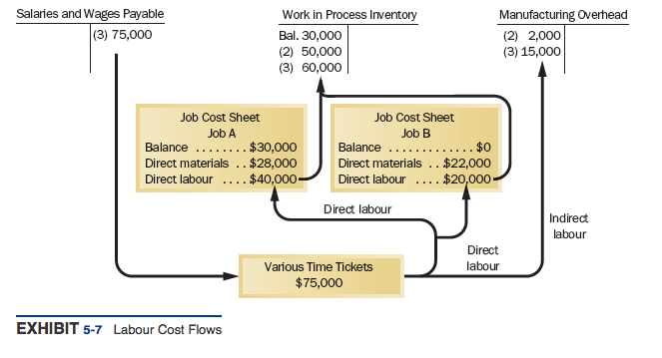
  - $15,000 represents the indirect labor costs of the period, such as supervision, janitorial work, and maintenance
- MV cost:
  - All manufacturing overhead costs are recorded directly into the Manufacturing Overhead account
  - Manufacturing Overhead account is debited for costs during a period
    - ACTUAL OVERHEAD :
utilities (heat, water, hydro)----------- A
rent on factory equipment ------------- B
factory cost-------------------------------C
total ----------------------------------------D
  - MO ---------------------------------------------------------D 4000
Accounts payable--------------------------------D 4000
Actual overhead costs are debited to the accounts as they are incurred day by day throughout the year
  - MMMMM recognized $13,000 in accrued property taxes and that $7,000 in prepaid insurance expired on factory buildings and equipment.
    - MO -------------------------------------------- E + F
Property taxes payable------------ E
Prepaid insurance -----------------F
  - Mmmmm recognized $18,000 in depreciation on factory equipment during April.
    - MO--------------------------------------------------------O
Accumulated Depreciation------------------------O

The application of manufacturing overhead:
- A predetermined overhead rate is established at the beginning of each year - predetermined overhead rate is based entirely on estimates of what overhead costs are expected to be, and it is established before the year begins
- Actual overhead costs are debited to the accounts as they are incurred day by day throughout the year
- The MO applied to “Work in process” is debited and MO is credited
- When assigning MO in the Work in Process account,
  - Work in process ------------------------------------------------------- 90,000
MO------------------------------------------------------------------- 90,000
- 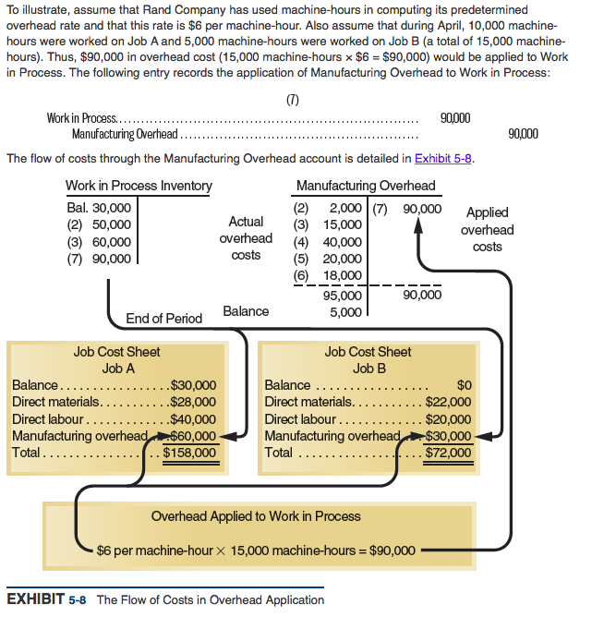
- Actual overhead costs are not charged to jobs; actual overhead costs do not appear on the job cost sheet, nor do they appear in the Work in Process account. Only the applied overhead cost, based on the predetermined overhead rate, appears on the job cost sheet and in the Work in Process account.
- Actual overhead costs for the period are $5,000 greater than the overhead cost that was applied to Work in Process, resulting in a $5,000 debit balance in the Manufacturing Overhead account
- 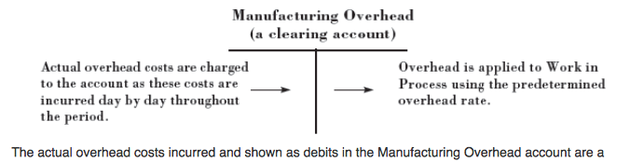
If the actual manufacturing overhead cost is applied to jobs, then the company must wait until the end of the accounting period to apply overhead and to cost jobs.

Non-manufacturing cost:
- Non-manufacturing cost should not go into MO account.
- Assume that mmm incurred $30,000 of selling and administrative salaries during April
  - Salaries Expense-----------------------------------------------------30,000
Salaries and wages payable-----------------------------------30,000
- Assume the depreciation on office equipment during April was $7000
  - Depreciation expense -------------------------------------------------7000
Accumulated depreciation ----------------------------------------7000
- Depreciation on factory equipment was debited to Manufacturing Overhead and is therefore a product cost.
- Depreciation on office equipment was debited to Depreciation Expense. Depreciation on office equipment is considered to be a period expense rather than a product cost.
- Assume that advertising was $42,000 and that other selling and administrative expenses in April totaled $8,000
  - Advertising Expense----------------------------------------------------42,000
Other selling and administrative Expense--------------------------8,000
Accounts payable ----------------------------------------------------50,000
- Any selling and administrative expenses go directly into expense accounts, they have no effect on product costs.
  - Including sales commissions, depreciation on sales equipment, rent on office facilities, insurance on office facilities, and related costs.
  - Depreciation and salaries should be classified as product costs if related to manufacturing but are classified as period costs if related to non-manufacturing activities.
Cost of goods manufactured ：
- The costs of the completed job are transferred out of the Work in Process account and into the Finished Goods account.
  - Assume that Job A was completed during April. The following entry transfers the cost of Job A from Work in Process to Finished Goods:
  - Finished goods inventory --------------------------------------------158,000
Work in process inventory ------------------------------------158,000
  - 158,000 represents the completed cost of job a, as well as the cost of goods manufactured for this month.
  - Job b was not completed by month-end, so its cost will remain in the “Work in Process” account and carry over to the next month.
    - In a balance sheet, job b will appear as “Work in Process Inventory” in the asset section

- Cost of goods sold:
  - As units in finished goods are shipped to customers, the cost is transferred from the “Finished goods” account and “Cost of Goods Sold” account ------- to transfer the entire cost appearing on the job cost sheet into the “cost of goods sold” account
  - In most cases, only a portion of units involved in a particular job will be immediately sold, the unit cost must be used to determine how much the product cost should be removed rom Finished Goods and charged to Cost of Goods Sold.
  - Assume that 750 of the 1,000 gold medallions in Job A were shipped to customers by the end of the month, for total sales revenue of $225,000. Since 1,000 units were produced and the total cost of the job from the job cost sheet was $158,000, the unit product cost was $158. The following journal entries record the sale
  - Accounts receivable -----------------------------------------225,000
Sales -----------------------------------------------------225,000
Cost of goods sold (750 units * $158 per unit = 118,500)------ 118,500
Finished goods Inventory--------------------------------------118,500

The journal entries:
- The purchase of raw materials:
  - On April 1, Rand Company had $7,000 in raw materials on hand. During the month, the company purchased an additional $60,000 in raw materials.
  - Raw material inventory ------------------------------------------ 60,000
Accounts payable ----------------------------------------------60,000
- Requisition of direct and indirect materials:
  - During April, $52,000 in raw materials was requisitioned from the storeroom for use in production. These raw materials include $50,000 of direct materials and $2,000 of indirect materials.
  - Work in process inventory(direct)----------------------50,000
Manufacturing overhead (indirect)-----------------------------2,000
Raw materials inventory ---------------------------52,000
- Paying direct and indirect labor cost:
  - In April, $60,000 was recorded for direct labour and $15,000 for indirect labor
  - Work in process inventory (direct)-----------------------------60,000
Manufacturing overhead (indirect)---------------------------15,000
Salaries and wages payable ---------------------------75,000
- All actual manufacturing overhead costs are recorded directly into the Manufacturing Overhead account
ACTUAL OVERHEAD :
utilities (heat, water, hydro)--------------------------------------------------- A
rent on factory equipment ------------------------------------------------------ B
factory cost-------------------------------------------------------------------------C
total --------------------------------------------------------------------------D
FINALLY - RECORDED DIRECTLY INTO MOV account

Manufacturing overhead ----------------------------------------------------D (4000)
Accounts payable------------------------------------------------------------D (4000)
- MMMMM recognized $13,000 in accrued property taxes and that $7,000 in prepaid insurance expired on factory buildings and equipment.
MO -------------------------------------------- E + F
Property taxes payable------------ E
Prepaid insurance -----------------F
- Mmmmm recognized $18,000 in depreciation on factory equipment during April.
MO--------------------------------------------------------O
Accumulated Depreciation------------------------O
- Assigning MO in the Work in Process account,
Work in process ------------------------------------------------------- 90,000
MO------------------------------------------------------------------- 90,000
The sum of costs in job cost sheets is equal to work-in-process. Job cost sheet: direct labor, direct material, and MO (using predetermined MO rate, rather than actual MO)
- Non-manufacturing cost: Assume that mmm incurred $30,000 of selling and administrative salaries during April
  - Salaries Expense-----------------------------------------------------30,000
Salaries and wages payable-----------------------------------30,000
- Non-manufacturing cost was debited to Depreciation Expense.
- Manufacturing cost was debited to Manufacturing Overhead
- Non-manufacturing cost should not go into MO account
9. Assume the depreciation on office equipment during April was $7000
  - Depreciation expense -------------------------------------------------7000
Accumulated depreciation -----------------------------------7000
Accumulated Depreciation is also the title of the contra asset account which is credited when Depreciation Expense is recorded each accounting period. The amount of accumulated depreciation is used to determine a plant asset's book value (or carrying value).

10. Assume that advertising was $42,000 and that other selling and administrative expenses in April totaled $8,000
Advertising Expense--------------------------------------------------------42,000
Other selling and administrative Expense-------------------------------8,000
Accounts payable ----------------------------------------------------50,000

- When completing the job:
Assume that Job A was completed during April. The following entry transfers the cost of Job A from Work in Process to Finished Goods:
Finished goods inventory --------------------------------------------158,000
Work in process inventory ------------------------------------158,000
When completing the job the cost (in job cost sheet) will transfer from Work in Process Inventory -- Finished Goods Inventory

12. When units in finished goods are shipped to customers:
Assume that 750 of the 1,000 gold medallions in Job A were shipped to customers by the end of the month, for total sales revenue of $225,000. Since 1,000 units were produced and the total cost of the job from the job cost sheet was $158,000, the unit product cost was $158. The following journal entries record the sale
- Accounts receivable -----------------------------------------225,000
Sales -----------------------------------------------------225,000
Cost of goods sold (750 units * $158 per unit = 118,500)------ 118,500
Finished goods Inventory--------------------------------------118,500
When units in finished goods are shipped to customers:
the “Finished goods Inventory” --- “Cost of Goods Sold”
HOWEVER !!!!!: unit cost
In most cases, only a portion of units involved in a particular job will be immediately sold, the unit cost must be used to determine how much the product cost should be removed rom Finished Goods (the number of products are sold ) and charged to Cost of Goods Sold.

LOOK AT PAGE 172 TWO GRAPHS

Under-applied and Over-applied overhead:
- The predetermined overhead rate is established before a period begins and is based entirely on estimated data
- There will generally be a difference between applied overhead cost and actual overhead cost actually incurred during a period
- Under-applied overhead:
  - A debit balance in MO account
  - When the amount of actual overhead cost is greater than the amount of applied overhead cost
- Over-applied overhead:
  - A credit balance in MO account
  - When the amount of actual overhead cost is less than the amount of applied overhead cost
- When the allocation base is dollars ---- such as direct materials cost------the predetermined overhead rate is the percentage of the allocation base ---- when dollars are divided by the dollars, the result is a percentage

