Homeostasis
- Walter canon: the ability of the body to maintain stable internal conditions even though there is continuous change in the outside world.
- Dynamic state of equilibrium involving many systems
- Adequate blood levels of vital nutrients
- Heart activity and blood pressure monitored and adjusted as needed.
- Waste can no accumulate
- Body temperature

Homeostatic control
- Communication within the body is done by the nervous and endocrine system through neural electric impulses and blood-borne hormones.
- All homeostatic process involve three components that work together.
- Receptor :
- sensor that monitors the environment and responds to changes called stimuli. Sends information (input) to the control center through the afferent pathway.
- Control center:
- determines set point which is the level at which a variable is to be maintained.
- Analyzes the input it receives from receptor and determines appropriate response. Information (output) flows from the control center to the effector through efferent pathway.
- Effector:
- provides the means for the control center’s response (output) to the stimulus.
- The results of the response then feed back to influence the effect to the stimulus.
- Reduces stimulus in negative feedback to shut off the control process
- Enhances stimulus in positive feedback so the process continues at even a faster rate.
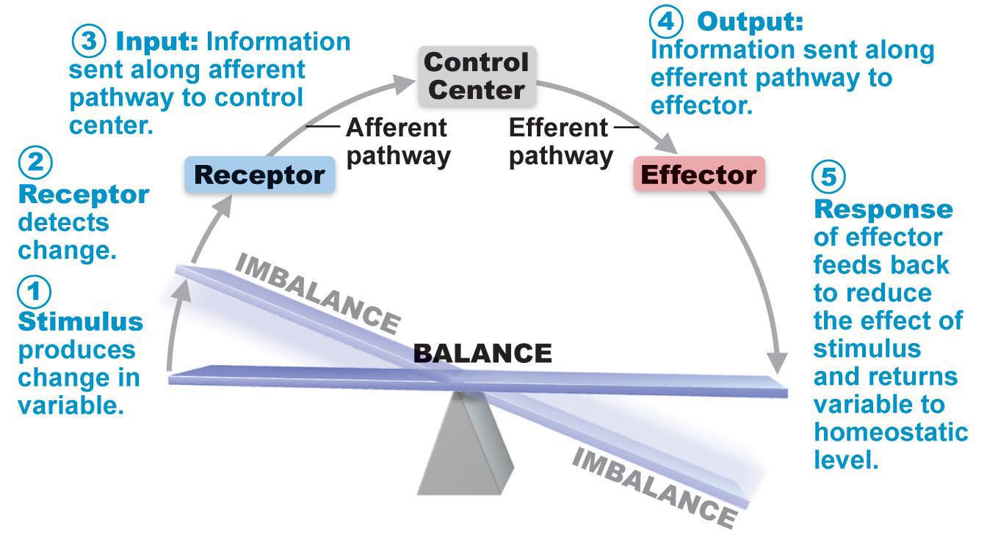
Negative feedback mechanism
- Most control mechanisms are negative feedback.
- The output shuts off or reduces the intensity of the original stimulus.
- Cause variable to change in direction opposite to the initial change returning to ideal value.
- In hormone or neural pathways negative feedback reduces secretion
- processes regulated in opposite direction by hormones or neural pathways. Ex: blood glucose.
- Goal of negative feedback is to prevent sudden or severe changes.
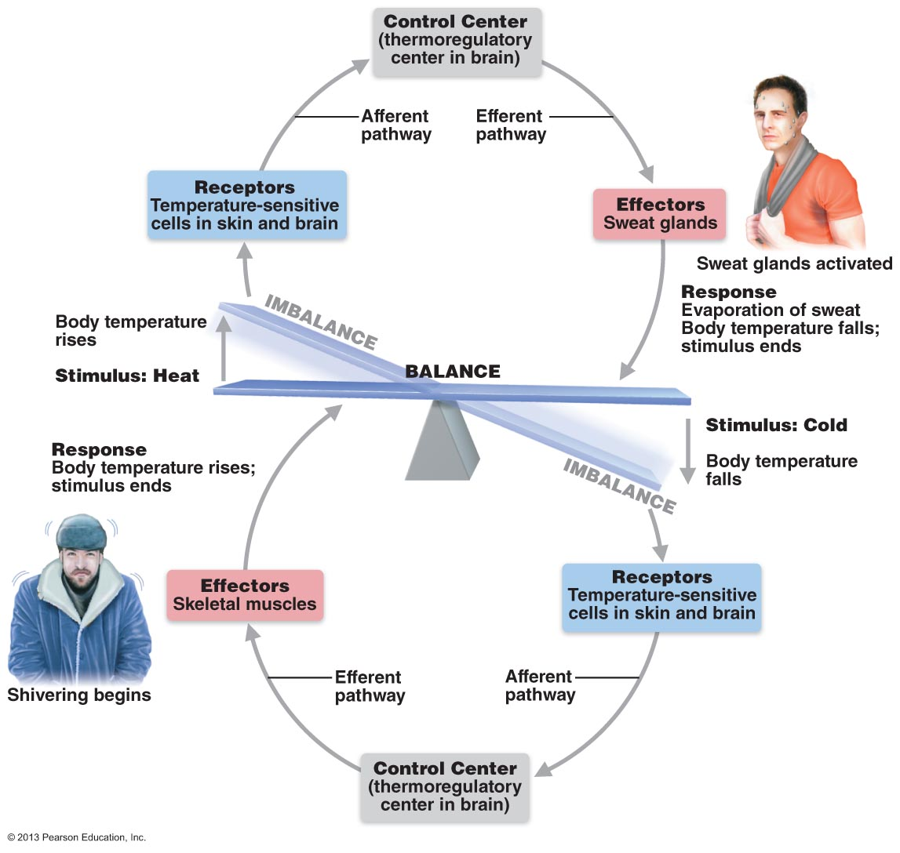

Positive feedback mechanism
- The result enhances original stimulus so the response is accelerated.
- The change that results proceeds in the same direction as the original change.
- Usually control infrequent events that do not require continuous adjustment.
- Set off series of events that set off waterfall event. (cascades)
- Enhancement of labor contractions and blood clotting.
- In labor oxytocin causes contractions to be more frequent and more powerful. The increased contraction causes more oxytocin which results in more contractions. The birth ends this process.
- In blood clotting, once a vessel has been damaged platelets begin to attach to the injured site and release chemicals that attract more platelets. The growing pile of platelets causes a plug in the tear to form a clot.

The Autonomic nervous system
- The system of motor neurons that innervate smooth and cardiac muscle and glands.
- Shunts blood to needy areas
- Speed/slow heart and respiratory rates
- Adjust blood pressure and body temp
- Increase/decrease gastric secretions
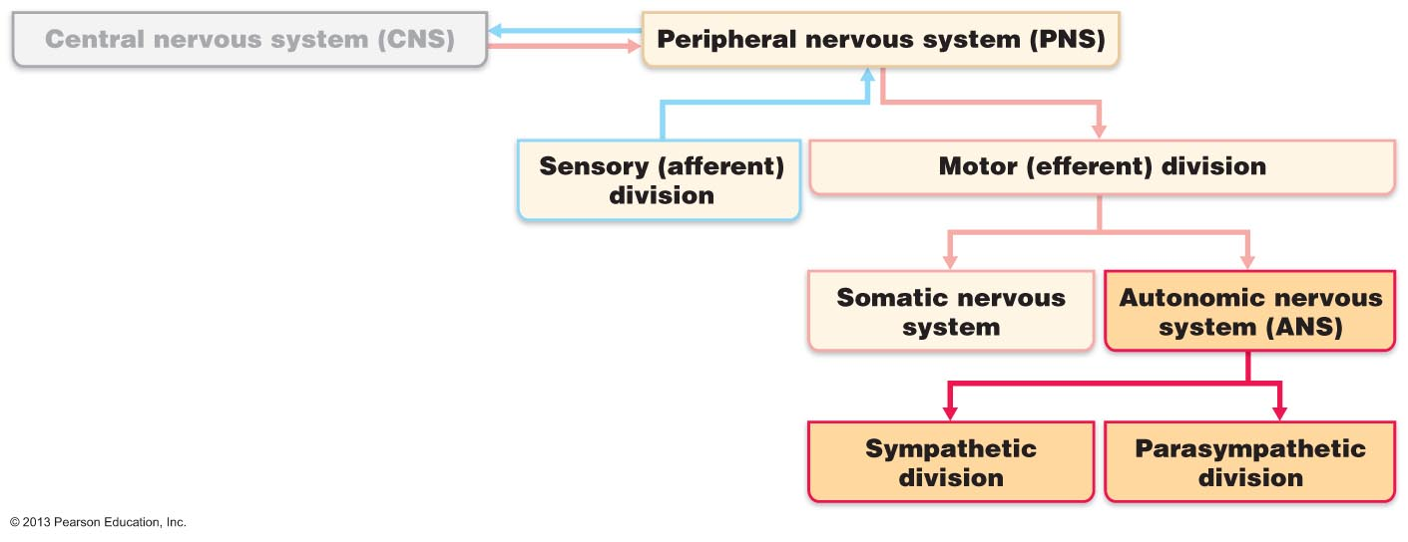

Comparison of the autonomic and somatic nervous system
- Both systems have motor fibres but they differ in their effectors, efferent pathways and ganglia and target organ responses to neurotransmitters.
- Effectors
- Somatic nervous system stimulates skeletal muscles
- ANS innervates cardiac and smooth muscle and glands
- Efferent pathways and ganglia
- Somatic nervous system: Motor neuron cell bodies in CNS. Their axons extend in the spinal or cranial nerves, all the way to the skeletal muscles. Motor fibres are thick and heavily myleinated group of fibres that conduct nerve impulse rapidly. (No ganglia)
- ANS: uses two-neuron chain to reach its effectors.
- 1) cell body of first neuron preganglionic neuron resides in the brain or spinal cord. Its axon, preganglionic axon, synapses with the second motor neuron
- 2) the postganglionic neuron is the second motor neuron. Its cell body is an autonomic ganglion outside the CNS. Its axon (postganglionic axon) extends to the effector organ.
- Preganglionic axons are thin and lightly myleinated.
- Postganglionic axons are even thinner and nonmyeleinated
- Conduction through the autonomic efferent chain is slower than conduction through the somatic system.
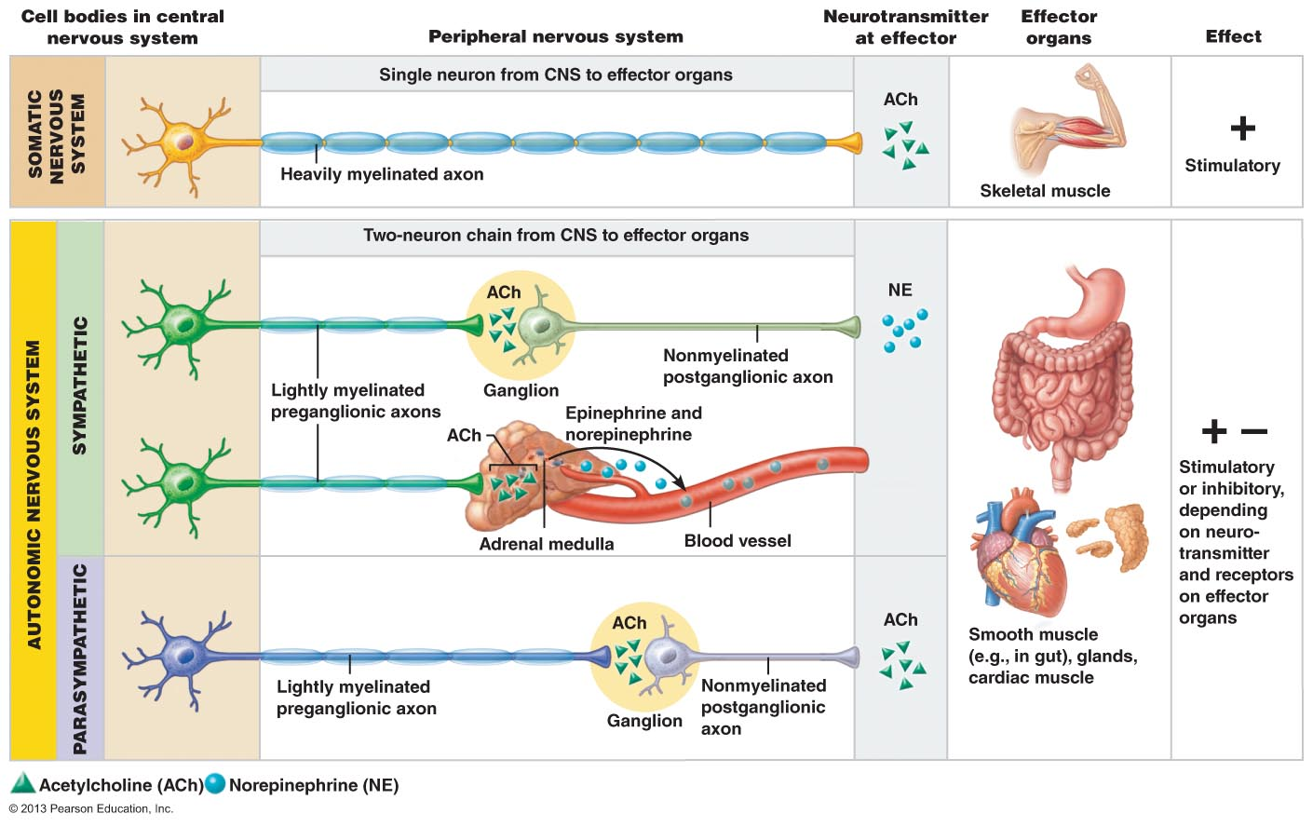

ANS divisions
- Parasympathetic and sympathetic divisions.
- They both serve the same organs but cause opposite effects.

Parasympathetic
- Promotes maintenance functions and conserves body energy
- Sometimes called the rest and digest system.
- Keeps body energy use as low as possible through housekeeping activities (digestion, waste removal)
- Predominant effect of parasympathetic nervous system while reading after a meal? Blood pressure and heart rate regulated at low normal levels and the gastrointestinal tract is actively digesting food. Pupils are constricted and lenses are accommodated for close up vision to improve clarity of magazine.
- D system: Digestion, Defecation, Diuresis

Sympathetic
- Mobilizes the body during activity.
- Often called fight or flight system
- Evident when we are excited or find ourselves in emergency situations.
- Rapidly pounding heart, deep breathing, dry mouth, cold, sweaty skin, and dilated eye pupils.
- E system: Exercise, Excitement, Emergency and Embarrassment.

Sympathetic and vascular tone
- Blood vessel kept in a state of partial vasoconstriction, blood shunting possible via variations in sympathetic output to specific vessels.
- Major n controlling blood pressure even at rest.
- Sympathetic fibres keep blood vessels in state of partial constriction called sympathetic or vasomotor tone.
- When BP is too low, sympathetic fibres fire more rapidly, causing blood vessels to constrict and raise BP. Vise verca when BP is too low.

Parasympathetic tone:
- Tonic slowing effect on heart, regulation of contractile activity of smooth muscle GI tract and urinary tract- can be overridden by SNS.

Interactions of autonomic divisions
- Most visceral organs receive dual innervation

Antagonist Interactions

In fight or flight situations the sympathetic nervous system reacts and after the emergency is over the parasympathetic system restores functions.
 | PNS | SNS
Heart | Restores heart rate | Increases heart rate
GI system | Restores digestion processes. | Inhibits digestion
Resp. System | Airway diameter to resting level | Dilates airways

Cooperative effects
- Cooperative ANS occurs in the external genitalia during intercourse.
- PNS dilates blood vessel in penis, producing erection.
- SNS causes ejaculation

Unique role of sympathetic Nervous System
- Regulates the adrenal medulla, sweat glands, arrector pili, muscles of skin, kidneys and most blood vessels.
- Thermoregulatory response to heat: Applying heat to skin causes blood vessels in that area to dilate reflexively. When body temp rises, sympathetic nerves dilate the skin’s blood vessels which allows heat to escape from skin flushed with warm blood. It also activates the sweat glands to help cool the body. When body temp drops, skin blood vessels constrict to prevent heat loss from the skin.
- Renin release from kidneys
- Sympathetic impulses stimulate kidneys to release renin. (enzyme responsible for formation of blood pressure increasing hormones.)
- Metabolic effects:
- Increase metabolic rate of body cells
- Raise blood glucose levels
- Stimulates mobilization of fats
- Increase mental alertness
- Increase strength/speed of muscle contractions

The PNS and SNS differ
- Sites where nerves originate
- Relative lengths of pre and post ganglionic fibres
- Locations of ganglia

Controls of autonomic function

Brain stem and spinal cord controls
- Direct effects on ANS regulated activities.
- Ventrolateral medulla regulate heart rate and blood vessel dilation and GI activities
- Midbrain centers control muscle concerned with pupil and lens focus.
- Urination reflexes integrated at spinal cord level.

Hypothalamic control
- Integration center of the ANS
- Anterior regions control parasympathetic functions
- Posterior regions control sympathetic functions.
- Hypothalamic centers exert their effect directly or through reticular formation.
- Hypothalamus coordinates heart activity, blood pressure, body temp, water balance and endocrine activity.
- Also mediates our reaction to fear through associations with the amygdala and periaqueductal grey matter
- Emotional responses to the limbic system of the cerebrum to danger and stress signal hypothalamus to activate sympathetic system in fight or flight situations.

Cortical controls
- Meditation and biofeedback allow some conscious control over visceral activities.
- During meditation you can lower heart rate , oxygen use and metabolic rate.
- Biofeedback improves management of migraine, stress and cardiac functions

Homeostatic imbalance of ANS
- Hypertension results from sympathetic vasoconstrictor response promoted by continuous high levels of stress. Forces the heart to work harder. Treated with adrenergic receptor-blocking drugs to counteract the effects of the sympathetic nervous system.

After surgery, patients are often unable to urinate and bowel sounds are absent. What division of the ANS is affected by anaesthetic? Parasympathetic nervous system.

The Endocrine system
- Influences metabolic activity by means of hormones (chemical messangers secreted by cells into extracellular fluid.)
- Endocrine glands (ductless gland) produce hormones and lack ducts.
- Hormones must bind to specific receptors to influence target cell functions.
- Hormones are specific, level of target cell activation depends on
- Hormones concentration
- Target cell receptor content
- Affinity of hormones for receptors.
- Amino acid based hormones
- Contains amino acids, peptide and proteins.
- Steroid hormones
- Synthesized from cholesterol
- Only gonadal and adrenocortical hormones are steroids.
- Eicosanoids
- Include Leukotrienes (signalling chemicals that mediate inflammation and allergic reactions) and prostaglandins (raising blood pressure, increase uterine contractions at birth to enhance blood clotting)
- All cell membranes release these biologically active lipids.
- Effect only nearby cells therefore they are not hormone like.

Mechanism of hormone action
- Hormones alter level of cell activity based on:
- Membrane permeability and potential channels
- Synthesis of enzymes within cells
- Enzyme activation/deactivation
- Induction of secretory activity
- Stimulation of mitosis
- Water soluble hormones: include all amino acid based hormones except thyroid. Act on receptors in plasma membrane. Receptors are coupled by G proteins to intracellular second messengers to mediate the target cell’s response.
- Lipid-soluble hormones: Steroid and thyroid hormones. Act on receptors inside the cell which directly activates genes.
- Peptide/protein hormones: Bind to cell surface receptors>>activate membrane bound G protein>>Production of second messenger (cyclic cAMP) >>activation of protein kinases to regulate activity of key enzymes.
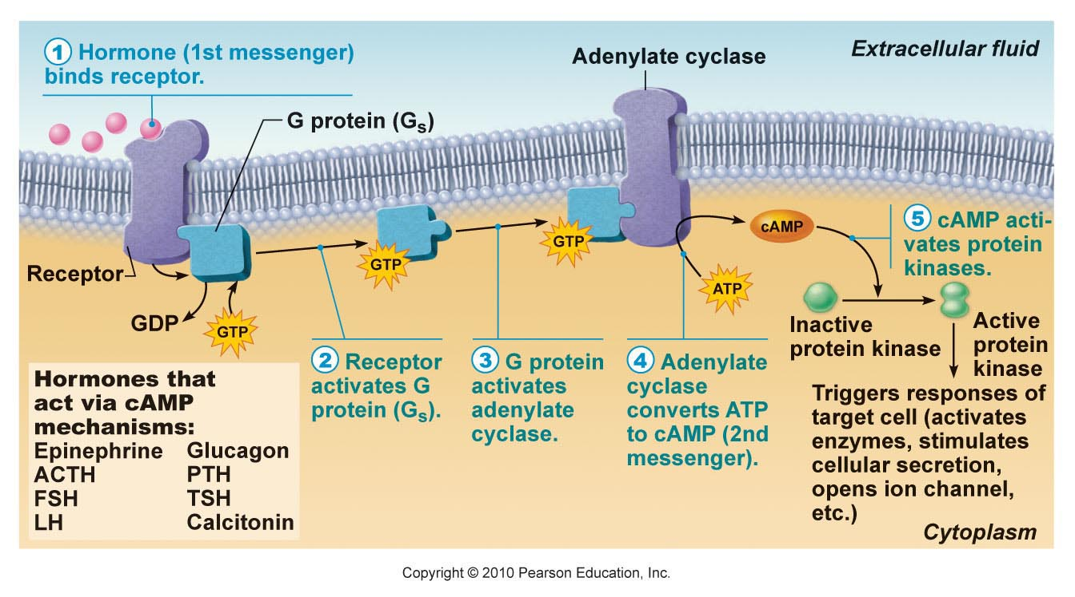

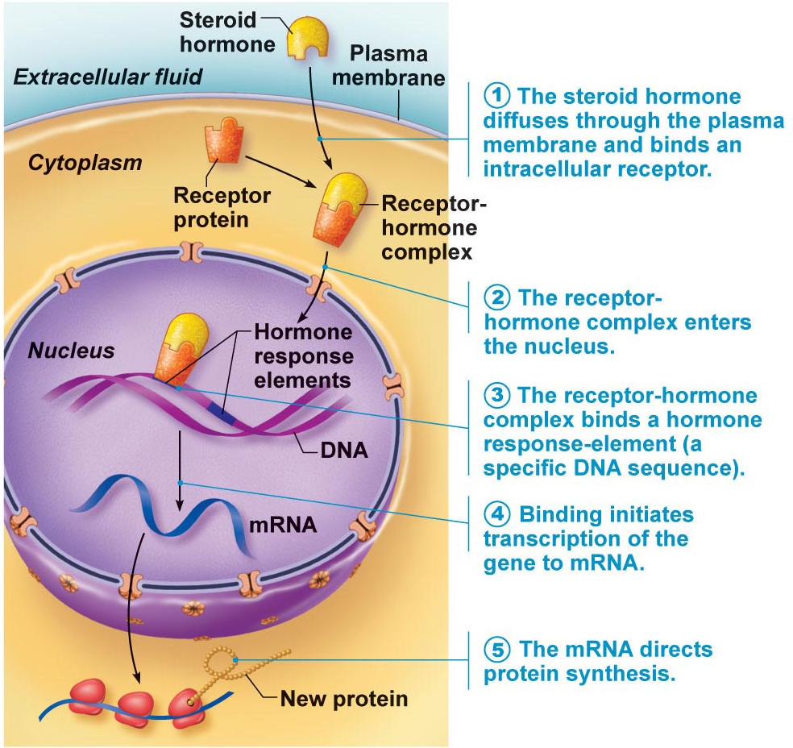
Steroid hormones:
Entry into the nucleus and activation of gene transcriptase.
Lipid soluble hormones.

Half-life, Onset, and Duration of Hormone activity
- Hormones are potent chemicals
- Circulate the blood stream free or bound to a carrier.
- Lipid-soluble proteins travel blood stream while attached to plasma proteins.
- Blood level of hormones depends on rate of synthesis and rate of clearance from the blood.
- Half life is the length of time for a hormone’s blood level to decrease by half. Varies from a minute to a week.
- Time to onset of hormone action is variable. Enzyme activation is rapid (minutes) enzyme synthesis (hours to days)
- Some hormones are secreted as prohormones. They are activated once they reach the target cell.
- Duration of hormone action is also variable (hours to days)

Control of Hormone Release
- Usually negative feedback (setpoint); sometimes positive feedback (goal)
- 3 types of stimuli trigger endocrine glands to manufacture and release hormones.
- Humoral stimuli: secrete hormones in direct response to changing blood levels of certain critical ions and nutrients. Example parathyroid hormones (PTH) & blood calcium, Insulin and blood glucose.
- Neural Stimuli: Nerve fibers stimulate hormone release. Example is neural stimuli in response to stress. SNS stimulates the adrenal medulla to release norepinephrine and epinephrine.
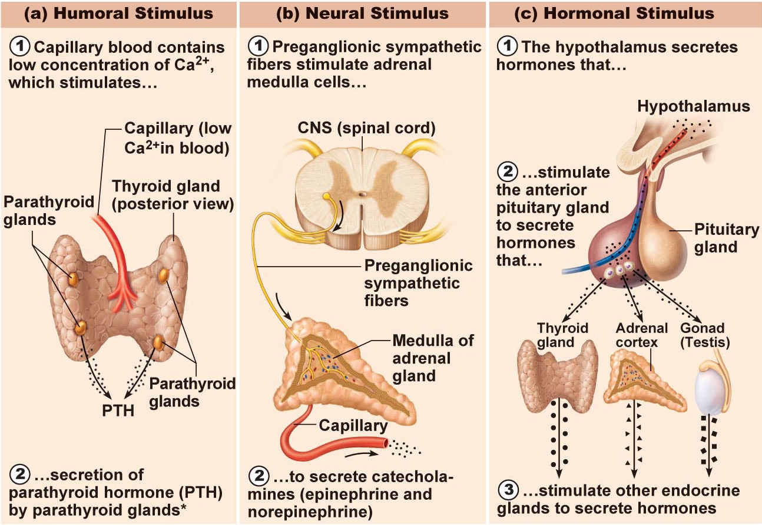
- Hormonal stimuli: release hormones in response to hormones released by other endocrine organs. Three tiered system involving hypothalamus, pituitary & target endocrine gland. Concept of hypothalamic-pituitary axis.
Hormonal Stimulus (cont.)
Thyroid-releasing hormone (TRH)
(hypothalamus)
Thyroid-stimulating hormone (TSH)
(anterior pituitary)
Thyroid hormones (T₃ & T₄)
(thyroid gland)
Hypothalamus is neural; produces a number of releasing factors (hormones) which travel to anterior pituitary via hypophyseal portal system
(what is a portal system?)

The pituitary gland
- the size and shape of a pea.
- Infundibulum connects pituitary to hypothalamus
- Has two major lobes. One lobe is neural tissue and the other lobe is glandular.
- Posterior lobe is composed of neural tissues and nerve fiber. Releases neurohormones it receives from hypothalamus.
- Has a hormone storage area.
- The anterior lobe is composed of glandular tissue.
- Oxytocin
- Strong stimulant of uterine contractions high amounts during child birth and nursing
- Released from posterior pituitary
- Child birth and milk ejection result from positive feedback mechanism
- Also neurotransmitter in the brain responsible for sexual and affectionate behavior.
- Antidiuretic hormone (ADH)
- Substance that inhibits urine production
- Prevents wide swings of water balance, helping the body to avoid dehydration and water overload.
- Hypothalmic neurons (osmoreceptors) monitor the solute concentration of the blood and when is become too high they tranmis impulses to release ADH.

The complete Hypothalmic-pituitary target organ system
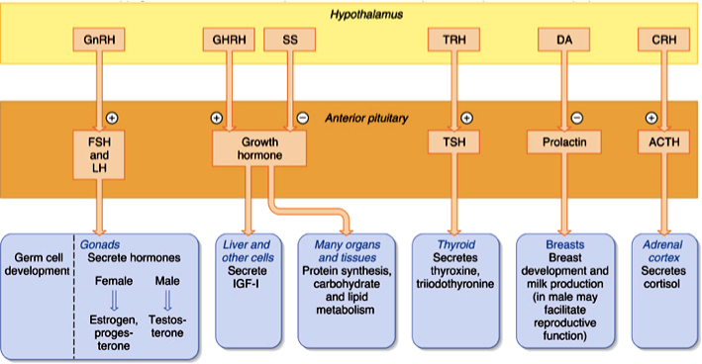
Topic 4.1 Blood

Components of blood
- Only fluid tissue in the body
- Specialized connective tissue in which living blood cells (Formed elements) are suspended in a non living matrix called plasma.
- Red mass at the bottom of centrifuge is erythrocytes( red blood cells that transport oxygen). Yellow mass on top is plasma.
- Buffy coat is a thin whitish layer at the erythrocyte-plasma junction. This contains leukocytes (while blood cells that protect the body and platelets, cell fragments that help stop bleeding)
Physical characteristics
- Sticky, opaque fluid with metallic taste.
- Color varies depending on the amount of oxygen its carrying. Scarlet (oxygen rich) dark red (oxygen poor)
- More dense and viscous than water due to its formed elements
- pH is between 7.35 to 7.45
- accounts for 8% of the body weight (5-6 L males, 4-5L females)
Functions
- Distribution
- Deliver oxygen from lungs and nutrients from digestive tract to all body cells.
- Transport metabolic waste products from cells to elimination sites (to the lungs to eliminate carbon dioxide, and to kidneys to dispose of nitrogenous waste in urine.)
- Transport hormones from the endocrine organs to their target organs
- Regulation
- Maintain appropriate body temperature by absorbing and distributing heat throughout the body and to the skin surface to encourage heat loss.
- Maintain normal pH in body tissues. Blood proteins act as buffers. Blood acts as reservoirs for the body’s alkaline reserve of biocarbonate ions.
- Maintaining adequate fluid volume in circulatory system. Blood proteins prevents excessive fluid loss from the blood stream into the tissue spaces.
- Protection
- Preventing blood loss. When a blood vessel is damaged platelets and plasma proteins initiate clot formation to reduce blood loss.
- Preventing infection. There are antibodies in the blood along with complement proteins, white blood cells, to help defend the body against foreign invaders such as bacteria and viruses. 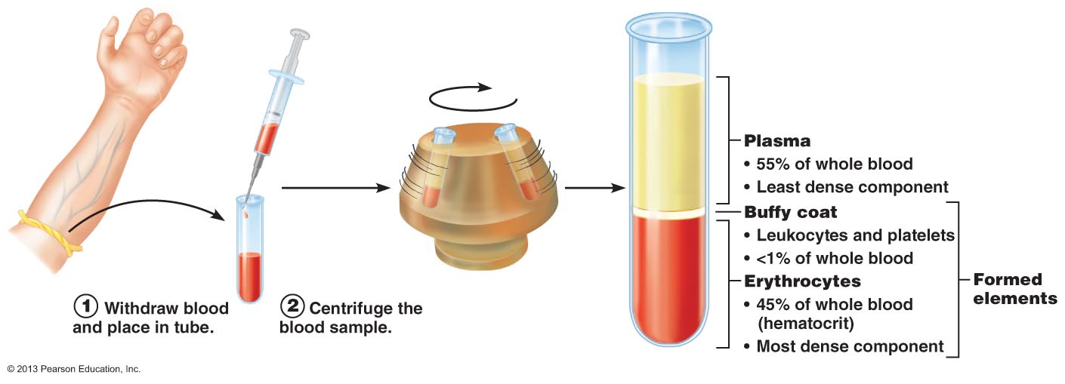
Blood plasma
- Straw colored; 90% water + many other solutes.
- Plasma proteins are produced in the liver except for gamma globulin (functional proteins that remain in the blood) plasma proteins are not taken up by cells to be used as fuel.
- Albumin is 60% of the plasma proteins. Carries curtain molecules through circulation. Its an important blood buffer and major blood protein contributing to plasma osmotic pressure.
- Blood is constantly adjusting to keep its composition, pH within normal range.
- What is the major osmotic ion?

Formed elements
- Erythrocytes, leukocytes and platelets.
- Erythrocytes have no nuclei or organelle and platelets are cell fragments. Only leukocytes are complete cells.
- Formed elements survive in the blood stream for only a few days
- Blood cells do not divide. Stem cells divide continuously in red bone marrow to replace them.

Erythrocytes (red blood cells)
- 7.5 um in diameter.
- Shaoed like biconcave disc. (flattened discs with depressed centers. Lighter at the thin center)
- Lack nucleus with no organelles (bags of hemoglobin).
- Function is gas transport pick up oxygen in capillaries of lungs and releases it to tissue cells across body.
- Transports 20% of carbon dioxide released by tissue cells back to the lungs.
- RBC protein that acts as gas transport. Regulate cell shape.
- Spectin: attaches to cytoplasmic face of RBC plasma membrane to maintain the biconcave shape of the erythrocyte. The spectrin net is deformable to allow the erythrocytes to change shape and twist as necessary to pass through capillaries with diameters smaller than itself.
- Three structural characteristics allow it to carry out gas transport functions.
- The small size and biconcave shape give it a huge surface area to volume ratio. No point within the cytoplasm is far from the surface.
- 97% of the non-water composition is hemoglobin which is molecule that binds to and transports respiratory gases.
- They lack mitochondria and generate ATP by anaerobic mechanisms so they do not consume any of the oxygen they carry, making them very efficient.
- Major factor contributing to blood viscosity; women have lower RBC count (4.3-5.2 x 10⁶ cells/μl) than men (5.1-5.8 x 10⁶ cells/μl)
- Rate of blood flow inversely affected by RBC count

Functions of Erythrocytes
- Hemoglobin is protein globin bound to red Heme pigment. Binds easily to oxygen.
- Globin consists of two polypeptide chains. Two alpha and two beta, each binding a ring like heme group with an atom of iron in its center.
- A hemoglobin molecule can transport four molecules of oxygen because each iron atom can combine reversibly with one molecule of oxygen. Each RBC contain 250 million HB molecules.
- Hemoglobin contained in erythrocytes prevents it from breaking into fragments that would leak out of the blood stream and from making the blood more viscous and raising osmotic pressure.
- Oxygen loading occurs in lungs.Oxygen deficient blood moves to the lungs. Oxygen diffuses from air sacs of lungs into erythrocytes where it binds to hemoglobin. When oxygen binds to iron the hemoglobin is now called oxyhemoglobin, changed to three D shape and becomes ruby red.
- Carbon dioxide loading occurs in tissues. Carbon dioxide combines with globin part to form carbaminoglobin.

Production of Erythrocytes
- Hematopoiesis: Production of blood cells. Occurs in red bone marrow. These are immature RBC’s. as they mature they move through capillary wall to blood.
- Hematopoietic stem cell (hemocytoblast): stem cells for all formed elements. Cells become committed to a particular blood pathway.
- Erythropiesis (erythrocyte production)
- Myeloid stem cell transforms into proerythroblast which gives rise to basophilic erythroblast to produce huge number of ribosomes.
- The cells divide many times. Hemoglobin is synthesized and iron accumulates as the basophilic erythroblast transforms into polychromatic erythroblast and then to orthochromatic erythroblast.
- The color changes because the blue ribosomes becomes masked by the pink hemoglobin.
- When the orthchromatic erythroblast has accumulated all of its hemoglobin, it ejects most of its organelles and the nucleus degenerates and pinches off and the shape changes to biconcave.
- This results in reticulocyte (young erythrocyte) because it still contains networks of clumped ribosomes.

Regulation and requirements for Erythropoiesis
- RBC in an individual reflects a balance between RBC production and destruction.
- Having too little RBC leads to tissue hypoxia (oxygen deprivation) but having too many makes the blood too viscous.
- Production rate for new cells is 2 million per second in healthy people. This process is controlled hormonally and requires enough iron, B vitamins and amino acids.
Hormonal controls
- Erythropoietin is a glycoprotein hormone that stimulates the production of erythrocytes. It is produced in the kidney and liver.
- There is always some EPO in the blood circulating to keep RBC production at basal rate.
- Drop in blood oxygen levels that triggers EPO formation can result from
- Reduced number of RBC cells due to hemorrhage (bleeding) or excessive RBC destruction
- Insufficient hemoglobin per RBC (iron deficiency)
- Reduced availability of oxygen, might occur at high altitudes or during pneumonia
- The level of oxygen transport is monitored and acts as a signal.
- Erythropoietin: enhances maturation rate of committed RBC precursor. (1-2 days to see results)
- Route of stimulation: Hypoxia>>Kidneys>>Erythropoietin>>Activation of bone marrow>>more mature RBC

Homeostatic balance
- Renal failure patients: problem due to the lack of EPO (RBCcount reduced by 50%) helped by recombinant EPO.
- Some athletes abuse recombinant EPO which increases hematocrit from 45% to 65%. This increases the viscosity plus dehydration during race can cause clotting, stroke and heart failure.
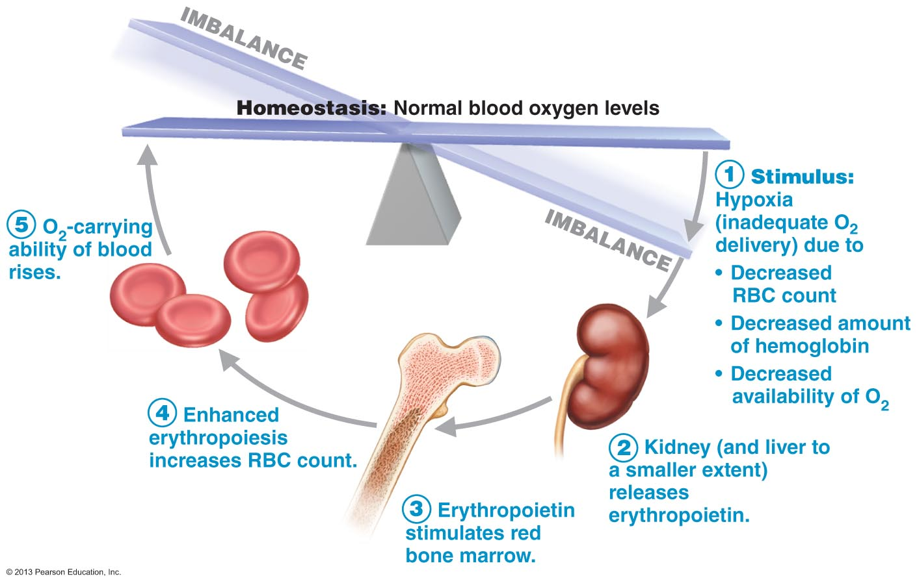
- Testostrone also enhances the kidney’s production of EPO.

Dietary requirements
- amino acids, lipids and carbohydrates.
- Iron is essential for hemoglobin synthesis. Intestinal cells control the absorption of iron into the bloodstream in response to changing body’s storage level.
- 65% of the body’s iron supply are in hemoglobin.
- The rest is stored in liver, spleen and bone marrow.
- Free iron ions are toxic so protein-iron complexes such as ferritin and hemosiderin.
- In the blood, iron is transported in loosely bound to a transport protein called transferrin.
- Small amounts of iron are lost in feces, urine and sweat.
- The average loss of iron in women is 1.7 and in men its 0.9
- Vitamin b12 and folic acid are also essential.

Fate and destruction of Erythrocytes
- RBC have life span of 100 to 120 days.
- RBC are unable to synthesize new proteins, grow or divide. They become old when they lose their flexibility. And their hemoglobin degenerates.
- In the spleen RBC become trapped and break into small fragments. This is why the spleen is called the graveyard of RBC.
- The iron core is salvaged and bound to protein (ferritin and hemosiderin) and stored for reuse.
- The balance of the heme group is degraded to bilirubin (yellow pigment that is released to the blood and bind to albumin for transport)
- Liver cells pick up biliburin and secrete it in bile into the intestine, where it is metabolized to urobilinogen.
- Most of this degraded pigment leaves the body in the feces as a brown pigment called stercobilin
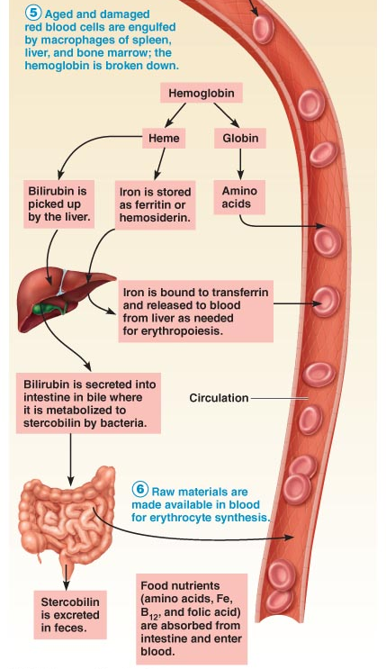
- The protein part (globin) is broken down to amino acids which are released to the circulation.

Anemia
- the blood’s oxygen carrying capacity is too low to support normal metabolism.
- People with anemia are tired, pale, short of breath and chilly.
- The cause of anemia is divided into three groups.
- Blood loss:
- Hemorrphagic anemia caused by blood loss.
- Blood loss is rapid (due to wound) and treated by replacing lost blood cells.
- Examples: hemorrhoids or ulcers
- Erythropoetic mechanisms replace lost blood cells.
- Not enough blood cells produced
- Example: lack of iron and failure of bone marrow.
- In iron deficiency erythrocytes produced called microcytes are small and pale because they do not have their hemoglobin.
- Pernicious anemia: is an auto immune deffiency that affects the elderly. The immune system destroys cells of the stomach mucus. These cells produce substances called intrinsic factor that must be present for vitamin b12 to be absorbed by intestinal cells. Without B12 the developing erythrocytes grow but can not divide resulting in large pale RBC called marcocytes. Treament contains injections of Vitamin B12.
- Renal anemia is caused by lack of EPO (hormone that controls RBC production) can be treated with synthetic EPO.
- Aplastic anemia results from destruction of red marrow by certain drugs and chemicals. Treatment is blood transfusion.
- Too many red blood cells destroyed
- Hemolytic anemia: erythrocytes rupture prematurely. Here we focus on hemoglobin abnormalities due to genetic basis.
- Examples include sickle cell and Thalassemia. The globin part of the hemoglobin is abnormal and the erythrocytes formed rupture prematurely.
- Thalassemias occurs in greek and italian people. One of the globin chains is absent and the erythrocytes are thin. Monthly blood transfusion is required.
- Sickle cell anemia caused by abnormal hemoglobin S. results from a chain in just one of the amino acid in beta chain of the globin molecule. This causes beta chains to link together under low oxygen conditions forming stiff rods so that the hemoglobin S becomes sharp. This causes RBC to become cresent shape when they unload oxygen. Small erythrocytes ruprute easily and dam up in small blood vessels. Inhale nitric oxide to dilate blood vessels. Common in black people who live in malaria belt of Africa.

Polycythemia
- Abnormal excess of erythrocytes that increase blood viscosity.
- Polycythemia vera: a bone marrow cancer characterized by dizziness and high RBC. Hematocrit is 80% and blood volume may double. Causing the vascular system to become overflown with blood and impairing circulation. Treated by diluting blood. Removing some blood and replacing it with saline.
- Secondary polycythemia: results when less oxygen is available or EPO production increases. Occurs in poepl living at high altitudes because of reduced atmospheric pressure and low oxygen content of the air.
- Artifical polycythemia: blood doping in athletes. RBC are drawn off and stored. Boy quickly replaces these RBC then the stored RBC is reinfused before the marathon. Since RBC carry oxygen the additional RBC should translate into oxygen carrying capacity for greater endurance and speed.

Platelets
- Cytoplasmic fragments of very large cells (megakaryocytes)
- Exhibit blue staining outer region and inner area with purple granules.
- Granules contain chemicals that act in clotting process.
- Platelets form temporary plugs by sticking to damaged site
- They are anucleate so they age quickly and die within 10 days.
- A hormone called thrombopoietin regulates the formation of platelets. Repeated mitosis of megakaryoblasts occurs but cytokenisis does not. Final result is mature megakaryote cell. Then megakaryocyte presses against the sinusoid (capillary in red marrow) and sends cytoplasmic extensions to the bloodstream, releasing platelet fragments into the blood.

Homeostasis
- When blood vessel walls break, homeostasis stops the bleeding.
- Following homeostasis the clot retracts and dissolves as it is replaced by fibrous tissue.
- Vascular spasm
- Damaged blood vessels respond by constricting (vasoconstriction)
- Triggers are damage, chemicals from endothelial cells and platelets as well as pain reflexes.
- Constricting the artery reduced blood loss for 30 mins giving time for the next two steps to occur.
- Platelet plug formation
- Platelets stick together to form a plug to seal the break in the vessel.
- Platelets don’t usually stick together. NO and PGI2 produced by endothelial cells prevent them from sticking together.
- When endothelium is damaged and collagen fibers are exposed, platelets adhere to the collagen fibers.
- Plasma protein (von willebrand factor) makes a bridge between the collagen and platelets. This causes platelets to swell and become stickier and release chemical messengers. Such as ADP (enhances sticking and degranulation) and serotonin & Thromboxane A2 (enhance vascular spasm and aggregation)
- Coagulation
- Blood is transformed from liquid to gel with substances called clotting factors.
- Activation turns clotting factors into enzymes then it activates the next clotting factor in the sequence.
- Phase 1: two pathways to prothrombin activator
- Coagulation initiated by intrinsic or extrinsic pathways. Same events usually trigger both pathways. In test tubes only intrinsic pathways initiated clotting.
- Components in both pathways are negatively charged membranes. Platelets that contain phosphatidylserine (PF3). Intermediate of both pathways are activated only by PF3.
- Both pathways cascade toward intermediate factor X. activation of factor X complexes with calcium ions, PF3 and V factor to form prothrombin factor. (slowest step)
- Intrinsic pathway: factors needed for clotting are found within the blood. Triggered by negatively charged substances such as platelet, collagen and glass (test tube). It is slower because it involved many intermediate steps.
- Extrinsic pathway: required tissue factor is outside of the blood. Triggered by exposing blood to factors found in tissues underneath the damaged endothelium. Called tissue factor (TF) or factor III
- Phase 2: Common pathway thrombin
- Prothrombin activator catalyzes the conversion to thrombin enzyme.
- Phase 3: Common pathway to fibrin mesh
- Thrombin transform fibrinogen to fibrin which joins together to form long fibrin strands.
- Fibrin strands glue platelets together to make a web. It also makes the liquid blood more gel like and trams formed elements that try to pass through.
- In the presence of calcium ion, thrombin also activates factor XIII (fibrin stabilizing factor). This enzyme binds the fibrin strands together tightly to form a mesh.
- Anticoagulants are factors that inhibit clotting.
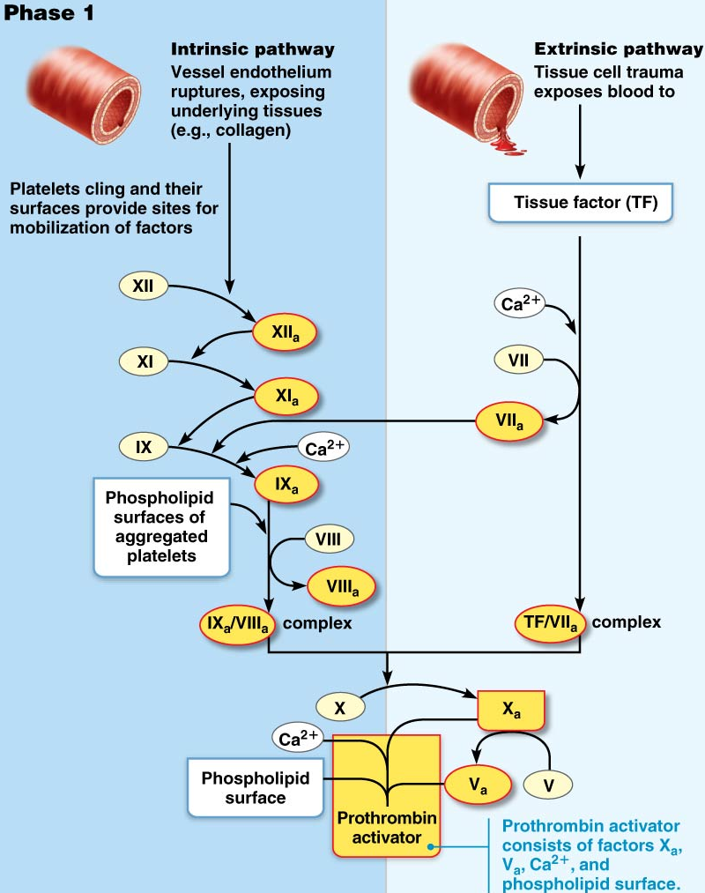

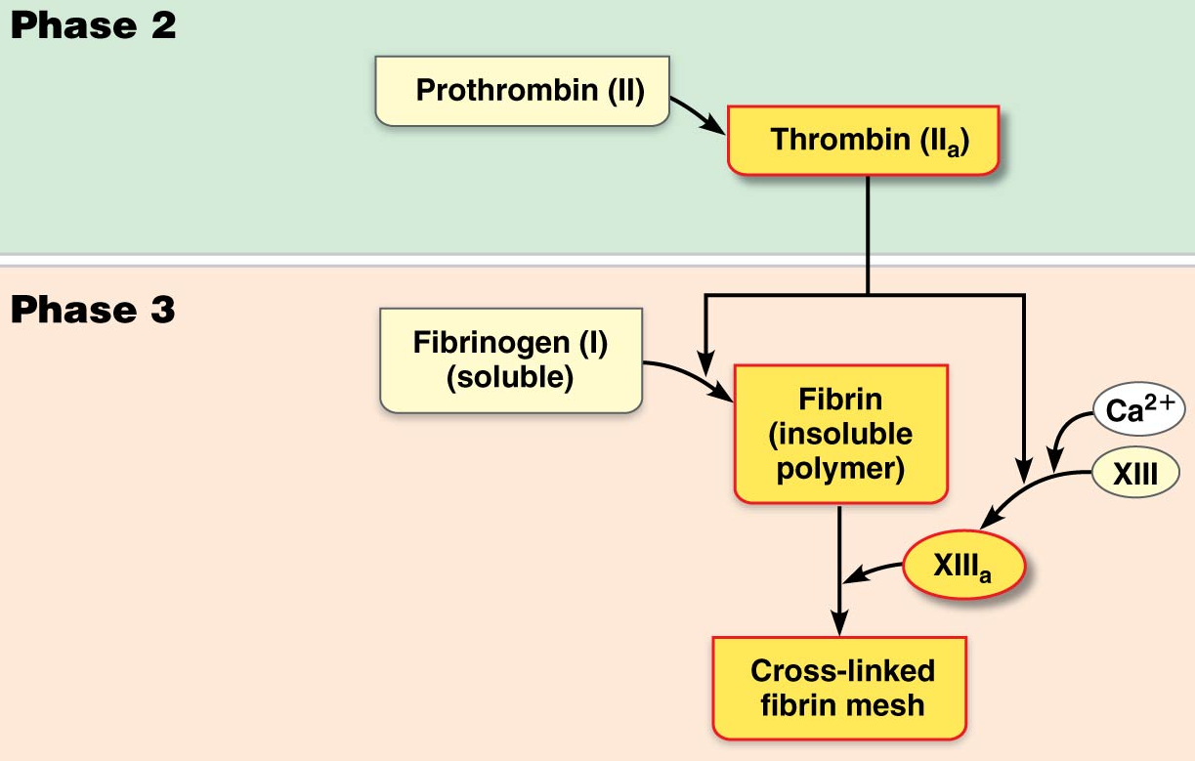
Clot retraction
- Platelet induced process that further stabilizes the clot. Occurs within 30-60 mins.
- Contractile proteins in platelets called (Actin and myosin) contract and pull in the surrounding fibrin strands.
- Serum squeezed from the clot and draw the ruptured edges of the blood vessel more closely together.
- Platelet-derived growth factor (PDGF) is released by platelets to stimulate smooth muscle cells and fibroblasts to divide and rebuild vessel walls. Fibroblast form connective tissue and endothelial cells (stimulated by VEGF; vascular endothelial growth factor) multiply and restore the endothelial lining.

Fibrinolysis
- Removed unneeded clots when healing has occurred.
- Fibrin-digesting enzyme called plasmin is produced when plasminogen is activated. Plasminogen is activated by TPA (tissue plasminogen activator) released by endothelial cells.
- Circulating enzymes destroy any plasmin in the plasma.
- Begins within two days and continues until the clot is dissolved.

Factors liming blood clot and formation/growth
- Two homeostatic mechanisms prevent clots from becoming too large.
- Swift removal of coagulation factors.
- Inhibition of activated clotting factors.
- Clot formation requires procoagulation factors to be greater than anticoagulation factors.
- Normal flowing blood washes away procoagulants
- Thrombin exerts positive feedback on coagulation process. Speeds up production of prothrombin activator and accelerates intrinsic pathways by activation of platelets. By binding thrombin, fibrin acts as an anticoagulant. (prevents clot from getting bigger)
- Antithrimbin III (protein in plasma) inactivates any escaping thrombin. Along with protein C (produced by liver) inactivate any intrinsic pathway procoagulants.
- Heparin ( found in basiphile and mast cells) natural anticoagulant. Found on the surface of endothelial cells. Inhibits thrombin by enhancing antithrombin III and it also inhibits the intrinsic pathway.
- Smooth endothelial lining of undamaged blood vessels. (also endothelial-derived heparin and prostacyclin)

Disorders of hemostasis

Thromboembolic disorder
- Thrombus: clot that develops in unbroken vessel. May block circulation of cells and damage tissue.
- Embolus: a thrombus which has broke free in the blood stream. Becomes a problem when it encounters a vessel too narrow for it to go through. When it obstructs the vessel it becomes embolism. (example: pulmonary or cerebral emboli)
- Asprin: antiprostaglandin drug that inhibits the formation of thromboxane A2 formation. (blocking platelet aggregation and plug formation)

Bleeding disorder
- Interfere with normal clotting functions.
- Thrombocytopenia
- Number of circulating platelets is deficient. Causes spontaneous bleeding from small blood vessels all over the body.
- Any movement leads to brusing (internal hemorrhage)
- Platelet count under 50 000 ul
- Whole blood transfusion provides temporary relief.
- Impaired liver function
- Liver is unable to supply usual supply of clotting factors.
- Caused from hepatitis, cirrhosis or vitamin K difficiency.
- Liver cells require vitamin K to make clotting factors. Impaired liver function fails to produce bile which is responsible for absorbing fat and vitamin K.
- Hemophilias
- Hereditary bleeding disorder
- Hemophilia A (83% of cases) deficiency in factor VIII.
- Hemophilia B deficiency in factor IX both sex linked conditions
- Requires transfusions and injections of purified clotting factors.

Transfusion
- Body compensates for some blood loss by 1) vasoconstriction to decrease blood vessel volume and 2) increased rate of erythropoiesis
- Blood loss of 15-30% leads to weakness. Loss of more than 30% can induce shock.
- Whole blood transfusion: substantial blood loss (thrombocytopenia) ;packed red cells for anemia.
- Donor blood is mixed with heparin (anticoagulant) and can be stored for several weeks at 4 degrees.

Human blood groups
- Transfusions of incompatible blood can be fatal.
- RBC antigen promote agglutination (clumping)
- Only the ABO and Rh antigens cause serious agglutination problems during transfusion.

ABO blood groups
- Based on the presence or absence of two agglutinogens type A and type B.
- Depending on which of these the person inherits his or her ABO blood group will be A, B, AB or O.
- In the ABO group is the presence in the plasma of performed antibodies called aggulitins. They act against RBC carrying ABO antigens that are not present on a persons own red blood cells.
- New born blood has no aggulitins. Begins to appear within 2 months and peak at 8-10 years old. Slowly declines with age.
- A person with neither A or B antigen (group O) has both anti-A and anti-B antibodies.
- Those with group A blood and b-antibodies and those with group B blood nad b-antibodies.
- AB individuals have neither antibody.
Blood type Antigens Antibodies
A A Ant-B
B B Anti-A
AB A & B None
O None Anti-A/B
Rh Blood groups
- There are at least 8 different types of Rh factors (only C, D and E are fairly common)
- Rh D first identified in Rhesus monkeys. It was later discovered in humans. 85% of north American are Rh+, meaning that their RBC carries the D antigen
- Rh antibodies are not spontaneously formed in blood of Rh- individuals. Individuals become sensitized upon first exposure to Rh antigens (transfusion, Rh+ fetus)
- Antibodies will attack donor RBC in response to second and subsequent exposure.
- Rh- mothers carrying second Rh+ fetus treated with RhoGram (anti Rh serum) to prevent erythroblastosis fetalis.

Transfusion reactions, Agglutination and Hemolysis
- When mismatched blood is infused, a transfusion reaction occurs in which the recipient’s plasma agglutinins attack the donor’s red blood cells. The problem is not with the donor’s antibodies because they are diluted in the recipient’s circulation.
- Agglutination clogs small blood vessels
- Clumped RBC’s rupture or are destroyed by phagocytes and hemoglobin is released into blood stream and goes to kidney tubules causing cell death and renal failure.
- Blood type O is the universal donor because they bear neither type A or B antigens.
- Overall result includes blocked flow to tissues, reduced oxygen carrying ability of blood, hemoglobin precipitates and clogs kidney tubules.
- Side effects are chills, fever, nausea, vomiting, kidney toxicity.
- Prevent kidney failure by administering alkaline fluids to dissolve hemoglobin. Also diuretics.
- Autologous transfusion: the patient predonates his or her own blood. It is stored and immediately available if needed during an operation.

Blood typing
- Use serum containing anti-A and anti-B agglutinins
- Cross matching tests if the recipients serum will agglutinate with the donor’s RBC or the donor’s serum will agglutinate with the recipient’s RBC.
- Similar procedure for Rh factor typing.

The circulatory system: The heart

Size, location and orientation
- About the size of a fist. It is hollow and cone shaped. Weighs less than a pound.
- It is enclosed with the mediastinum, the medial cavity of the thorax.
- Extends obliquely 12-14 cm from the second rib to fifth intercostal space. 2/3 of the mass is on the left side and the right side is laying on the diaphragm.
- The broad and flat base is directed towards the right shoulder and the apex points towards the hip.

Coverings of the heart
- Enclosed with a double wall sac called pericardium. The loosely fitting superficial part of this sac is fibrous pericardium. It is a dense connective tissue layer that protects the heart, anchors it to surrounding structures and prevents overfilling of the heart with blood.
- Deep to the fibrous pericardium is serous pericardium. This is a slippery two layers membrane that forms a closed sac around the heart.
- Epicardium is the integral part of the heart wall.
- The pericardial cavity contains serous fluid to allow the heart move friction free.
Layers of the heart wall
- Composed of three layers. Epericardium, myocardium and endocardium.
- Superficial endocardium is the visceral layer of the serous pericardium. Infiltrated with fat in older people.
- Myocardium (muscle heart) is composed of cardiac muscle and form the bulk of the heart. This is the layer that contracts. Cardiac muscles cells are connected together by crisscrossing connective tissue fibers and arranged n spirals. This reinforces myocardium internally and anchors cardiac muscle fibers. It also provides additional support for great vessels and valves. Direct spread of action potential across heart to specific pathways.
- Endocardium is a white sheet of endothelium resting on a thin convective tissue layer. Its located on the inner myocardial surface. It lines the heart chambers and covers the fibrous skeleton of the valve. It is continuous with the endothelium of vessels leaving and entering the heart.

Chambers and associated great vessels
- The heart has four chambers. Two superior atria and two inferior ventricles.
- The interarterial septum divides the internal part of the heart longitudinally where it separates the atria. And in the interventricle septum where it separates the ventricles.
- Right ventricle forms most of the anterior surface of the heart. Left ventricle dominates infer posterior aspect of the heart and forms the apex.
- The two grooves that carry blood vessels supplying the myocardium are the coronary sulcus and anterior-posterior interventricular sulcus.
- The coronary sulcus (atrioventricular groove) encircles the junction of the atria and ventricles like a crown.
- The anterior interventricle sulcus marks the anterior position of the septum, separating the right and left ventricles. It continues as the posterior interventricular sulcus to provide the similar landmark to the heart’s posteroinferior surface.

Atria: receiving chambers
- Protruding appendages called auricles increase the atrial volume.
- The right atrium has a smooth-walled posterior part and an anterior portion where bundles of muscle tissue form ridges in the wall. These muscles are called pectinate muscles (look like teeth). The posterior and anterior ridges are separated by crista terminalis.
- The left atrium is mostly smooth. Pectinate are only found in the auricles. The interarterial has fossa ovalis which marks the spot where an opening existed in fetal heart.
- Atria are receiving chambers for blood returning to the heart from circulation. Atria are small and thin walled and contract to push blood into ventricles.
- Deoxygenated blood enters the right atrium via three ways
- The superior vena cava: returns blood from body regions superior to the diaphragm.
- Inferioir vena cava: Returns blood from body areas below the diaphragm
- Coronory sinus: collects blood draining from the myocardium.
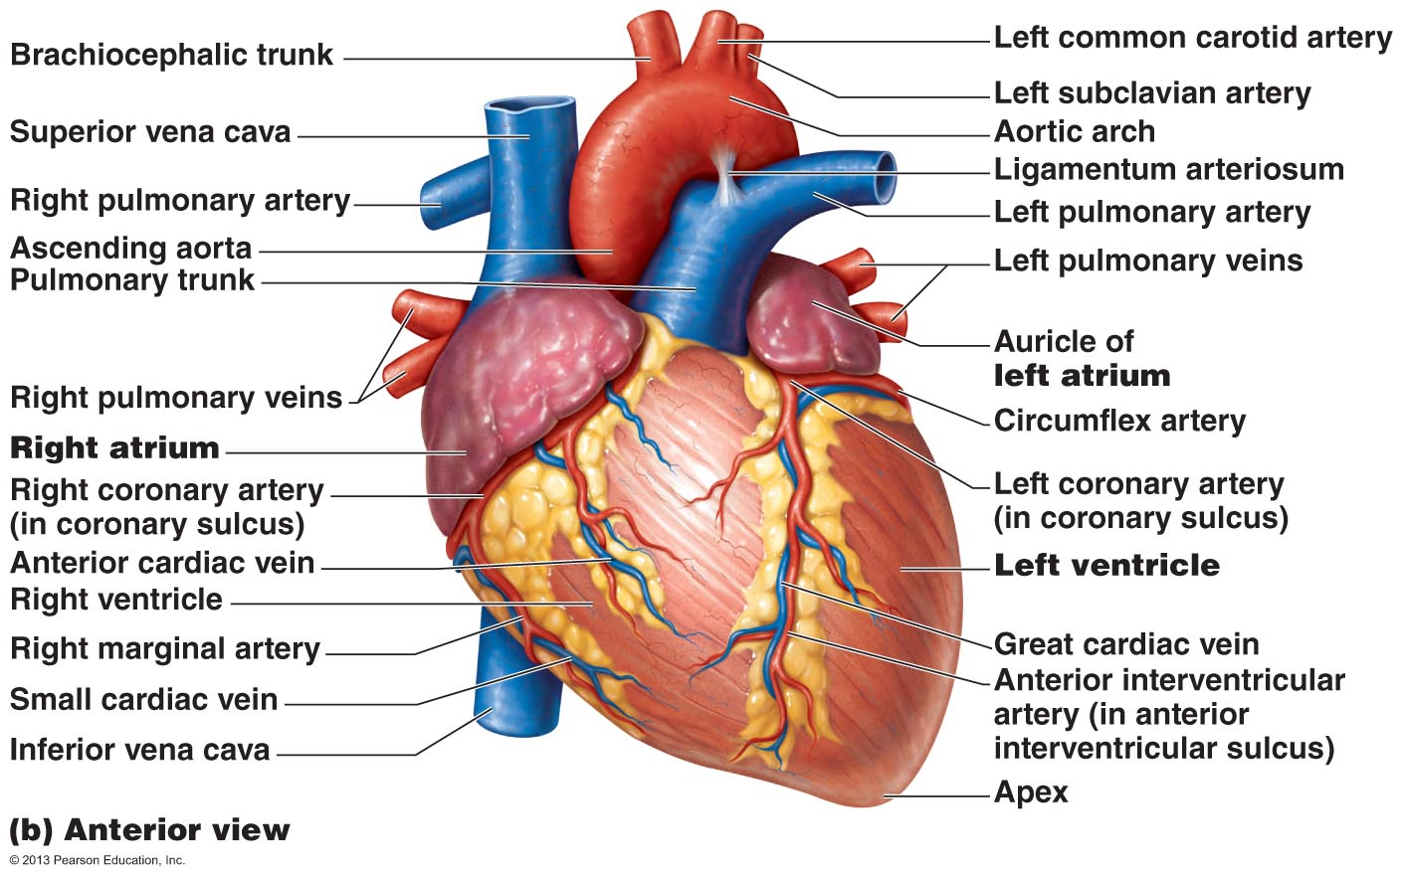
- Oxygenated blood enters the left atrium via 4 pulmonary veins. These veins transport blood from the lungs back to the heart.

Ventricles: discharging chambers
- Trabeculae carneae muscles form the internal walls of the ventricular chambers.
- Papillary muscles play a role in valve function.
- Right ventricle pumps blood into the pulmonary trunk which roots the blood to the lungs for gas exchange.
- Left ventricle ejects blood into the aorta (largest artery in body)

Heart valves
- Blood flows from atria to ventricles. One way direction.
- Four valves do this by opening and closing due to difference in blood pressure.
- Chordae tendinae and papillary muscles are important.

Atriventricular valve (AV)
- Prevent back flow into the atria when ventricles contract. One located at each atriventricular junction.
- Tricuspic valvue (right AV valve) has three flexible cusps. From the right atrium to right ventricle.
- Mitral or bicuspid valve (left AV valve) is left atrium to left ventricle.
- Tiny whote collagen cords (chordea tendinea) are attached to each AV valve flap. To anchor cusps to the papillary muscles in ventricle walls. They serve as guy wires that anchor the valves in their closed positions. If they weren’t anchored the cusps would blow into the atria.

Semilunar valves (SL)
- Guard the base of the large arteries issuing from ventricles and prevent backflow into the associated ventricle.
- Each valve has three pocketlike cusps. The valve opens and closes in response to pressure difference.
- Paired from ventricles to either pulmanory pr systemic circuits.
- Pulmanory valve: right ventricle to pulmonary artery
- Aortic valve: left ventricle aorta.
- Incomplete valve forces the heart to repump the same blood over and over again because the valve does not close properly and blood backflows.
- In stenosis the valve flaps become stiff and constrict the opening. This stiffness compels the heart to contract more forcibly.
- Both conditions increase the heart’s workload and weaken the heart.

Pathway of blood through the heart
- Left side of the heart is the systematic circuit pathway and the right side of the heart is the pulmonary circuit pump.
- The pulmonary circuit is a short, low pressure circulation. (right ventricle)
- The systematic circuit takes a long pathway through the entire body and encounters lots of friction and resistance to blood flow. (left ventricle)
- The walls of the left ventricle are three times thicker than those of the right ventricle and its cavity is circular. Therefore the left ventricle can generate much more pressure and is a more powerful pump.

Coronary circulation
- Provides nourishment to the heart. Shortest circulation in the body
- Coronary arties both arise from the base of the aorta. And encircle the heart in the coronary sulcus.
- The left coronary artery runs towards the left side of the heart and branches into two major branches.
- Anterior interventricular artery: supplies blood to the interventricular spetum and anterior walls.
- Cirmuflex artery: supplies the left atrium and posterior walls of the left ventricle.
- The right coronary artery divides into two branches in the right side of the heart.
- Right marginal artery: serves the myocardium of the lateral right side of the heart.
- Posterior interventricular artery: runs to the heart apex and supplies the posterior ventricular walls.
- Anastomes along the coronary arterial branches are fusing networks that provide additional routes for blood delivery to the heart muscle. They cant supply nutrition when a coronary artery is suddenly blocked. The blockage leads to tissue death and heart attack.
- They actively deliver blood when the heart is relaxed.
- They are ineffective when the ventricle is contracting because they are compressed by contracting myocardium.
- Coronary veins: venous blood is collected in cardiac veins. These veins join to form an enlarged vessel called the coronary sinus which empties blood into the right atrium.
- The sinus has three large sections. The great cardiac vein, middle cardiac vein and small cardiac vein.
- Angina pectoris: thoracic pain caused by fleeting deficiency in blood delivery to myocardium. Result from stress induced spasms of the coronary arteries or from physical demands from the heart. The myocardial cells are weakened by the temporary lack of oxygen but they do not die.
- Mycardial infraction (heart attack): prolonged coronary blockage. Cells do not die. Dead tissue is replaced with noncontractile scar tissue. Survival of the person depends on the extend and location of the damage. Damage to the left ventricle (systematic pump) is more serious.
Cardiac Muscle
shorter, fatter
single or double nuclei
intercalated disks (desmosomes, gap junctions) = interdependence
functional syncytium
20-40% of volume is mitochondria
myofibril diameters vary & much branching gives indistinct striations
fewer T-tubules; less elaborate Ca⁺⁺ delivery
less developed sarcoplasmic reticulum
almost exclusively aerobic metabolism
abundance of fuel type determines fuel used
Skeletal Muscle
longer, cylindrical
multinucleate
structural independence; motor unit grouping
functional independence
2-5% of volume is mitochondria
uniform myofibrils give distinct striations
many T-tubules; complex Ca⁺⁺ delivery
complex sarcoplasmic reticulum
readily uses anaerobic metabolism
intensity determines fuel type used

Microscopic anatomy
- Cardiac muscles are short, fat, branched and interconnected. They are connected to the cardiac skeleton.
- The muscle fibers in skeletal muscles are independent of each other but in cardiac muscles the fibers are connected to one another through junctions called intercalated discs.
- Intecalated discs contain desmosomes and gap junctions. Desmosomes prevent adjacent cells from separating during contraction. Gap junctions allow for ions to pass from cell to cell, transmitting current through entire heart.
- Gap junctions electrically couple cardiac cells so the myocardium behaves as a functional syncytium (single coordinated unit)

Mechanisms and events of contraction
- Means of stimulation: skeletal muscles must be stimulated to contract by nerve endings. Some cardiac muscles are self excitable. These cells can initiate the rest of the heart’s depolarization. This is called automaticity.
- Organ versus motor unit contraction: in skeletal muscle impulses do not spread from cell to cell.
- In the heart either all fibers contract as a whole unit or the heart doesn’t contract at all. This occurs because gap junctions tie all cardiac muscles together into a single contractile unit.
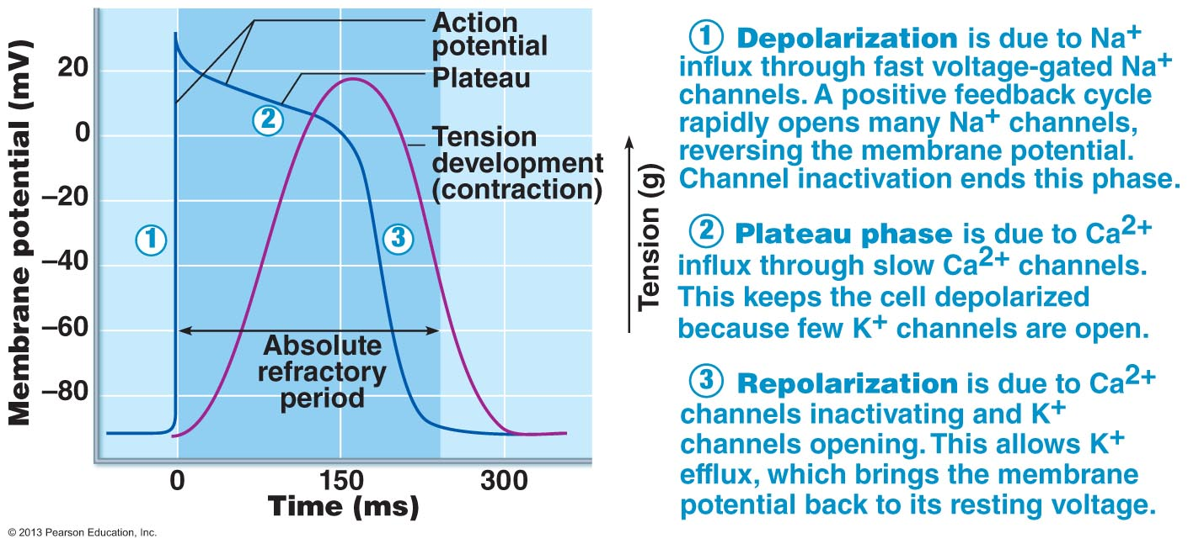
- Length of absolute refractory period: this is the inexcitable period when Na channels are still open or inactivated. In cardiac muscles this lasts about 200 ms.

- The heart relies exclusively on aerobic respiration. Cardiac muscles can not function without oxygen.
- Absolute refractory period is muscle twitch which allows the heart to fill again.
- The heart needs to be stimulated in just one location, the whole organ responds.

Setting the basic rhythm: Intrinsic conduction system
- Consists of noncontractile cardiac cells specialized to initiate and distribute impulses throughout the heart so that it contracts in a sequential manner.
- Action potential initiation by pacemaker cells
- Unstimulated contractile cells of the heart maintain stable membrane potential.
- Pace maker potentials initiate the action potentials that spread throughout the heart to trigger rhythmic contractions.
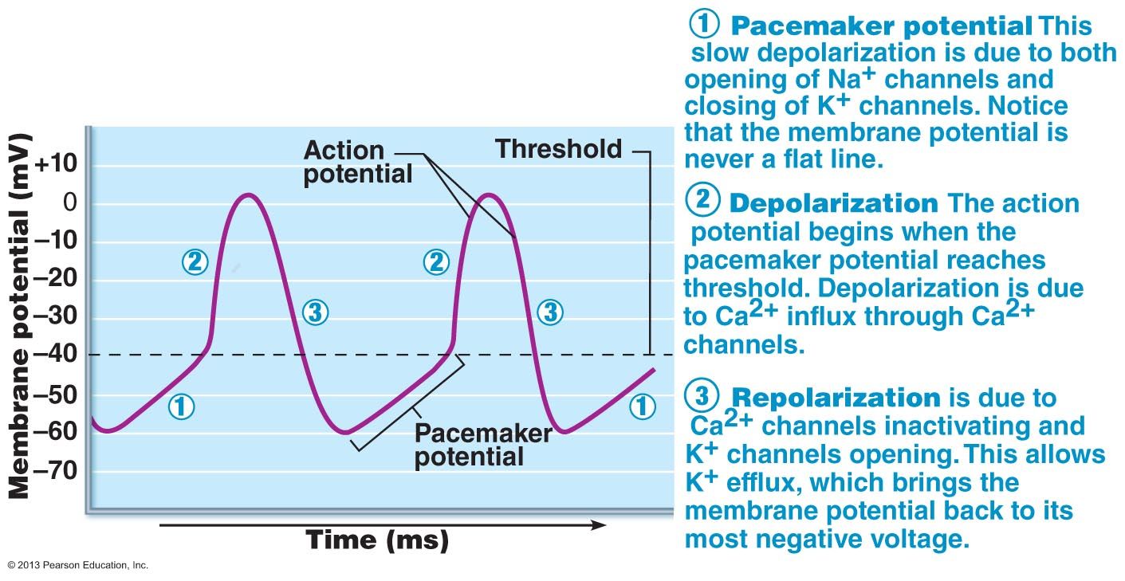
- Action potential in pace maker cells:

Autorhythmic cells have unstable resting. The action potential in these cells is due to ion channels in the sacromella

Sequence of excitation:
- Sinoartrial (SA) Node: generates impulses. It sets the pace for the heart because no other region of the conduction system has a faster depolarization rate. It is the heart’s pace maker and it’s rhythm (sinus rhythm) determines heart rate.
- Atrioventricular node (AV): the depolarization wave travels to it via gap junctions. The impulse is delayed here to allow the atria to respond and complete their contraction before the ventricles contract.
- Atriventricular (AV) bundle: the atria and ventricles are not connected by gap junctions. The AV bundle is only the electrical connection between them. It insulates the rest of the AV junction.
- Right and left bundle branches: course toward the heart apex.
- Purkinjie fibers: ventricular depolarization depends on large fibers of the contracting network. And transmission via gap junctions between ventricular muscle cells. These fibers are more elaborate in the left side of the heart.
- It takes 0.22 seconds from initiation at the SA node to depolarization of last of ventricular cells.

Extrinsic innervation of the heart
- Fibers of the autonomic nervous system modify the beat and introduce suble variability.
- Systematic nervous system increases the rate and force of the heart beat. Increases depolarization and repolarization rates. (Accelrator)
- Parasympethatic activation slows the heart. Decreases diastolic depolarization rate (breaks)
- What is bradycardia, tachycardia and sinus rhythm.

Electrocardiography
- Electrocardiograph detects electrical current spread throughout the heart.
- P wave= atrial depolarization. Lasts about 0.08 seconds. Results from movement of depolarization wave from SA node through the atria.
- QRS complex-ventricular repolarization. Lasts about 0.08 seconds. Atrial repolarization takes place during period of ventricular excitation.
- P-R interval: time from beginning of atrial excitation to the beginning of ventricular excitation. Includes arterial depolarization (contraction)
- S-T segment: action potential of ventricular myocytes are in their plateau phase so entire ventricular myocardium is depolarized.
- S-T interval: last 0.38 seconds. From beging of ventricular depolarization through ventricular repolarization.
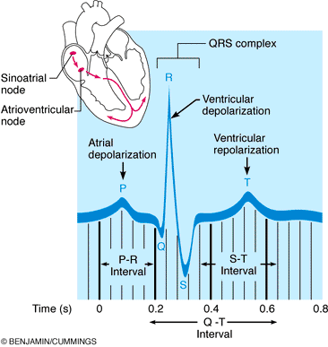

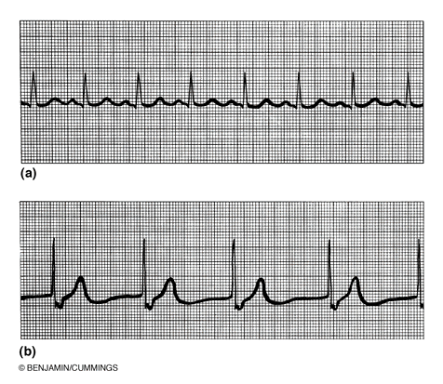
- sinus rhthym
- Junctional rhythm: the SA node is non-functional. P waves are absent. The AV node paces the heart 60 beats/min
- Second degree heart block: Some P waves are not conducted through the AV nodes. More P than QRS waves.
- Ventricular fibrillation: acute heart attack and electrical shock.

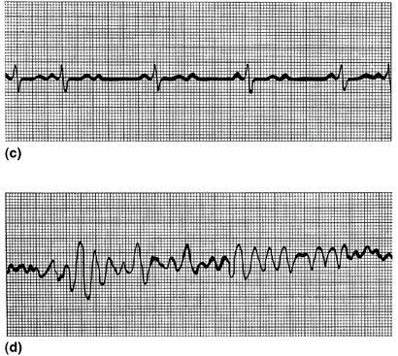

The cardiac cycle: mechanical event
- All events associated with blood flow in one complete heart beat.
- Systole is periods of contraction (pumping out) and diastole is periods of relaxation. (filling)
- At the start of the cycle the atria and ventricles are quite. mid-to-late diastole.
- Ventricular filling: mid-to-late diastole
- Pressure through the heart is low. Most of ventricular filling occurs during this period.
- AV valves are open but the SL valves are closed.
- After ventricular filling the AV valves begin to close resulting in P wave and atrial systole.
- Atrial pressure increases and the rest of the blood enters ventricles. (end diastolic volume EDV)
- Atrial diastole for the rest of the cycle.
- Ventricular systole: (atria in diastole)
- Ventricles begin to contract and increased pressure closes the AV valves (period of isovolumetric contraction; volume constant, a closed system)
- Increased pressure opens the SL valves causing ventricular ejection phase (aortic pressure up to 120 mm Hg)
- Isovolumetric Relaxation: Earl diastole
- Ventricles are relaxed and the pressure decreases rapidly.
- Backflow of aortic/pulmaroy blood closes SL valve. (dicrotic notch)
- Atria continued in diastole and have been filling. When pressure is higher than ventricular pressure the AV valves open and the cycle goes back to the beginning.
- Heart has 75 beats/min and each cardiac cycle is 0.8 seconds.
- Atrial systole: 0.1 seconds
- Ventricular systole: 0.3 seconds
- Quiescent period: 0.4 seconds (total period of relaxation)
- Two important features that drive the cardiac cycle are a) blood flow through heart controlled entirely by pressure changes and b) blood flows from higher to lower pressure through any available opening.
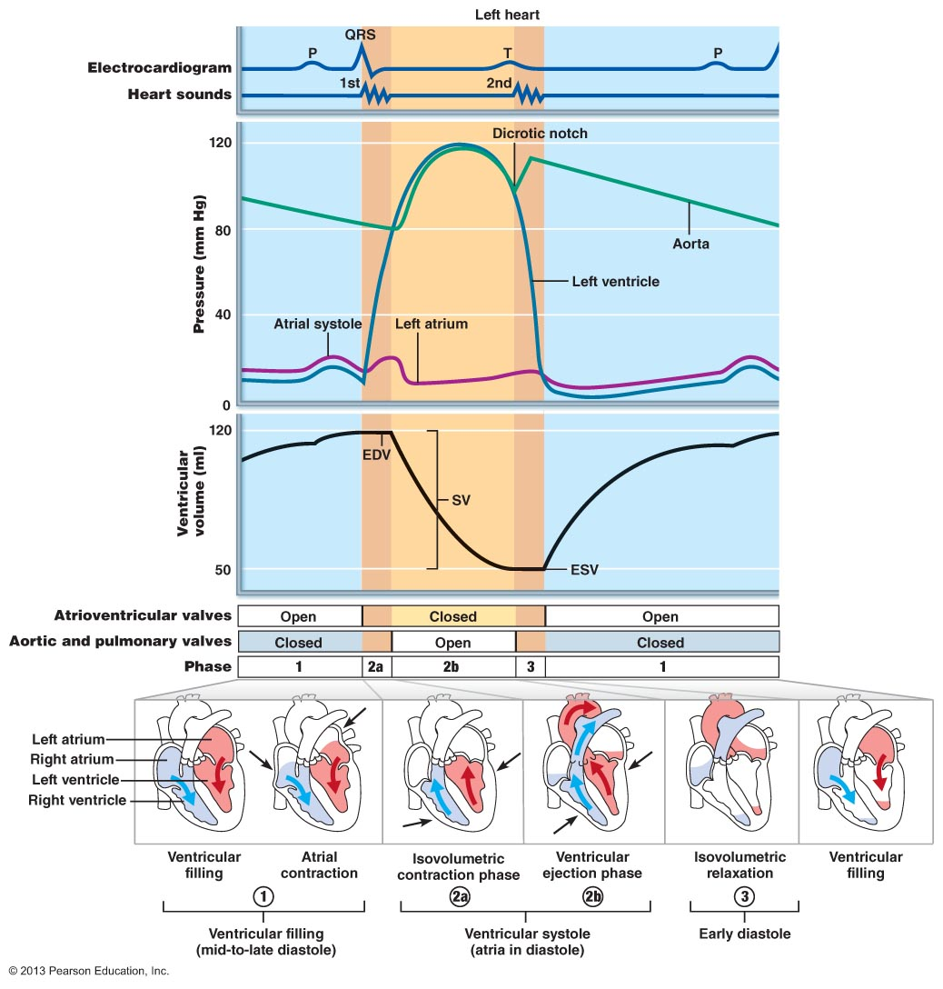
- The electrical activity of the left and righ t hearts are almost simultaneous.

Heart sounds
- first heard sound: closure of AV valves= beginning of systole
- second heard sound: Closure of SL valve= end of systole
- Heart sounds due to vibrations of chest due to valve closure are called murmurs.

- Heart murmurs
- Due to valvular obstruction. High velocity jet of blood through narrow openings cause high pitched sounds.
- Due to valvular insufficiency: leakage of blood back causes sounds when there should be silence.
- Abnormal blood flow such as stenosis, the narrow pulmonary valve openings causes the blood to be turbulent and noisy and heard as murmur.

Cardiac output
- Amount of blood pumped out by each ventricle into aorta in one minute.
- Product of heart rate and stroke volume (volume of blood pumped out by one ventricle with each beat) (SV= EDV-ESV) normal sv=70
- Cardiac reserve is the difference between resting and maximal CO. it is 4-5 times higher in a fit person and 7 times higher in a well trained marathon runner.
- Preload:stretch of heart muscle
- The higher the preload the higher the stroke volume will be.
- Relationship between preload and stroke volume is the frank sterling law of the heart.
- Cardiac muscle has optimal length for contraction.. resting=shorter than optimal length.
- Each ventricle is regulated independently. Frank sterling mechanism ensures that each ventricle pumps the same volume over a period of time.
- Contractility:
- Contractile strength achieved at a given muscle length.
- Enhanced contractility means more blood is ejected from the heart (greater SV)
- Afterload:
- Pressure that the ventricles must overcome to eject blood.
- Healthy: 80 mm in aorta and 10 mm in pulmonary trunk. Not a major determinant of SV.
- Hypertension reduces ability of ventricles to eject blood.
- What are the effects of chronically elevated blood pressure on cardiac muscles? They respond by becoming stronger and being able to more effectively get the blood pressure up. Eventually the heart will start to wear out and cause heart failure.

Regulation of heart rate
- Heart rate determined by rate of spontaneous depolarization of SA node.
- Autonomic fibers innervating SA node
- Circulating hormones (epinephrine)
- Plasma electrocyte concentration ( Ca+, Na +, )
- Body temperature (useful in surgery)
- NE (sympathetic) increases rate of spontaneous depolarization. Heart rate increases.
- Ach (parasympathetic) Decreases rate of spontaneous depolarization. Heart rate decreases.
- Resting conditions: parasympathetic nervous system dominant (vegal tone)
- Tachycardia: abnormally fast heart rate that may result in elevated body temp or heart disease.

Extrinsic influences on stroke volume
- Factors outside the heart which change vigour of contraction without changing EDV= change in contractility.
- Change in strength of contraction due to increased calcium influx.
- Sympathetic stimulation: increases rate of contraction and relaxation.
- Drugs such as digoxin increase heart contractility.
- Parasympathetic nervous system antagonizes sympathetic stimulation.

