From Silent to Sound

Although film is often thought of as an essentially visual experience, underestimating the importance of sound cannot be sought. The sound track of a film is comprised of many different things, performed by several people, through a complex process. Sound has played an important role in the cinematic experience throughout the history of moving images. Although audiences experienced sound in the early exhibitions of motion picture, it was mostly produced live, and it was technology that allowed for motion pictures to transform from a silent to a sound film. Aside from technological ones, factors that affect the revolution in synchronized sound include, but are not limited to, institutional, economic, aesthetic and ideological ones. Towards the end of the 20th century, leading into the 21st, film sound evolved, transforming sound in both its production and its reception. This essay will provide an overview of the history of film sound, more specifically, the transition from silent to sound films.

The sound of film music began in the early 1890s with the “silent film”. These films were in fact theatre shows whose sound was limited to the sound of the piano being played as the background to the image onscreen. During this silent era, the method of sound production was dependent on the film content and the venue it which it was being shown. The transition from silent film to the “talkies” in the mid 1920s transformed the American film industry and mass entertainment. “Going to the picture show” was a marvelous experience, giving American in large cities an escape from their dreary realities, and instead offered an evening of “crystal chandeliers, marble fountains, gilt inlay and richly upholstered seats” (Miller, n.d.). Although they paid 25 cents to enjoy the “silent film”, it is false to say that the film was entirely silent, considering that all silent films were accompanied by live music. Depending on the size of the theatre, the city of location, and the money that could be put into it, some of these films were accompanied by symphonic orchestras, others had sound effects made possible by an organ, while smaller theatres used the piano to add sound. From this era, came a legendary actor, Charlie Chaplin. Chaplin always played a character called The Little Tramp, who can be described as poor yet elegant man, who although had good intentions, often got himself into troubling situations. Although the character never spoke, audiences were able to understand his thoughts and feelings through his physical movements and expressions. With all this being said, dialogue was still nonexistent during this silent era, and actors therefore only had body language and facial expression to tell a story. This in turn made allowed silent films to be accessible to all audiences in and in areas where there were large immigration and English was not the first language, however a change in taste of this audience would eventually lead to a change in the traditional film (Kalinak, 2015).

In his book, “The Talkies: American Cinema’s Transition to Sound 1926-1931”, Donald Crafton identifies a change in the taste of audience as a reason that pushed Hollywood to evolve its traditional silent film practices. The transition of silent to sound film was a three-stage process, invention, adaptation, and diffusion, respectively.

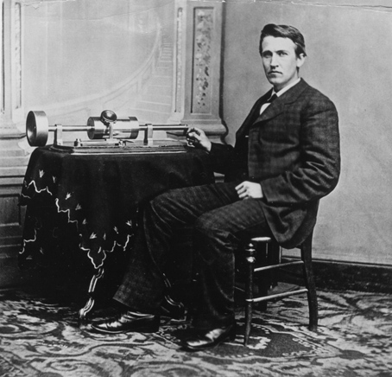

The first phase “invention”, relies on technology, which would be a key factor to the transition of audience taste, in other words, to the transition from silent to sound film. This stage begins with Thomas Edison’s phonograph invention up until 1925. In 1877, Thomas Edison invented the phonograph, allowing people, for the first time ever, to record sound. To make a recording, one would speak into a big horn, which then collected the sound energy that was then sent to a needle that created a wavy grove. After the recording was made, placing the needle at the start of the grove, and spinning the record in circles allowed for the record to be played back. It seemed almost surreal at the time to hear a voice coming not from a person directly, but from the horn of a machine (Buhler., & Neumeyer, 2010).

In 1890s, Edison invented moving pictures (or movies). A long strip of small photographs was captured on film by a special camera, so that each picture slightly differed from the one before and after it. The strip was then run through another machine, referred to as a projector that would blend the different pictures together to create the illusion of motion and project the movie onto a large theater screen. This prompted Edison to try to find a way to incorporate his two inventions, the sound of his phonograph with his moving pictures, in order to create a picture of a story with movement and dialogue – the illusion of life itself. Unfortunately, the two machines did not cooperate together due to synchronization issues. It was very difficult to sync both machines so that the recorded voice sounds would match the movements of their lips seen in the moving pictures. Each invention did however have individual success. People now had recorded music as their disposal as well as had new theaters playing silent moving pictures. Since there was still no dialogue accompaniment to them, the words the characters spoke would appear on screen, in pictures called “titles” (Thompson, 2011)).

There was a studio however, that was not fully satisfied with these “titles”, the Warner Brothers – Harry, Al, Sam and Jack. They opened their first theater in 1903 in Pennsylvania showing movies others had made. After much success with their theater, they built more across the United States and even started making their own films. By 1925, they were looking for a way to be the toughest competitor in the film industry, and found that synchronized sound would enable that (Thompson, 2011).

During this time, there was another group of inventor trying to accomplish what Edison had not been able to; to synchronize recording sound and moving pictures. They were able to use electricity as a tool to play their sounds, the same way the telephone and radio did. They used small microphones as a replacement to Edison’s horn, which collected sound, and used devices called amplifiers to make sound louder. Electricity also enabled and simplified the process of synching the sound with the image. After taking their invention to Hollywood, where most movies were made, they were repeatedly turned away until they went to Warner Brothers, a studio looking to evolve. However, the brothers, like everyone else in Hollywood, were skeptical about the audience’s to hear actors talk, so they decided to keep making silent movies, but to use this new invention to record music for the silent pictures (Thomson, 2011). This would in turn replace live musicians, and would allow for all theaters, rich or not, to have the same soundtrack of a full orchestra. This would also allow for the studio to decide on the music that would accompany the film, as opposed to each individual theater deciding. These new movies were referred to as Vitaphone movies, which means “the sound of life”.

The first Vitaphone was Don Juan, a romantic adventure of a famous swordfighter and the many women that he was infatuated with. The moving picture was accompanied by a recording of an orchestra and sound effects such as clashing swords, which were perfectly synched with the action. Don Juan was a big success with audiences across America, and the Warner brothers decided to make more vitaphone films. This would be the end of the “invention” stage, and the mark of the “adaptation” phase (Crafton, 1999).

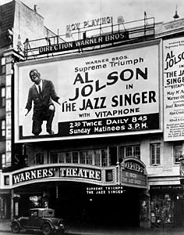
This second stage that Crafton refers to as the adaptation stage, begins with the time when more and more studios were experimenting with various methods of applying sound. This stage is based entirely on adapting to more modern ways, however studios did not do so right away, and even with the success of Don Juan, still believed this would be a temporary trend. In 1927, Warner Brothers released the first movie with dialogue, The Jazz Singer. The film featured Al Jolson, a famous singer, whose character sang, talked and kidded. The feedback and reaction from audiences was unimaginable, and left the rest of Hollywood with no choice but to adapt to the audience’s changing taste (Crafton, 1999).

Unfortunately for these studios, it was no easy to perform their new duties of vitaphone films. Sound movies required expensive equipment, along with employees who knew how to use this new equipment. Moreover, actors who were suitable for silent films, were not necessarily suitable for sound films, due to certain things such as heavy accents or monotone voices. This led to another challenge for studios to find new actors, who would be able to memorize lines and portray this story through verbal delivery. In addition, directors would no longer be able to shout out instructions while cameras were rolling because of the sensitivity of the microphones. In fact, microphones were so sensitive even to the sound of the cameras, that cameramen were put inside special boxed that muffled the sound. In turn, everyone who worked to make movies now had to learn an entirely new way for performing their job when the innovation of sound movies came about (Thompson, 2011).

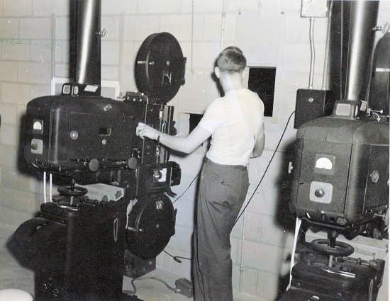

This was also the case for workers in theaters. For example, projectionists who initially working in a small both usually at the top back of the theater, running films through the projection, now had to also operate phonographs at the same time, which was of great challenge. It was however worse for theater musicians, who lost their jobs because they were inevitably no longer needed to perform live. Audiences also had to change and adapt to the revolution of sound movies. With silent film, the international language was body and facial expression; however now it was real dialogue and people who were hard of hearing now struggled with understanding the story. Due to the fact that actors could not move very much in order to ensure that the microphones would catch their voice, body language was become less and less apparent in the film industry. Sound movies at this point had much less action than silent movies, and that movement was replaced with dialogue, which led to people calling the new movies “talkies” (Thompson, 2011).

During this time of the transition, many moviegoers were experiencing disappointment and the actor and his voice did not match their preconceptions. This phenomenon became known as the “Talkie Terror”. During this transitional phase, a divide between Old Hollywood and New Hollywood was beginning to transpire. Some studios were only adding music and sound effects to their films. Others were using a process referred to as “goat glanding”, where existing silent films were being worked on again to add sound effects and dialogue in some key scenes. Studios were also releasing silent versions of their talkies. All these methods were ways to ensure the success of studios while they gambled and experimented with new sound technology, until they mastered it (Miller , n.d.).

Starting in the 1930s, studios had now started to master the art of sound technology, the silent films would now be a thing of the past and completely replaced with sound films; this would be what Crafton refers to as the thirds phase, diffusion. “Diffusion” describes the release of talkies nationally and internationally, as well and the wiring of all theaters for the new sound technology. By 1930, after studios had time to experiment with new technological methods, sound movies had as much action as silent films once had. New, quiet cameras had come about, along with microphones that were modified to be less sensitive and allowed actors to move around. There was also a new method of film created where the sound recording was printed onto the film itself instead of on a separate phonograph record, making it easier for the projectionist to do his job. With these new advancements and elapsed time, sound film was now able to become the only form film.

When the last silent film was made, it represented the end of a certain form of art. “Footlight Parade”, a musical released in 1933, starts with a farewell to the silent film era.(Miller, n.d.). After several inventions and trials, years of adaptation, and new modifications, it is safe to say that the six-year transition period is an indication that silent films did not go so silently.

References

Buhler, J., Neumeyer, D., & Deemer, R. (2010). Hearing the Movies. New York: Oxford University Press.

Crafton, Donald. (1999). The Talkies: American Cinema’s Transition to Sound, 1926-1931. California: University of California Press.

Kalinak, Kathryn. (2015). Sound: Dialogue, Music, and Effects. Rutgers University Press.

Miller, Francesca E. (n.d) “Silents to Talkies.” Francescamiller.com.

Thompson, Emily. (2011). A Very Short History of the Transition from Silent to Sound Movies. Princeton University.

FFAR 298H 2015 FINAL ASSIGNMENT
Research Paper
December 8, 2015
From Silent to Sound

