Chapter 1 -The Sociological Perspective: Theory and Methods

Global Sociological Imagination-
- The ability to see the relationship between individual experiences and the larger society
- The interconnectivity of personal and shared knowledge
- This allows us to create links between the personal experience and social contexts in which they occur
- Tool used to distinguish between personal issues and social issues (ex. Suicidal thoughts due to unemployment vs. mass unemployment due to economic changes), it can be seen here how personal troubles may correlate with public issues.
Key Terminology:

Society – a large social grouping that shares the same geographical territory and is subject to the same political authority and dominant cultural expectations

Global interdependence – a relationship in which the lives of all people are intertwined closely and any one nation’s problems are part of a larger global problem

Commonsense knowledge – notions of ordinary conduct in everyday life

Myths – popular but false notion, used intentionally or unintentionally to perpetuate certain beliefs or theories, even in light of conclusive evidence to the contrary

Race – a term used by many people to specify groups of people distinguished by physical characteristics such as skin color

Ethnicity – refers to the cultural heritage or identity of a group and is based on factors such as language or country of origin

Class – relative location of a person or group within a larger society, based on wealth, power, prestige, or other valued resources

Sex – refers to the biological and anatomical differences between females and males

Gender – refers to the meanings, beliefs and practices associated with sex difference

Industrialization – the process by which societies are transformed from dependence on agriculature and handmade products to an emphasis on manufacturing and related industries

Urbanization – is the process by which an increasing proportion of a population lives in cities rather than in rural areas

Theory – a set of logically interrelated statements that attempts to describe, explain and (occasionally) predict social events

Perspective – an overall approach to or viewpoint on some subject

Social facts – patterned ways of acting, thinking and feeling that exists outside any one individual but that exert social control over each person

Anomie – a condition in which social control becomes ineffective as a result of the loss of shared values and of a sense of purpose in society

Alienation – a feeling of powerlessness and estrangement from other people and from oneself

Class conflict – the struggle between the capitalist class and the working class

Bourgeoisie – comprise of those who own and control the means of production

Means of production – refers to the tools, land, factories and money for investment that form the economic basis of a society

Working class (proletariat) – comprises those who must sell their labor because they have no other means to earn a livelihood

Manifest functions – intended or overtly recognized by the participants in a social unit

Latent functions – unintended functions that are hidden and remain unacknowledged by participants

Dysfunctions – the undesirable consequences of any element of a society

Power elite – small clique comprising top business, political and military officials

Macro level analysis - examines whole societies, large scale social structures and social systems

Micro level analysis – focuses on small groups rather than large scale social structures

Symbol – anything that meaningfully represents something else

Importance of a Global Sociological Imagination:

- Developed/ high income countries – highly industrialized economies; technologically advanced industrial, administrative and service occupations
- Ex; Japan, New Zealand
- Middle income countries – industrializing economies, particularly in urban areas and moderate levels of national and personal income
- Ex; Brazil, Mexico
- Low income countries – primarily agrarian, little industrialization and low levels of national and personal income
- Ex; China, India

- After industrial revolution a shift from being a producer to a consumer began whereby families in cities had to buy food with own wages, as opposed to growing food on crops. Similarly, people had to pay rent for housing as opposed to exchanging services for lodging.
- This created new social problems: inadequate housing, overpopulation of polis areas, unsanitary living standards, poverty, crime and pollution
- This led to sociologists attempting to understand the change of society:
- Auguste Comte
- Harriet Martineau
- Herbert Spencer
- Emile Durkheim

Contemporary Theoretical Perspectives:
Each of these views represents a method of analyzing the same notion.
- Functionalist
- Conflict
- Feminist
- Symbolic interactionist
- Post modern

- Functionalist perspective:
- Based on the assumption that society is a stable, orderly system, one which is characterized by societal consensus, whereby the majority of members share a common set of values, beliefs and behavioral expectations
- Cultures meets people’s:
- > biological or physical needs (food and procreation)
- > instrumental needs (laws and education)
- > integrative needs (religion and art)
- Conflict perspective:
- Based on the assumption that groups in society are engaged in a continuous power struggle for control of scarce resources
- Values and norms help create and sustain the privileged positions in society while excluding others
- Ruling class creates ideology, through which it affects the thoughts and actions of members of other classes
- Bourgeoisie -> has control over material production and mental production
- Feminist perspective:
- Focus on the significance of gender in understanding and explaining inequalities that exist between men and women in the household, paid labor force and in the realms of politics, la and culture
- Symbolic Interactionist perspective:
- Based on the assumption that society is the sum of the interactions of individuals and groups
- Uses micro level analysis as opposed to functionalist and conflict perspectives which use macro level.
- It is in the interactions that people create, maintain, and modify culture in their daily lives
- Postmodern perspective:
- Existing theories have been unsuccessful in explaining social life in modern societies that are characterized by post industrialization, consumerism and global communications
- Eurocentric approach to culture
- No single perspective can grasp the complexity and diversity of the social world
- Reality may not be what it seems: we should deconstruct existing beliefs and theories about culture
Five sources of knowledge i.e. ways of knowing (TOK)
- Personal experience
- Tradition; what we are told, how things are done for centuries
- Authority; experts, governmental bodies
- Religion; based on personal faith, defines moral values, food, clothing
- Science; systematic observations that are tested in the natural environment or experimental, relies on reason (human sciences), objective characteristics
Note: study group, every Wednesday 7pm-8:30pm at 9OU152. Julia Morris @ rezmentor12@uottawa.ca
Nature of scientific knowledge
- Sociology is the systematic study of human society and social interaction: by applying theoretical perspectives and research methods
- Empirical (direct, systematic observation)
- Systematic, public
- Has a mechanism of self correction (formulates hypotheses instead of absolute truths)
- Objective (value and bias free)
Key terminology:
Altruism – good acts which benefit everyone in society
Utilitarianism – good acts which benefit everyone in society with the exception of the actor themselves
Sociological studies:
Descriptive:
- Describes social reality or provides facts about a group, a practice or an event
- Ex. Census
Explanatory:
- Explain relationships and answer the question “why”

The theory and research cycle:
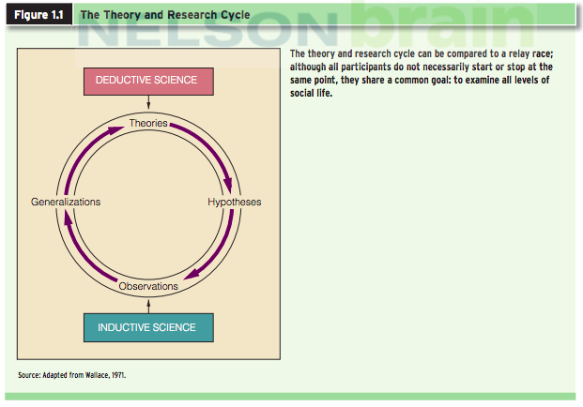
Deductive sciences:

Inductive -> practice to theory
Quantitative research (data measured numerically)
- Select and define research problem
- Review previous research
- Formulate the hypothesis
- Develop the research design (experiments, surveys, field research, secondary analysis of data)
- Collect and analyze the data
- Draw conclusions and report the findings

Variables

Reliability/ validity/ analysis:
Reliability: the extent to which a measurement gives results that are consistent across time and individuals
Validity: the degree to which an assessment measures what it is supposed to measure
Analysis: organization of data in a form so that comparisons can be made and conclusions drawn
Ethnography: the study and systematic recording of human culture
Final report:
- Relate data to your hypothesis
- Review each step in the research process (replication)
- Report findings
Qualitative research method
- A detailed picture of a particular social phenomenon or social problem
- Research question cannot be answered through numbers and statistics
- Smaller number of cases and many variables
- The research problem is formulated broadly
- Data are gathered in natural settings
- Can generate new theories and innovative findings incorporating the perspectives of the research subject
Qualitative research steps
- Engage in problem formulation to clarify the research question, as well as the concerns and interests of the researchers
- Collect and analyze data to assess the validity of the starting proposition
- Report the results
Field research
- The study of social life in its natural setting
- Observations; face to face discussions; participation in the events
- Limitations: qualitative would allow a smaller group of cases which provides depth but not breadth, whereas with quantitative it is easier to create generalizations
- Qualitative data supports a basis of understanding towards the quantitative results

