Volcanoes
Learning Objectives (Lecture 1)
Identify key properties of different types of magma.
 | Mafic Magma | Felsic Magma
Temperature | HIGH temperature | LOW temperature
Viscosity | LOW viscosity (runny) | HIGH viscosity
Silica Content | LOW silica content | HIGH silica content
Gas Content | LOW gas content | HIGH gas content
Rock Type | Produces light colored rock  Ex: basalt | Produces dark colored rock  Ex: rhyolite

Explain why magma erupts or not.
Eruption style dependent on magma composition
Mafic magma effusive style eruption
Felsic magma explosive style eruption

Describe the different types of eruptions and how they relate to magma properties.
Effusive Eruptions: (mafic magma)
- Low gas content – pressure is released and gas escapes
- Melt at a higher temperature, lower viscosity
- Oceanic
- This eruption style is relatively SAFE
Explosive Eruptions: (felsic magma)
- High gas content – kept under increasing pressure
- Melt at a lower temperature, higher viscosity
- Continental
- This eruption style is DANGEROUS

List the different categories of volcanic rocks and explain the difference in the magmas that they cooled from.
Intrusive Rock: (plutonic)
- Igneous rock formed at depth (within the Earth’s crust) magma cools slowly to form large crystals
Extrusive Rock: (volcanic)
- Igneous rock formed at Earth’s surface lava cools quickly to produce small crystals

Explain why some magmas erupt explosively and some erupt effusively.
Eruption type is dependent on magma composition; namely gas content and viscosity of magma.

Explain the difference between pahoehoe and a’a lavas.
Pahoehoe lavas are limited in volume and flow down channels. They have low viscosity and high temperatures, which allows them to flow much faster than a’a lavas (can move a few km/h). They cool to form a smooth and ropy texture.

A’a lavas are blocky and rough on the surface, and cooler than pahoehoe lavas. There is a larger amount of volume associated with a’a flows, as well as a much higher viscosity. A’a flows tend to be a lot slower because of this.

- Learning Objectives (Lecture 2)
- Explain the global distribution of volcanoes.
- Approximately 2/3 of all volcanoes on land are located along the Ring of Fire, which surrounds the Pacific Ocean. The volcanoes lie above the subduction zones.
  - Volcanoes can be found on other plate boundaries (divergent & convergent) as well as hotspots.

List 3 types of plate boundaries and the types of volcanoes that occur at each.
- i. Convergent Plate Boundaries:
- Subduction Zones
  - oceanic crust subducts below continental crust due to differences in density oceanic crust is denser … rising heat and pressure dries out the rock and lowers its melting temperature (dehydration) this allows for magma to easily melt through it and reach the surface (grabs extra silica from continental crust, which makes the magma felsic)
  - stratovolcanoes occur at subduction zones

- ii. Divergent Plate Boundaries:
- Mid-ocean Ridges
  - basaltic magma derived from the asthenosphere rises to the ocean floor to create new crust mixes with no new materials, therefore the magma is entirely basaltic (mafic)
  - shield volcanoes occur where spreading ridges occur on land
- iii. Transform Boundaries:
- ** NO VOLCANOES OCCUR HERE **

- Describe the type of volcano that occurs at hotspots.
- Hotspots beneath Oceanic Plates:
  - magma wells up beneath a plate at a stationary point, rather than at a plate boundary
  - the upwelling magma focused on a single spot creates a volcano… shift in plate movements create chains of volcanoes (ex: Hawaiian Islands)
- Hotspots beneath Continental Plates:
  - calderas form in this tectonic setting

- Describe the morphology, dominant rock type, and typical eruption style of the different types of volcanoes.

Volcano Type | Shape | Si Content | Viscosity | Rock Type | Eruption Type
Cinder Cone | steep cone, usually w/ summit crater | Low | Low | Basalt | Explosive activity
Shield Volcano | gentle arch or dome w/ gentle slopes | Low | Low | Basalt | Lava flows, some explosive activity
Stratovolcano | cone shaped w/ steep sides | Inter. | Inter. | Andesite | Lava flows + explosive activity

- Describe the tectonic setting of southern British Columbia and determine the dominant type of volcano that occurs here.
- BC is close to the Juan de Fuca plate, which is subducting underneath the North American Plate. Due to additional subduction along the Cascadia Plate, we have the Cascade Volcanoes (volcanic arch).
  - We mostly have stratovolcanoes

Learning Objectives (Lecture 3)

Explain what lava flows, fire fountaining, lava bombs and volcanic ash are and how they form.

Lava Flows:
  - flows of basaltic lava (mafic)
  - they flow because of the low silica content and non-explosive properties of the lava
- Fire Fountaining: (stereotypical lava explosion)
  - occur when basaltic lava contains a significant amount of gas causes a small eruption to occur
  - liquid may form a lava flow upon reaching the ground
- Lava Bombs:
  - hot lava thrown out of the volcano in twisted chunks that may change shape during (a) flight or (b) impact with the earth
- Volcanic Ash (Pyroclastic Falls):
  - consists of tiny, jagged particles of rock and natural glass blasted into the air by a volcano

- Explain what controls volcanic explosivity.
- Gas content and melt viscosity.

- Describe the types of volcanic eruptions and how they relate to magma properties.

Hawaiian | Strombolian | Vulcanian | Plinian
Basaltic magma | Basaltic / andesitic magma | Viscous andesitic / rhyolitic magma | Andesitic / rhyolitic ash
Low viscosity | Lava bombs, flows | Continuous | Pyroclastic flows
Non-explosive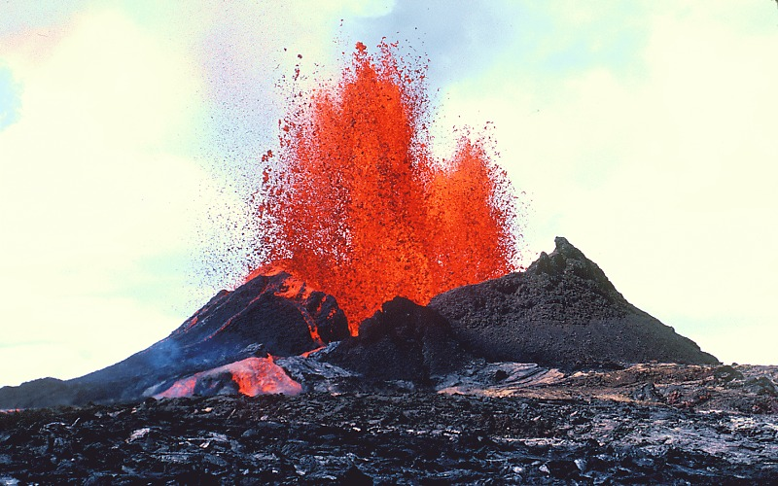 | Mildly explosive  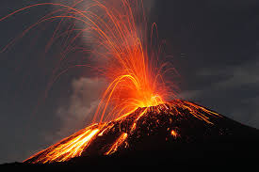 | Very explosive  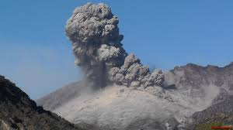 | Violently explosive  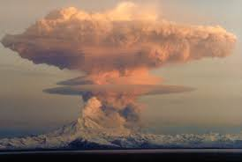

Use the VEI to rank the size of explosive eruptions.
- Key Characteristics:
  - volume of erupted material
  - height of ash plume
  - duration of eruption
- ex: Hawaiian – VEI 3
- Plinian – VEI 8

- Learning Objectives (Lecture 4)
- Explain what is meant by hazard and risk.
- A hazard is any given event that could cause harm to people or the economy, whereas a risk is the probability that any hazardous event might occur.

- Describe the hazards associated with pyroclastic flows, lahars, dome collapses, sector collapses, lateral blasts and toxic gases. Include how they form.
- Pyroclastic Flows: (an avalanche of pyroclastic material, air and gas)
  - How they form:
    - Collapse of volcanic column
    - Explosive collapse of lava dome(s)
  - Hazards:
    - Usually stay in valleys, but can flow over edges if they become big enough
    - They have high velocity & temperature

** people caught in a pyroclastic flow have no chance of survival
- Lahars: (flows of water and loose volcanic debris)
  - How they form: N/A
  - Hazards:
    - Usually flow along valleys and are very dangerous
    - They do not need an eruption to occur
    - Velocity & temperature are less than in pyroclastic flows
    - They are escapable with forewarnings
- Dome Collapses: (roughly circular mound-like protrusion)
  - How they form:
    - Slow extrusion of viscous lava from a volcano
  - Hazards: N/A
- Sector Collapses: (part of the volcano is weakened and collapses causes a debris avalanche)
  - How they form:
    - Weakening of part of the volcano
  - Hazards:
    - Debris avalanche can lead to lateral blasts
- Lateral Blasts: (eruptions that take place along the flanks of the volcano, rather than at the summit)
  - How they form:
    - Typical at rift zones
    - It is easier for magma to flow laterally out the sides of the weak flanks
  - Hazards: N/A
- Toxic Gases: (the gases released by volcanoes)
  - How they form:
    - Released from cracks or volcanic eruptions
  - Hazards:
    - Breathing in these gases can cause asphyxiation and death

- List the volcanic hazards & risks that might affect Vancouver.
- - Pyroclastic falls
- - Lahars

Learning Objectives (Lecture 5)

Explain how risk is assessed.

Risk is assessed using potential monetary and human losses as well as a population’s vulnerability.

List the different volcano monitoring techniques and instruments used.

Geology and Mapping:
  - Hazard maps
    - Map volcanic deposits determine deposit type determine age of deposits and eruption frequency consider risk
- Monitoring:
  - Seismology – most important tool
  - Ground deformation – volcano changes shape
    - GPS
    - TM (tilt-meter)
  - Gas emission by direct sampling
    - COSPEC – identifies new gas rich magma
    - FTIR
  - Lahar detection
  - Satellite observation

