BehNeuroII Post-Midterm Notes

With the chapters that have been tested on before, the questions will be mostly conceptual with less detail. The rest will be tested in the midterm fashion.

Drug Addiction and Administration

Psychoactive Drugs: Drugs that influence subjective experience and behaviour by acting on the nervous system

Administration
- Oral, Intragastricm, Transdermal: patches and implants
- Injection
  - Subcutaneous (SC): under the skin
  - Intramuscular (IM): into large muscles
  - Intravenous (IV): into veins
  - Intrathecal: into subarachnoid space
- Through mucous membranes: nose, mouth, rectum

Drug Penetration: how well a drug reaches its target tissue, or bioavailability

Agonists: increase synthesis, number of NTs by destroying degrading enzymes, increase release, bind to autoreceptors and block inhibitory effect on NT release, activating post-synaptic receptors, or blocking reuptake/ degradation

Antagonists: Block synthesis, vesicle leakage/SNARE docking, block release, activate autoreceptors, binds to post-synaptic receptor instead of drug

Metabolism and Elimination
- First pass liver metabolism by enzymes, excreted in the urine, sweat, feces, breath, and mother’s milk

Drug Tolerance: Decreased sensitivity to a drug due to exposure to it
- Shift of dose-response curve to the right and needing a larger dose to mimic the effects that used to get
Cross Tolerance: exposure of one drug can produce tolerance to similar drugs, such as alcohol and benzodiazepines
Sensitization: Inverse Tolerance (Increased sensitization based on the brain’s abilities to anticipate and enhance a drug’s effect)
- Tolerance can develop via multiple mechanisms, such as metabolic tolerance (less bioavailability at sight of action) or functional tolerance due to a lower responsiveness to a drug (fewer receptors, decreased efficiency of binding, or less responsive receptors)

Drug Withdrawal and Physical Dependence

Withdrawal: Illness brought on by the elimination from the body of a drug
Physical Dependence: When a person experiences withdrawal upon cessation of drug use: Compensatory body changes: body functions normally with drug present

Addicts are those who continue to use a drug despite its adverse effects on health or social life: Addiction and physical dependence may occur together or separately

Role of Learning in Drug Use and Addiction
- Responses to drugs can be modulated by conditioned situations or stimuli

Contingent Drug Tolerance: tolerance only develops to drug effects that are experienced
- Stimuli that predict drug use become conditioned, such as exteroceptive (environment) or interoceptive (thoughts)
Conditioned Drug Tolerance: Maximal tolerance effects are seen in the environment in which a drug is usually taken (Hypothermic effects of alcohol)
- Conditioned compensatory responses (seigel), where responses are opposite to those of the drug when in a situation where the drug is usually taken
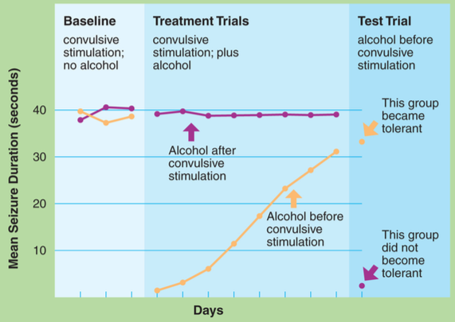
Conditioned Sensitization:

Experiencing the anticonvulsive effect of alcohol (purple), they did not develop tolerance, so when they did receive it before convulsing, it had great effects
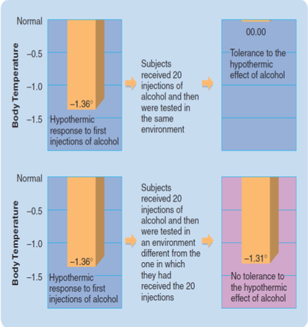
- Tolerance to the anticonvulsive effects repeatedly did show tolerance effects
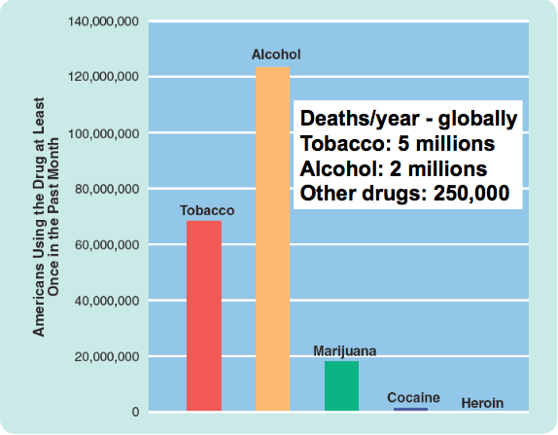
Additive potential of drugs of abuse, noting that increased use leads to dependence: Most in nicotine, then alcohol and cocaine, then weed last

Tobacco
- Tar and 4000 other chemicals, plus nicotine as the major agonist of the Nicotinic Ach receptor
- First time users: nausea, vomiting, coughing, sweating, abdominal cramps, dizziness, flashing, diarrhea
- Regular users: relaxed, alert, less hungry due to tolerance to certain effects
- Said that 70% of those who experiment become addicted, and only about 20% of attempts to stop are successful
- 56% heritability estimate through twin studies

Long-Term Health Effects
- Smoker’s syndrome: chest pain, labored breathing, wheezing, coughing, increased susceptibility to respiratory infections
- Lung disorders: Pneumonia, bronchitis, emphysema, lung cancer
- Cardiovascular: High blood pressure, heart attacks, stroke, Buerger’s disease
- Various cancers: lung, larynx, mouth, esophagus, kidneys, pancreas, bladder, stomach
- Shorter life span
- Teratogenic effects: abnormal fetal development, miscarriage, still berth, and early death of child

Buerger’s disease: blood vessel inflammation/constriction especially in the extremities that can lead to gangrene

Alcohol
- An organic compound with a hydroxyl functional group attached to a hydrocarbon
- Obtained by fermentation of sugars, such as sucrose, fructose, glucose
- Ethanol: the alcohol contained in beverages

Acute Effects
- A toxic substance
- Highly penetrating, due to lipid and water solubility
- A depressant at moderate to high doses
- Disinhibitor at low doses
- Acts on GABA, glutamate and neuronal Ca2+
- Moderate doses: cognitive, perceptual, verbal and motor impairments, as well as vasodilation (skin rush), diuretic
- High doses: unconsciousness, hypothermia, respiratory depression (respiratory block/lethal)

Delayed Effects
- Mild Withdrawal Syndrome: headache, nausea, vomit, tremors
- Severe Withdrawal Syndrome: 3 phases
  - 5-6 Hours: severe tremors, agitation, all from mild withdrawal, cramps, profuse sweating, hallucinations
  - 15-30 hours: convulsive activity
  - 24-48 hours: delirium tremens (hallucinations, delusions, agitation, confusion, hypothermia, tachycardia) that could last 3-4 days

Alcohol Addiction
- Highly (70% addictive) with tolerance and physical dependence
- Functional and metabolic tolerance
- Heritability for alcohol addiction being 50%, with several genes identified (alcohol dehydrogenase)

Health Effects of Chronic Alcohol Consumption (>2 mill deaths/yr world)
- Korsakoff’s Syndrome: direct and indirect
- Brain Damage: Neurotrophins, cell-adhesion molecules, apoptosis
- Organ Inflammations and Scarring: liver cirrhosis, pancreatitis, gastritis, increased risk of liver cancer and stomach ulcers
- Teratogen: Fetal alcohol syndrome
- Traffic and other accidents, violence
- Disulfiram (acute hangover symptoms) as a potential treatment (acetaldehyde intoxication)
- Brain Atrophy: loss of white matter, reduction in number and size of neurons, neurotrophins, CEMs, apoptosis
- Wernicke encephalopathy: Thiamine (B1) deficiency Korsakoff’s synfrom
- Marchiafave-Bignami disease: acute demylenation or necrosis of the corpus callosum
- Other demylenation syndromes
- Hepatitic Encephalopathy: during liver failure, possibly reversible
- Alcohol withdrawal syndrome in former abusers

Marijuana
- Cannabis sativa, a common hemp plant and 80 other chemicals
- Delta-9-tetrahydrocannabinol (THC) primary psychoactive constituent
- CB1 and CB2 receptors that both regulate NT release (mostly GABA) via retrograde mechanisms
- Endocannabinoids: anandimide and 2-arachidonoylgltcerol (2-AG)

Acute Effects of Nuggets
- Low recreational dose: very subtle, vivid sensory perception and thought formation
- High doses impair STM and interfere in tasks involving multiple steps
- Addiction potential is low (6-10%)
- Negative effects of LT use are far less severe than those associated with alcohol or tobacco

Health Effects of Heavy Users
- Respiratory problems: cough, bronchitis, asthma with prolonged use
- Single large doses can trigger heart attacks in susceptible individuals
- Little evidence that marijuana causes permanent brain damage
- Some temporary memory impairment
- Possible correlation between use and schizophrenia, but no causal link has been shown

Schweinsberg et al (2010): Adolescents (15-18) comparing recent users, abstinent users and non-users with behavioural assessments, neuropsychological functioning, as well as anatomical and functional imaging during spatial memory tasks
- No group differences in behavioural and most neuropsychological tests
- Recent and abstinent users: small increase in vigilance, but not memory, in the spatial WM task
- Recent users: greater activation of the PFC (more effortful cognition?)
- Recent users: greater activation of the insula: greater inhibitory effort?
- Abstinent users: greater activation in the right precentral gyrus, linked to faster reaction time?

Meier (2012) and Miffit (2013)
- Longitudinal study for those born in the 70s
- IQ tests
- Individuals who reported regular (>4 days a week) use in more assessments (out of 5 conducted over 20 years) incurred greater average declines in IQ between childhood and age 38
- Age at first diagnosis affects impact on IQ: The relationship between IQ decline and cannabis dependence was stronger among individuals who were first diagnosed before age 18 than among those who were first diagnosed after age 18
- Persistant Cannabis users who quit may not fully regain lost IQ: more so in those who reported frequent usage during more of the tests

Medicinal Uses
- Treats nausea, reduces some forms of pain, blocks seizures, reduces anxiety, facilitates sleep, dilates bronchioles of asthmatics, reduces eye pressure and severity of glaucoma, and stimulates appetite (limits disease associated weight loss, e.g. AIDS)

Cocaine
- A catecholamine reuptake inhibitor that increases DA and NE
- A stimulant, analgesic, and addictive based on effects on DA
- Simulant: a wave of well being, self confident, alert, energetic, friendly, outgoing, fidgety, and talkative, as well as inhibiting hunger and desire to sleep
- Coke sprees: 2-3 days of high dose intake: can cause cocaine psychosis
- Tolerance to some effects like euphoria
- Sensitization is seen to motor & convulsive effects
- Highly addictive, but withdrawal is relatively mild

Side effects of Chronic Use
- Increased risk of a stroke, reduced attention, insatiable hunger, insomnia/hypersomnia, lethargy
- Throat soreness and hoarse voice
- Hemoptysis (coughing up blood), bronchospasm, dyspnea (labored breathing), eosinophilia (asthma and allergy immune type cell increase), chest pain, and asthma
- Fever, rhinorrhea (nose discharge), bruxism (abrasion), heart infarction, pruritus (severe skin itch)

Cocaine Psychosis
- Excitability, anxiety, talkativeness, increased pulse and BP, pupil dilation, fast breathing, temperature increase, sweating, loss of appetite, insomnia
- Bizarre, erratic, sometimes violent behaviour and paranoid psychosis that appears if discontinued
- Sometimes misdiagnosed as paranoid schizophrenia

Medicinal Synthetic Cocaine Analogs
- Very effective local anesthetics: Licocaine and procaine

Other Stimulants
- Enhance monoamine release, highly addictive, and cocaine-like effects
- D-amphetamine (dextroamphetiamine, or speed), Methamphetamine, 3,40Methylenedioxymethamphetamine (MDMA, ecstasy)

Long Term Health Effects of Stimulants
- Impair DA and 5-HT functions
- Impair executive function, inhibitory control and decision making
- Insomnia, Psychosis, reduced cortex, limbic functional brain scan abnormalities, electrocardiographic abnormalities
- Prenatal exposure neurological and cardiovascular problems

Reduced striatum D2 receptor activation in coke and meth users
- Loss of cortical volume in amphetamine users

Methamphetamine Dependents (7-10 days abstinent)
- Meth causing enhanced aggression, difficulties understanding emotions, no difference in amygdala activation, lower activation of ventral inferior frontal gyrus (limited emotional insight and perceived aggression)

Opiates

Opiate Drugs: Exogenous ligands such as opium, codeine, morphine, and heroin
Opioids: Endogenous ligands: enkephaline, endorphins, dynorphins, and nociception
- Mu, delta, kappa, and a few other receptors in the PAG, hypothalamus, and other brain areas

Opiate Addiction
- Drawn to use by the rush following intravenous injection
- Tolerance and physical dependence develop
- Desire to avoid withdrawal adds to motivation to use
- Although highly addictive, direct health hazard are relatively minor
- Overdose can kill via respiratory block
- Many health hazard related to the use of needles, the quality of the drug, and the lifestyle
- When quitting, withdrawal symptoms peak at 2-3 days and end at 6-7 days after the last dose

Opiate Withdrawal
- Early include agitation, anxiety, muscle aches, tearing, insomnia, runny nose, sweating, yawning
- Late symptoms include diarrhea, dilated pupils, goose bumps, nausea, and vomit
- Uncomfortable reactions that are not life threatening that start within 12 hours of last usage and within 30 hours of last methadone exposure

Opiate Addiction – Brain Effects
- Prescription opioid dependent patients matched with healthy individuals in structural and functional MRI
- Reduced amygdala volume, decreased amygdala-specific axonal pathways, decreased connectivity between amygdala insula and nucleus accumbens, with changes correlated to duration of addiction
- Changes in the brain regions implicated in emotions, impulse control, reward and motivation

Opiate Medicinal Drugs
- Morphine and oxycontin: agonists and analgesics
- Methadone and buprenorphine: agonist and treatment for addiction
- Naloxone: antagonist and first line of treatment of opiate overdose

Biophysiological Theories of Addiction

Physical-Dependence Theories of Addiction
- Detoxification addicts no longer experience physical withdrawal, then detox should cure addiction
- However, addicts relapse long after detox and addiction develop to drugs that do not produce severe withdrawal symptoms

Positive-Incentive Theories of Addiction
- Hedonic values: a drugs pleasurable effects
- Incentive value: the expected pleasurable effects
- All drugs of addiction produce some pleasurable effects
- However, hedonic value and positive incentive value are often different, so positive incentive theory does not explain how a drug user becomes an addict: most first time users do not become addicts

Incentive-Sensitization Theories of Addiction:
- It is not the hedonic value, it is the sensitization of the positive incentive value (wanting or craving) of a drug that causes addiction
- Hedonic value initially linked to wanting and may actually decline due to drug tolerance
- The result is that addicts crave drugs more and enjoy them less

Neurobiology of Drug Addiction

The Brain’s Pleasure Centers
- Circuitry that reinforces behaviours
- Drug use may be reinforced by acting on this circuitry
- Intracranial Self-Stimulation: many species will work for stimulation of brain’s pleasure centers including the septum, lateral hypothalamus, and mesotelenchephalic DA system

Dopamine
- Synthesis in the mesencephalon from Tyrosine, L-DOPA, DA, then can be converted into NE or EPI
- D1 like (D1 and D5 receptors)
- D2-like (D2,3,4 receptors)

Substantia Nigra dorsal striatum (nigrostriatal system)
Ventral Vegmental Area Limbic system (mesolimbic system) and the prefrontal cortex (mesocortical system)

Mesocorticolimbic Pathway and Reward
- Self-stimulation sites are mostly here
- Self-stimulation induces increase in DA release here
- DA agonists increase and antagonists decrease ICSS
- Lesions here disrupt self-stimulation

Self-Administration (addictive potential/ drug taking) and conditioned place-preference (drug seeking)

Role of the Nucleus Accumbens

Stages of Drug Addiction

- Initial Drug Taking
  - Peer pressure, availability, cost
  - Pleasurable effects
  - Instruments for some function: alcohol and cannabis facilitate social interactions or sex
  - Self-medication: Alcohol and cannabis ease anxiety, nicotine eases symptoms of schizophrenia such as anhedonia (inability to experience pleasure)
  - Stress (social, environmental, food restriction)
  - Certain behavioural traits such as novelty seeking
- Habitual Drug Taking
  - Incentive sensitization theory
  - Drug taking may become a matter of wanting or craving (incentive) rather than liking (hedonic value)
  - DA release in the NAcc more linked to wanting than liking
  - Persisting anhedonia
  - Addicts differ psychologically from non-addicts, as in poor decision-making, excessive risk taking, and deficits in self-control (PFC mediated?)
- Drug Craving and Addiction Relapse
  - Craving for many drugs increases over a period of abstinence (incubation of craving)
  - Relapse: return to a drug habit after a period of voluntary abstinence
  - Relapse caused by stress, priming (single exposure), environmental cues (conditioned drug tolerance, and conditioned compensatory responses can cause craving
  - Improved environment reduces relapse in animals and humans

Brain Structures and Addiction

- Initial Drug Taking: mesocorticolimbic pathway, ventral striatum (NAcc), PFC (decisions), hippocampus, and amygdala
- Habitual Drug Taking: Dorsal striatum (habit formation) and hypothalamic stress circuits take over. Impairment of PFC (loss of control)
- Drug Craving and Addiction Relapse: Priming doses (PFC), drug associated cues (amygdala), and stress (hypothalamus)

Also…
Addiction is not only about drugs: conpulsive eating, gambling, sex, shopping, kleptomania (excessive stealing)
Addiction is not only about DA: Endogenous opioids, glutamate, NE, GABA, and Endocannabinoids

Lateralization and Language

- Human bilateral symmetry
- Anterior and posterior cerebral commissures, massa intermedia of the thalamus, corpus callosum, optic chiasm, and hippocampal commissure
- Many functional differences between the two hemispheres
- Split-brain patients = commisurotomy
- Language is the most lateralized function

Aphasia: deficit in language comprehension of production
- Damage to left broca’s area
Apraxia: Inability to correctly imitate hand gestures and voluntary pantomime tool use
- Damage to the left parietal cortex and premotor cortex
- Both are due to left brain damage, where the left hemisphere is dominant and the right is minor

Tests of Cerebral Lateralization
- Sodium amytal test for selective hemisphere silencing
  - Inject Na2+ into either right or left carotid
  - Ipsilateral hemisphere anesthetized
  - Contralateral not anesthetized
- Dichotic Listening Task for Language Lateralization
  - Recall as many as possible of 6 digits simultaneously spoken to the two ears, 3 to each ear
  - Greater recall of digits spoken to dominant hemisphere
- Imaging of Brain activation
  - PET: injected radioactive compounds
  - fMRI: Level of oxygenated blood

Speech Laterality and Handedness
- Speech hemisphere is not the dominant hand hemisphere (the two show a very week, but existent association
- Left hemisphere is dominant in almost all dextrals and most sinestrals
- Right-hemisphere dominance is about 27% in strong left handers (sinestrals) compared to 4% in strong dextrals and 15% in ambidextrous

Sex Differences in Brain Lateralization of Language
- Females may use both hemispheres more often for language than do men, who are less lateralized
- Come contradictory results
- EEG showed a sex difference, but fMRI and PET did not

Myers and Sperry
- Transected optic chiasm and corpus callosum, or one or the other
- The corpus callosum and optic chiasm need to be cut for there to be no retention of memory when the patch switches from one eye to the other, as there is no way for the information to get from one hemisphere to the other

Commisurotomy: Split Brain patients (Sperry and Gazzaniga)
- The fact that the representation of what is seen crosses hemispheres, but the left hemisphere is the only one that can speak of what is seen
- With split brain patients, things presented in the left visual field (right hemisphere represented) cannot be named
- The two hemispheres can act independently and drive behaviour based on that knowledge

The left hemisphere can tell what it has seen, the right hemisphere can only show it
- Picture to the right visual field (left brain)
  - Left hemisphere can you what it is
  - Right hand can show you, left hand cant
- Picture to the left visual field
  - Subject will report that they do not know what it was
  - Left hand can show you what it was, while the right cant

Cross-Cuing
- An indirect means for one hemisphere to find out what the other hemisphere knows
- Facial feedback: the right hemisphere makes the face frown when the left hemisphere gives an incorrect spoken answer
- Can also be auditory feedback

Doing two things at once
- Learn two different things at the same time
- Helping-hand phenomenon: presented with two different visual stimuli, the hand that “knows” may correct the other
- Dual foci of attention: split-brain hemispheres can search for target item in an array faster than intact controls
- Chimeric figures task (black guy half face and white girl half face): only symmetrical version of right half of faces verbally recognized/described

The Z Lens: A contact lens that is opaque on one side, so that visual input reaches only one hemisphere
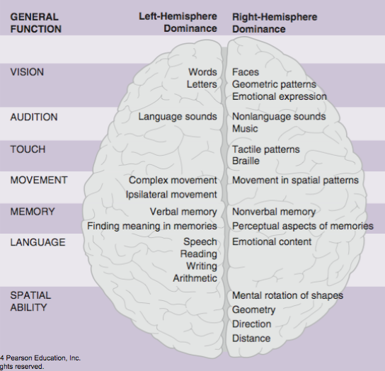
- A telescope projects the entire visual field onto the Z lens, so that the lens focuses the entire visual field on half of the retina, making the entire visual field project onto one hemisphere

Cerebral Lateralizations
- Many functions: there is no substantial differences between the hemispheres
- Lateralized functions where one side may show dominance, but not absolut control
- Left Hemisphere: superior in controlling ipsilateral movement
- Right hemisphere superior in spatial ability, emotion (maybe), musical ability, and some memory tasks
Broad categories or abilities are not lateralized, but individual, constituent, cognitive processes may be
- Two spatial tasks, the left hemisphere is better at judging above or below, while the right is better at judging how close two things are

Lateralization is likely an ancestral train in vertebrates

Analytic Synthetic theory (vague and hard to test)
- Left hemisphere analytical thinking (details_
- Right hemisphere synthetic thinking (big picture)
Motor Theory
- Left hemisphere fine movements
Linguist Theory
- Left hemisphere specialized for language
All purpose theories
- One hemisphere controls similar functions
- Lateralization allows simultaneous cognitive functions

Language

Evolution of Language
- 3 different warning calls for vervet monkeys, one for a snake (stand up and look on ground), one for a leopard (run up a tree), and one for an eagle (run into a bush)

Motor Theory of Speech Perception: words activate speech comprehension and motor areas
- Premotor cortex has Broca area (speech production) and mirror neurons (active in social contexts communication?)
- Other motor cortex is very active in speech comprehension
- Other primates (chimps) have a highly nuanced vocabulary of hand gestures
- A group of niggeroguans spontaneously developed a sign language with grammar and semantic rules, and pre-language children use a spontaneous sign language too

Anatomical Brain Asymmetries
- Frontal operculum (contains Broca’s area) with a larger cortical volume on the left compared to the right
  - Just anterior and dorsal of the sylvian sulcus
- Planum temporale (Wernicke’s area) for language comprehension: with a greater volume in the left over right in 65% of human brains, and greater left lateralization in those with perfect pitch
  - Dorsal/posterior region of the top temporal gyrus
- Primaty auditory cortex (Heschl’s gyrus) that is larger on the right (with two gyri) than the left (has one gyrus)
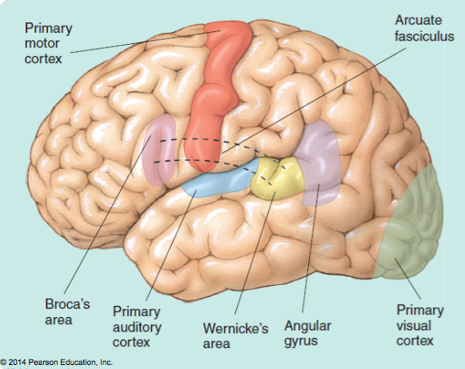
Broca’s Area: speech production
- Where damage leads to expressive aphasia (broca’s aphasia)
- Normal comprehension, speech is meaningful but awkward
Wernicke’s Area: Speech comprehension
- Damage causes receptive aphasia (wernicke’s apasia)
- Poor comprehension, speech sounds normal, but has no meaning
Arcuate Fasciculus: Broca-wernicke’s connection
- Damage causes conduction aphasia (poor speech repetition)
- Comprehension and speech are normal
Left Angular Gyrus
- Damage causes alexia (trouble reading) and agraphia (cant communicate through writing)
- Normal speech production and comprehension

Wernicke-Geschwind Model: The Evidence
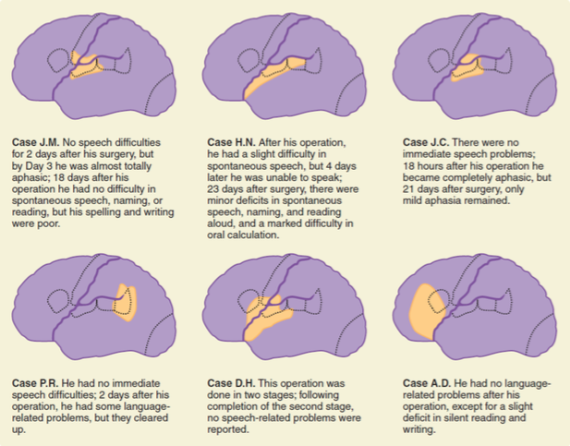
- Studies of patients with accidental brain damage, surgical brain damage, electrophysiological studies with epileptic patients and imaging studies
- No aphasic patients have damage restricted to B or W’s areas
- Aphasics almost always have damage to subcortical white matter
- Large anterior lesions most likely produce expressive symptoms
- Large posterior lesions most likely produce receptive symptoms
- Global aphasia is usually related to massive lesions of several regions
- Aphasics sometimes have damage in areas other than Wern-Gesch areas

Electrical Stimulation
- This is more considered a mosaic, where there is large individual variability, and a range of regions that are involved in different aspects of language
- Lots of overlap in sites at which stimulation disrupted or completely arrested speech

The Wernicke-Geschwind Model Today
- Empirical evidence supports the important roles of Broca and Wernicke’s areas
- That anterior and posterior damage produce expressive and receptive deficits
- No support for more specific predictions
- Damage limited to identified areas has little lasting effect on language, pure aphasia of either kind is rare, brain damage in other areas can produce aphasia, and there is large inter-individual variability

Cognitive Neuroscience of Language
- No language-only specific areas, but scatter in various regions
- Linguistic processes are broken down into small constitutive processes (phonology, grammar, and semantics), and are performed by areas that serve those processes (WM, pattern recognition for reading)
- Activity of reading sentences vs jumbled consonants: tiny and spread out differenes, large participant differences, left>right hemisphere activation, and activity within and outside areas in the Wern-Gesch model
- Naming specific items activates separate areas, with item-areas mapped in adjacent areas along a line in the MTL

Dyslexia: Reading difficulties not due to some other deficit (vision or intelligence)

Developmental Dyslexia: apparent when learning to read (5-11%), 50% heritability, and 2-3x higher in boys than girls
- Multiple types and multiple brain differences identifies
- A deficit in phonological processing, or the representation and comprehension of speech sounds (auditory areas in the lateral fissure)
- Often also a deficit in sensorimotor processing

Incidence in English speakers twice than Italian speakers due to more phonemes (one sound differing two words like pat and bat) and more ways of spelling them
- Italian: left superior temporal lobe more active, English:left inferior temporal and frontal lobes more active
- Many issues with pronunciation of words that sound the same but are spelled differently
- Simplified spelling helps
- Reading aloud uses the lexical procedure (using stored information about words) and the phonetic procedure (sounding out)

Surface Dyslexia: lexical procedure lost, can’t recognize words
- Has to do with a lack of ability to pronounce words like have, lose, and steak and assume their pronunciation is more like cave, xxxx, or beak

Deep dyslexia: Phonetic procedure lost, and can’t sound out unfamiliar words
- More responsive to the general looks of the word or pronounce a word that is semantically associated with the word
- Extensive damage to the left-hemisphere language areas (loss of phonetic reading)
- The left language areas and right hemisphere mediate lexical abilities in deep dyslexics

Acquired Dyslexia: due to brain damage and relatively rare

Stress and Emotions

Stress: Coordinated series of responses to an actual or potential aversive stimulus (physical, social, cognitive, immune) which typically include alterations in neuroendocrine and autonomic functions with complex changes in behaviour
- Experience of stress us common to all organisms
- Influenced by one’s experience, genetics, and behaviour (idiographic and individual differences)
- The inverted U of the costs of stress, where some stimulation is good, too much causes overstimulation and stress

Hans Selye (1950s): General adaptation syndrome, as an adaptive function to return the body to normal (homeostasis)

Hypothalamic-pituitary-adrenal axis (with feedback loop)

Hypothalamus, paraventricular nucleus (PVN)
- Corticotropin releasing hormone/factor (CRH or CRF)
- Neuroendocrine cell bodies in the hypothalamus produce CRF
- CRF is released from axon terminals that synapse on the primary plexus of the portal system, where CRF travels via portal veins to the anterior pituitary

Adrenal Pituitary
- Adrenocorticotropic hormone (ACTH) or cortictropin
- Hormone producing cells in the anterior pituitary respond to the hypothalamic signals by releasing ACTH and B-endorphin

Adrenal cortex (top of the kidneys)
- ACTH and B-endorphin travel through the bloodstream and regulate the endocrine glands
- Glucocorticoids exit the adrenal gland and decrease CRF production and/or release by feeding back to the hypothalamus, hippocampus, and other limbic structures
- The hippocampus has some of the highest levels of ACTH receptors, and is highly responsive to adding a level of emotion to learning
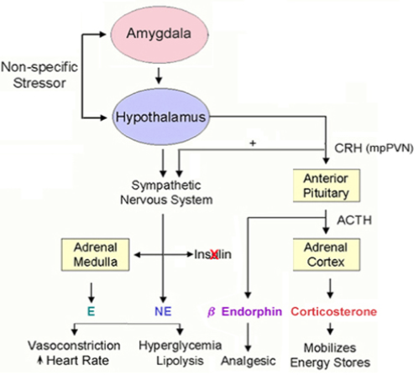
ACTH and Cortisol both peak just after awakening, decrease in the morning, and rise throughout the day

Stress and Stress Hormones

Stressors act on the brain, which then acts on the
- Anterior pituitary Adrenal cortex glucocorticoids
- Sympathetic nervous system adrenal medulla NE and EPI

The anterior pituitary can have additive effects on the SNS

Adrenal Medulla
- Inner layer of the adrenal gland
- Releases catecholamines NE and EPI, derived from phenylalanine Tyrosine
Adrenal Cortex
- Outer layer of the adrenal gland
- Releases steroids such as Glucocorticoids (cortisol and corticosterone) and Mineralcorticoids (aldosterone), all derived from cholesterol

Fight or Flight Response
- Norepinephrine from sympathetic nerves can increase HR, BP, and peripheral vasoconstriction
- Epinephrine from the adrenal medulla can increase BP, HR, impact peripheral vasoconstriction, increase lipid breakdown, convert glycogen into glucose and impact coronary and bronchial dilation

Animal Models of Stress
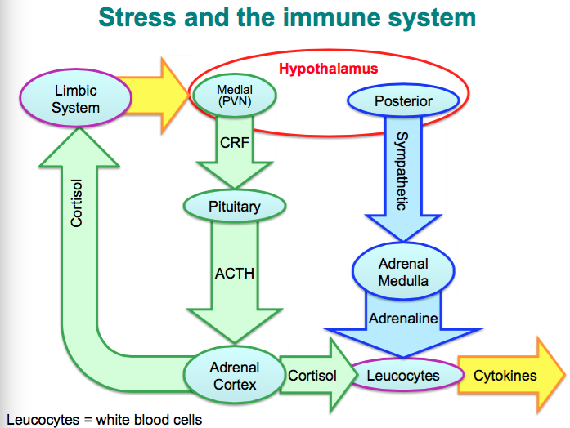
- Physical: pain, restraint, high/low ambient temperature, aggressive attacks
- Physiological: conditioned fear, conditioned defeat subordination (psychosocial)

Psychosomatic Disorders: Caused by a mental factor such as stress: Gastric Ulcers
- Lesions of stomach lining, are more common in people who are stressed, caused by Helicobacter pylori bacterium
- 75% of healthy subjects have the bacterium
- Chronic or repeated stress makes the body vulnerable to H. pylori

Psychoneuroimmunology
- Study of the interaction of psychological factors, the nervous system, and the immune system
- Glucocorticoids, the SNS, and PNS all impact the immune system (Thymus, Immune cells, Spleen, Lymph nodes, bone marrow)
- The immune system releases Cytokines back into the vagus nerve and the hypothalamus

Innate Immune System
- First line of defense at entry points
- Attacks generic molecules by various pathogens
- Phagocytes: leukocytes and microglia (in the CNS), which carry toll-like receptors which trigger phagocytosis that engulf pathogens
- Phagocytes releases cytokines, which trigger the inflammatory response (swelling, redness, aches, fever) and activate cell mediated immunity

Adaptive Immune System
- Targets specific antigens on foreign cells
- Is slower and has memory (vaccination immunity)
- Cytokines activate lymphocytes (types of leukocytes)
Cell-mediated immunity (T cells or T lymphocytes)
- Macrophage’s cell surface has antigens of ingested foreign cells
- T lymphocyte recognizes macrophage’s and antigen foreign particles
Antibody-Mediated Immunity (B cells or B lymphocytes)
- Recognize specific antigens
- Release specific antibodies
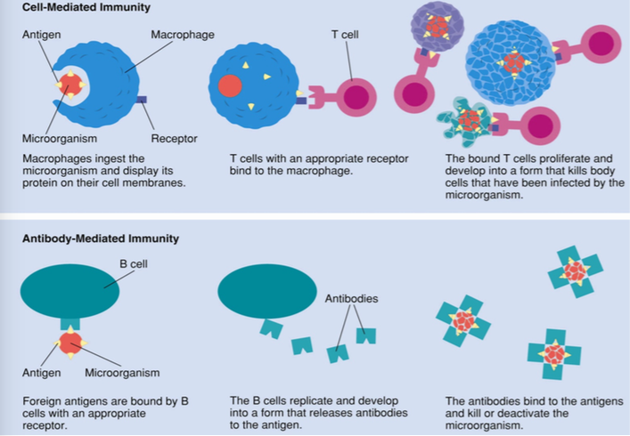

Eustress: Enhances immune functions, such as acute single stress and controllable stress

Distress: Impairs immune functions, such as chronic stress, some repeated acute stress, and uncontrollable stress
Acute Cytokine Activation: Enhances immune functions
Chronic Cytokine Activation: Impairs immune functions

Stress and Infectious Diseases

Animal Studies
- Chronic and uncontrollable stress enhances infection rate
Human Correlation Studies
- Stress correlated with infection rate
Human Partially Controlled Studies
- Impairs immune function
- High self-reported stress linked to higher infection rate after nasal administration of cold virus

Early Experience of Stress

Perinatal and Early Life Stress
- Impaired stress response
- Higher anxiety/ fear behavioural profile
- Higher depression

E.g. Rat pups separated from their mothers
- Enhanced behavioural and hormonal stress response in adulthood
E.g. Rat pups handled by researchers
- Reduced behavioural and hormonal stress response in adulthood
E.g. Fearful Poor Mothers
- Pups become fearful in adulthood
- Daughters become poor mothers

Brief daily handling decreases and extended separation increases:
- Fearful behaviour, HPA activation to stress, plasma adrenocorticoid hormone, plasma corticosterone, CRF mRNA (hypothalamus and amygdala), CRF receptors (locus coeruleus)
Brief daily handling increases and extended separation decreases:
- Glucocorticoid receptors (hippocampus and frontal cortex) and GABAa receptors (locus coeruleus and amygdala)

Low interaction as a pup increases in adult stress response are reduced almost to normal interaction levels when there is handling

Epigenetic Regulation of Gene Expression
- A change in phenotype that is heritable but dose not involve DNA mutation
- DNA Methylation: Gene transcription
  - Methyl marks added to certain DNA bases repress gene activity
- Histone Modifications: Access to DNA
  - A combination of different molecules can attach to the tails of proteins called histones, which alter the activity of the DNA wrapped around them

High Maternal Cares De-methylation of Nr3c1, the gene for the glucocorticoid receptor
- This increases brain GRs, enhanced glucocorticoid inhibitory feedback, reduced CRF, reduced pituitary-adrenal responses, lowers anxiety,
- Glucocorticoid receptors in the hippocampus for example allow the brain to react more profoundly to glucocorticoids, or the mechanism for negative feedback of the HPA axis
- Also lead to healthier pups, with the difference being hereditary

High Maternal Licking and Grooming
- This Nr3c1 de-methylation occurs through 5-HT receptor activation
- This leade to low anxiety, low corticosterone levels
- 5-HT receptors acton cAMP, then PKA, then on CBP (CREB protein transcription factor), that then actos on NGFIA (nerve growth factor inducible A), then de-methylating the Nr3c1 gene

Licking and grooming activates the thyroid hormone, which increases hippocampal serotonin levels and binding to the 5-HT7 receptor
- The 5-HT7 receptor sets of the cAMP PKA cascade
- In the end, there is increased glucocorticoid feedback in the brain (anygdala) and reduced anxiety behavioural responses

Stress and the Hippocampus
- Stress impairs: dendritic branching in pyramidal neurons, dendritic spines, adult neurogenesis, hippocampal-dependent learning and memory
- Similar effects with corticosteroids
- Effects blocked with adrenalectomy

Sex Differences in the Stress Response
- Females: Greater cortisol response than males, tend and befriend (copying strategies, social modulation – oxytocin?)
- Males: Fight or flight
- Testosterone reduces the stress response
- Estrogens potentiate the stress response
- Progesterone reduces the stress response
- Social support increases oxytocin, increasing social reqard circuits, increasing reward sensitivity (trust, social bonding, and therapeutic alliance), and social functioning, which can reduce PTSD symptoms

Biopsychology of Emotions

Phineas Gage Case (1848): Loss of the PFC reduced affective capacity, social cues, etc.

Theories of Emotion

Charles Darwin: Expression of emotions in man and animals, relating reactions and facial expressions
- Emotions can evolve into communication signals
- Principle of antithesis, or the opposite physical manifestations of opposite type emotions
- Dogs: approach with hostile intentions with back arched up, tail up, compared to affectionate frame which looks more like lordosis
  - The dog’s play bow
  - Metacommunication: where the signal acts as a scene setter for play
- Opposite in cats
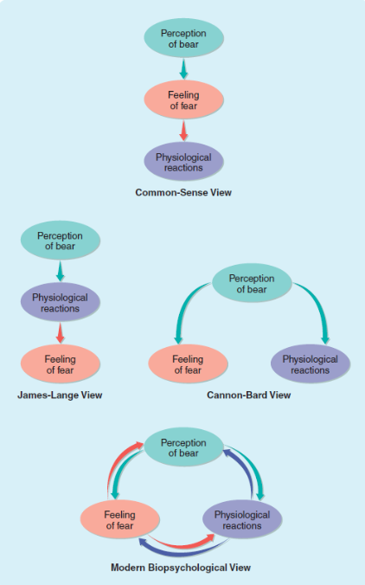
Common Sense View
- Stimulus Emotion
- Emotion Autonomic/skeletal response

James-Lange (1884)
- Stimulus autonomic/skeletal response
- Autonomic/skeletal response emotion

Cannon-Bard (1915)
- Stimulus autonomic/skeletal response
- Stimulus Emotion

Telencephalon – Limbic System
- Amygdala, hippocampus, fornix, cingulate cortex, septum, mammillary bodies
- Mainly large, subcortical nuclei
- Main functions of the 4 Fs, as well as emotions, learning, and memory

Kluver-Bucy Syndrome (1939)
- Rare cerebral neurological disorder
- Urge to put objects into mouth, memory loss, extreme sexual behaviour, placidity, visual distractibility
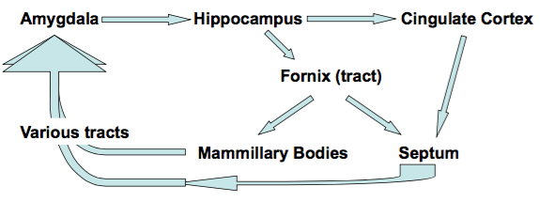
- Very friendly and non-aggressive
- Results from bilateral damage to the temporal lobes including (amygdala)

Autonomic Nervous System (ANS)
- Common ANS responses include increased HR, BP, pupil dilation, increased blood flow to muscles, respiration, release of EPI and NE from the adrenal medulla
- Spectrum of Total Specificity and Total Generality: Specific one pattern of ANS activation for one emotion, or all emotions eliciting the same pattern of ANS activation

Measured by skin conductance and cardiovascular activity (HR, BP, blood volume)

Polygraphy: Lie detection is really emotion detection
- Control-question technique: target question vs control question with a success rate of about 80%
- Guilty knowledge technique: Question that only the culprit would know the answer to with a success rate of 88% in one study

Emotions and Facial Expression

Ekman & Friesen (1970s)
- Facial expressions have universal meaning
- 6 Primary emotions (plus 3 new ones) including (Surprise, anger, disgust, fear, happiness, contempt, embarrassment, pride)
- Constant across cultures in the face and emotion

Orbicularis oculi and zygomaticus (around the eyes and vertically in cheeks): Smile
Corrugator (Eyebrow movement): Frowning in anger
Levator (sides of the nose): Grimace of disgust

Voluntary Control of Facial Expressions
- Microexpressions: brief facial expressions reveal true emotions
- Duchenne smile: the mouth corners raise (zygomaticus) and the eyes raising forming the crows feet around (orbicularis) are both involved
- Fake smile: Either only the mouth or mouth + eyes but the eyes are delayed

Fear (emotional reaction to a threat), Defense (Designed to protect from threat or harm, motivated by fear), and Aggression (designed to threaten or harm)

Factors Influencing Aggression
- Neurobiological: Hormonal, neural, neurochemical
- Genetic and epigenetic factors
- Evolutionary
- Developmental: Family, socialization
- Cognitive characteristics: individual experience
- Situational: Cultural, socio-economic
- Environmental

Categories of Aggressive and Defensive Behaviours In Rats
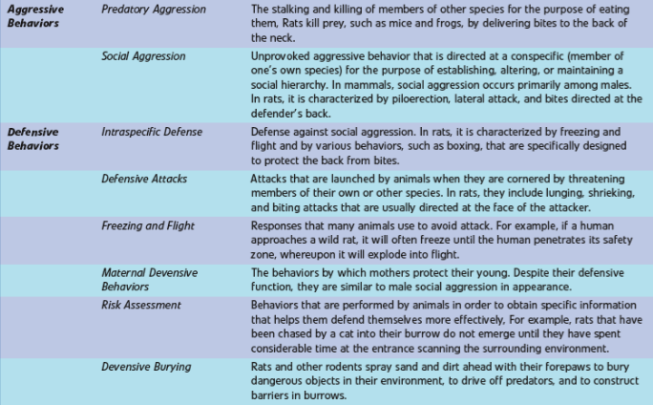
Heterogeneity of Aggression

Function
- Interspecific, offensive such as predatory
- Interspecific, defensive or anti-predatory
- Intraspecific, offensive such as competitive, territorial, or dominance/hierarchical
  - Territorial aggression in inter-male conspecifics (moose)
  - Territorial in red-winged blackbirds for the best land close to a lake
- Intraspecific, defensive such as maternal or subordination/hierarchical

Behaviour (Rats)
- Overt aggression in bites, attacks, and fights
- Ritualized aggression such as various communication signals
  - Upright posture
  - Lateral threat display
  - Freeze/flight
- Biting pattern – target side
  - Dorsal: Offensive
  - Ventral: Defensive
- Impulsive Aggression
  - Angry, rage (hate), frustration

Indirect Aggression: Such as social in humans for ignoring bitches
Motivation
- Offensive aggression: not fear
- Defensive aggression: fear

Konrad Lorenz’s Psychohydrolic Model
- Motivation for aggression accumulates
- Motivational energy is released by an appropriate sign stimulus
- Simulus behaviour (fixed action pattern, consummatory response)
- Motivational energy is released when the pressure on the valve causes an action pattern to occur spontaneously (vacuum activity)
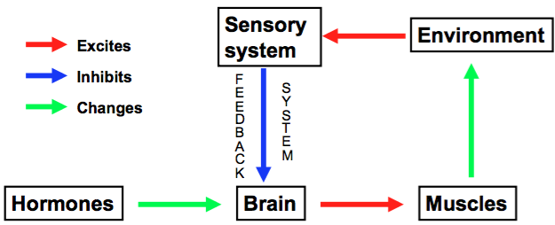
Aggression in the stickleback fish is almost 5x as bad when they grew up in isolation

Deuthsch’s Model

Aggression in Laboratory Rodents
- Intruder Test: with isolated animals, with colonies, and with mothers
- Diminance with dyads and colonies
- Competition for resources
- Psychosocial stress
- Shock-induced fighting

Neurobiology of Aggression
- Brain areas: Hypothalamus, Amygdala, PAG, Septum (inhibits), PFC (inhibits)
- Neurohormonal Systems (pro-aggression): Testosterone (and estradiol), serotonin, vasopressin, NO, DA (and opioids), Catacholamines (and stress hormones), GABA
- Neurohormonal Systems (Anti-aggression): Oxytocin, DA (opioids), Estradiol, Progesterone, GABA

Sea Anemones (Aggression without a brain)
- The nerve net: Diffuse mesh of nerve cells that take part in simple reflex pathways
- Nerve cells interact with sensory and contractive cells
- Epithelial calls and sensory cells act to close the sea anemone when threatened

Sham Rage: Decorticated cats, where the leaving the hypothalamus leads to aggression and removing the cortex causes random aggression

Central Mechanisms of Aggression
- Limbic system: Amygdala (arousal, rapid response)
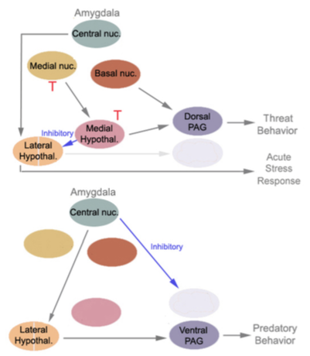
- Hypothalamic (specific nuclei for adding and subtracting from the response
- PAG: pain
- Striatum: pain, cognitive
- Cortical: PFC (cognitive component)

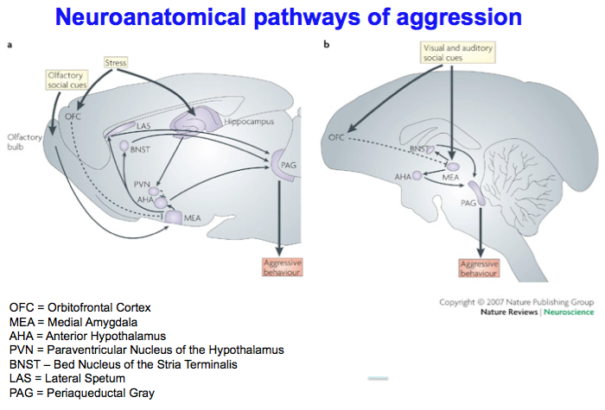

- Explain the experiment demonstrating visual discrimination in split-brain cats. List all 4 experimental groups and briefly describe the procedure. What did they find? What do their results indicate? (7 points)
1. Unlesioned controls
2. Lesioned corpus callosum 3. Lesioned optic chiasm 4. Lesioned both CC and OP. Description (1 point): Cats had a patch placed over 1 eye and learned to discriminate between 2 visual cues. Then the patch was transferred over to the opposite eye, and where asked whether they could still visually discriminate between the two cues = test. Results (2 points): When groups 1-3 were tested on the discrimination, they had no problem discriminating the two visual cues. However, group 4 could not (but they could learn to discriminate the visual cues if trained). Implications (2 points): This implies that both the CC and OC are capable of relaying visual information between the cerebral hemispheres. With both of these connections cut, each hemisphere seems to process information independently from one another.

2) Based on the studies of lateralization of brain function discussed in class, describe what you would expect a patient with a commissurotomy (split brain) to report (verbally) when viewing stimuli that are briefly presented to either the left or right visual field. What would you expect to see when patients were asked to instead report their visual observations using related picture cards (non-verbal)? Why? (5 points)

- Visual stimulus presented to the right visual field (0.5 point) is processed by the left hemisphere (0.5 point) and will be verbally reported normally (0.5 point)
- However, the patient will report not seeing anything (0.5 point) when images are restricted to the left visual field (0.5 point ), which is processed by the right hemisphere (0.5 point)
- This is because speech is localized in the left hemisphere (1 point).
- Using a picture cards, patients could only use their left hand to show image in left visual field (0.5 point); image in right visual field could be shown using picture card in right hand (0.5 point).

