CLASS 1

The research process
- Identify management or organizational problem
- Build a proposed explanation with support from relevant literature, develop hypotheses
- Choose a research design – experiment or field study/survey, cross-sectional or longitudinal
- Plan measures and data collection – self report questionnaire, interview, observation, sampling, ethics of data collection
- Analyze the data – quantitative, qualitative analysis, accept or reject hypotheses
- Write a report, prepare presentation, make recommendations to managers, future researchers

Applied management research: research conducted to solve a problem within a particular setting. The findings and recommendations are expected to be of value to practicing managers or other actors in organizations
k
Research process: the process of identifying a researchable problem, building an explanation and specific hypotheses, designing and conducting data collection and analysis to test hypotheses, interpreting results and making recommendations to practitioners and to future researchers

Hypothesis: a formal statement predicting a relationship between variables
Measurement: the process of observing, recording, and assigning numbers to objects or events to indicate size, amount or frequency
Sampling: when predetermined number of observations will be taken from a larger population

Research ethics: the expected norms of what constitutes appropriate behaviors (code of conduct) when conducting research
Analysis: detailed examination of the elements

Research based recommendations: a suggestion or proposal as to the best course of action

Why do management research?
- To make better decisions
- Innovation/creativity
- Problem solving
- Continuous improvement

CLASS 2

Theoretical framework: a link to existing knowledge (theoretical and empirical findings) that provides a perspective through which to examine a topic of interest; the foundation on which a research study is based, including clear explanations for the types of variables included and their expected relationships

Independent variable: a predictor variable that predicts or causes a change in a dependent variable (this is the variable that is manipulated in an experiment)

Dependent variable: an outcome variable that is expected to change because of a change to the independent variable

Mediating variable: a variable that explains the relationship between an independent and dependent variable

Moderating variable: a variable that changes the nature/strength of a relationship between an independent and dependent variable

Literature review: a summary of the relevant knowledge conducted by previous researchers in the field; it is used to develop a theoretical framework and hypotheses for a research study; it ensures researchers build on the most recent state of affairs and do not miss any critical variables in their study

Freedom from coercion (ethics of data collection): the expected norms of what constitutes appropriate behaviors when collecting data includes ensuring that participants are not coerced into participating but rather feel it is their choice

Bivariate hypothesis: a prediction about the relationship between two variables only (ex: X is related to Y, the greater the X, the less the Y and X1 will have more Y than X2)

Aims of research:
- Observe and describe
- Predict
- Determination of the causes
- Explain

Formulating the research problem
- Literature review, use of existing knowledge
- Using computer databases
- Possible explanations
- Key variables emerge form literature, observations & common sense

CLASS 3

Causality: The relation of cause and effect such that one variable is the cause of a change in another

Manipulation: How a researcher exposes participants to an independent variable (experimental condition) in an experimental research design

Random assignment: The process of assigning individuals to different groups in an experiment so that each individual has an equal chance of being in any group. This ensures that possible confounding variables are evenly distributed across the groups

Control of extraneous variables: The process of controlling for the effect of undesirable variables (variables not part of the experiment that may have a possible confounding effect) on the cause and effect relationship of interest, either through random assignment of participants or statistical control

Field & lab experiments: Research that manipulates an independent variable (cause) to measure its effect on another variable (dependent variable) under controlled circumstances; can take place in a controlled environment (lab experiment) or the participants’ natural environment (field experiment)

Internal validity: The confidence that changes in the independent variable are the cause of changes to the dependent variable (cause and effect)

Selection effect: A threat to internal validity that occurs when participants in the experiment and control groups are different from each other in a way that influences the results

Subject effect: A threat to internal validity that occurs when participants expect a certain result and thus consciously or unconsciously report that expected result; bias in responses that come from guessing the research hypothesis

Experimenter effect: A threat to internal validity that occurs when the researcher gives away any cues or signals that affect the participants’ response or behavior

External validity:
Generalizability of the results of a study to other research settings

Ethics of experimental design: The expected norms of what constitutes appropriate behaviors when conducting an experiment includes taking care to ensure participants in control groups are not disadvantaged in relation to those in experimental groups (or vice versa); ensuring freedom from coercion because the experimental setting makes participants feel powerless

CLASS 4

Nominal (Categorical): A measure that categorizes participants’ responses into groups such as male/female; no ordering of values is implied

Interval (Continuous): A multi-point measure that uses numbers that are equidistant, such as extent of agreement on a scale from 1-5. It is assumed that numbers are in order, and the distance from 1 to 2, for example, is the same as the distance from 4 to 5

Ratio (Continuous): A measurement with an absolute zero origin, which can determine the proportion of differences among responses such as years of work experience or age

Likert scale: An interval scale that assesses participants’ agreement to a statement using set anchors such as Strongly Disagree to Strongly Agree (often on a 5- or 7- point scale)

Coding key: A listing of the questionnaire items that are used to measure each variable in a research study

SPSS: “Statistical Package for the Social Sciences” is a software package used for statistical analysis

t-test: A statistical test that looks at whether two group means differ from one another on a variable of interest; the independent variable must be nominal with two groups only while the dependent variable must be continuous (ratio or interval)

Use the t-test when:
Variable 1 = Nominal with 2 levels (2 groups)
Variable 2 = Interval or Ratio

One-way ANOVA: A statistical test (Analysis of Variance) that looks at whether three or more group means differ from one another on a variable of interest; the independent variable must be nominal with three or more groups while the dependent variable must be continuous (ratio or interval)

Use one-way Analysis of Variance (ANOVA) when
Variable 1 = Nominal with 3 or more levels
Variable 2 = Interval or Ratio

CLASS 5

Descriptive statistic: Statistics that provide a description or summary of the basic features of the data used in a research study, such as means and standard deviations

Inferential statistic : Statistics that help to establish relationships between variables used in a research study, allowing researchers to make predictions about a larger population than the original sample (e.g., an ANOVA or a correlation)

Value of test statistic : A numerical summary of a data set in the form of a value that can be used to perform a hypothesis test (i.e., it determines the probability of obtaining a given value)

Statistical significance (p-value): A value that indicates how confident you can be that your result is not due to chance alone; a p-value of 0.05 is typically used as cut-off indicating there is a less than 5% change that your results are due to chance alone (alternatively, you can be 95% confident that your hypothesis is supported)

Marginal significance: Some researchers will report results as marginally significant if their result has a p-value of 0.10 or less, indicating that there may be an effect that is interesting to explore further (however, there is up to 10% chance that this result is due to chance alone and should thus be interpreted cautiously)

One-tailed test: A prediction about a relationship between variables that indicates an expected direction (positive or negative)

Two-tailed tests: A prediction about a relationship between variables that does not specify a direction

Null hypothesis: A prediction about the absence of a relationship between variables (i.e., there is no relationship between them)

Rationale for non-experimental designs: Sometimes it is impossible to conduct an experiment with random selection of participants and a control group (e.g., unrealistic, unethically, non-feasible, too expensive, time sensitive), leading researchers to use other forms of research designs such as field studies or correlational designs

Ethical issues in reporting results:
There are also ethical considerations in reporting results: “Am I violating standard research practices?”
- Data collection
- Data analysis
- Dissemination of findings
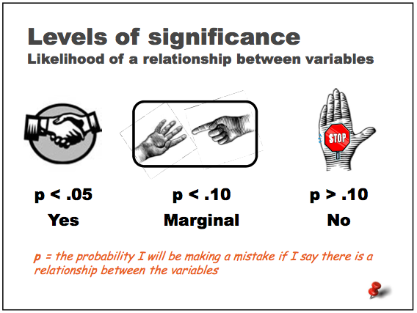

Correlation does NOT equal causation

Just because the movements of two variables track each other closely over time doesn't mean that one causes the other.

- Be critical of statistics that you see
- Look for a causal link or mechanism
- Demand a little bit of scientific rigor in showing that there's a strong, statistically significant correlation

CLASS 6

Survey study: The use of a survey questionnaire to collect data from participants in the field

Field study: The collection of data/information outside of a laboratory or artificial setting

Reverse causation: When the direction of a cause-and-effect relationship may be in the opposite direction than expected such that the dependent variable is actually having a causal effect on the dependent variable; a threat to internal validity

Spurious relationships: When a correlation between two variables is due to the influence of a third variable rather than a direct relationship (i.e., a third variable makes two variables co-vary that alone would have no causal connection); a threat to internal validity

Reliability: Consistency of measurement

Validity: Evidence that a measure (e.g., instrument, scale, technique) is accurately measuring/reflecting what it is intended to measure (i.e., it fully represents all aspects of the relevant construct)

Closed-ended questions: Allows respondents to answer a question using set choices/alternatives provided

Open-ended questions: Allows respondents to answer a question on a survey questionnaire or interview in any way they prefer

Memory aids: a way to help respondents recall information by placing events in time or offering other probes

Sensitive questions: Questions that are emotionally loaded such that they may elicit emotional or biased responses

Double-barreled questions: Questions that include more than one question at a time, thereby lending themselves to different possible responses from the respondents

Ethics related to self-report: Anonymity, Confidentiality & Informed consent: The expected norms of what constitutes appropriate behaviors when collecting survey data includes ensuring that participants are (a) asked to give their informed consent to participate in the survey, indicating that they understand what the purpose and process of the survey are; (b) guaranteed that their responses will be confidential; and (c) told whether their anonymity is guaranteed or at least protected in cases where personal information needs to be collected

Cronbach’s alpha: A measure of internal consistency or how closely a set of items are related to each other as a group; a Cronbach’s alpha of .70 is typically considered acceptable/reliable. (Alpha ranges from 0 to 1)

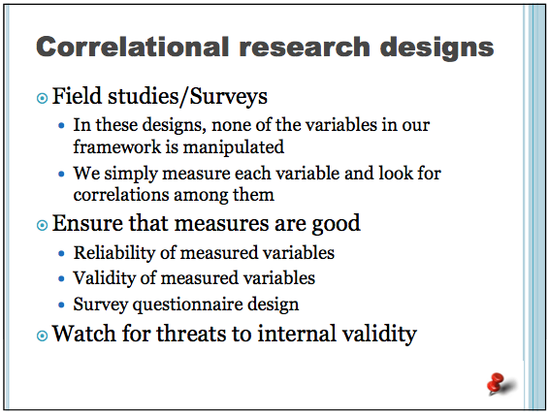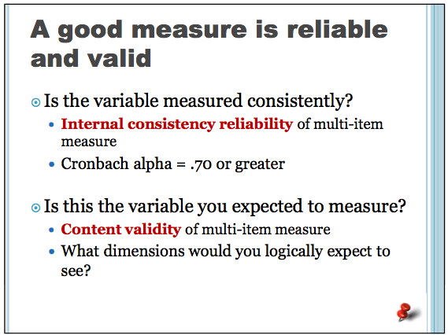

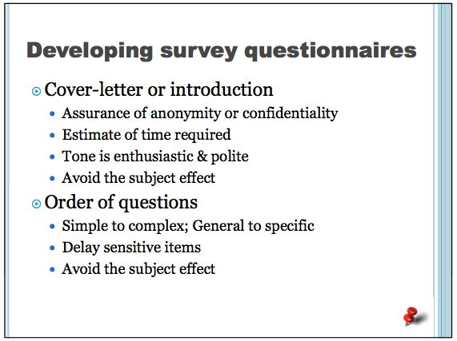

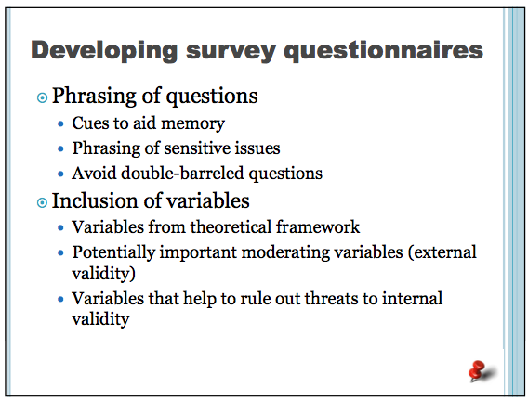

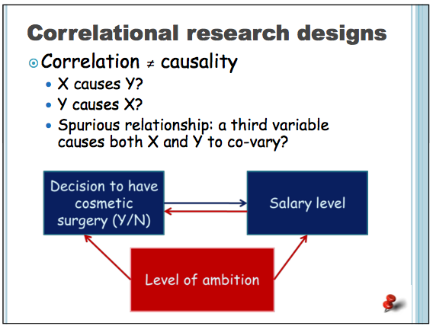

CLASS 7

Distribution techniques: Surveys are distributed in person, via mail, or electronically as dependent on the goals and resources of the researchers
- In-person surveys tend to generate a relatively high response rate and allow researchers to clarify questions or concerns participants may have. However, these surveys take time and effort to conduct, and the researcher may introduce bias to the process (e.g., the experimenter effect)
- Mail and electronic surveys are quick and easy to distribute to participants within a broad geographical area and they allow participants to respond at their own convenience. However, they tend to generate a low response rate and there is no way to clarify questions or concerns from the participants.

Random sample: A sample of participants that has been randomly selected for researchers to gain an accurate selection of the full population (all participants have the same probability of being selected); while it is costlier and more time consuming to gain access to a random sample than a convenience sample, researchers can draw conclusions from the data without concern for bias

Convenience sample: A sample of participants that has been selected based on convenience, such as proximity or availability to the researcher; while this is a cost effective sampling method, researchers must be aware of potential bias due to the non-random selection process such that the results may not be generalizable

Reverse coding: The inclusion of items that are negatively worded/phrased in the opposite direction of the other items in a survey scale are called reverse coded items; these items are used to motivate participants to respond more carefully and to avoid giving the same answer to all items. Before calculating an index including reverse coded items, researchers must change the value of those responses (i.e., reverse code) so that a high value indicates the same type of response on every item (1 become 5, 2 becomes 4 for the reverse coded items, and so on)

Index: The average of several questionnaire items that are used to measure a single variable (for example, a job satisfaction index may include five different questions about individuals’ feelings about their job and an index is an average of all five questions)

Correlation coefficient: Measures the strength and direction of a relationship between two continuous (interval or ratio) variables ranging from 0 to 1 (positive correlation) or 0 to -1 (negative correlation)

Multiple regression analysis: An assessment of the relationship between two or more independent variables and one dependent variable (all variables must be continuous, i.e., interval or ratio)

Questionnaire distribution techniques:
- Electronic surveys
- Mass-administered surveys
- Telephone interviews
- Individually administered surveys
- Mailed surveys (snail mail)
- Face to face interviews

Facts to consider:
- Complexity of questions
- Cost
- Potential for researcher bias
- Respondents’ motivation
- Need for anonymity
- Speed

Rules of thumb about sample size:
- Sample sizes larger than 30 and less than 500 are appropriate for most research
- Where samples are to be broken into groups (e.g. female / male) a minimum of 15 per group is necessary
- In multivariate research, the sample should be at least 10 times as large as the number of variables
- In tightly controlled experimental research, samples may be as small as 20

Testing hypothesis:
Use the correlation coefficient when there are two variables
- Variable 1 = Interval or Ratio
- Variable 2 = Interval or Ratio
Use multiple regression when
- There is more than one independent variable and all are Interval or Ratio
- Dependent variable is Interval or Ratio

When several questionnaire items are used to measure a single variable, we take an average of the items to represent each participant’s score—this is called an index
- Change reverse-scaled items
- Check internal consistency reliability (Cronbach’s alpha)
- Calculate the average score for the variable

Scatter diagram: to get a feel of the relationship (if any) between the variables as suggested by the data. The closer the points are to a straight line, the stronger the linear relationship between two variables

Basic assumptions: The observations are assumed to be independent. For correlation, both variables should be random variables.

There are three main uses for correlation and regression.
- One is to test hypotheses about cause-and-effect relationships. In this case, the experimenter determines the values of the X-variable and sees whether variation in X causes variation in Y. For example, giving people different amounts of a drug and measuring their blood pressure.
- The second main use for correlation and regression is to see whether two variables are associated, without necessarily inferring a cause-and-effect relationship. In this case, neither variable is determined by the experimenter; both are naturally variable. If an association is found, the inference is that variation in X may cause variation in Y, or variation in Y may cause variation in X, or variation in some other factor may affect both X and Y.
The third common use of linear regression is estimating the value of one variable corresponding to a particular value of the other

CLASS 8

Cross-sectional: A study in which data is collected just once (in one-shot), typically over a few days or weeks; a survey study is a cross-sectional study where participants respond to one survey only

Longitudinal designs : A study in which data is collected at two or more different points in time to assess people or phenomenon and their changes over time, either with or without intervention (see also program evaluation); longitudinal studies are typically costlier and take longer than cross-sectional studies, but they are also better at identifying a cause-and- effect relationship by separating the independent variable from the dependent variable in time; experimental design is a type of longitudinal study where researchers collect data before and after a manipulation

Proximal outcome : Short-term or more immediate outcome of a program/intervention

Distal outcome: Long-term outcome of a program/intervention
Internal validity issues

Internal validity: The confidence that changes in the independent variable are the cause of changes to the dependent variable (cause and effect)

- History: A threat to internal validity that occurs when events or factors that take place during the course of a research study may influence the dependent variable

- Mortality: A threat to internal validity that occurs when those participants who drop out of the study differ from those who remain in the study (or when the drop-out rate is different for the experimental group and control group), the dependent variable may be influenced by the particular demographics of the remaining participants

- Maturation: A threat to internal validity that occurs when natural changes take place in the participants during the time of the research study (e.g., aging, work experience, boredom etc), the dependent variable may also change

Longitudinal research:
- Study of organizational changes over time
- Often conducted to evaluate new programs
  - PROGRAM EVALUATION - Assessing interventions that are intended to bring about positive change in organizations

Program evaluation
- Establishing goals of the intervention
  - Proximal and distal goals
- Program monitoring
  - Is the program being carried out as planned?
- Impact assessment
  - Outcomes as predicted?
  - Assess using longitudinal research designs
- Decision making
  - Recommendations to continue, terminate or modify the program

Ideal longitudinal research designs: (to track changes overtime)
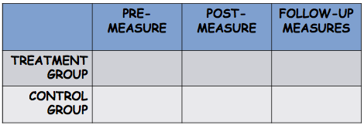

**But sometimes research designs do not reach the ideal due to threats of internal validity (history, maturation, mortality)

Threats can be ruled out by having a control group

CLASS 9

Transcription of interview data: The process of transcribing (or writing out) a verbal interview in a word-for-word format; used to code and analyze interview data

Expected themes & emergent themes: The process of examining and recording patterns of qualitative data (e.g., interviews or observations) leads to themes; either expected themes (i.e., in line with the interview questions and focus) or emergent themes (i.e., in line with participants’ reactions and interpretation of interview; possibly unexpected to researcher)

Inter-rater reliability: How consistent several raters are in their interpretation of a phenomenon or event

Interviewing tips
- Neutral, pleasant facial expression and tone of voice
- Try not to show agreement, disagreement, surprise at answers... beware the experimenter effect
- Take notes about answers during and immediately after interview
- Use follow-up questions as probes
- Take “field notes” of your observations and reactions during the interview

Observation
- Sometimes self-report will not provide the information we need
- Observational measures may avoid problems of sensitivity, memory or lack of awareness
- Observation schedules allow us to record our field observations rapidly and accurately
- Inter-rater reliability is vital
- In some circumstances, observation requires attention to ethical considerations: Invasion of privacy, deception, betrayal of trust

CLASS 10

Illustrative comments: Comments or quotations from an interview that are used to provide evidence, explanation, and a deeper understanding of the results

Contingency table: A table that displays the frequency distribution of two or more categorical variables; used to analyze the relationship between categorical variables

Chi square analysis: A statistical test for analyzing a relationship between two nominal (categorical) variables
If hypothesis is directional: one-tailed
If hypothesis is non-directional: two-tailed

Analysis of qualitative data:
CODING INTERVIEW TRANSCRIPTS
Seek themes or patterns in data (expected, emergent)
Test relationships (chi-square)
Tell an interesting store consistent with your analyses

DATA REDUCTION
Seek themes / patterns in the data
- Start with expected themes
  - Anticipated by the researcher when designing interview guide or observation schedule
  - Record frequency of comments for each interview theme
- Verify your operational definitions and check inter-rater reliability (% agreement)
  - Is it easy or hard to agree on themes?
  - 80% is good inter-rater (inter-judge) reliability
- Look for emergent themes
  - Unexpected participant reactions to interview questions
  - Unexpected events in field observations

DATA DISPLAY
Create contingency tables of interesting relationships
- For example 2x2 or 2x3 tables
- Test relationships: chi square analysis of contingency tables

DRAWING CONCLUSIONS
- Present illustrative quotes from interviews
- Draw inferences and tell a store about your topic that is consistent with your analyses

